Module 7: Portfolio Project: System Planning and Process

Justan E Dunn
Colorado State University Global
CSC501-1: Management for the Computer Science Professional
Professor Steven Evans
05/04/2025

Abstract
This portfolio project presents the system planning and process development for a fictitious project focused on building a Project Management API with integrated blockchain components. Throughout this paper, key project management concepts are applied—including stakeholder engagement, project planning, design methodology, and risk mitigation—culminating in a formalized strategic plan supported by industry best practices. Each module milestone contributes to a comprehensive understanding of managing technical projects across lifecycles, aligned with guidance from the Project Management Institute (PMI) and Agile principles.

Module 7: Portfolio Project: System Planning and Process
Effective project planning and system implementation require alignment across organizational goals, technology strategies, and stakeholder expectations. This portfolio project outlines a complete project lifecycle for designing and deploying a blockchain-integrated project management API system. It incorporates progressive milestones from stakeholder engagement to design methodology and risk management. The goal is to simulate realistic planning processes applicable in enterprise-level systems projects (PMI, 2021).
System Overview and Selection
The chosen project focuses on the creation of a Project Management API powered by blockchain for transparency, traceability, and automated control of project phases and deliverables. The system supports role-based access, project lifecycle tracking, milestone validation, and automated reporting through smart contracts. This system was selected due to the increasing demand for decentralized and auditable project management solutions in cross-functional organizations.
Stakeholder Engagement Analysis
Stakeholder analysis began with the identification of core influencers using the Stakeholder Engagement Assessment Matrix. This matrix evaluates influence, interest, and required engagement strategies across five levels—from unaware to leading.
Figure 1
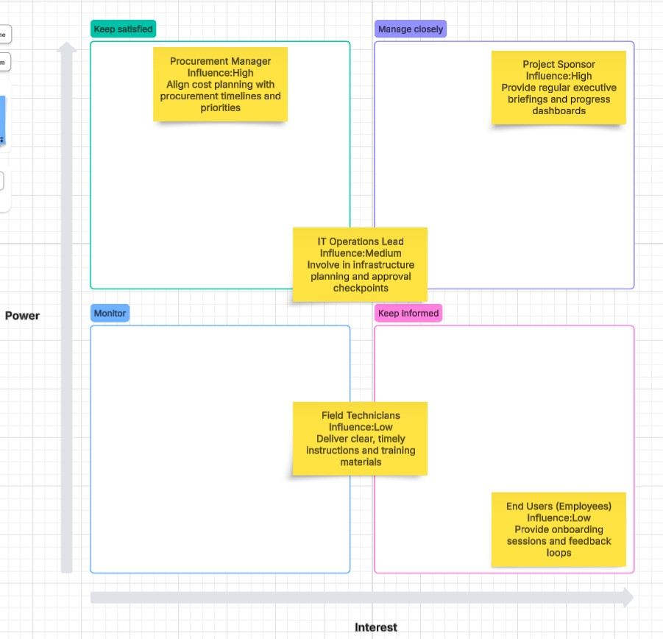
Stakeholder Engagement Assessment Matrix
This analysis ensures targeted communication and ownership, especially among technical leads and executive sponsors, to minimize resistance and promote collaboration (Kerzner, 2022).
Use Case Summaries by Engagement Level
Each of the five stakeholder engagement levels is represented in the matrix. Below are use cases that explain the rationale for each stakeholder’s placement.
Unaware – Field Technicians
Technicians responsible for physical deployment were not initially included in technical planning conversations. Their awareness level is low, and an engagement strategy is needed to bring them up to speed via technical briefs and region-specific onboarding meetings.
Resistant – Procurement Manager
Procurement expressed concern over vendor approval timelines and early budget requests. Their resistance stems from competing initiatives. This stakeholder will be engaged through clearer budget alignment and phase-specific purchasing justification.
Neutral – IT Operations Lead
The IT lead is aware of the project but has yet to engage directly. Their moderate influence and interest can be leveraged through collaborative meetings that connect infrastructure needs to planned system integrations.
Supportive – Project Sponsor
The sponsor is actively encouraging project progress but has limited bandwidth. Scheduled updates, executive summaries, and key milestone involvement will help maintain their support without overloading their calendar.
Leading – Department Power Users
Departmental team leads are excited about the system and have volunteered to test early builds. Their enthusiasm and influence on others make them ideal champions. They will be given early access and feedback loops to drive adoption.

Project Planning and WBS
The next phase established the project’s Work Breakdown Structure (WBS), separating high-level objectives into manageable tasks and deliverables. The initial Work Breakdown Structure (WBS) was created to logically segment the project into manageable components while aligning with agile best practices and scope control mechanisms. The five main deliverables of the WBS are:
1. Project Planning – This includes defining project scope, identifying stakeholders, drafting the WBS itself, and establishing a communication strategy. These tasks are foundational to ensure clear roles, expectations, and alignment with organizational systems such as approval workflows and status reporting cadence.
2. System Architecture & Development – This phase encompasses the core development of the API backend, blockchain ledger configuration, version control setup, and UI integration. The WBS allows technical tasks to be sequenced in sprints while maintaining traceability of milestones and features.
3. Testing & Security Validation – Focused on smart contract verification, penetration testing, and ensuring the security of blockchain-based logging. This aligns with the risk management process and ensures readiness for production.
4. Deployment & Integration – Includes server configuration, live deployment, and platform integrations. Tasks in this phase are tied to organizational systems that manage hosting, code promotion, and final sign-offs.
5. Stakeholder Enablement & Training – Involves creating documentation, hosting training sessions, and collecting stakeholder feedback for future iterations. This ensures the system is both adopted and refined based on real-world use.
Environment Variables, Scope Processes, and Organizational Systems
The WBS was constructed with attention to key environment variables such as distributed team collaboration, cloud infrastructure, and evolving security requirements. These contextual elements influence scope boundaries, which are tightly defined and validated using a formal scope management plan. Organizational systems—such as change control, stakeholder review workflows, and communication platforms—are embedded at key points within the WBS to ensure the project remains aligned with strategic objectives and team capabilities.
Figure 2
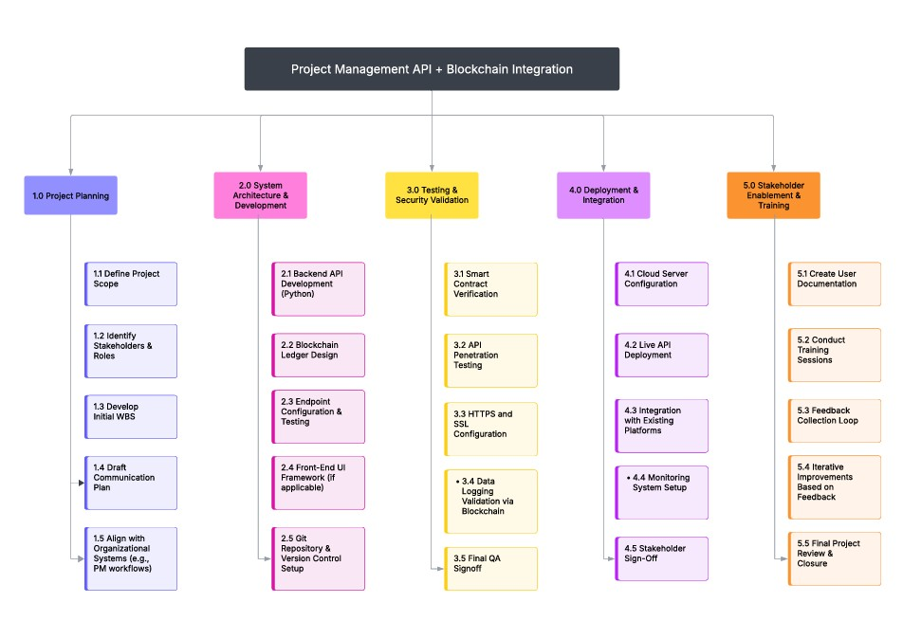
Work Breakdown Structure outlining project scope across phases.

This structure provides clarity, improves scheduling, and lays the foundation for resource and time allocation (PMI, 2021).
Project Design and Outline
A Gantt chart was developed to visualize the timeline of each WBS component, incorporating estimated durations, dependencies, and milestones.
Figure 3
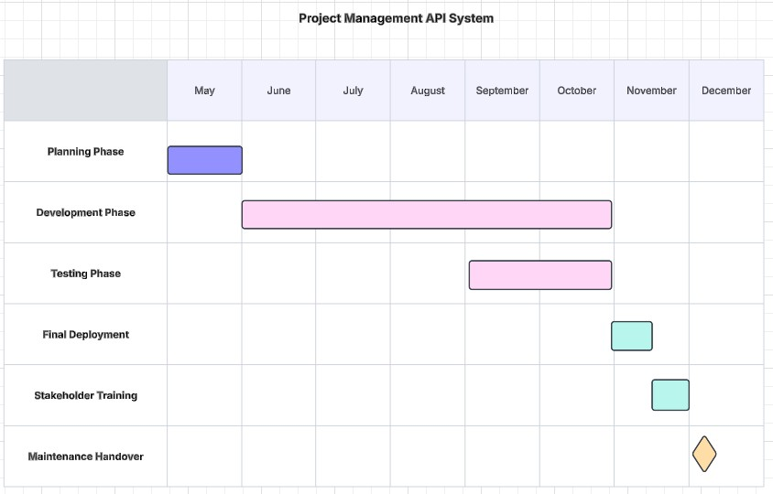
Gantt Chart showing phase timelines and critical paths.
This ensures visibility across stakeholders, allowing for iterative feedback and resource reallocation as needed.
Design Methodology
The project follows an Agile hybrid model. Early requirements are captured in planning sprints, while design and development follow a DevOps-integrated pipeline. The system emphasizes:
- Continuous integration and testing
- Role-based user stories and acceptance criteria
- Blockchain smart contracts for audit trails
This methodology is ideal for evolving requirements and continuous delivery (Larman & Vodde, 2016).
Risk Matrix
The Risk Matrix identifies high-priority risks like blockchain security vulnerabilities, API integration failures, and stakeholder misalignment.
Figure 4
Risk Matrix
Risk | Likelihood | Impact | Risk Rating (LxI) | Response Strategy
Cybersecurity Breach | High | Critical | Extreme | Mitigate and Avoid
Equipment Delivery Delays | Moderate | High | High | Transfer and Mitigate
Employee Pushback | High | Moderate | High | Mitigate and Accept
Budget Overrun | Moderate | High | High | Mitigate
Inadequate Training | Low | High | Moderate | Mitigate
Biometric Data Misuse | Low | Critical | High | Avoid and Transfer

Risk Matrix outlining severity and likelihood of key project risks.

Contingency plans include code audits, UAT cycles, and stakeholder briefings. The company maintains a low risk tolerance for data breaches but moderate tolerance for budget adjustments tied to security improvements.
Cybersecurity Breach
Given the sensitive nature of biometric data and the system's exposure to external threats, the risk of a cybersecurity breach is considered high. A breach would result in catastrophic consequences, including reputational damage, legal repercussions, and significant employee distrust. As INCOSE (2015) emphasizes, protecting data assets through encryption, strong access controls, and proactive security measures is vital for system integrity.
Equipment Delivery Delays
Due to the project’s multi-site deployment across metropolitan areas, logistics challenges are a foreseeable risk. Transportation delays of critical hardware like servers and biometric devices could disrupt the deployment timeline. Kerzner (2022) stresses that supplier coordination and contingency planning are essential strategies for mitigating schedule disruptions.
Employee Pushback
Resistance among employees is a high-probability risk, particularly due to privacy concerns over biometric data usage. Engaging employees early, maintaining transparency about data handling policies, and involving them in the implementation process can help reduce resistance (Kerzner, 2022).
Budget Overrun
Unexpected expenses, such as additional cybersecurity features, training needs, or extended support contracts, can contribute to project budget overruns. INCOSE (2015) highlights that maintaining a robust risk reserve within project budgeting frameworks is crucial to absorb such unforeseen costs without jeopardizing project delivery.
Inadequate Training
If employees are inadequately trained, errors and operational disruptions are likely. Effective risk mitigation includes providing comprehensive training programs during the implementation phase and offering post-deployment support, as recommended by Kerzner (2022).
Biometric Data Misuse
Internal misuse of biometric data poses another serious risk. Without clear governance frameworks, even trusted insiders may misuse access privileges. INCOSE (2015) underscores the importance of strict internal controls, regular audits, and access reviews to protect sensitive information.
Conclusion
This project offers a full-cycle plan for implementing a modern project management solution using blockchain. By combining structured methodologies with agile flexibility, stakeholder engagement, and thorough risk planning, the system provides a model for effective, transparent, and secure project oversight. This simulated plan demonstrates how to apply theoretical principles into real-world systems development, supporting strategic innovation and operational excellence.
References
Kerzner, H. (2022). Project management: A systems approach to planning, scheduling, and
controlling (13th ed.). Wiley.
Larman, C., & Vodde, B. (2016). Large-Scale Scrum: More with LeSS. Addison-Wesley.
PMI. (2021). A guide to the project management body of knowledge (PMBOK Guide) (7th ed.).
Project Management Institute.
uCertify. (n.d.). Project Management for IT Professionals. Retrieved from CSU Global Learning
Platform.

