Module 4: Loops

Justan E Dunn
Colorado State University Global
CSC500-1: Principles of Programming
Professor Steven Evans
02/09/2025

Abstract
This document details the development of a Python program that simulates an online shopping cart using object-oriented programming principles. The program implements an ItemToPurchase class to represent individual shopping items, prompts the user to enter details for two items, calculates the total cost, and displays the formatted output. This milestone demonstrates the use of classes, constructors, instance attributes, and method calls. The source code and execution screenshots are included to provide a comprehensive understanding of the implementation.
Module 4: Loops
With the rise of e-commerce and online transactions, implementing an efficient shopping cart system is a fundamental aspect of software development. This project aims to simulate an online shopping cart using Python’s object-oriented programming approach. By creating an ItemToPurchase class, this program enables users to input item details, compute total purchase costs, and display formatted outputs. The assignment reinforces key programming concepts such as class definition, instance attributes, user input handling, and basic arithmetic operations. This document outlines the pseudocode, source code, execution results, and references to demonstrate a structured approach to problem-solving using Python.
Pseudocode
Part 1: Define the ItemToPurchase Class
- Define a class named ItemToPurchase
- Create three attributes:
  - item_name (string), default = "none"
  - item_price (float), default = 0
  - item_quantity (int), default = 0
- Define a method print_item_cost() that prints the item details in the format: item_name item_quantity @ $item_price = total_cost
Part 2: Create Objects and Prompt User Input
- Prompt the user for details of Item 1 (name, price, quantity)
- Create an ItemToPurchase object with the provided input
- Prompt the user for details of Item 2 (name, price, quantity)
- Create another ItemToPurchase object with the provided input
Part 3: Compute and Display Total Cost
- Call print_item_cost() for both objects
- Compute total cost by summing the costs of both items
- Display the total cost in the format:
  - TOTAL COST
[Item 1 details]
[Item 2 details]
Total: $total_cost
Source Code
Part 1: Main Code Section and User Prompts
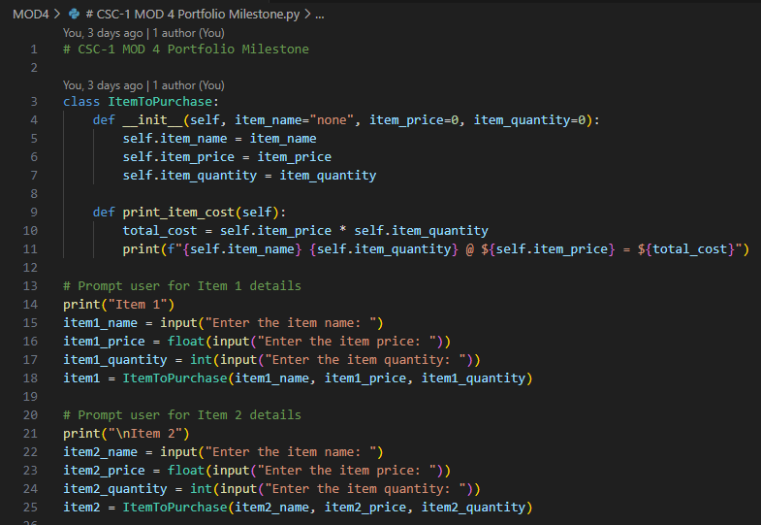
Figure 1. Python class definition for ItemToPurchase.
Part 2: Total Cost Output
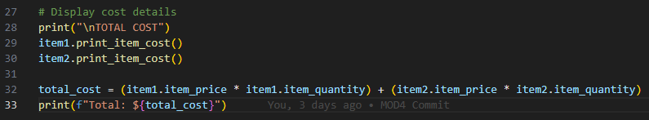
Figure 2. Computing and displaying total cost of purchased items.
Screenshots of Program Execution
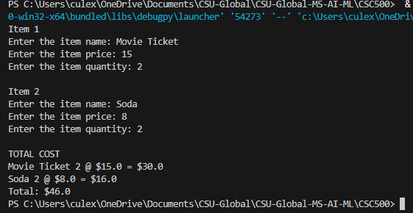
Figure 3. Execution of ItemToPurchase class.
GIT Repository Link
https://github.com/justandunn/CSU-Global-MS-AI-ML.git
Conclusion
This milestone demonstrated the implementation of a Python class to represent shopping items and the use of instance attributes and methods. By prompting user input, computing the total cost, and displaying formatted output, the assignment reinforces object-oriented programming concepts. The approach ensures scalability, allowing additional items to be added in future extensions of the program.

