Justin Tang, jt1186

Step 1:

| **Navigation goal** | **Command to type** |
| --- | --- |
| Move down a level in the directory structure | cd <directory_name> |
| Move up a level in the directory structure | cd .. |
| Check your current location in the file system | pwd |
| From wherever you are, go to your home directory | cd ~ |
| Go to a location using its absolute path | cd /path/to/directory |
| Go to a location using its relative path | cd <relative_path> |

Step 2:

| **File management goal** | **Command to type** |
| --- | --- |
| Add a directory as a subdirectory of the current location called foo | mkdir foo |
| Remove the empty subdirectory called foo | rmdir foo |
| Create an empty file called foo.txt | touch foo.txt |
| Delete the file called foo.txt | rm foo.txt |

Step 3:

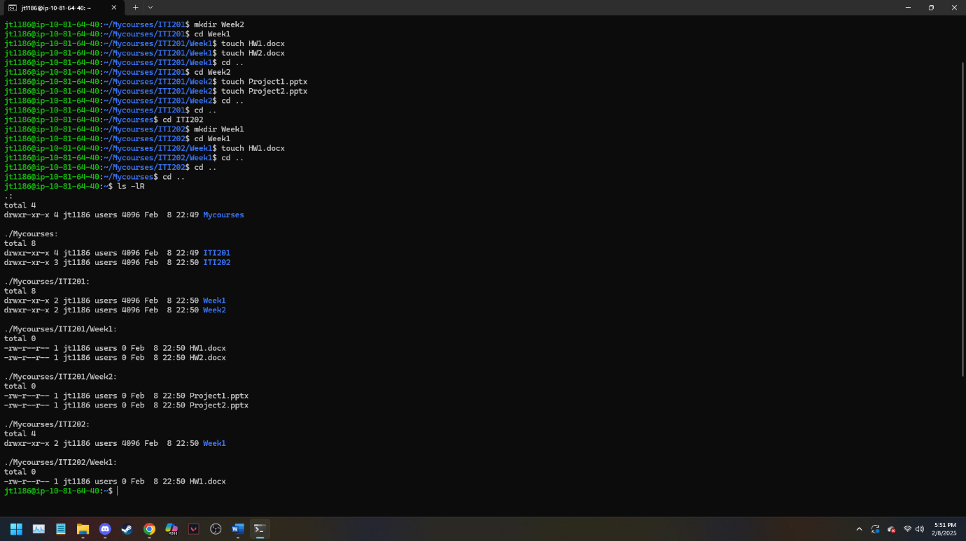

I then used rm -rf ~/Mycourses to remove all files and directories.

Step 4:

1. I troubleshot the private server by sending a ping, but it never came back to respond, therefore no connection could be made with that ip address. I then tried another /etc/ command, and I have no permissions.
2. A screenshot of a computer

   Description automatically generated

***I have a question!* What does it mean to find the configuration necessary for communicating with privateserver. I mean I can’t even ping or log in to the address.**

1. The admin of the server should use /etc/hosts.allow or /etc/hosts.deny to check if you can even access the server. Maybe there is a fire wall so it might be good to check that too. You can also check for account lockouts, such as when they fail to login too many times, or check user permissions to help log in.

Final Answers for LAB.

1. ls -1R displays all directories and every file and that is within it. ls shows the list of all directories. -R stands for recursive, and prints what is beyond the current directory, that means it lists the subdirectories and the contents of it as well.
2. I used rm -rf ~/Mycourses to remove all files and directories.
3. A file is heavily reliant on the right file extension that is added. That is because when you open up a software and try to open a different file type that does not associate with it, such as opening a pptx on Microsoft word, then it would not work. Therefore files and their extensions are very important to allow software to operate and each software prefers its own file type.
4. Done above ^^^