Group Project Documentation   
Advanced Cross-Platform Application Programming with .NET

*Interactive Family Tree*

**Vo Thi Thanh Van - Lecturer**

***Tran Minh Thien - SE160413***

***Phan Truong Minh Dang - SE160408***

***Do Thanh Bo -SE160385***

***Nguyen Hong Hiep - SE160001***

**Ho Chi Minh City, 2023**

**Table of Contents**

**Table of Contents ii**

**Revision History ii**

**1.** **Project Introduction 1**

1.1 Product Perspective 1

1.2 User Classes and Characteristics 1

**2.** **Database Design 1**

**3.** **System Architecture 1**

**4.** **Implementation 2**

4.1. Deployment Considerations 2

4.2. Screenshots and explanations 2

**5.** **References 2**

**Revision History**

| **Name** | **Date** | **Reason For Changes** | **Version** |
| --- | --- | --- | --- |
|  |  |  |  |
|  |  |  |  |
|  |  |  |  |
|  |  |  |  |

# Project Introduction

## Product Perspective

* Many younger individuals may not be inclined to explore traditional family history resources due to their perceived complexity or lack of interactivity. By providing a user-friendly and interactive platform, the system aims to engage the younger generation, making the exploration of family history more appealing and relevant to them.
* The Interactive Family Tree system is designed to help users create and maintain a digital family tree that can be accessed by family members. The purpose of this system is to make it easier for family members to keep track of their family history and to stay connected with one another.

## User Classes and Characteristics

* **Admin**:
  + View all users existed in a tree
  + View all family tree available in application
  + Handle reports about events and users have reported
* **User**:
  + Invites family members to join via code.
  + View family members’ personal information
  + Add new Members to their own family.
  + View and Edit Personal Information
  + Add or edit family events, invite other members of family trees to join.
  + Accept or reject an invitation to join events from other members.
  + Report a family member (for delete).
* **Guess**:
* Access to Home page
  + Login and register.
  + Join a family tree via invite code
  + Create new Family tree

# Database Design

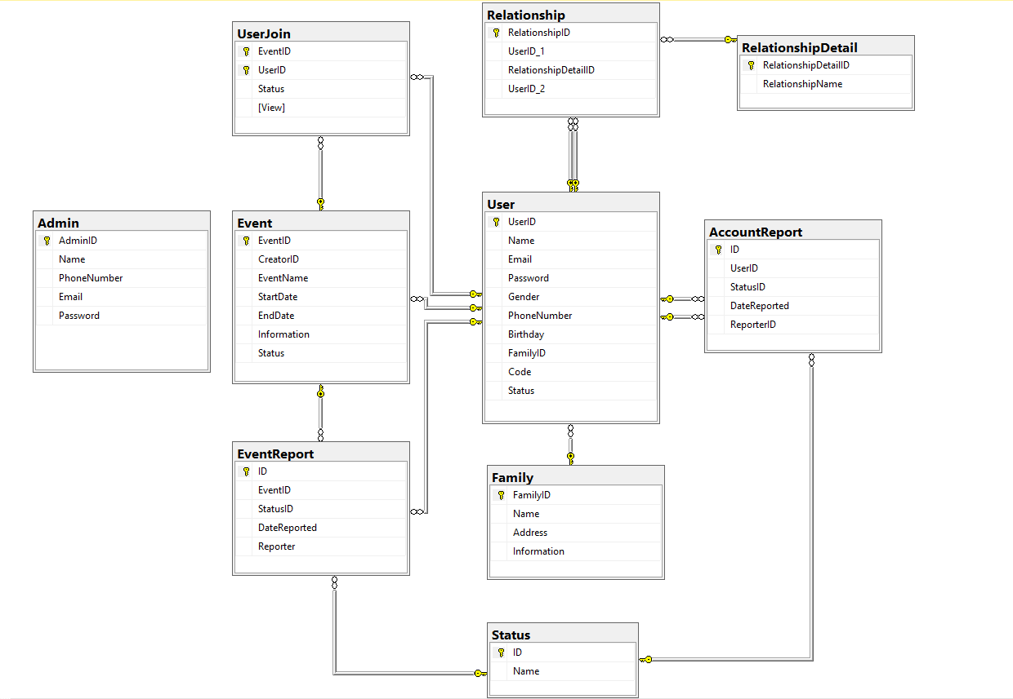

# System Architecture

**system architecture diagram**

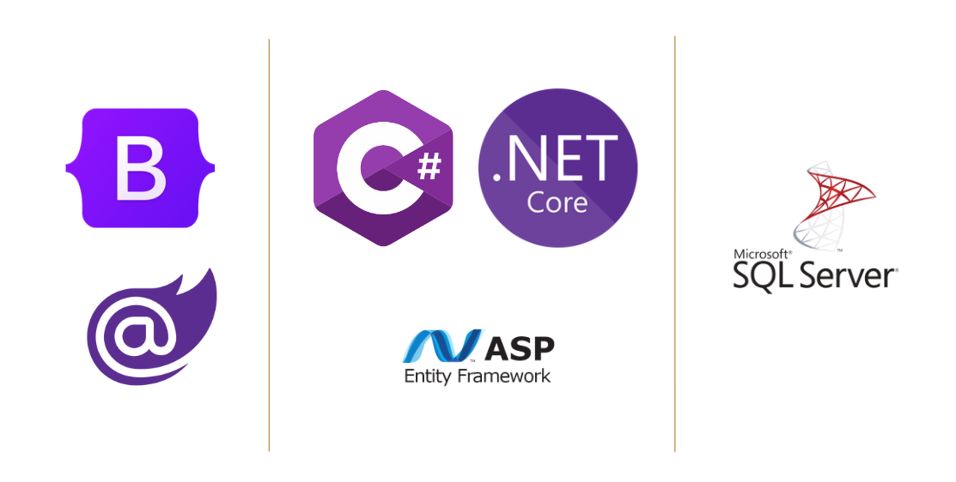

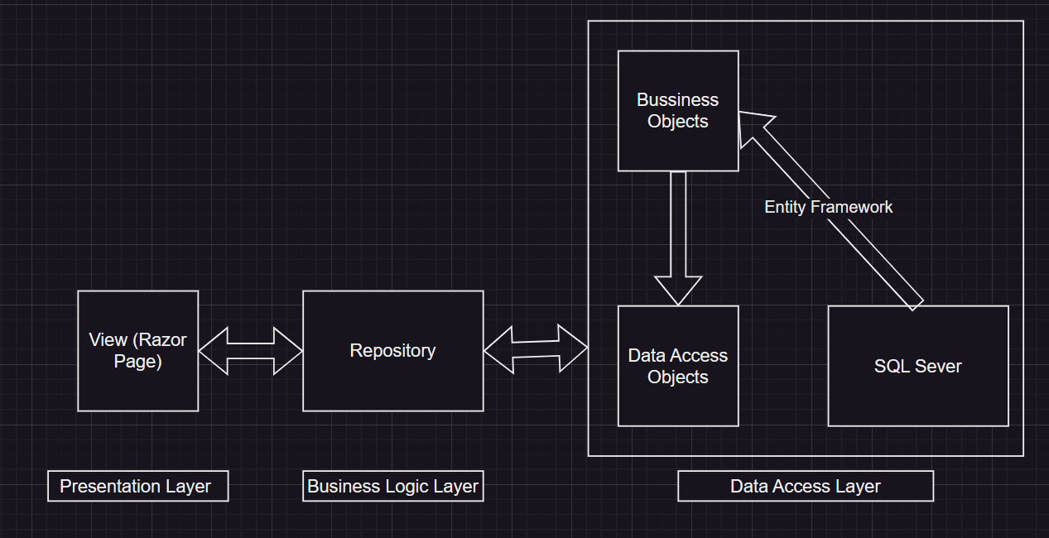

# Implementation

## Deployment Considerations

* This project run in ASP.NET Core 5.0.17
* Run FamilyTree.sql script for project database “FamilyTree” DB
* Modify file appsettings.json to connect local host

## Screenshots and explanations

**CREATE NEW FAMILY FLOW**

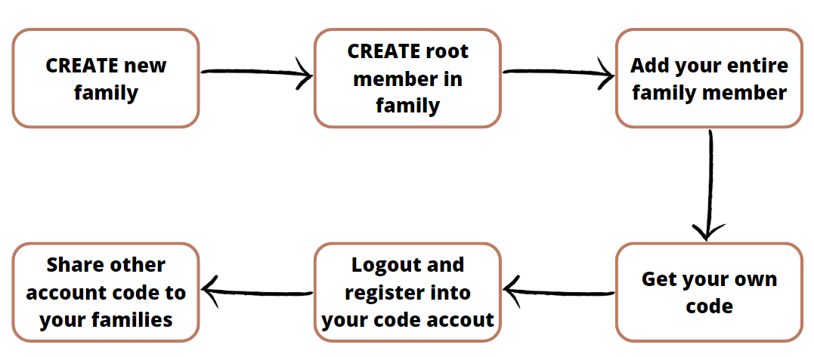

**JOIN AN EXISTED FAMILY TREE**

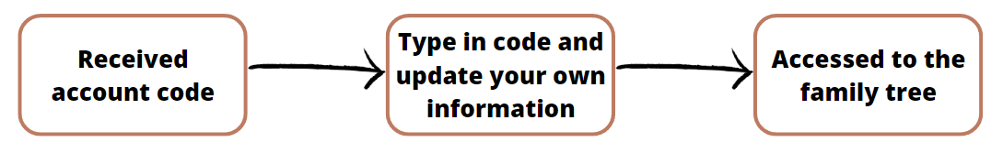

**CREATE/JOIN EVENT**

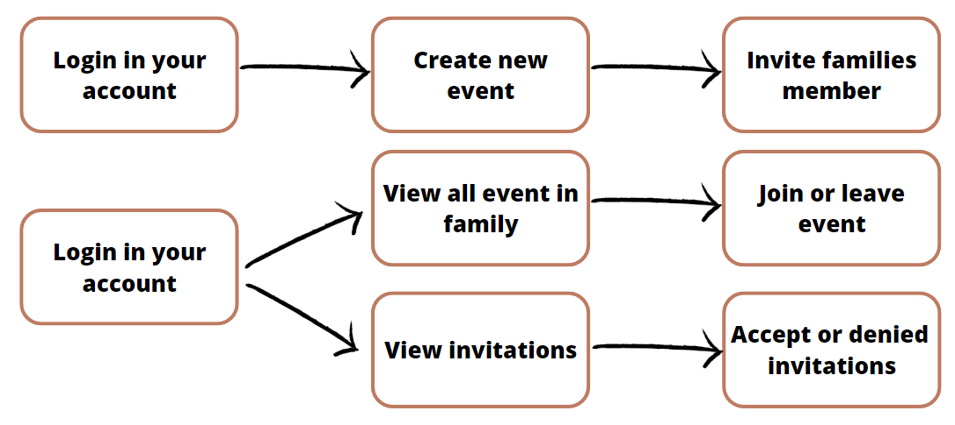

# References

N/A