**QPP Scripts** June 2020

Keilholz MIND Lab, GATech and Emory, [shella.keilholz@bme.gatech.edu](mailto:shella.keilholz@bme.gatech.edu), bzyousefi@gmail.com

The folder **QPPv0620SD** contains **Matlab scripts with sample data**, respectively located in folders **QPPv0620** and **All_preproc_Data**, to detect multiple **Q**uasi-**P**eriodically recurring spatiotemporal **P**atterns **(QPPs)** of the brain’s intrinsic activity based on the following two methods:

**M1_GrpFst**, for **fast detection of multiple QPPs, at the group level**, by concatenating all scans of all subjects and running the QPP algorithm (introduced by Majeed et al 2011) for a few randomly selected initial segments (folders **M1_GrpFst_HCPR3** and **M1_GrpFst_HCPR40** in **/QPPv0620SD/QPPv0620/**).

**M2_S2GRbst**, for **robust detection of multiple QPPs**, which starts from subject level and runs the QPP algorithm for all possible initial segments; each group QPP is then obtained by fine-tune averaging the QPPs of subjects (folders **M2_S2GRbst_HCPR40** and **NI20_S2GRbst_HCP817** in /QPPv0620SD /QPPv0620/, the latter folder being the scripts of **Yousefi and Keilholz, NeuroImage, 2020**).

M2_S2GRbst (introduced by Yousefi et al 2018 and Yousefi and Keilholz 2020) gives similar results to M1_GrpFst, for the healthy adults of the high-quality Human Connectome Project (HCP) dataset, but takes more time, see the related supplementary analysis (SA) in M2_S2GRbst_HCPR40. Therefore, we suggest **using the M1_GrpFst first on a new dataset and later trying M2_S2GRbst to examine the robustness of the results. On any new dataset, always have in mind to start by revising the settings of the free parameters** such as the duration of QPPs, as will be explained further.

**Note: if you** are accessing this document via the KeilholzLab drive, make a local copy of the codes and the sample data in your personal directory and please be careful not to change anything in the QPPv0620SD. **If you** are accessing this document via the KeilholzLab website or github page, use your own copy of the HCP dataset or download 100 unrelated subjects from the HCP website (resting-state fMRI, preferably FIX-denoised and both days) and please apply our additional preprocessing described below - note, a small parcellated sample data is shared in the KeilholzLab website or github page, so that you can readily try parts of the QPP scripts.

**Start your first QPP analysis** by M1_GrpFst_HCPR3, which detects 5 group QPPs of 3 Randomly selected unrelated subjects from rsfMRI dataset of the HCP S900 with 2 scans included per subject. **QPP scripts are numbered based on the order that they should be run. The first script** (M10_Params.m) **sets the parameters and paths that are saved in a .mat file** (Params_~.mat) **and read by other scripts within the same folder** (e.g., M11_~.m to M14_~.m in M1_GrpFst_HCPR3).

Data for HCPR3 (B_GWCR_HCPR3.mat), located in /QPPv0620SD/All_Preproc_Data/, also shared in the KeilholzLab website and github page, has our own additional preprocessing and is parcellated (Non-parcellated additionally preprocessed data is located in folder /GWCR_HCPR3/). Parameters and paths of the data and the additional preprocessing are set in P0_~.m and saved in Preproc_Params_~.mat. This mat file is further read by P1_~.m, which is the script that implements the additional preprocessing. Note that folder /QPPv0620SD/Utils/ contains all the required toolboxes, indices for parcellations, etc. Also, **note that Preproc_Params_~.mat is read by the postprocessing scripts and is needed along the data; it is the first item to set in M10_Params.m for the QPP analysis.**

Go through all the items in M10_Params.m. **As a reference** for the QPP method, the free parameters or what is implemented by each part of the QPP scripts, the method part of Yousefi and Keilholz (2020) is provided in this document, starting from the end of this page.

Run M10_Params.m, M11_GrpQPP.m and M12_Plts and note the generated plots. These plots are also provided in /QPPv0620/Plts2Expect/.

If you are accessing the scripts via our lab website or github and only have B_GWCR_HCPR3.mat, this is the last stage; switch to your own downloads of the HCP data, pick any few subjects, run our additional preprocessing, particularly generate Preproc_Params_~.mat, and proceed further with the QPP scripts.

Run M13_GrpQPP_VxSm and M14_Plts and visualize QPPs in grayordinates by opening the cifiti files in HCP workbench.

M1_GrpFst_HCPR3 is suitable for start (e.g., as an intro or a demo), but the data is not long enough to get significant magnitudes for QPPs, particularly in the subcortical regions. So, we have not included much analysis in grayordinates for M1_GrpFst_HCPR3. More complete analyses in grayordinates are included in folders M1_GrpFst_HCPR40, M2_S2GRbst_HCPR40 and NI20_S2GRbst_HCP817.

M1_GrpFst_HCPR40 and M2_S2GRbst_HCPR40 are based on 40 randomly selected unrelated subjects from HCP S900 dataset with all 4 scans included per subject. Preprocessed data for HCPR40, applied by P0_~.m, is also located in /All_Preproc_Data/ in the Keilholzlab drive.

You can start running scripts in M1_GrpFst_HCPR40, which takes some time. Meanwhile, browse scripts of M2_S2GRbst_HCPR40 and note the script differences with M1_GrpFst_HCPR40.

M2_S2GRbst_HCPR40, **which can be run after you start analyzing your own data with the first method**, or, takes more time compared to M1_GrpFst_HCPR40 but is more robust, as mentioned before. Both folders related to the second method (M2_S2GRbst_HCPR40 and NI20_S2GRbst_HCP817) have multiple supplementary analyses (SAs), which validate various choices in the pre-/post-processing or support some claims and statements in Yousefi and Keilholz 2020.

NI20_S2GRbst_HCP817, which contains the scripts of Yousefi and Keilholz 2020 and detects 3 QPPs of all subjects in HCPS900 dataset who had 4 complete scans (817 subjects), is minorly different in terms of division of scripts, compared to M2_S2GRbst_HCPR40; this made it easier to analyze a large number of subjects. Also, obtaining the threshold for significance of activity within QPPs is appearing as SA (NI20_S2GRbst_HCP817/SA/SA2_SigActiv/) because this part was added in the revision process and we meant the scripts that generated the results of the publication to stay unchanged.

Finally, we recommend the current structure of the scripts for the QPP analysis, meaning, making a folder for each project, having a parameter mat file, etc. QPP scripts can be modified, simplified, or more scripts can be added, based on the study question. Current functions used throughout the scripts (located in /QPPv0620SD/QPPv0620/QPPfv0620/) can be used in different context, e.g., comparing QPPs between groups using Tcomp.

**QPP Method (Yousefi and Keilholz, 2020)**

QPP method is described broadly in what follows and all required details can be found in the supplementary materials (additional text, diagrams and table at the end).

*Data and further preprocessing. We* used the minimally preprocessed grayordinate and FIX de-noised rsfMRI scans of the HCP S900 dataset (Glasser et al., 2013) and included all 817 individuals with four complete scans (repetition time (TR) of 0.72s, ~15 minutes per scan). The following preprocessing steps were additionally applied to each scan (Fig.S1). The grayordinate timeseries (~62K cortical vertices and ~30K non-cortical voxels) were demeaned and filtered (0.01 - 0.1Hz). Gray matter (GM), white matter (WM) and cerebrospinal fluid (CSF) signals were regressed, which is equivalent to global signal regression (GSR). The spatial dimension was reduced to 360 cortical parcels (Glasser et al., 2016), and each parcel's timeseries was normalized to zero mean and unit standard deviation.

*Main algorithm to detect a QPP.* The original method to detect a QPP, developed by Majeed and colleagues (Majeed et al., 2011), is centered around an algorithm that identifies similar segments of a rsfMRI scan using an iterative, correlation-based approach, then averages these segments to create a representative spatiotemporal template (Fig.S2). In this algorithm, a segment with a preset duration (here, ~20s or 30 consecutive timepoints) is initially selected. This initial segment is flattened and correlated with all the segments of the scan, which are selected and flattened one after another in a sliding fashion. This results in a timecourse of correlation between the initial segment and the rsfMRI scan, where timepoints corresponding to local maxima above a preset threshold (referred to as maxima for brevity) are then identified. The segments of the scan starting at those maxima are similar to the initial segment and are averaged together. The process is then repeated with the average of segments in place of the initial segment until negligible change between iterations is reached. The outputs of the algorithm are the final spatiotemporal QPP template obtained by averaging similar segments, and the correlation timecourse that shows the correlation of the final template with the scan at each point in time. The maxima in the correlation timecourse indicate the start of the segments that contribute to the final template, also referred to as the timepoints when the final template occurs.

*Obtaining group QPP1: an overview.* The original method to obtain the group QPP1 (Majeed et al., 2011) involved concatenating the rsfMRI scans of individuals, running the described algorithm for a limited number of randomly selected initial segments, and from the resulting final templates, selecting the most similar one to the others as the QPP. We implemented a number of modifications to the original method, described in the sections that follow.

*Robust detection of QPP1 in individuals.* To obtain group QPP1, we built upon our recent method improvements (Yousefi et al., 2018) by first robustly detecting QPP1 of individuals (Fig.S3). After concatenating the four preprocessed scans of each individual, all possible initial segments were examined using the main QPP algorithm. For each resulting template, the sum of correlation values at maxima was found. QPP1 was selected as the template with the maximum sum, which reflects a combination of high strength and frequent occurrence. In humans, QPP1 is ~20s long (Majeed et al., 2011; Yousefi et al., 2018; Abbas et al., 2019a,b; Briend et al., 2020); hence, we preset the segment duration to 30 timepoints (21.6s). In the prior studies (Majeed et al., 2011; Yousefi et al., 2018; Abbas et al., 2019a, 2019b; Belloy et al., 2018a, 2018b) the correlation threshold was set to 0.1 for the first three iterations of the main algorithm, and 0.2 for the remaining iterations; however, we increased this threshold to 0.2 for the first two iterations and 0.3 for the remaining iterations, mainly because of high quality and large dataset used here.

*Phase-adjusting individual QPP1s.* A QPP is a spatiotemporal template that involves a cycle of activation and deactivation of different areas with different phases, and the detected QPP of each individual can be at any phase of the cycle in a given area. Proper averaging of the QPPs across individuals to move to the group level requires each QPP to have a certain phase in a reference parcel (referred to as the seed parcel for phase-adjustment; here chosen as left early visual cortex (V2)). For example (Fig.S4a), in an ideal phase-adjusted QPP, the 30-timepoint timecourse in V2 starts around zero at timepoint 1 and reaches its maximum before timepoint 15. To phase-adjust QPP1 of individuals, we used a roughly similar procedure to (Yousefi et al., 2018) that involves comparison of each QPP1 with all other templates, corresponding to all the examined initial segments. Out of the similar templates to QPP1, the one that met the criteria for an ideal phase was selected (see Fig.S4b for detailed description). Note that when comparing QPP1 with any other template, to account for minor differences in their phases, we used a fine phase-matching procedure, which involves shifting QPP1 a few timepoints forward and backward, and taking the maximum correlation across different time-shifts (see Fig.S5 for detailed description).

*Fine-tuned averaging of individual QPP1s.* Before averaging the phase-adjusted QPP1 from all individuals, we included a fine phase-matching stage to mitigate the imperfections of the phase-adjustment procedure (see Fig.S6 for detailed description). We then used the template resulting from averaging the individual QPP1s as a prior for group QPP1. We correlated this prior template with all the scans of all individuals, identified the supra-threshold local maxima in the correlation timecourse, and used those timepoints as the start of the contributing segments to the final group QPP1. This last stage further mitigated any imperfections in the phase-adjustment procedure and ensured that group QPP1 (hereon, referred to as QPP1 for brevity) is simply an average of similar segments across the individuals.

*QPP1 in grayordinates.* The reduction of the spatial dimensions from grayordinates to cortical parcels is a very effective and practical step that facilitates identification of the segments that contribute to QPP1. QPP1 in grayordinates can then be constructed by averaging the same contributing segments over the grayordinate timeseries instead of the parcellated timeseries (Fig.S1b). Unlike prior work, we did not place a threshold on the amplitude of QPP1 when visualizing in grayordinates, making it possible to observe more subtle trends of activation and deactivation. For all analysis beyond qualitative visualization, however, only vertices/voxels that exhibit statistically significant activation or deactivation at some time interval during the 20 s duration of the QPP1 were included. Statistically significant activity was defined as surpassing the 99th percentile of a null distribution of activity created by averaging randomly selected spatiotemporal segments (for all details about various statistical analyses described here on, see Supplemental Material: Statistical evaluation of activity within QPPs; for this part, Fig.S7-8).

*Summarizing and evaluating the propagation of activity within QPP1.* To obtain a coarse summary of the activity within QPP1 in grayordinates, we clustered its timecourses, by comparing each pair of timecourses with the fine phase-matching procedure (maximum timeshift: ±2 timepoints). The upper triangle of the comparison matrix was then used to build the distance vector for the hierarchical clustering. We set the cut-off to 0.1 and kept the first ten largest clusters (These values, although somewhat arbitrary, have negligible influence on the results and do not change our conclusions). To obtain a more detailed summary of the activity within QPP1, for each timecourse of QPP1, we also found the times of peak activation and deactivation (the latter as supplementary results; also called time of dip). For these summary maps, which are also the basis for the further statistical evaluations or comparisons, we only included the timecourses that exhibit statistically significant activity. To statistically evaluate the propagation of activity within QPP1, pair-wise t-tests, corrected for multiple comparisons, were used to determine significant differences in the time of peak/dip across clusters of timecourses.

*Existing parcellations, functional networks and gradients for comparison.* Activity within QPP1, as a simple average of similar segments of rsfMRI timeseries, can be described at the level of the whole brain, without the need for division into anatomical regions, networks or parcels. However, to identify different brain areas and to compare QPP1 with the existing parcellations, particularly the resting-state networks (RSNs) or functional connectivity gradients (FCGs), we adopted the parcellation and gradient schemes listed in Table S1 for seven brain regions of cerebral cortex, cerebellum, thalamus, hippocampus, amygdala, brainstem and deep brain nuclei, and striatum (also see Fig.S9). For quantitative comparison, first, we found the correlation between QPP1’s time of peak map and cortical FCG1 (using the results reported in Margulies et al., 2016, and shared by the first author); strong correlation supports propagation of activity within QPP1 consistent with FCG1. Although we only qualitatively compared QPP1 with the existing non-cortical FCGs, the statistically evaluated summary maps of QPP1 per each region were the basis for such comparison. Next, we grouped QPP1’s timecourses into the cortical RSNs (Yeo et al., 2011) and performed pair-wise t-tests between groups to determine the significance of differences in the time of peak activation; shifts of a few timepoints between pairs of RSNs within QPP1 shows their sequential activation and again supports propagation of activity within QPP1. Finally, we found the size of each cluster of QPP1’s timecourses per network/parcel per brain region, to show the extent of correspondance between QPP1’s coarse summary of activity and particularly the existing non-cortical parcellation schemes.

*Timing differences between brain regions.* To examine the nuanced timing differences between brain regions that can suggest the driving mechanisms between them, per each of seven brain regions, we found the number of vertices/voxels with a significant peak at each timepoint of QPP1, resulting in seven histograms, each with 30 bins corresponding to the timepoints of QPP1. These historgrams/distributions are mostly bimodal, and for the scope of this work, we only focused on the second mode, identified as the entries above the mid point of the cortical distribution. Only including the times of peak later than such midpoint, we then performed pair-wise t-tests between the seven regions to determine the significant differences.

*Detection of additional QPPs.* To examine whether additional recurring spatiotemporal patterns of activity are present in the rsfMRI timeseries, we regressed QPP1 and reanalyzed the residuals. Two methods for regression were implemented, both using GLM, and performed at the individual level for each of the four scans. First, scan-wise regression (Fig.S10a), where QPP1 was convolved with its correlation timecourse to build the regressor. Since QPP1 is a spatiotemporal pattern and its timecourse are different for each parcel, the timecourse for each parcel was convolved with the QPP1’s correlation timecourse and the result was regressed from that parcel’s timeseries. Second, segment-wise regression (Fig.S10b), where QPP1 was regressed from each of its contributing segments, which were replaced by the residuals. To ensure no similar segments to QPP1 exist in this residual scan, QPP1 was correlated with the residual scan and was regressed from segments corresponding to any detected supra-threshold local maxima. The two regression methods have similar outcomes (Fig.S11a), and we based our group-level report on the scan-wise regression, which runs faster.

After QPP1 of each individual was regressed per scan, each parcel’s timeseries was normalized to zero mean and unit standard deviation and concatenated across the four scans. The secondary QPP (QPP2) was then detected and phase-adjusted following the same methods used for QPP1. We further regressed QPP1 and QPP2 of individuals and reanalyzed the residuals to detect and phase-adjust QPP3. We limited the scope of this work to QPPs 1 to 3. When building QPP2 and QPP3, averaging the contributing segments over the original scans or the residual scans resulted in nearly identical templates (Fig.S11b). We therefore averaged the segments from the original scans to avoid possible minor distortions induced by regression. Group QPPs 2 and 3 were obtained for the parcellated data and then for grayordinates, summarized and statistically evaluated using the same methods as for group QPP1.

*Definition of terms.* To simplify the description of the activity within QPPs, we utilize a few specific terms. (I) Propagation axis. Within a QPP, simultaneous and consistent propagation of activity from all the nodes that constitute a RSN (e.g., RSN1) to all the nodes that constitute another RSN (e.g., RSN2) often occurs. We state that the activity propagates from the RSN1 to the RSN2 or that the propagation axis is RSN1→RSN2. When an existing FCG maximally separates RSNs 1 and 2, we also state that the activity propagates along that FCG. (II) LPCC switching timepoints. As a reference for describing the timing of activity within a QPP, we built a timecourse by averaging all the QPP’s timecourses that belong to the five central parcels of the left posterior cingulate cortex (LPCC) (Glasser et al., 2016). We define the coarse range of timepoints that the LPCC switches from deactivated to activated, or vice versa, as the LPCC switching timepoints. Any parcel could have been chosen for reference to describe the timing of activity within QPPs (for example, left V2, which was used as the seed parcel for phase-adjustment). We chose the LPCC because it is a prominent node of the DMN, which plays an important role in QPPs 1 and 2, in particular. (III) Transitory clusters. There are two very prominent clusters of timecourses for QPPs 1-3. The first contains the DMN nodes (plotted as the first cluster in all figures), and the second contains the timecourses that are anticorrelated with the DMN nodes (plotted as the second cluster in all figures). The prominence of these two clusters results in bimodal distribution of peak times. The remaining clusters have intermediate phases and locations relative to these two clusters and are referred to as transitory clusters.

*QPP basic metrics and transition count.* For each QPP, we can readily find its strength (the median of the supra-threshold local maxima in the QPP’s correlation timecourse with the scan) and its occurrence interval (the median of the time interval between successive maxima in the correlation timecourse). These metrics reflect how well each QPP represents its contributing segments, and how often it occurs. The strength and occurrence interval of QPPs 1-3 were calculated at the individual level and averaged across individuals. We also characterized transitions between QPPs, by counting the number of times that a contributing segment of QPPi was followed by a contributing segment of QPPj. This resulted in a 3x3 matrix for each individual, which was summed across individuals to obtain the group level matrix.

*Contribution to functional connectivity.* To examine the extent to which patterns of activity represented by the QPPs contribute to functional connectivity, we calculated the Pearson correlation between each pair of the 360 cortical areas using the original timeseries and the residual timeseries after regressing QPPs 1-3, using the scan-wise method. For this calculation, we first sorted the 360 cortical parcels based on the seven RSNs (Yeo et al., 2011), using a simplified rule to assign each parcel to the RSN with which it has maximal overlap. The resulting functional connectivity matrices were averaged across individuals after Fisher transformation. To characterize these matrices at a high level, we created histograms of correlation values for all pairs of areas for four cases: before regression of any QPPs, after regression of QPP1, after regression of QPPs1 and 2, and after regression of QPPs 1-3. We then determined the percentage of correlation values above 0.1 or below -0.1 for each case (0.1 was chosen somewhat arbitrarily to be qualitatively meaningful but is above the 99th percentile of null values built by phase-shuffling the timeseries and applying the abovementioned procedure).

We further performed the following complementary analyses. First, the variance of the functional connectivity matrix before and after regression of each QPP was calculated. To obtain null values, the QPPs were convolved with their shuffled correlation timecourses, regressed scan-wise, and the variance of the functional connectivity matrix was found. Second, the correlation between the functional connectivity matrix before regression of any QPP and the functional connectivity matrix after regression of each QPP was calculated. Finally, the correlation between 360 cortical areas within each QPP (i.e., functional connectivity within QPP, over the ~20 s timecourses) was calculated and qualitatively compared with the functional connectivity matrices before and after regression of that QPP.

*Robustness analyses.* In our preprocessing pipeline, GM was regressed along with WM and CSF (i.e., GSR). Although GSR is a controversial practice (Power et al., 2017), our recent work indicates that it improves the correspondence of QPPs across individuals (Yousefi et al., 2018). To examine the influence of GSR on our results, we averaged the contributing segments of each QPP over the WM and CSF regressed timeseries and compared the resulting template with that QPP (obtained after GSR) at the individual level. To further examine the effects of any nuisance regression or filtering on the main features of the QPPs at the group level in grayordinates, we averaged the contributing segments of each QPP over timeseries that were only demeaned and visually compared the resulting template to that QPP (obtained after filtering and nuisance regression). To examine the effect of choosing a particular area as the seed for phase-adjustment, for each group QPP, we chose another seed parcel to obtain a template with a reversed phase to that QPP and visually compared the results (LPCC was used for QPP1, left supramarginal gyrus (smg) for QPP2, and left primary motor area (M1) for QPP3). To test the reproducibility of the QPPs, individuals were randomly divided into two approximately equal subgroups, 50 times, and QPPs 1-3 were obtained for each subgroup, then compared across subgroups.

**Supplemental Material on Statistical Evaluation of Activity within QPPs (Yousefi and Keilholz, 2020)**

*Definition of significant activity within a QPP.* To quantitatively analyze the activity within a QPP, only the vertices/voxels that statistically become activated/deactivated, at any time interval within the ~20s duration of that QPP (for brevity, the active vertices/voxels) were included. To identify these active vertices/voxels, first, we built null spatiotemporal patterns by averaging randomly selected Ni number of non-overlapping segments, from all four scans of all 817 individuals, with Ni being the number of the contributing segments to the group QPPi (i=1:3). The random selection was repeated 50 times for each Ni, resulting in 50 null patterns. Next, we calculated the root sum square of each ~20s-long timecourse corresponding to each vertex/voxel within each null pattern and found the 99th percentile of the root sum square values across all vertices/voxels and all null patterns (~92Kx50 entries; Fig.S7). This percentile, which can serve as a power threshold to determine the active vertices/voxels of a QPP, increases as the number of randomly selected segments decreases, i.e., it is higher for N3 segments (corresponding to QPP3) compared to N2 or N1 because there are fewer segments that contribute to QPP3. To simplify, we used the threshold obtained based on N3 randomly selected segments for all QPPs.

*Timepoints of significant activity within a QPP.* To determine the timepoints that the active vertices/voxels become statistically activated/deactivated within the 30-timepoint duration of a QPP, we found the 99th percentile of the magnitudes (i.e., the absolute values) of all 30 timepoints per timecourse of all vertices/voxels and all null patterns corresponding to each Ni (~92Kx30x50 entries for each Ni; Fig.S8). This percentile also increases as Ni decreases and to simplify, we again used the N3-based threshold to serve as the magnitude threshold for all QPPs. We further added a second step for the identification of the active vertices/voxels of a QPP by only including the vertices/voxels with peak magnitude (i.e., either the magnitude of peak activation or the magnitude of dip deactivation) larger than the magnitude threshold.

*Summary maps of activity within a QPP: primary basis for further statistical analysis.* Only including the active vertices/voxels, the summary maps of the activity within each QPP were calculated, by clustering the timecourses (coarse summary), described in detail in the main text, and finding the time of peak activation and the time of dip deactivation for each timecourse (fine summary). These summary maps will be the primary basis for further statistical analysis. For the fine summary map, we only included the times that correspond to a peak/dip larger than the magnitude threshold described previously. We included the time of dip because of a few clusters of timecourses with only supra-threshold dip but not supra-threshold peak due to their particular phase. If the QPP is phase-adjusted to have a reversed phase, the same timecourses exhibit supra-threshold peak but not supra-threshold dip.

*Significant propagation of activity within a QPP.* To quantitatively show the sweep of activity within a QPP, we separated the ten clusters of the QPP’s timecourses into seven brain regions (cerebral cortex, cerebellum, thalamus, hippocampus, amygdala, brainstem and deep brain nuclei, striatum), resulting in seventy groups, and tested the significance of differences in the times of peak activation and the times of dip deactivation between pairs of groups, using t-test (both dependent and independent) and corrected alpha value of 0.01/(70x69/2)=4.1e-6. Since some of the groups have a few or even no members, we excluded the groups whose size are lower than 15 (5th percentile across all 70 groups). To address the difference in size for any pair of groups (cortical regions are much larger than non-cortical regions), we lowered the size of the larger group by random selection, repeating and testing 50 times and choosing the maximum p-value across the repetitions. As supplementary tests, we also performed independent t-test and Kolmogorov-Smirnov test (ks-test), without matching the group sizes, and both tests had similar outcome compared to using the dependent t-test.

There are instances of focal propagation of activity, which are specifically mentioned for QPP1 across the lateral temporal lobe (TL) and across V1. The sweep across TL seems to be in synch with the posterior-anterior sweep along the hippocampus towards the amygdala because of the same clusters of timecourses with the same order that tile these areas. To quantitatively show the occurrence of these focal sweeps, we tested the significance of time differences between the clusters in the TL-Hippocampus-Amygdala and V1, using the same procedure described above. For the TL-Hippocampus-Amygdala, we only tested the time of dip deactivation, but we separated the left and right hemispheres, and for V1, we only tested the time of peak activation.

*Comparison between QPPs and FCGs.* To quantitatively show the sweep of activity within the QPP along a particular FCG across the cortical sheet, we calculated the correlation between the QPP’s time of peak map and that FCG. We obtained the cortical FCGs from a dscalar.nii file published in Margulies et al (2016) and shared with us by the first author in summer 2018. The cortical vertices that were identified as non-active or those with the peak magnitude smaller than the threshold, which overall are only ~2% of ~60K cortical vertices, were excluded from the FCG vector before correlating it with the QPP’s time of peak map. We also found the correlation map within a QPP, with Left PCC (or left V2 for QPP3) being the seed timecourse, and correlated this correlation map with its corresponding FCG, which resulted in slightly higher correlation compared to QPP’s time of peak map. Although we only qualitatively compared each QPP with the existing non-cortical FCGs, the statistically evaluated summary maps of QPP per each region were the bases for such comparison.

*Timing differences across cortical RSNs within QPPs.* To quantitatively show the sequential activity of RSNs within a QPP (which is the basis for the description of QPP’s activity in the results section and also another way of showing the sweep of activity within a QPP), we grouped the active cortical vertices of that QPP according to the Yeo’s seven cortical RSNs and tested the significance of differences in the time of peak activation between pairs of groups, using t-test (both dependent and independent) and corrected alpha value of 0.01/(7x6/2)=4.8e-4. To address the group size difference between any pairs of groups, we reduced the size of the larger group to the size of the smaller group by random selection, repeating such random selection plus the t-test 50 times and choosing the maximum p-value across the repetitions (independent t-test and ks-test, without matching group sizes, were performed and resulted in similar outcome).

Although only the active cortical vertices were included, we also calculated a magnitude threshold for activation/deactivation of the average timecourse across a RSN. We averaged the timecourses of each null pattern (described previously) across the cortical RSNs and found the 99th percentile of magnitude values of all seven timecourses across all 50 null patterns. In all QPPs, all timecourses of all seven cortical RSNs reach above the magnitude threshold.

Finally, as a supplementary analysis, we also found the time of zero-crossing, from active to deactive or vice versa, for the active cortical vertices belonging to the seven RSN groups and tested the significance of differences between pairs of groups, using the same procedure described above for the time of peak. This analysis was to test the observation that a few RSNs seem to remain active/deactive as the sign of activity is switching in other RSNs.

*QPPs versus the existing non-cortical parcellation schemes.* To show the match of a QPP’s coarse summary of activity with the existing non-cortical parcellation schemes adopted for the six non-cortical brain regions (Table S1), we found the size of each cluster of QPP’s timecourses per network/parcel per region. We did not group the non-cortical voxels according to the parcellation schemes to test for the timing differences, similar to what we have done for the cortical RSNs. The reason is the inconsistencies in existing non-cortical parcellation schemes and the observation that the coactivity map of non-cortical areas with the cortical areas changes between QPPs (parcellation methods based on static functional connectivity could easily be insensitive to such dynamic changes resulting in inconsistent maps with subtle changes in methods).

*Timing differences between brain regions within QPPs.* To examine the nuanced timing differences between brain regions during a QPP, that can suggest the driving mechanisms, per each of seven regions, we found the number of vertices/voxels with a significant peak at each timepoint of a QPP, resulting in seven histograms, each with 30 bins corresponding to the QPP’s timepoints. As revealed by these histograms, QPPs 1-3 all involve two large coarsely anticorrelated clusters of areas, hence, their distributions of time of peak per brain region (or across the whole) are bimodal. To quantify the nuanced timing differences between brain regions, first, we found the mid timepoint of the cortical distribution. Then, for each of seven brain regions, we found all the time of peaks higher than that mid timepoint and tested the significance of differences between regions using the same procedure described earlier (using dependent t-test and matching group sizes; independent t-test and ks-test, without matching group sizes, had similar outcome). Only the time of supra-threshold peak of the active vertices/voxels were included and alpha value was corrected for multiple comparisons (0.01/(7x6/2)).

**Supplemental Figures (Yousefi and Keilholz, 2020)**

Fig.S1 (a) Additional preprocessing applied to the minimally preprocessed grayordinate and FIX denoised rsfMRI scans of HCP S900 dataset. (b) To compensate the parcellation used in (a), we can obtain a QPP in grayordinate when its contributing segments are identified based on a rsfMRI scan in parcel-space.

(a)

(b)

Demeaning, filtering, regressing GM, WM & CSF signals

Grayordinate timeseries

Normalizing zscore

Averaging across cortical parcels and normalizing zscore

QPP in grayordinate

Identifying the contributing segments of QPP

Averaging the contributing segments in grayordinate

per scan

Demeaning &

filtering 0.01-0.1Hz

Regressing GM, WM & CSF signals

Normalizing zscore

Averaging across Glasser’s 360 cortical parcels

Grayordinate timeseries of each scan (~92Kx1200)

Averaging across spatial dim.

Demeaning & filtering 0.01-0.1Hz

White Matter (WM) & CSF signals provided by HCP

Performed as default

Bandpass filter: fourth order Butterworth, 1dB cutoff frequencies of 0.01 and 0.1Hz, zero-pads at both ends of timeseries were inserted before filtering and removed afterwards to minimize transient effects

See part (b)

Further preprocessed scan

(360x1200)

Gray matter (GM) signal

Fig.S2 The main algorithm to detect a QPP, developed by Majeed et al., 2011, is correlation-based and iterative. It identifies similar segments of a functional scan and averages them for a representative spatiotemporal template.

timepoints

1 2 3 … 30

…

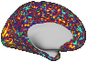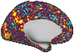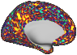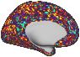

(with a preset duration, e.g., ~20s or 30 timepoints)

1 2 3 … 30

…

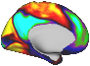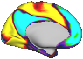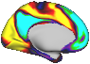

**Output1: A final template**

timepoints

=

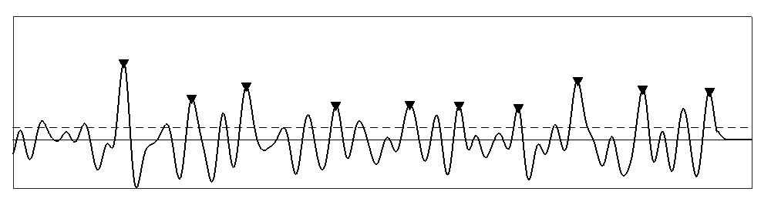

▼ **maxima**, or start of the **contributing segments** to the final template, or timepoints **when the final template occurs**

**Output2: Correlation timecourse of the final template**

**After convergence:**

**Replacing** the **initial segment with** the **average of similar segments** and **iterate till convergence**

**rsfMRI scan**

→ temporal dimension

Selecting an **initial segment**

↑

Finding

**Pearson correlation**

**Flattening** each segment

↓spatial dimension

→ Selecting **all segments** one after another from the start of scan in a sliding fashion

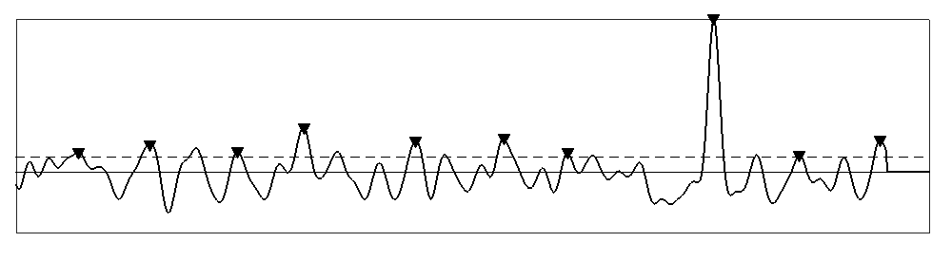

**Correlation timecourse of the initial segment with all segments**

Finding **local maxima above a preset threshold (maxima)**

**preset**

**threshold**

(e.g., 0.2)

**Averaging** these similar segments

**Segments starting at maxima** (similar segment)

Preprocessed & concatenated scans of each individual (360x4800)

Examining all initial segments using **the main algorithm**

For each resulting template, finding the sum of its correlation values at supra-threshold local maxima

Choosing the template with maximum sum as **the QPP**.

The QPP would have higher strength and periodicity compared to other templates

ΣCmaxima



Fig.S3 Robust detection of the QPP for an individual, introduced in Yousefi et al., 2018.

(b) Procedure for phase-adjusting a QPP

QPP of individual

Keeping similar templates with comparison values more than 0.88 (part (c))

Getting each template’s timecourse in left V2 (seed parcel for phase-adjustment)

Sorting those similar templates based on ΣCmaxima from high to low

Checking the strict criteria on each timecourse: the first one meeting the criteria belongs to the phase-adjusted QPP

Comparing using fine phase-matching

(Fig.S5)

Strict criteria: timepoint 1 has a near-zero value, average of the first three timepoints are greater than zero, maximum is in the first half of the cycle and before minimum

If needed, repeating with the relaxed criteria

Relaxed criteria: maximum is in the first half of the cycle and before minimum

Other templates corresponding to all inspected initial segments

(a) Example of an ideally phase-adjusted QPP

(c) Comparison values of a QPP with other templates per individual for all individuals

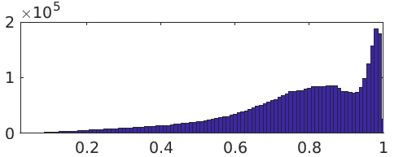

Correlation

Count

Fig.S4 (a) Example of an ideally phase-adjusted QPP. (b) Procedure for phase-adjusting a QPP. (c) Comparing QPP of an individual with other templates results in a bimodal distribution, when combining all individuals, with lower mode (0.88) taken as the threshold in part (b).

Left V2, chosen arbitrary as the seed parcel for phase-adjustment

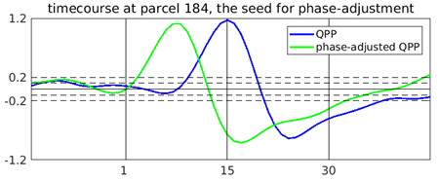

Timepoint

Amplitude

Timecourse in left V2

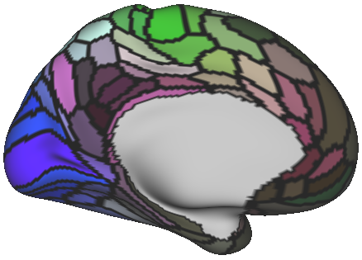

Central left PCC (5 parcels),

another choice for phase-adjustment seed (used in robustness analysis)

Template j

2D array, e.g., 360x30

Flatten to 1D

Temporal extension

Each template is the average of its contributing segments, e.g., with duration of 30 timepoints. For temporal extension, segments of length 60, starting 15 timepoints earlier, are averaged

Time-shifting & keeping central part

Extended Template i,

2D array e.g.,360x**60**

Shifted Template i

2D array e.g.,360x30

Time-shifting (e.g., from -7 to 7) is done by zero-padding one end and deleting the other end, the central part (e.g., timepoints 16 to 45) is kept

Flatten to 1D

Pearson correlation

Finding maximum correlation across different shifted versions of Template i

Template i

2D array,

e.g.,360x30

Fig.S5 Comparing two templates by fine phase-adjusting (Template i = QPP1 for phase-adjusting).

Fig.S6 Obtaining the group QPP by fine-tuned averaging.

Phase-adjusted QPP of individual i

Comparing using fine phase-matching and building the matrix of inter-individual comparison

Finding the reference individual, who is the most similar to others, by summing entries per columns and finding maximum

Fine phase-matching the phase-adjusted QPPs of all individuals to that of the reference individual, and averaging them to obtain a **prior template**

Correlating the prior template with the individuals’ scans, and finding the supra-threshold local maxima, which would serve as the **fine-tuned contributing segments** for the group QPP

Phase-adjusted QPP of individual j

Fig.S7 Statistics to identify the active vertices/voxels of a QPP (i.e., vertices/voxels that become activated/deactivated at any time interval within the ~20s duration of that QPP). (a) Histograms of root sum square of ~20s-long timecourse corresponding to a vertex/voxel within a null pattern, across all ~92K vertices/voxels and all 50 null patterns (~92Kx50 entries); each null pattern was built by averaging randomly selected N1 (~28.3K) or N3 (~9.8K) number of segments, with Ni being the number of the contributing segments to the group QPPi. 99% quantile of root sum square values, which can serve as a threshold to identify active vertices/voxels, increases as Ni decreases; to simplify, we used the threshold obtained based on N3 randomly selected segments (0.1) for QPPs 1-3. (b) Histograms shown in part (a) separated for each brain region, showing near identical distributions for all regions. (c) Histograms of root sum square of timecourses for QPPs 1-3 per brain region vs the threshold for identifying the active vertices/voxels (0.1); as expected, the root sum square values in the subcortical regions are lower compared to the cerebral cortex.

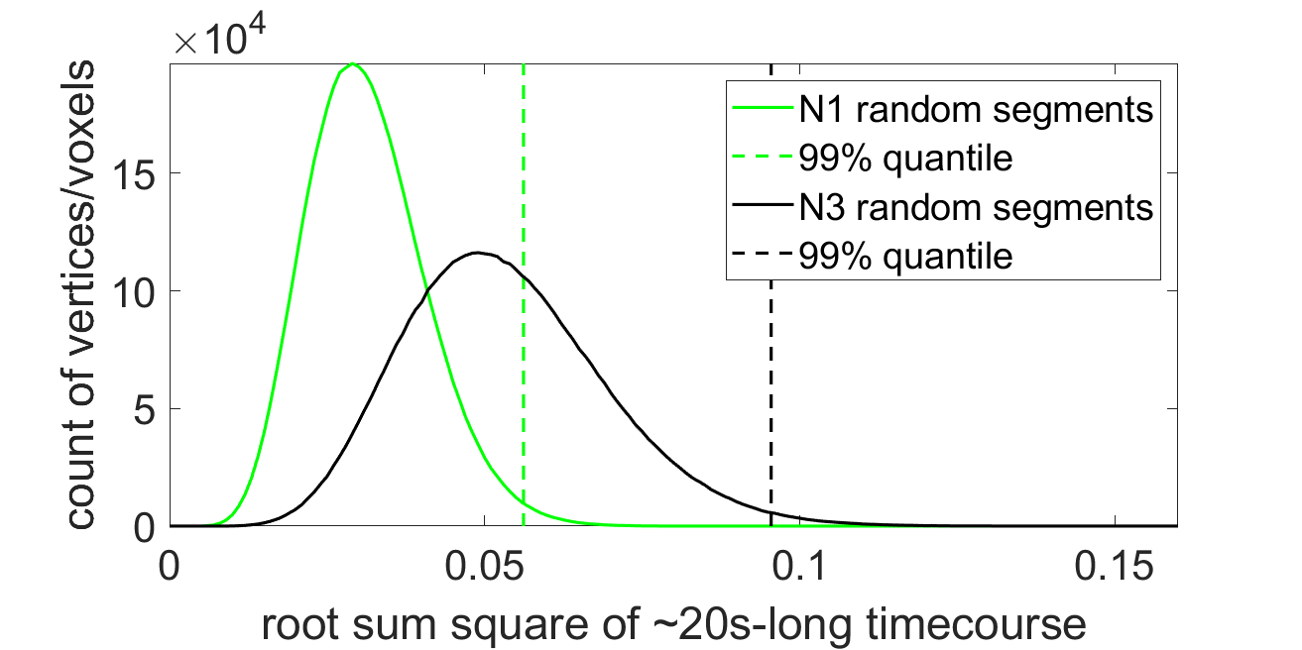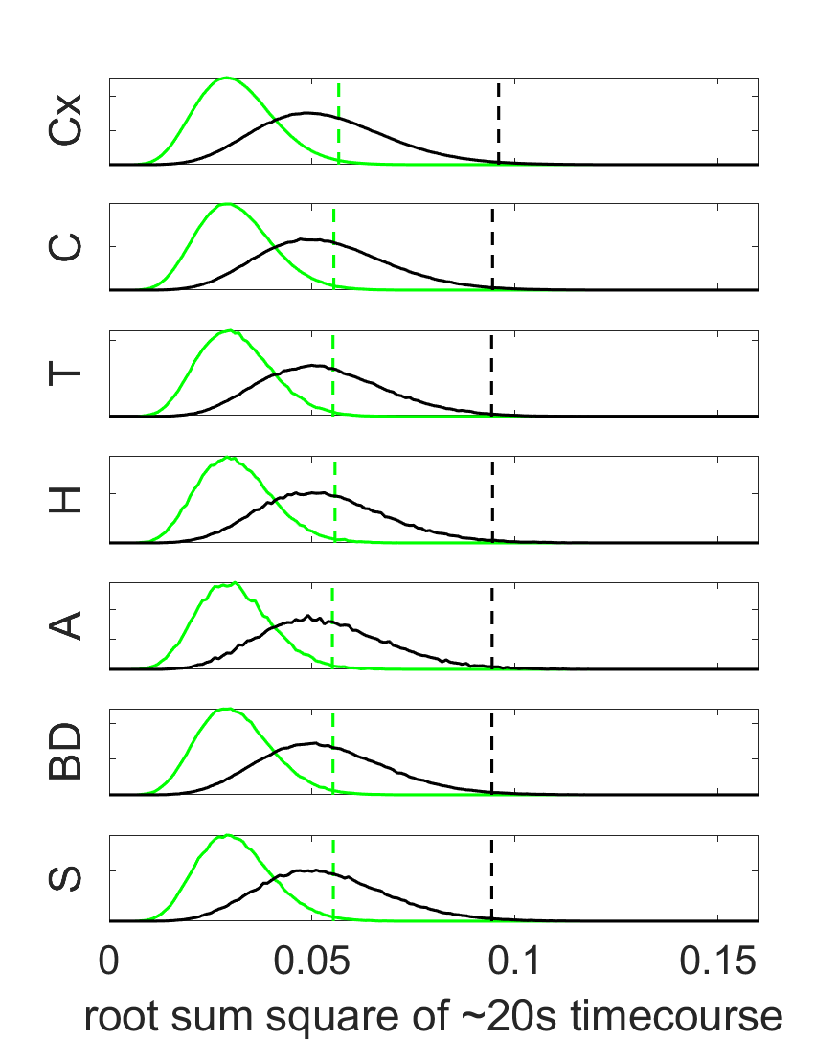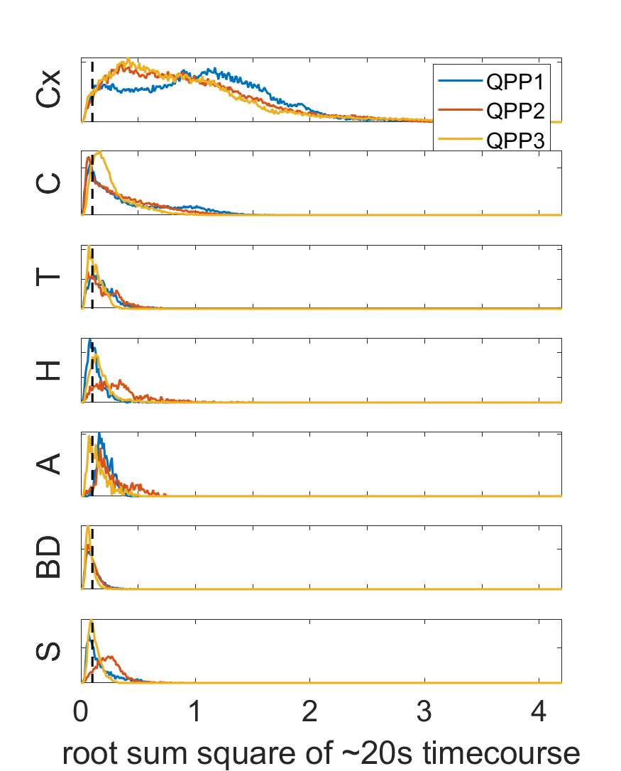

(a)

(b)

(c)

Brain Region

Cx: Cerebral cortex, C: Cerebellum, T: Thalamus, H: Hippocampus, A: Amygdala, BD*: Brainstem and Deep brain, S*: Striatum

*As anatomically labeled in the HCP dataset in grayordinates, we have included Brainstem, Ventral Diencephalon and Pallidum in BD, and Caudate, Putamen and Accumbens in S

Fig.S8 Statistics to determine the activation/deactivation time intervals within the ~20s duration of a QPP. (a) Histograms of the amplitude value at each timepoint of each timecourse corresponding to a vertex/voxel within a null pattern, across all timepoints, timecourses and null patterns (30x~92Kx50 entries); each null pattern was built by averaging randomly selected N1 (~28.3K) or N3 (~9.8K) number of segments, with Ni being the number of the contributing segments to the group QPPi. 99% quantile of the magnitude values (i.e. the absolute of the amplitude values), which can serve as a threshold to define activation/deactivation time intervals, increases as Ni decreases; to simplify, we used the threshold obtained based on N3 randomly selected segments (0.025) for QPPs 1-3. (b) Histograms shown in part (a) separated for each brain region showing near identical distributions. (c) Histograms of amplitude value of only the “active vertices/voxels” for QPPs 1-3 vs the magnitude threshold; amplitude values in the subcortical regions are lower compared to the cerebral cortex, as expected. A second step for the identification of the active vertices/voxels of a QPP was added by only including the vertices/voxels with peak magnitude (i.e., amplitude of peak activation or dip deactivation) larger than the magnitude threshold. (d) Total number of active vertices/voxels and their percentage per region.

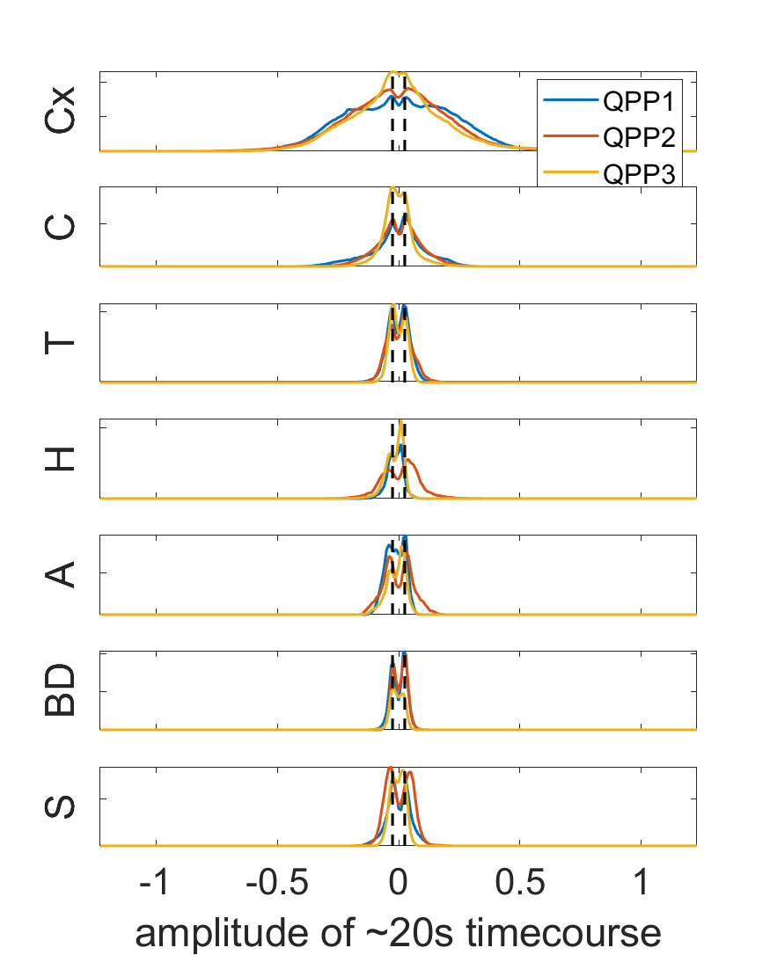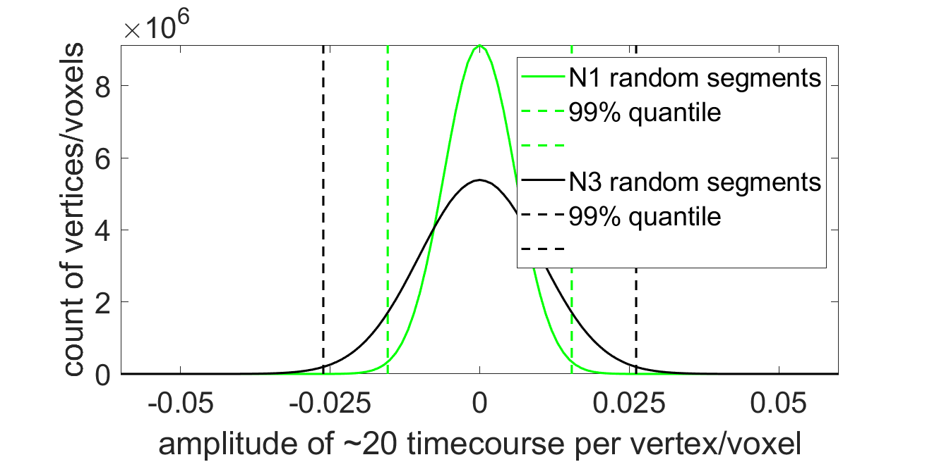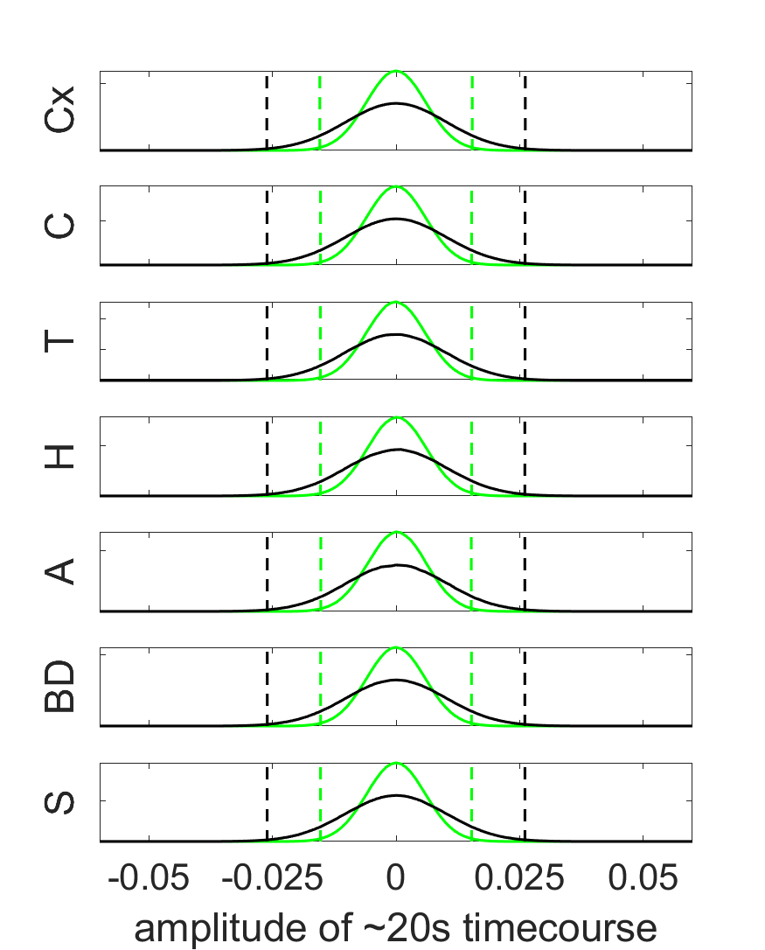

(a)

(b)

(c)

(d)

Cx: Cerebral cortex, C: Cerebellum, T: Thalamus, H: Hippocampus, A: Amygdala, BD: Brainstem and Deep brain, S: Striatum

|  |  |  |  |  |  |
| --- | --- | --- | --- | --- | --- |
|  |  | **QPP1** | **QPP2** | **QPP3** | **All** |
| **Number of active vertices/voxels** | **Cx** | 58317 | 58452 | 58088 | 59412 |
| **C** | 14526 | 14248 | 15672 | 17853 |
| **T** | 1939 | 1836 | 1500 | 2536 |
| **H** | 912 | 1439 | 1215 | 1559 |
| **A** | 639 | 617 | 422 | 647 |
| **BD** | 2349 | 2252 | 1287 | 5447 |
| **S** | 2349 | 3535 | 2195 | 3828 |
| **All** | 81031 | 82379 | 80379 | 91282 |
| **Percent of active vertices/voxels** | **Cx** | 98 | 98 | 98 |  |
| **C** | 81 | 80 | 88 |  |
| **T** | 76 | 72 | 59 |  |
| **H** | 58 | 92 | 78 |  |
| **A** | 99 | 95 | 65 |  |
| **BD** | 43 | 41 | 24 |  |
| **S** | 61 | 92 | 57 |  |
| **All** | 89 | 90 | 88 |  |

Table S1 Existing parcellations, functional networks and gradients* for comparison with QPP1

|  |  |  |
| --- | --- | --- |
| Region | Parcellations and gradients | References |
| Cortex | Seven resting-state networks (RSNs), the first three functional connectivity gradients (FCGs) and 360 multimodal parcellation to identify cortical areas | Thomas Yeo et al., 2011;  Margulies et al., 2016; Glasser et al., 2016 |
| Cerebellum | RSN-based parcellation and two cerebellar FCGs | Buckner et al., 2011; Guell et al., 2018 |
| Thalamus | Tractography-based parcellation | Behrens et al., 2003 |
| Hippocampus | Multimodal parcellation and two hippocampal FCGs | Robinson et al., 2016; Vos De Wael et al., 2018 |
| Amygdala | Structural parcellation** | Tyszka and Pauli, 2016 |
| Brainstem and deep brain nuclei+ | Probabilistic maps of locus coeruleus (LC), ventral tegmental area (VTA), substantia nigra pars compacta/pars reticulata (SNc/SNr), basal nucleus of Meynert (BNM), pedunculopontine nucleus (PPN), dorsal raphe (DR), median raphe (MR), periaqueductal gray (PAG) ***, subthalamic nucleus (STH), globus pallidus external/internal (GPe/GPi) and hypothalamus (HTH) | Keren et al., 2009 (LC); Pauli et al., 2016 (VTA, SN, GP, STH, HTH); Li et al., 2014 (BNM); Edlow et al., 2012 (PPN, DR/MR, PAG) |
| Striatum+ | RSN-based parcellation and two striatal FCGs | Choi et al., 2012; Marquand et al., 2017 |

* Other than the cortical gradients, we did not obtain any file for the non-cortical regions and just qualitatively compared the non-cortical gradients with the statistically evaluated summary maps of QPPs.

** After downloading the amygdala parcellation, to simplify, we regrouped the parcels into six (P1 to P6), which are as follows. P1: lateral (La), P2: basolateral (BL), P3: accessory basal (BM), P4: Paralaminar (BLV), P5: corticomedial nucleus (CMN) and central nucleus (CEN), P6: amygdalostriatal transition area (ASTA), periamygdaloid cortex (ATA), anterior amygdaloid area (AAA) and intercalated nuclei (AMY).

*** DR, MR and PAG are medial nuclei, not showing up in the representative planes chosen for the main figures.

+ As anatomically labeled in the HCP grayordinates, we included the Brainstem, Ventral Diencephalon and Pallidum in the “Brainstem and deep brain region” and the Caudate, Putamen and Accumbens in the “Striatum region”.

Fig.S9 Existing parcellations and functional networks. Representative planes chosen for the main figures (top part) and more sagittal planes (bottom part)

QPP1’s correlation timecourse per scan (C1: 1x1200)

QPP1 (360x30)

Convolving QPP1 per parcel with C1, to build a regressor for each parcel

Each scan (360x1200)

Regressing the regressor from the scan, per parcel, using GLM

(a) Scan-wise regression of QPP1

QPP1 (360x30)

Contributing segments of QPP1

(multiple 360x30)

Flatten to 1D

to build a regressor

Correlating QPP1 with the residual scan to find any supra-threshold maxima, repeating QPP1 regression till all maxima fall below the threshold

Flatten to 1D

Regressing using GLM

Replacing the contributing segment with the reshaped residuals (reshaped back to 360x30) and constructing the residual scan (360x1200)

(b) Segment-wise regression of QPP1

(c) Regressing QPPs 1 and 2

QPP1 and C1

Convolving QPP1 with C1 and QPP2 with C2, both per parcel, to build two regressors for each parcel

Each scan

Regressing the two regressors from the scan, per parcel, using GLM

QPP2 and C2

Scan-wise method

QPP2: derived by scan-wise regression of QPP1

C2: correlation timecourse of QPP2

Segment-wise regression of QPP1

Segment-wise regression of QPP2

Each scan

QPP1

QPP2

Residual scan

Segment-wise method

QPP2: derived by segment-wise regression of QPP1

Fig.S10 Scan-wise (a) and segment-wise (a) regression of QPP1. Regressing QPPs 1 and 2 (c).

(b) Presence of QPPs 2 and 3

(a) Robustness to regression method

Fig.S11 (a) Correlation between QPPs 2 and 3 of individuals obtained by two regression methods. (b) Correlation between QPPs 2 and 3 of individuals obtained based on the original scans and residual scans using both regression methods. Nearly identical results shows QPPs 2 and 3 are present in rsfMRI timeseries, similar to QPP1.

