Justin Buchanan & Alex Gurney  
CS3630 Assignment 3  
Final Submission

# Part 4

The particles expand and move away from the robot over time because without sensor feedback, the particles cannot improve their positions. Therefore, the uncertainties associated with each actuation accumulate over time, making it harder and harder to be sure where the robot is.

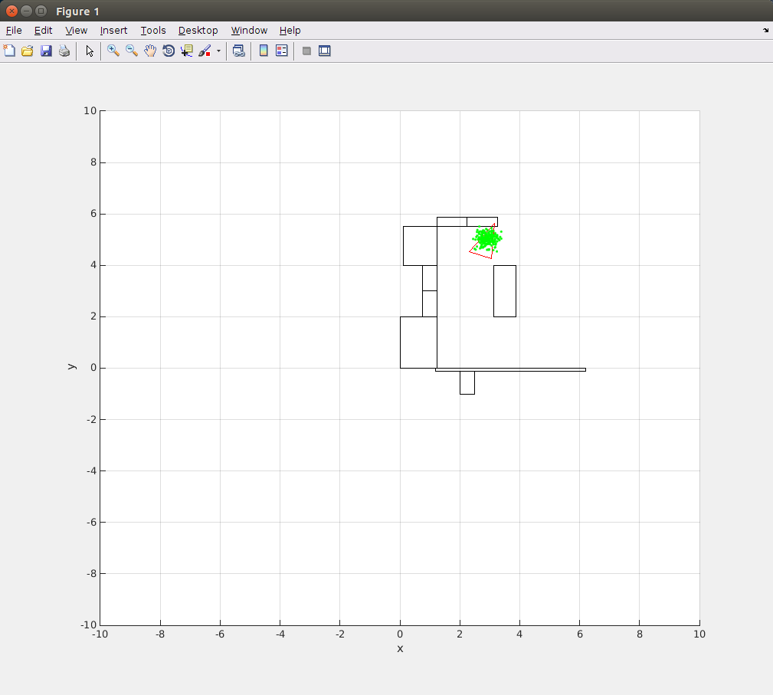

# Part 5

The particles when used with sensor feedback still spread out from the robot, especially during long stretches when the robot is unable to sense anything. However, when the robot can see something, like the wall in the below example, the particles begin to converge, as more and more sensor readings confirm the location of the feature the robot perceives. In the below picture, the particles are in a straight line, as the distance to the wall is more certain than where exactly along the wall the robot is.

