Alexander Gurney  
Justin Buchanan

CS 3630

3/26/2015

Assignment 5 Checkpoint

# 

# Path

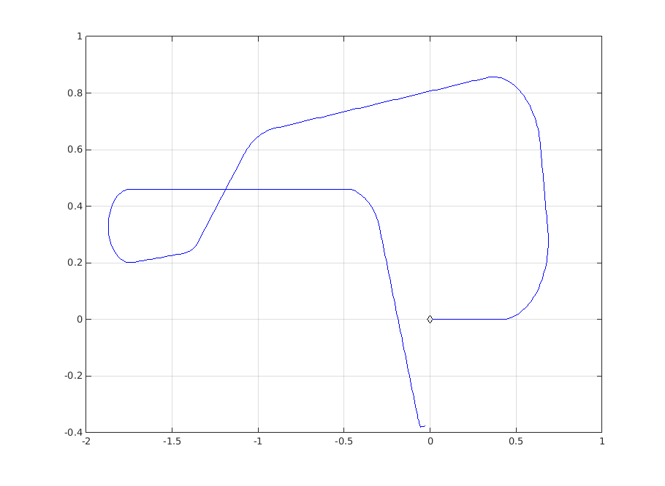

# Video

Please find our video of this path traversal submitted through t-square!