Alexander Gurney  
Justin Buchannon  
Assignment 6 Checkpoint  
4/9/2015

Visual Servoing Algorithm

## Overview

1. This algorithm will be implemented in matlab, using the RVT toolkit
2. The control algorithm will be Position Based Visual Servoing, as described in Corke p 448 (Figure 1).
3. PID will be the implemented controller.
4. This algorithm will be implemented using the PBVC (Position Based Visual Servo) class in the RVT Toolbox.

## Preprocessing

1. Create matrix K, the matrix representing the intrinsic properties of the camera.
2. Construct a Camera object using a stored picture from the final state as its image, ie the robot 1 foot in front of and facing the black square target (Figure 2). Name this CameraFinal in the program.
3. Take a picture with the black square feature visually in frame (Figure 3)
4. Create a Camera object using this image called CameraNow
5. Create a PBVS object instantiated with CameraNow and CameraFinal

## Control Loop

1. Take a new picture and update the image in CameraNow
2. Call the step method on the PBVS object to allow the loop to run once
3. If the calculated error is low enough, or iterations high enough, the loop exits
4. Otherwise, convert and issue the returned commands to the robot, then stop the motors

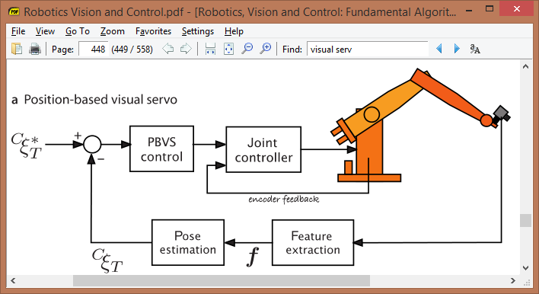

**Figure 1. Position Based Visual Servo Control Algorithm**

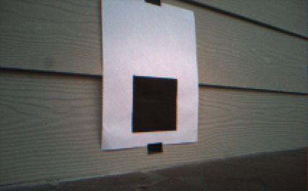

**Figure 2. Picture from start position 2’ and 45 degrees away**

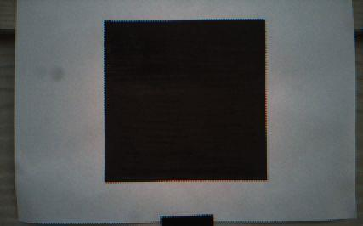

**Figure 2. Picture from goal position 1’ and 0 degrees away**