计算机学院实验报告

课 程 数据库
实验名称 创建实验用的数据库
专 业 软件工程
班 级 1602
学 号 161060009
学生姓名 黄佳俊

嘉应学院计算机学院
2018 年 3月 31 日
一、实验目的
通过实验掌握使用SQL SERVER向导和标准的SQL语言在SQL SERVER数据库管理系统中建立数据库和SQL的定义基本表、修改基本表和删除基本表的方法。
二、实验原理：
数据库的数据定义：
Syntax
1、CREATE DATABASE database_name
[ ON
[ < filespec > [ ,...n ] ]
[ , < filegroup > [ ,...n ] ]
]
[ LOG ON { < filespec > [ ,...n ] } ]
[ COLLATE collation_name ]
[ FOR LOAD | FOR ATTACH ]

< filespec > ::=

[ PRIMARY ]
( [ NAME = logical_file_name , ]
FILENAME = 'os_file_name'
[ , SIZE = size ]
[ , MAXSIZE = { max_size | UNLIMITED } ]
[ , FILEGROWTH = growth_increment ] ) [ ,...n ]

< filegroup > ::=

FILEGROUP filegroup_name < filespec > [ ,...n ]

File type File name extension
Primary data file .mdf
Secondary data file .ndf
Transaction log file .ldf

2、CREATE TABLE
CREATE TABLE
[ database_name.[ owner ] . | owner. ] table_name
( { < column_definition >
| column_name AS computed_column_expression
| < table_constraint > ::= [ CONSTRAINT constraint_name ] }

| [ { PRIMARY KEY | UNIQUE } [ ,...n ]
)

[ ON { filegroup | DEFAULT } ]
[ TEXTIMAGE_ON { filegroup | DEFAULT } ]

< column_definition > ::= { column_name data_type }
[ COLLATE < collation_name > ]
[ [ DEFAULT constant_expression ]
| [ IDENTITY [ ( seed , increment ) [ NOT FOR REPLICATION ] ] ]
]
[ ROWGUIDCOL]
[ < column_constraint > ] [ ...n ]

< column_constraint > ::= [ CONSTRAINT constraint_name ]
{ [ NULL | NOT NULL ]
| [ { PRIMARY KEY | UNIQUE }
[ CLUSTERED | NONCLUSTERED ]
[ WITH FILLFACTOR = fillfactor ]
[ON {filegroup | DEFAULT} ] ]
]
| [ [ FOREIGN KEY ]
REFERENCES ref_table [ ( ref_column ) ]
[ ON DELETE { CASCADE | NO ACTION } ]
[ ON UPDATE { CASCADE | NO ACTION } ]
[ NOT FOR REPLICATION ]
]
| CHECK [ NOT FOR REPLICATION ]
( logical_expression )
}

< table_constraint > ::= [ CONSTRAINT constraint_name ]
{ [ { PRIMARY KEY | UNIQUE }
[ CLUSTERED | NONCLUSTERED ]
{ ( column [ ASC | DESC ] [ ,...n ] ) }
[ WITH FILLFACTOR = fillfactor ]
[ ON { filegroup | DEFAULT } ]
]
| FOREIGN KEY
[ ( column [ ,...n ] ) ]
REFERENCES ref_table [ ( ref_column [ ,...n ] ) ]
[ ON DELETE { CASCADE | NO ACTION } ]
[ ON UPDATE { CASCADE | NO ACTION } ]
[ NOT FOR REPLICATION ]
| CHECK [ NOT FOR REPLICATION ]
( search_conditions )
}
3、ALTER TABLE
Modifies a table definition by altering, adding, or dropping columns and constraints, or by disabling or enabling constraints and triggers.

Syntax
ALTER TABLE table
{ [ ALTER COLUMN column_name
{ new_data_type [ ( precision [ , scale ] ) ]
[ COLLATE < collation_name > ]
[ NULL | NOT NULL ]
| {ADD | DROP } ROWGUIDCOL }
]
| ADD
{ [ < column_definition > ]
| column_name AS computed_column_expression
} [ ,...n ]
| [ WITH CHECK | WITH NOCHECK ] ADD
{ < table_constraint > } [ ,...n ]
| DROP
{ [ CONSTRAINT ] constraint_name
| COLUMN column } [ ,...n ]
| { CHECK | NOCHECK } CONSTRAINT
{ ALL | constraint_name [ ,...n ] }
| { ENABLE | DISABLE } TRIGGER
{ ALL | trigger_name [ ,...n ] }
}

< column_definition > ::=
{ column_name data_type }
[ [ DEFAULT constant_expression ] [ WITH VALUES ]
| [ IDENTITY [ (seed , increment ) [ NOT FOR REPLICATION ] ] ]
]
[ ROWGUIDCOL ]
[ COLLATE < collation_name > ]
[ < column_constraint > ] [ ...n ]

< column_constraint > ::=
[ CONSTRAINT constraint_name ]
{ [ NULL | NOT NULL ]
| [ { PRIMARY KEY | UNIQUE }
[ CLUSTERED | NONCLUSTERED ]
[ WITH FILLFACTOR = fillfactor ]
[ ON { filegroup | DEFAULT } ]
]
| [ [ FOREIGN KEY ]
REFERENCES ref_table [ ( ref_column ) ]
[ ON DELETE { CASCADE | NO ACTION } ]
[ ON UPDATE { CASCADE | NO ACTION } ]
[ NOT FOR REPLICATION ]
]
| CHECK [ NOT FOR REPLICATION ]
( logical_expression )
}

< table_constraint > ::=
[ CONSTRAINT constraint_name ]
{ [ { PRIMARY KEY | UNIQUE }
[ CLUSTERED | NONCLUSTERED ]
{ ( column [ ,...n ] ) }
[ WITH FILLFACTOR = fillfactor ]
[ ON {filegroup | DEFAULT } ]
]
| FOREIGN KEY
[ ( column [ ,...n ] ) ]
REFERENCES ref_table [ ( ref_column [ ,...n ] ) ]
[ ON DELETE { CASCADE | NO ACTION } ]
[ ON UPDATE { CASCADE | NO ACTION } ]
[ NOT FOR REPLICATION ]
| DEFAULT constant_expression
[ FOR column ] [ WITH VALUES ]
| CHECK [ NOT FOR REPLICATION ]
( search_conditions )
}

ALTER TABLE <表名>
[ ADD <新列名> <数据类型> [ 完整性约束 ] ]
[ DROP <完整性约束名> ]
[ ALTER COLUMN<列名> <数据类型> ];

4、DROP TABLE
DROP TABLE table_name
三、实验环境

Windows7（64位） VMware WoekstationPro ~windows2003

四、实验过程

1. 建立数据库
在D：盘建立两个临时目录d:\sqldata1和d:\sqldata
（1）使用向导。使用SQL SERVER向导建立名为school1的空数据库，数据库存放在d:\sqldata1了解建立过程
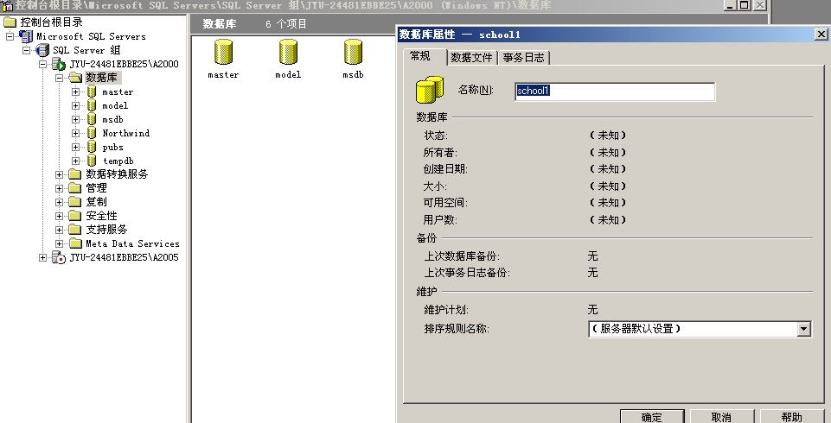
（2）使用T-SQL。在SQL查询分析器，使用T-SQL语句在d:\sqldata目录下建立名为school的数据库。
USE master
GO
CREATE DATABASE school
ON
( NAME = school_dat,
FILENAME = 'd:\sqldata\schooldat.mdf',
SIZE = 10,
MAXSIZE = 50,
FILEGROWTH = 5 )
LOG ON
( NAME = 'school_log',
FILENAME = 'd:\sqldata\schoollog.ldf',
SIZE = 5MB,
MAXSIZE = 25MB,
FILEGROWTH = 5MB )
GO
比较两种方法建立的数据库（1）在相关的目录查看；（2）在企业管理器中查看
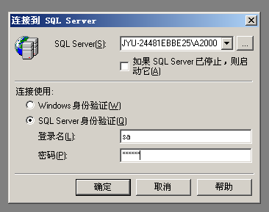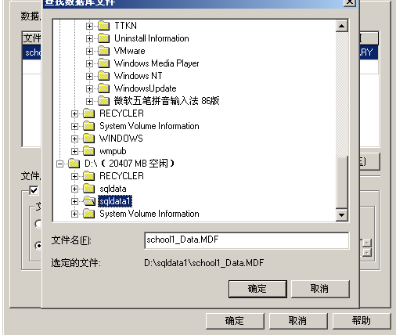
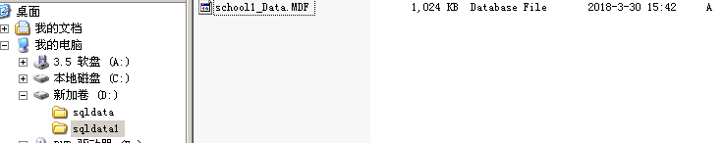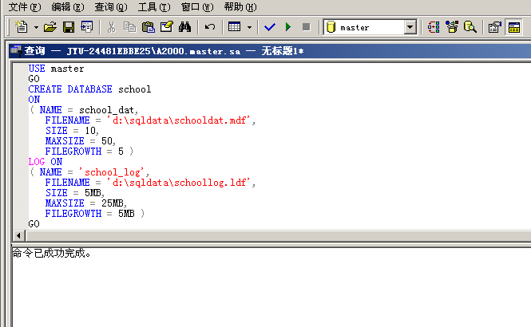
2.创建表

student表
Sno Sname Ssex Sage Sdept
95001 李勇 男 20 CS
95002 刘晨 女 19 IS
95003 王敏 女 18 MA
95004 张立 男 19 IS
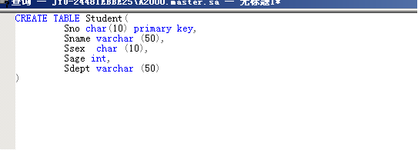
Course表
Cno Cname Cpno Credit
1 数据库 5 4
2 数学 2
3 信息系统 1 4
4 操作系统 6 3
5 数据结构 7 4
6 数据处理 2
7 PASCAL语言 6 4
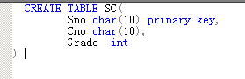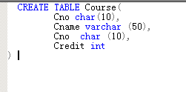
SC表
Sno Cno Grade
95001 1 92
95001 2 85
95001 3 88
95002 2 90
95002 3 80

根据上列内容用两种方法创建表
（一）定义基本表
（1）使用向导。使用SQL SERVER向导在school1数据库中建立3张表
（2）使用T-SQL。在SQL查询分析器，使用SQL语句建立3张表
CREATE TABLE Student(
Sno char(10) primary key,
Sname varchar (50),
Ssex char (10),
Sage int,
Sdept varchar (50)
)
同理，用SQL语言建立Course和SC表
（二）修改基本表
1、建立参照完整性约束
alter table sc add constraint fk_sno foreign key (sno) references student (sno)
alter table sc add constraint fk_cno foreign key (cno) references course (cno)
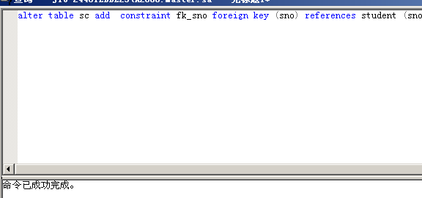
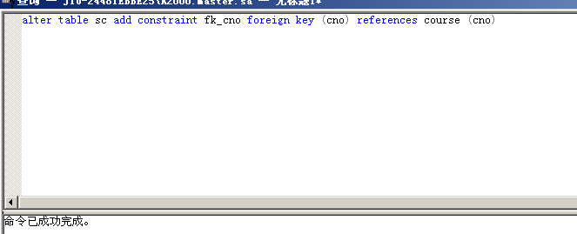
2、添加新列
在SC表中添加2个新列，名为T1和T2数据类型均为整型。参考ALTER TABLE 语法
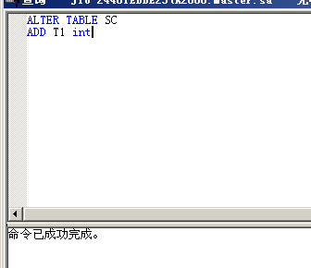
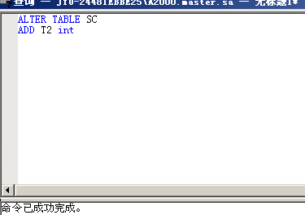
3、删除T2列，参考ALTER TABLE 语法

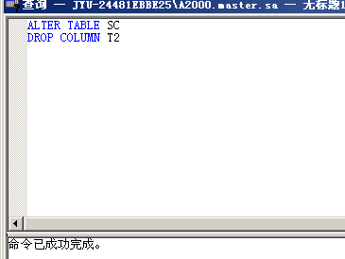
（三）删除完整性约束

删除SC 表中建立的参照完整性约束。

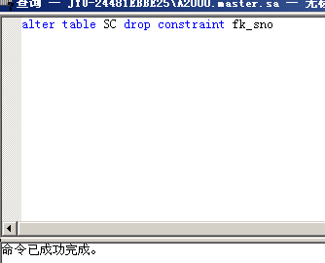
（四）添加记录
insert into student values ('95001','李勇','男',20,'CS')
insert into student values ('95002', '刘晨','女',19,'IS')
insert into student values('95003', '王敏', '女',18, 'MA')
insert into student values('95004', '张立', '男',19, 'IS')

insert into Course values('1','数据库', '5',4)
insert into Course values('2', '数学', '' ,2)
insert into Course values('3', '信息系统', '1', 4)
insert into Course values('4', '操作系统', '6', 3)
insert into Course values('5', ' 数据结构', '7', 4)
insert into Course values('6', '数据处理', '', 2)
insert into Course values('7', 'PASCAL语言', '6', 4)

insert into SC values('95001', '1', 92)
insert into SC values('95001', '2', 85)
insert into SC values('95001', '3', 88)
insert into SC values('95002', '2', 90)
insert into SC values('95002', '3', 80)

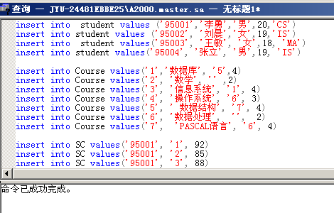
分别用select * from student, select * from course 和select * from sc,检验三张表是否存在正确的数据。

