**First Use Instructions**

*Default Username and Password Settings*

|  |  |
| --- | --- |
| Admin Username | ROTA |
| Admin Password | ROTA |
| WiFi Connection SSID | ROTA |
| WiFi Connection Password | ROTA12345678 |
| Access Point SSID | ROTA |
| Access Point Password | ROTA |
| mDNS Domain Name | rota-rapidfire.local |

**1.** Power the controller on. The controller light should blink ten times to indicate ROTA has configured its WiFi access point

**2.** Connect to the **ROTA** WiFi access point using the default password **ROTA12345678**

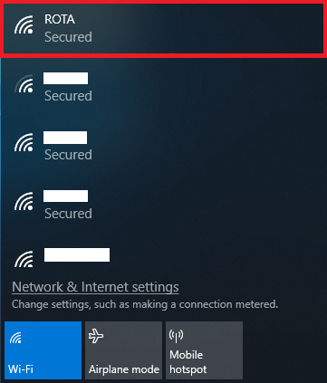

**3.** In your web browser, navigate to <http://192.168.4.1>

**4.** When prompted for credentials, enter **ROTA** for the Username and Password

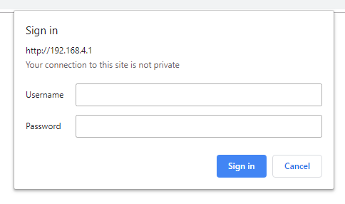

**5.** On the **Home** page, click **Settings** to configure your personal admin settings for ROTA

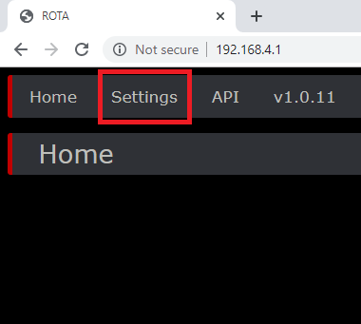

**6.** Using the settings page, you can configure your personal usage settings for ROTA.

**Note:** To save any changes made, you must click **Apply**. For changes to take effect, you must click **Restart**

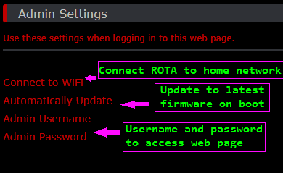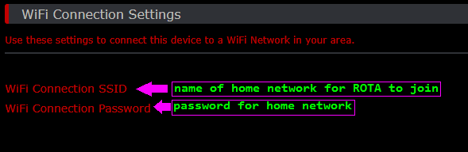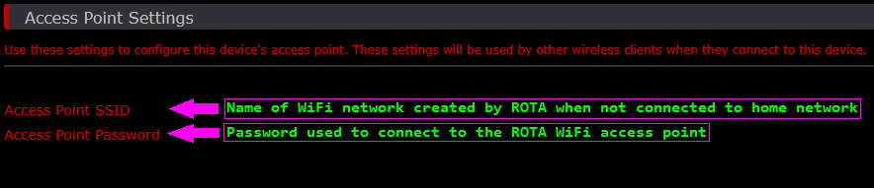

**Note:** If ROTA is configured to connect to your home network, you will need to use the URL shown under mDNS Settings to access ROTA from your web browser shown here

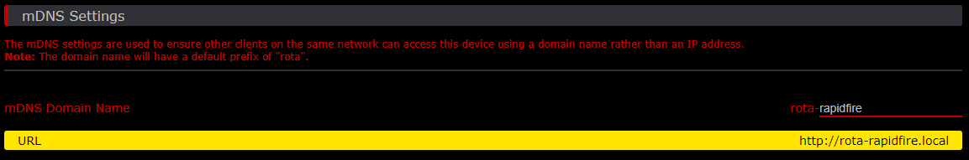

**7.** Use the **Home** page to adjust fire rate and mode of the mod and use the controller sync button to toggle the mod on and off

**Note:** **If you have forgotten any usernames or passwords, you can force ROTA to apply its default factory settings by double pressing the controller sync button within the first five seconds of the controller powering on**