**1.** Remove the two plastic grip covers, battery cover, and battery

**2.** Remove the five outer screws that hold the case together

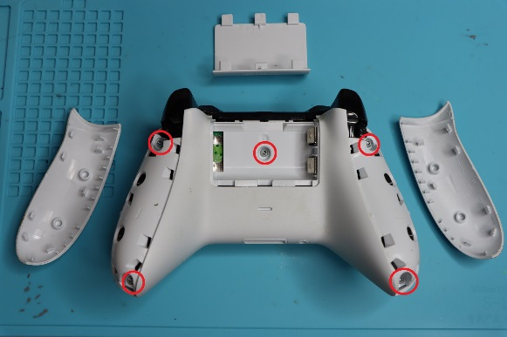

Figure 1

**3.** Flip the controller onto its front and remove the back panel

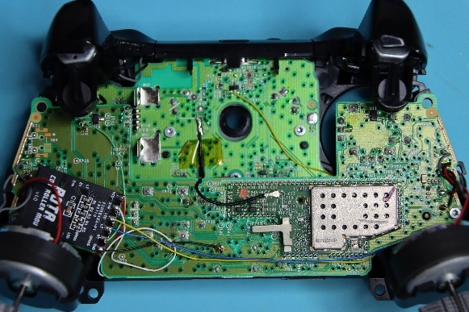

Figure 2

**4.** Remove the two screws that hold the upper and lower boards together shown in ***Figures 3 and 4***

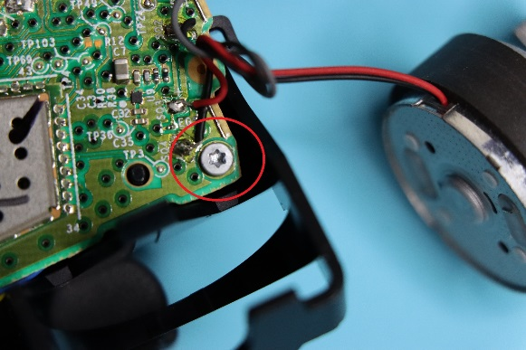

Figure

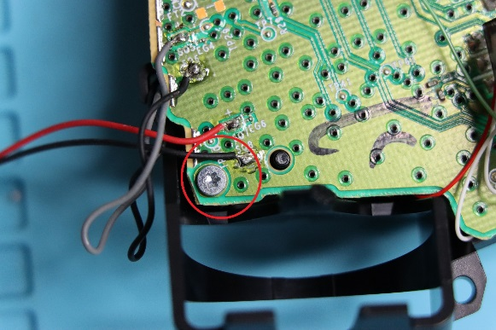

Figure

**5.** Disconnect the pigtail cable from the upper board shown in ***Figure 5***

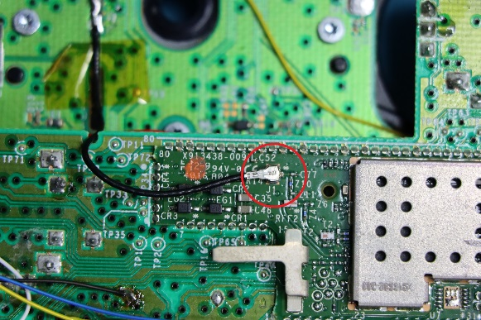

Figure

**6.** Disconnect the upper board from the lower board. Be careful not to lose the headphone jack

**7.** Using hot glue, fix ROTA to the controller's upper board as shown in ***Figure 2***

**8.** Solder the six connections shown in ***Figures 6-14***

**9.** Press-fit the upper and lower boards back together

**10.** Reconnect the pigtail cable to the upper board from ***Figure 5***

**11.** Secure the upper and lower boards with the two smaller screws from ***Figures 3 and 4***

**12.** Close the controller case with the back panel and the five larger screws from ***Figure 1***

**13.** Snap the two plastic grip covers, battery, and battery cover back into place

*Figures 6-14*

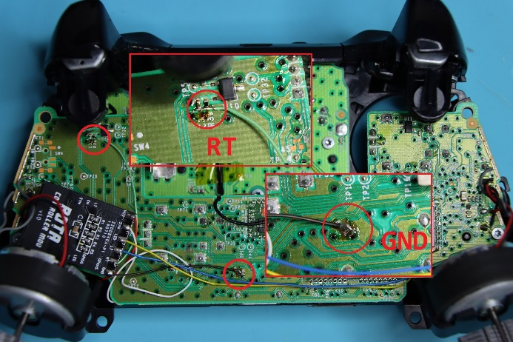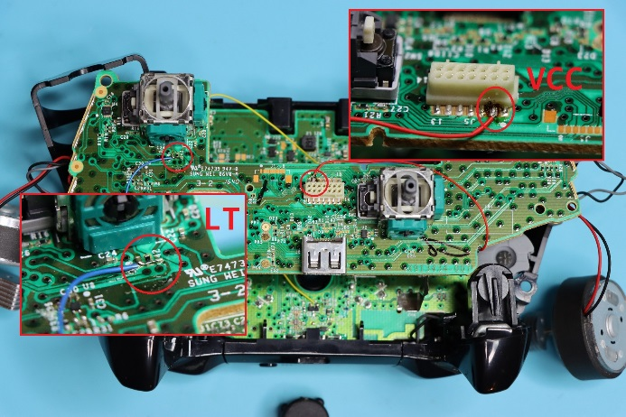

*Figures 6-14 cont.*

