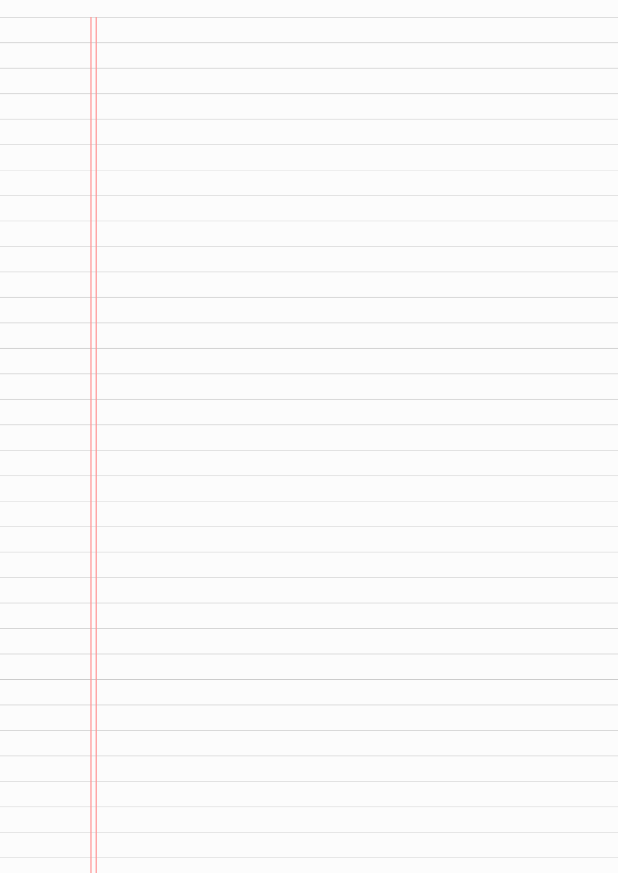
<!DOCTYPE html>
<html lang="hi">
<head>
<meta charset="UTF-8">
<meta name="viewport" content="width=device-width, initial-scale=1.0">
<title>Pannaa — Free Book Library</title>
<link rel="preconnect" href="https://fonts.googleapis.com">
<link href="https://fonts.googleapis.com/css2?family=Fraunces:ital,opsz,wght@0,9..144,400;0,9..144,600;0,9..144,800;1,9..144,500&family=Source+Sans+3:wght@400;600;700&display=swap" rel="stylesheet">
<style>
:root{
--cream:#F4EFE3;
--paper:#FBF8F1;
--ink:#2B2723;

--green:#1F3A2E;
--green-light:#2E5141;
--gold:#C9A24B;
--rose:#B5524A;
--line: rgba(43,39,35,0.12);
}
*{margin:0;padding:0;box-sizing:border-box;}
body{
background:var(--cream);
color:var(--ink);
font-family:'Source Sans 3', sans-serif;
line-height:1.6;
}
h1,h2,h3,.brand{font-family:'Fraunces', serif;}

/* ===== Header / Bookmark Nav ===== */
header{
background:var(--green);

color:var(--paper);
position:sticky;
top:0;
z-index:100;
box-shadow:0 2px 10px rgba(0,0,0,0.15);
}
.header-inner{
max-width:1100px;
margin:0 auto;
display:flex;
align-items:center;
justify-content:space-between;
padding:18px 24px 0 24px;
flex-wrap:wrap;
gap:10px;
}
.brand{
font-size:1.6rem;
font-weight:800;
letter-spacing:0.5px;
color:var(--paper);

display:flex;
align-items:baseline;
gap:6px;
}
.brand span{color:var(--gold);}
nav{
display:flex;
gap:6px;
margin-bottom:0;
}
.tab{
font-family:'Fraunces', serif;
font-weight:600;
font-size:0.95rem;
color:var(--paper);
background:var(--green-light);
border:none;
cursor:pointer;
padding:10px 22px 14px 22px;
border-radius:6px 6px 0 0;
position:relative;

transition:background .2s, transform .15s;
clip-path: polygon(0 0, 100% 0, 100% 100%, 50% 80%, 0 100%);
}
.tab:hover{background:#3a6651;}
.tab.active{
background:var(--gold);
color:var(--green);
transform:translateY(-2px);
}

main{max-width:1100px;margin:0 auto;padding:40px 24px 80px;}
.page{display:none;animation:fade .4s ease;}
.page.active{display:block;}
@keyframes fade{from{opacity:0;transform:translateY(8px);}to{opacity:1;transform:translateY(0);}}

/* ===== Hero ===== */
.hero{
display:grid;
grid-template-columns: 1.2fr 1fr;
gap:40px;
align-items:center;
padding:50px 0 60px;
border-bottom:1px solid var(--line);
}
.hero h1{
font-size:3rem;
line-height:1.15;
margin-bottom:18px;
}
.hero h1 em{color:var(--rose);font-style:italic;}
.hero p{font-size:1.1rem;max-width:520px;color:#564f48;margin-bottom:26px;}
.btn{
display:inline-block;

background:var(--green);
color:var(--paper);
font-family:'Fraunces',serif;
font-weight:600;
padding:14px 28px;
border-radius:4px;
text-decoration:none;
border:none;
cursor:pointer;
transition:background .2s;
}
.btn:hover{background:var(--green-light);}
.btn.ghost{
background:transparent;
border:2px solid var(--green);
color:var(--green);
margin-left:10px;
}
.hero-art{
position:relative;
height:280px;

}
.hero-stack{
position:relative;
width:100%;
height:100%;
}
.hero-stack .spine{
position:absolute;
border-radius:4px;
box-shadow:4px 6px 14px rgba(0,0,0,0.18);
display:flex;
align-items:center;
justify-content:center;
font-family:'Fraunces',serif;
color:var(--paper);
font-weight:600;
text-align:center;
padding:10px;
font-size:0.85rem;
}


/* ===== Section headings ===== */
.section-title{
font-size:1.8rem;
margin:50px 0 24px;
display:flex;
align-items:center;
gap:14px;
}
.section-title::after{
content:"";
flex:1;
height:1px;
background:var(--line);
}

/* ===== Book grid / cards ===== */
.grid{
display:grid;
grid-template-columns:repeat(auto-fill,minmax(220px,1fr));

gap:24px;
}
.card{
background:var(--paper);
border:1px solid var(--line);
border-radius:8px;
overflow:hidden;
display:flex;
flex-direction:column;
transition:transform .2s, box-shadow .2s;
}
.card:hover{
transform:translateY(-4px);
box-shadow:0 10px 24px rgba(0,0,0,0.10);
}
.cover{
height:160px;
display:flex;
align-items:center;
justify-content:center;

font-family:'Fraunces',serif;
color:var(--paper);
font-weight:700;
font-size:1.1rem;
text-align:center;
padding:14px;
line-height:1.3;
}
.card-body{padding:16px;display:flex;flex-direction:column;gap:8px;flex:1;}
.card-body h3{font-size:1.05rem;}
.card-body .author{font-size:0.85rem;color:#7a716a;}
.tag{
display:inline-block;
font-size:0.7rem;
text-transform:uppercase;
letter-spacing:1px;
background:var(--cream);
color:var(--green);
padding:3px 10px;

border-radius:20px;
align-self:flex-start;
font-weight:600;
}
.card-actions{
display:flex;
gap:8px;
margin-top:auto;
padding-top:8px;
}
.card-actions a{
flex:1;
text-align:center;
font-size:0.85rem;
padding:8px 0;
border-radius:4px;
text-decoration:none;
font-weight:600;
border:1px solid var(--green);
color:var(--green);
}

.card-actions a.primary{
background:var(--green);
color:var(--paper);
border-color:var(--green);
}
.card-actions a:hover{opacity:.85;}

/* ===== Search page ===== */
.search-bar{
display:flex;
gap:10px;
margin-bottom:30px;
flex-wrap:wrap;
}
.search-bar input, .search-bar select{
font-family:'Source Sans 3',sans-serif;
font-size:1rem;
padding:12px 16px;
border:1px solid var(--line);
border-radius:6px;
background:var(--paper);

color:var(--ink);
}
.search-bar input{flex:1;min-width:200px;}
.no-results{color:#7a716a;font-style:italic;padding:30px 0;}

/* ===== Category page ===== */
.cat-pills{
display:flex;
gap:10px;
flex-wrap:wrap;
margin-bottom:30px;
}
.pill{
padding:8px 18px;
border-radius:20px;
border:1px solid var(--green);
color:var(--green);
background:transparent;
cursor:pointer;
font-weight:600;

font-size:0.9rem;
font-family:'Source Sans 3',sans-serif;
transition:all .2s;
}
.pill.active, .pill:hover{
background:var(--green);
color:var(--paper);
}

/* ===== About page ===== */
.about-wrap{
display:grid;
grid-template-columns:1fr 1fr;
gap:40px;
align-items:start;
}
.about-wrap h2{margin-bottom:14px;}
.about-wrap p{color:#564f48;margin-bottom:14px;}
.stat-row{display:flex;gap:30px;margin-top:30px;}

.stat-row div{text-align:center;}
.stat-row .num{font-family:'Fraunces',serif;font-size:2.2rem;color:var(--green);font-weight:800;}
.stat-row .label{font-size:0.8rem;color:#7a716a;text-transform:uppercase;letter-spacing:1px;}
.quote-card{
background:var(--green);
color:var(--paper);
padding:36px;
border-radius:8px;
font-family:'Fraunces',serif;
font-size:1.3rem;
font-style:italic;
position:relative;
}
.quote-card::before{
content:"“";
font-size:4rem;

color:var(--gold);
position:absolute;
top:-10px;left:20px;
font-style:normal;
}
.quote-card .by{
display:block;
margin-top:18px;
font-size:0.95rem;
font-style:normal;
color:var(--gold);
}

footer{
background:var(--green);
color:var(--paper);
text-align:center;
padding:24px;
font-size:0.9rem;
}
footer span{color:var(--gold);}


@media(max-width:760px){
.hero{grid-template-columns:1fr;}
.hero-art{order:-1;height:200px;}
.about-wrap{grid-template-columns:1fr;}
.hero h1{font-size:2.2rem;}
}
</style>
</head>
<body>

<header>
<div class="header-inner">
<div class="brand">Panna<span>a</span></div>
<nav>
<button class="tab active" data-page="home">Home</button>
<button class="tab" data-page="search">Search</button>
<button class="tab" data-

page="category">Category</button>
<button class="tab" data-page="about">About</button>
</nav>
</div>
</header>

<main>

<!-- ===================== HOME ===================== -->
<section class="page active" id="home">
<div class="hero">
<div>
<h1>Padhiye jo dil chahe, <em>bilkul free.</em></h1>
<p>Pannaa par hazaaron classic kitaabein available hain — online padhiye ya seedha PDF download kar lijiye. Koi signup nahi, koi charge nahi.</p>
<a href="#" class="btn" data-

page="search">Kitaab Khojiye</a>
<a href="#" class="btn ghost" data-page="category">Categories Dekhiye</a>
</div>
<div class="hero-art">
<div class="hero-stack">
<div class="spine" style="background:#1F3A2E; width:90px; height:240px; left:10%; top:10px; transform:rotate(-6deg);">Fiction</div>
<div class="spine" style="background:#B5524A; width:90px; height:210px; left:38%; top:30px;">Classics</div>
<div class="spine" style="background:#C9A24B; color:#2B2723; width:90px; height:230px; left:66%; top:5px; transform:rotate(5deg);">Self-Help</div>
</div>
</div>

</div>

<h2 class="section-title">Featured Books</h2>
<div class="grid" id="featured-grid"></div>
</section>

<!-- ===================== SEARCH ===================== -->
<section class="page" id="search">
<h2 class="section-title">Kitaab Khojiye</h2>
<div class="search-bar">
<input type="text" id="searchInput" placeholder="Naam, author ya genre likhiye...">
<select id="sortSelect">
<option value="title">Title (A–Z)</option>
<option value="author">Author (A–Z)</

option>
</select>
</div>
<div class="grid" id="search-grid"></div>
<p class="no-results" id="noResults" style="display:none;">Koi kitaab nahi mili. Kuch alag try kariye.</p>
</section>

<!-- ===================== CATEGORY ===================== -->
<section class="page" id="category">
<h2 class="section-title">Category ke hisaab se</h2>
<div class="cat-pills" id="catPills"></div>
<div class="grid" id="category-grid"></div>
</section>

<!-- ===================== ABOUT ===================== -->

<section class="page" id="about">
<h2 class="section-title">Hamare baare mein</h2>
<div class="about-wrap">
<div>
<h2>Pannaa kya hai?</h2>
<p>Pannaa ek free digital library hai jahan readers ko duniya ki classic kitaabein — fiction, self-help, science aur biography — bina kisi kharche ke milti hain. Hamara maksad simple hai: padhne ko sabke liye easy banana.</p>
<p>Har kitaab online padhne ke saath-saath PDF format mein download bhi ho sakti hai, taaki aap offline bhi apni reading jaari rakh sakein.</p>
<div class="stat-row">
<div><div class="num">100%</div><div class="label">Free</div></div>
<div><div class="num">6+</div><div class="label">Categories</div></div>

<div><div class="num">PDF</div><div class="label">Download</div></div>
</div>
</div>
<div class="quote-card">
Ek kitaab ek sapna hai jo aap apne haathon mein pakad sakte hain.
<span class="by">— Pannaa Team</span>
</div>
</div>
</section>

</main>

<footer>
Made with <span>♥</span> for readers — Pannaa, 2026
</footer>

<script>
// ===== Book Data =====
const books = [
{
title: "Pride and Prejudice",
author: "Jane Austen",
category: "Fiction",
color: "#B5524A",
pdf: "https://www.gutenberg.org/files/1342/1342-pdf.pdf",
read: "https://www.gutenberg.org/ebooks/1342"
},
{
title: "Alice's Adventures in Wonderland",
author: "Lewis Carroll",
category: "Fiction",
color: "#2E5141",
pdf: "https://www.gutenberg.org/files/11/11-pdf.pdf",
read: "https://www.gutenberg.org/

ebooks/11"
},
{
title: "The Adventures of Sherlock Holmes",
author: "Arthur Conan Doyle",
category: "Mystery",
color: "#1F3A2E",
pdf: "https://www.gutenberg.org/files/1661/1661-pdf.pdf",
read: "https://www.gutenberg.org/ebooks/1661"
},
{
title: "Frankenstein",
author: "Mary Shelley",
category: "Science Fiction",
color: "#C9A24B",
pdf: "https://www.gutenberg.org/files/84/84-pdf.pdf",
read: "https://www.gutenberg.org/

ebooks/84"
},
{
title: "The Picture of Dorian Gray",
author: "Oscar Wilde",
category: "Fiction",
color: "#7a4b6b",
pdf: "https://www.gutenberg.org/files/174/174-pdf.pdf",
read: "https://www.gutenberg.org/ebooks/174"
},
{
title: "Meditations",
author: "Marcus Aurelius",
category: "Self-Help",
color: "#4a6a7a",
pdf: "https://www.gutenberg.org/files/2680/2680-pdf.pdf",
read: "https://www.gutenberg.org/ebooks/2680"

},
{
title: "The Origin of Species",
author: "Charles Darwin",
category: "Science",
color: "#3a5f4d",
pdf: "https://www.gutenberg.org/files/1228/1228-pdf.pdf",
read: "https://www.gutenberg.org/ebooks/1228"
},
{
title: "The Autobiography of Benjamin Franklin",
author: "Benjamin Franklin",
category: "Biography",
color: "#8a6a3a",
pdf: "https://www.gutenberg.org/files/20203/20203-pdf.pdf",
read: "https://www.gutenberg.org/ebooks/20203"

},
{
title: "A Christmas Carol",
author: "Charles Dickens",
category: "Fiction",
color: "#9c3d3d",
pdf: "https://www.gutenberg.org/files/46/46-pdf.pdf",
read: "https://www.gutenberg.org/ebooks/46"
}
];

// ===== Card renderer =====
function bookCard(b){
return `
<div class="card">
<div class="cover" style="background:${b.color}">${b.title}</div>
<div class="card-body">
<span class="tag">${b.category}</

span>
<h3>${b.title}</h3>
<p class="author">${b.author}</p>
<div class="card-actions">
<a href="${b.read}" target="_blank">Read Online</a>
<a href="${b.pdf}" target="_blank" class="primary">Download PDF</a>
</div>
</div>
</div>`;
}

// ===== Render Home featured (first 4) =====
document.getElementById('featured-grid').innerHTML = books.slice(0,4).map(bookCard).join('');

// ===== Search page =====
const searchGrid =

document.getElementById('search-grid');
const searchInput = document.getElementById('searchInput');
const sortSelect = document.getElementById('sortSelect');
const noResults = document.getElementById('noResults');

function renderSearch(){
const q = searchInput.value.trim().toLowerCase();
let results = books.filter(b =>
b.title.toLowerCase().includes(q) ||
b.author.toLowerCase().includes(q) ||
b.category.toLowerCase().includes(q)
);
results.sort((a,b) => a[sortSelect.value].localeCompare(b[sortSelect.value]));
searchGrid.innerHTML = results.map(bookCard).join('');

noResults.style.display = results.length ? 'none' : 'block';
}
searchInput.addEventListener('input', renderSearch);
sortSelect.addEventListener('change', renderSearch);
renderSearch();

// ===== Category page =====
const categories = ["All", ...new Set(books.map(b => b.category))];
const catPills = document.getElementById('catPills');
const categoryGrid = document.getElementById('category-grid');

catPills.innerHTML = categories.map((c,i) =>
`<button class="pill ${i===0?'active':''}" data-cat="${c}">${c}</button>`

).join('');

function renderCategory(cat){
const filtered = cat === "All" ? books : books.filter(b => b.category === cat);
categoryGrid.innerHTML = filtered.map(bookCard).join('');
}
renderCategory("All");

catPills.addEventListener('click', e => {
if(!e.target.classList.contains('pill')) return;
document.querySelectorAll('.pill').forEach(p => p.classList.remove('active'));
e.target.classList.add('active');
renderCategory(e.target.dataset.cat);
});

// ===== Navigation =====
document.querySelectorAll('[data-

page]').forEach(el => {
el.addEventListener('click', e => {
e.preventDefault();
const page = el.dataset.page;
document.querySelectorAll('.tab').forEach(t => t.classList.remove('active'));
document.querySelector(`.tab[data-page="${page}"]`).classList.add('active');
document.querySelectorAll('.page').forEach(p => p.classList.remove('active'));
document.getElementById(page).classList.add('active');
window.scrollTo({top:0, behavior:'smooth'});
});
});
</script>

</body>
</html>

