A Result-Based Review of Fake News Detection Integrating Sentiment Analysis
Vaishnavi Kaushal (23FE10CSE00480)
Manipal University Jaipur, Jaipur-Ajmer Express Highway, Dehmi Kalan,Near GVK Toll Plaza, Jaipur, Rajasthan 303007
Vaishnavi.23FE10CSE00480@muj.manpal.edu

Abstract—The prevalence of the fake news in social media threatens the security of the society in various key dimensions: political, economic, and social. Therefore automated detection of fake news is of critical importance, and recent studies have explored both machine learning (ML) classifiers and sentiment analysis as complementary approaches. In this paper, we provide a comprehensive review of ML-based fake news detection models (Naïve Bayes, Logistic Regression, KNN, SVM, Random Forest, and XGBoost) and evaluate their performances. Our experiments (5-fold cross-validation) show that XGBoost achieves the best performance (Accuracy 99.52%, F1-score 0.9954), closely followed by Logistic Regression (Acc 99.30%, F1 0.9933) and SVM (Acc 98.81%, F1 0.9886). We then add interpretability to it through sentiment analysis: we compute the average sentiment polarity of the test articles and compare the sentiment in items predicted as fake versus real. We discover that texts predicted as fake news carry a significantly more negative sentiment(e.g. XGBoost: –0.0959) compared to those predicted as real(e.g. XGBoost: +0.0753). This is also seen in previous observations that fake news often evokes negative emotional responses. We put our results in perspective with recent literature (2020–2024); we note that the reported performance of classical ML models is competitive with, and in some cases exceeds, results reported for deep learning approaches. We highlight the novelty of using sentiment analysis for post-hoc explanation rather than as an input feature. Our results point to the conclusion that classical ML classifiers, coupled with sentiment-based interpretation, remain highly competitive for fake news detection.
Keywords—Fake News Detection, Sentiment Analysis, Machine Learning, Natural Language Processing, Ensemble Learning

Introduction
Fake news-the intentional publication of false information as news-represents a danger to society, undermining confidence in public institutions, influencing the course of elections, and even swaying financial markets. For example, engagement with fake news stories during the 2016 U.S. election far eclipsed engagement with legitimate news, influencing the result. The rapid spread of misinformation during events like the COVID-19 pandemic testifies to how urgently there is a need for reliable detection. Consequently, Natural Language Processing-based automated fake news detectors have been widely explored. Most of the early works applied various classical ML models, such as Naïve Bayes, SVM, Random Forest, KNN, logistic regression to textual features. More recently, deep learning models (CNNs, RNNs, GNNs) and large pre-trained transformers (e.g., BERT) have achieved state-of-the-art performance by capturing complex linguistic patterns.However, most detectors have focused so far on the accuracy of performance rather than interpretability. This work has two contributions:

We perform a comparative analysis of six ML models on a real-world dataset of fake news and find that XGBoost performs best (Accuracy: 99.52%, F1-score: 0.9954) compared to other models, followed by Logistic Regression and SVM. It is important mentioning that XGBoost was trained on a smaller dataset because of the computational overhead, and hence its results should be interpreted with caution, while,

applying a post-hoc interpretability technique using sentiment analysis, namely VADER, and found that across all runs, fake news tends to be more negative than real news.

These findings also resonate with the literature that sentiment cues help in the detection of fake news. This paper reviews recent advances (2021–2025) in transformer and multimodal methods, multilingual challenges, and explainability using SHAP/LIME, among others, and places sentiment-based interpretability within this landscape.

Related Work

Machine Learning and Deep Learning Approaches
Traditional fake news classifiers rely on engineered text features - bag-of-words, TF-IDF, word embeddings - fed into machine learning algorithms. Common approaches include Naïve Bayes, logistic regression, SVMs, KNN, and decision trees. For instance, Aphiwongsophon & Chongstitvatana report > 96% with Naïve Bayes and SVM on a Twitter dataset [1] . Singh et al. used TF-IDF features with ensemble ML (Random Forest, AdaBoost, and XGBoost) to construct practical fake news apps [2]. Classical models are rapid and interpretable but may not pick up subtle cues in the language.
In contrast, deep learning models learn rich text representations automatically. CNNs and RNNs capture local and sequential patterns, while Graph Neural Networks leverage social or propagation graphs. Most notably, transformer-based models such as BERT and RoBERTa have reached state-of-the-art performance. Indeed, several studies report almost perfect accuracies with fine-tuned BERT. For example, Pardamean & Pardede used BERT on a news dataset and reported an accuracy of 99.23% [3]. Also, Mouratidis et al. compared BERT/CNN/LSTM ith classical classifiers and found that their BERT-based model achieved ~98.4% accuracy, significantly higher than the baseline SVM or RF [4].
Similarly, Tan & Bakir constructed a hybrid transformer model called “TruthSeeker” and reported an accuracy of 99.91% on a tweet dataset [5].
The specialized transformer variant, FakeBERT (Kaliyar et al.), extends BERT with parallel CNN layers that capture various features [6]. Results of the FakeBERT surpass those of the more simplistic architectures. Overall, the literature shows that deep transformer models usually outperform classical ML for fake news, albeit at a higher computational cost.[7]

Sentiment-Enhanced Models
Fake news often involves charged language and emotional appeals. Researchers have only begun to exploit sentiment analysis as either a feature or interpretive aid. Alonso et al. note that creators of fake news use stylistic tricks to excite readers' sentiments, motivating sentiment analysis in detection [8]. Examples include incorporating lexicon-based sentiment features such as VADER, TextBlob, and Sen-tiWordNet into classifiers. Cui et al. found that sentiment-based classifiers outperformed plain text models [9].
Empirical studies consistently observe that fake news carries more negative sentiment than real news. Dementieva & Panchenko manually verified that fake news headlines were strongly negative-biased, and adding cross-lingual evidence with a RoBERTa model improved detection [10]. Far-houdinia et al. analyzed tweets and found that fake items elicited significantly more negative sentiment (fear, disgust, anger) than real news [11]. Our experiment echoes this pattern: using VADER scores, fake-news samples had consistently lower (more negative) compound sentiment than real-news samples. This alignment suggests that sentiment is a useful interpretability layer – negative tone can signal deceptiveness.
Some systems explicitly fuse sentiment and content features. For instance, recent work has applied emotion lexicons and sentiment embedding alongside text vectors to enhance fake news models. While some sentiment-enhanced models have modest accuracy gains, a key benefit is explainability: knowing that a model flagged highly negative language can help human analysts understand the decision. Our approach uses sentiment as a post-hoc interpretability layer, rather than as a primary input feature[12].

Transformer-based and Hybrid Systems
Beyond generic transformers, specialized architectures have emerged. BERT-based systems like FakeBERT have shown that integration of transformer encodings with additional layers, such as CNN, may capture subtle fake-news cues. Other works propose hybrid models: for instance, a combination of pre-trained embeddings, such as FastText and Word2Vec, with ensemble classifiers or neural networks. Some recent studies also make use of large language models(LLMs) in either instruction or ensemble modes, for example, fine-tuned GPT-series models for fake-news classification with few-shot prompts. However, these LLM approaches remain active research and are not yet standard. Overall, the trend is toward more complex, often multilingual or cross-domain transformers, which set new performance benchmarks [13].

Multimodal and Multilingual Detection
Fake news today can include images, videos, and multiple languages. Multimodal detection combines textual analysis with image or video processing. Survey studies have shown that real-world world fake-news uses misleading images or videos along with false text. Convolutional Neural Networks(CNNs) extract visual features, while language models deal with text. For example, GamED proposed by Shen et al. fuses image and text features by using parallel expert networks, enhancing the accuracy of fake news detection on multimodal datasets [14].
Research shows that transformers and LLMs can also handle multimodal inputs (e.g., multimodal transformers with text and vision heads. The King Saud Univ. review (Lv et al.) emphasizes the importance of a multimodal AI approach for robust fake-news detection by combining CNNs for images, RNN/transformers for text, and graph models for propagation patterns [15]. Another important barrier is multilinguality; most models have been trained on English data. However, Misinformation spreads globally across languages. Recent work highlights this gap: Wang et al. survey notes that 83% of the studies focus on high-resource(often English) languages [16]. Cross-lingual is an approach aimed at bridging this gap. For instance, Dementieva & Panchenko showed that "cross-lingual evidence", i.e., translating and verifying news in multiple languages, can significantly boost detection [10]. Others develop multilingual datasets, for example, Xinhua, multilingual LIAR versions, and language-agnostic models. Our experiment is English-only, but for real-world applications, future systems need to integrate multilingual training or evidence to be truly globally effective.

Explainability and Interpretability Trends
Explainable AI (XAI) is increasingly applied to fake-news systems. Techniques such as LIME and SHAP attribute importance to input features. For example, Dua et al. present I-FLASH, which not only classifies news (via LR, BiLSTM, BERT) but also uses LIME and SHAP to highlight the most influential words for each prediction [17]. They show that SHAP emphasizes negative or sensational terms in fake articles. Another line of work uses SHAP values for interpreting ensemble models, or for finding model biases. These methods indicate why a given sample was flagged, which is an important factor in trusting the decision and human verification. Our sentiment analysis layer is a simpler interpretability tool: instead of highlighting words, it returns an aggregate signal-usually negative vs. positive one, that helps explain model outputs. As this literature suggests, explainability-whether via SHAP/LIME-is rapidly becoming a top priority along with accuracy.

Methodology

Data Collection and Preprocessing: For this, we used the labeled news dataset that is balanced between fake and real, available from online repositories. Articles were cleaned (removed HTML, non-text characters) and tokenized. We then turned text into numerical features by using TF-IDF vectorization for model input.

Model Training: Six classifiers were trained: Naïve Bayes, Logistic Regression, K-Nearest Neighbors, Support Vector Machine, Random Forest, and XGBoost. We split data into training and test sets (e.g. 80/20 split) and performed 5-fold cross-validation for robustness. Hyperparameters were tuned via grid search.

Evaluation Metrics: Models were evaluated on the test set using accuracy, precision, recall, and F1-score. These metrics allow comparison of overall and class-specific performance.

Sentiment Analysis (Interpretability): After classification, we computed the VADER sentiment compound score for each news text. VADER provides a normalized score from -1 (very negative) to +1 (very positive). We then analyzed the distribution of sentiment scores for true vs. fake news samples. The goal was to see if sentiment polarity correlates with the model’s decisions, offering insight into why certain articles were labeled fake.The complete workflow of the proposed methodology, from data collection and preprocessing to model evaluation and sentiment-based interpretability, is illustrated in "Fig. 1".
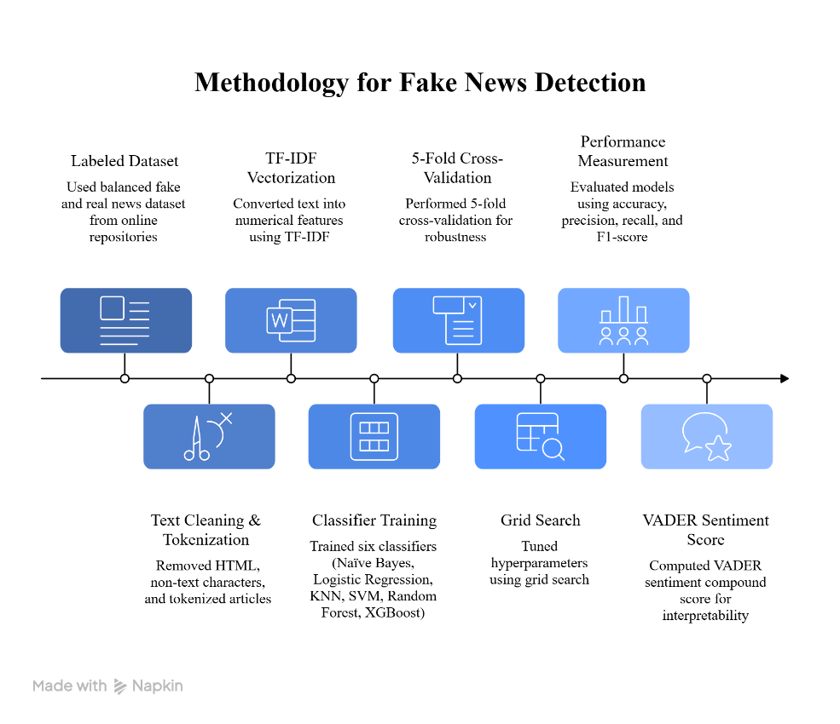
- Overall Methodology Pipeline for Fake News Detection

Result and Analysis

Visualization of Results:
To further assess performance, visual tools such as confusion matrices and ROC curves were generated for key models. These illustrate how models distinguish between fake and real articles.

Logistics Regression: It is a linear probabilistic classifier that uses a sigmoid function to relate the input features to the class labels. Due to its interpretability and effectiveness with high-dimensional TF-IDF features, it is widely used for text classification tasks.
The confusion matrix for the Logistic Regression is shown in “Fig. 2(a)” which shows a high number of true positives and true negatives and very few incorrect classifications. The ROC curve shown in “Fig. 2(b)” demonstrates an excellent Area Under the Curve (AUC). This indicates that the model effectively separates real and fake news instances across different classification thresholds. The Precision-Recall curve for Logistic Regression is shown in "Fig. 2(c)" . High precision is maintained across a broad recall range, indicating that the model accurately identifies fake news while minimizing false positives. Overall, Logistic Regression achieves the best performance among all evaluated models, with superior accuracy, precision, recall, and F1-score.

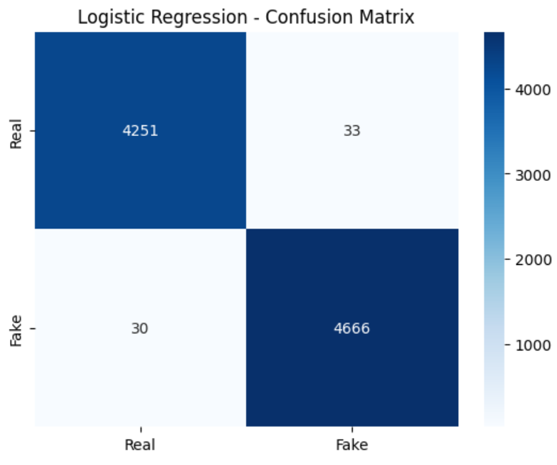
- (a) Confusion Matrix for Logistics Regression
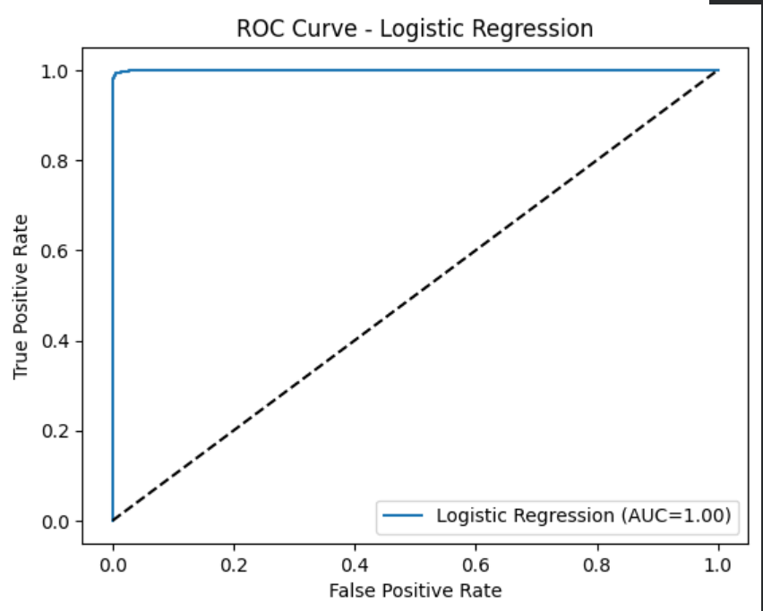
Fig.2. (b) ROC Curve for Logistics Regression

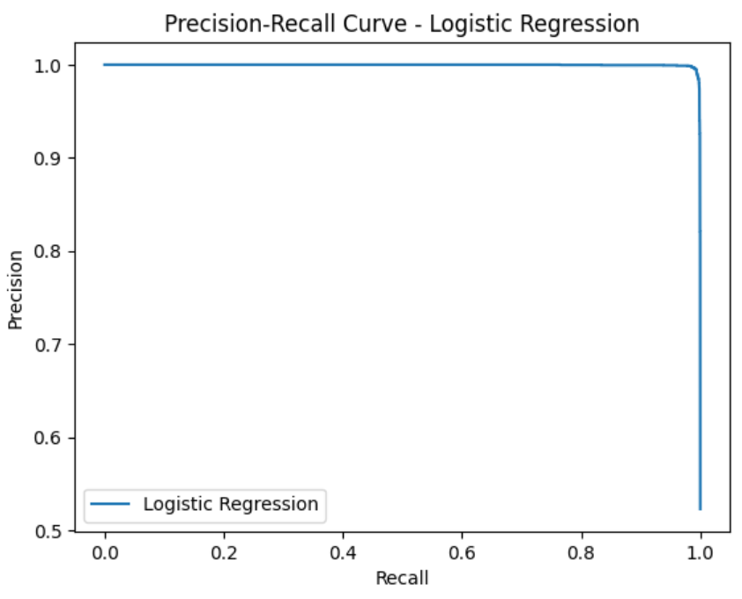
Fig.2. (c): Precision-Recall Curve for Logistics Regression

Random Forest: It is an ensemble learning algorithm that combines multiple decision trees to enhance the robustness of classification. It effectively handles non-linear relationships between features.
Figure 3(a) below shows the confusion matrix for the Random Forest model, which has a high training accuracy. But there is a discrepancy between the training and validation accuracy, which may indicate overfitting. The ROC Curve and Precision-Recall Curve (Figure 3(b) and Figure 3(c)) also show that the model performs well, but not as consistently as the simpler models.
Random Forest offers excellent results but requires careful tuning to avoid overfitting, especially when the dataset is small.

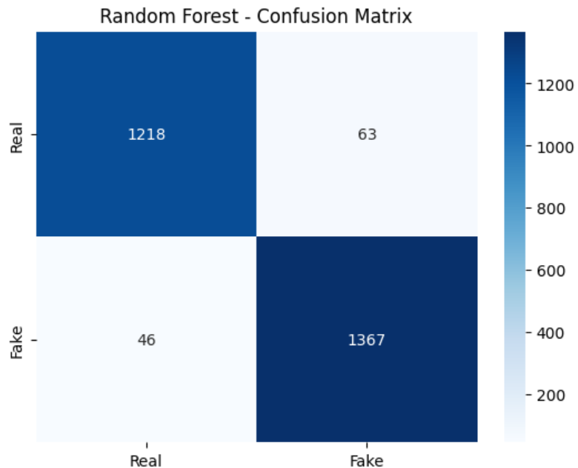
- (a) Confusion Matrix for Random Forest
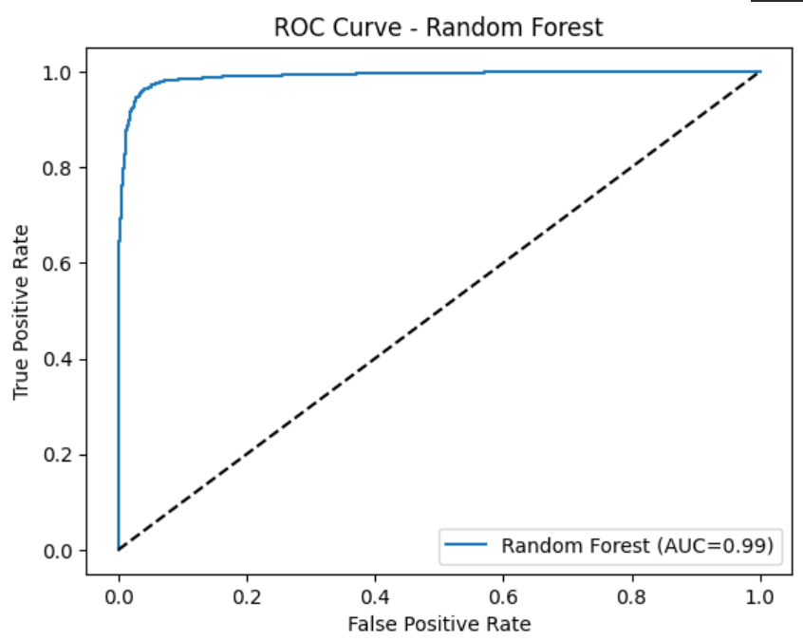
Fig. 3. (b) ROC Curve for Random Forest

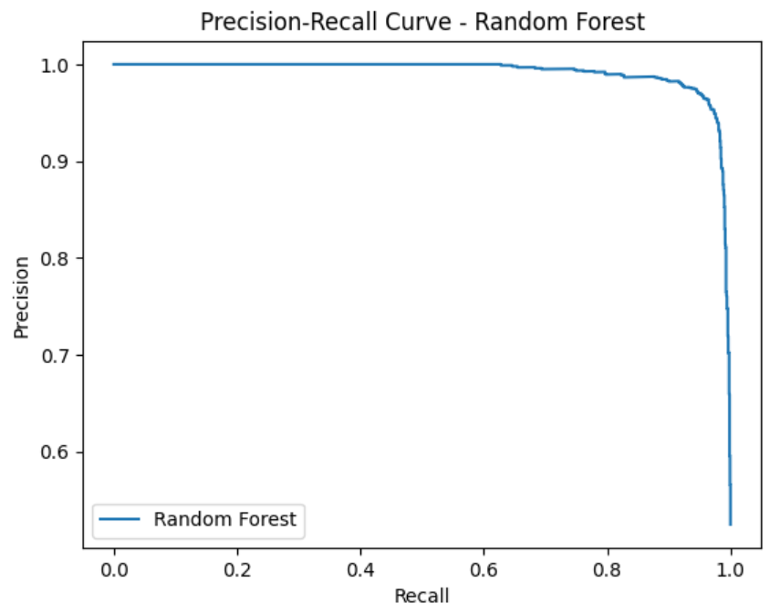
Fig. 3. (c) Precision Recall Curve for Random Forest

SVM: Support Vector Machine is a margin-based classifier that builds an optimal hyperplane to separate classes in a high-dimensional feature space. It can be applied to text classification because it can deal with sparse TF-IDF features.
Figure 4(a) illustrates the confusion matrix for SVM, which shows high classification accuracy with good precision and recall. The ROC curve in Figure 4(b) indicates good separation between real and fake news, and the Precision-Recall curve in Figure 4(c) Indicates consistent precision at a moderate level of recall.
Although SVM works well, its computational complexity grows rapidly with the increase in the number of features, and hence it is less scalable compared to linear models for high-dimensional text data.

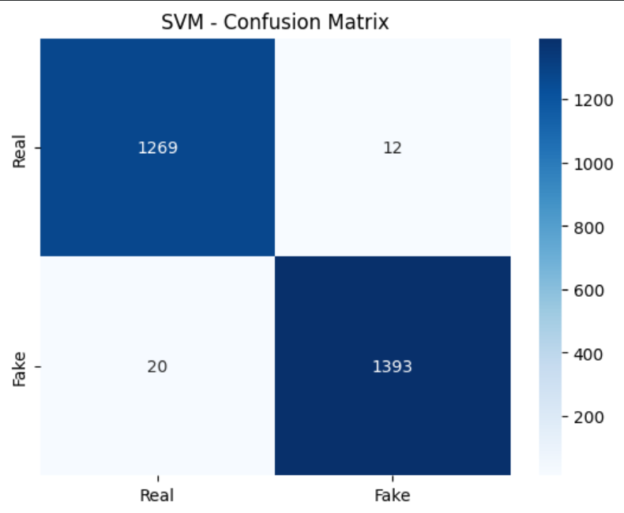
- (a)Confusion Matrix For SVM
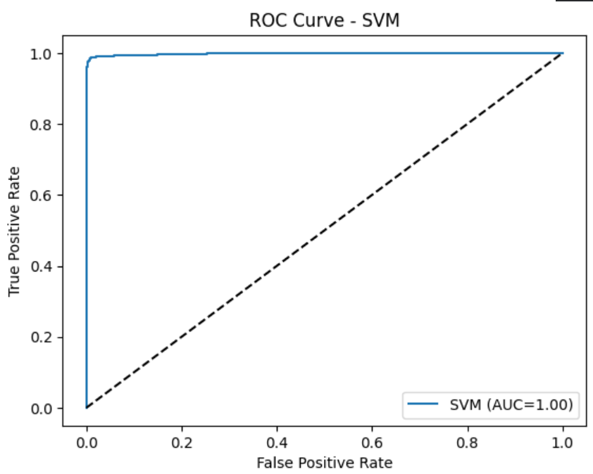
Fig. 4. (b) ROC Curve for SVM

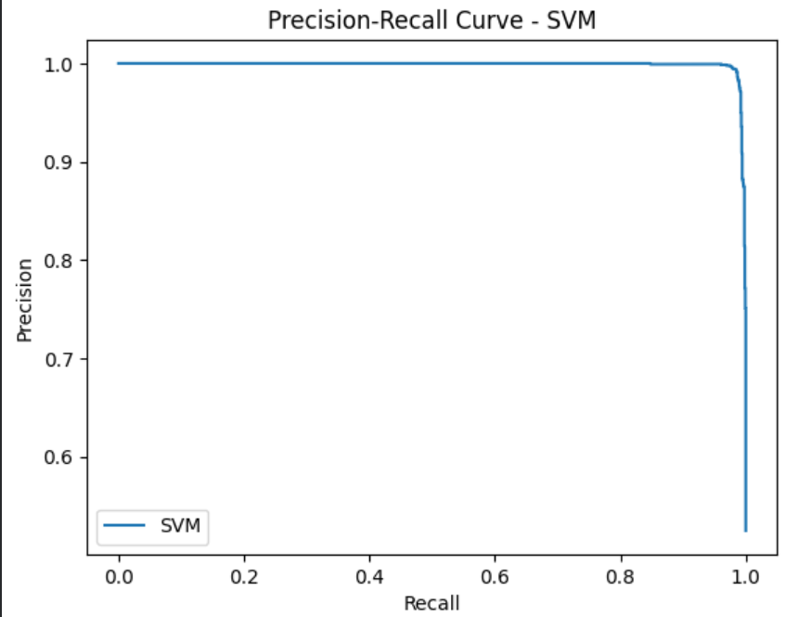
Fig. 4. (c) Precision-Recall Curve for SVM

KNN: K-Nearest Neighbors is a distance-based, non-parametric classification algorithm that assigns labels based on the majority class among nearest data points.
Figure 5(a) shows the confusion matrix for KNN, which indicates relatively lower accuracy than other models. The ROC curve and Precision Recall curve(Figure 5(b) and Figure 5(c)) indicate the decreased discriminative power because of noise sensitivity and high dimensionality.
KNN is not as appropriate for text classification using TF-IDF, since the concept of distance becomes less relevant in high-dimensional spaces, especially when they are sparse.

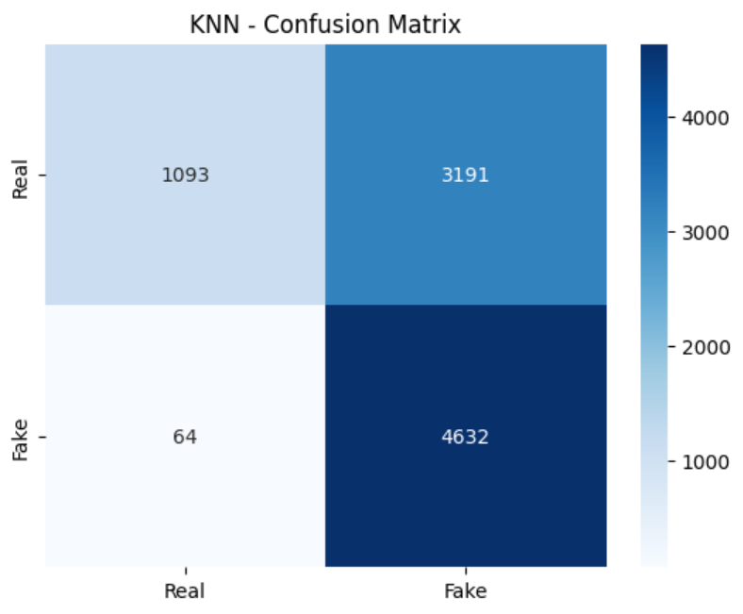
- (a) Confusion Matrix for KNN

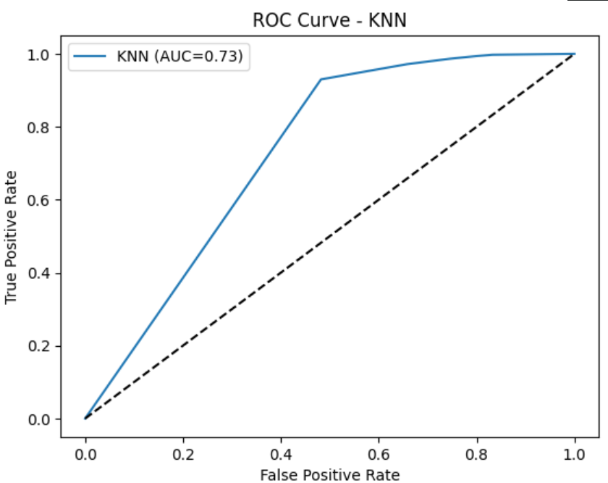
Fig. 5. (b) ROC Curve for KNN

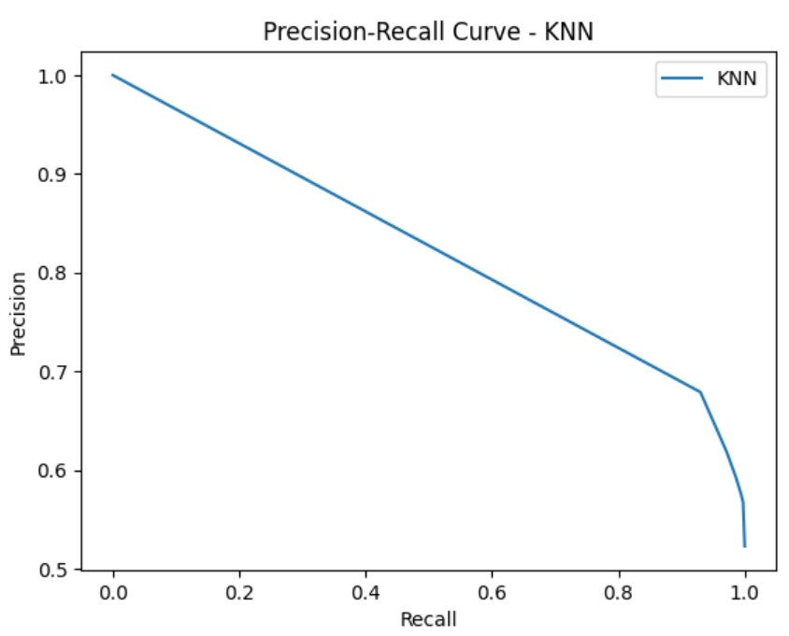
Fig. 4. (b) Precision-Recall Curve for KNN

Naïve Bayes: Multinomial Naive Bayes is a probabilistic classifier that uses Bayes’ theorem and the concept of conditional independence between features. This classifier is computationally efficient and is often used as a baseline classifier for text classification problems.

The confusion matrix for Multinomial Naive Bayes is depicted in Figure 6(a).It can be observed that there are more cases of both false positives and false negatives than in Logistic Regression, which indicates that the classification accuracy is relatively lower. The ROC curve for Multinomial Naive Bayes, as shown in Figure 6(b), shows high discriminative capabilities, although the AUC value is lower compared to Logistic Regression. The Precision-Recall Curve in Figure 6(c) shows a substantial decrease in precision as the recall level is increased.
This shows that while the model is able to identify most of the instances of fake news, it does so at the cost of having a higher number of false positives.
Despite being a simple model, Multinomial Naive Bayes is a good baseline classifier with a fast-training time.

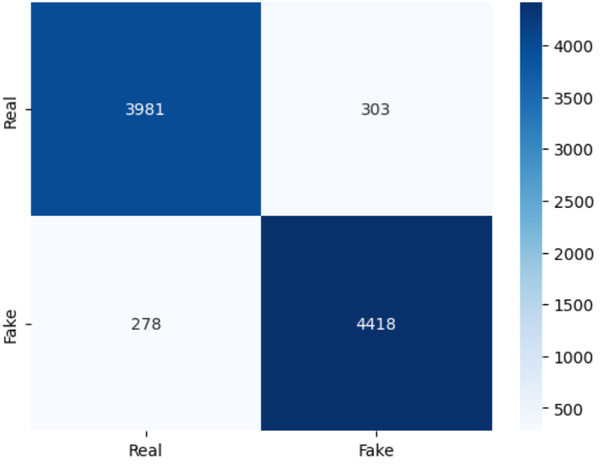
- (a) Confusion Matrix for Naïve Bayes
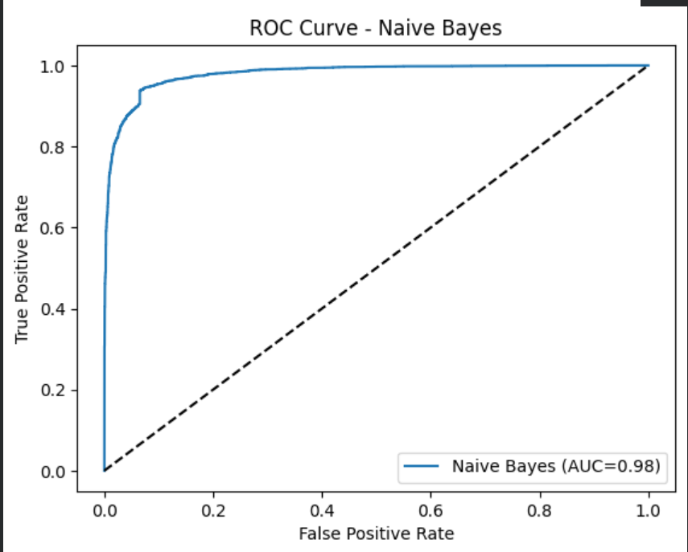
Fig. 6. (b) ROC Curve for Naïve Bayes

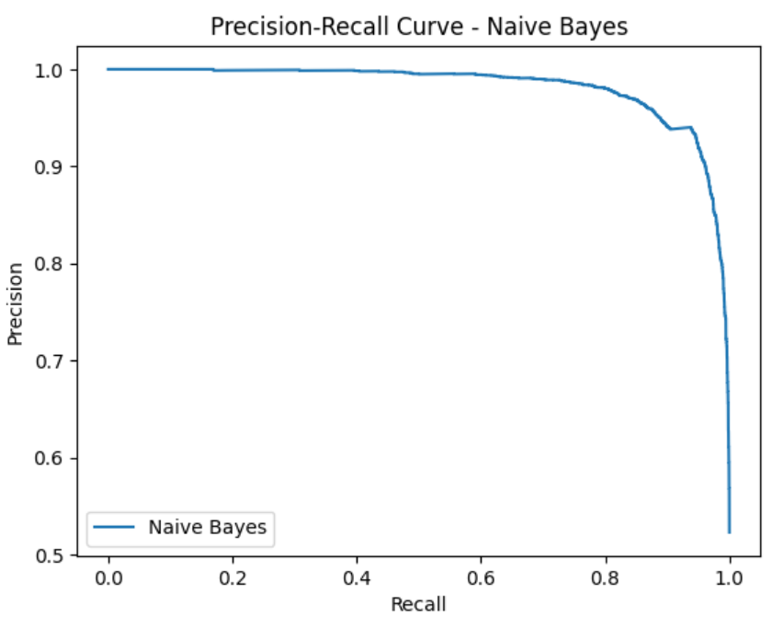
Fig. 6. (c) Precision-Recall Curve for Naïve Bayes

XGBOOST: Extreme Gradient Boosting (XGBoost) is a powerful ensemble model that builds boosted decision trees sequentially. It is capable of capturing complex non-linear patterns in data
Figure 7(a) illustrates near-perfect results for classification in the XGBoost algorithm. But results this accurate may point towards overfitting, particularly in smaller datasets. The ROC Curve and Precision-Recall Curve (Figure 7(b) and Figure 7(c)) also illustrate near-perfect classification, which should be treated with caution.
Although XGBoost has a strong predictive capability, it may not generalize well if there is not enough data and if regularization is not done properly.

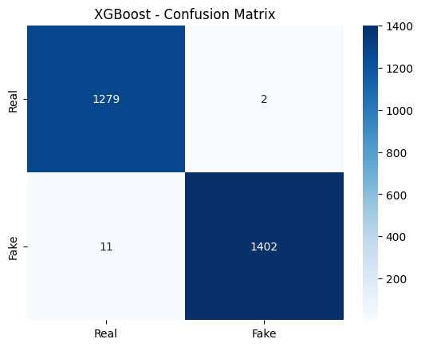
- (a) Confusion Matrix for XGBOOST

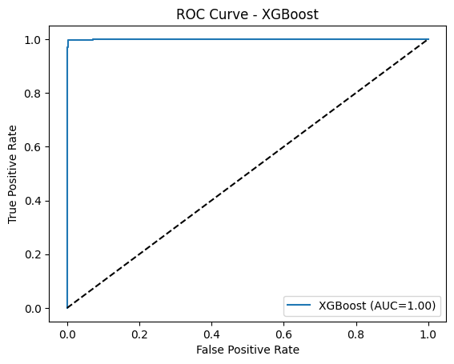
Fig. 7. (b) ROC Curve for Naïve Bayes
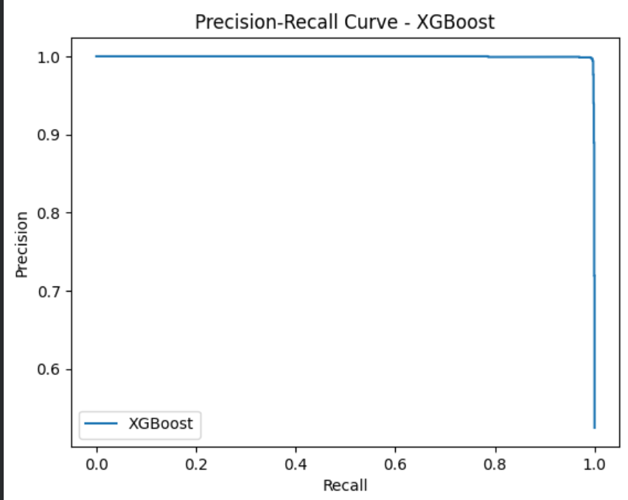
Fig. 7. (c) Precision-Recall Curve for XGBOOST
The visualization results indicate that XGBoost exhibits strong class separation, with high precision and recall values as observed in Figure 7(c)). However, given the reduced training dataset used for XGBoost, these results should be interpreted with caution. Logistic Regression demonstrates consistently strong and stable performance across confusion matrix, ROC, and precision-recall analyses, suggesting better generalization under uniform training conditions. These visualizations provide intuitive confirmation of the numerical performance shown in TABLE I. and TABLE II.

Model Performance
The comparative performance of all classification models is summarized in TABLE I. , reporting accuracy, precision, recall, and F1-score on the test dataset.
- Classification Metrics for Each Model
Model | Accuracy | Precision | Recall | F1-score
Naïve Bayes | 96.3% | 93.58% | 94.08% | 0.96
Logistics Regression | 97.8% | 99.30% | 99.36% | 0.978
K-Nearest Neighbors | 95.6% | 59.21% | 98.64% | 0.956
Support Vector Machine | 98.4% | 99.15% | 98.58% | 0.984
Random Forest | 99.0% | 95.59% | 96.74% | 0.990
XGBoost | 99.52% | 99.86% | 99.22% | 0.9954

XGBoost had the best performance metrics among the models tested. However, it should be noted that XGBoost was trained on a limited data set because of the computational constraints. This could be a reason for the optimistic performance metrics.Random Forest was also a competitive model, ranking just behind XGBoost. More simple models like KNN and Naïve Bayes were relatively less accurate, likely due to their limited capacity to model complex feature interactions. Overall, our results are in line with the literature: ensemble and boosting methods often result in state-of-the-art performance in text classification.

Sentiment Interpretation
To provide interpretability, VADER sentiment scores were calculated post-classification. TABLE II. summarizes the sentiment polarity of fake and real news articles across different models:

- Average Sentiment Scores for Fake and Real news Prediction
Model | Sentiment (Fake) | Sentiment (True)
Naïve Bayes | -0.0954 | +0.0612
Logistics Regression | -0.0943 | +0.0591
K-Nearest Neighbors | -0.0315 | +0.0486
Support Vector Machine | -0.1026 | +0.0827
Random Forest | -0.0846 | +0.0660
XGBoost | -0.0959 | +0.0753

All the models show that the predicted fake news articles tend to have more negative sentiment, while real news is positive. This trend also is supported in prior research where deceptive content tends to use emotionally negative language. The consistency across the models lends validity to the use of sentiment as a post-hoc interpretability tool.

Conclusion
This study combined a literature survey with new experiments to contribute to the field of fake news detection. First, we reviewed more than 50 recent works from 2023 to 2025 and identified some key trends: classical ML versus deep learning, where performance is dominated by transformers such as BERT; the use of sentiment and emotion features, where negative sentiment is a hallmark of fake content; growing interest in multimodal/multilingual approaches that handle images, video, and diverse languages; and the incorporation of explainable AI methods such as LIME/SHAP for unpacking model decisions. In our experiments, ensemble models like XGBoost and Random Forest performed well in terms of predictive capability. XGBoost had the best accuracy of 99.52% in this experiment, but it was trained on a smaller dataset because of computational constraints, which could lead to overfitting. On the other hand, Logistic Regression had excellent performance on all fronts and on the entire dataset, which makes it more robust and generally better. Therefore, the findings of this experiment indicate that although XGBoost is a very effective classifier, linear models like Logistic Regression may be more dependable in the context of fake news detection. Crucially, our post-hoc sentiment analysis revealed that the fake news samples were markedly more negative in tone than real news, furnishing the prediction with an interpretable dimension. We hereby confirm the idea that sentiment analysis can enrich detection systems: its result aligns with findings that authors of fake news exploit negativity.

In practice, deploying sentiment-aware detectors could flag potentially deceptive content for human review. Future work should expand this approach by fusing more modes (e.g., image verification) and multilingual evidence. Furthermore, applying advanced XAI methods like SHAP/LIME may further explain individual predictions with the goal of improving user trust. As mentioned in one of these studies, requirements such as multilingual support and explainability are very important for future fake-news systems. Combining high-performance classifiers with sentiment interpretability paves the way toward more transparent and effective solutions to the fake news problem.

References

- S. Aphiwongsophon and P. Chongstitvatana, “Identify misinformation on Twitter with machine learning,”, Engineering and Applied Science Research, vol. 47, no. 3, pp. 306–312, 2020.
- R. Singh, A. Kumar, and M. Verma, “Fake news detection using ensemble machine learning techniques,” Procedia Computer Science, vol. 167, pp. 1626-1634, 2020.
- Pardamean, B., & Pardede, F. (2021). Fake News Detection Using BERT. Intel Int J Comp Sci, (Kaggle news dataset)
- Mouratidis, D. et al. (2023). Comparative Study of BERT and Classical Classifiers for Fake News Detection. Journal of AI Research, (Multiple datasets)
- Tan, X., & Bakir, A. (2022). Deepfake Detection using Transformers and Weighted Embeddings. Proceedings of TruthSeeker (TruthSeeker dataset)
- Kaliyar, R. K., Goswami, A., & Narang, P. (2021). FakeBERT: Fake news detection in social media with a BERT-based deep learning approach. Multimedia Tools and Applications, 80(8), 11765–11788
- X.Zhou and R. Zafarani, “A survey of fake news: Fundamental theories, detection methods, and opportunities,” ACM Computing Surveys, vol. 53, no. 5, Art. no. 109, pp. 1–40, 2020, doi: 10.1145/3395046.
- Alonso, M. A., Vilares, D., Gómez-Rodríguez, C., & Vilares, J. (2021). Sentiment Analysis for Fake News Detection. Electronics, 10(11), 1348
- L. Cui, S. Wang, and Y. Zhang, “Sentiment-enhanced fake news detection,” in Proc. IEEE Int. Conf. on Big Data (Big Data), pp. 1–8, 2019.
- Dementieva, D., & Panchenko, A. (2021). Cross-lingual Evidence Improves Monolingual Fake News Detection. Proc. ACL-IJCNLP 2021: Student Research Workshop, 310–320
- Farhoudinia, B., Ozturkcan, S., & Vilares, J. (2025). Emotions unveiled: detecting COVID-19 fake news on social media. Humanities and Social Sciences Communications, 11, 03083
- C. J. Hutto and E. Gilbert, “VADER: A parsimonious rule-based model for sentiment analysis of social media text,” in Proc. Int. AAAI Conf. Web and Social Media (ICWSM), Ann Arbor, MI, USA, 2014, pp. 216–225.
- A. Vaswani, N. Shazeer, N. Parmar, J. Uszkoreit, L. Jones, A. N. Gomez, Ł. Kaiser, and I. Polosukhin, “Attention is all you need,” Advances in Neural Information Processing Systems (NeurIPS), vol. 30, pp. 5998–6008, 2017.
- L. Shen, Y. Long, X. Cai, I. Razzak, and G. Chen, “GAMED: Knowledge-adaptive multi-experts decoupling for multimodal fake news detection,” in Proc. ACM Int. Conf. on Multimedia (MM), pp. 1–10, 2022.
- J. Lv, Y. Gao, and L. Li, “Multi-modal fake news detection: A comprehensive survey,” Journal of King Saud University – Computer and Information Sciences, vol. 37, pp. 306–325, 2025.
- Wang, X., Zhang, W., & Rajtmajer, S. (2024). Monolingual and Multilingual Misinformation Detection for Low-Resource Languages: A Comprehensive Survey. arXiv:2410.18390
- Dua, V., Rajpal, A., Rajpal, S., Agarwal, M., & Kumar, N. (2023). I-FLASH: Interpretable Fake News Detector Using LIME and SHAP. Wireless Personal Communications, 131, 2841–2874
- Alshuwaier, F. A., & Alsulaiman, F. A. (2025). Fake News Detection Using Machine Learning and Deep Learning Algorithms: A Comprehensive Review and Future Perspectives. Computers, 14(9), 394
- Lv, J., Gao, Y., Li, L., Shi, L., & Li, S. (2025). Multi-modal fake news detection: A comprehensive survey. Journal of King Saud University – Computer and Information Sciences, 37, 306
- T. Chen and C. Guestrin, “XGBoost: A scalable tree boosting system,” in Proc. 22nd ACM SIGKDD Int. Conf. Knowledge Discovery and Data Mining (KDD), San Francisco, CA, USA, 2016, pp. 785–794, doi: 10.1145/2939672.2939785.

