**Name: Mai Gia Minh**

**ID: 521H0102**

**QT1_SE_HomeWork**

**1. Ask question to make a clear for above requirements and write them in the form of Excel (Q&A)**

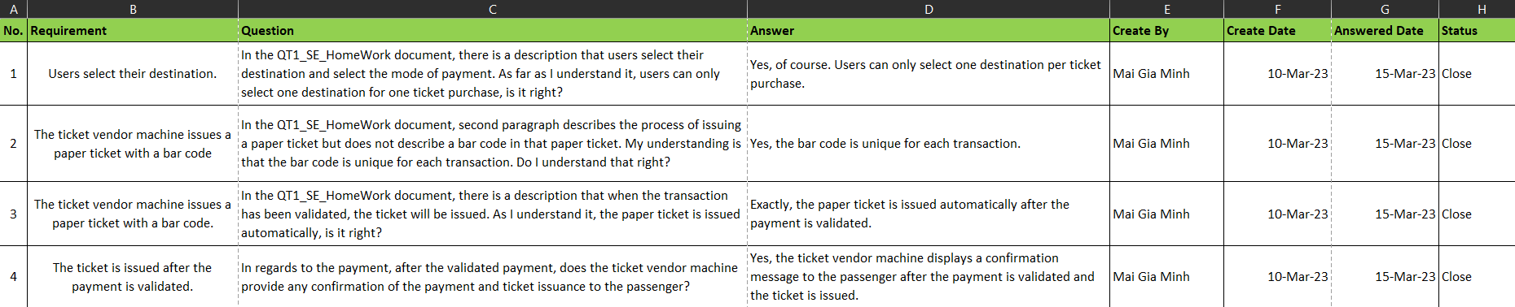

**Q:** In the QT1_SE_HomeWork document, there is a description that users select their destination and select the mode of payment. As far as I understand it, users can only select one destination for one ticket purchase, is it right?

**A:** Yes, of course. Users can only select one destination per ticket purchase.

**Q:** In the QT1_SE_HomeWork document, second paragraph describes the process of issuing a paper ticket but does not describe a bar code in that paper ticket. My understanding is that the bar code is unique for each transaction. Do I understand that right?

**A:** Yes, the bar code is unique for each transaction.

**Q:** In the QT1_SE_HomeWork document, there is a description that when the transaction has been validated, the ticket will be issued. As I understand it, the paper ticket is issued automatically, is it right?

**A:** Exactly, the paper ticket is issued automatically after the payment is validated.

**Q:** In regards to the payment, after the validated payment, does the ticket vendor machine provide any confirmation of the payment and ticket issuance to the passenger?

**A:** Yes, the ticket vendor machine displays a confirmation message to the passenger after the payment is validated and the ticket is issued.

**2. Write a set of functional, non-functional and domain requirements for a Ticket Vendor Machine. You can conduct this exercise to Excel or Word. Remember to concentrate on expectations of reliability and response time.**

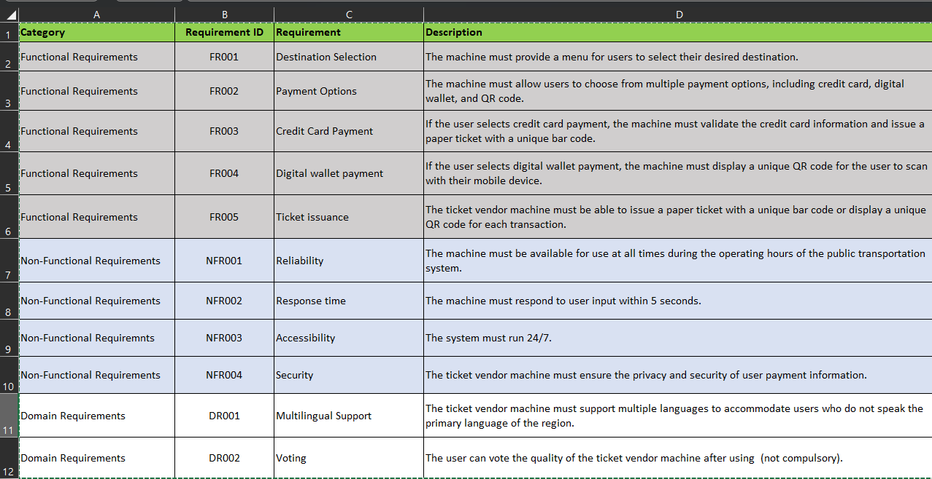

**Functional Requirements:**

* The machine must provide a menu for users to select their desired destination.
* The machine must allow users to choose from multiple payment options, including credit card, digital wallet, and QR code.
* If the user selects credit card payment, the machine must validate the credit card information and issue a paper ticket with a unique bar code.
* If the user selects digital wallet payment, the machine must display a unique QR code for the user to scan with their mobile device.
* The ticket vendor machine must be able to issue a paper ticket with a unique bar code or display a unique QR code for each transaction.

**Non-Functional Requirements:**

* The machine must be available for use at all times during the operating hours of the public transportation system.
* The machine must respond to user input within 5 seconds.
* The system must run 24/7.
* The ticket vendor machine must ensure the privacy and security of user payment information.

**Domain Requirements:**

* The ticket vendor machine must support multiple languages to accommodate users who do not speak the primary language of the region.
* The user can vote the quality of the ticket vendor machine after using (not compulsory).

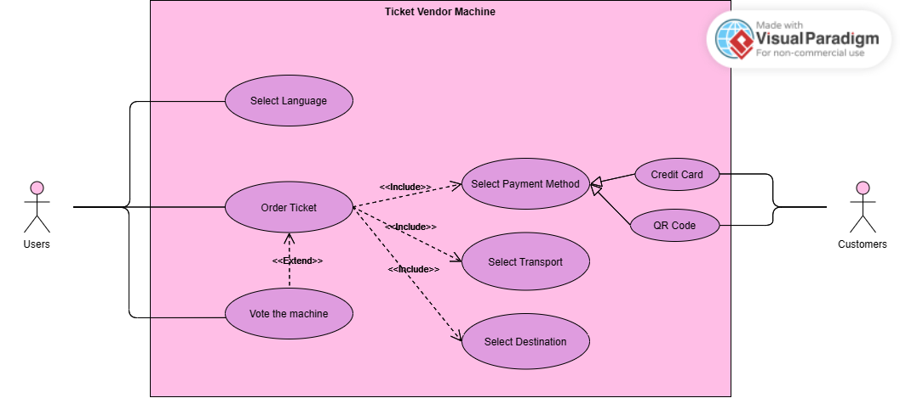**3. Develop Use Case modelling for Ticket Vendor Machine, you are also encouraged to make Use Case Description for each use case on your use case diagram.**

Use Case Diagram

**4. Make an Activity diagram to present the process of passenger’s buying a ticket from ticket vendor machine (Look like ATM) and the activity diagram for communication among systems if your system is integrated with other system like Momo, VNPay, ZaloPay,...etc**

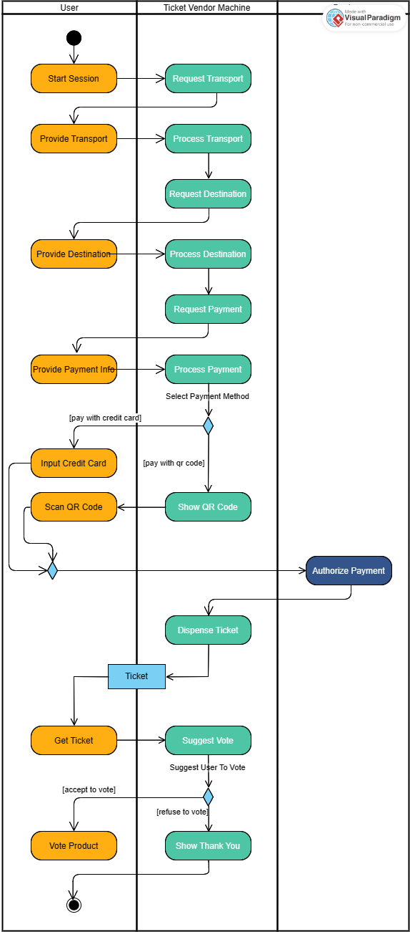

Activity Diagram

**5. Let’s say that the Ticketing Vendor Machine have main use case: Buy a ticket then you are required to complete the sequence diagram, State chart diagram, and Class diagram.**

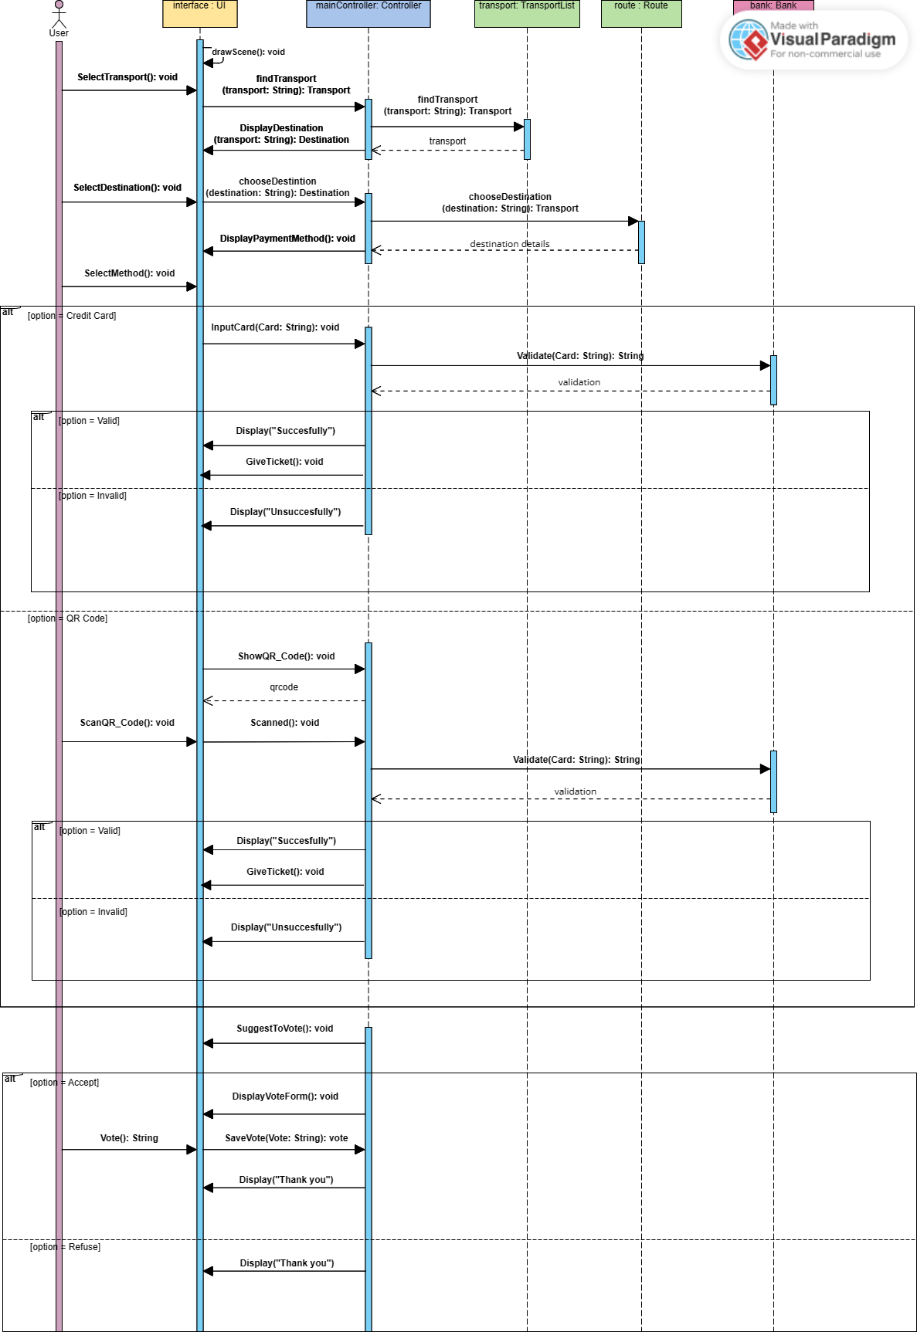 Sequence Diagram

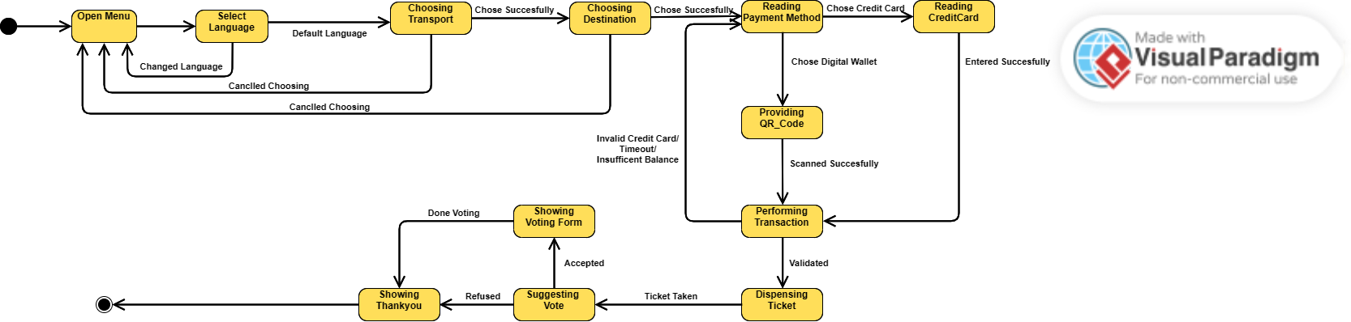

State Diagram

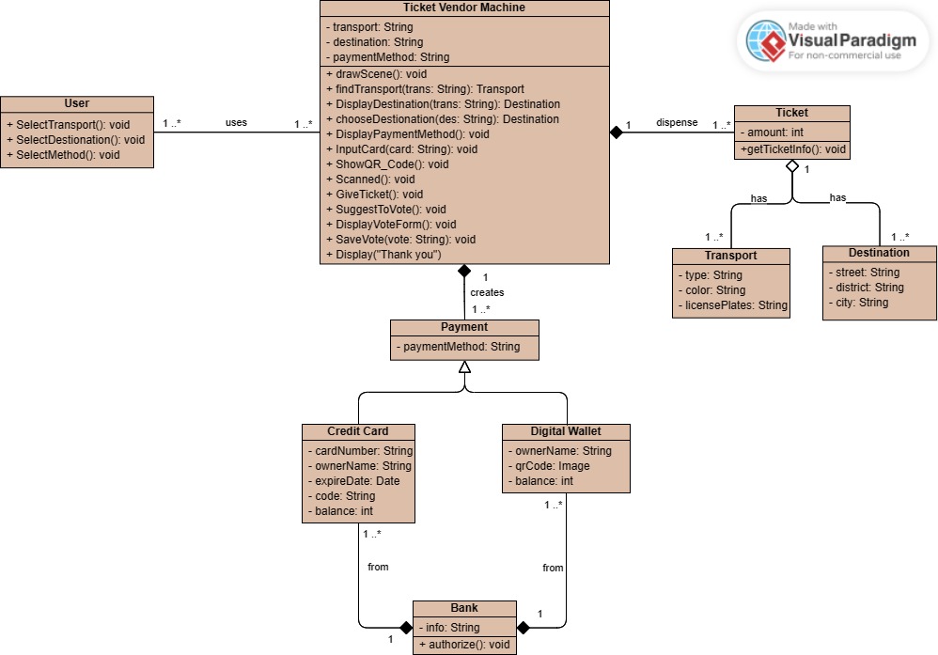

Class Diagram

**6. Design an either wireframe/mockup with balsamiq or prototype with figma for your use cases.**

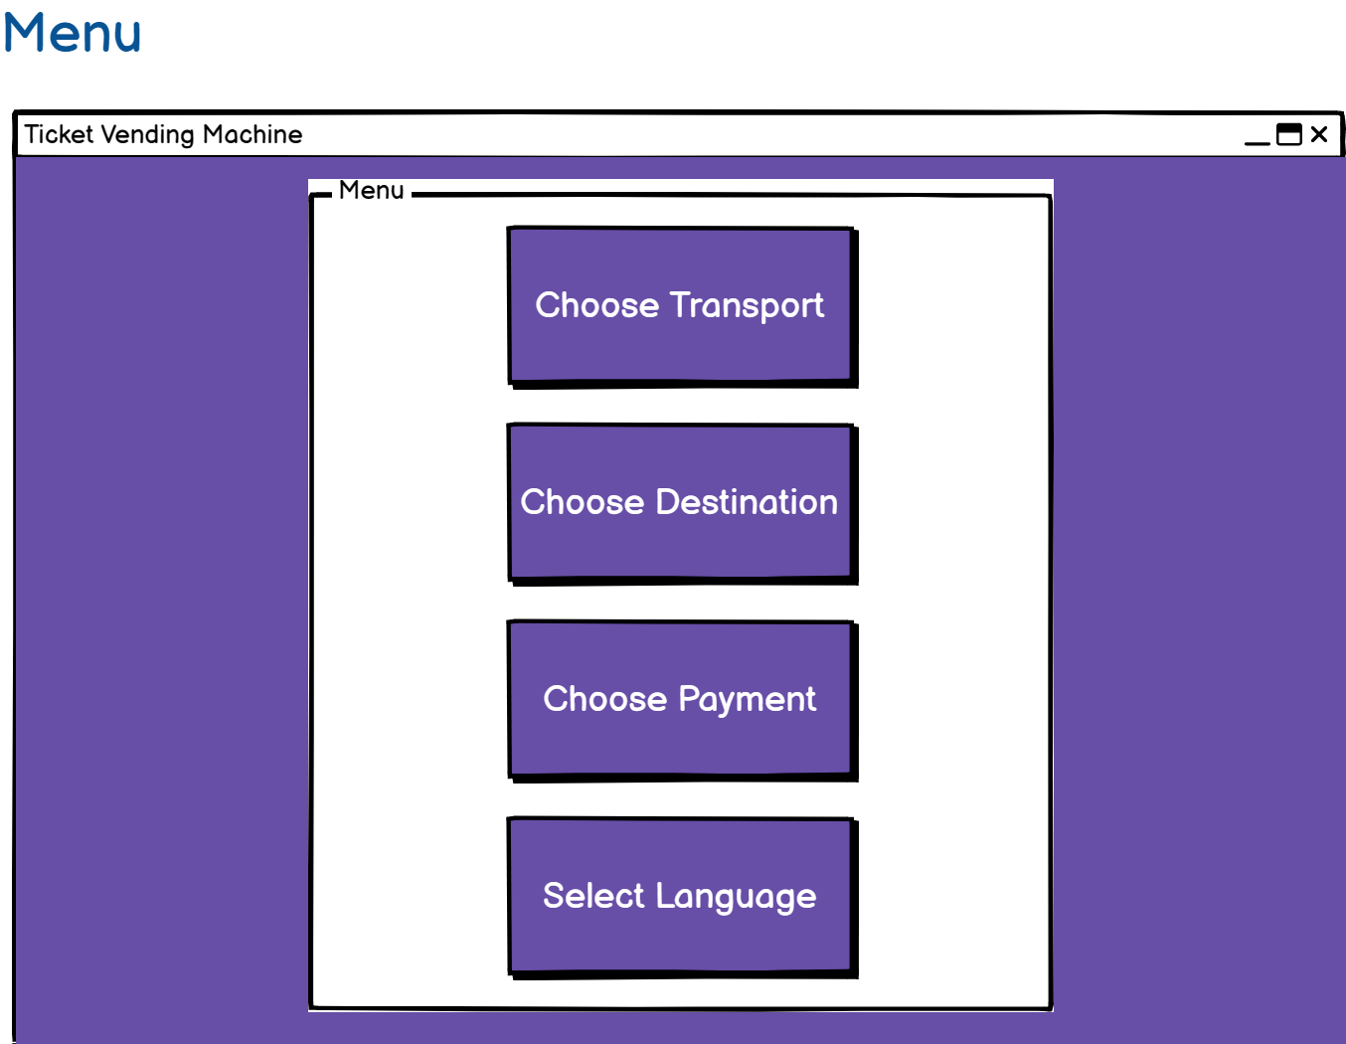

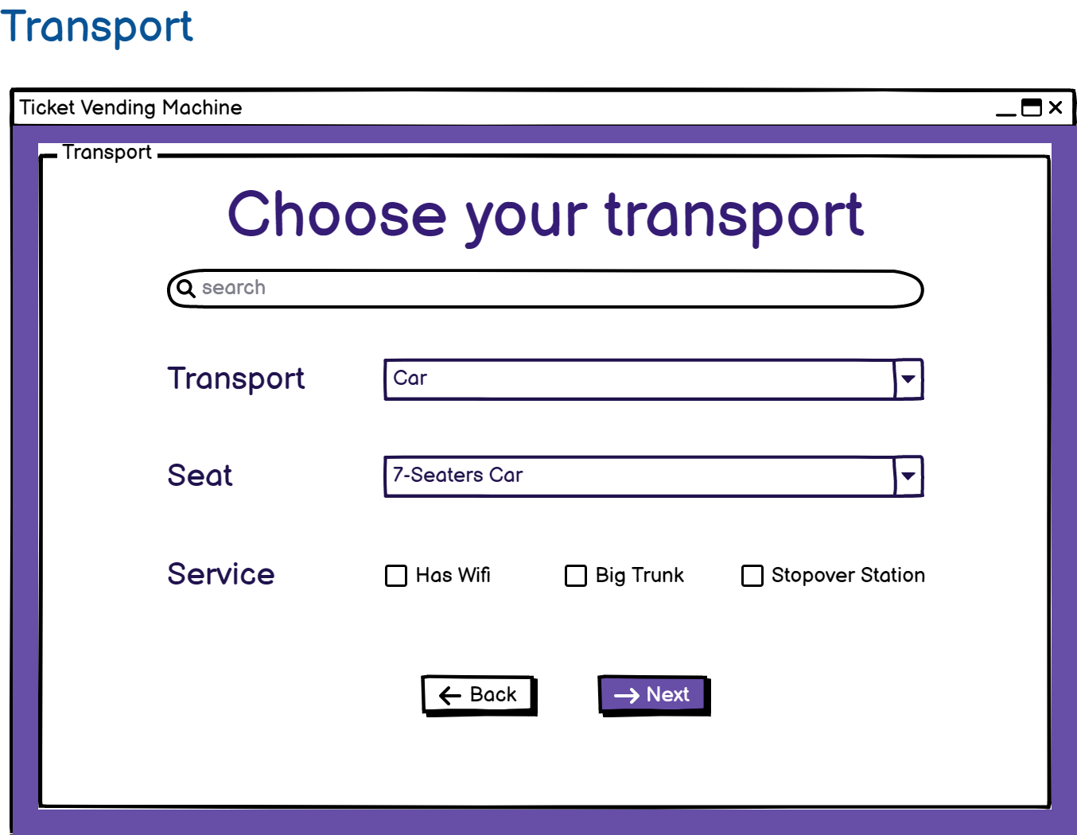

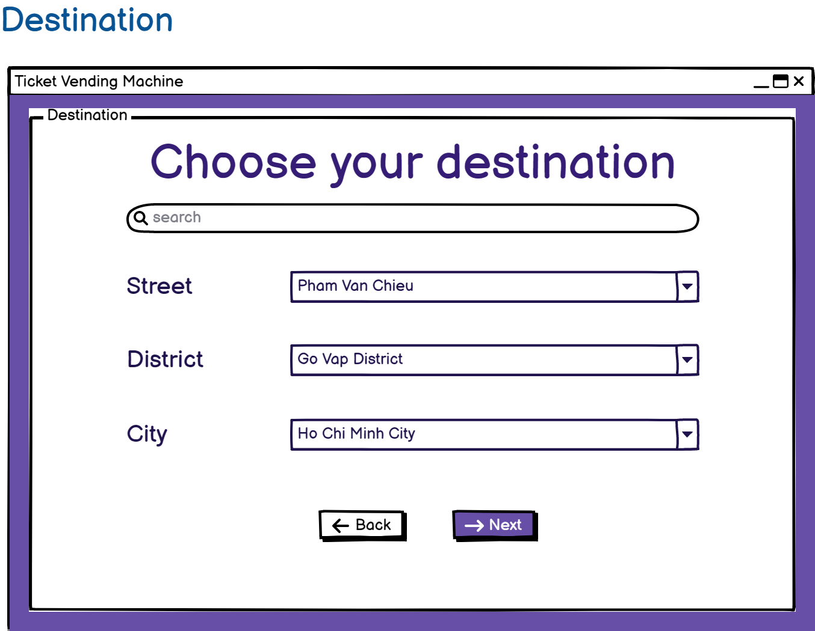

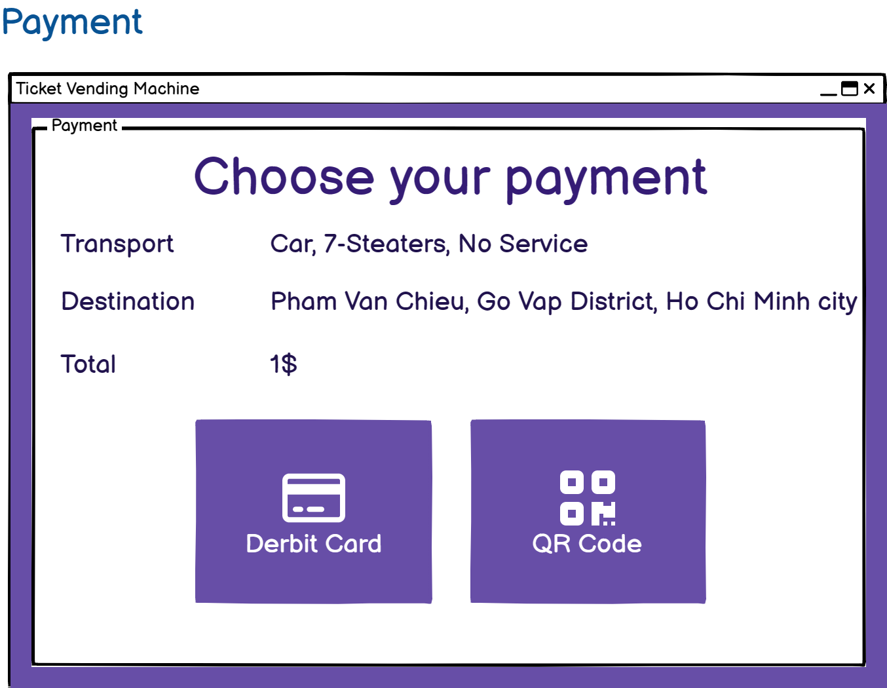

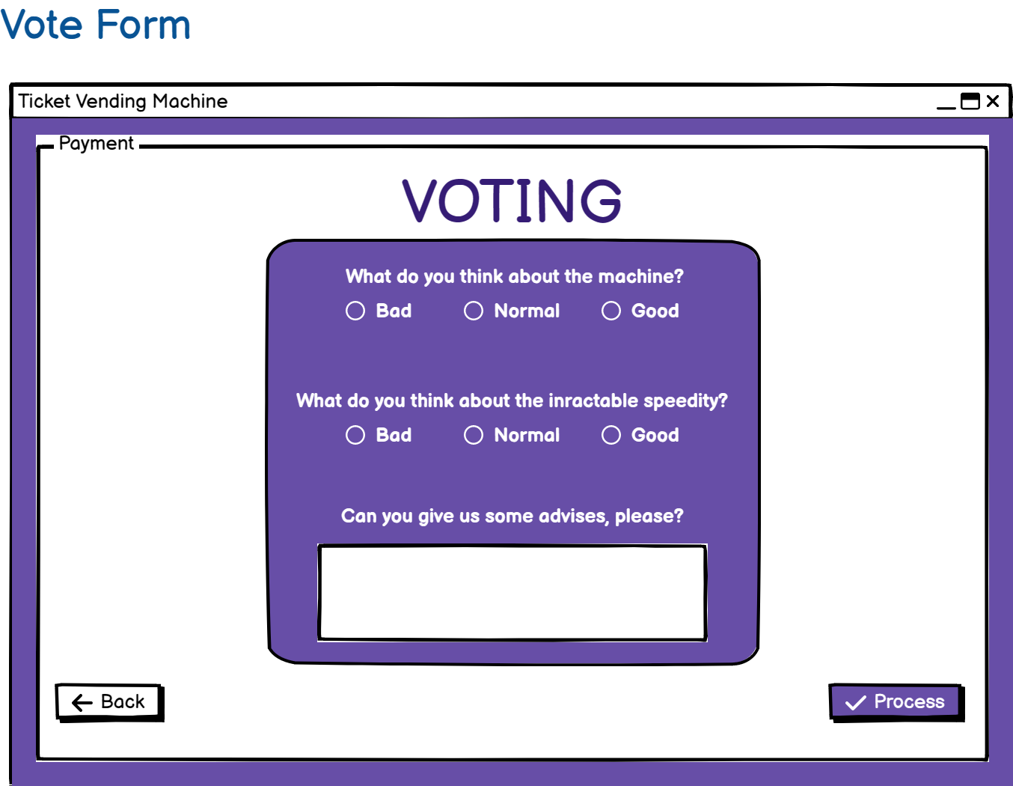

**8. Demo**

