**Pouring Vinegar as homemade Cleaning Agent**

**Introduction**

Vinegar is a weak acid usually made by fermenting Sugar Canes or Rice. It can be used as a food condiment. Because of its inherent acidity, it can soften up egg shells to the point it will turn soft and rippable. One common household Cleaning agent is Muriatic Acid which is used to clean and remove limestones from floor tiles or walls. We intend to know if the acidity of vinegar is sufficient enough to remove limestones from floors at a cheaper cost.

**Materials**

**Hypothesis**

Vinegar is a better cleaning agent than water, but is worse than muriatic acid. This is because vinegar is a weaker acid, and thus kills less bacteria than muriatic acid, which is a diluted form of hydrochloric acid.

**Experimental Procedure**

Find an area in your house that you would like to do the said experiment. In this said experiment, we chose to apply vinegar in the bathroom.

* Toilet
* Pour a cup of vinegar in the bowl. Let it sit overnight.
* The next morning, sprinkle with baking soda or borax; scrub, then flush.
* Tub or Sink
* Pour 1/2-cup distilled white vinegar around closed drain and let sit several hours.
* Scrub to remove buildup.
* Drain, then rinse.
* Showerhead
* Pour some white vinegar into a plastic bag, and secure it to your showerhead with a twist-tie.
* Make sure there's enough vinegar so the bottom part of the showerhead is submerged.
* Leave the bag on overnight. Remove the next morning just before showering.
* Tile Surfaces
* Mix 1/2-cup white distilled vinegar with a gallon of warm water.
* Mop floors or scrub countertops with the solution and allow to air dry.

**Data and Results (Table)**

|  |
| --- |
| **Stain Removal Data** |

|  |  |  |  |  |
| --- | --- | --- | --- | --- |
| **Cleaning Agent** | **Highly Effective (stain is gone)** | **Moderately Effective (stain almost gone)** | **Slightly Effective (some of the stain is gone)** | **Ineffective (stain is unaffected)** |
| Water |  |  | x |  |
| Vinegar |  | x |  |  |
| Muriatic Acid | x |  |  |  |

According to the data, vinegar is more effective as a cleaning agent than water but is less effective than muriatic acid.

**Data and Results (Graph)**

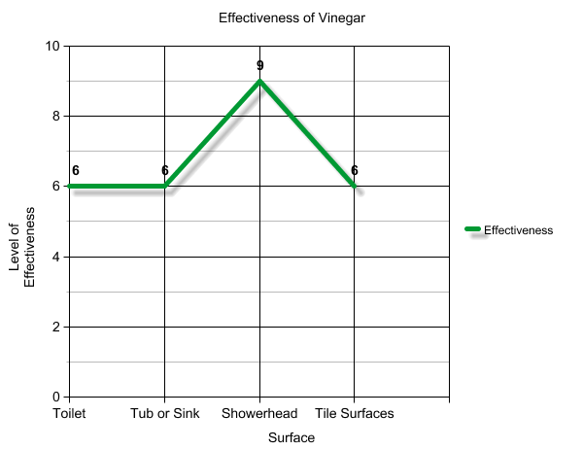

In this graph, we can see that most of the stains on the showhead were mostly removed because of the vinegar, which means that the vinegar actually worked. Compared to other surfaces which removed some of the stains but not like the case of the showerhead. For the cases of the tub, tiles and toilet, most of the dirt were removed but there were some stains left behind.

**Data and Results (Chart)**

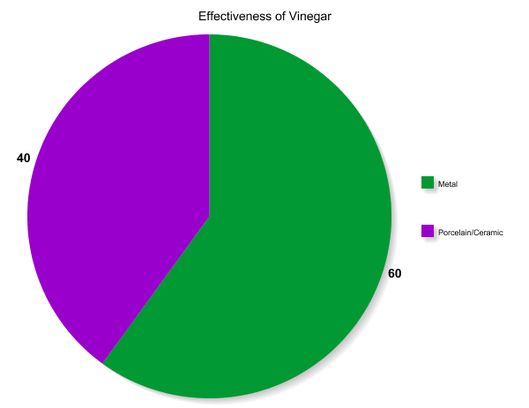

After performing different trials of cleaning process with common household objects, floors, surfaces, etc. The data shows us that the vinegar was most effective on the metal showerhead and not so effective on the ceramic tub, the toilet and the tile floor. From this, we can conclude that vinegar is very effective on metal surfaces even though it doesn’t remove the rust while it does remove the dirt from ceramic surfaces, the stains still remain.

**Observation**

Toilet

It is evident that the vinegar is an effective cleaning agent in the toilet. It is noticeable that the stain in the toilet before is not that much. This might be a factor that proves that the vinegar has worked well in this situation. If the stain was many, muriatic acid might be a better cleaning agent than the vinegar.

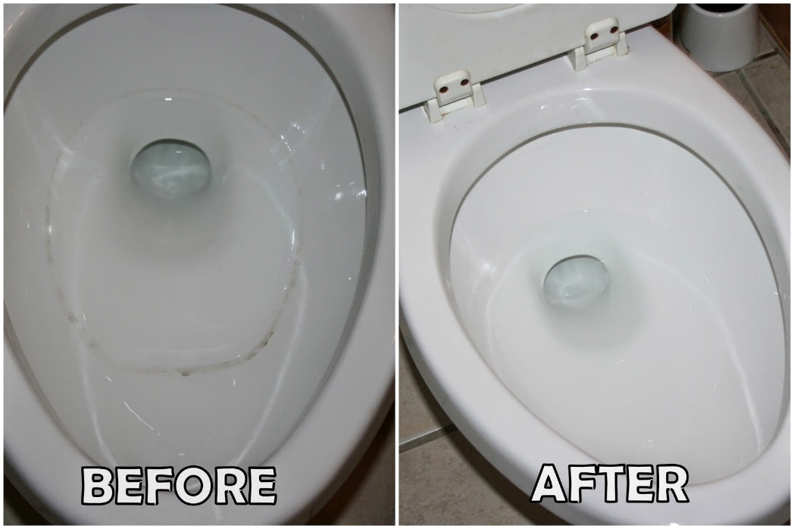

Tub or Sink

The vinegar is also effective in cleaning stains in a tub. The result shows that the vinegar indeed have cleaned majority of the stains, but it still left a yellowish stain in the tub. Muriatic acid would have cleaned all the stains with no remaining spots. But overall, vinegar as a cleaning agent for tubs still produced satisfactory results.

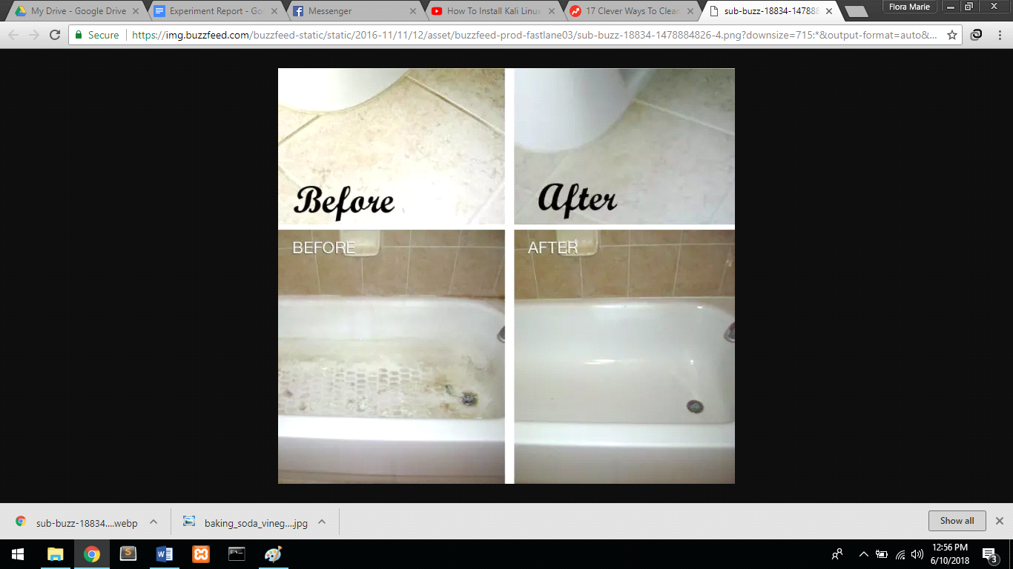

Showerhead

It is also clearly seen that the vinegar has removed most of the dirt in the showerhead. It has successfully got rid of the yellow stains. Although it’s seen that the rust was not removed by the vinegar, this situation is understandable since rust requires a much more improved process of cleaning.

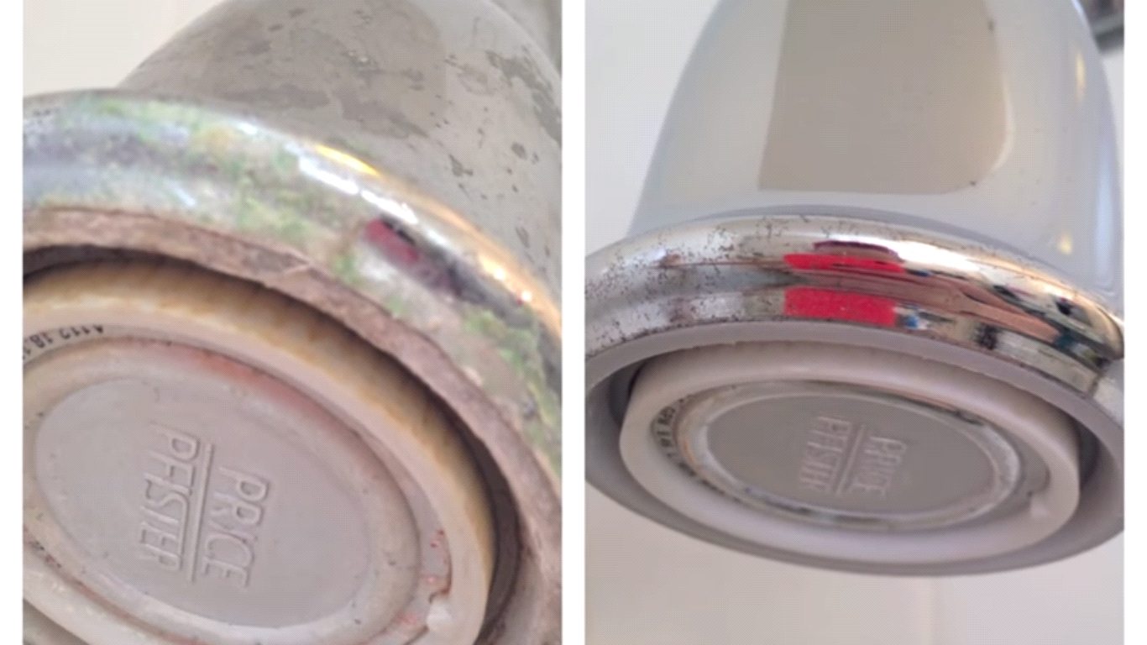

Tile Surfaces

Vinegar was also successful in getting rid of dirt in tile surfaces. It works almost similar as the muriatic acid’s effectiveness. The difference is that, there are still little stains left in the tile itself after the cleaning process. Muriatic acid would be a powerful agent in cleaning such leftover stains. But overall, vinegar still works.



**Conclusion**

Therefore, vinegar is indeed an effective cleaning agent in the household. In terms of cleaning process, it is more effective than water but its effectiveness is lesser compared to that of muriatic acid. The power of an acid is ranked by chemists by its pH level. Both vinegar and muriatic acid are acids with different types of concentration. Vinegar is a solution of acetic acid and its pH level is 6. Muriatic acid is a solution of hydrochloric acid and its pH level is 14, the strongest acid in the chart. This concludes that indeed, muriatic acid is much better compared to vinegar. But despite vinegar being a mild acid, vinegar still works as a cleaning agent and can give satisfactory results.

**References:**

* https://student.unsw.edu.au/simple-lab-report
* <https://writing.wisc.edu/Handbook/LabBact.html>
* <http://homepage.smc.edu/gallogly_ethan/sample_lab_reports.htm>
* http://www.plasmaspider.com/viewtopic.php?t=10510
* http://www.abc.net.au/news/health/2018-01-12/does-vinegar-really-kill-household-germs/8806878
* archive.reefcentral.com/forums/showthread.php?t=1249619
* <https://sciencing.com/penny-cleaning-experiments-fifthgrade-science-fair-10036748.html>
* <https://www.scientificamerican.com/article/bring-science-home-cabbage-chemistry/>
* <https://www.bhg.com/homekeeping/house-cleaning/tips/cleaning-with-vinegar/>
* <https://www.thekitchn.com/what-is-vinegar-and-what-makes-it-a-good-cleaner-236459>
* <https://indianapublicmedia.org/amomentofscience/vinegar/>
* https://keeperofthehome.org/vinegar-myth-vinegar-great-natural-cleaner/