Finite State Machine
Student’s Name
Institutional Affiliation
Date

Table of contents

1.0 Table of contents 2
2.0 Introduction 3
3.0 Background and Literature Review 3
4.0 Method 5
5.0 Discussion 6
6.0 Conclusion 9
References 10

Introduction
The finite state machine (FSM) is designed under the principle of circuit output which acts as the systems states. The states are set in a state register to hold the state of the machine, and the next set state logic to decode the next stage. An output register is put in place to define the output of the machine. The FSM together with the Visual Automata Simulator was based on the automata theory to improve the efficiency of automated tools (Dash & Nayak, 2012). In FSM, states tend to react to signals which are triggered by inputs from the external world. An FSM is defined by the numerical operations that enable its evaluation to produce an output. Such variables include (Σ, S, s₀, δ, F), where Σ is the input alphabet, S the non-empty set of states, s₀ the transitional state function, δ a set of final state, while F and O are set of final states on the set of possible outputs respectively. This variable help in understanding the state and transition period of a state.

Vending machines incorporate the FSM principle to automate conventional purchasing methods. The auto billing features in Vending Machines enables FSM to place a transaction in motion and also reverse it (Ding et al., 2018). The FSM can support a cancel button that automates return of the requested item and returns the money to the user.

Background and Literature Review
A Finite State Machine is a reactive system whose response to a particular signal, or input is different in every occasion depending on its current state. The machine states are controlled through the transition from state to state. Its suitable in building different system software that verifies the preciseness of protocols or circuits and the analysis component of a compiler. Its purpose in the systems is to assist in the control unit, a principle which is applied in many physical systems that include automated traffic signals, elevators and the Vending Machine(VM) (Verma et al., 2016). The FSM can be divided into two types; Mealy and Moore state machines. The Moore machine is also known as Asynchronous FSM, which uses only entry actions, and the output of the system depends on the current state.
The following is an example of an FSM.
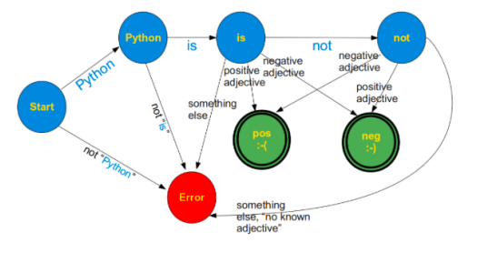
In daily operations, FSM is incorporated in Vending Machines, Traffic Lights, Cash Registers and Microwave. The above devices operate by reacting to inputs which are sent from the external world. Finite State Machine has a class that keeps track of the current states, and the titles of all valid state transitions (Hopcroft, 2008). One defines the states transitions by specifying “From State,” “To State,” “condition” and a “callback” state. A case of state transition employs the current systems state to optimize the next state system transition.

Recent research indicate that FSM level of application surpasses the regular delivery system and its virtual operation in machines helps in applying its knowledge through compiler design, artificial intelligence, and other computational theory fields. Occasionally, FSM has been fully incorporated into vending machines because of the effective ability to accurately complete a transaction after an input state has been signaled. FSM are of two types, deterministic and nondeterministic finite automata. Comparison in the two machines lies in their transitions, where deterministic finite automata ensure a must in exactly one transition function for every input symbol in Σ from each state (Quresh et al., 2011). While nondeterministic finite automata do not require transition functions for every symbol in Σ, additionally, there can be multiple transition functions in the same state symbol for the same symbol. Also, nondeterministic finite automata can utilize a null transition indicated as є. The exploited null transition can jump from one state to an alternative state devoid of reading a symbol in the states. A limitation related to the FSM is that they can recognize regular languages (Holub & Steke, 2009). This is because natural languages compose a small finite portion of all possible languages to be used by the system.

Method
Application software requires a design plan to create a formal design. In many design planning, developers consider the application of design patterns to help improve the code quality and also the software quality (Quresh et al., 2011). A common approach is the application of a Finite state machine (FSM) as a design pattern. In its application, the FSM is applicable in various stages of the software project, from the initial overall concept to the coding phase, which is considered the lowest. Some software that borrow the idea of FSM are majorly categorized as having distinct modes or being control intensive (Zhang Wen & Zhang Xin, 2010). This is because they contain a complex logic structure which results in a huge relative figure of control blocks, such as conditional statements and case structures. Some of the real-time systems FSM embedded include command interpreters, device handlers, language processors and multitasking executives. Though the FSM pattern may be appropriate to user-oriented systems such as accounting software’s, it might not be best for designing computational and algorithmic routines.

A software design that applies FSM pattern to solve sequence problems will impose some requirements before its development. Such requirements include; the use of a standard programming language, to avoid the creation of a special syntax (Quresh et al., 2011). Secondly; the tool to be developed has to be layered, with independent support libraries for different functionality it needs to provide. Thirdly, there should be portability across different platforms of software. The package to be developed has to contain a graphical apparatus to edit the state diagrams and provide source code. Lastly, the tool to be designed has to support nested states and allow reusability for the rest of the control systems which are different from the Experimental Physics and Industrial Control System (EPICS). Different designed application impose different roles on their input data, the FSM design pattern of this application is to enable the transition of states from the initial to the next (Quresh et al., 2011). The input data determines the first state of the application; hence only the correct type of input can enable state transition.

5.0 Discussion
The Vending machine state diagram majorly consists of four states; user selection, money insertion, item delivery, and servicing. Vending machines primary mode allows the user to press the reset button which alerts the machine to be ready for user product selection. This portrays the initial state of the vending design (Quresh et al., 2011). Afterward, a user can choose a product to be dispensed, in which the state can be one among the select1, select2, select3, and select4. Such a machine can be set to accept two types of notes or coin, either a 20/- or a 10/- rupee. After the user inserts the desired amount, the machine will transition to the accepting state. If the user pressed the select sel_1 input, the devices check if the product is available and if any money was inserted. If the conditions are satisfied, the machines transitions to state_2 where it chooses the product to be delivered at the product output (Monga & Singh, 2012). If the product is not available, the machines transitions to control unit to demand to service and after servicing, the machines are then reset. The following flow diagram further explains the methodology of the machine.
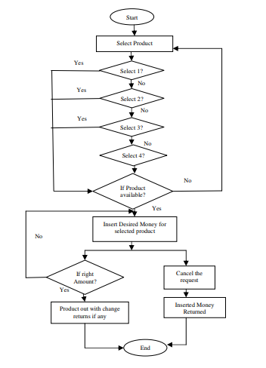 Figure2: A Flow chart for Vending Machine

A withdrawal request is an additional feature which is triggered if the user chooses not to take the product. When a cancel switch is pressed, the inserted money will be refunded to the user through the return output. The machine utilizes a money count signal to check the total money added in the machine (Zhang Wen & Zhang Xin, 2010). If the inserted amount is more than the price for the product, the machine will then return the extra change to the user. Similar, users can choose and acquire other items in the machine following the procedure indicated above (Quresh et al., 2011).

Vending machine state description
During initialization, money count=0, change=0 and product =0. When a product is selected: sel1 &! Sel2 &! Sel3 &! Sel4, when product is available= 1=>nx_st 1<= wating1; when product is unavailable = 0 => nx_st 1<= service 1. During the waiting transition: waiting1 =>, when 10&! _20=>nx_st 1<= state_1, when !_10& _20 => nx_st 1<=state_2, change =0, product = 0, when money count >= 30 nx_st1 <= product. When the state is 1: state_1 => rs_10=1 & rs_20=0, change = 0, product = 0, money count= money_count+10 (Monga & Singh, 2012).
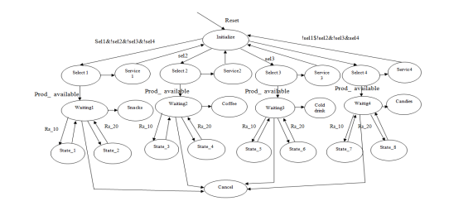

Figure 3: Finite State Diagram of Vending Machine

6.0 Conclusion
Many design vending machines have been incorporated with the help of NFSM automata theory and Visual Automata Simulator (VAS) tool. Such optimization in FSM contributes to devices having fewer states which allow the device to deliver fast response service. Using these tools and appropriate design, the efficiency of vending machines and other applications can easily be enhanced. Future FSM applications need to utilize complexity reduction which involve space and time improving the efficiency of the overall system. Such a designed machine can be used by many applications, and one can improve the number of available selections. The next stage is the conversion of the vending machine into a hardware model to calculate and enhance to total power consumption.

References

Dash, T., & Nayak, T. (2012). Quantum Finite Automata: a Language Acceptor Model. International Journal of Advanced Research in Computer Science and Software Engineering, 2(9).
Ding, Y., Li, W., Zhong, D., Huang, H., Zhao, Y., & Xu, Z. (2018, January). System states transition safety analysis method based on FSM and NuSMV. In Proceedings of the 2018 2nd International Conference on Management Engineering, Software Engineering and Service Sciences (pp. 107-112). ACM.
Holub, J., & Štekr, S. (2009, July). On parallel implementations of deterministic finite automata. In International Conference on Implementation and Application of Automata (pp. 54-64). Springer, Berlin, Heidelberg.
Hopcroft, J. E. (2008). Introduction to automata theory, languages, and computation. Pearson Education India.
Verma, G., Papreja, A., Shekhar, S., Maheshwari, S., & Virdi, S. K. (2016, March). Low power implementation of FSM based vending machine on FPGA. In 2016 3rd International Conference on Computing for Sustainable Global Development (INDIACom) (pp. 2054-2058). IEEE.
Zhang Wen & Zhang Xin Long (2010) “Design and Implementation of automatic vending machine Based on the short message payment” International Conference on Information and Communication Technology in Electrical Sciences, Neijiang, Sichuan, China.pp.978-981.
Qureshi, M. A., Aziz, A., Rasool, H. F., Ibrahim, M., Ghani, U., & Abbas, H. (2011). Design and Implementation of Vending Machine using Verilog HDL. In 2011 2nd International Conference on Networking and Information Technology, IPCSIT (Vol. 17).
Monga, A., & Singh, B. (2012). Finite state machine based vending machine controller with auto-billing features. arXiv preprint arXiv:1205.3642.

