ECE 282 Lab 10

Lab Report Due: 6pm, March 28,2017

Justin Edwards

Before doing this lab, please download the files from these links using **wget**  
wget -O A.tar https://iu.box.com/s/jbgsq6ah9zbvldof34wxow8hwmicmwvp  
wget -O B.zip https://iu.box.com/s/ebp46jsw8sramcnzsq2uvc3cmaukl7eo  
wget -O C.tar.gz https://iu.box.com/s/zuvslmddcb36iyb9bubpxj6cafksir5n  
wget -O D.tgz https://iu.box.com/s/6h2nvq7dkyfied4wuvin3wf6mazr7qg0

# Command practice

**Tutorial:** <http://eecs.mines.edu/Courses/csci274/Content/13_misc.html>

What do the following commands do?

1. history  
   **lists all previous commands entered**
2. sort  
   **sorts lines of text files**
3. sed  
   **GNU stream editor, edit strings in a file**
4. uniq  
   **omit or report lines that are repeated in text**

Write down the commands that can do the following tasks:

1. Unarchive A.tar   
   **tar -xvf file.tar**  
   **Note: Having a directory A, I compressed it using tar –cvf A.tar A**
2. Uncompress B.zip  
   **Unzip B.zip**  
   **Note: Having a directory B, I did: zip -r B.zip B**
3. Uncompress C.tar.gz (You may use one or multiple commands)  
   **tar -xzvf C.tar.gz**  
   **Note: Having a directory C, I did: tar –cvf C.tar C ; gzip –v C.tar;**
4. Uncompress and unarchive D.tgz (You may use one or multiple commands)  
   **tar -xvzf D.tgz**  
   **Note: Having a directory D, I did: tar –cvzf D.tgz D**
5. **Bonus:** Count the number of unique lines in a file.  
   Example: input is a file with 5 lines of “a \n b \n c \n b \n b”, output is 3  
     
   **Hint: sort + uniq + ?**

# Stream Editor

**Sed** is a very powerful stream editor tool in UNIX because after all, all the data flow in UNIX are in form of stream! That how you learned about input/output redirection (<, >, >>) or pipeline (| ). There are many commands for sed; however, we will just cover the substitute (s) and deletion (d) today.

Substitution syntax: sed ‘s/word_to_find/word_to_replace/g’  
Note: If you exclude the last ‘g’, sed will only replace the first occurrence in each line.

Example: **echo Monday and Sunday | sed 's/day/night/g'**

Example 2:

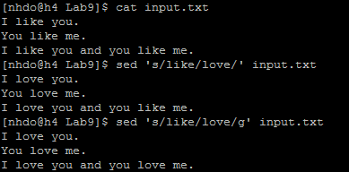

Sed is case sensitive for “word_to_find”! To make it case insensitive, with the input.txt above, add the letter **i** at the end, like:  
**sed 's/you/Jim/gi' input.txt**

In case you want to delete all lines that contain word_to_find, use sed ‘/word_to_find/d’

Example:



You can replace “word_to_find” with a string pattern (aka regular expression)

Example: Replace all numbers with zero



Now are your tasks, write the **sed** command to:

1. Replace all string “this” to “that”, case sensitive (“This” should not be replaced)  
   **sed ‘s/this/that/g’**
2. Replace all string “this” to “that”, but only replace the first occurrence in each lines  
   **sed ‘s/this/that/’**
3. Replace all string “this” to “that”, case insensitive (“This”, “tHis” should be replaced by “that”)  
   **sed ‘s/this/that/gI’**
4. Delete all lines that contains a digit  
   **sed ‘/[0-9]/d’**
5. Delete all string “this” from a file input3.txt, and output the result to output3.txt  
   **sed ‘/this/d’ input3.txt > output3.txt**  
   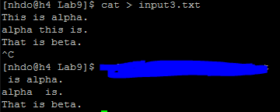
6. Capitalize your username in the output of “who”  
   **who | sed -e ‘s\justedwa\Justedwa\g’**  
   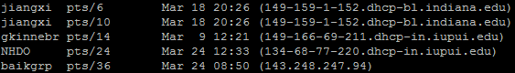

# The prompting shell

In this lab you need to modify psh2.c from chapter 8. This program currently works by taking one argument at a time, until ‘\n’ is the last argument or a maximum of 20 arguments is entered. Then it will run the first argument, arg[0], and will pass the whole array of arguments to the newly forked process.

You need to modify the program such that instead of taking arguments one on each line, it would take the whole string, and chunk it into space-separated arguments and put them into the array of arguments. Then, same as before, it would run the first argument, arg[0], and pass the array of arguments to the process.

You must write a function which would take the input string, and convert it into the array of arguments and return a pointer to it. Design and develop this function properly, since you are going to need it for later assignments and the final project.

Notice that the argument to this function is char* and the return type is char**.

Note: Now you know **wget**, you may want to download the source code directly from: <http://wps.prenhall.com/wps/media/objects/510/522376/Molay_Unix_SourceCode/ch08/psh2.c>

Why does this shell program do not exit after calling “execvp”?

Submit the .c code and .pdf report to Canvas. Print function that you developed for this assignment in the lab report.

Lab Report: Submit soft copy to Canvas, and hard copy in the class.