# Appendix A: Ambient Air Quality Reference Concentrations (RfC)

The Clean Air Act, which was last amended in 1990, requires EPA to set National Ambient Air Quality Standards (40 CFR part 50) for pollutants considered harmful to public health and the environment. The Clean Air Act identifies two types of national ambient air quality standards. **Primary** standards provide public health protection, including protecting the health of "sensitive" populations such as asthmatics, children, and the elderly. **Secondary** standards provide public welfare protection, including protection against decreased visibility and damage to animals, crops, vegetation, and buildings.

Criteria pollutants

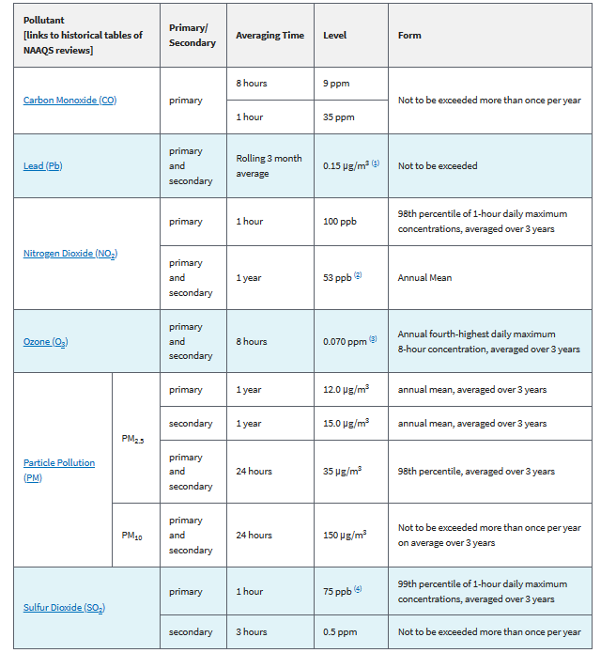

source: https://www.epa.gov/criteria-air-pollutants/naaqs-table

Convert SO2 in ppm to ug/m^3

1ppb = 0.001ppm

X ug/m^3=(Y ppm)(molecular weight)/24.45(1000ug/mg)

Primary standard: SO2 X ug/m^3 = (0.075ppm)(64.06g/mol)/24.45 * (1000ug/mg) = 196.5 ug/m^3

Secondary standard: SO2: X ug/m^3 = (0.5ppm)(64.06g/mol)/24.45 * (1000ug/mg) = 1310 ug/m^3

# Appendix B: AERMOD Primer



The runstream file is divided into five functional "pathways." These pathways are identified by a two-character pathway ID placed at the beginning of each runstream image. The pathways and the order in which they are input to the model are as follows:

CO - for specifying overall job COntrol options;

SO - for specifying pollution SOurce information;

RE - for specifying REceptor information;

ME - for specifying MEteorology information;

EV - for specifiying EVent processing;

OU - for specifying OUtput options.

*For this lab, you will be using all but the event (EV) pathways. The following section creates a run called TRITEST1 which calculates average concentrations of a pollutant (here specified as BENZENE) over 24 hours and the secondary keyword refers to the average for the entire data period. Also, settings for the .... are set such that default regulatory options will be used (DFAULT) and concentrations will be calculated (CONC in µg/m^3) based on an assumed flat terrain (FLAT).*

CO STARTING

CO TITLEONE TRITEST1

CO MODELOPT CONC FLAT

CO AVERTIME 3 24 PERIOD

CO POLLUTID BENZENE

CO RUNORNOT RUN

CO ERRORFIL ERRORS.OUT

CO FINISHED

*The next section specifies a source located at the node (439746 m, 4630746 m, 0 m) in the (x,y,z) directions. The SRCPARAM statement specifies release parameters (in this order: Source ID label, emission rate in g/s (e.g., 150.2), release height in meters (76), stack gas exit temperature in degrees Kelvin (353), stack gas exit velocity in meters/second (5), and stack inside diameter in meters(3)). A second source has been added by simply adding another set of LOCATION, SRCPARAM statements. Include the SRCGROUP ALL statement to include all of the above locations in the analysis.*

SO STARTING

SO LOCATION STACK1 POINT 439746 4630746 0.0

SO SRCPARAM STACK1 150.2 76. 353. 5. 3.0

SO SRCGROUP ALL

SO FINISHED

*The next section specifies a Cartesian grid with 200 nodes spaced every 50m in the x direction and the same in the y direction beginning at the southwest corner of the study area (the first coordinate, 416589, represents the location of lower left vertex of the study area in the x direction and the second coordinate, 4607430, represents the location of the lower left vertex of the study area in the y direction). You can retrieve the precise locations of the bottom, left vertex using ArcCatalog’s metadata tool (refer to the “spatial” tab with the study area selected). The entire grid spans 10 km by 10 km.*

RE STARTING

GRIDCART NET1 STA

XYINC 416589 50 200. 4607430 50 200.

GRIDCART NET1 END

RE FINISHED

*The next section specifies a surface air meteorological data file called METSURFACE.SFC and an upper air meteorological data file named METUPPER.PFL. It also states that the surface meteorological weather station was 94846 and the upper air weather station used was 14842. Both data sets represent records for the year 2000 (which, coincidentally, does not coincide with the year of the TRI and criteria emissions data, but no worries).*

ME STARTING

ME SURFFILE METSURFACE.SFC

ME PROFFILE METUPPER.PFL

ME SURFDATA 94846 2000 CHICAGO, IL

ME UAIRDATA 14842 2000 CHICAGO, IL

ME PROFBASE 0.0 METERS

ME FINISHED

*The RECTABLE keyword provides the highest, second-highest and third-highest values by receptor. For this example problem we will select the highest and second-highest values by receptor, and the maximum 50 values for all averaging periods. The last section specifies the type of output, including a plottable text file called TRIPLOT.PLT.*

OU STARTING

OU RECTABLE ALLAVE FIRST SECOND

OU MAXTABLE ALLAVE 50

OU PLOTFILE PERIOD ALL TRIPLOT.PLT

OU FINISHED

Once the AERMOD input file is complete (and saved), you are able to execute AERMOD by opening the DOS command prompt (To open the command prompt, click the Start Menu, click “Run”, type “cmd” into dialog box and click “OK”), navigate to the AERMOD subdirectory (using the DOS change directory command; e.g., “cd C:\WorkingDirectory”) and, at the command prompt, enter:

C:\WorkingDirectory >aermod inputfilename outputfilename

For example:

C:\WorkingDirectory >aermod aermod.in aermod.out

The program should begin compiling weather data for each day. An output file will then be created which shows concentrations of the pollutant in question at each node in the grid (you can create a uniform-interval grid with several nodes or receptor locations). For comprehensive reference to AERMOD, consult the user’s manual. Below is a portion of one of the output plot files.

* AERMOD (07026): TRITEST1

* MODELING OPTIONS USED:

* CONC FLAT

* PLOT FILE OF HIGH 1ST HIGH 24-HR VALUES FOR SOURCE GROUP: ALL

* FOR A TOTAL OF 2500 RECEPTORS.

* FORMAT: (3(1X,F13.5),3(1X,F8.2),3X,A5,2X,A8,2X,A4,6X,A8,2X,I8)

* X Y AVERAGE CONC ZELEV ZHILL ZFLAG AVE GRP HIVAL NET ID DATE(CONC)

* ____________ ____________ ____________ ______ ______ ______ ______ ________ ________ ________ ________

426651.00000 4620224.00000 22.37642 0.00 0.00 0.00 24-HR ALL 1ST NET1 90082224

426851.00000 4620224.00000 25.65848 0.00 0.00 0.00 24-HR ALL 1ST NET1 90082224

427051.00000 4620224.00000 29.00201 0.00 0.00 0.00 24-HR ALL 1ST NET1 90082224

427251.00000 4620224.00000 32.17934 0.00 0.00 0.00 24-HR ALL 1ST NET1 90082224

427451.00000 4620224.00000 34.95601 0.00 0.00 0.00 24-HR ALL 1ST NET1 90082224

427651.00000 4620224.00000 37.15995 0.00 0.00 0.00 24-HR ALL 1ST NET1 90082224

427851.00000 4620224.00000 38.73687 0.00 0.00 0.00 24-HR ALL 1ST NET1 90082224

# Other resources

<https://www.epa.gov/scram/air-quality-dispersion-modeling-preferred-and-recommended-models#aermod>

<http://www.naviknow.com/2018/09/26/aermet-made-easy-aermet-input-files/>

<https://ruc.noaa.gov/raobs/>

<https://www.energy.gov/nepa/downloads/eis-0460-final-environmental-impact-statement>

<https://www.chicagotribune.com/business/ct-xpm-2012-09-02-ct-biz-0902-crawford-fisk-20120902-story.html>

<https://rdrr.io/cran/worldmet/man/importNOAA.html>

<http://mesonet.agron.iastate.edu/request/download.phtml?network=IL_ASOS>