EXERCISE #4: Environmental Suitability Analysis  GEO 3/446: GIS Analysis for Environmental and Public Health  Winter Quarter 2022 | C. Scott Smith, PhD AICP  DePaul University  312-362-5770

Project Description
Generating power from cleaner sources of energy is important, but such energy still needs to find its way from the power source to the consumer. In an effort to boost California's wind power infrastructure, southern California’s largest electric utility, Southern California Edison (SCE), is planning a renewable transmission project with the capacity to transmit 4,500 megawatts of electricity from wind farms under development in the region. You have been hired by SCE to identify three feasible alignment scenarios for a transmission line that will connect to the regional electricity grid. Specifically, the transmission line will connect a substation in Kern County to another substation located in Los Angeles County; it is your job to identify an optimal path between the two locations.

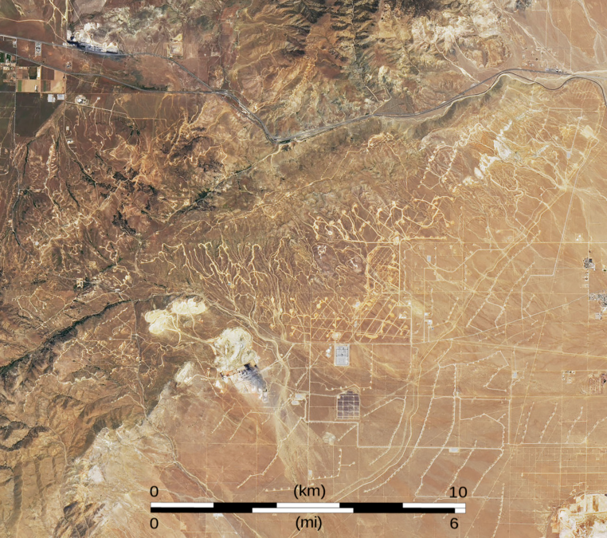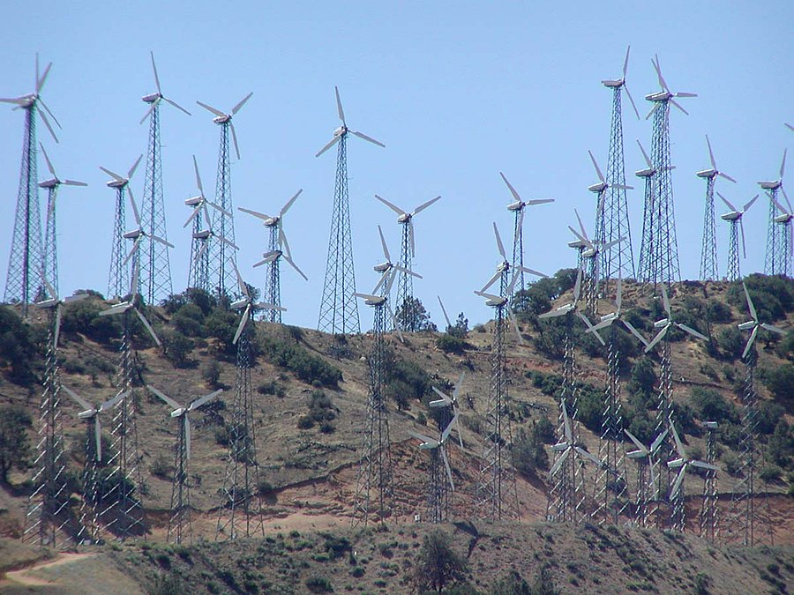
Siting such a transmission line is not a trivial location task. The construction of an electricity transmission line is expensive, time consuming and often fiercely debated by the public. For this project you will need to carefully consider not only the cost of installing the transmission line (up to $1.5 million per mile), but also the potential impacts the new infrastructure will have on residential populations and the environment. Further, you will need to consider risk factors that may compromise the long-term integrity of the new transmission line such as wildfire and seismic activity.

Project Objective and Deliverables
You will use ArcGIS Pro Spatial Analyst together with the provided GIS data (see Appendix A) to develop three unique alignment scenarios for the transmission line connecting the Kern county (source) and Los Angeles county (destination) substations. You will write a one-page report describing the model specification and results for each of the three scenarios (see Appendix B for example template). The alignment scenarios should emphasize different dimensions of the proposed development (e.g., public safety, development cost and environmental integrity).

After optimizing the alignment for each of the three scenarios, you will write a two-page summary that: (1) compares the three alignment scenarios with respect to their length, cost and other considerations; (2) describes the overall limitations of the three models, more generally; (3) proposes one of the four alignments for development with a brief justification as to why you propose this alignment; and (4) presents geographic depictions of the three scenarios on a single PowerPoint slide (see PowerPoint template). The final (exercise 4) report will be four to five pages in length (i.e., one page for each alignment scenario and one- to two-pages for the summary). General instructions for carrying out the analyses are provided below.

Step 1: Download Data, Create ArcGIS Project
Download zipped data file (see Appendix A for more info) into a new project directory. Open ArcGIS Pro and create a new project using blank map template in your new project directory. In ArcMap, click the red toolbox icon in the standard toolbar to open ArcToolbox.

Step 2: Create three scenarios
In order to better understand the complexity of the proposed project, SCE wants you to create three unique scenarios for siting the transmission line using the datasets provided. For example, in scenario one you may attempt to maximize the long-term integrity of the transmission line while another scenario may maximize public safety or biodiversity. This may be a good time to create a new Word document for your final report and describe the three scenarios (refer to the Alignment Scenario template in Appendix B).

Step 3: Select, Derive and Reclassify Datasets
In step two, identify three or more factors or GIS feature themes that you will use to model each scenario. For example, the long-term integrity of the transmission line may be enhanced by minimizing proximity to earth quake fault lines, fire hazard and steeper slopes (note that steep slopes make it difficult to repair and maintain transmission infrastructure). In about 200 words, explain in the report why you selected these three features themes or factors or how these factors speak to the particular alignment scenario. As part of your analysis you may need to derive new datasets from the original GIS themes. For example, you can use the “Euclidian Distance” tool (available under the Analysis/Toolbox in ArcGIS Pro) to create a distance to fault lines dataset. Keep track of new datasets by saving them to the working directory where the original data are located.

Note: After selecting the three or more feature themes for each scenario, reclassify their values with respect to a standard scale or consistent range (e.g., make 1 the least cost/most desirable areas/values in the raster layer and 10 the highest cost/least desirable areas/values). For all utilized datasets, make sure that the maximum value represents the least desirable attributes whereas the minimum value represents a more desirable situation with respect to the transmission line alignment. For example, if you are trying to minimize fire risk, reclassify areas with the highest fire risk to 10 and areas with the lowest fire risk to 1.

The reclassify tool can be accessed via Analysis Tools menu or by typing “reclassify” into the Geoprocessing dialog box. Open the tool, select the input raster then click each entry and type the new value you wish the old value to become in the output raster (alternatively, use the “Classify” option to automate the categorization process). To remove an entry, select the entry, then click delete on the keyboard or add an entry by adding value in the bottom of the values table. When the boundary of two input ranges contain the same value, the higher end of the lower input range is inclusive, and the lower end of the higher input range is exclusive. Click Run to create the reclassified raster dataset.

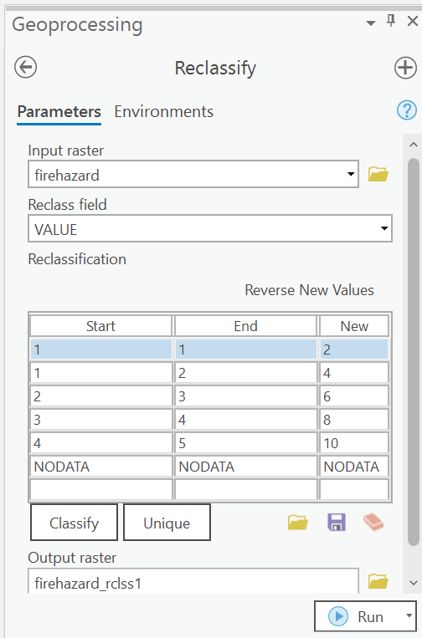

Step 4: Prioritize and Weight Datasets
After selecting and reclassifying the scenario-specific feature themes, prioritize them with respect to their relative importance in the model. For example, you may prioritize or weight more heavily the importance of steep slopes relative to other feature themes included in the model given that dramatic relief will make it difficult to maintain the transmission line on a regular basis. Fire hazards and earth quakes, on the other hand, could be assigned lower weights or priorities given that they provide only sporadic threats to the line’s integrity. In 200 words, explain the logic underlying your prioritization scheme.

Note: For each set of scenario-specific feature themes, the sum of their relative weights should equal one. For example, the weight of the steeper slopes feature layer could be assigned a 0.5 whereas fire hazards and distance to fault lines 0.30 and 0.20, respectively.

Use the Raster Calculator tool to multiply the grid by the assigned weight. The Raster Calculator tool is under the Spatial Analyst toolbar. Build the expression in the box by typing directly into the box or adding raster layers, numbers and operators by clicking buttons in the dialog. Click Run to create the weighted raster dataset.

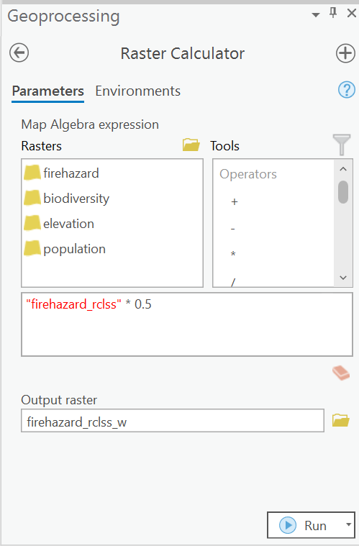

Step 5: Calculate Cumulative Cost Grid and Alignment
Once all of the input datasets for a particular scenario are prioritized or weighted, sum them using the raster calculator tool in ArcGIS Pro. As stated above, in order for the cumulative cost grid to be represented in the same scale as the input grids, the sum of the input weights must equal one. Adding all of the input grids will yield a scenario-specific cost grid representing the relative “suitability” of each pixel for the development of the transmission line.
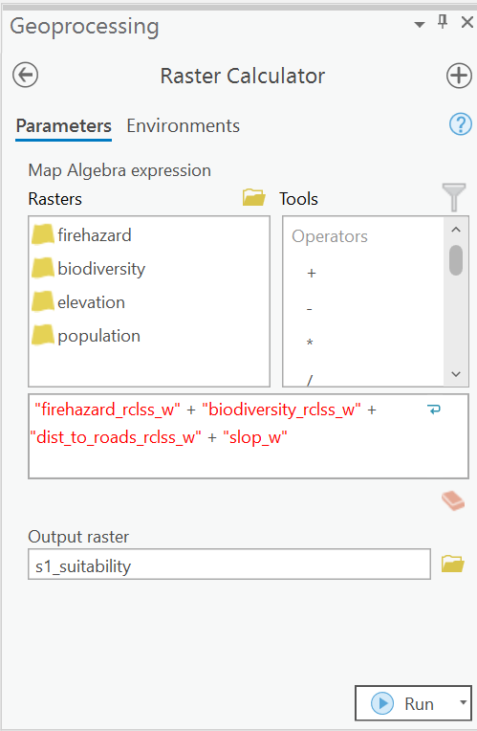

Step 6: Calculate the Cost Distance Rastet
After you have calculated the cumulative cost grid, you are ready to estimate the global cost distance in ArcGIS Pro using the Distance Accumulation tool. The cost-weighted distance is a modified version of a basic Euclidean distance from the Kern county “origin” substation in that it uses the cumulative cost grid you created in Step 4. Put another way, the cost to travel from the origin substation through any adjacent cell is weighted relative to the values represented in the cumulative cost grid, with the most suitable pixels having lower values, thus having lower costs for travel. Be sure to produce/provide names for both an output raster and a backlink raster. These two grids (i.e., the cost distance raster and the backlink raster) will be used to calculate the optimal alignment in Step 7.

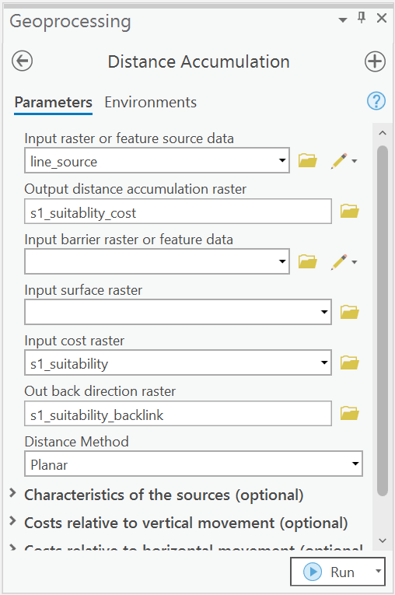

Step 7: Calculate the Least Cost Alignment
After you have calculated the cost distance and backlink grids, you are ready to estimate the least cost alignment or optimal cost path for the particular scenario using the “Optimal Path as Line” tool. The cost path function determines the path from a destination point (the Los Angeles county substation) to a source (the Kern county substation). The least-cost path travels from the destination to the source. This path is one cell wide, travels from the destination to the source, and is guaranteed to be the optimal transmission line alignment relative to the cost units defined by the cumulative cost raster created in Step 4. Specify the cumulative cost and backlink rasters in the Optimal Path as Line dialog and click Run to create the alignment as a feature layer. Overlay the proposed alignment path on the cumulative cost raster and copy map to your report.

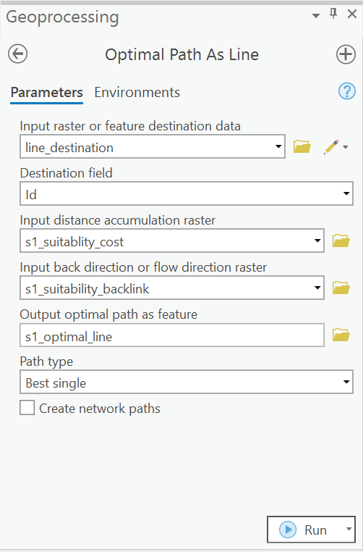

Appendix A

GIS Data / GIS Feature Layers

SCE has made available to you the following GIS data to inform your analysis (all are projected in the UTM Zone 11 coordinate system, units=meters). You will find datasets 1-9 in a zipped file that can be extracted into your project directory. Other datasets, such as 10 and 11, may be derived from the original datasets. A description of each data layer is provided below.

- Study area boundary (studyarea)
- Location of the origin substation in Kern County (line_source)
- Location of the destination substation in Los Angeles County (line_destination)
- Natural biodiversity ranked into five categories (biodiversity)
- Roads or categorized transportation routes (roads)
- Fire hazard risk ranked into four categories (firehazard)
- Elevation in meters (elevation)
- Population total (population)
- Earthquake fault lines (faultlines)
- Slope in meters (derive from elevation grid)
- Distance to earthquake fault lines (derive from Eathquake fault lines vector shapefile)

Appendix B

Alignment Scenario 1: Public Safety

Dataset selection rationale:
Lorem ipsum dolor sit amet, consectetuer adipiscing elit. Mauris vitae risus interdum nibh facilisis adipiscing. Cras turpis felis, ultricies eu, vestibulum id, pellentesque at, quam. Nulla facilisi. Nulla aliquam, mauris tempus pulvinar eleifend, odio odio tincidunt pede, eget euismod tortor erat ac neque. In vel eros. Suspendisse auctor semper enim. Maecenas lorem eros, placerat eget, euismod vitae, adipiscing at, lorem. In vestibulum, lorem id tincidunt gravida, ipsum metus tempus mauris, ut vestibulum ipsum felis sit amet augue. Vivamus mattis vestibulum massa. Vivamus nisi metus, posuere at, iaculis non, vestibulum vitae, dolor. Nam blandit erat id lacus. Vivamus convallis lacinia nisi. Aliquam lacinia lacus vitae leo.

• Lorem ipsum dolor sit amet, consectetuer adipiscing elit.
• Nullam sed magna sed mi cursus tincidunt.
• Nam mollis nunc in urna.
• Nunc pretium rutrum nisi.

Dataset prioritization rationale:
Aenean accumsan, velit eu dictum pellentesque, nunc sem fermentum leo, ut lobortis ante mi pellentesque quam. Quisque id neque. Donec sagittis nisi lobortis nibh. Cras venenatis quam nec dolor vulputate pulvinar. Proin luctus, diam sed pharetra fringilla, magna sem cursus lacus, ut mollis turpis augue id magna. Nullam bibendum, mauris ac venenatis volutpat, magna nunc aliquam pede, sollicitudin adipiscing tortor justo quis turpis. Aliquam blandit nulla et pede. Nulla facilisi.

• Donec interdum risus quis purus. (0.25)
• Praesent ac orci sed purus suscipit blandit. (0.10)
• Proin et augue et tortor pulvinar aliquam. (0.10)
• Pellentesque euismod tincidunt mi. (0.55)

Cumulative Cost Grid and Alignment Results:
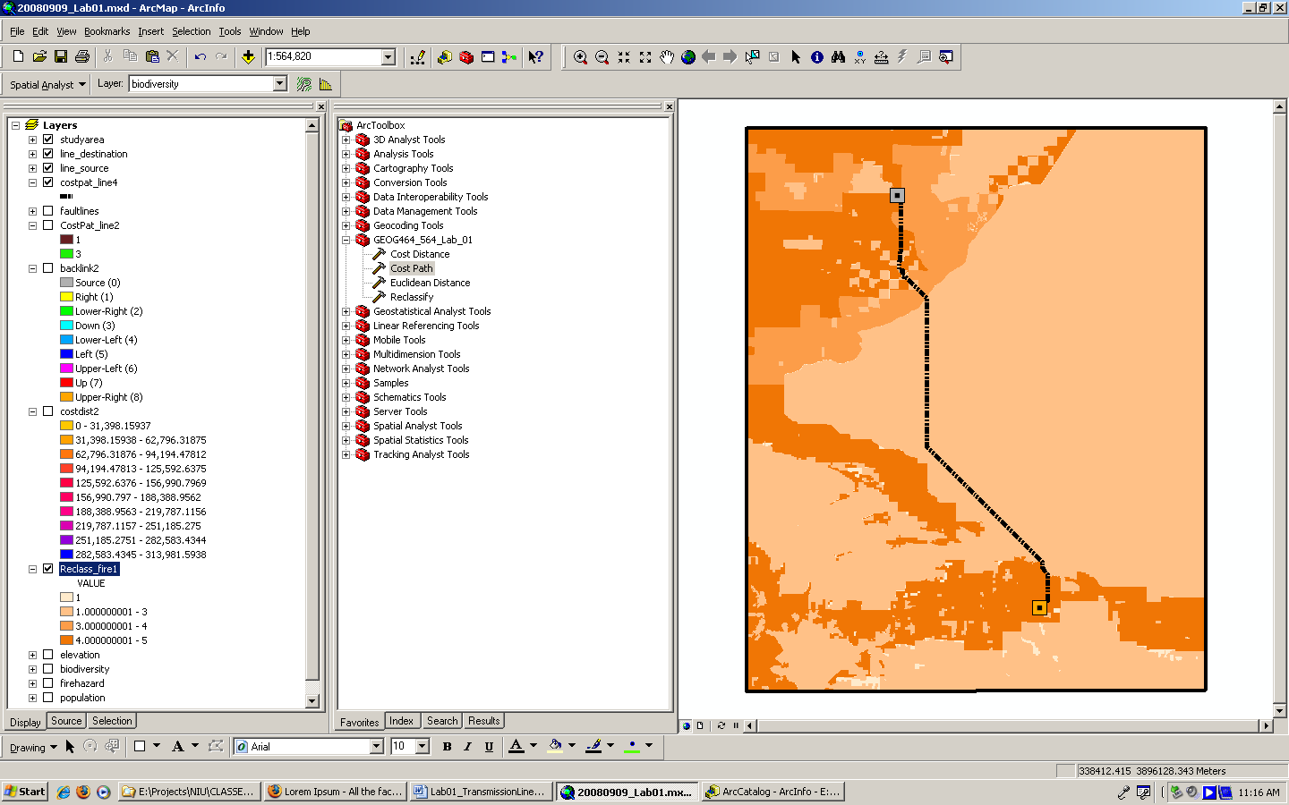 | Nunc venenatis ante nec dolor. Fusce sed sapien. Vivamus rutrum lacus in nisl. Donec sagittis, eros at fermentum posuere, libero metus dictum metus, ut aliquam tellus leo eu purus. Sed adipiscing sapien ac turpis. Vestibulum orci felis, mattis sit amet, interdum non, condimentum sit amet, mi. Praesent dignissim. Mauris ipsum enim, tincidunt at, semper id, sagittis sit amet, pede. Fusce dignissim. Phasellus quis tellus quis justo porta sagittis. Vivamus tincidunt lorem in metus. Morbi sit amet dolor. Nulla sollicitudin sem vel risus lacinia aliquam. Duis id sapien.  Total distance: XX miles; Total cost XX miles x $1.5 million = $XX million

Appendix C

Glossary

Backlink: Backlink creates an output cost backlink Raster. The backlink Raster contains values of 0 through 8 that define the direction or identify the next neighboring cell (the succeeding cell) along the least accumulative cost path from a cell to reach a source. If the path is to pass into the right neighbor, the cell will be assigned the value 1, 2 for the lower right diagonal cell, and continuing clockwise. The value 0 is reserved for source cells.

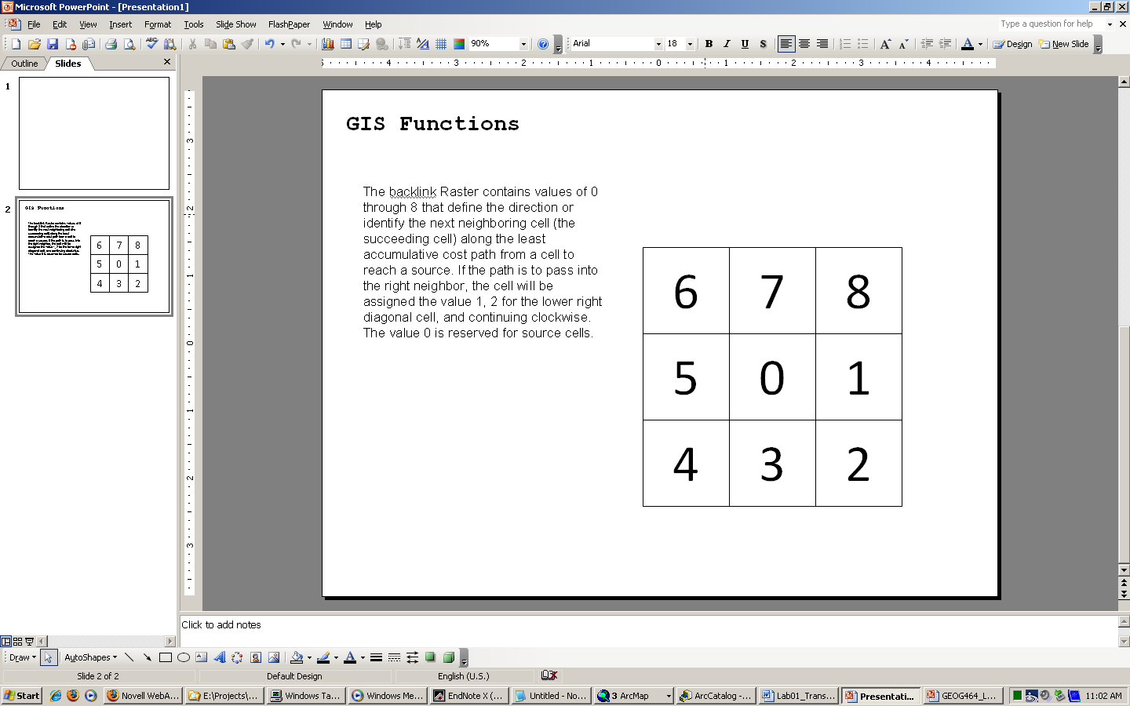

Cost distance: Requires a source grid from which distance will be calculated and a cost grid (which includes impedance values. The Euclidean algorithm works as follows: For each cell, the distance is calculated to each source cell by calculating the hypotenuse, with the x-max and y-max as the other two legs of the triangle. This calculation derives the true Euclidean, not cell, distance. The shortest distance to a source is determined, and if it is less than the specified maximum distance, the value is assigned to the cell location on the output raster. The output values for the Euclidean distance raster are floating-point distance values. If the cell is at an equal distance to two or more sources, the cell is assigned to the source that is first encountered in the scanning process.

