ExplainMyLetter
Admin Panel
Complete Step-by-Step Guide
For Administrators — All Features Explained

May 2026

Table of Contents
This guide covers every section of the ExplainMyLetter Admin Panel. Navigate using the sections below.

1. | Introduction & Overview | 3
2. | Logging In | 4
3. | Dashboard | 5
4. | Job Management | 8
5. | Job Detail View | 11
6. | Prompts | 14
7. | Pricing (Categories & Base Prices) | 15
8. | Upsells (Add-on Services) | 18
9. | Feedback | 21
10. | Settings — OCR & Extraction | 22
11. | Settings — OpenAI / AI | 23
12. | Settings — Downloads & Files | 25
13. | Settings — Disclaimer | 26
14. | Settings — Operations | 27
15. | Quick Reference Cheat Sheet | 29

1. Introduction & Overview
Welcome to the ExplainMyLetter Admin Panel guide. This document walks you through every page, field, and button in the admin dashboard — explaining what it does, what to enter, and when to use it.

What is ExplainMyLetter?
ExplainMyLetter is an AI-powered platform that helps members of the public understand complex letters — legal notices, medical letters, government correspondence, and more. Users upload their letter, receive a free plain-English summary, and can optionally pay for a full detailed breakdown.

What does the Admin Panel do?
As an administrator, you have complete operational control over the platform without needing to touch any code. Through the Admin Panel you can:
- Monitor all jobs (document submissions) in real time
- View revenue, token usage, and AI costs
- Configure prices for every letter category
- Create and manage upsell add-ons shown at checkout
- Edit the AI prompts used to generate summaries and breakdowns
- Adjust OCR quality thresholds and AI limits
- Issue refunds and regenerate failed jobs
- Configure legal disclaimers and platform settings

Navigation
The left-hand sidebar is your main navigation menu. It contains: Dashboard, Jobs, Prompts, Pricing, Upsells, Feedback, and Settings. Each section is covered in detail in this guide.

2. Logging In
The Admin Panel is a secure, password-protected area separate from the main user-facing website.

How to access the Admin Panel
- Open your web browser and navigate to your site's admin URL explainmyletter.co.uk/admin/login.
- Enter your administrator email address and password.
- Click Sign In to access the dashboard.

TIP Your admin login is completely separate from the user-facing site. Never share your admin credentials. Sessions expire automatically for security after a few hours — you will be asked to log in again after inactivity.

Admin account information
Your name and email are shown in the top-right corner of every page once logged in. The current date and time are also displayed there for reference. You can sign out at any time using the Sign Out link at the very bottom of the left sidebar.

3. Dashboard
The Dashboard is the first page you see when you log in. It gives you a real-time overview of all platform activity at a glance.

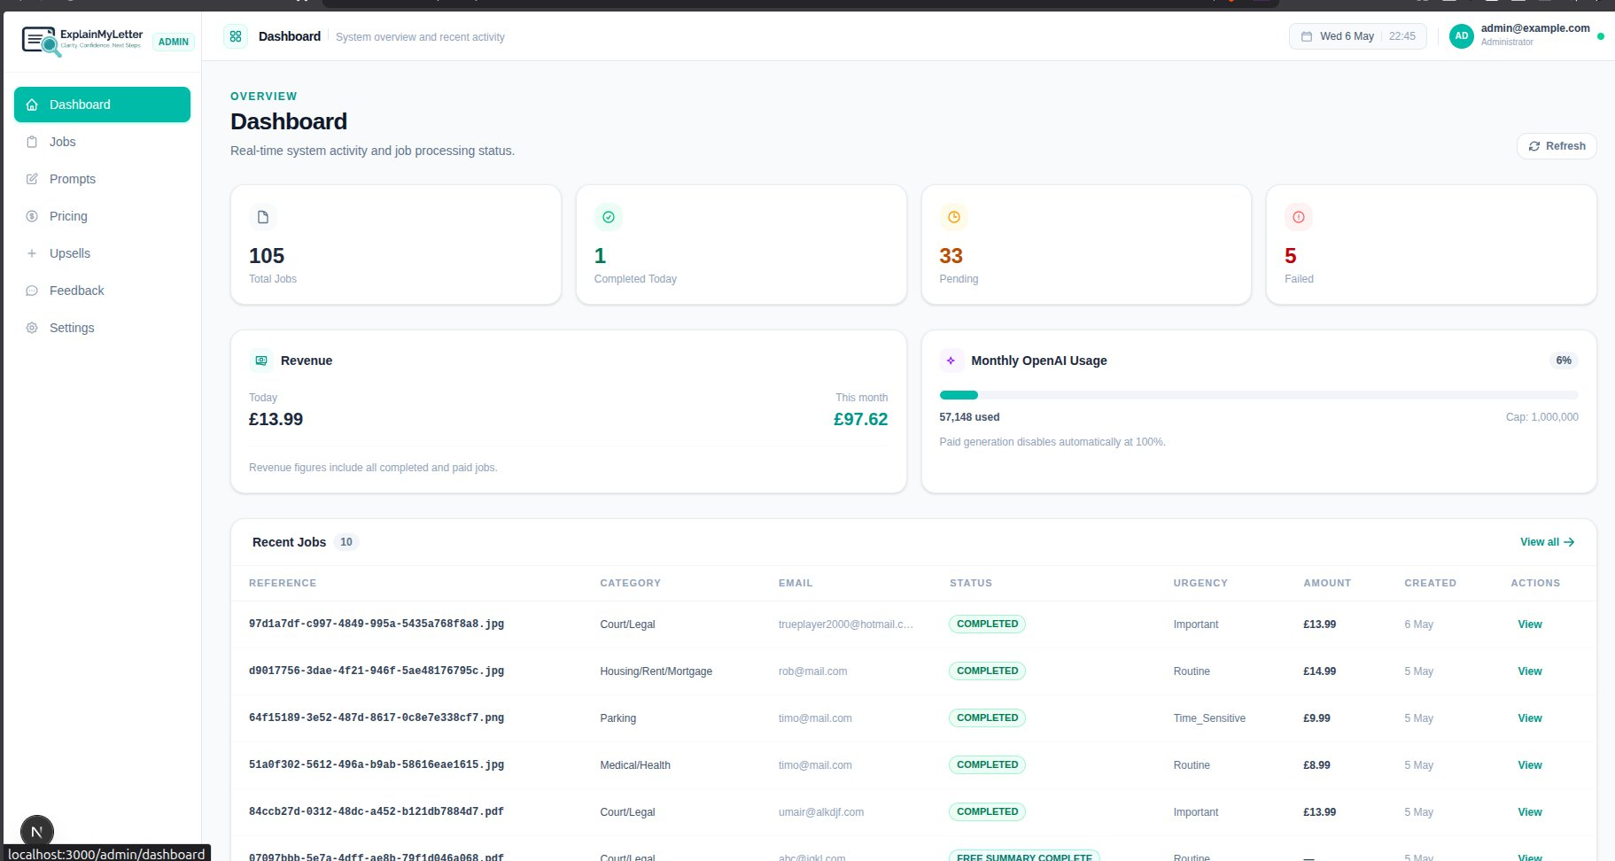

Overview Stats Cards
Across the top of the Dashboard are four summary cards. Each shows a key metric about your platform's current state:

Field | What it does | Example / Default
Total Jobs | The total number of document submissions ever received by the platform — across all statuses, all time. | e.g. 105
Completed Today | How many jobs have been fully processed and delivered to users today. Resets at midnight. | e.g. 1
Pending | Jobs that are currently in progress — either uploading, being processed by OCR, generating summaries, or awaiting payment. A high pending count may indicate a processing backlog. | e.g. 33
Failed | Jobs that encountered an error and could not complete successfully. These require your attention — see the Jobs section for how to handle them. | e.g. 5

Revenue Panel
The Revenue panel shows your earnings from paid jobs. It displays two figures:
- Today — the total revenue collected from completed, paid jobs today.
- This month — the total revenue for the current calendar month.

IMPORTANT Revenue figures only include completed and paid jobs. Jobs that are pending payment, failed, or refunded are not counted here. These numbers come directly from Stripe payment records.

Monthly OpenAI Usage
This panel shows how much of your monthly AI processing allowance has been used. It displays:
- A progress bar showing the percentage of your monthly cap consumed (e.g. 6% used).
- The number of tokens used this month (e.g. 57,148 used).
- Your cap limit (e.g. Cap: 1,000,000 tokens).

TIP Tokens are the unit of measurement OpenAI uses for AI processing. Each word in a document consumes roughly 1–2 tokens. You can configure your monthly cap in Settings → OpenAI / AI. When you reach 100% of the cap, paid AI generation is automatically paused to prevent runaway costs.

The note 'Paid generation disables automatically at 100%' is an important safety feature — the system will never exceed your configured limit without your intervention.

Recent Jobs
The bottom section lists the 10 most recent job submissions. Each row shows:
Field | What it does | Example / Default
Reference | A unique file reference ID for the job. Click 'View' to open the full job detail. | UUID filename
Category | The letter type the user selected when uploading (e.g. Court/Legal, Parking, Medical/Health). | Court/Legal
Email | The email address the user provided when submitting their document. | user@example.com
Status | The current processing status of the job (Completed, Pending, Failed, etc.). | COMPLETED
Urgency | The AI-assigned urgency level: Routine, Important, or Time-Sensitive. | Important
Amount | The amount charged for this job in GBP (only shown for paid jobs). | £13.99
Created | The date the job was submitted. | 4 May
Actions | Click 'View' to open the full detail page for that job. | View →

To see all jobs (not just the 10 most recent), click the 'View all →'(highlighted in the above screenshot) link in the top-right of the Recent Jobs panel, or click Jobs in the left sidebar.

Refresh Button
The Refresh button in the top-right of the Dashboard reloads all stats and job data to show the latest information. Use this if you have been on the page for a while and want to check for new activity.

4. Job Management
The Jobs page is the central hub for managing all document submissions. Click 'Jobs' in the left sidebar to access it.

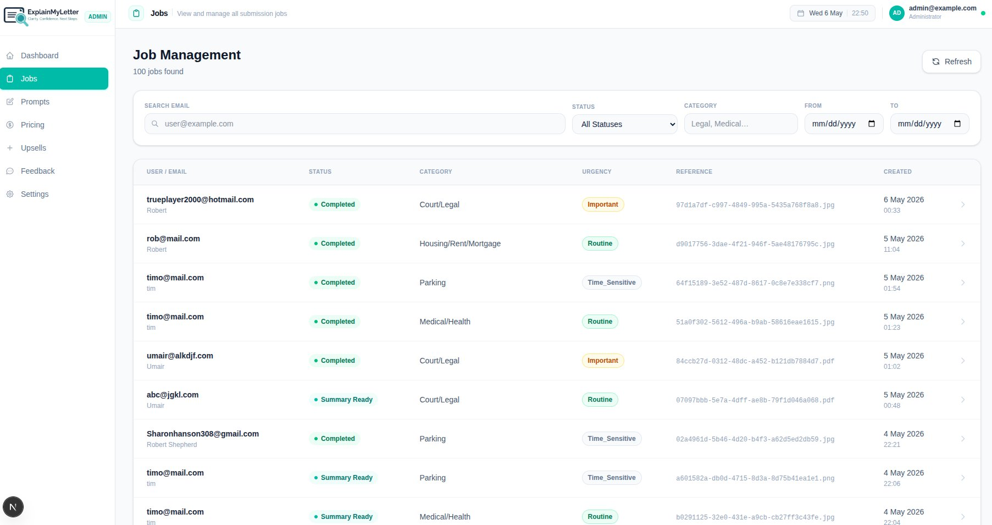

Job:
Every time a user uploads a letter on the platform, a 'job' is created. The job tracks the entire lifecycle of that document — from upload, through AI processing, payment, and delivery. The Jobs page shows all jobs ever created, with 100 jobs found in the example above.

Search & Filter Tools
At the top of the Jobs page are filter tools to help you find specific jobs quickly:

Field | What it does | Example / Default
Search Email | Type all or part of a user's email address to filter the list to only their jobs. Useful for looking up a specific customer. | e.g. rob@mail.com
Status filter | Use the dropdown to show only jobs with a specific status. Options include: All Statuses, Completed, Pending, Failed, Summary Ready, Refunded, and more. | All Statuses
Category filter | Type a category name to filter jobs by letter type (e.g. type 'Legal' to see only Court/Legal jobs). | Legal, Medical...
From / To dates | Set a date range to filter jobs created between specific dates. Leave blank to see all dates. | mm/dd/yyyy

Job List Columns
Each row in the job list represents one submitted document:
Field | What it does | Example / Default
User / Email | The user's email and name as they entered during submission. | trueplayer2000@hotmail.com
Status | The current status of the job. See the Status Guide below for what each means. | Completed
Category | The letter category selected by the user. | Court/Legal
Urgency | AI-assigned urgency. Important jobs are amber, Time-Sensitive are red, Routine are green. | Important
Reference | The unique file reference ID for this job. | 97d1a7df-...
Created | Date and time the job was submitted. | 6 May 2026, 00:33

Opening a Job
Click anywhere on a job row (or the arrow on the right) to open the full Job Detail page for that submission. This is where you can see all the detailed information, take actions, and issue refunds.

5. Job Detail View
Click to issue the refund
The Job Detail page shows everything about a single job submission. You access it by clicking on any job in the Jobs list.

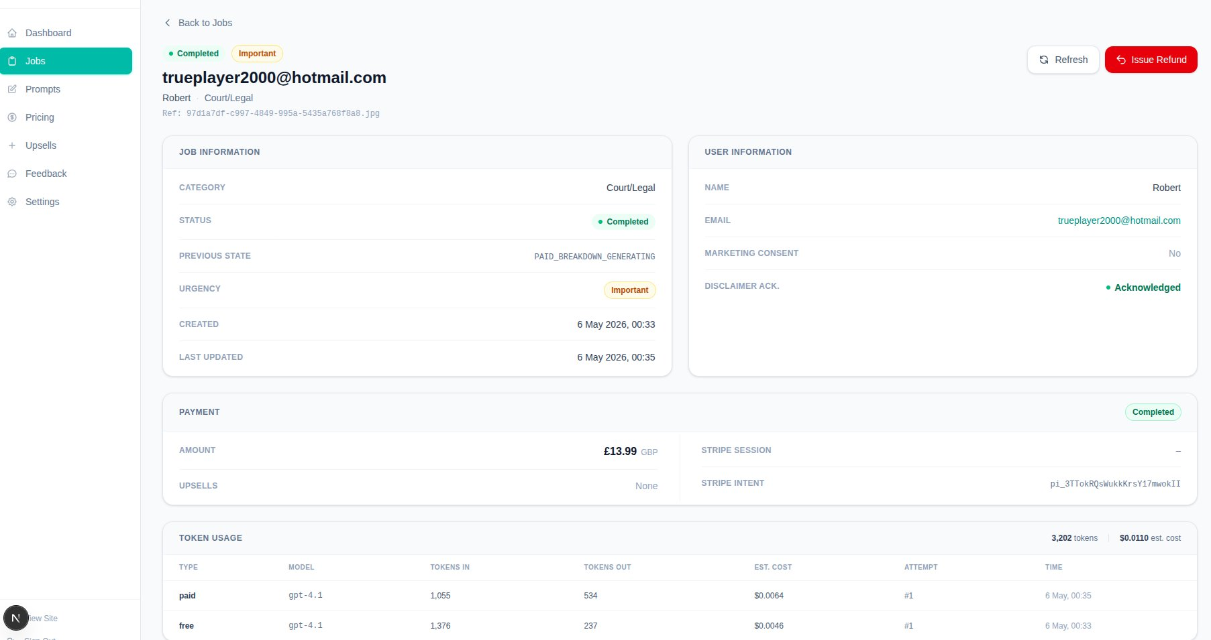

Header Information
At the top of the job detail page you will see:
- The user's email address (large heading) — e.g. trueplayer2000@hotmail.com
- The user's name, the letter category, and the unique Reference ID for this job.
- Status badges — showing the current status (e.g. Completed) and urgency level (e.g. Important).

Job Information Panel (Left Side)
Field | What it does | Example / Default
Category | The letter type selected by the user at submission (e.g. Court/Legal, Medical/Health). | Court/Legal
Status | The current state of this job in the processing pipeline. | Completed
Previous State | The state the job was in just before reaching its current state. Useful for debugging. | PAID_BREAKDOWN_GENERATING
Urgency | The AI-assessed urgency level for this document. | Important
Created | The exact date and time this job was submitted. | 6 May 2026, 00:33
Last Updated | The most recent time the job record was modified (e.g. when status last changed). | 6 May 2026, 00:35

User Information Panel (Right Side)
Field | What it does | Example / Default
Name | The name entered by the user when they submitted their document. | Robert
Email | The user's email address. Click to open your email client. | trueplayer2000@hotmail.com
Marketing Consent | Whether the user ticked the marketing opt-in checkbox. 'No' means they did not consent to marketing emails. | Yes / No
Disclaimer Ack. | Whether the user acknowledged the legal disclaimer before paying. 'Acknowledged' (green) means yes — this must be true for payment to have been allowed. | Acknowledged

IMPORTANT The Disclaimer Acknowledged field is a legal requirement. A job should never reach 'Payment Confirmed' state without this being Acknowledged. If you see a paid job without acknowledgement, contact your developer immediately.

Payment Panel
The Payment panel shows all financial details for this job:
Field | What it does | Example / Default
Amount | The total amount charged to the user for this job, in GBP. | £13.99 GBP
Upsells | Any additional add-on services the user purchased at checkout. | None / Express Delivery
Payment Status | The Stripe payment status badge (Completed = payment confirmed). | Completed
Stripe Session | The Stripe checkout session ID. Used for reference if you need to look up this transaction in your Stripe dashboard. | cs_...
Stripe Intent | The Stripe Payment Intent ID. This is the primary reference for the actual charge in Stripe. | pi_3TTok...

TIP If a user disputes a charge or contacts you about a payment issue, the Stripe Intent ID (starting with pi_) is what you give to Stripe support or use to look up the transaction in your Stripe Dashboard.

Token Usage Panel
This panel shows a detailed breakdown of every AI API call made for this job — helping you understand costs and debug any issues:
Field | What it does | Example / Default
Type | 'free' = the initial free summary generation. 'paid' = the paid detailed breakdown. Other types may appear for upsell processing. | free / paid
Model | The OpenAI model used for this specific call. | gpt-4.1
Tokens In | The number of tokens sent to OpenAI (the document text + prompt instructions). Larger documents use more tokens. | 1,055
Tokens Out | The number of tokens returned by OpenAI (the generated summary or breakdown). | 534
Est. Cost | The estimated cost of this individual API call in USD, calculated from OpenAI's published pricing. | $0.0064
Attempt | Which attempt number this was (#1 = first try, #2 = first retry after failure, etc.). | #1
Time | The exact timestamp of this API call. | 6 May, 00:35

The total at the top of the Token Usage panel shows the combined token count and estimated cost across all calls for this job.

Actions: Issue Refund
The red 'Issue Refund' button at the top-right of the job detail page allows you to refund a user's payment directly through Stripe, without leaving the Admin Panel.

- Click 'Issue Refund' on the job detail page.
- Confirm the action when prompted.
- The system contacts Stripe to process the refund.
- The job status automatically updates to 'Refunded'.
- The user's download access is automatically revoked.

IMPORTANT Refunds are irreversible. Once issued, the job is marked as Refunded and download links are deactivated. You cannot undo a refund through the Admin Panel — it must be handled in your Stripe dashboard if needed.

Actions: Regenerate (Failed Jobs)
If a job has a 'Failed' status AND the user has paid, a 'Regenerate' button will appear. This lets you re-attempt the AI breakdown generation without requiring the user to pay again.

- Locate the failed job in the Jobs list or via the Dashboard.
- Open the job detail page.
- Click the 'Regenerate' button (only visible on Failed + Paid jobs).
- The system re-runs the paid AI breakdown using the same document and settings.
- Monitor the job status — it should move from Failed back to Paid Breakdown Generating and then to Completed.

TIP You can regenerate a failed job up to 3 times (configurable in Settings → Operations). Each regeneration attempt is logged with a timestamp and your admin account ID for audit purposes.

6. Prompts
The Prompts page lets you view and edit the AI instruction templates that control how ExplainMyLetter generates summaries and breakdowns. Click 'Prompts' in the left sidebar to access this section.

What are prompts?
Prompts are the instructions sent to the OpenAI AI model along with the user's document text. They tell the AI what kind of output to produce — a short free summary or a detailed paid breakdown — and how to structure it. Different letter categories (Legal, Medical, etc.) have their own tailored prompts for better accuracy.

Prompt types
Field | What it does | Example / Default
Free Prompt | Used to generate the initial 100–130 word plain-English summary shown to all users at no charge. Must include urgency classification (Routine / Important / Time-Sensitive). | Per category
Paid Prompt | Used to generate the full detailed breakdown after payment is confirmed. Can include structured sections, key actions, deadlines, and next steps. | Per category

Editing a prompt
- Find the category and prompt type you want to edit.
- Click the edit button for that prompt.
- Modify the prompt text. You can use the following placeholder tokens which are automatically filled in at processing time: YOU MUST ADD THE DOCUMENT TEXT PLACEHOLDER
  - {{document_text}} — the extracted text from the user's uploaded letter
  - {{category}} — the letter category selected by the user
  - {{urgency}} — the urgency level assigned to this document
- Save your changes. Previous versions are retained for rollback if needed.

IMPORTANT Be careful when editing prompts. Poorly written prompts can result in low-quality AI output, unexpected formatting, or incorrect urgency classifications. Always test changes on a sample job after editing. Previous prompt versions are kept for rollback.

7. Pricing — Categories & Base Prices
Click to add a new Category
The Pricing page is where you manage letter categories and the base price charged for the paid breakdown in each category. Click 'Pricing' in the left sidebar.

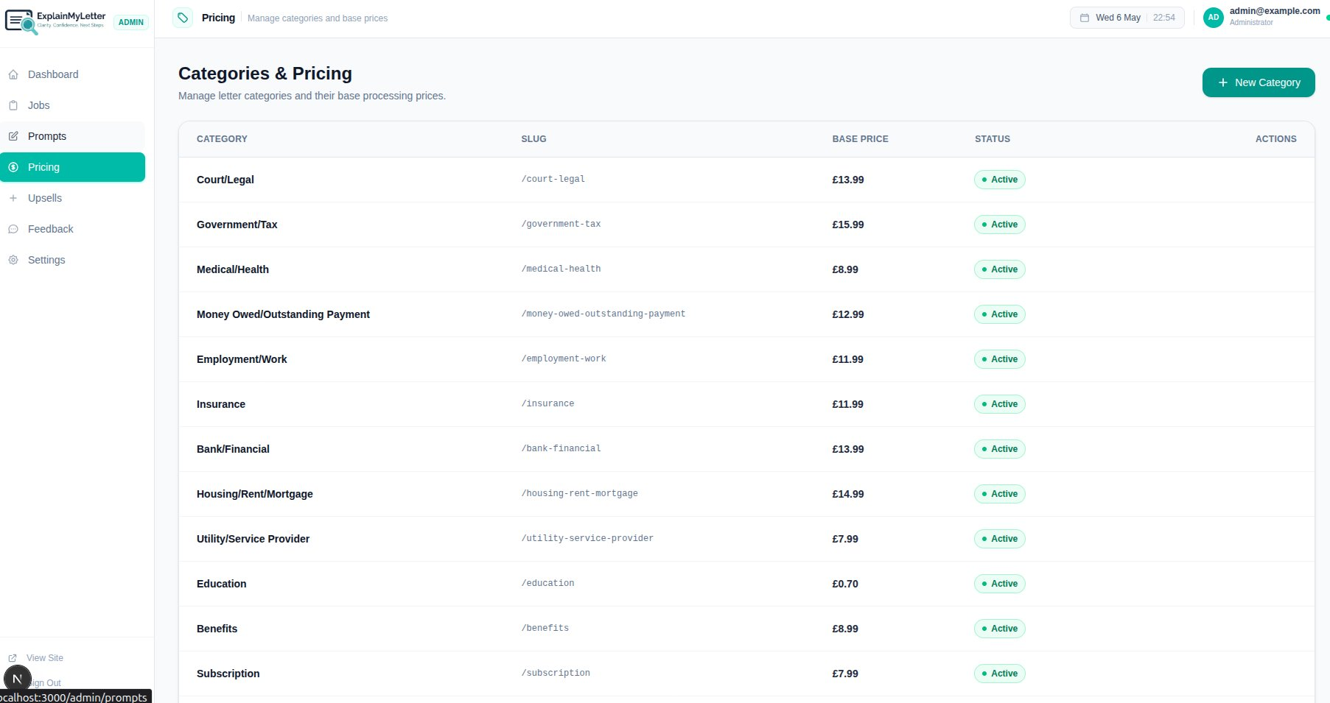

Understanding the Pricing Table
Each row represents one letter category that users can select when uploading a document:
Field | What it does | Example / Default
Category | The display name of the letter type, shown to users on the website. | Court/Legal
Slug | The URL-friendly identifier used internally by the system. Automatically generated from the category name. | /court-legal
Base Price | The price charged for the paid breakdown in this category. This is what the user pays at checkout (before any upsell add-ons). | £13.99
Status | Whether this category is currently visible to users. Active = visible; Inactive = hidden from the website. | Active
Actions | Edit or deactivate an existing category. | Edit / Toggle

Creating a New Category
To add a new letter category to the platform, click the '+ New Category' button in the top-right of the Pricing page. A dialog box will appear:

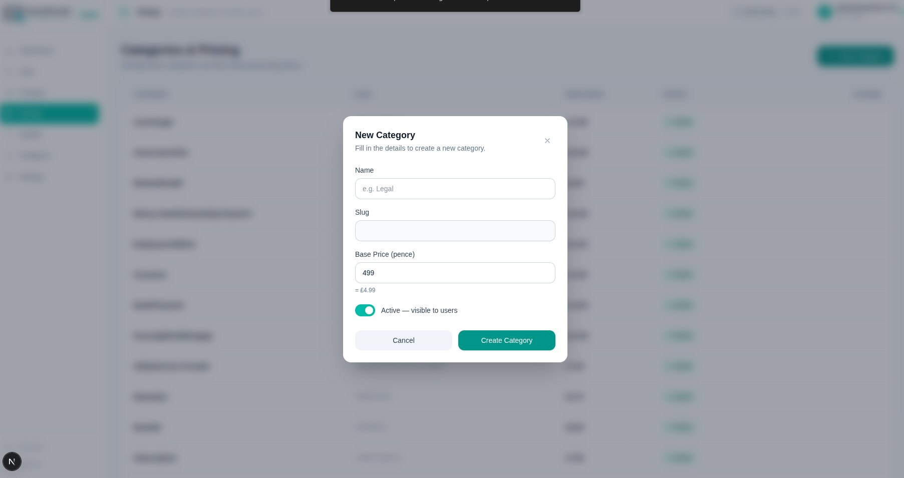

Field | What it does | Example / Default
Name | The display name for the new category. This is what users will see on the website when choosing their letter type. Use clear, plain-English terms. | e.g. Legal
Slug | Auto-generated from the name — a URL-safe version (lowercase, hyphens instead of spaces). You can edit this if needed, but the auto-generated version is usually fine. | e.g. /legal
Base Price (pence) | Enter the price in pence (not pounds). The system shows you the pound equivalent in real time below the field. For example, entering 1399 sets the price to £13.99. | 1399 = £13.99
Active toggle | Toggle this on (blue/teal) to make the category immediately visible to users on the website. Toggle off to create it but keep it hidden until you are ready. | On = visible to users

- Fill in the Name field — the Slug will auto-populate.
- Enter the Base Price in pence (e.g. 1399 for £13.99).
- Check the pound equivalent shown below the price field to confirm it is correct.
- Set the Active toggle to on if you want users to see it immediately.
- Click 'Create Category' to save.

TIP Prices are entered in pence to avoid decimal confusion. Always double-check the pound equivalent shown below the price field before saving. A mistake here will affect what users are charged at checkout.

8. Upsells — Add-on Services
The Upsells page lets you configure optional add-on services that are offered to users at checkout. These are stackable — users can select one or more add-ons in addition to the base breakdown. Click 'Upsells' in the left sidebar.

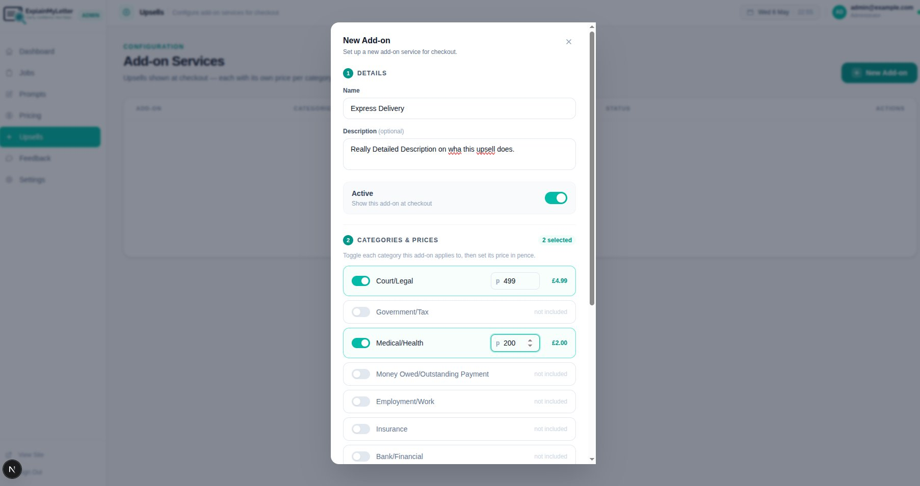

Upsells:
Upsells are additional AI processing options shown to users at the checkout stage. The default upsells are More Detail, Legal Formatting, and Tone Rewrite — but you can create your own. Each upsell can be:
- Priced differently per letter category (e.g. Express Delivery costs more for Legal than for Medical)
- Turned on or off for specific categories
- Activated or deactivated globally

Creating a New Add-on
Click the '+ New Add-on' button to create a new upsell service. The dialog has two sections:

Section 1 — Details
Field | What it does | Example / Default
Name | The name of the add-on shown to users at checkout. Keep it short and descriptive. | Express Delivery
Description (optional) | A longer explanation of what this add-on provides. Shown to users during checkout to help them decide. Be clear and specific. | Really Detailed Description on what this upsell does.
Active toggle | Turn this on to make the add-on visible at checkout. Turn it off to temporarily disable it without deleting it. | On = shown at checkout

Section 2 — Categories & Prices
This section lists every letter category. For each category, you decide whether this add-on applies and, if so, how much it costs:
Field | What it does | Example / Default
Category toggle | Toggle on (teal) to include this category — the add-on will be shown at checkout for jobs in this category. Toggle off to exclude it. | On = included
Price field (pence) | When a category is toggled on, enter the price for that category in pence. The pound equivalent is shown to the right. | 499 = £4.99

In the example shown, the 'Express Delivery' add-on is enabled for Court/Legal (at £4.99) and Medical/Health (at £2.00), but not for Government/Tax or other categories.

- Enter the add-on Name.
- Optionally add a Description for users.
- Set the Active toggle to on if you want it live immediately.
- In the Categories & Prices section, toggle on each category this add-on should apply to.
- For each enabled category, enter the price in pence.
- Scroll down and click 'Create Add-on' (or equivalent save button) to save.

IMPORTANT Prices must be entered in pence for each category separately. A price of 0 is not valid — if you want an add-on to be free for a category, simply leave that category toggled off rather than entering 0.

TIP You can have different prices for the same add-on across different categories. For example, 'Legal Formatting' might cost £4.99 for Court/Legal jobs but only £2.99 for Employment/Work jobs. This flexibility lets you price add-ons appropriately for the complexity of each letter type.

9. Feedback
The Feedback page shows user satisfaction ratings collected after job completion. Click 'Feedback' in the left sidebar.

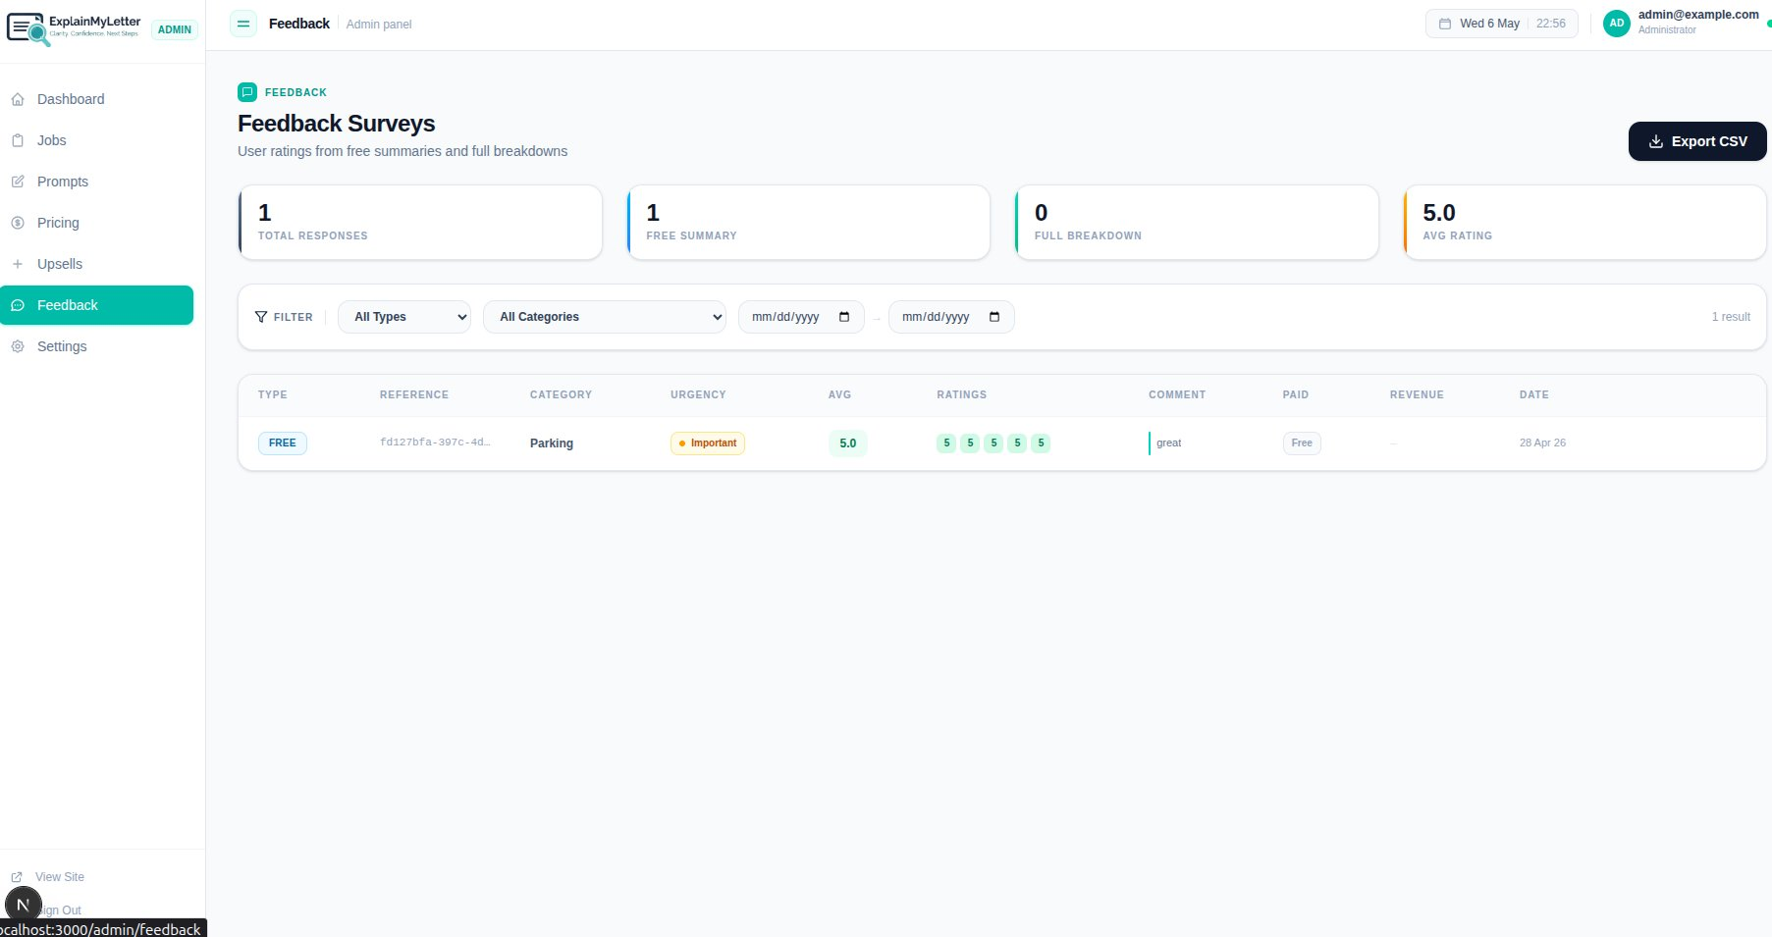

Feedback Overview Stats
Field | What it does | Example / Default
Total Responses | The total number of feedback submissions received across all jobs. | e.g. 1
Free Summary | How many of the feedback responses came from users of the free summary (not the paid breakdown). | e.g. 1
Full Breakdown | How many responses came from users who paid for the full breakdown. | e.g. 0
Avg Rating | The average star rating across all feedback submissions (out of 5). | 5.0

Feedback Filter
Use the filter tools to narrow down feedback by:
- Type — All Types, Free Summary only, or Full Breakdown only
- Category — Filter by letter type (e.g. only Parking feedback)
- Date range — Set a From and To date

Feedback Table Columns
Field | What it does | Example / Default
Type | Whether this feedback was for a Free summary or a Paid full breakdown. | FREE / PAID
Reference | The job reference ID this feedback belongs to. Can be cross-referenced with the Jobs page. | fd127bfa-...
Category | The letter category for this job. | Parking
Urgency | The urgency level of that job. | Important
Avg | The average rating score for this submission (out of 5). | 5.0
Ratings | Individual scores given across the different rating dimensions (shown as numbered bubbles). In the example, five 5-star ratings were given. | 5 5 5 5 5
Comment | Any written comment left by the user. | great
Paid | Whether the feedback came from a free or paid job. | Free / Paid
Revenue | The revenue generated by the job this feedback is linked to. | £0 for free
Date | When the feedback was submitted. | 28 Apr 26

Export CSV
Click the 'Export CSV' button in the top-right to download all feedback data as a spreadsheet. This is useful for analysing ratings trends, identifying problem categories, or sharing satisfaction data with stakeholders.

10. Settings — OCR & Extraction
The Settings page is divided into five tabs. Start with the 'OCR & Extraction' tab. This tab controls the quality thresholds for the document scanning process. Click 'Settings' in the sidebar, then select the OCR & Extraction tab.

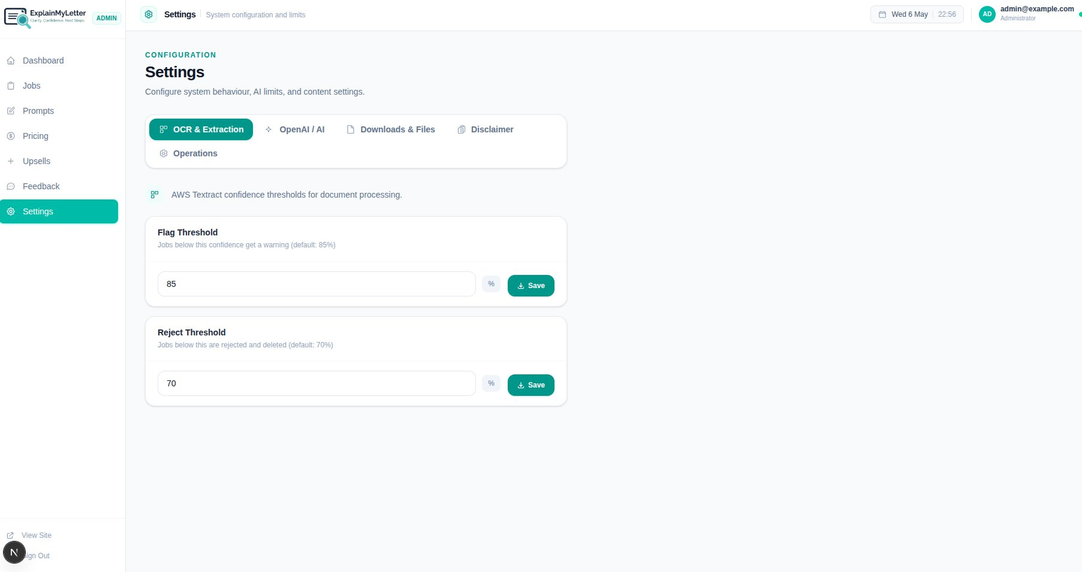

What is OCR?
OCR stands for Optical Character Recognition. When a user uploads a photo or scanned image of a letter, the system uses AWS Textract (Amazon's OCR service) to extract the text from the image. The OCR engine assigns a confidence score to each block of extracted text — higher confidence means the text was read more accurately.

Flag Threshold
Field | What it does | Example / Default
Default value | 85%
What it does | Jobs where the OCR confidence score falls between 70% and 84% are processed but flagged with a warning. The user is shown a notice that some text may be unclear and is offered the option to re-upload a clearer image. Processing continues — the user is not blocked.
When to lower it | If you are getting too many unnecessary warnings on acceptable-quality documents, try lowering this to 80%. | 80
When to raise it | If users are receiving poor-quality output from marginally legible documents, raise this to 88% or 90% to flag more of them. | 90

- Enter the new threshold value in the Flag Threshold field.
- Click 'Save'.

Reject Threshold
Field | What it does | Example / Default
Default value | 70%
What it does | Jobs where OCR confidence falls below 70% are automatically rejected. The document is considered too poor quality to process reliably. The file is deleted immediately, the user is shown an error message with a highlighted preview of unreadable areas, and they are asked to re-upload a clearer image. No charge is made.
When to lower it | If the system is rejecting documents that users report as readable, try lowering to 60–65%. | 65
When to raise it | If you want stricter quality control and are willing to reject more borderline documents, raise to 75%. | 75

IMPORTANT The Reject Threshold must always be lower than the Flag Threshold. A sensible gap of at least 10–15 percentage points between them is recommended. Setting them too close together reduces the usefulness of the warning system.

- Enter the new threshold value in the Reject Threshold field.
- Click 'Save'.

11. Settings — OpenAI / AI
This tab controls how the AI model is configured — which model is used, how many tokens are allowed per request, and your monthly usage cap. Select the 'OpenAI / AI' tab in Settings.

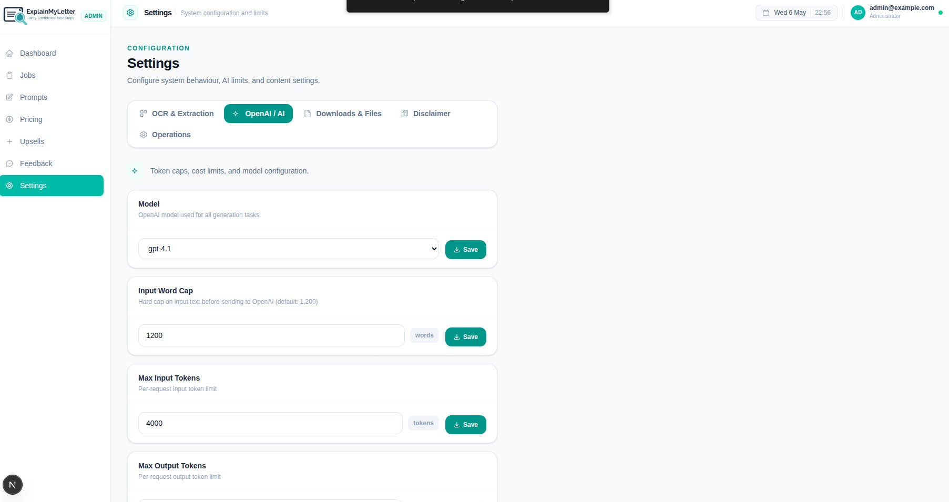

Model
Field | What it does | Example / Default
Default value | gpt-4.1
What it does | Selects the OpenAI model used for all AI generation tasks (both free summaries and paid breakdowns). gpt-4.1 is the recommended model — it provides high-quality, accurate output for document understanding.
When to change it | Only change this if instructed by your developer or if OpenAI releases a newer model you want to trial. Different models have different costs and quality levels. | gpt-4.1

- Use the dropdown to select a different model if needed.
- Click 'Save'.

Input Word Cap
Field | What it does | Example / Default
Default value | 1,200 words
What it does | This is a hard limit on how many words of document text are sent to OpenAI per request. If a user uploads a very long document, only the first 1,200 words are processed. This prevents unexpectedly high AI costs from very large documents.
When to increase it | If users frequently complain that important information at the end of their long letters is missing from their breakdown, consider increasing to 1,500 or 2,000 words — but be aware this will increase per-job AI costs. | 1500
When to decrease it | If you want to reduce costs and are satisfied the most important content is typically in the first part of letters. | 800

- Enter the new word limit.
- Click 'Save'.

Max Input Tokens
Field | What it does | Example / Default
Default value | 4,000 tokens
What it does | A token-level limit on the input sent to OpenAI per request (separate from the word cap — both limits apply). Tokens include both the document text and the prompt instructions.
Guidance | Leave at 4,000 unless your developer advises otherwise. This is a safety backstop alongside the word cap. | 4000

- Enter the new token limit.
- Click 'Save'.

Max Output Tokens
(Visible by scrolling down on this tab.) This controls the maximum length of the AI's response per request. A higher value allows longer, more detailed breakdowns — but increases cost. The default is typically 1,000–2,000 tokens. Save after changing.

Monthly Cap & Email Alerts
(Visible by scrolling further down.) The monthly cap limits total OpenAI token usage for the calendar month:
- Enter the monthly token cap (e.g. 1,000,000 tokens).
- The system automatically disables paid AI generation when 100% of the cap is reached.
- An email alert is automatically sent to the email selected in the settings when usage reaches 80% of the cap (threshold is configurable see below).
- The cap resets automatically on the 1st of each month, or you can manually reset it early.

TIP Monitor your Dashboard's Monthly OpenAI Usage bar regularly. If you see it climbing quickly, check whether there is an unusual spike in submissions or whether your prompts are generating unusually long outputs that could be trimmed.

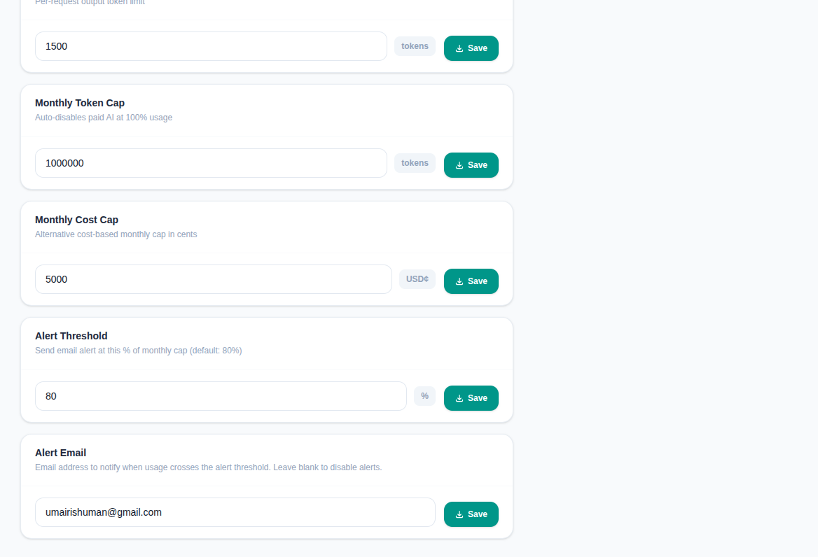

12. Settings — Downloads & Files
This tab controls how long files and download links remain accessible after a job is completed. Select the 'Downloads & Files' tab in Settings.

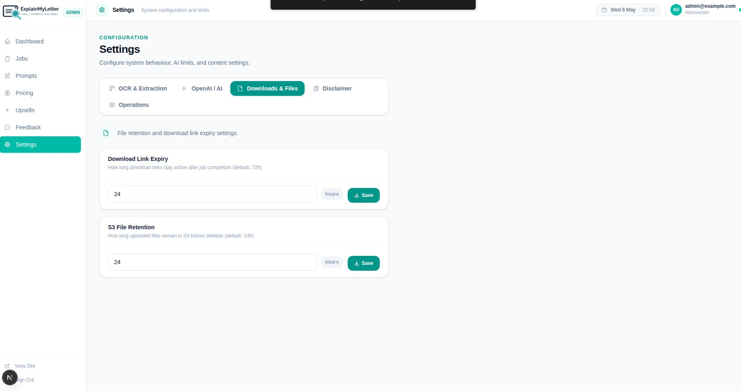

Download Link Expiry
Field | What it does | Example / Default
Default value | 24 hours
What it does | After a job is completed, the user receives download links for their PDF, Word, and text files. This setting controls how many hours those download links remain active. After expiry, the links stop working and the user must contact support to retrieve their files.
When to increase it | If users frequently report that their download links have expired before they could access them, increase to 48 or 72 hours. | 72
When to decrease it | For tighter data security and GDPR compliance, lower this to 12 or 24 hours. | 12

- Enter the new expiry duration in hours.
- Click 'Save'.

S3 File Retention
Field | What it does | Example / Default
Default value | 24 hours
What it does | Controls how long the original uploaded document files are stored in AWS S3 (Amazon's cloud storage) before being automatically deleted. This is separate from the download link expiry — it governs the original uploaded file, not the generated output files.

IMPORTANT User-uploaded documents contain personal and sensitive information. Keep the S3 File Retention period as short as practically possible. The platform is designed to process documents quickly — long retention periods are not necessary and create unnecessary data privacy risk.

- Enter the new retention duration in hours.
- Click 'Save'.

13. Settings — Disclaimer
This tab lets you edit the legal disclaimer text and checkbox label shown to users before they can proceed to payment. Select the 'Disclaimer' tab in Settings.

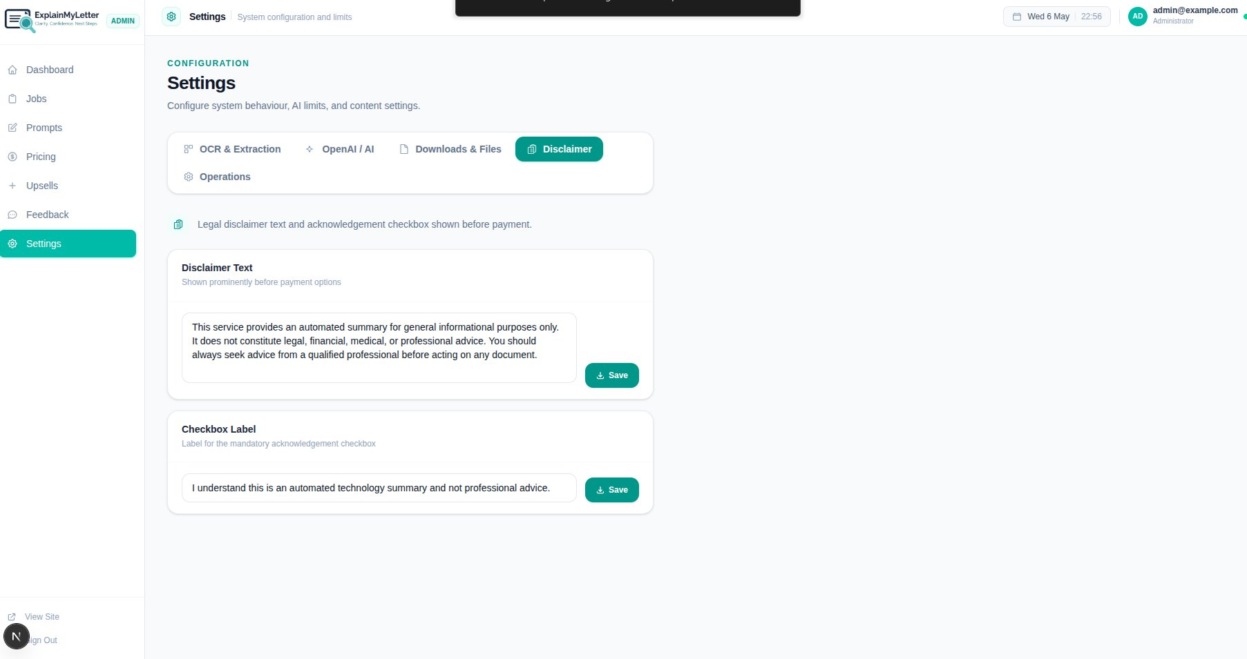

Disclaimer Text
Field | What it does | Example / Default
What it does | This text is displayed prominently to the user on the results page, before the payment options are shown. It must be clearly visible without scrolling.
Default text | This service provides an automated summary for general informational purposes only. It does not constitute legal, financial, medical, or professional advice. You should always seek advice from a qualified professional before acting on any document.

- Edit the disclaimer text in the text area.
- Click 'Save' to update it immediately. Changes take effect on the next page load for users.

Checkbox Label
Field | What it does | Example / Default
What it does | This is the label shown next to the mandatory acknowledgement checkbox. Users must tick this before the payment button is enabled.
Default text | I understand this is an automated technology summary and not professional advice.

- Edit the checkbox label text in the field.
- Click 'Save' to update.

IMPORTANT The disclaimer acknowledgement is validated both on the user's screen (the pay button stays disabled until ticked) and on the server (the system refuses to create a Stripe payment session if the acknowledgement flag is false). Do not remove or weaken this protection.

14. Settings — Operations
The Operations tab controls system behaviour settings: stuck job detection, regeneration limits, and data retention. Select the 'Operations' tab in Settings.

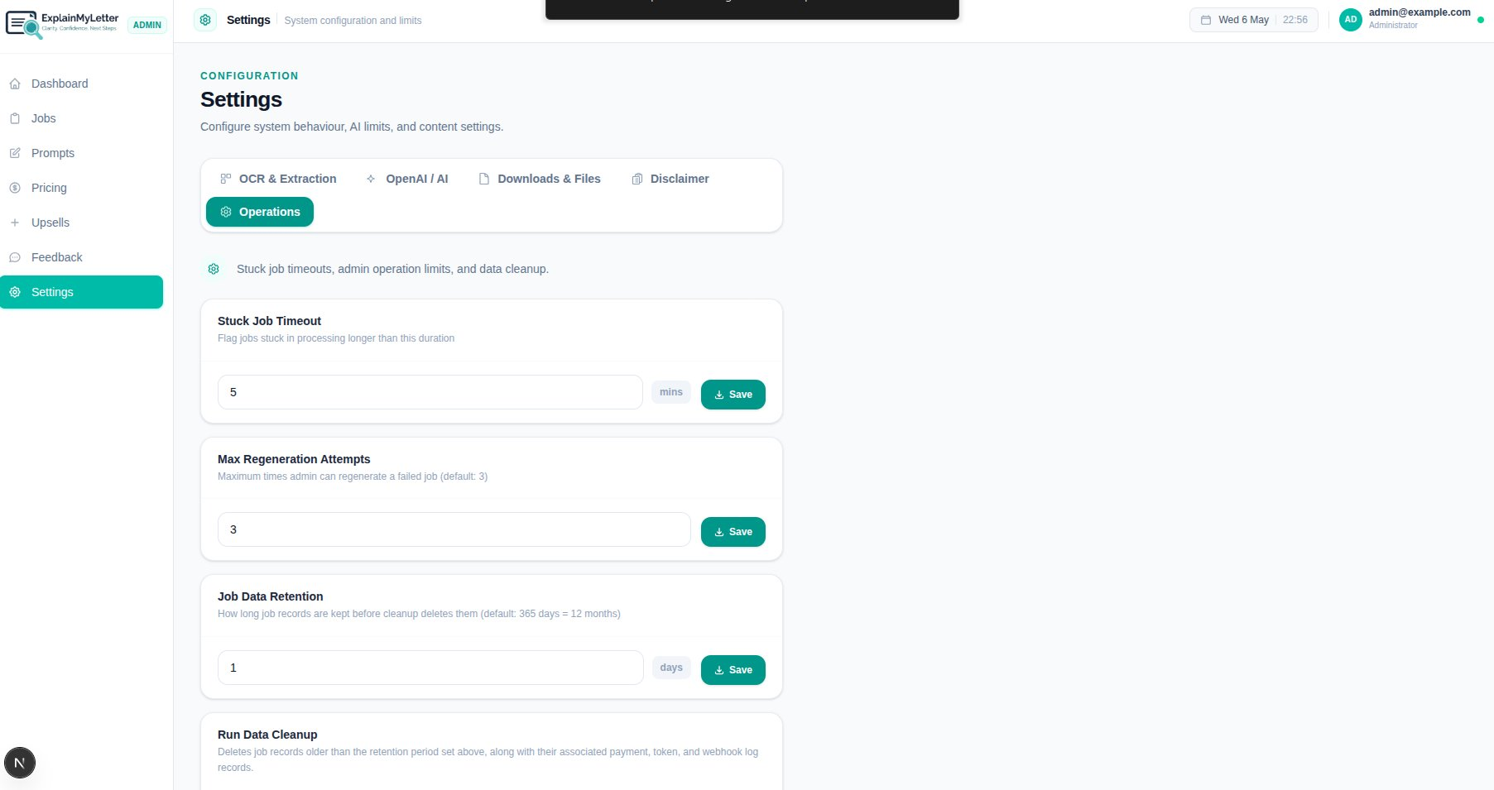

Stuck Job Timeout
Field | What it does | Example / Default
Default value | 5 minutes
What it does | If a job remains in a processing state (e.g. OCR Processing or Paid Breakdown Generating) for longer than this timeout period, it is automatically flagged in the admin dashboard as 'stuck'. This helps you identify and investigate jobs that may have encountered a silent error.
When to increase it | If legitimate processing (particularly for large or complex documents) regularly takes longer than 5 minutes and generates false stuck-job alerts, increase to 10 minutes. | 10
When to decrease it | If you want faster detection of stuck jobs and your infrastructure is reliably fast, lower to 3 minutes. | 3

- Enter the new timeout in minutes.
- Click 'Save'.

Max Regeneration Attempts
Field | What it does | Example / Default
Default value | 3 attempts
What it does | The maximum number of times an admin can use the 'Regenerate' button on a failed job. Once this limit is reached, the Regenerate button is disabled for that job. This prevents runaway AI costs from repeatedly re-attempting a job that will keep failing.
When to increase it | If you frequently encounter jobs that need more than 3 regeneration attempts (e.g. due to intermittent API issues), increase this to 5. | 5
When to decrease it | To limit costs and force a manual review after fewer retries. | 2

- Enter the new maximum number of regeneration attempts.
- Click 'Save'.

Job Data Retention
Field | What it does | Example / Default
Default value | 1 day (shown as 1 in the current config — recommended to change to 365 for production)
What it does | How many days job records are kept in the database before the automated cleanup process deletes them. This includes job metadata, token usage logs, and payment records. Note: this does not affect Stripe's own records, which are kept by Stripe independently.
Recommended production value | 365 days (12 months) — as specified in the system requirements. | 365
When to reduce it | Only reduce below 365 days if required by specific data privacy obligations or if database storage becomes a concern. | 180

IMPORTANT The current value of '1' day in the screenshot appears to be a test/development configuration. For production use, this should be set to 365 days to retain 12 months of job history for audit, support, and dispute purposes.

- Enter the new retention period in days (enter 365 for the recommended 12-month retention).
- Click 'Save'.

Run Data Cleanup
Below the Job Data Retention setting is a 'Run Data Cleanup' button. This manually triggers the cleanup process, deleting all job records older than the configured retention period.

IMPORTANT Running Data Cleanup is permanent and irreversible. All job records older than the retention period — including their associated payment records, token logs, and webhook event logs — will be permanently deleted from the database. Only run this when you are certain you no longer need those records.

TIP The data cleanup process runs automatically on a schedule — you do not need to run it manually in normal operation. Use the manual trigger only if you need to immediately free up database space or perform a scheduled GDPR erasure.

15. Quick Reference Cheat Sheet
Use this section as a rapid-reference guide for the most common admin tasks.

Common Tasks at a Glance
Task | Where to go | How to do it
Check platform health | Dashboard | Look at the 4 stats cards (Total, Completed, Pending, Failed)
Find a specific user's job | Jobs | Search by email in the Search Email field
View all failed jobs | Jobs | Set Status filter to 'Failed'
Regenerate a failed paid job | Jobs → Job Detail | Open the job, click Regenerate (only visible on Failed + Paid jobs)
Issue a refund | Jobs → Job Detail | Open the job, click the red Issue Refund button
Change a category price | Pricing | Click edit on the category row, change the Base Price in pence, save
Add a new letter category | Pricing | Click + New Category, fill in Name, Price (pence), toggle Active, save
Create a new upsell | Upsells | Click + New Add-on, add Name and Description, toggle on categories and set prices, save
Edit an AI prompt | Prompts | Find the category + type, click edit, modify text (use {{document_text}} placeholder), save
Adjust OCR quality thresholds | Settings → OCR & Extraction | Change Flag Threshold (default 85%) or Reject Threshold (default 70%), click Save
Change the AI model | Settings → OpenAI / AI | Select model from dropdown, click Save
Adjust download link expiry | Settings → Downloads & Files | Enter new duration in hours, click Save
Edit the legal disclaimer | Settings → Disclaimer | Edit text in Disclaimer Text field, click Save
Check monthly AI usage | Dashboard | Look at the Monthly OpenAI Usage progress bar
Export feedback data | Feedback | Click Export CSV button

Default Settings Summary
Setting | Default | Location
OCR Flag Threshold | 85% | Settings → OCR & Extraction
OCR Reject Threshold | 70% | Settings → OCR & Extraction
AI Model | gpt-4.1 | Settings → OpenAI / AI
Input Word Cap | 1,200 words | Settings → OpenAI / AI
Max Input Tokens | 4,000 tokens | Settings → OpenAI / AI
Monthly Token Cap | 1,000,000 tokens | Settings → OpenAI / AI
Email Alert Threshold | 80% of monthly cap | Settings → OpenAI / AI
Download Link Expiry | 24 hours | Settings → Downloads & Files
S3 File Retention | 24 hours | Settings → Downloads & Files
Stuck Job Timeout | 5 minutes | Settings → Operations
Max Regeneration Attempts | 3 | Settings → Operations
Job Data Retention | 365 days (12 months) | Settings → Operations

