INSURANCE CHARGE PREDICTOR

INTERNSHIP REPORT
Submitted in partial fulfilment of the requirement for the award of the degree of
Bachelor of Technology
in
Computer Science & Engineering – AIML
Submitted to
DR. A.P.J. ABDUL KALAM TECHNICAL UNIVERSITY, UTTAR PRADESH, LUCKNOW

Submitted by  Student Name: Gurmeet Singh  Roll No: 2301531530027  Semester & Section: [Semester] / D | Under the Supervision of  [Industry Mentor Name]  [Designation]


Department of Computer Science & Engineering & Allied Branches
Lloyd Institute of Engineering & Technology
Plot No. 3, Knowledge Park II, Greater Noida, Uttar Pradesh 201306
Session: 2026–27
CERTIFICATE
This is to certify that the Internship Report entitled “Insurance Charge Predictor” is a bonafide record of the internship undertaken by Gurmeet Singh (Roll No. 2301531530027) at [Organisation Name, Location] from [DD/MM/YYYY] to [DD/MM/YYYY], in partial fulfilment of the requirements for the award of the degree of Bachelor of Technology in Computer Science & Engineering (AIML) during the academic session 2026–27, IV Year, at the Department of Computer Science & Engineering (AIML), Lloyd Institute of Engineering & Technology.
The work embodied in this report has not been submitted elsewhere for the award of any other degree or diploma. To the best of our knowledge, the report fulfils the prescribed structure and formatting requirements of the Internship Report guidelines.

______________________  Internship Coordinator  [Name]  [Designation] | ______________________  Head of Department  [Name]  [Designation]

Date: [DD/MM/YYYY]
Place: [City]

INTERNSHIP COMPLETION CERTIFICATE
[Attach the authentic internship completion certificate issued by the host organisation.]
DECLARATION
I hereby declare that the Internship Report entitled “Insurance Charge Predictor” submitted to the Department of Computer Science & Engineering (AIML), Lloyd Institute of Engineering & Technology, in partial fulfilment of the requirements for the degree of B.Tech. in Computer Science & Engineering (AIML), is a record of the work carried out by me during my internship at [Organisation Name] from [DD/MM/YYYY] to [DD/MM/YYYY], under the guidance of [Industry Mentor Name, Designation].
I further declare that this report has not been copied from any other source, and that all references, data and material taken from other sources have been duly acknowledged. Any confidential information of the organisation has been included only with its permission.

Signature: ____________________
Name: Gurmeet Singh
Roll No.: 2301531530027
Date: [DD/MM/YYYY]
Place: [City]
ACKNOWLEDGEMENT
I would like to express my sincere gratitude to [Organisation Name] for giving me the opportunity to undertake my internship in the area of machine learning and regression. I am especially thankful to my industry mentor, [Mentor Name, Designation], for the valuable guidance, patient support and constructive feedback throughout the internship period.
I am grateful to [Coordinator Name], Internship Coordinator, and [HOD Name], Head of the Department of Computer Science & Engineering (AIML), for providing the necessary support and facilities. I extend my thanks to [Dean Name], Lloyd Institute of Engineering & Technology, for providing a conducive academic environment.
Finally, I thank all the faculty members, my family and friends for their continuous support and motivation during the course of this internship.

Gurmeet Singh
2301531530027
ABSTRACT
Insurance Charge Predictor is a supervised regression application that estimates the medical charge recorded in a public insurance benchmark from age, sex, body mass index, dependents, smoking status and US region. The project covers data auditing, preprocessing, model comparison, evaluation and a local browser interface.
The original dataset contains 1,338 records. Removing one exact duplicate produces 1,337 clean records, with no missing cells. A fixed 80/20 split creates 1,069 training records and 268 test records. A mean baseline, ridge regression, random forest and gradient boosting are compared by five-fold cross-validation on training records. All preprocessing steps remain inside the pipeline to avoid leakage.
Gradient boosting obtains the lowest mean cross-validation MAE of USD 2,097.37. On the held-out test records, it records an MAE of USD 1,352.65, an RMSE of USD 3,297.50 and an R² of 0.9246. The browser application supports individual profiles, scenario comparison and batch CSV prediction. Verification reproduces saved metrics and rejects invalid inputs.
The contribution is a complete, reproducible educational application. The historical US benchmark does not establish current Indian premiums, individual prediction intervals or policy eligibility. Differences between cross-validation and test performance demonstrate the need for broader validation.
Keywords: supervised learning, regression, insurance charges, gradient boosting, cross-validation.
TABLE OF CONTENTS
CHAPTER 1: INTRODUCTION 1
1.1 Background of the Internship 1
1.2 Internship Details 3
1.3 Objectives of the Internship 4
1.4 Scope of the Internship 6
CHAPTER 2: ORGANISATION PROFILE 8
2.1 About the Organisation 8
2.2 Vision, Mission and Services 9
2.3 Organisational Structure 9
2.4 Department and Project Stakeholders 10
CHAPTER 3: INTERNSHIP OVERVIEW 11
3.1 Role and Responsibilities 11
3.2 Internship Schedule and Activity Sequence 12
3.3 Tools and Technologies Used 13
3.4 Skills and Concepts Applied 15
CHAPTER 4: WORK UNDERTAKEN 17
4.1 Project Overview and Architecture 17
4.2 Methodology and Dataset Provenance 19
4.3 Implementation and Folder Organisation 33
4.4 Challenges and Integration Decisions 42
CHAPTER 5: RESULTS AND LEARNING OUTCOMES 43
5.1 Results and Experimental Evidence 43
5.2 Verification and Reproducibility Checks 53
5.3 Learning Outcomes 55
CHAPTER 6: CONCLUSION AND FUTURE SCOPE 56
6.1 Conclusion 56
6.2 Limitations 57
6.3 Future Scope 58
APPENDICES 60

CHAPTER 1: INTRODUCTION

1.1 Background of the Internship
Insurance Charge Predictor is a supervised machine learning application that estimates the charges recorded in a public medical-cost dataset. A user supplies age, sex, body mass index, number of children or dependents, smoking status and US region. The application returns a numerical estimate in US dollars. Because the answer is a continuous amount, the learning task is regression. The application demonstrates the complete path from a CSV file to an interactive prediction.
The project combines an experiment with a usable software interface. The experiment compares four approaches on the same training partitions. The application loads the selected fitted pipeline and exposes it through a local browser form and CSV batch requests. Training and prediction share a feature schema, which reduces the chance that a form input is interpreted differently from a training column.
The original dataset contains 1,338 rows. One exact duplicate is removed, leaving 1,337 clean records. A fixed split assigns 1,069 records to training and 268 to testing. Gradient boosting is selected by the lowest mean five-fold training cross-validation MAE. Its held-out MAE is USD 1,352.65, RMSE is USD 3,297.50 and R² is 0.9246. These are measurements from this experiment rather than guaranteed future errors.
The project is intended for a B.Tech. evaluation in CSE AIML. Its practical contribution is the connection between data cleaning, reproducible model selection, input validation and a working demonstration. The historical benchmark does not establish current insurance premiums, policy eligibility or a tariff for a particular insurer. The report therefore explains the target precisely and presents the limits alongside the results.

1.1.1 Problem Statement and Motivation
A spreadsheet of past observations does not directly answer what charge a new profile may resemble. Manually choosing similar rows is inconsistent and becomes difficult when several inputs interact. The project formulates this as a learning problem: given a feature vector x with six recorded attributes, estimate the target y called charges. The learned function produces an estimate for an admissible new vector using patterns found in the training records.
The central engineering problem is to make this estimate reproducible and understandable. A model score alone is insufficient if the data source is unclear, duplicates appear in both partitions, the interface changes the feature order, or a user enters unsupported categories. The solution therefore treats the data contract, evaluation protocol and user interface as parts of the same system.
Question | Project response
What is predicted? | The numerical charges field in the source benchmark.
What evidence is available? | Six profile inputs and one observed target per record.
How is quality measured? | Training cross-validation and an isolated test set.
How is the result used? | An educational form, profile comparison and CSV output.

This topic was chosen because a small tabular dataset permits transparent inspection and quick demonstrations on a normal computer. It supports a simple mean baseline, an interpretable linear comparison and nonlinear ensemble models within one consistent experiment. Evaluators can inspect both successful predictions and large errors, rather than relying only on a headline score. The scope is sufficiently focused for a mini project while still requiring meaningful software integration.

1.2 Internship Details
Field | Details
Student | Gurmeet Singh
University roll number | 2301531530027
Programme | B.Tech. CSE AIML, IV Year
Section | D
Institute | Lloyd Institute of Engineering & Technology
Project title | Insurance Charge Predictor
Host organisation | [Organisation name and location]
Industry mentor | [Name and designation]
Faculty mentor | [Name and designation]
Internship period | [Start date] to [End date]; [Duration]

The technical work described in this report consists of dataset inspection, cleaning, model development, evaluation and local application integration. Its evidence is stored in the project files. The data audit documents changes to the CSV; the split manifest records partition membership; and saved predictions permit independent recalculation of the test metrics.
Official internship records have a different purpose from technical evidence. The offer letter, attendance diary, completion certificate and mentor feedback should contain the actual dates and authorised signatures. The corresponding fields and attachment positions are retained in the report so the final institutional submission can be completed using authentic records.
The academic focus is the application of machine learning and software engineering concepts learned in the CSE AIML programme. The project can be demonstrated locally without connecting to an insurer or asking an evaluator for personal documents. Sample profiles and the supplied example CSV provide a repeatable evaluation sequence.

1.3 Objectives of the Internship
The primary objective is to build an explainable regression workflow that can be run and inspected during an evaluation. The workflow must preserve source data, apply a documented cleaning policy, compare reasonable model families and serve predictions through a usable interface. Each objective is linked to a concrete artifact so that completion can be checked directly.
Objective | Evidence and acceptance condition
Traceable data | raw.csv remains unchanged; its SHA-256 matches the audit.
Clean inputs | clean.csv contains 1,337 unique complete records.
Fair comparison | Four candidates use the same five training folds.
Isolated evaluation | 268 test records are excluded from fitting and selection.
Reusable inference | A saved pipeline serves form and CSV predictions.
Clear demonstration | The interface exposes metrics, data audit and downloads.

A secondary objective is to distinguish an observed experimental result from a stronger claim that the experiment does not support. For example, R² is a regression score and should not be described as classification accuracy. A test MAE is an average over a particular sample; it is not an error bound for every profile. These distinctions are essential when explaining the project in a viva.
The learning objectives also include consistent file organisation, explicit validation, readable documentation and repeatable commands. Completing these steps produces a project that an evaluator can run independently. It also makes failures easier to diagnose: a missing model, invalid CSV or unsupported category should lead to a clear error rather than a misleading numerical output.

1.3.1 Use and Reasons for Choosing the Project
The immediate use is educational: the application makes the relationship between a tabular dataset and a trained prediction system visible. A student can change inputs, observe estimates, compare model families and explain how preprocessing works. The numeric target makes errors easy to express in the same units as the output. This is useful for understanding the practical meaning of regression metrics.
The project is suitable for an evaluation because it has a short, complete demonstration path. The evaluator first sees a valid profile and an estimate, then the model comparison and test results, and finally the cleaning audit and batch output. The presentation can move from user-facing behaviour to experimental evidence without requiring a separate notebook server or an external API.
The choice also creates opportunities for discussing technical tradeoffs. Ridge regression provides a regularised linear comparison. Random forest and gradient boosting can represent nonlinear patterns. Keeping a mean baseline establishes whether the extra complexity adds value. A shared pipeline prevents the selected estimator from becoming disconnected from the preprocessing used to train it.
The implemented system is not a commercial quotation service. Its output describes a benchmark target, and the dataset omits many attributes that a real product might require. A future system for a specific population would need an appropriate dataset, a precise target definition and independent validation. Recognising that boundary makes the project easier to defend honestly and keeps its academic purpose clear.

1.4 Scope of the Internship
The scope includes a local supervised regression experiment, a saved prediction pipeline and a browser interface. The input schema has exactly six features. The target is used only during training and evaluation; it must not be included in a prediction request. The application supports individual profiles, temporary scenario comparisons and a feature-only CSV batch.
Included | Outside the implemented scope
CSV audit and duplicate removal | Collection of new policyholder records
Four-model comparison | A search across every possible algorithm
Cross-validation and held-out testing | Independent temporal or external validation
Local form and batch predictions | Provider integration or commercial underwriting
Numerical estimates in USD | Current Indian premiums or eligibility decisions

The observed numeric ranges define the supported demonstration inputs: age 18–64, BMI 15.96–53.13 and children 0–5. Categorical values are restricted to those represented in the benchmark. These checks prevent obvious extrapolation outside individual feature ranges, although they do not prove that every possible combination is well represented in the data.
The software runs on the local loopback address and uses files already present in the project folder. First-time dependency installation needs internet access. Once installed, training and prediction use local data and artifacts. There is no user-account system, online policy database or claim-processing workflow in this version. The report and demonstration should describe that implemented behaviour consistently.

1.4.1 Functional Requirements and User Scenarios
A functional requirement states what a user or evaluator can do. The most important requirement is that a valid profile produces a finite prediction using the saved preprocessing and model. Supporting requirements make that result inspectable: the interface displays evaluation metrics, identifies the dataset scope and permits example data to be used without manual CSV preparation.
Scenario | Expected behaviour
Predict one profile | Validate six inputs and show estimated charges in USD.
Compare profiles | Keep selected estimates in a temporary browser table.
Inspect evaluation | Display test metrics and training model comparison.
Inspect data | Display row counts, cleaning audit and a preview.
Predict a batch | Validate a feature CSV and return every predicted row.
Submit invalid data | Return a clear message without generating an estimate.

For a repeatable demonstration, the presenter can begin with a preset profile, predict it and save the result to comparison. A second profile can then be added. The comparison illustrates how the fitted function responds to inputs; it is not a controlled causal study. The included five-row CSV provides a separate path that exercises the same validation and inference functions.
Nonfunctional requirements are modest but concrete. The app should run from documented commands, preserve raw data, avoid saving form requests, and use a small dependency set. The project supplies source code, a notebook and verification commands so an evaluator can trace the result beyond the browser screen. These requirements guide the architecture discussed in Chapter 4.

CHAPTER 2: ORGANISATION PROFILE

2.1 About the Organisation
Host organisation: [Organisation name]. Official address: [Address and location]. Department or business unit: [Department name]. The final institutional copy should contain the organisation’s approved description, service areas and reporting details in these fields.
The project itself belongs to the domain of applied machine learning for tabular data. It uses a public benchmark rather than a proprietary host dataset. The technical deliverables therefore remain reproducible independently of a particular organisation. They include the original and cleaned CSV files, a fitted pipeline, evaluation artifacts and the local interface.
Organisation record | Information to enter
Official name and location | [Organisation name and full address]
Primary activities | [Verified principal services or products]
Internship department | [Department or team]
Industry supervisor | [Name, designation and department]
Official internship evidence | [Offer letter and completion certificate references]

An organisation profile should describe the actual host rather than infer company facts from the project topic. For example, developing an insurance dataset demonstration does not establish that the host is an insurer. The technical context in this chapter therefore identifies how the project’s activities relate to a software or analytics workflow, while official company information remains in its dedicated fields.
The report’s source-code and experiment sections can be evaluated using the supplied files. Institutional confirmation of internship duration and supervision should be supported by the signed records included in the front matter and appendices.

2.2 Vision, Mission and Services
Organisation vision: [Insert the official vision statement]. Organisation mission: [Insert the official mission statement]. Principal services: [Insert verified services relevant to the internship]. These statements should be completed from an authorised organisation source.
At the project level, the working aim is to make a regression experiment understandable and repeatable. The application turns a technical workflow into steps that an evaluator can inspect: a clear data source, a documented transformation, a defensible model comparison and a validated prediction interface. This aim describes the project and does not replace the organisation’s official mission.
The software workflow demonstrates services that commonly appear in an analytics development process. Data preparation produces a clean table and rejection audit. Model development produces a selected fitted pipeline. Evaluation produces metrics and diagnostic plots. Interface integration makes the saved function accessible through a local application. Each output has a specific owner in the code and a clear location in the folder structure.

2.3 Organisational Structure
Role | Reporting field
Organisation / business unit | [Organisation and unit]
Industry supervision | [Industry mentor and designation]
Academic supervision | [Faculty mentor and designation]
Student project work | Gurmeet Singh, CSE AIML, Section D

The reporting arrangement should connect technical review to institutional supervision. Code, metrics and demonstrations can support a review meeting; attendance and official feedback require the actual organisation’s records. Keeping these evidence types clear helps prevent technical artifacts from being mistaken for official internship approval.

2.4 Department and Project Stakeholders
The project workflow involves several review roles even though the software can be developed and demonstrated by one student. The student maintains the implementation and explains the experiment. A technical mentor can inspect assumptions, data preparation and evaluation choices. An academic evaluator can assess understanding, reproducibility and the quality of the demonstration.
Stakeholder | Information needed from the project
Student developer | Readable modules, documented commands and test feedback.
Technical mentor | Data provenance, pipeline design and experimental evidence.
Academic evaluator | Problem definition, measured results and a working demo.
Demonstration user | Valid input choices, a clear output and understandable errors.

The main handoffs occur between data preparation, model training and application inference. The training program writes a bundle that contains the fitted pipeline, expected features, metrics and library versions. The application reads this bundle instead of rebuilding transformations in JavaScript. This handoff is important because the browser should submit feature values, not invent its own category codes.
Documentation supports a second handoff: another person should be able to open the project folder and reproduce the workflow. The README supplies setup commands, the source-data note explains provenance, and the report explains the decisions. The verification script connects these documents to checks on actual files. The department name, mentor identities and official reporting chain remain [Department and reporting details] until completed using institutional records.

CHAPTER 3: INTERNSHIP OVERVIEW

3.1 Role and Responsibilities
The student’s technical role is to build and explain a complete tabular regression application. Responsibilities begin with defining the prediction target and end with a repeatable demonstration. The work includes validating the data contract, keeping source data unchanged, constructing model pipelines, comparing candidates and connecting the selected pipeline to form and CSV inputs.
The implementation separates responsibilities into small modules. The schema module defines valid columns and values. The training module owns cleaning, splitting, cross-validation and evaluation. The prediction module owns bundle loading and inference. The local server owns HTTP routes, while the browser files own presentation and temporary scenario state. This division makes it possible to explain each stage independently.
Responsibility | Deliverable
Data preparation | raw.csv, clean.csv, removed_rows.csv and audit JSON
Experiment design | Split manifest, seed and training CV comparison
Model integration | Saved pipeline and shared prediction function
Quality checks | Metric reproduction and invalid-input tests
Communication | Report, presentation, walkthrough and demo guide

A responsibility is considered demonstrated when its corresponding artifact can be inspected or reproduced. For example, a claim that preprocessing uses only training records is supported by the fitted scaler statistics and the verification script. Official internship attendance, mentor approval and calendar dates belong to the signed records rather than being inferred from the existence of these technical files.

3.2 Internship Schedule and Activity Sequence
The development sequence follows the dependencies between project stages. The target and schema must be understood before cleaning. Cleaning must be complete before a split is saved. The model comparison must finish before a final model is selected. Interface integration then uses the saved model, and verification checks the complete path. The table records this sequence without assigning unconfirmed calendar dates.
Stage / dates | Activity | Evidence
[Week / dates] | Problem and data inspection | Target definition; source note
[Week / dates] | Validation and cleaning | Clean CSV; rejection audit
[Week / dates] | Model development | Four candidate pipelines
[Week / dates] | Selection and evaluation | CV table; test predictions
[Week / dates] | Application integration | Form, comparison and CSV routes
[Week / dates] | Verification and documentation | Checks; report; presentation

The sequence also provides a practical debugging order. If the interface fails, the command-line predictor can be run first. If predictions differ, the saved bundle and feature schema can be checked. If a metric changes, the split manifest, raw-data hash and installed versions can be compared before changing an algorithm.
The actual internship diary should add dates, work completed, review comments and mentor initials. A software milestone is evidence of a technical activity, but it does not by itself establish the date or duration of that activity. The editable diary in the appendix is intended for those verified records.

3.3 Tools and Technologies Used
Python is used for training, validation, prediction and the local HTTP server. pandas provides labelled tables and CSV handling. NumPy provides numerical operations and finite-value checks. scikit-learn supplies preprocessing, pipelines, candidate regressors, cross-validation and regression metrics. Matplotlib produces the diagnostic figures, and joblib stores the fitted bundle.
Technology | Project use
Python 3.12 | Application runtime and command-line programs
pandas / NumPy | Data frames, CSV parsing and numeric validation
scikit-learn 1.9.1 | Preprocessing, model comparison and prediction
Matplotlib | Distribution, comparison and diagnostic charts
joblib | Persistence of the trusted fitted pipeline
HTML / CSS / JavaScript | Browser forms, navigation, tables and downloads
HTTP standard library | Local server bound to 127.0.0.1

The requirements file pins scikit-learn and gives version ranges for supporting packages. The tested environment versions are recorded in reports/tested_versions.json. This record matters because a serialised model depends on the library representation used to create it. Retraining after installing dependencies is recommended so the model and runtime agree.
The main app does not require a notebook server or a web framework. The optional walkthrough notebook explains the workflow interactively, while the browser application runs with python run.py. Keeping this distinction clear makes setup easier for an evaluator: the complete demonstration can be performed using the documented Python environment and a normal browser.

3.3.1 Frontend, Backend and File Technologies
The frontend is implemented using plain HTML, CSS and JavaScript. HTML defines the input controls and result panels. CSS provides the page layout and visual hierarchy. JavaScript changes the active panel, collects values, sends requests to the local server, displays responses and prepares downloadable files. It also keeps comparison scenarios in memory for the current page session.
The backend uses Python’s ThreadingHTTPServer with an explicit route map. GET requests serve the interface, evaluation JSON, example CSV and permitted figures. POST requests accept either a JSON profile collection or CSV text. Both prediction routes call the same Python inference function. The server therefore remains the authority for schema validation even when the browser performs convenience checks.
File format | Reason for use
CSV | Readable tabular data and portable batch inputs/outputs
JSON | Metrics, audit records and structured HTTP responses
joblib | A complete fitted Python preprocessing/model bundle
PNG | Stable screenshots and charts for the report/interface
Markdown / notebook | Readable setup, explanation and walkthrough

The implementation stores generated evidence in predictable folders rather than mixing it with the source CSV. This is useful during evaluation because the presenter can move directly from a result to its underlying file. It also limits accidental mistakes such as editing the original data or loading a prediction CSV as if it were training data. The full folder and module map appears in Chapter 4.

3.4 Skills and Concepts Applied
The project applies supervised learning, regression, data preprocessing and experimental comparison. It also requires software concepts such as modular design, input contracts, serialisation, HTTP requests and reproducible commands. These ideas interact: a model can only be evaluated fairly if data handling is correct, and a user-facing estimate is only meaningful if the application uses the same transformations as training.
A key reasoning skill is choosing a comparison before inspecting the test result. The project uses training cross-validation MAE as its selection criterion. It reports RMSE and R² as complementary measures. This prevents a candidate from being selected simply because one test metric looks attractive. The mean baseline provides a reference that helps determine whether more complex models learn useful structure.
Another skill is distinguishing data cleaning from changing the learning problem. Removing an exact duplicate follows a documented rule. Deleting expensive observations merely because they are difficult to predict would change the target distribution and could make the result misleading. The project retains finite, nonnegative charge observations, including the high-cost tail, and analyses the resulting large errors.
Communication is also part of the work. An evaluator should be able to understand the target, follow a profile through the system and identify one limitation. The report therefore connects each technical choice to its effect on the experiment or application. Clear explanations of units, errors and data scope are treated as part of the project’s correctness rather than as optional presentation details.

3.4.1 Feasibility and Design Decisions
The prototype is technically feasible on a normal development computer because it uses a small tabular dataset and modest models. Training compares four candidates on five folds rather than running an extensive search. Inference loads a small saved bundle and evaluates a limited number of validated profiles. The application can operate without external services once dependencies are installed.
Decision | Reason | Tradeoff
Local CSV dataset | Simple, reproducible input | Limited population and time coverage
Fixed split and seed | Repeatable evaluation | One split may be unusually easy or hard
Shared preprocessing | Consistent train/inference path | Requires compatible saved libraries
Plain local web app | Easy demonstration | No production access-control system
Explicit schema | Clear input errors | Rejects values beyond the benchmark scope

Operational feasibility comes from the runbook and included examples. The presenter installs the requirements, trains, verifies and starts the server. The evaluation can then be repeated with known profiles and the five-row CSV. The model comparison, data audit and charts are available without needing to reconnect to a remote dataset source.
The design favours a complete and inspectable academic workflow. A more demanding deployment would require different decisions about authentication, monitoring, data collection, validation and maintenance. Those extensions should be justified by the intended users and target, rather than added only to increase the number of technologies in the project.

CHAPTER 4: WORK UNDERTAKEN

4.1 Project Overview and Architecture
The architecture has a training path and an inference path. Training reads the original CSV, normalises the schema, audits excluded rows and produces a clean dataset. It then creates a fixed holdout split, compares candidate pipelines on training folds, fits the selected pipeline and writes evaluation artifacts. The inference path reads the saved bundle and applies it to new validated features.
TRAINING
raw.csv -> normalise -> audit -> clean.csv
-> train/test split + split_manifest.csv
-> 5-fold candidate comparison on training rows
-> selected pipeline fitted on training rows
-> test metrics + charts + model bundle
INFERENCE
Browser form / CSV / command line
-> shared feature validation
-> saved preprocessing + regressor
-> finite estimate -> display / CSV download
The model bundle is the connection between the two paths. It contains the fitted pipeline together with expected features, metrics and library versions. The application does not refit the model when a user presses Predict. This keeps interactive behaviour tied to the experiment whose results are displayed.
The architecture also separates evidence from presentation. Metrics and audit values are written as files and read by the dashboard. The browser provides a readable view of those artifacts, while the report explains how they were created. The verification script independently checks their relationships. The following sections describe the data, transformation and module boundaries in detail.

4.1.1 System Requirements and Data Contracts
The runtime needs Python, the packages in requirements.txt and a browser. The model bundle, dashboard JSON, web files and source data should remain in their documented relative locations. The server resolves paths from the project root rather than relying on the terminal’s current working directory, which helps the app start consistently from the project folder.
Boundary | Contract
Training dataset | Six feature columns plus charges; no unexpected columns.
Prediction frame | Exactly age, sex, bmi, children, smoker, region.
Single/profile API | A JSON object containing a profiles list of 1–50 objects.
Batch API | Feature-only CSV, at most 2,000 rows and a 2 MB request.
Prediction response | Validated features, predicted_charges_usd and model metadata.

A data contract describes more than column names. Numeric inputs must be finite; age and children must be whole numbers; categorical values must belong to the recorded choices. Numeric ranges match the observed benchmark support. These rules are enforced in Python so every entry path receives the same treatment.
The browser should communicate validation failures clearly without presenting a stale result as a successful new prediction. The server returns structured error messages for invalid requests and unavailable artifacts. The project does not accept arbitrary filesystem paths or arbitrary model uploads through the UI. Those boundaries keep the local academic interface focused on the intended demonstration.

4.2 Methodology and Dataset Provenance
The dataset is insurance.csv from the public Machine Learning with R datasets repository maintained by stedy. The project includes an untouched copy as data/raw.csv and an attribution note as data/SOURCE.md. The note identifies the exact source and records a SHA-256 fingerprint. The related Medical Cost Personal listing is useful context, while the included raw file is the direct experimental input.
Provenance item | Recorded value
Original rows | 1,338
Original columns | 7: six features and charges
Clean rows | 1,337 after one exact duplicate is removed
Missing cells | 0 in the original and clean files
Data source | stedy / Machine-Learning-with-R-datasets / insurance.csv

The fingerprint is 505c1cbc2e63d0363bac59501563df2530aadf4cdb9cfee226f4ef32f5468281. A file hash identifies the exact bytes used; it does not establish that the underlying observations are representative, current or collected using a particular process. Provenance and representativeness therefore require separate explanations.
The benchmark records US region categories and is treated as a US-dollar charge dataset. Its public source does not establish a current tariff or a verified policy period for this application. The model learns the supplied target as recorded. The report avoids extending that target to current premiums or another country merely by changing a currency symbol. Source references are collected in Appendix F.

4.2.1 Feature Dictionary and Target Definition
The feature dictionary is shared across training and prediction. It defines what each column means within this benchmark and which values the demonstration accepts. The target charges is a numeric observation used to supervise the model. At inference time the target is unknown and must be absent from the request.
Field | Type | Allowed values / interpretation
age | Integer | 18–64 years
sex | Category | female or male, as recorded
bmi | Number | 15.96–53.13
children | Integer | 0–5 recorded children / dependents
smoker | Category | no or yes
region | Category | northeast, northwest, southeast, southwest
charges | Target | Finite nonnegative recorded charge, treated as USD

The interface uses readable labels, while the API and CSV retain stable column names. For example, the browser label Dependents maps to children. The term does not add new information beyond that source column. Sex is limited to the categories recorded in the dataset; those categories are a limitation of this benchmark rather than a complete description of all users.
The numeric range checks define an input boundary for the demo. They do not guarantee reliable estimates for every admissible combination. A 64-year-old with an unusual BMI and dependents count may still have few similar training examples. This distinction between individual ranges and joint coverage is part of the limitations discussed later in the report.

4.2.2 Cleaning Procedure and Audit Trail
Cleaning begins by checking the dataset columns. Categorical strings are stripped and converted to lowercase. Numeric columns and the target are converted to numeric values. Infinite values are treated as missing. Incomplete records would be recorded and removed before exact duplicate detection. The current source has no missing cells, so the only removal is one exact duplicate.
Audit measure | Value
Raw records | 1,338
Incomplete records removed | 0
Exact duplicates removed | 1
Clean records | 1,337
Clean missing cells | 0
Target policy | Retain finite nonnegative charges, including high values

The original file is never overwritten. Cleaned rows are written to clean.csv, and excluded rows are written to removed_rows.csv with their source row identifier and reason. This makes the transformation inspectable. A reader can verify that one row was excluded and see why, instead of treating cleaning as an undocumented preprocessing step.
Removing exact duplicates before splitting reduces the risk that an identical full record appears in both training and testing. It does not establish that all remaining observations represent different real people; the source does not provide identities for such a check. The verification script confirms that the current clean file equals the original file after exact duplicate removal and contains neither duplicate rows nor missing values.

4.2.3 Numerical Exploration of the Clean Dataset
Descriptive statistics provide a first check on scale, coverage and unusual values. The clean dataset contains 1,337 observations. Age and children are integer-valued, while BMI and charges are continuous. The table is calculated from data/clean.csv and therefore describes the complete benchmark rather than only the training subset.
Variable | Minimum | Median | Mean | Maximum
Age | 18 | 39 | 39.22 | 64
BMI | 15.96 | 30.40 | 30.66 | 53.13
Children | 0 | 1 | 1.10 | 5
Charges USD | 1,121.87 | 9,386.16 | 13,279.12 | 63,770.43

Mean charges exceed median charges, which indicates that high observations pull the average upward. The standard deviation of charges is about USD 12,110.36. This variation explains why an average prediction is a useful baseline but is unlikely to describe every profile well. It also motivates reporting an error measure that is sensitive to large mistakes alongside MAE.
Exploration should not be used to choose a final model by inspecting test errors repeatedly. These descriptive checks help understand data quality and the target. The actual candidate selection remains based on cross-validation within the training partition. If extensive data-driven feature design were added later, it would need to be confined to the appropriate training process.
Simple numeric correlations with charges are approximately 0.298 for age, 0.198 for BMI and 0.067 for children. These values describe linear marginal associations. They cannot rule out nonlinear relationships or interactions with categorical features, and they do not establish causal effects.

4.2.4 Categorical Coverage and Data Workflow Screen
The clean dataset has 675 male and 662 female records. It contains 1,063 non-smoker and 274 smoker records. Region counts are 364 southeast, 325 southwest, 324 northwest and 324 northeast. These counts help explain why the split is stratified by smoker status: the smaller category should remain represented in both partitions.
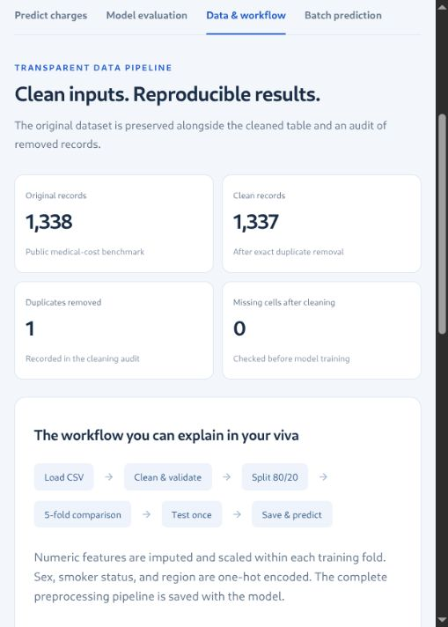
Figure 4.1 Actual Data and workflow screen showing the cleaning audit
The screenshot is taken from the running application. It exposes original and clean row counts, the duplicate count and missing-cell count, followed by the training workflow and a data preview. This gives the evaluator a visible connection between the files and the interface.
Balanced category counts alone do not establish representative sampling or fair model behaviour. Regional labels are coarse, and the public source does not provide enough collection detail to assess every source of sampling bias. The later subgroup tables describe errors on this test split and should be read as exploratory diagnostics rather than broad population conclusions.

4.2.5 Distribution of Recorded Charges
Recorded charges have a wide range and a right-hand tail. The median is USD 9,386.16, the 90th percentile is USD 34,832.74 and the 99th percentile is USD 48,537.80. These values are computed from the clean benchmark. They describe observations, not acceptable error thresholds or future price bounds.
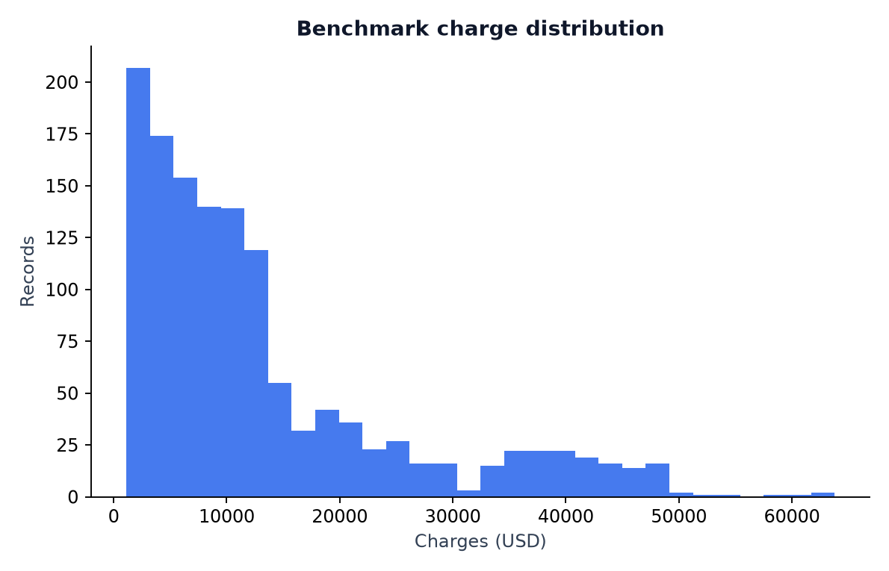
Figure 4.2 Charge distribution for the 1,337 clean benchmark records
The histogram shows why high observations should not be deleted simply because they are far from the centre. Expensive records may be part of the target the project is intended to learn. The cleaning policy therefore retains finite nonnegative charges and reports the consequences through error analysis.
A transformed target, robust loss or alternative metric could change the emphasis of an experiment. The current project uses the original target scale and selects candidates by MAE. Gradient boosting uses Huber loss during fitting. These choices are documented so the reader can distinguish the optimisation used inside a model from the criterion used to select among models.

4.2.6 Train Test Split and Leakage Prevention
After cleaning, train_test_split creates an 80/20 partition with random_state=42 and stratification by smoker. The result is 1,069 training records and 268 test records. The source row indices are preserved in split_manifest.csv, making it possible to reconstruct partition membership without guessing which rows were selected.
Partition | Rows | Smoker records | Mean charges USD
Training | 1,069 | 219 | 13,355.93
Test | 268 | 55 | 12,972.74

Data leakage occurs when information that should be unavailable during fitting influences the learned system or its selection. A common example is fitting a scaler on all records before cross-validation. Validation records would then influence the training transformation. The project avoids this by keeping the complete preprocessing inside each candidate pipeline and passing that pipeline to cross_validate.
The final selected pipeline is fitted on training rows only. Test features are transformed using fitted training statistics. Test targets are used afterward to calculate metrics, not to choose the winning candidate. The verification script compares the fitted scaler means with means calculated from the recorded training row IDs.
Stratification preserves smoker representation in the holdout split, but the five training folds use shuffled KFold rather than a stratified regression splitter. A fixed seed makes the procedure repeatable; it does not remove sampling uncertainty. If future development repeatedly uses the test diagnostics to revise the model, a new independent final test set would be required for an unbiased final assessment.

4.2.7 Numerical Preprocessing
The numeric branch of the ColumnTransformer receives age, bmi and children. It contains a median SimpleImputer followed by StandardScaler. The imputer and scaler are fitted separately inside each training fold during comparison. When the selected pipeline is finally fitted, their statistics come from the full training partition.
numeric_pipeline = Pipeline([
("impute", SimpleImputer(strategy="median")),
("scale", StandardScaler()),
])
# For each numeric feature, the scaler learns
# a training mean and standard deviation.
# A transformed value has the conceptual form:
z = (value - training_mean) / training_std
Scaling is useful for the ridge comparison because its penalty depends on coefficient magnitudes and the input scales. Tree splits do not require standardisation in the same way. The project uses a shared preprocessing layout across candidates so that comparisons and persistence remain easy to inspect. This is a design choice rather than a claim that every estimator needs the same transformations.
The current training data contain no missing values, and prediction validation rejects missing or nonfinite inputs. The imputer is therefore an explicit pipeline component that does not fill gaps in the current clean experiment. Its presence should not be interpreted as permission for the user to omit required values. The data contract remains stricter than the fitted transformer’s technical capabilities.
A saved scaler must never be refitted on a new profile. Doing so would change the meaning of the model’s inputs. Inference calls pipeline.predict on validated features, which applies the already fitted numeric transformation automatically.

4.2.8 Categorical Encoding
The categorical branch receives sex, smoker and region. It includes a most-frequent imputer followed by OneHotEncoder with handle_unknown="error" and sparse_output=False. One-hot encoding converts each recorded category into an indicator column without assigning an artificial numeric order to region names.
Input column | Recorded choices | Encoded columns
sex | female, male | 2
smoker | no, yes | 2
region | northeast, northwest, southeast, southwest | 4
Numeric branch | age, bmi, children | 3
Total transformed features | All branches combined | 11

For example, a northeast region activates its corresponding indicator and leaves the other region indicators at zero. This representation allows models to learn relationships associated with categories without treating southwest as numerically larger than northeast. The full fitted pipeline retains the learned category mapping so the application does not need to reproduce it manually.
The public schema validates categories before encoding. It strips whitespace and converts strings to lowercase, then checks membership in the allowed choices. An unsupported region such as india is rejected. The encoder also raises an error for unknown categories, providing a second boundary if invalid data reaches that stage.
Keeping all indicator columns is the default configuration used here. Ridge regularisation can operate with this representation. For tree models, redundant binary indicators can split feature-importance contributions between equivalent columns, so later importance values are aggregated by original feature and interpreted cautiously.

4.2.9 Mean Baseline and Ridge Regression
The mean baseline uses DummyRegressor(strategy="mean"). It ignores profile differences and predicts the mean target learned from each training fold. This establishes a useful reference: a complex model should improve on a constant estimate if it captures predictive structure. The baseline’s mean cross-validation MAE is USD 9,155.46.
Ridge regression adds a linear model with an L2 coefficient penalty. In conceptual form it fits a weighted sum of the transformed inputs while penalising large coefficients. The project uses alpha=1.0. The scaled numeric inputs and encoded categories become the explanatory variables for this linear comparison.
Mean baseline:
prediction(x) = mean(training_targets)
Ridge model, conceptual objective:
minimise sum((y_i - prediction_i)^2)
+ alpha * sum(coefficient_j^2)
Configured ridge parameter:
alpha = 1.0
Ridge obtains mean cross-validation MAE of USD 4,398.39, substantially below the baseline. However, its additive linear form may miss interactions and nonlinear structure unless these are explicitly represented. The tree ensembles provide a comparison that can capture such patterns through split rules.
The ridge candidate is valuable even though it is not selected. It demonstrates that a simpler structured model improves on a constant predictor and helps justify why nonlinear candidates are considered. The experiment does not tune alpha over a search grid, so it should not be described as an exhaustive optimisation of ridge regression.

4.2.10 Random Forest Regression
The random forest candidate combines many decision trees. Each tree uses split rules to divide the transformed feature space and produce local predictions. Averaging across trees reduces the instability associated with a single tree. This provides a nonlinear comparison that can model interactions without manually writing every combination of features.
Parameter | Configured value | Meaning in this experiment
n_estimators | 200 | Number of trees in the ensemble
min_samples_leaf | 3 | Minimum records permitted in a leaf
random_state | 42 | Repeatable pseudo-random choices
n_jobs | 1 | Single-worker fitting configuration

The minimum leaf size limits very small partitions and acts as one control on model complexity. The candidate still has many possible split rules and can fit nonlinear relationships. The current configuration is one documented model choice, not the result of an extensive hyperparameter search.
Random forest obtains mean training cross-validation MAE of USD 2,778.84 and RMSE of USD 4,839.69. Its RMSE is slightly lower than gradient boosting’s cross-validation RMSE, while its MAE is higher. The declared selection rule uses MAE, so this small RMSE advantage does not change the selected model.
This comparison illustrates why a project should define its selection criterion before examining all scores. Different metrics emphasise different aspects of error. Reporting several scores is informative, but choosing whichever score makes a preferred algorithm look best would undermine the experimental procedure. The final table reports all candidates using the same folds and metrics.

4.2.11 Gradient Boosting Regression
GradientBoostingRegressor builds an additive model in stages. Each new shallow tree is fitted to improve the current prediction under the configured loss. The learning rate scales each stage’s contribution. In this project the estimator uses 250 trees, learning_rate=0.04, max_depth=2, loss="huber" and random_state=42.
Configured estimator:
GradientBoostingRegressor(
n_estimators=250,
learning_rate=0.04,
max_depth=2,
loss="huber",
random_state=42,
)
Conceptual additive prediction:
F_m(x) = F_previous(x) + learning_rate * tree_m(x)
Shallow trees limit the complexity of each stage, while many small updates allow the ensemble to represent useful nonlinear structure. Huber loss changes how large fitting errors contribute compared with a purely squared-error loss. The report documents the configured loss without claiming that it eliminates outliers or guarantees robustness for every future input.
The candidate achieves the lowest mean training cross-validation MAE, USD 2,097.37, and is therefore selected. It is then fitted on the entire training partition and evaluated on the held-out records. Its performance is an empirical result for this dataset and configuration; it is not a universal ranking of gradient boosting above other algorithms.
A later tuning study could vary the learning rate, number of trees and tree complexity within a controlled training-validation design. That extension would need to preserve an untouched final evaluation set. The current project keeps the configuration small and explicit so it can be reproduced during assessment.

4.2.12 Cross Validation and Candidate Selection
The training partition is evaluated with KFold(n_splits=5, shuffle=True, random_state=42). For each candidate, cross_validate clones and fits the complete pipeline on four folds and evaluates it on the remaining fold. Repeating this process yields five validation scores. The project calculates their mean for each metric and the standard deviation of MAE.
for each candidate regressor:
pipeline = preprocessing + candidate
scores = cross_validate(
pipeline, training_features, training_targets,
cv=five_shuffled_folds,
scoring=[MAE, RMSE, R2]
)
record mean validation metrics
select candidate with lowest mean CV MAE
fit selected pipeline on all training records
evaluate selected pipeline on held-out test records
Scikit-learn’s negative error scorers return values whose sign is reversed so larger scores remain better under the scorer convention. The training program converts MAE and RMSE back to positive dollar errors before writing the comparison table. A negative displayed MAE would therefore be a reporting mistake rather than superior performance.
The MAE standard deviation describes variation across these five folds. It is not a confidence interval for a new person’s charge and is not the standard deviation of all possible train/test splits. A repeated or nested validation design would be needed to study broader selection variability.
Only the winning candidate is evaluated as the final model on the test partition in the saved metrics. This makes the role of the test set clear. Chapter 5 interprets the difference between the cross-validation and held-out results.

4.2.13 Saved Pipeline and Model Bundle
After selection, the training program fits the winning pipeline on all 1,069 training records and saves it with joblib. The bundle contains the fitted preprocessing/model pipeline, expected feature names, reported metrics and package versions. Saving these elements together reduces the risk of loading a model without the transformations that gave its features meaning.
Bundle item | Purpose
pipeline | Fitted ColumnTransformer and selected regressor
features | The six expected source feature names
metrics | Selection rule, holdout scores, row counts and seed
versions | Library versions used to create the fitted object

The prediction module caches the loaded bundle using lru_cache(maxsize=1). Repeated requests in one server process therefore do not repeatedly read the file. If the model file is replaced while the process is running, the server should be restarted so it loads the intended version. The saved bundle is a static artifact during a demonstration.
Joblib persistence is convenient for trusted local Python objects. The project should load only its trusted generated bundle. A downloaded model from an unknown source is not interchangeable with an ordinary data CSV. In addition, compatibility depends on installed libraries; retraining after installation is the documented way to align the bundle with the environment.
This design supports reproducibility but does not implement a full model registry. There is no automated deployment promotion, rollback service or model-version API. Those facilities would be separate extensions for a deployment with multiple trained versions and users.

4.3 Implementation and Folder Organisation
The project keeps source code, data, model artifacts, browser files and evidence in separate folders. This organisation makes it easier to identify which files are original inputs and which are generated outputs. It also gives an evaluator a direct path from a report statement to its corresponding file.
Path | Responsibility
data/raw.csv | Untouched source dataset
data/clean.csv | Validated unique training/evaluation data
data/removed_rows.csv | Excluded records and reasons
data/split_manifest.csv | Source row membership of each partition
src/schema.py | Input names, ranges, categories and validation
src/train.py | Cleaning, comparison, fitting and charts
src/predict.py | Shared bundle loading and inference
src/verify.py | Traceability and reproducibility checks
run.py | Local HTTP server and route handlers
web/ | HTML, CSS and JavaScript interface
models/ | Selected fitted pipeline bundle
reports/ and docs/ | Evidence, explanations and evaluation documents

The README is the entry point for installation and demonstration. The optional walkthrough notebook explains the experiment in a sequential form, while the source modules provide the runnable implementation. Keeping both forms avoids making the main application depend on a notebook session.
Generated data and reports are intentionally retained because they support evaluation. Temporary environments, Python caches, environment-variable files and notebook checkpoints are excluded by .gitignore. The repository can therefore contain the complete academic evidence without including a machine-specific virtual environment.

4.3.1 Shared Validation Implementation
validate_features is the common entry point for form, batch and command-line inference. It requires a nonempty pandas DataFrame, rejects duplicate column names, and checks for exactly the six expected feature names. It then restores a fixed column order before validating values. This prevents reordered CSV columns from changing the interpretation of the model input.
FEATURES = [
"age", "sex", "bmi",
"children", "smoker", "region"
]
# Simplified control flow from validate_features:
reject empty frames or duplicate columns
compare provided columns with FEATURES
out = frame[FEATURES].copy()
for numeric column: parse, check finite and range
for age and children: require whole numbers
for category column: normalise and check membership
return out
The function explicitly rejects boolean values for numeric features because Python may otherwise treat True and False as numbers. It rejects NaN and infinity, requires whole-number ages and children counts, and checks the observed ranges. Categories are stripped and lowercased before membership checks, so harmless whitespace differences do not become different categories.
Validation occurs before the model is called. A pipeline technically capable of imputing a missing value does not override this public contract. The user must still provide a complete supported profile. This makes the demonstration’s assumptions visible and prevents accidental inputs from being silently accepted.
The verification script exercises invalid inputs including missing columns, an extra charges column, unsupported regions, fractional ages and nonfinite BMI values. The server adds checks for request structure and CSV duplicate headers before calling the shared function.

4.3.2 Training Program and Artifact Generation
The training program coordinates the experiment in a fixed order. It checks the original columns, normalises values, writes clean and removed-row files, creates the split manifest, compares candidates and fits the winner. It then writes metrics, test predictions, dashboard data, library versions and the model bundle. Finally it creates the plots used in the interface and report.
main training stages:
1. Read data/raw.csv and verify the schema.
2. Normalise categories and numeric values.
3. Audit incomplete rows and exact duplicates.
4. Validate clean features and nonnegative target.
5. Save clean data and partition membership.
6. Cross-validate four complete pipelines.
7. Select by mean validation MAE.
8. Fit the selected pipeline on training rows.
9. Evaluate the holdout and save predictions.
10. Save model, metrics, versions and figures.
The program uses paths resolved relative to its own project location. Output folders are created when needed. The raw dataset must already be present; a missing file produces an instruction to consult the source note rather than silently downloading a different dataset. This helps preserve a stable experimental input.
The saved test prediction table includes source row identifiers, actual charges, predictions and absolute errors. Those values provide stronger evidence than a metric alone because they permit independent recalculation. The final report’s error quantiles and subgroup tables are derived from this saved table joined to the original feature rows.
The training script is reproducible under the recorded seed and compatible environment. Exact floating-point results can still depend on package versions and numerical implementations, which is why the environment record accompanies the model and the verification uses appropriate numerical comparisons.

4.3.3 Prediction Function and Command Line
The prediction module owns the shared inference function. It validates a frame, loads the cached trusted bundle, calls the fitted pipeline and checks that every returned value is finite. It then copies the validated feature table and adds predicted_charges_usd rounded to two decimals. The raw regression output is not clipped to an invented lower or upper price bound.
def predict(frame):
data = validate_features(frame)
bundle = load_bundle()
values = bundle["pipeline"].predict(data)
if not np.isfinite(values).all():
raise ValueError("Nonfinite prediction")
result = data.copy()
result["predicted_charges_usd"] = np.round(values, 2)
return result
# Command-line use:
python src/predict.py data/example_profiles.csv
The same function is called by the form API, batch API and command-line entry point. This is a useful integration check: predictions should not depend on whether the profile was entered through HTML or read from CSV. The feature validation and fitted transformations are shared, while only presentation and transport differ.
Rounding is applied when constructing the returned table. The held-out metrics in the training artifacts use the full model predictions before display rounding. A two-decimal output is therefore a display convention, not a claim that prediction uncertainty is only one cent.
The command-line path is useful for diagnosing interface problems. If it works while a browser request fails, the issue is likely in transport, request structure or UI handling. If both fail, the schema, model file or runtime dependencies can be checked first.

4.3.4 HTTP Routes and Request Processing
The server uses an explicit mapping of permitted GET routes and two POST routes. It binds to 127.0.0.1 on port 8502 by default. The root route serves the browser interface; supporting routes serve JavaScript, CSS, dashboard JSON, the example CSV and named figures. An unknown route returns a structured 404 response.
Route | Method | Purpose
/api/health | GET | Report readiness and selected model
/api/dashboard | GET | Return audit and model comparison data
/example.csv | GET | Supply the five-row feature example
/api/predict | POST | Predict 1–50 JSON profile objects
/api/batch | POST | Predict a feature-only CSV of up to 2,000 rows

{"profiles": [{
"age": 45, "sex": "male", "bmi": 31.5,
"children": 2, "smoker": "yes",
"region": "southeast"
}]}
The handler validates request length before reading the body, decodes UTF-8 text, parses the appropriate format and calls the shared inference function. Successful responses include predictions, selected model and currency. Invalid inputs return a 400 response; oversized or empty request lengths return 413. The exact behaviour is discussed in the testing section.
Response headers identify the content type and length, disable content sniffing and request no caching. This local prototype has no authentication or production deployment layer. Its explicit routes and loopback binding are appropriate to the implemented demonstration, while a public service would require a separate deployment design.

4.3.5 Single Profile Prediction Screen
The prediction screen places six controls alongside the estimate panel. Numeric limits and category choices correspond to the Python schema. Preset buttons supply convenient sample profiles so the evaluator can start a demonstration quickly. Pressing Predict sends the feature values to the backend rather than performing machine learning inside JavaScript.

Figure 4.3 Actual prediction screen with a completed estimate
The displayed example uses age 45, male, BMI 31.5, two dependents, smoker and southeast. The running model returns USD 40,856.24. The result is a benchmark-based estimate, and the adjacent MAE refers to the average held-out error rather than an interval for this profile.
The output panel identifies the submitted profile so the presenter can connect the result to its inputs. A download option exports the result, and Add to comparison keeps it in the temporary scenario table. This makes the screen useful for explaining the entire inference path in a short viva demonstration.

4.3.6 Scenario Comparison and Browser State
Scenario comparison stores selected results in the current page session. It allows the presenter to keep several profile estimates visible at once, including their inputs and predicted amount. This is a presentation feature built around completed backend predictions. It does not train a new model or calculate a causal treatment effect.
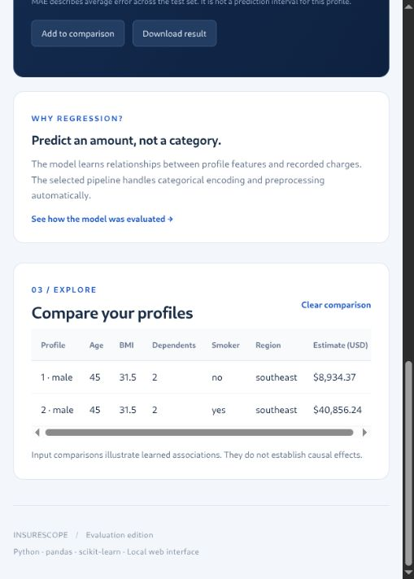
Figure 4.4 Actual scenario comparison from the running project
In the demonstrated pair, age, sex, BMI, children and region are held fixed while smoker changes from no to yes. The saved estimates are USD 8,934.37 and USD 40,856.24. This difference describes how the fitted function responds to that input change. It does not establish what would happen to a real person’s future charges if their behaviour changed.
The browser keeps scenarios in memory, and refreshing the page clears them. The backend does not save submitted form requests. This limited state model is sufficient for a local evaluation and avoids implying that the application maintains customer records, persistent accounts or an insurance history.

4.3.7 Batch Prediction and Download
The batch screen accepts a CSV containing exactly the six feature columns. The target charges must be excluded. An included example removes the need to prepare a file during evaluation. The server checks duplicate headers, parses the CSV, enforces the row limit and applies the same validation and fitted pipeline used for individual profiles.
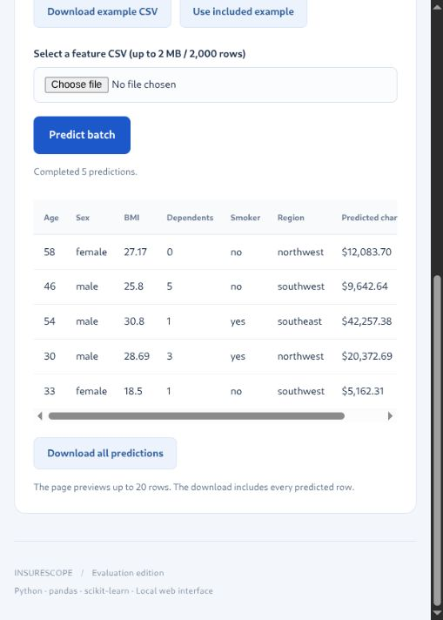
Figure 4.5 Actual batch screen showing five completed predictions
The result table shows the original features with predicted_charges_usd. The page previews up to 20 rows, while the download includes all predicted rows. The implemented request limit is 2 MB and at most 2,000 rows; this is a controlled demonstration interface rather than a large-scale batch processing service.
The five example predictions are also stored in reports/example_batch_predictions.csv. They provide a repeatable comparison between the browser, command line and saved evidence. If a batch contains invalid values, validation rejects the request with an explanatory message rather than silently skipping problematic rows.

4.3.8 Error Handling and Input Boundaries
Error handling is designed to make invalid requests distinguishable from valid estimates. The server first checks the route and body length, then parses the content and validates its structure. Feature validation occurs before inference. Expected input exceptions become structured messages; unexpected failures are reported as a generic server error and logged to the terminal.
Condition | Expected handling
Missing or additional feature columns | Reject with the expected schema and column difference.
Unknown category or out-of-range number | Reject with valid choices or numeric limits.
NaN, infinity or fractional integer fields | Reject before calling the fitted model.
Duplicate CSV column names | Reject before pandas header handling can obscure them.
Unknown route | Return 404.
Invalid request length | Return 413.
Missing dashboard/static artifact | Return 503 with a training instruction.

The app does not silently convert an unknown country into a US region or accept the target column as a feature. Such behaviour would change the meaning of the input. Category normalisation is restricted to harmless formatting differences such as whitespace and case.
These checks define the supported interface, not a guarantee of reliable predictions for every valid combination. Validation can establish that a request follows the benchmark schema. It cannot prove that the benchmark represents the person or period of interest, or that the model has a calibrated uncertainty estimate for the requested profile.

4.4 Challenges and Integration Decisions
A major challenge is keeping training and application inputs consistent. If the browser created its own category numbers or changed column order, a valid-looking request could have a different meaning from the training data. The solution is a shared Python schema and a saved complete pipeline. The frontend sends named features, and the backend owns their validation and transformation.
Another challenge is presenting metrics without overstating them. The project displays MAE, RMSE and R² with their roles and units. It distinguishes training cross-validation from held-out testing. The selected model is chosen by MAE even though random forest has a slightly smaller cross-validation RMSE. This preserves a consistent selection rule.
Challenge | Implemented response
Trace source and cleaning | Keep raw.csv, a fingerprint and excluded-row audit.
Avoid duplicate leakage | Remove exact duplicates before saving the split.
Keep transformations consistent | Persist preprocessing with the regressor.
Make evaluation repeatable | Save row IDs, seed, predictions and versions.
Support a short demonstration | Provide presets, evidence panels and example batch data.

The prototype also balances simplicity with completeness. A standard-library server and plain browser files are enough for the local evaluation. Adding a database or remote service would create more setup requirements without improving the current experimental evidence. Future extensions should therefore be linked to a concrete requirement, such as multiple users, a new dataset or model monitoring, rather than to technology count alone.

CHAPTER 5: RESULTS AND LEARNING OUTCOMES

5.1 Results and Experimental Evidence
The selected gradient boosting pipeline records test MAE of USD 1,352.65, RMSE of USD 3,297.50 and R² of 0.9246 on 268 held-out records. It was selected using mean five-fold cross-validation MAE on the 1,069 training records. The training CV MAE is USD 2,097.37. The test set did not determine the selected candidate.
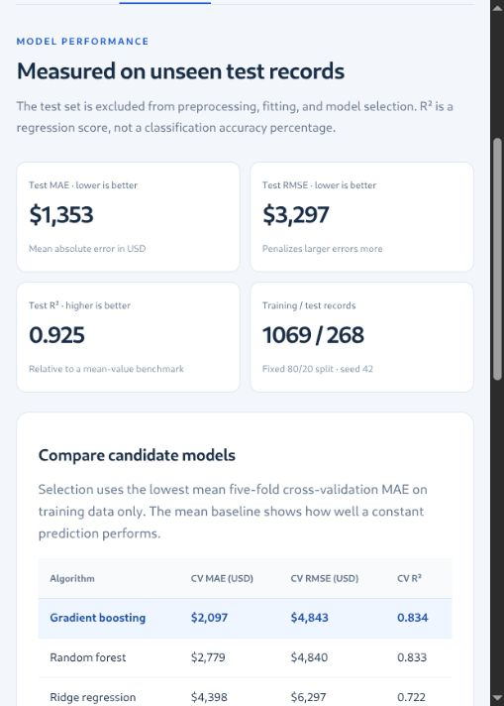
Figure 5.1 Actual evaluation screen displaying held-out metrics
The screenshot shows the application’s rounded display values. The report and CSV evidence retain more precise values for calculation. R² is a regression goodness-of-fit score, not a classification accuracy percentage. Likewise, the displayed average error should not be interpreted as a confidence interval for an individual profile.
The following pages examine the comparison table, the meaning of each metric, residuals, error quantiles and exploratory subgroup diagnostics. This evidence explains both the strong overall fit and the remaining large errors.

5.1.1 Cross Validation Comparison
All candidates use the same training partition, preprocessing arrangement and shuffled folds. The table reports positive dollar errors after reversing the negative scorer convention. Gradient boosting is selected because its mean MAE is the lowest. The standard deviation column describes fold-to-fold MAE variation in this experiment.
Candidate | CV MAE USD | MAE std | CV RMSE USD | CV R²
Gradient boosting | 2,097.37 | 277.23 | 4,842.59 | 0.8344
Random forest | 2,778.84 | 349.86 | 4,839.69 | 0.8328
Ridge regression | 4,398.39 | 358.23 | 6,297.01 | 0.7225
Mean baseline | 9,155.46 | 814.56 | 12,098.18 | -0.0154

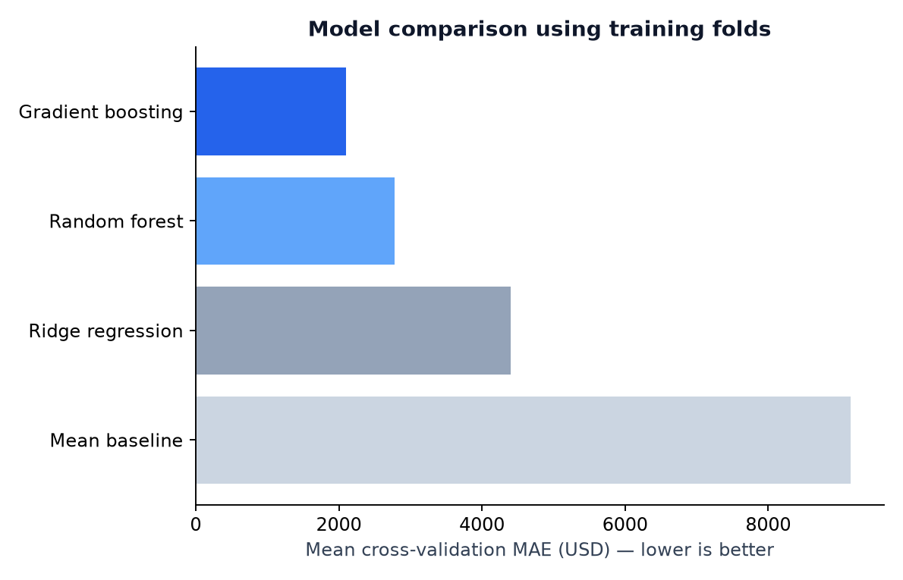
Figure 5.2 Training-fold MAE comparison of the four candidates
Gradient boosting reduces mean CV MAE by about 77.1% relative to the mean baseline in this comparison. This is a reduction in a particular validation error metric, not an accuracy percentage. Random forest’s marginally smaller RMSE illustrates that the candidate ranking depends on which error characteristic is prioritised.
The comparison evaluates the documented configurations only. It does not establish that the selected model would remain best after extensive tuning, repeated splits or evaluation on another dataset. Those are possible future experiments rather than completed results.

5.1.2 Mean Absolute Error and Root Mean Squared Error
Mean absolute error averages the magnitudes of prediction mistakes. If actual charge is y and prediction is p, the absolute error is |y − p|. MAE is the sum of these errors divided by the number of evaluated records. Its units remain dollars, which makes it straightforward to communicate in a regression demonstration.
For n test observations:
MAE = sum(abs(actual_i - predicted_i)) / n
RMSE = sqrt(sum((actual_i - predicted_i)^2) / n)
Illustrative errors, not project observations:
absolute errors = [100, 200, 900] USD
MAE = (100 + 200 + 900) / 3 = 400 USD
RMSE = sqrt((10000 + 40000 + 810000) / 3)
= approximately 535.41 USD
RMSE squares errors before averaging and taking the square root. Larger mistakes therefore contribute more strongly. In the project, test RMSE of USD 3,297.50 is much larger than MAE of USD 1,352.65. This difference signals that a relatively small number of substantial errors matter to the result. The error quantiles and largest-error examples provide direct evidence of that tail.
Neither metric identifies which direction the model is wrong. A positive and a negative residual contribute equally to MAE after taking absolute values. Direction is examined separately using actual minus predicted values. Neither metric is a guarantee that every new prediction will be within that amount of its true charge.
The training program calculates both metrics from unrounded model outputs. Rounding displayed predictions to two decimals is a presentation step and should not be confused with the precision or reliability of the underlying estimate.

5.1.3 Interpretation of the R Squared Score
R² compares the sum of squared prediction errors with the variation around the mean target in the evaluated sample. A score of 1 represents perfect predictions for that sample. A score near 0 indicates squared error comparable with predicting the sample mean, and a negative score is possible when predictions are worse under that comparison.
R2 = 1 - SSE / SST
SSE = sum((actual_i - predicted_i)^2)
SST = sum((actual_i - mean(actual))^2)
Project held-out result:
R2 = 0.9246 on 268 test records
The project’s value of 0.9246 indicates that its squared prediction error is substantially smaller than the total squared variation around the test target mean. It is not the percentage of people classified correctly, because no classes are being predicted. It also does not mean that every charge is predicted with 92.46% precision.
R² depends on the evaluated target distribution. A sample with wider charge variation can produce a different R² even when the dollar errors are similar. Reporting MAE and RMSE alongside R² therefore helps the reader understand both practical error scale and fit relative to target variation.
The mean baseline has slightly negative mean CV R² in the saved comparison. Each fold’s baseline predicts a mean learned from its training subset, which need not equal the validation subset’s mean. This is consistent with the score definition. It reinforces why the baseline is a reference experiment rather than an assumption that its validation R² must be exactly zero.

5.1.4 Actual Versus Predicted Charges
The scatter plot compares actual and predicted values for each of the 268 test records. The diagonal represents perfect prediction. A point above that line has a prediction larger than its actual charge; a point below the line has been underestimated. The distance from the line shows the size of the error in the plotted coordinates.
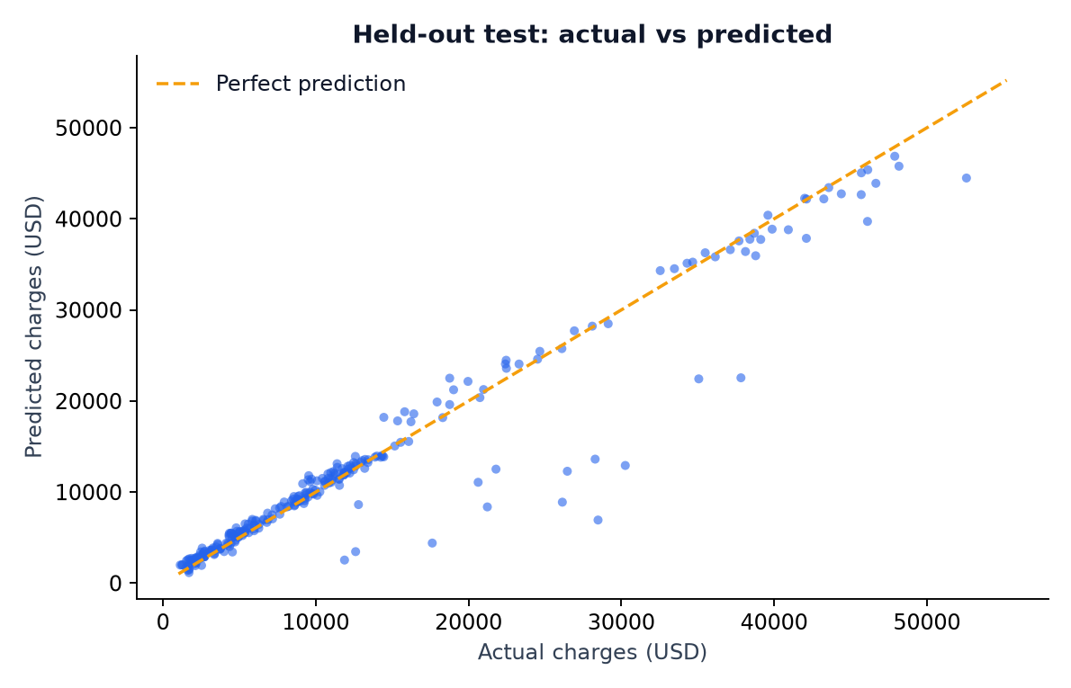
Figure 5.3 Actual and predicted charges on the held-out test set
Many points follow the diagonal, which is consistent with a strong overall fit. Some points are much farther away, demonstrating that the high R² does not remove individual failures. The plot is therefore useful as a complement to the score table, especially when explaining why RMSE remains materially larger than MAE.
The figure uses the final selected pipeline and the saved holdout split. It is a diagnostic view of this evaluation rather than an additional independent validation dataset. The report does not use the plot to change the model and then reuse the same test score as an untouched final estimate.

5.1.5 Residual Analysis
A residual is defined here as actual charge minus predicted charge. Positive residuals indicate underestimation, while negative residuals indicate overestimation. Plotting residuals against predictions shows the direction and spread of mistakes across the output range. A horizontal reference line at zero marks exact agreement.
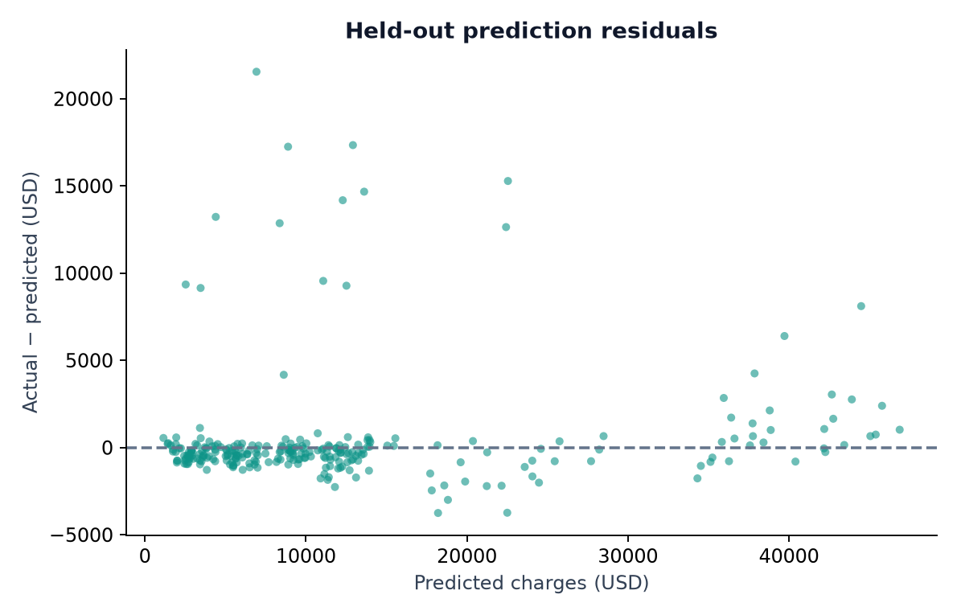
Figure 5.4 Held-out residuals defined as actual minus predicted charges
The mean signed residual is about USD 415.69 on this split, indicating average underestimation in aggregate. This signed average is smaller than MAE because positive and negative residuals cancel. It should not be substituted for MAE when describing the typical magnitude of error.
Large positive residuals show that some observed charges are substantially higher than the model expects from the six available features. The benchmark does not contain enough information to identify every reason for such differences. The appropriate conclusion is that the model leaves substantial unexplained variation, not that the expensive observations are necessarily incorrect.

5.1.6 Error Quantiles and Large Mistakes
Error quantiles describe the shape hidden by a single average. The median absolute error is USD 527.62, while the 95th percentile is USD 7,508.52. The maximum absolute error is USD 21,546.50. These figures are calculated from the 268 saved test predictions and are descriptive values for this specific split.
Absolute error statistic | USD
25th percentile | 218.09
Median | 527.62
75th percentile | 950.79
90th percentile | 2,194.76
95th percentile | 7,508.52
Maximum | 21,546.50

The three largest errors are all underestimates. For the largest, actual charges are USD 28,476.73 and predicted charges are USD 6,930.23. The second has actual USD 30,260.00 and predicted USD 12,920.31. The third has actual USD 26,140.36 and predicted USD 8,892.67. Their large magnitudes explain why squared-error metrics remain sensitive to the tail.
These are anonymous benchmark rows, not newly collected user cases. Listing them helps an evaluator inspect a failure mode without suggesting that a particular medical explanation has been established. The six features omit many possible drivers of charges, and the dataset source does not provide detailed case notes.
An empirical percentile of observed errors is not automatically a calibrated prediction interval for a new profile. Building uncertainty estimates would require a separate method and validation. The current interface correctly presents a point estimate and an average-error explanation.

5.1.7 Exploratory Subgroup Error Analysis
The saved test predictions can be joined to their original feature rows using source_row_id. The table summarises absolute error by selected categories. It is an exploratory diagnostic added to understand this test split; it did not select the model. Each row includes the sample count so differences are not presented without context.
Grouping | Category | Test n | MAE USD
Smoker | no | 213 | 1,184.91
Smoker | yes | 55 | 2,002.29
Sex | female | 140 | 1,160.81
Sex | male | 128 | 1,562.49
Region | northeast | 62 | 1,242.36
Region | northwest | 66 | 1,118.28
Region | southeast | 71 | 1,307.33
Region | southwest | 69 | 1,722.58

The smoker group has a larger MAE in this sample, and the southwest region has the largest regional MAE. Dollar errors can differ partly because target levels and case difficulty differ. These numbers alone cannot establish why a difference occurs or whether it will persist in another sample.
The groups are small, and some contain influential large errors. No confidence intervals, significance tests or external subgroup validation are included. The table therefore does not establish population fairness, causal effects or fitness for underwriting. It identifies questions that a stronger validation study should examine.
A future assessment could predefine subgroup metrics, evaluate uncertainty and use representative independent data. Any development guided by the current test diagnostics should be followed by a fresh final evaluation rather than repeatedly treating the same inspected holdout as unseen evidence.

5.1.8 Model Feature Importance and Its Limits
The fitted gradient boosting estimator exposes impurity-based feature_importances_. Because categorical variables are represented by multiple indicators, the values below are summed back to the six original features. They describe how the fitted trees allocate split-related importance and sum approximately to one.
Original feature | Aggregated importance
Smoker | 0.7329
Age | 0.1420
BMI | 0.1169
Children | 0.0067
Region | 0.0008
Sex | 0.0005

Smoking status dominates this particular fitted model’s importance allocation, followed by age and BMI. The two smoker indicator columns encode equivalent binary information, so looking at only one indicator would understate their combined contribution. Aggregation makes the table easier to relate to the original input form.
These values are not regression coefficients, dollar effects or causal contributions. Split-based importance can be affected by correlated or redundant features and the opportunities available for splits. A very small value does not prove that an attribute is irrelevant in the real world; it describes the fitted model and benchmark representation.
The report does not implement SHAP values or claim a validated explanation for each individual estimate. A future explainability study could compare alternative importance methods and examine stability across samples. Such work should be evaluated carefully, particularly before using explanations to justify decisions about people. The current table supports understanding of the model’s structure in an academic setting.

5.1.9 Example Batch Predictions
The included feature-only example contains five profiles drawn from the recorded test-feature set. It demonstrates batch inference without asking an evaluator to prepare personal data. The table shows the saved predictions also visible in the running application. These examples are demonstrations, not a second independent test dataset.
Age | Sex | BMI | Children | Smoker | Region | Estimate USD
58 | female | 27.17 | 0 | no | northwest | 12,083.70
46 | male | 25.80 | 5 | no | southwest | 9,642.64
54 | male | 30.80 | 1 | yes | southeast | 42,257.38
30 | male | 28.69 | 3 | yes | northwest | 20,372.69
33 | female | 18.50 | 1 | no | southwest | 5,162.31

The request contains only age, sex, bmi, children, smoker and region. Adding charges is rejected because the target is not an input. The output retains the validated features and adds predicted_charges_usd. This makes the download useful for tracing each estimate back to the submitted row.
The same examples can be evaluated from the command line with python src/predict.py data/example_profiles.csv. Agreement between this output and the browser result checks that the two presentation paths use shared inference. It does not add new evidence about generalisation because the underlying model and example profiles are unchanged.
The demonstration should explain at least one row, identify the selected model and state the units. It should also show where results can be downloaded and point out that two-decimal formatting is a display convention. Predictive uncertainty remains much larger than a cent, as the error analysis demonstrates.

5.2 Verification and Reproducibility Checks
The supplied src/verify.py checks data traceability, partition separation, model consistency and input validation. The checks pass for the submitted project. They use actual files rather than assuming that displayed dashboard values are correct. The script is run after training and can be repeated independently during evaluation.
Check group | What is verified
Source and cleaning | Raw SHA-256, row counts, exact duplicate removal and no missing cells.
Partition integrity | Unique source IDs, disjoint train/test sets and complete coverage.
Fitted preprocessing | Scaler means equal means from the recorded training rows.
Model evidence | Saved predictions reproduce MAE, RMSE and R².
Selection consistency | The selected model has the minimum recorded CV MAE.
Input validation | Valid five-row batch succeeds; unsupported inputs fail.

The metric checks regenerate predictions from the saved pipeline and original feature rows. They compare the regenerated values with reports/test_predictions.csv and recalculate the metrics. This helps detect stale evidence, a mismatched model file or a changed split manifest.
Verification does not establish every possible software property. It does not prove source data representativeness, security of a public deployment or calibrated uncertainty. Its purpose is to check the reproducible relationships claimed by this specific local project. The report separates those checks from broader limitations rather than treating a passing script as universal validation.

5.2.1 Application and HTTP Verification
Application verification checks that the local service is ready, static assets and dashboard data are accessible, and prediction routes return expected results. The saved HTTP verification record documents the performed checks. Browser screenshots add visible evidence that the interface displays the same data and predictions.
Test scenario | Expected result
Health endpoint | Ready status with Gradient boosting as the selected model.
Valid JSON profile | HTTP 200 and a finite numerical estimate.
Included CSV batch | Five output rows with predicted_charges_usd.
Invalid feature value | HTTP 400 with a validation message.
Unsupported route | HTTP 404.
Empty or oversized declared body | HTTP 413.

The server’s implementation provides these response branches, while the saved verification output records the concrete checks performed. A future automated test suite could exercise all boundary sizes and malformed payload combinations. The current report does not claim load testing, penetration testing or testing on every browser.
Manual evaluation should include the complete user path: open the app, predict a preset, add a comparison, inspect metrics, inspect the audit and run the example batch. This path covers the main modules without needing to invent new test data in front of the evaluator.
The app binds to the local loopback address. A GitHub repository stores source and artifacts; it does not by itself host the Python application. Running a public service would require a separate hosting configuration and operational checks. The submitted runbook therefore documents local execution explicitly.

5.3 Learning Outcomes
The completed project demonstrates that an ML application is a chain of dependent decisions. A numerical model cannot compensate for an unclear target, inconsistent inputs or a contaminated evaluation. The most important learning outcome is therefore the ability to connect data preparation, experimental design and interface behaviour into one explainable system.

5.3.1 Technical Skills Acquired
Technical skills include pandas-based data inspection, schema validation, categorical encoding, scaling, pipeline composition, cross-validation and regression evaluation. The project also applies model serialisation, HTTP request handling, browser state management and CSV downloads. The verification work shows how to compare saved artifacts with regenerated predictions rather than trusting a dashboard alone.
The model comparison develops practical judgement about complexity. Ridge improves substantially over a constant mean, while tree ensembles improve further under the chosen criterion. At the same time, large holdout errors remain. This combination shows why model selection should consider both measured improvement and the limits of available features.

5.3.2 Professional Skills Developed
The deliverables require clear file organisation, source attribution, readable setup instructions and an honest explanation of limitations. Writing the report and preparing a short demo develop the ability to present evidence in an order an evaluator can follow. Editable official fields keep technical work separate from attendance and mentor approval.
The project also strengthens debugging discipline. The command-line predictor can isolate model issues from browser issues; the split manifest can isolate data changes from algorithm changes; and the version record can identify environment mismatches. These habits make the system easier for another person to run and assess.

CHAPTER 6: CONCLUSION AND FUTURE SCOPE

6.1 Conclusion
Insurance Charge Predictor achieves the main academic objective: a complete supervised regression workflow connected to a working local interface. It preserves the source CSV, records a reproducible cleaning transformation, compares four model families and serves a saved pipeline through individual and batch inputs. The report explains the system from problem definition through implementation and evaluation.
Objective | Completed outcome
Traceable source data | Original CSV, attribution note and fingerprint retained.
Documented cleaning | One duplicate removed; 1,337 clean rows remain.
Controlled comparison | Four candidates evaluated on five training folds.
Measured performance | Held-out MAE 1,352.65; RMSE 3,297.50; R² 0.9246.
Usable demonstration | Form, scenarios, evaluation, data audit and CSV batch.
Reproducible evidence | Model bundle, predictions, manifest and passing checks.

Gradient boosting is the selected candidate under the declared mean CV MAE rule. The strong test R² is supported by many predictions close to the observed charges, but error quantiles reveal a substantial tail. The maximum absolute test error exceeds USD 21,000. Both findings are part of the conclusion and should be explained together.
The project is useful as an educational demonstration of how tabular machine learning becomes an application. Its contribution is the complete and inspectable workflow. It does not establish a commercial quotation system or an externally validated model for current insurance products. The limits and future work below define what further evidence would be needed for a different use.

6.2 Limitations
The source benchmark is small and its original collection process is not fully established by the distributed CSV. It contains only six input features, coarse US region categories and a restricted set of recorded category values. It does not establish a current pricing period. These limits constrain any claim about populations or products beyond the benchmark.
The experiment uses one fixed holdout split and five-fold training comparison. The test MAE is lower than the mean CV MAE, showing that the particular partition matters. No external dataset, temporal split or repeated final holdout study is included. The report’s additional error diagnostics are exploratory and do not create a new independent validation set.
The model lacks policy coverage, deductibles, benefit limits, provider prices, medical history and many other possible determinants of a real charge. This omitted information can help explain why profiles with similar recorded inputs can have very different targets. The project cannot identify the cause of every residual from the available data.
Input range validation is also limited. It prevents unsupported individual values but does not measure joint feature coverage or detect all out-of-distribution combinations. The application returns a point estimate without a calibrated prediction interval. Feature importance is descriptive of the fitted trees and does not justify causal conclusions or individual decisions.
Operationally, the implementation is a local demonstration. It has no user account system, persistent policy database, monitoring service or production deployment controls. GitHub publication makes the project files available for evaluation but does not turn the Python server into a hosted website. These boundaries should guide any proposed extension.

6.3 Future Scope
Future work should begin with the intended prediction task. If the aim is to study a specific current insurance product, the project would need appropriately licensed, representative data with a clearly defined target and period. Converting dollars to another currency would not address differences in population, coverage or pricing processes.
Priority | Proposed extension | Evidence needed
1 | Richer representative dataset | Documented collection, target and permitted use
2 | Repeated / nested validation | Stable selection under new partitions
3 | External or temporal testing | Performance on independent relevant observations
4 | Uncertainty estimation | Coverage checks for prediction intervals
5 | Predefined subgroup study | Adequate samples and uncertainty analysis
6 | Deployment and monitoring | A concrete user need and operational validation

Hyperparameter tuning could compare alternative learning rates, tree depths and regularisation settings within a training-validation process. Any model revisions guided by existing test diagnostics should be followed by a fresh final evaluation. This would protect the distinction between development feedback and independent evidence.
Application extensions could add model-version display, authenticated access, request monitoring or larger batch processing when those features are required. Their value should be judged against the intended users and data sensitivity. The current project establishes a small reproducible base from which such extensions can be studied without claiming they are already implemented.

6.3.1 Evaluation Demonstration and Reproduction
A clear demonstration begins by stating the target: the model estimates the benchmark’s recorded charges from six features. The presenter should identify regression as the task and USD as the output unit. This gives the evaluator a correct interpretation before any result is shown.
Step | Action | Point to explain
1 | Open Predict charges and choose a preset | Inputs and supported ranges
2 | Predict and add a comparison | Saved pipeline inference; association only
3 | Open Model evaluation | CV selection, holdout MAE, RMSE and R²
4 | Open Data and workflow | Raw data, duplicate removal and split
5 | Run the included CSV example | Shared validation and downloadable results
6 | Show verification and one large error | Reproducibility and practical limitations

To reproduce the software, create a virtual environment, install requirements, train, verify and start the server. The detailed commands are in Appendix D. Training uses the included data and writes the evidence displayed by the app. If the environment differs from the recorded versions, retraining aligns the saved model with the installed libraries.
The final discussion should answer why the project was chosen, why gradient boosting was selected in this experiment and what the test scores do not prove. A concise, evidence-based answer is stronger than an unsupported claim of perfect accuracy. The screenshots and saved files in this report support that explanation without requiring an internet connection during the demonstration.

APPENDICES

Appendix A and B Official Records and Weekly Diary
Appendix A Offer Letter or Confirmation
[Attach the authentic offer letter, internship letter or confirmation email issued by the host organisation.] The official completion certificate is retained in the front-matter attachment position. Organisation name, dates and signatures should match the corresponding official records.
Appendix B Weekly Log
Week / dates | Activity and evidence | Mentor initials
[Week / dates] | Target definition and source-data inspection | [Initials]
[Week / dates] | Cleaning audit and schema validation | [Initials]
[Week / dates] | Pipeline development and candidate comparison | [Initials]
[Week / dates] | Holdout evaluation and diagnostic charts | [Initials]
[Week / dates] | Local form, comparison and batch integration | [Initials]
[Week / dates] | Verification, report and evaluation demo | [Initials]

Diary entries should record the actual work performed during each period, any review comments and the next action agreed with the mentor. The activity sequence above corresponds to the project workflow. It is not a record of confirmed attendance until completed and approved using the actual internship dates.
Student signature: ____________________ Date: [DD/MM/YYYY]. Industry mentor signature: ____________________. Organisation seal, if required: ____________________. Supporting records should be attached in the institution’s required form.

Appendix C and D Mentor Review and Runbook
Appendix C Mentor Evaluation
[Attach the authentic completed mentor evaluation or feedback form.] Student: Gurmeet Singh. Roll: 2301531530027. Organisation: [Organisation name]. Mentor: [Name and designation]. Review areas include problem understanding, implementation, testing, documentation and professional conduct. Signature and date: [Mentor to complete].
Appendix D Source Code and Running Instructions
python -m venv .venv
# Linux / macOS:
source .venv/bin/activate
# Windows alternative:
.venv\Scripts\activate
pip install -r requirements.txt
python src/train.py
python src/verify.py
python run.py
Open http://127.0.0.1:8502 and leave the terminal running. Stop with Ctrl+C. If the port is occupied, run python run.py --port 8503 and use the corresponding URL. Python 3.12 is recommended. Package installation requires internet; the included dataset permits offline training and prediction afterward.
The source modules are src/schema.py, src/train.py, src/predict.py and src/verify.py. The server is run.py, and browser files are under web/. Dataset attribution is data/SOURCE.md. Metrics, test predictions and versions are under reports/. The complete source is included in the project archive. The intended repository location is https://github.com/justguru91/insurance-charge-predictor.
If startup reports a missing model, run training first. If a trusted saved model is incompatible with installed libraries, retrain in that environment. If a CSV fails validation, check that it contains only the six required feature columns and supported values.

Appendix E Viva Questions and Answers
1. What does the project predict? It predicts the charges field in a public medical-cost benchmark from six profile features. The output is continuous and treated as USD.
2. Why is this regression? The target is a number rather than a category. The model is evaluated with MAE, RMSE and R² rather than classification accuracy.
3. Why choose this project? It provides a manageable complete workflow covering cleaning, model comparison, evaluation, interface integration and a repeatable demonstration.
4. What cleaning was performed? Categories were normalised, numeric validity was checked and one exact duplicate was removed. The raw file remains unchanged; excluded rows are audited.
5. How is leakage reduced? Duplicates are removed before splitting, test rows are isolated, and preprocessing is fitted inside each training fold through complete pipelines.
6. Why was gradient boosting selected? It has the lowest mean five-fold training CV MAE, USD 2,097.37, among the four documented candidates.
7. What are the test results? MAE is USD 1,352.65, RMSE is USD 3,297.50 and R² is 0.9246 on 268 held-out observations.
8. Is R² accuracy? It is a regression score comparing squared prediction error with target variation. It is not the percentage of profiles classified correctly.
9. Do comparisons prove causality? No. They show how the fitted function responds to changed inputs, not the causal effect of changing a real person’s behaviour.
10. What is the strongest limitation? The historical small benchmark, limited features and absence of external validation restrict use beyond an educational demonstration. The app is not a current policy quotation or eligibility system.

Appendix F References and Glossary
[1] stedy. Machine Learning with R datasets, insurance.csv. Direct source used for data/raw.csv. https://github.com/stedy/Machine-Learning-with-R-datasets/blob/master/insurance.csv
[2] Scikit-learn documentation. Ensemble methods and gradient boosting. https://scikit-learn.org/stable/modules/ensemble.html
[3] Scikit-learn documentation. Cross-validation. https://scikit-learn.org/stable/modules/cross_validation.html
[4] Scikit-learn documentation. Common pitfalls and recommended practices. https://scikit-learn.org/stable/common_pitfalls.html
[5] Project experimental evidence. reports/metrics.json, model_comparison.csv, test_predictions.csv, data_audit.json, tested_versions.json and verification.txt.
[6] Project implementation. src/schema.py, src/train.py, src/predict.py, src/verify.py, run.py and web/. Interface screenshots were captured from the running local application.
[7] Supplementary calculations. Descriptive statistics use data/clean.csv. Error quantiles and subgroup metrics use reports/test_predictions.csv joined to source rows. Feature importances come from the saved gradient boosting estimator and are aggregated by original feature.
Term | Meaning in this report
Feature / target | An input attribute / the observed value to estimate.
Pipeline | Fitted preprocessing and estimator applied together.
Holdout | Records reserved for evaluation after model selection.
Residual | Actual charge minus predicted charge.
MAE / RMSE | Average absolute error / root mean squared error.
Data leakage | Evaluation information influencing fitting or selection.

