Week 1 Documentation

Xavier Matheson

Zurtle: I created the Zurtle in Blender using a single sphere and the blob tool. I drew a texture on it using the Texture Paint tab in Blender.

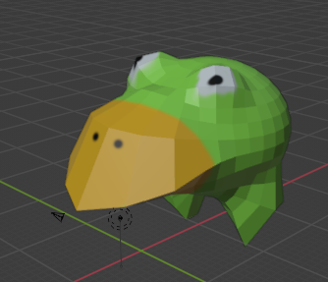

“A Guy”: An unused model I made in blender. I used the blob tool to create the head, then used multiple resized rectangles to create the body. The bones were made by Jason.

