Week 3 Documentation

Xavier Matheson

Lantern: Somehow the Blender file for the lantern got reversed, so I went back to last week’s commit and replaced the reversed version with the completed version. Unity’s particle system was used to give it a flame and give off light in-game.

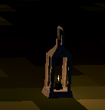

Campfire: I built the campfire in Blender using duplicated cylinders that I resized and used the blob tool under sculpting to give them a small amount of shape. I then learned how to use Unity’s particle system to give it a flame and give off light in-game.

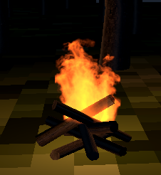

Health bar: To make the health bar, I first made a canvas on which I used a free asset to make a nice-looking bar.

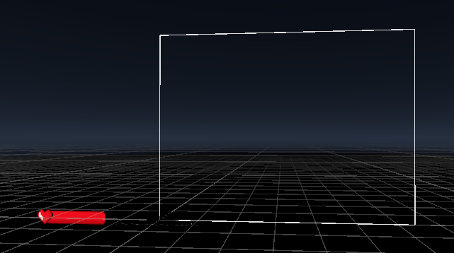

Next, I gave it a fill property, which adds the red bar behind it. The Fill, Border and Heart are all parented by the HealthBar object.

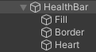

I then gave HealthBar the Slider component, set the max value to 20, and set the bar to only move by whole numbers.

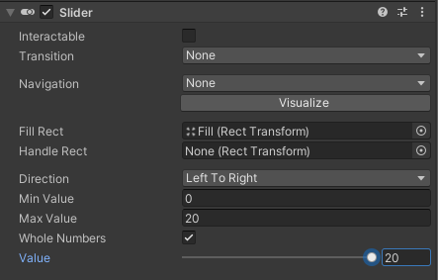

I gave HealthBar a second component, a custom script.

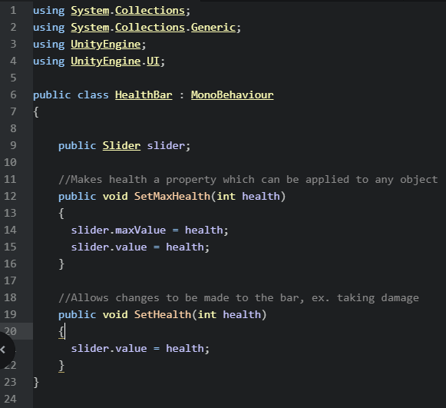

I gave the player a new custom script called Player Health, then I set the max health to 20 inside the script. I also made it possible to damage the player by pressing K.

