# Introduction

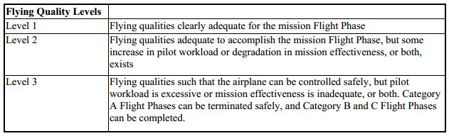

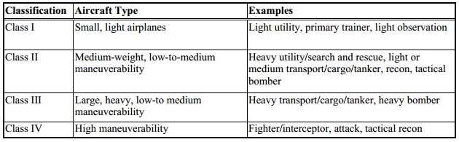

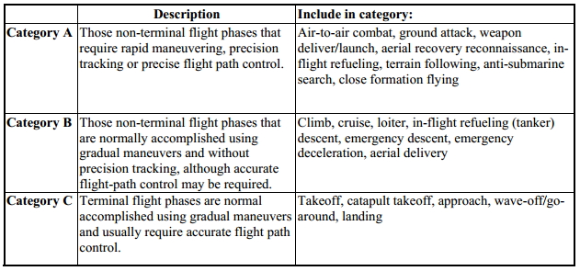

## Transfer functions

FlatEarth v9.53 was utilized to characterize the dynamical motion of the designed aircraft. The dynamic model was linearized and the following transfer functions were obtained from the resulting state space.

From input "deltaE(r)" to output "q(r/s)":

-35.24 s^4 - 174.9 s^3 - 105.1 s^2 - 0.004634 s

-----------------------------------------------------------

s^5 + 9.748 s^4 + 44.52 s^3 + 22.8 s^2 + 53.75 s + 0.003176

From input "deltaA(r)" to output "p(r/s)":

107.3 s^3 + 285.3 s^2 + 2883 s - 472.8

-------------------------------------------

s^4 + 23.48 s^3 + 124.3 s^2 + 575.1 s - 334

From input "deltaR(r)" to output "r(r/s)":

-19.26 s^3 - 399.8 s^2 - 84.73 s - 21.75

-------------------------------------------

s^4 + 23.48 s^3 + 124.3 s^2 + 575.1 s – 334

From input "deltaR(r)" to output "p(r/s)":

1.646 s^3 - 14.25 s^2 - 32.52 s + 0.357

---------------------------------------------

s^4 + 11.84 s^3 + 16.96 s^2 + 74.61 s - 5.602

We are primarily interested in these transfer functions as they pertain to how the control surface inputs affect aircraft flight dynamics.

## Characteristic equations

From the transfer functions, we note that roll rate and yaw rate output transfer functions share the same denominator. This denominator corresponds to the characteristic polynomial for lateral motion. More specifically, the characteristic polynomial describes the output motion of a system without input. Similarly, the denominator for the pitch rate output transfer function corresponds to the characteristic polynomial for longitudinal motion.

By setting the characteristic polynomial to zero, we obtain the characteristic equation. The roots of the characteristic equation yield information pertaining to the response of the system without input. The following plots illustrate these roots for both the longitudinal and lateral systems. Note that these roots have associated names due to their high significance.

Longitudinal motion characteristic equation:

s^5 + 9.748 s^4 + 44.52 s^3 + 22.8 s^2 + 53.75 s + 0.003176 = 0

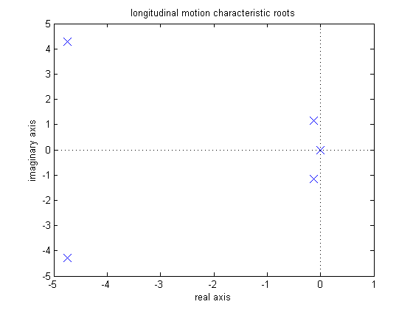

**Zero-cancelled pole**

**phugoid mode**

**Short period mode**

**Figure XXX:** longitudinal motion characteristic roots

Lateral motion characteristic equation:

s^4 + 23.48 s^3 + 124.3 s^2 + 575.1 s – 334 = 0

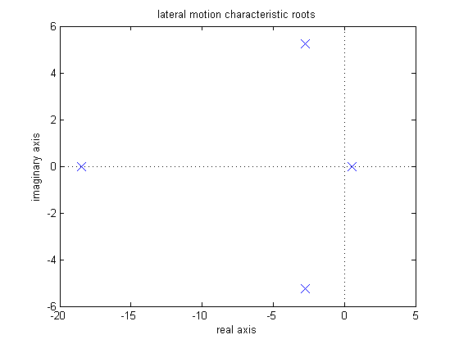

**Dutch roll mode**

**Roll mode**

**Spiral mode**

**Figure XXX:** lateral motion characteristic roots

**Table XXX:** characteristic roots for various aircraft

|  |  |  |  |  |  |
| --- | --- | --- | --- | --- | --- |
|  | Team 2 Designed Aircraft | | | | |
|  | Longitudinal Open-loop | | Lateral Open-loop | | |
|  | short period | Phugoid mode | dutch roll | roll mode | spiral |
| roots | -4.75 +/- 4.27i | -0.13 +/- 1.14i | -2.75 +/- 5.23i | -18.50 | 0.52 |
| damping ratio | 0.74 | 0.11 | 0.47 | 1.00 | -1.00 |
| natural frequency (r/s) | 6.39 | 1.15 | 5.91 | 18.50 | 0.52 |
|  |  |  |  |  |  |
|  | MPX5 Test case aircraft | | | | |
|  | Longitudinal Open-loop | | Lateral Open-loop | | |
|  | short period | Phugoid mode | dutch roll | roll mode | spiral |
| roots | -6.13 +/- 6.50i | -0.05 +/- 0.59i | -0.92 +/- 3.79i | -15.17 | 0.19 |
| damping ratio | 0.69 | 0.09 | 0.24 | 1.00 | -1.00 |
| natural frequency (r/s) | 8.94 | 0.60 | 3.90 | 15.17 | 0.19 |
|  |  |  |  |  |  |
|  | PA_28_161_Warrior Test case aircraft | | | | |
|  | Longitudinal Open-loop | | Lateral Open-loop | | |
|  | short period | Phugoid mode | dutch roll | roll mode | spiral |
| roots | -2.90 +/- 4.95i | -0.03 +/- 0.25i | -0.50 +/- 2.59i | -10.92 | 0.07 |
| damping ratio | 0.51 | 0.10 | 0.19 | 1.00 | -1.00 |
| natural frequency (r/s) | 5.74 | 0.25 | 2.64 | 10.92 | 0.07 |

Table XXX illustrates the lateral and longitudinal characteristic roots for three separate aircraft. The first aircraft corresponds to the current aircraft design for Team 2. The MPX5 aircraft represents a UAV designed by Mark Peters for a Masters Thesis in 1996. The Warrior represents a small manned aircraft. The following analysis in this report will include and compare these 3 aircraft.

# Phugoid motion

Phugoid motion corresponds to the long-term oscillation of the aircraft in the longitudinal direction. The following figure illustrates this motion.

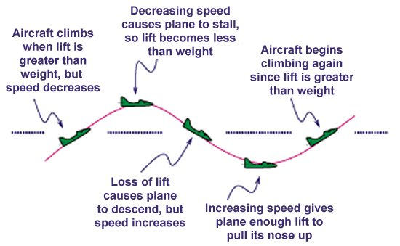

**Figure XXX:** illustration of long-term phugoidal motion in longitudinal direction

Typically, the period for phugoidal motion is near 30 seconds. It is desirable for this motion to dampen over time and slowly arrest the amplitude of oscillation. The following equation correlates flying quality to the phugoidal damping ratio.

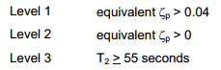

**Table XXX:** Phugoid mode flying quality

|  |  |  |
| --- | --- | --- |
|  | phugoid mode damping quality | |
|  | phugoid mode damping ratio | Flying quality level |
| Team 2 aircraft | 0.11 | 1 |
| MPX5 test case | 0.09 | 1 |
| Warrior test case | 0.10 | 1 |

Table XXX illustrates that the current aircraft design yields an open-loop phugoidal mode damping ratio of 0.11. Since this value is greater than 0.04, the aircraft is best described by level 1 flying quality. This corresponds to a stable and easy-to-control aircraft in this mode.

# Short Period Mode

## Damping ratio range

The short period mode corresponds to short-term oscillations caused by either changes in control inputs or by gusts of wind. It is desirable to keep the damping ratio within a specified range for this motion. More specifically, if the damping ratio is too low, the oscillation amplitude can be too large. However, if the damping ratio is too large, the control input response can appear sluggish. The following table correlates short-term damping ratio to flying quality.

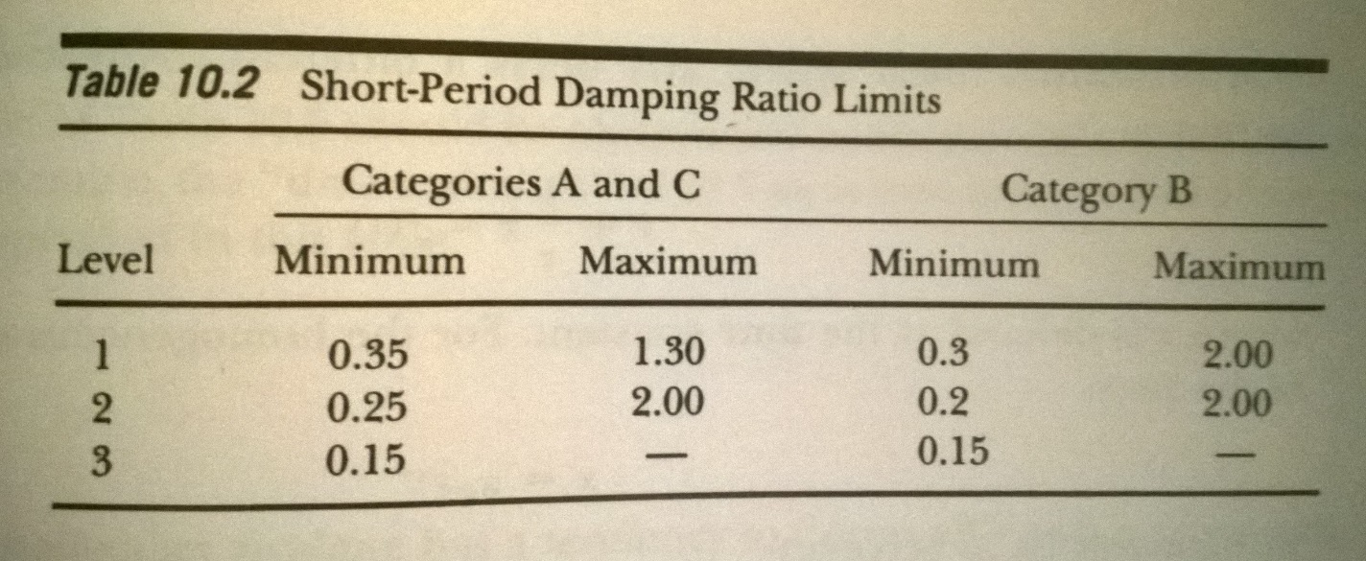

**Table XXX:** short period mode flying quality

|  |  |  |
| --- | --- | --- |
|  | short period mode damping quality | |
|  | short period damping ratio | Flying quality level |
| Team 2 aircraft | 0.74 | 1 |
| MPX5 test case | 0.69 | 1 |
| Warrior test case | 0.51 | 1 |

As seen in Table XXX, the damping ratio for the aircraft yields an acceptable level 1 flying quality.

## Damping ratio and frequency target plot

1.42 Hz

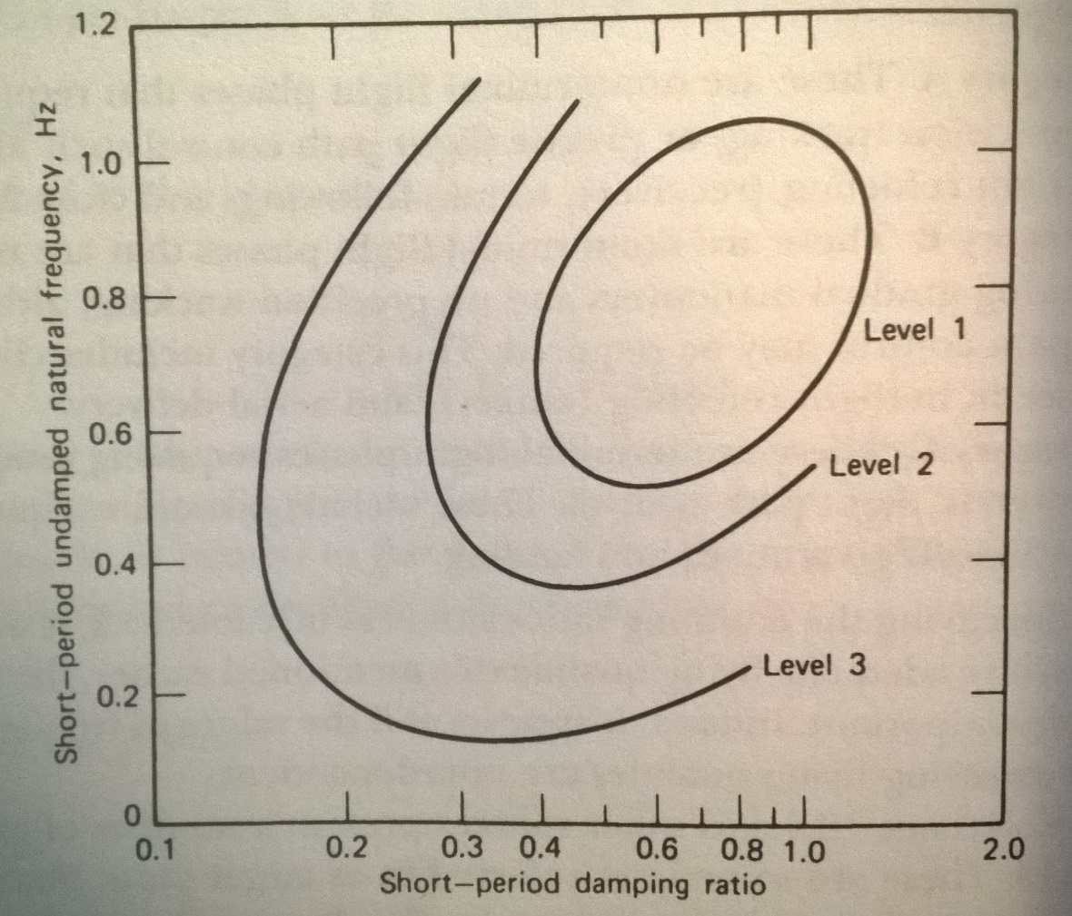

0.91 Hz

1.02 Hz

= Warrior test case aircraft

= Team 2 aircraft

= MPX5 test case aircraft

**Figure XXX:** target plot for short-period mode

Figure XXX illustrates the relationship between short-period frequency, damping ratio, and flying quality. Optimal flying quality depends on the coupled relationship between frequency and damping ratio.

**Table XXX:** short-period mode flying quality

|  |  |  |  |
| --- | --- | --- | --- |
|  | short period mode damping quality | | |
|  | short period damping ratio | natural frequency (Hz) | Flying quality level |
| Team 2 aircraft | 0.74 | 1.02 | 1 |
| MPX5 test case | 0.69 | 1.42 | 3 |
| Warrior test case | 0.51 | 0.91 | 1 |

Table XXX illustrates that the coupled natural frequency and damping ratio yields an acceptable level 1 flying quality.

# Roll mode

It is necessary for the aircraft to be capable of rolling quickly enough to accomplish the goals of specified phases of flight. The roll mode time constant can be used to characterize the time to roll. The following table correlates the time constant to levels of flying quality.

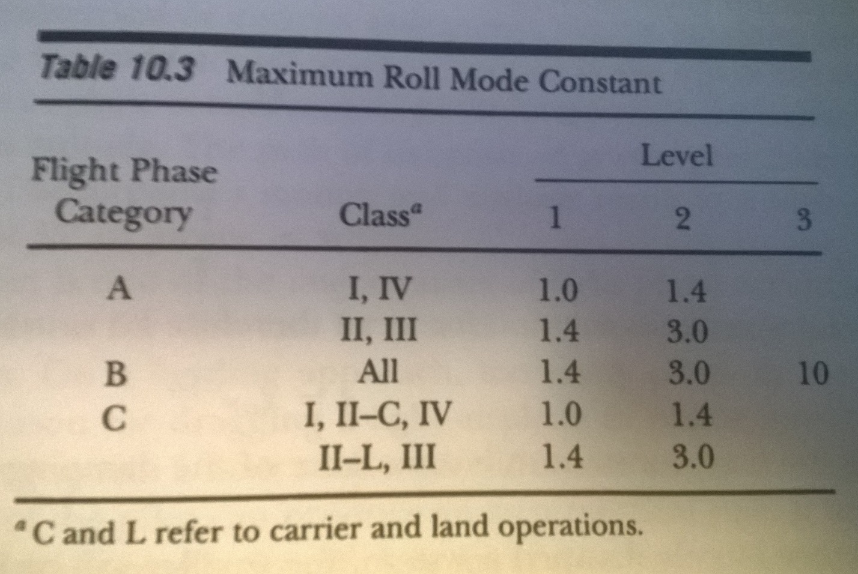

𝑜𝑡 𝑡 caseoearget plot

**Table XXX:** roll mode flying quality

|  |  |  |
| --- | --- | --- |
|  | roll mode time constant | |
|  | Time constant (s) | Flying quality level |
| Team 2 aircraft | 0.05 | 1 |
| MPX5 test case | 0.07 | 1 |
| Warrior test case | 0.09 | 1 |

Table XXX illustrates that the time constant for the current aircraft is very low. As such, the aircraft is able to roll quickly and be classified as level 1 flying quality for this flight mode.

# Dutch roll mode

The dutch roll is characterized by a coupled and out-of-phase oscillation in the yaw and roll directions. The following figure illustrates an aircraft undergoing a dutch roll.

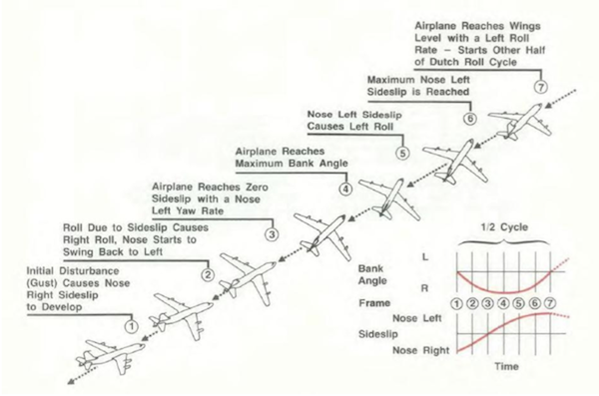

**Figure XXX:** illustration of dutch roll

The following figure correlates aircraft characteristics to flying quality.

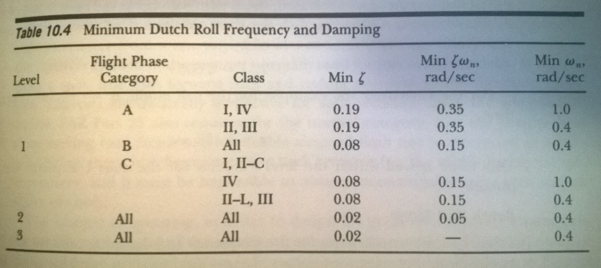

**Table XXX:** dutch roll mode flying quality

|  |  |  |  |  |
| --- | --- | --- | --- | --- |
|  | dutch roll mode | | | |
|  | dutch roll damping ratio | damping ration * frequency (r/s) | dutch roll natural frequency (r/s) | Flying quality level |
| Team 2 aircraft | 0.47 | 2.75 | 5.91 | 1 |
| MPX5 test case | 0.24 | 0.94 | 3.90 | 1 |
| Warrior test case | 0.19 | 0.50 | 2.64 | 1 |

# As seen in Table XXX, the parameters for dutch roll frequency and damping ratio as well within bounds for level 1 flight quality.

# Spiral mode

The spiral mode is characterized by the turning of the aircraft in the yaw direction over time. The following figure illustrates this motion.

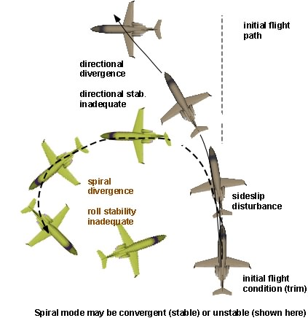

**Figure XXX:** illustration of spiral mode on aircraft yaw response

It is typical for the spiral mode of an aircraft to by divergent. More specifically, without pilot input, the yaw rate will continue to grow. It is desirable to keep the period for this motion very long such that the pilot can respond quickly enough to maintain the aircrafts intended flight path. The following table correlates the minimum time to double bank angle response to flying quality.

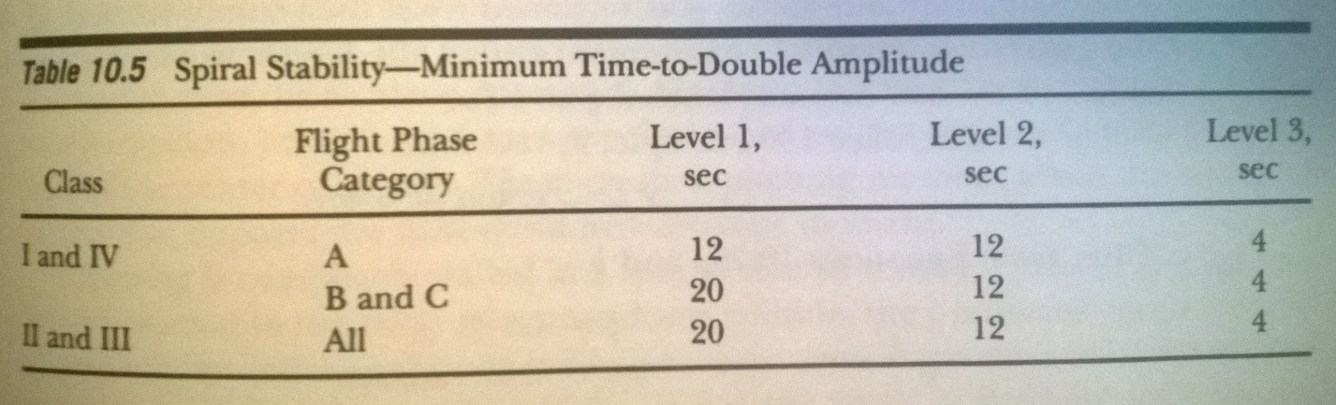

To determine time to double bank angle, the rudder was deflected for 1 degree for 1 second. The resulting time response was obtained from FlatEarth.

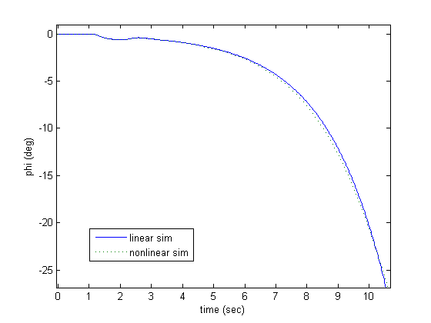

1.32 seconds

-20 degree bank angle

-10 degree bank angle

**Figure XXX:** determination of time to double bank angle

As seen, it takes approximately 1.32 seconds for the bank angle to double from 10 degrees to 20 degrees without pilot input. For comparison purposes, the same time response was obtained for the MPX5 and Warrior test case aircraft.

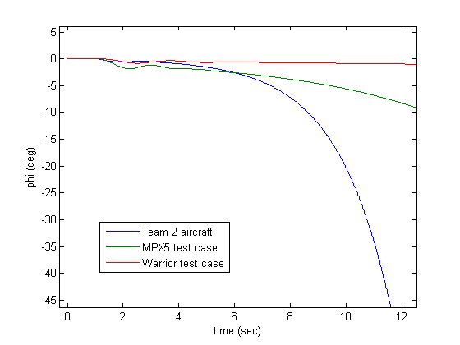

**Figure XXX:** comparison of spiral mode response for 3 aircraft

**Table XXX:** spiral mode flying quality

|  |  |  |
| --- | --- | --- |
|  | spiral mode | |
|  | time to double bank angle (s) | Flying quality level |
| Team 2 aircraft | 1.32 | 3 |
| MPX5 test case | 3.50 | 3 |
| Warrior test case | 9.40 | 2.5 |

Table 3 shows that flying quality for the current aircraft in the spiral mode is very poor. As such, the pilot has to labor intensely to keep the aircraft from falling into a spiral dive.

# Control feedback

From the open-loop flying quality analysis, we concluded that the aircraft displayed acceptable level 1 flying quality in every mode of flight except for in the spiral mode. Next, we will investigate how the use of a feedback control system can be utilized to improve spiral mode response.

From Table XXX, we see that the pole for spiral mode is 0.52 radians/s. A positive pole corresponds to an inherently unstable response. More specifically, the response can be improved by moving the pole towards the negative plane. This movement can be achieved through the use of proportional feedback controllers.

We recognize that the spiral mode pole can be found in 2 transfer functions: aileron input to roll rate output and rudder input to roll rate output. As such, applying feedback control to either the aileron or rudder can move the pole. A root locus is used to identify the gains required to achieve this desired movement.

|  |  |
| --- | --- |
| C:\GitHub\classwork\AAE 451\Code\report\pics\8.png | C:\GitHub\classwork\AAE 451\Code\report\pics\10.png  Increasing stability  Increasing gain |
| C:\GitHub\classwork\AAE 451\Code\report\pics\9.png | C:\GitHub\classwork\AAE 451\Code\report\pics\11.png  Spiral mode pole |

**Figure XXX:** root locus plots for aileron and rudder inputs to roll output

The following table illustrates the effect of various gain combinations on spiral mode response.

**Table XXX:** effect of closed-loop gain on spiral mode response

|  |  |  |
| --- | --- | --- |
| spiral mode closed-loop feedback response | | |
| aileron gain | rudder gain | time to double bank angle (s) |
| 0.10 | -0.10 | 2.39 |
| 0.30 | -0.30 | 2.59 |
| 0.30 | -0.60 | 2.89 |
| 1.00 | -1.00 | 3.79 |

From Table XXX, we see that as the gain values increase, the time to double bank angle also increases. This corresponds to a more desirable spiral mode response as the pilot is given more time to respond and correct bank angle. However, large values of gain result in sluggish aircraft performance as it takes longer for the aircraft to respond to pilot input.

## Gain selection

Our team has chosen to utilize the following feedback control gains:

**Table XXX:** selection of feedback control gains

|  |  |
| --- | --- |
| Feedback control gain selection | |
| aileron gain | 1.00 |
| rudder gain | -1.00 |
| elevator gain | 0 |

Table XXX shows that feedback control will not be utilized on elevator input. The open-loop flight quality analysis concluded that the aircraft displays acceptable level 1 flight quality in the longitudinal direction. As such, a feedback controller is not necessary.

The open-loop flight quality analysis for the lateral direction concluded that the aircraft displayed acceptable level 1 flying quality in every mode of flight except for in the spiral mode. As such, proportional feedback control was utilized to improve the spiral mode response by changing the time to double bank angle. However, moderate gains of -1 on the rudder and 1 on the aileron were only able to adjust time to double bank angle from 1.32 seconds to 3.79 seconds. Table XXX describes 3.79 seconds as a poor spiral mode response. Nonetheless, the MPX5 and the Warrior test case vehicles both display similarly low time to double bank angle values. Since these aircraft are both flight-worthy, it can be concluded that the flight quality correlation described in Table XXX does not properly apply to the smaller aircraft being analyzed by this report. With this notion, the feedback gains were selected by matching the spiral mode response of the aircraft to the spiral mode response of the MPX5 test case aircraft.

## 

# Simulator

A real-time controllable simulator was created for the purpose of test-flying the aircraft and for testing various feedback control inputs.

## Operation

The following figure illustrates the graphical user interface (GUI) for the simulator.

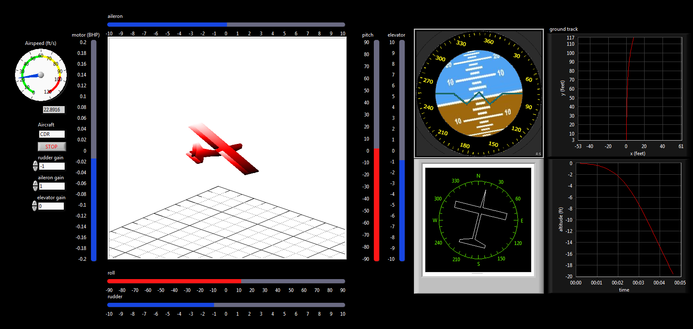

**Figure XXX:** graphical user interface for simulator

GUI display features

* 3-D render of aircraft
* Attitude gimbal display
* Heading display
* Ground track display
* Airspeed indicator
* Control surface input display
* Time plots of any state space variables or outputs

Control inputs

* Elevator
* Aileron
* Rudder
* Throttle

Simulator configuration parameters

* Specify aircraft
* Specify aileron proportional feedback gain
* Specify elevator proportional feedback gain
* Specify rudder proportional feedback gain
* Specify sim run-time rate

Control inputs are scanned from a joystick connected to the computer. The following figure illustrates the mapping of joystick axes to aircraft control surface input.

|  |  |
| --- | --- |
| http://www.xdatabase.de/bilder/en/x3/combiningseveralgamecontrollers/001.jpg | Where:  Y = elevator control  X = aileron control  RZ = rudder control  Throttle = motor power |

**Figure XXX:** Joystick configuration for simulator control

# Theory of operation

The following is a summary of the process for simulating the aircraft response in real-time:

1. FlatEarth v9.53 generates linearized state space for aircraft dynamics
2. MATLAB script exports state space to text config files
3. Labview 2014 reads config files on startup
4. Labview 2014 Control Design and Simulation Module utilized for performing state space calculations
5. Timing logic used to enforce real-time operation

The state space obtained from FlatEarth is illustrated in Figure XXX:

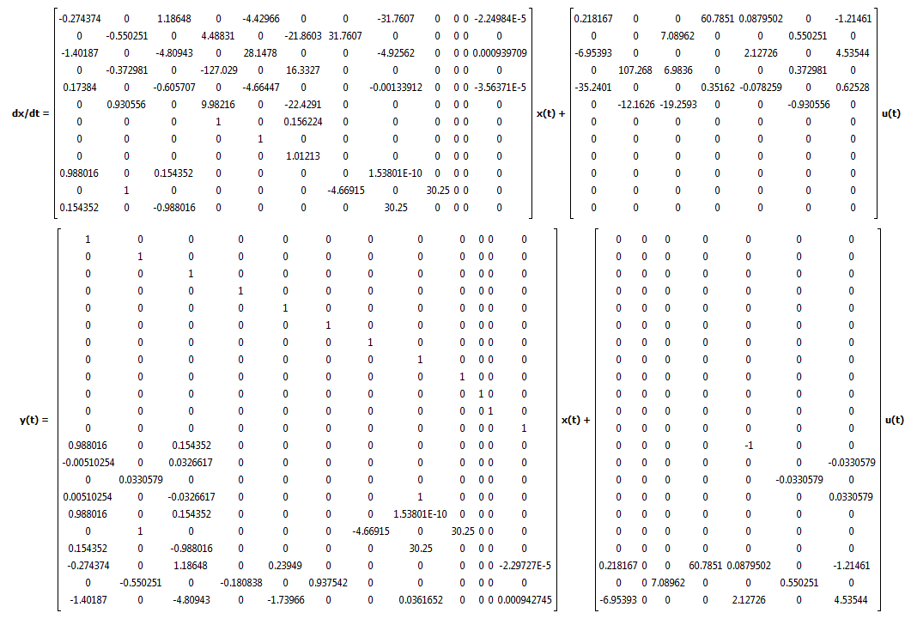

**Figure XXX:** FlatEarth state space output to Labview

## State Space feedback control

It is desired to be able to apply proportional feedback control gains to the aileron, rudder, and elevator for aircraft testing. The figure below illustrates how the open-loop state space is wrapped by a proportional controller.

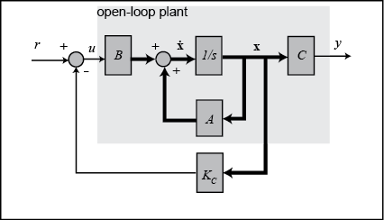

**Figure XXX:** proportional feedback controller applied to state space

With the addition of the proportional controller, the state space equation can then be written as:

𝑢𝑡𝑡𝑎𝑛𝑡 𝑎𝑙 ntroller, ional controller, the state space equation can then be written as:evator for aircraft testing.

# Simulator validation

## Longitudinal Direction

The longitudinal model was tested by injecting a doublet input on the elevator. More specifically, the elevator was deflected 1 degree from trim for 1 second, then deflected -1 degrees from trim for 1 second, and then brought back to trim. The following figures show the FlatEarth output and Labview simulation output.

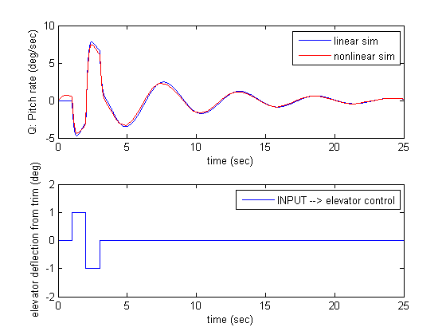

**Figure XXX:** FlatEarth - pitch rate response to doublet elevator input

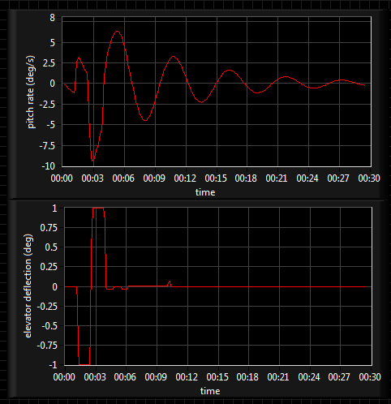

**Figure XXX:** Labview simulation – pitch rate response to doublet elevator input

We see that the nonlinear FlatEarth, linear FlatEarth, and Labview simulation results are all in acceptable agreement. As such, the following can be concluded:

* Linearized model acceptable for near-trim flight
* Labview simulation model acceptably operating at real-time

We also see that with an elevator deflection, the pitch rate dampens out and approaches a steady state value of zero. This corresponds to a dynamically stable aircraft in the longitudinal direction. This observation is in agreement with the flight qualities analysis.