**Endterm Project**

Adil Zeineshev & Dias Aidyngaliyev SE-2009

<https://github.com/justifyzz/endterm>

Our idea for project is to create backend for app IKEA, where you can find out your salary, place of work, cost and place an order. And as a supplier, find out the place of delivery, etc.

Main - the main part of the code is here. Creating class objects, using a database, user interaction, etc.

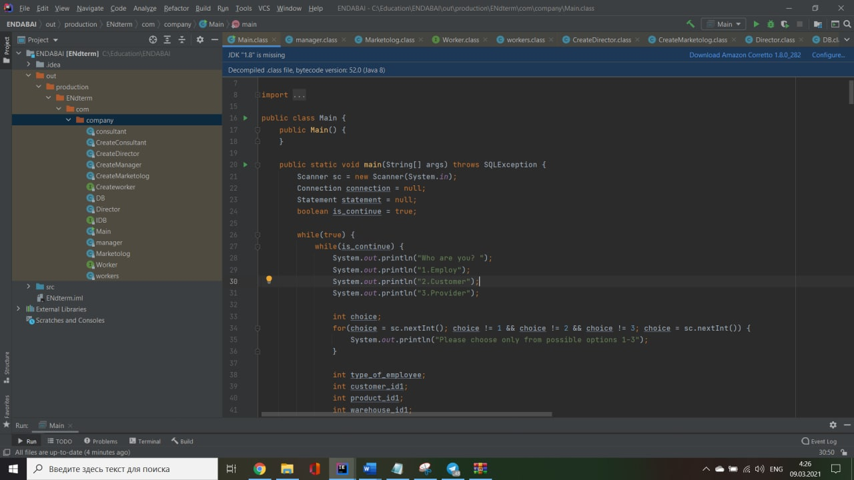 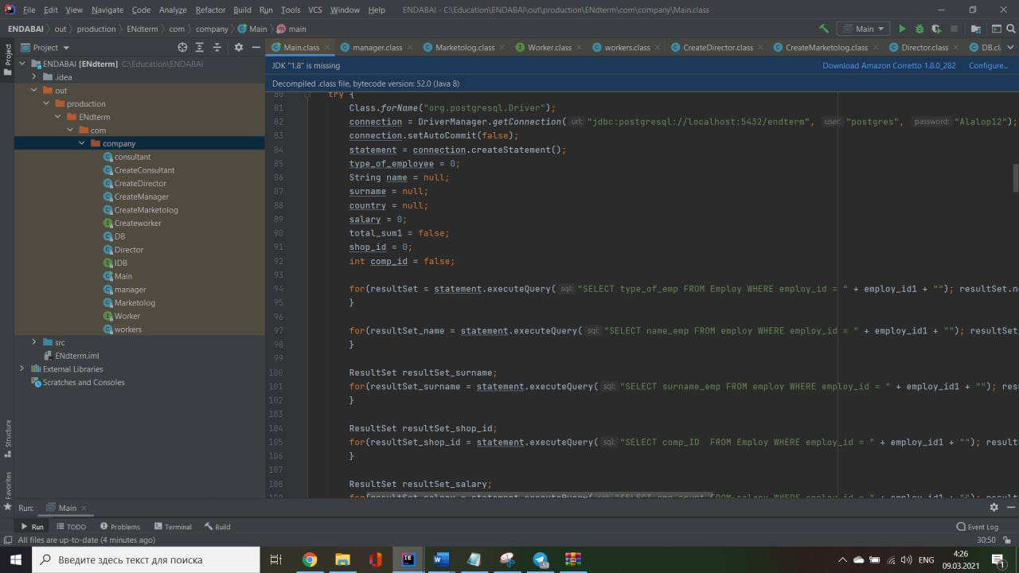 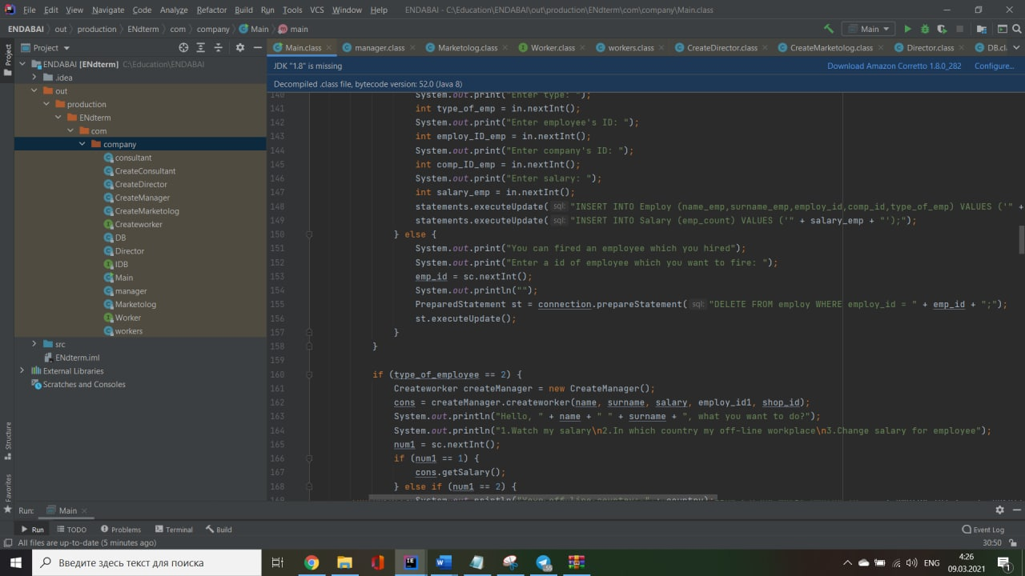

DB - for connecting Java and PostgreSql

IDB - interface for connection

Worker - interface, need for easy, effective and understanable creating classes(director, manager, marketolog, consultant)

Createworker - interface, need for easy, effective understanable creating classes(CreateDirector, CreateManager, CreateMarketolog, CreateConsultant)

workers - class parent for director and etc.

(director, manager, marketolog, consultant) - classes, types of employees

(CreateDirector, CreateManager, CreateMarketolog, CreateConsultant) - classes for easier and more effective creating employee. 