HW-7 Report
When Your Startup’s Flash Sale Almost Failed
CS 6650 — Scalable Distributed Systems
March 2026

Part II: Synchronous vs Asynchronous Order Processing

Phase 1: Synchronous System Baseline

Architecture
POST /orders/sync → acquire payment slot (chan, cap=1) → sleep 3s → release → 200 OK

The bottleneck is a Go buffered channel of size 1 that serializes all payment processing. No matter how many users hit the endpoint concurrently, only one order can be “in payment” at a time.

Test 1: Normal Operations (5 users, 30s)
Metric | Value
Total Requests | 9
Failures | 0 (0%)
Min Response Time | 3,003 ms
Median (P50) | 15,000 ms
P95 | 15,000 ms
Average | 11,670 ms
Max | 15,004 ms
Throughput | 0.4 req/s

Key insight: Min = 3,003ms (first user, no queue). Max = 15,004ms ≈ 5 × 3s (last user waited for 4 others). The queue length × 3s formula holds exactly.

Test 2: Flash Sale (20 users, 60s)
Metric | Value
Total Requests | 19
Failures | 0 (0%)
Min Response Time | 3,017 ms
Median (P50) | 30,000 ms
P95 | 57,000 ms
P99 | 57,000 ms
Average | 30,017 ms
Max | 57,018 ms
Throughput | 0.4 req/s

Key insight: Throughput did not change (0.4 req/s) — only customer wait time exploded. A 57-second checkout is an abandoned cart.

Phase 2: Bottleneck Analysis

The Math
Variable | Value
Payment processor speed | 1 order / 3s = 0.33 orders/s
Flash sale demand | ~60 orders/s
Actual throughput (measured) | 0.33 orders/s (unchanged)
Orders lost per second | 60 - 0.33 = ~59.67/s
Queue backlog after 60s | 59.67 × 60 = ~3,580 orders
Time to drain with 1 worker | 3,580 × 3s = 10,740s ≈ 179 minutes

The buffered channel (make(chan struct{}, 1)) is a hard serialization point. Adding concurrent users only adds goroutines waiting to acquire the slot.

Workers needed to match demand: 60 orders/s × 3s = 180 goroutines

Phase 3: Async Solution

Architecture
Customer → POST /orders/async → SNS publish → 202 Accepted (<100ms)
↓
SQS queue
↓
Order Processor (ECS) → payment sleep 3s → DeleteMessage

Deployment Issues & Fixes
Issue 1 — Docker provider 403: Terraform’s kreuzwerker/docker provider tried to pull a BuildKit cache from ECR and received 403. Fixed by removing docker_image resources and building/pushing images manually.
Issue 2 — Go version mismatch: aws-sdk-go-v2 v1.41.4 requires Go 1.24. Fixed Dockerfiles from golang:1.22-alpine to golang:1.24-alpine.
Issue 3 — x509 TLS failure: FROM scratch has no CA certificate bundle. AWS SDK HTTPS calls to SNS/SQS failed. Fixed by switching to alpine:3.19 with apk add ca-certificates.

Async Flash Sale Results (20 users, 60s)
Metric | Value
Total Requests | 6,100
Failures | 0 (0%)
Min Response Time | 34 ms
Median (P50) | 81 ms
P95 | 150 ms
P99 | 200 ms
Average | 82 ms
Max | 268 ms
Throughput | ~242 req/s

Key insight: ~600× more orders accepted vs sync. The 3-second payment never touches the HTTP thread — all 6,100 orders got 202 in ~80ms.

Phase 4: The Queue Problem
Variable | Value
Order acceptance rate | ~242 req/s
Single worker processing rate | 0.33 orders/s
Queue growth rate | ~242 messages/s
Messages accumulated (~25s test) | ~6,100
Time to drain with 1 worker | 6,100 ÷ 0.33 = ~5.1 hours

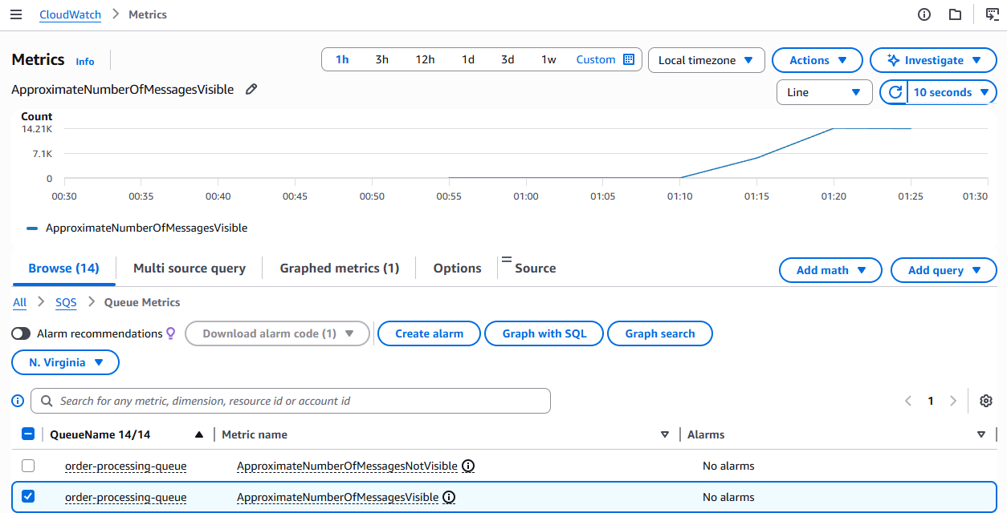
CloudWatch: Queue depth spiked to 14,210 messages at 01:10 and stayed flat — 1 worker cannot visibly drain at this scale.

Phase 5: Scale Your Workers
Workers | Processing Rate | Time to Drain ~17K | CloudWatch Observation
1 | 0.33/s | ~14.3 hours | Queue flat at 14.21K — no visible drain
5 | 1.67/s | ~2.8 hours | Queue flat at 16.9K — drain too slow to see
20 | 6.67/s | ~42 min | Queue flat at 17.97K — marginal improvement
100 | 33.3/s | ~12 min | Queue 27.17K → 13.58K in 5 min (~45/s) — first visible drain

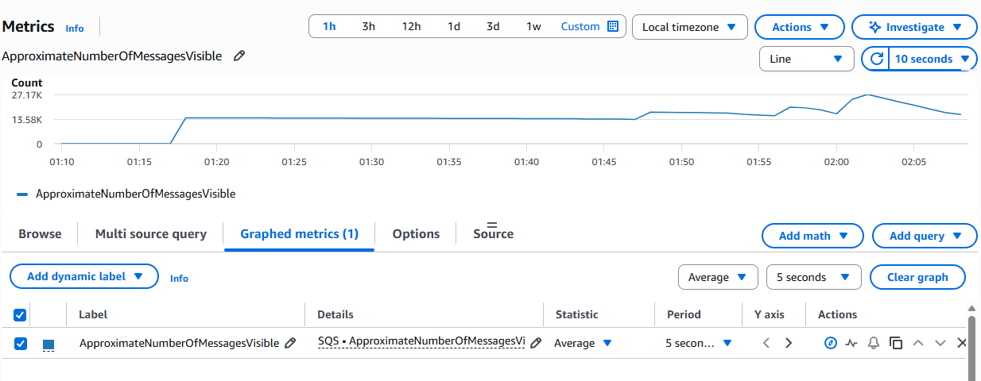
CloudWatch: With 100 workers, the steep downward slope appeared within minutes — queue dropped 13.59K messages in 5 minutes.

Minimum workers to match 60 orders/s: 60 × 3s = 180 goroutines. 100 workers gets to 33.3/s (56% of demand). 200 workers slightly exceeds 60/s.

Sync vs Async: When to Choose Each
Choose sync when:
- Operation must complete before responding (e.g., inventory check before seat confirmation)
- Latency is low enough that users will wait (< 500ms)
- Simplicity matters more than throughput

Choose async when:
- Processing takes seconds (payment verification, image resizing, email sending)
- You want to decouple acceptance rate from processing rate
- You need resilience — SQS holds messages if the processor crashes

Part III: Lambda as the Processor

Architecture
POST /orders/async → SNS topic
├── SQS subscription → ECS order-processor (pull-based)
└── Lambda subscription → order-processor Lambda (push-based)

Both subscribers receive every SNS message. Lambda is invoked directly per message — no polling, no worker pool, no manual scaling.

Cold Start Observation
INIT_START Runtime Version: provided:al2.v143
START RequestId: 9e4dd097 Version: $LATEST
2026/03/15 06:31:08 Lambda processing order 4f84a444 (customer 1)
2026/03/15 06:31:11 Lambda completed order 4f84a444
END RequestId: 9e4dd097
REPORT Duration: 3003.67 ms Billed: 3078 ms Memory: 512 MB Used: 20 MB Init: 74.06 ms

Metric | Value
Cold start (Init Duration) | 74.06 ms
Handler execution (Duration) | 3,003.67 ms
Billed duration | 3,078 ms (init + execution)
Memory allocated | 512 MB
Max memory used | 20 MB
Runtime | provided:al2 (Go custom runtime)

Cold vs Warm Start
 | Cold Start | Warm Start
Init Duration present | Yes (74.06 ms) | No
Billed duration | 3,078 ms | ~3,001 ms
Overhead | 2.4% | 0%

Go compiles to a static binary with no JVM or interpreter startup — 74ms cold start vs Java’s 1–2s or Python’s 200–500ms.

ECS vs Lambda Trade-offs
 | ECS (pull from SQS) | Lambda (push from SNS)
Scaling | Manual (NUM_WORKERS) | Automatic (up to 1,000 concurrent)
Cold start | None (always-on) | 74ms (Go), 1-2s (Java)
Cost model | Pay per hour (running task) | Pay per invocation (ms granularity)
Max execution time | Unlimited | 15 minutes
Backpressure control | Via SQS visibility timeout | Limited — SNS pushes immediately
Best for | Sustained high throughput | Spiky / unpredictable workloads

Cost Reality Check
Current ECS cost: 2 tasks × $8.50/month = $17/month (always running, even at 3am with zero traffic)

Monthly Orders | Requests Cost | Compute Cost | Total
10,000 | Under 1M free tier → $0 | 15K GB-s (under 400K free) → $0 | $0 (FREE)
267,000 | Still free tier → $0 | 400K GB-s (exactly free) → $0 | $0 (FREE)
1,700,000 | $0.20/M × 1.7M = $0.34 | ~2.55M GB-s × $0.0000167 = $42.50 | ~$43

Break-even: Lambda stays FREE until ~267K orders/month. ECS costs $17/month regardless of volume.

Switch Recommendation
Yes — for an early-stage startup under 267K orders/month, Lambda is the clear choice. The cost advantage is overwhelming ($0 vs $17/month), and the operational burden of ECS disappears entirely — no SQS depth alarms at 3am, no manual worker scaling, no health check tuning.

The trade-offs are real but manageable at this scale: SNS delivers each message independently with only 2 retries (vs SQS’s configurable retry + DLQ), and cold starts add 74ms to the first request after idle. For a 3-second payment handler, 74ms is 2.4% overhead — essentially invisible to the customer.

The calculus changes at sustained high volume (>1.7M orders/month). At that point, ECS with 200 workers processes at steady-state with zero cold starts and predictable latency.

Recommendation: Start with Lambda, set a CloudWatch alarm at $10/month spend, and migrate to ECS when the alarm fires.

