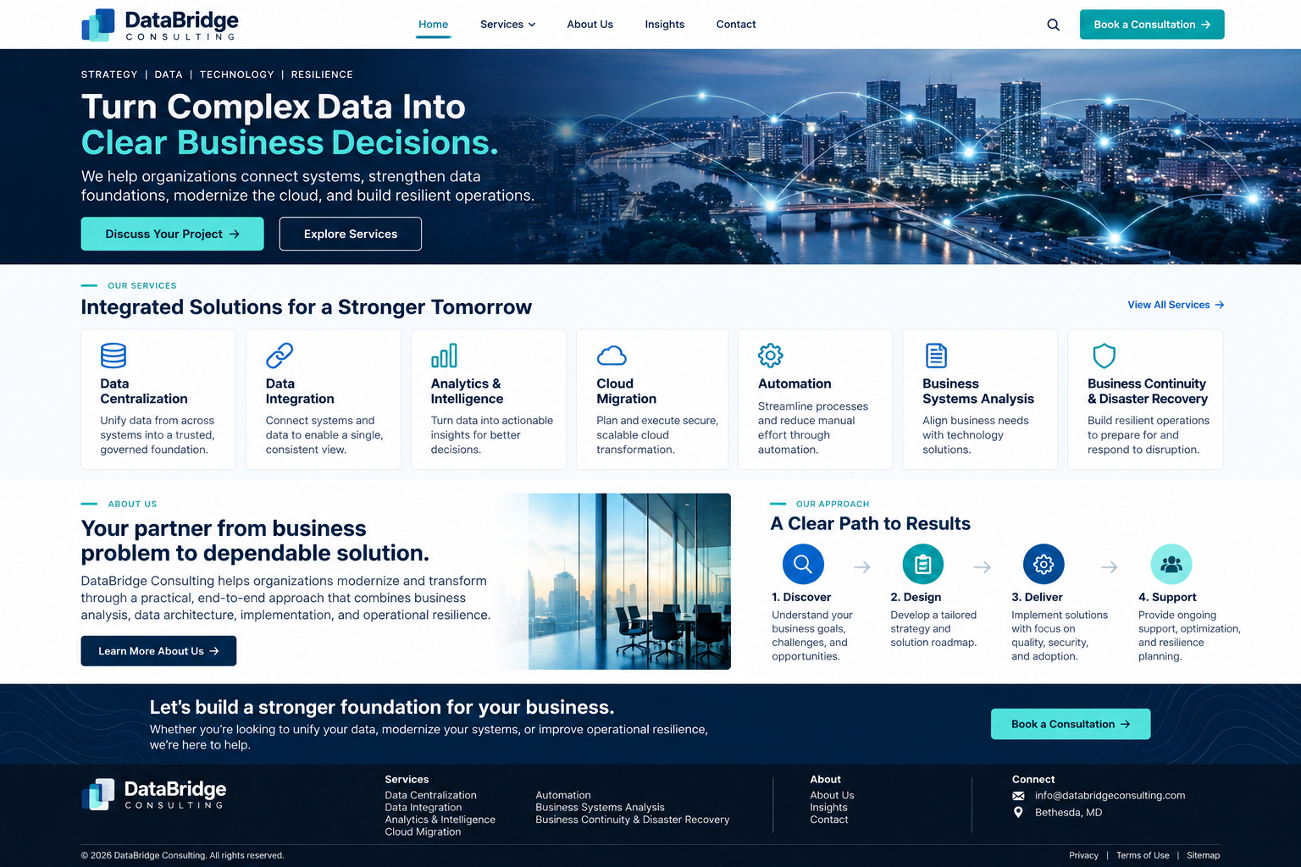

This is the company website (Comabys.com) concept for a data and technology consulting firm. Replace with Comabys Consulting, Bethesda, Maryland.
The concept positions the company as a strategic consulting partner that connects business needs, data, technology, and operational resilience.

Recommended website structure
The homepage should introduce the company, communicate its seven core services, explain its approach, and make it easy for prospective clients to request a consultation.

1. Homepage
Suggested headline: “Turn Complex Data Into Clear Business Decisions.”
Supporting message:
We help organizations connect systems, strengthen data foundations, modernize the cloud, and build resilient operations.
Primary calls to action: Discuss Your Project and Explore Services.

2. Our consulting services
Data Centralization
Bring information from multiple systems into a trusted, governed data foundation to improve consistency and accessibility.
Data Integration
Connect databases, applications, and external platforms so information flows reliably across the organization.
Analytics & Intelligence
Develop dashboards, performance indicators, analytical models, and decision-support capabilities that turn data into actionable insight.
Cloud Migration
Plan and execute cloud transitions with attention to security, application dependencies, cost, performance, and business continuity.
Automation
Streamline repetitive tasks, approvals, reporting, and business workflows to reduce manual effort and improve operational consistency.
Business Systems Analysis
Translate business goals into clear requirements, process models, functional specifications, solution designs, and testable outcomes.
Business Continuity & Disaster Recovery
Assess operational risks and develop recovery strategies, backup approaches, continuity plans, and testing procedures to help organizations recover from disruption.

3. About Us
Here is sample copy you could use on the website.

About Us

Practical Consulting. Connected Solutions. Lasting Value.
At Comabys Consulting, we help organizations solve complex business and technology challenges through thoughtful analysis, effective data management, and reliable technology solutions.
We understand that organizations often operate with disconnected systems, fragmented information, manual processes, and technology environments that are difficult to maintain. Our goal is to help clients bring these pieces together into a more integrated, efficient, and resilient operating environment.
Our consulting services span data centralization, data integration, analytics and intelligence, cloud migration, automation, business systems analysis, and business continuity and disaster recovery.
We take a business-first approach to every engagement. We work to understand each client's objectives, assess the current environment, identify practical opportunities for improvement, and develop solutions aligned with business priorities, security requirements, and long-term operational needs.

Our Mission
To help organizations transform data, technology, and business processes into trusted capabilities that support informed decisions, operational efficiency, and sustainable growth.

Our Vision
To be a trusted consulting partner recognized for connecting business strategy with dependable technology solutions and helping organizations adapt confidently to change.

Our Values
- Integrity: Communicate transparently and act responsibly.
- Practical Innovation: Recommend solutions that address real business needs.
- Collaboration: Work closely with clients and their teams.
- Reliability: Emphasize security, quality, documentation, and maintainability.
- Continuous Improvement: Help clients strengthen their capabilities over time.

4. How we work
I recommend presenting a simple four-step consulting approach:
1. Discover
Understand business goals, challenges, existing systems, risks, and opportunities.
2. Design
Develop requirements, target architecture, recommendations, and an achievable roadmap.
3. Deliver
Implement, integrate, test, document, and validate the agreed solution.
4. Support
Provide knowledge transfer, optimization, operational support, and resilience planning as agreed.

5. Additional website pages
Page | Purpose
Home | Introduce the company and its value proposition
Services | Explain all seven consulting capabilities in detail
About Us | Present mission, vision, values, experience, and approach
Industries | Describe the sectors the company serves, based on actual experience
Insights | Publish articles, technical guidance, and practical perspectives
Case Studies | Demonstrate completed work and verified outcomes
Contact Us | Capture project inquiries and consultation requests

6. Recommended visual identity
- Colors: Deep navy, white, and teal accents.
- Style: Modern, professional, technology-focused, and uncluttered.
- Imagery: Connected data systems, cloud architecture, analytics dashboards, and professional collaboration.
- Tone: Clear and credible; explain business outcomes rather than relying on technical jargon.
- Primary call to action: “Book a Consultation.”
For inspiration, consulting firms such as Comabys should demonstrate how data strategy, integration, migration, and analytics can be presented as connected services rather than unrelated technical offerings.

My recommendation: Lead with the business problems we solved, then present the seven services as the capabilities that solve them. This makes the website relevant to executives, government agencies, and business leaders, not only IT specialists.

