PATENT APPLICATION — TECHNICAL SPECIFICATION
  - FedAfya: Privacy-Aware Federated Health-Data Processing Method | Draft for NM-AIST IPMO and patent counsel
Status: proposed claims; no novelty, inventive-step, patent eligibility, grant, or actual deployment representation is made. Verify against code, experimental records and Tanzania-specific patent law before filing.

A.1 Title of the Invention
FedAfya: Privacy-Aware Federated Health-Data Processing Method

A.2 Inventor and Particulars
The following persons are potential contributors named in the prior disclosure; patent inventorship must be determined claim by claim. Do not sign until verified.
Proposed contributor | Role / address | Nationality and contact
Justin Alipoki Mwakatobe | Lead researcher; NM-AIST; P.O. Box 447, Arusha only if verified | [Verify]; [verify email, phone]
Dr. Devotha G. Nyambo | NM-AIST; P.O. Box 447, Arusha only if verified | [Verify]; [verify email, phone]
Prof. Kisangiri Michael | NM-AIST; P.O. Box 447, Arusha only if verified | [Verify]; [verify email, phone]
Dr. Catherine Mwaipopo | [Verify affiliation]; P.O. Box 447, Arusha only if verified | [Verify]; [verify email, phone]
Frank Wilbert Sichone | Developer; [verify affiliation]; P.O. Box 447, Arusha only if verified | [Verify]; [verify email, phone]

A.3 Owner of the Invention
Proposed owner/applicant: Nelson Mandela African Institution of Science and Technology (NM-AIST), P.O. Box 447, Arusha, Tanzania, subject to institutional ownership determination, assignments and any third-party contractual rights.

B.1 Technical Field
The invention concerns computer-assisted processing of heterogeneous electronic healthcare records and methods for preparing and controlling distributed predictive-model training in multi-institutional healthcare environments, with particular relevance to Tanzanian maternal and neonatal health information.

B.2 Background of the Invention
Healthcare facilities maintain electronic records with inconsistent field names, category definitions, measurement availability and outcomes. Cross-site learning may require a common logical representation, but naive standardisation can mistake a feature absent from one hospital system for a clinically measured zero or imputed observation. Federated learning can reduce routine transfers of raw patient records, yet model updates can still carry privacy risks. Technical measures must be specified and verified rather than inferred from the term federated learning.

B.3 Known Prior Art
Relevant published technical foundations are listed below for a formal search. These are research references, not a verified patent-search result; patent publication numbers, dates and claim overlap remain to be checked.
Prior-art starting point | Relevance / differentiation question
McMahan et al. (2017) | Federated averaging / decentralised model optimisation; investigate overlapping coordination claims.
Bonawitz et al. (2017) | Secure aggregation of model updates; not a FedAfya invention by itself.
Dwork and Roth (2014) | Differential privacy foundations; not novel by itself.
OHDSI / OMOP common data model literature | Harmonisation of heterogeneous clinical records; compare mapping and provenance rules.
Missingness-aware EHR and federated healthcare literature | Assess overlap with feature-availability masks, quality gates and privacy-aware FL.

B.4 Technical Problem to Be Addressed
The proposed method addresses non-equivalent hospital schemas, clinically significant structural missingness, and the risk of disclosing sensitive patient information when coordinating learning across healthcare institutions. The technical workflow maps source-specific observations to a versioned common logical schema, retains provenance and availability status, applies an eligibility or quality decision, and prepares compatible local model inputs. Subject to implementation verification, authorised model updates may be clipped or perturbed under differential privacy and combined using secure aggregation. These established components are not individually claimed as newly invented.

B.5 Technical Solution
A coordinated sequence is proposed: source-specific schema/provenance capture; mapping into a versioned logical schema; explicit encoding of observed, missing and structurally absent features; a defined eligibility gate; generation of a compatible local training representation; and controlled, auditable exchange of model updates only when privacy mechanisms are actually enabled. The possible inventive contribution is the specific interaction of these rules, not their mere aggregation. The exact differentiating rule and comparative technical evidence must be established before final claims.

B.6 Detailed Description / Manner of Carrying Out

Step 1 — Hospital-controlled clinical data source (100)
Obtain clinical data within an authorised processing environment and record the source schema, record provenance and applicable institutional access restrictions. The disclosed research includes heterogeneous hospital datasets; physical site-local deployment remains to be verified.

Step 2 — Source-schema and provenance capture (110)
Identify each source field and its data type, category convention, measurement unit where applicable, and source of origin. Preserve version identifiers for later audit.

Step 3 - Source-field mapping and validation (120). The production preprocessor uses heuristic column-name detection and writes a shared set of output columns; outcome categories are mapped by explicit labels. No versioned mapping registry, complete unit validation, or provenance/version record is present in the inspected path. The evaluation harness separately tests B1 semantic mappings; that is an audit implementation, not a production mapping service.
Apply documented mappings to common logical clinical fields and outcome categories; flag unmapped categories and invalid values instead of silently reclassifying them.

Step 4 - Missingness and structural-availability handling (130). The evaluation harness records source-level feature availability and can represent absent fields as missing values in B1. In the production cleaner, vital-sign values are imputed before the *_was_missing flag is calculated; the resulting flag therefore does not preserve the original missingness for imputed cells. The claimed three-state representation is not implemented end-to-end in the model input.
For each feature, distinguish an actual measured value from a missing item and from a variable absent in the source system. Where imputation is used, retain original missingness metadata. This proposed handling requires confirmation against the current implementation.

Step 5 - Quality assessment (140). The evaluation harness calculates validity, retention, availability, and schema metrics. The inspected main pipeline does not apply predeclared thresholds or reject unsuitable data or updates; the measured metrics are descriptive and do not function as an eligibility gate.
Calculate quality indicators, including mapping success, invalid-value frequency, observed-value coverage and structural availability; apply predeclared criteria to flag or withhold unsuitable data or updates. The threshold and enforcement mechanism must be evidenced.

Step 6 - Training operation (150). main.py reads and preprocesses CSVs in the research workspace, starts a local Flower server, and launches client functions in threads using local cleaned CSV paths. This supports a federated experiment simulation; it does not establish that training ran inside hospital-controlled infrastructure. Client preprocessing and training details are in Annex C.
Generate a compatible training representation and train a model according to a shared task and model version. Confirm whether each site executes locally or whether data are processed in a research simulation before describing deployment.

Step 7 - Conditional privacy control (160). client_app.py contains an Opacus PrivacyEngine path, enabled by default unless MWAKATOBE_USE_DP overrides it; runtime execution and privacy logs must be checked for each reported run. The same code raises an error if MWAKATOBE_USE_SMPC is enabled in this legacy NumPyClient path. Differential privacy here is a local-training mechanism, not secure aggregation.
Where implemented and activated, apply documented clipping/noise, privacy accounting, update protection or other controls; do not equate pseudonymisation with anonymisation and do not assert secure aggregation where disabled.

Step 8 - Federated aggregation coordinator (170). The server uses Flower FedAvg. The inspected server path does not configure secure aggregation. In the client return tuple, the aggregation weight is the size of the training array, which may be after SMOTE; model updates are not intrinsically private.
Receive eligible updates at a coordinator and combine them under the verified aggregation protocol. Avoid describing ordinary model updates as intrinsically private.

Step 9 - Experiment logging (180). The repository records experiment metrics and, when the Opacus path runs, writes epsilon/delta and mechanism parameters. A complete source-schema/mapping-rule version trail and eligibility-decision log are not established in the inspected path.
Record source mapping, model version, training participation and evaluation summaries; return approved model information and record failure or suspension decisions.

Example embodiment and technical evidence
The checksum-verified preprocessing-comparison run recorded 15,208 input rows across Hospitals A-C (12,000; 1,379; 1,829) and 13,329 output rows after the B2 path (10,569; 990; 1,770). B0 and B1 preserved all input rows; B2 deduplication and cleaning removed 1,879 rows. The comparison was one deterministic run and repeatability was not measured. These observations illustrate data-processing behavior only; they do not establish clinical benefit, patent novelty, physical local-only deployment, or a privacy guarantee. See Annex C and FIG. 4.

C. PROPOSED CLAIMS (for counsel review)
1. A method for preparing heterogeneous health records for distributed predictive-model training across multiple healthcare data environments, comprising: capturing, for each environment, a source-specific data schema and provenance information; mapping source clinical fields to a versioned shared logical feature specification; assigning to each mapped feature a state distinguishing an observed value, an item-level missing value, and a structurally unavailable feature; generating a training representation that preserves said state distinction; evaluating the representation against a predefined quality or eligibility rule; and producing a site-specific training input and associated non-identifying quality metadata.
2. The method of claim 1, wherein the shared logical feature specification comprises source-to-target category mappings, data-type constraints, measurement-unit rules, and outcome-label definitions.
3. The method of claim 1, wherein the structurally unavailable state is retained separately from any imputed numeric value so that an absent source measurement is not represented as an observed clinical measurement.
4. The method of claim 1, wherein the quality or eligibility rule uses at least one of observed-value coverage, valid-value coverage, semantic mapping completeness, and outcome-label integrity.
5. The method of claim 1, further comprising performing a local training operation using the site-specific training input and generating a model update for a versioned shared learning task, subject to confirmation of the deployment arrangement.
6. The method of claim 5, further comprising applying an enabled, specified differential-privacy mechanism to a model update and recording a corresponding privacy-accounting value, when supported by the implemented embodiment.
7. The method of claim 5, further comprising combining authorised model updates under an implemented secure-aggregation protocol, when supported by the implemented embodiment.
8. The method of claim 5, wherein a training round is flagged or withheld if a predefined eligibility or privacy-control condition fails.
9. The method of claim 5, further comprising recording a model version, source-schema version, mapping-rule version, and site-level quality summary to support reproducibility.
10. The method of claim 1, wherein the clinical data relate to maternal or neonatal care and the shared logical feature specification includes demographic, physiological, treatment and outcome fields.

D. Brief Description of Drawings
FIG. 1 is a method flow diagram comprising data sources 100, source/provenance capture 110, mapping 120, availability-state encoding 130, eligibility gate 140, local training 150, optional update privacy control 160, aggregation 170, and audit/feedback 180. FIG. 2 shows a three-hospital example and the distinction between raw patient records, local training inputs, and model-update communications.

E. Detailed Description of Drawings
In FIG. 1, the output of source 100 is processed by capture component 110 and mapping component 120. State encoding 130 records whether each mapped field was measured, missing, or absent in the source. Quality gate 140 assesses the resulting representation before it is passed to training operation 150. Optional control 160 is used only when configured and validated. Coordinator 170 combines eligible updates; audit component 180 records version and quality information. In FIG. 2, hospital environments A, B and C are illustrated separately; the diagram is conceptual and does not certify that the reported experiments were run on physical hospital infrastructure.

F. Drawings
FIG. 1 — conceptual method flow
100 Source records → 110 provenance → 120 schema mapping → 130 availability state → 140 quality gate
140 eligible → 150 training → 160 optional update controls → 170 aggregation → 180 audit / feedback
FIG. 2 — conceptual deployment
Hospital A: records → preparation → training
Hospital B: records → preparation → training
Hospital C: records → preparation → training
Authorised model updates only → coordinator (subject to actual deployment and privacy verification)

G. ABSTRACT (maximum 150 words)
A method is disclosed for preparing heterogeneous clinical records for distributed healthcare model training. The method captures source-specific clinical schemas and provenance, maps clinical fields to a versioned common feature specification, and distinguishes observed measurements from missing values and structurally unavailable fields. A quality-control operation evaluates semantic validity and feature availability before producing site-specific model-training representations and non-identifying quality metadata. In an embodiment subject to implementation verification, participating healthcare environments generate local model updates under a shared task definition, optionally applying differential-privacy controls and secure aggregation when enabled and validated. Versioned mapping and model information support traceability and review. The method is intended to reduce ambiguity introduced by incompatible electronic health-record formats while enabling controlled multi-institutional model development without routine disclosure of patient-level records.
Abstract word count: 124.

Annex: Essential Verification Before Filing
☐ Identify and test the exact new technical rule relative to closest patent and non-patent prior art.
☐ Verify source code supports original missingness-state capture, the claimed quality gate and its enforcement.
☐ Document whether training ran physically at hospitals or in a simulation; identify any central data access.
☐ Verify actual DP clipping/noise/accounting and secure-aggregation execution before asserting these mechanisms.
☐ Check public GitHub commits, manuscript submissions, conference presentations and other novelty-relevant disclosures.
☐ Confirm inventorship, NM-AIST ownership, third-party contracts, ethics and data permissions.
☐ Have Tanzanian patent counsel review statutory subject-matter eligibility and claim scope.

ANNEX A — Patent Drawings (conceptual)
These drawings illustrate proposed embodiments and do not independently establish that every feature is implemented, enabled or patentable. Reference numerals correspond to the technical description. Review and revise against verified source code before filing.

FIG. 1
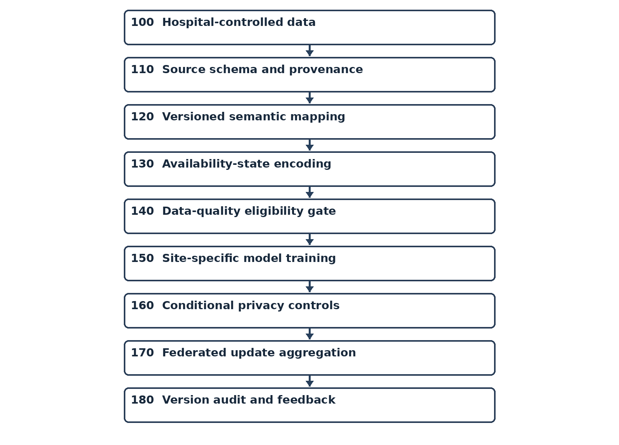
FIG. 1: Numbered method sequence.

FIG. 2
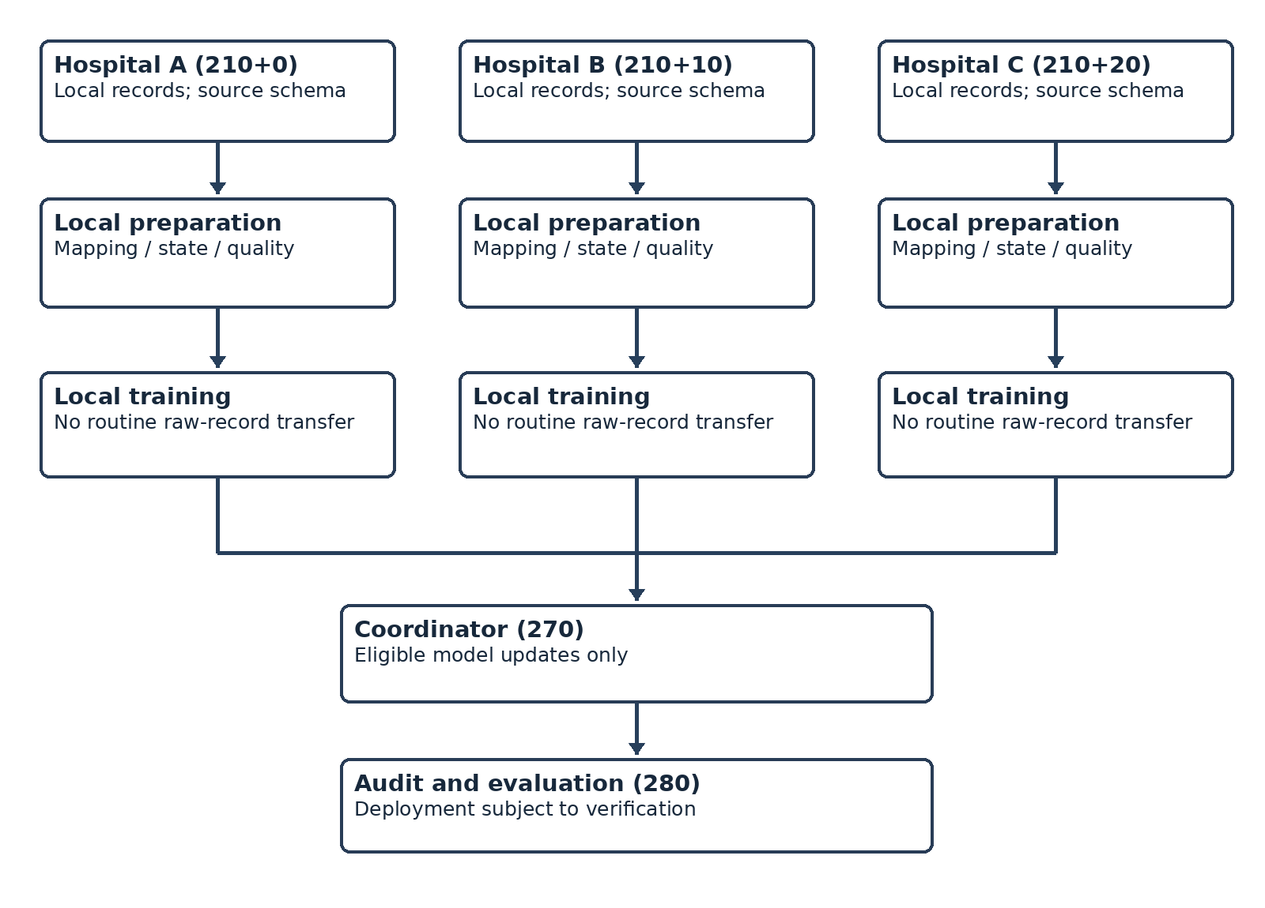
FIG. 2: Illustrative three-hospital training arrangement. Physical hospital-local deployment has not been verified.

ANNEX B - Code and Evidence Cross-Reference (repository snapshot reviewed 8 November 2026)
- client/data_utils.py (find_column; preprocess_single_file): heuristic source-column matching, transformation, hashing, and deduplication are present; no versioned semantic-mapping registry or schema-provenance record was identified.
- client/clean_app.py: vital values are filled before *_was_missing flags are assigned. The flags do not preserve pre-imputation missingness in the current path.
- main.py; client/client_app.py; server/strategy.py; server/server_app.py: clients consume workspace CSV paths and the server uses standard Flower FedAvg. Physical hospital-local execution and secure aggregation were not established.
- client/client_app.py: Opacus DP-SGD is conditionally configured (default flag true); SMPC activation raises RuntimeError in this NumPyClient path. Verify run-specific environment and privacy-accounting outputs before making runtime claims.
- evaluation/preprocessing_comparison.py and its CSV/JSON outputs: one checksum-verified comparison run (rule version preprocessing-comparison-v2); repeatability was not measured. It is an evaluation harness, not a production eligibility gate or prior-art novelty study.

ANNEX C - Implementation Steps, Code Excerpts, and Measured Evidence
Purpose and limits. This annex maps the proposed workflow to the inspected repository snapshot. ?Implemented? refers only to the code path described; ?audit-only? refers to the separate comparison script. The annex does not establish novelty, patentability, clinical effectiveness, or legal ownership. The evaluation results do not prove that the claimed three-state missingness and eligibility-gate method is implemented in production.
Evaluation provenance: run 2026-11-07T11:55:53.055340+00:00 UTC; rules version preprocessing-comparison-v2; input checksums verified; base commit e8d2e4959e67; one execution per method/site, with repeat equality not measured. The report notes worktree changes in client/clean_app.py and client/data_utils.py at run time.
Workflow step | Observed implementation | Evidence status
Source/schema capture | Heuristic column discovery; normalized output columns. The evaluator inspects field presence. | Partial; no versioned schema/provenance registry
Semantic mapping | Outcome and category transformations in preprocessing; B1 mapping exists in the comparison harness. | Partly implemented; mapping versioning absent
Missingness/availability | Evaluator reports source-level structural availability; production cleaner imputes vital values before flags. | Claimed state preservation not implemented end-to-end
Quality gate | Validity/retention/schema metrics are calculated and reported. | No threshold-based rejection in main pipeline
Local training | CSV-backed Flower clients; one-hot encoding, StandardScaler, train/test split, optional SMOTE. | Research-host experiment; hospital-local deployment not verified
Privacy control | Opacus PrivacyEngine path; configurable DP flag. SMPC flag raises an error. | Conditional code path; per-run activation must be evidenced
Aggregation | Flower FedAvg; client returns parameters and training-example count. | Standard aggregation; no secure aggregation
Audit/versioning | Experiment summaries and optional DP budget CSV. | No complete mapping/schema version audit trail found

C.1 Source schema discovery and mapping
The production preprocessor uses find_column() to compare lowercased column names after removing spaces and underscores, then selects the first matching source field. preprocess_single_file() writes standardized fields (including Age, Sponsor, Region, vital signs, Procedures, Medications, and Outcome). This is heuristic field matching, not a version-controlled terminology map; the inspected production flow does not retain a mapping version or field-level provenance record.
cols_lower = df.columns.str.lower().str.replace(r'[\s_]', '', regex=True)
mask = cols_lower.str.contains(name, na=False)
source_col = df.columns[mask].tolist()[0] if mask.any() else None
Source: client/data_utils.py, find_column() and preprocess_single_file() (approximately lines 139-240). The comparison harness additionally records whether a target field is source-observed, derived, or structurally unavailable; this status is used for reporting and is not carried through the production model input as a versioned state vector.

C.2 Missing values and structural availability
For a source feature j and record i, the intended pre-imputation missingness indicator is M_ij = 1 when the source value is missing and 0 otherwise. A structural-availability indicator A_hj can identify whether any source column for feature j exists at site h. These are distinct: a present column may have a missing value in a particular record, while an absent column is unavailable for that source system.
M_ij = 1[x_ij is missing before imputation]; A_hj = 1[feature j exists in site h schema]
The production cleaner currently computes the vital-sign flag after the fill operation. Thus for an imputed value x'ij, the stored flag is generally 0 even though M_ij = 1. This is an implementation limitation that must be fixed and re-tested before claiming preserved missingness.
df_clean[col] = df_clean[col].fillna(fill_val)
...
df_clean[f"{col}_was_missing"] = df_clean[col].isna()
Source: client/clean_app.py, lines 76 and 86. The comparison harness mirrors this ordering for B2 and explicitly reports it; its source_feature_status() and B1 frame distinguish source-level structural absence for evaluation only (evaluation/preprocessing_comparison.py, approximately lines 105-146 and 197-239).

C.3 Quality measurements (not an eligibility gate)
The comparison harness defines descriptive metrics over source-observed feature values. It does not configure thresholds that block a file, client, or update in main.py.
Availability A_h = |F_source-observed,h| / |F_required| = 5 / 11 for each evaluated hospital
Validity V = valid observed output values / assessed source-observed input values
Semantic retention R = semantically retained observed values / assessed source-observed input values
The availability denominator is the 11-feature target schema; age is listed as derived at Hospitals A and B, so the 5/11 numerator counts directly source-observed features and is not a measure of total usable fields. Retention uses the evaluator?s semantic equality rules; dropped-by-deduplication rows count as not retained. These metrics describe this test harness and are not a validated clinical quality score.

C.4 Reported preprocessing comparison
The input-checksummed run recorded 12,000 rows at A, 1,379 at B, and 1,829 at C. B0 is a direct common-schema projection, B1 applies the evaluator?s semantic mapping without deduplication or imputation, and B2 mirrors the existing preprocessing/cleaning path. The table reports the run?s observed-value validity and semantic retention rates. B2 failed target-schema conformance at all three sites. B1?s 100% retention is according to the evaluator?s semantic mapping rules; it is not evidence that the full federated model or proposed patent method is superior.
Site | Method | Validity | Retention | Schema conforms | Rows removed
Hospital A | B0 | 99.94% | 90.80% | True | 0
Hospital A | B1 | 99.94% | 100.00% | True | 0
Hospital A | B2 | 88.14% | 88.08% | False | 1431
Hospital B | B0 | 99.93% | 90.88% | True | 0
Hospital B | B1 | 99.93% | 100.00% | True | 0
Hospital B | B2 | 71.77% | 71.73% | False | 389
Hospital C | B0 | 100.00% | 80.10% | True | 0
Hospital C | B1 | 100.00% | 100.00% | True | 0
Hospital C | B2 | 96.77% | 96.77% | False | 59
Interpretation: B1 had the highest semantic retention in this single comparison; B2 had lower validity/retention and failed the harness schema check. The report did not measure repeated-run determinism, downstream predictive performance for these transformations, statistical significance, or patent-prior-art differentiation. Do not present these results as proof of novelty or clinical superiority.
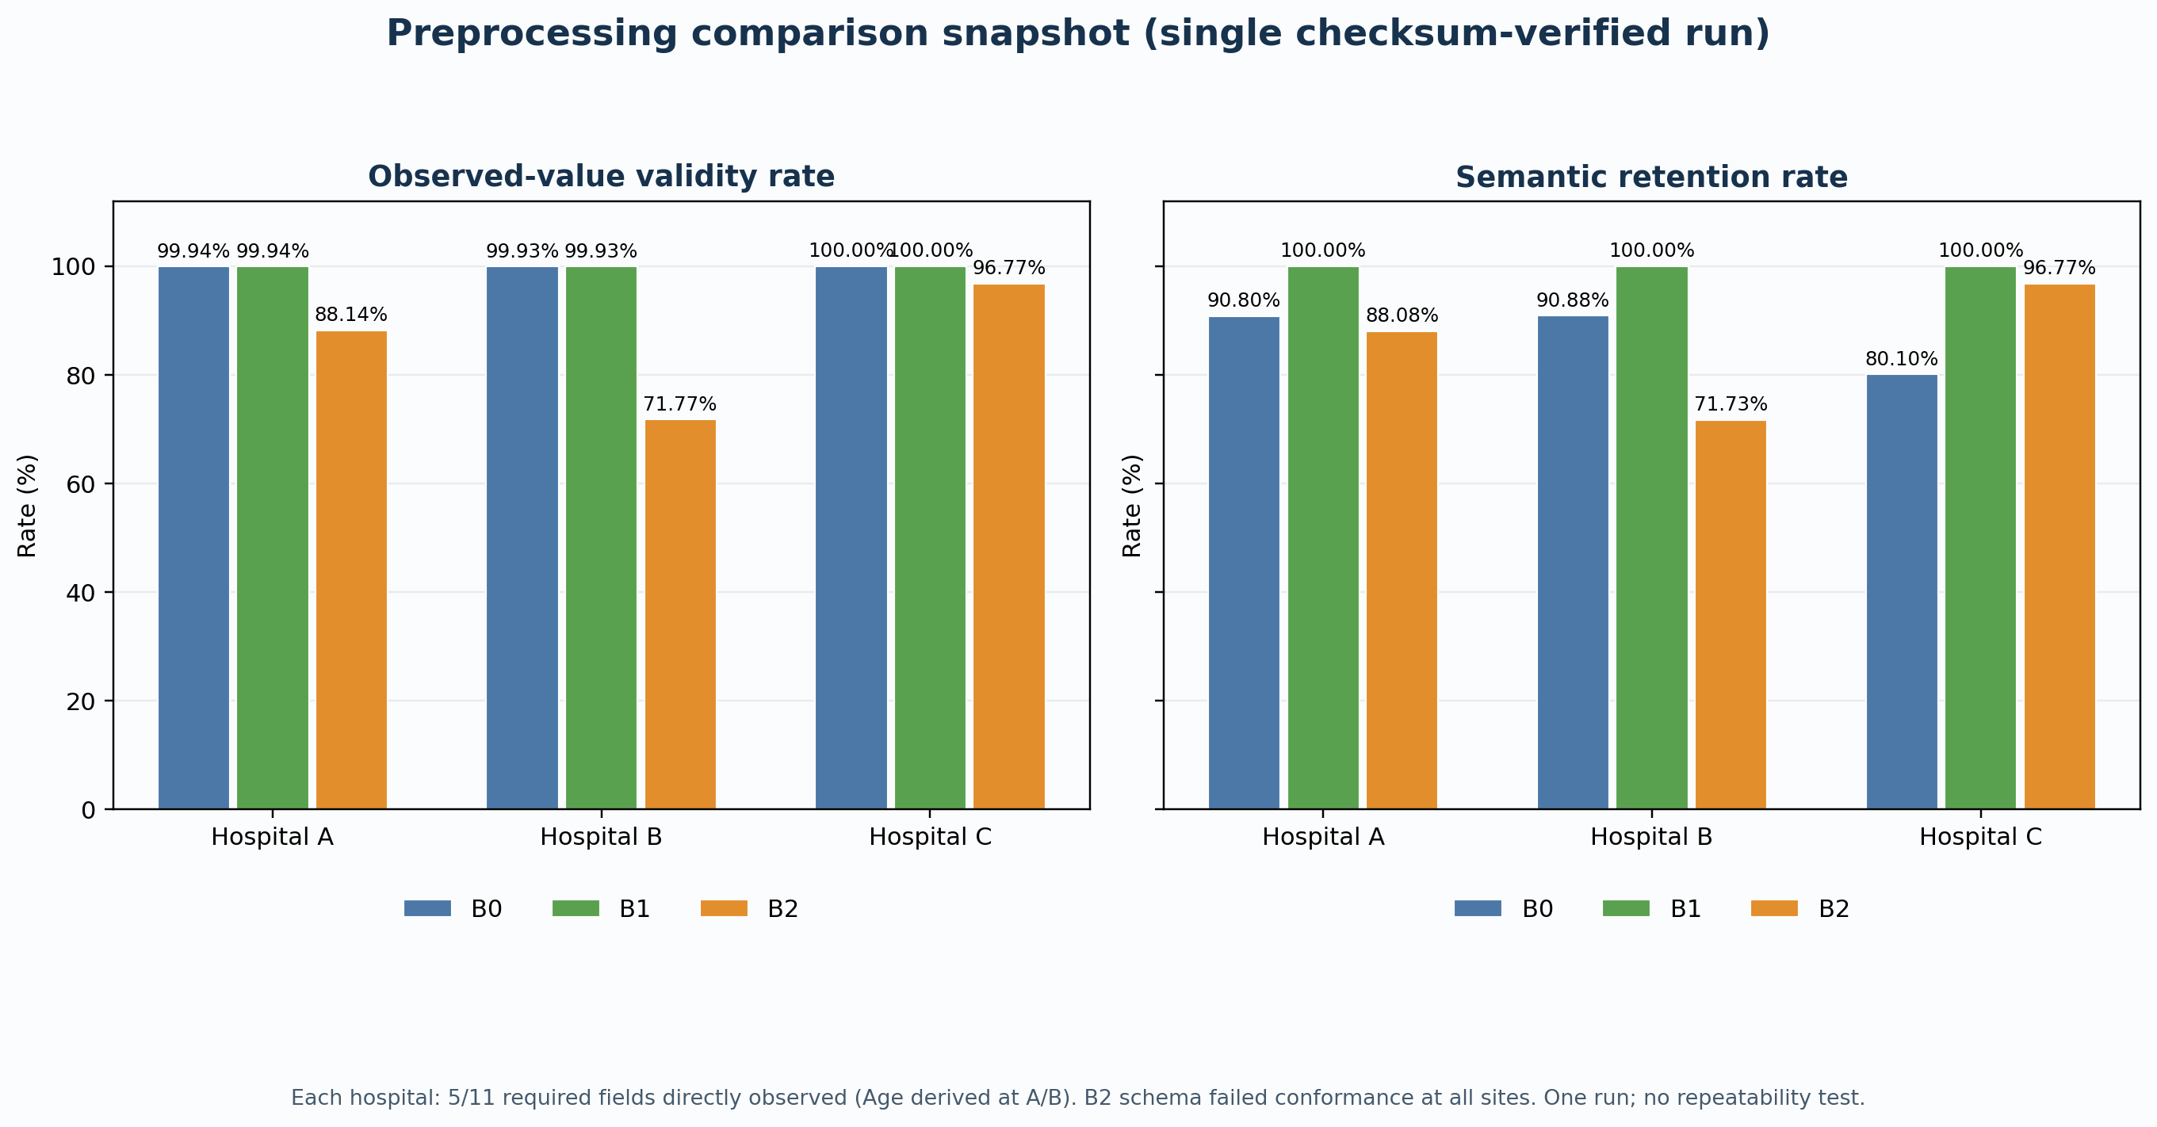
FIG. 4 - Observed-value validity and semantic retention from preprocessing-comparison-v2. Single run; metrics and limitations are defined above.

C.5 Model input, training, and aggregation
client_app.py selects 11 fields, one-hot encodes categorical fields, and fits StandardScaler separately while loading each client CSV. Because load_data() runs before train_test_split(), the scaler is fitted using the full local dataset, including rows later used for testing; reported test metrics may therefore include preprocessing leakage. GLOBAL_ENCODERS is initialized from the first client data loaded in the process and then reused. These details should be disclosed when interpreting results, not characterized as a fully versioned common schema.
scaler = StandardScaler()
X_scaled = scaler.fit_transform(df.values)
X_train_np, X_test_np, y_train_np, y_test_np = train_test_split(
X_np, y_np, test_size=0.2, random_state=42, stratify=stratify
)
z_ij = (x_ij - mu_hj) / sigma_hj, where mu_hj and sigma_hj are fit per client before the split
When enabled and the training-set minority class has more than one example, SMOTE is applied only to the training split, with k_neighbors = min(minority_count - 1, 5) and random_state 42. A synthetic point is interpolated between minority examples; the held-out test split is not resampled.
x_new = x_a + lambda (x_b - x_a), 0 <= lambda <= 1

C.6 Conditional differential privacy and ordinary FedAvg
The client config defaults MWAKATOBE_USE_DP to true unless overridden. When the flag is true, Opacus PrivacyEngine(accountant="rdp") wraps the model, optimizer, and data loader with the configured noise multiplier and gradient clipping norm; the client then writes epsilon/delta values. The preprocessing comparison report is not a DP run record. Verify the actual environment, logs, accountant assumptions, and complete run configuration before making a runtime privacy statement.
USE_DP = env_flag("MWAKATOBE_USE_DP", True)
self.privacy_engine = PrivacyEngine(accountant="rdp")
self.model, self.optimizer, self.train_loader = self.privacy_engine.make_private(
module=self.model, optimizer=self.optimizer, data_loader=self.train_loader,
noise_multiplier=DP_NOISE_MULTIPLIER, max_grad_norm=DP_MAX_GRAD_NORM
)
The inspected server uses standard Flower FedAvg. The client returns len(self.X_train) as the aggregation weight; X_train may already include SMOTE samples. No secure-aggregation protocol is configured in the inspected server path. If MWAKATOBE_USE_SMPC is true, the client raises RuntimeError rather than proceeding with secure aggregation.
theta_(t+1) = sum_h n_h theta_(h,t+1) / sum_h n_h, with n_h = len(client training array)
return self.get_parameters(), len(self.X_train), privacy_metrics
# server strategy: fl.server.strategy.FedAvg(...)
Sources: client/client_app.py, configuration near lines 37-41, feature loading near 304-335, split/SMOTE near 574-614, DP setup near 688-700, epsilon accounting near 756, and fit return near 775; server/strategy.py and server/server_app.py. Standard FedAvg does not itself protect updates from inspection.

C.7 Figures and source cross-reference
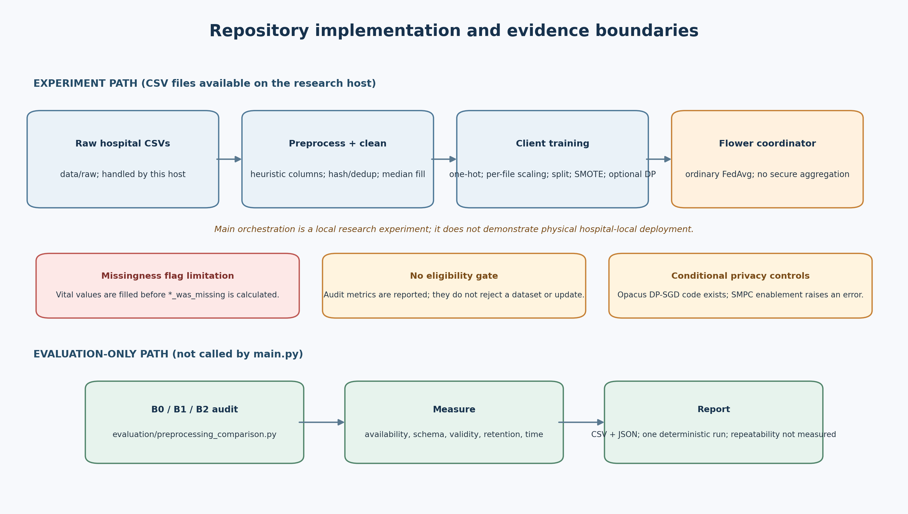
FIG. 3 - Repository implementation map separating the local experiment path from the evaluation-only comparison harness. Red/amber annotations indicate observed limitations, not proposed claim elements.
Primary source references: main.py (orchestration); client/data_utils.py (source-column heuristics and preprocessing); client/clean_app.py (imputation and missingness-flag order); client/client_app.py (encoding, scaling, split, SMOTE, DP-SGD, client update); server/strategy.py and server/server_app.py (FedAvg); evaluation/preprocessing_comparison.py with evaluation/preprocessing_comparison_report.csv and evaluation/preprocessing_comparison_summary.json (single-run audit). Re-run the comparison after relevant source changes and have patent counsel review any claim language before filing.

