PATENT APPLICATION — TECHNICAL SPECIFICATION
  - FedAfya: Privacy-Aware Federated Health-Data Processing Method | Draft for NM-AIST IPMO and patent counsel
Status: proposed claims; no novelty, inventive-step, patent eligibility, grant, or actual deployment representation is made. Verify against code, experimental records and Tanzania-specific patent law before filing.

A.1 Title of the Invention
FedAfya: Privacy-Aware Federated Health-Data Processing Method

A.2 Inventor and Particulars
The following persons are potential contributors named in the prior disclosure; patent inventorship must be determined claim by claim. Do not sign until verified.
Proposed contributor | Role / address | Nationality and contact
Justin Alipoki Mwakatobe | Lead researcher; NM-AIST; P.O. Box 447, Arusha only if verified | [Verify]; [verify email, phone]
Dr. Devotha G. Nyambo | NM-AIST; P.O. Box 447, Arusha only if verified | [Verify]; [verify email, phone]
Prof. Kisangiri Michael | NM-AIST; P.O. Box 447, Arusha only if verified | [Verify]; [verify email, phone]
Dr. Catherine Mwaipopo | [Verify affiliation]; P.O. Box 447, Arusha only if verified | [Verify]; [verify email, phone]
Frank Wilbert Sichone | Developer; [verify affiliation]; P.O. Box 447, Arusha only if verified | [Verify]; [verify email, phone]

A.3 Owner of the Invention
Proposed owner/applicant: Nelson Mandela African Institution of Science and Technology (NM-AIST), P.O. Box 447, Arusha, Tanzania, subject to institutional ownership determination, assignments and any third-party contractual rights.

B.1 Technical Field
The invention concerns computer-assisted processing of heterogeneous electronic healthcare records and methods for preparing and controlling distributed predictive-model training in multi-institutional healthcare environments, with particular relevance to Tanzanian maternal and neonatal health information.

B.2 Background of the Invention
Healthcare facilities maintain electronic records with inconsistent field names, category definitions, measurement availability and outcomes. Cross-site learning may require a common logical representation, but naive standardisation can mistake a feature absent from one hospital system for a clinically measured zero or imputed observation. Federated learning can reduce routine transfers of raw patient records, yet model updates can still carry privacy risks. Technical measures must be specified and verified rather than inferred from the term federated learning.

B.3 Known Prior Art
Relevant published technical foundations are listed below for a formal search. These are research references, not a verified patent-search result; patent publication numbers, dates and claim overlap remain to be checked.
Prior-art starting point | Relevance / differentiation question
McMahan et al. (2017) | Federated averaging / decentralised model optimisation; investigate overlapping coordination claims.
Bonawitz et al. (2017) | Secure aggregation of model updates; not a FedAfya invention by itself.
Dwork and Roth (2014) | Differential privacy foundations; not novel by itself.
OHDSI / OMOP common data model literature | Harmonisation of heterogeneous clinical records; compare mapping and provenance rules.
Missingness-aware EHR and federated healthcare literature | Assess overlap with feature-availability masks, quality gates and privacy-aware FL.

B.4 Technical Problem to Be Addressed
The proposed method addresses non-equivalent hospital schemas, clinically significant structural missingness, and the risk of disclosing sensitive patient information when coordinating learning across healthcare institutions. The technical workflow maps source-specific observations to a versioned common logical schema, retains provenance and availability status, applies an eligibility or quality decision, and prepares compatible local model inputs. Subject to implementation verification, authorised model updates may be clipped or perturbed under differential privacy and combined using secure aggregation. These established components are not individually claimed as newly invented.

B.5 Technical Solution
A coordinated sequence is proposed: source-specific schema/provenance capture; mapping into a versioned logical schema; explicit encoding of observed, missing and structurally absent features; a defined eligibility gate; generation of a compatible local training representation; and controlled, auditable exchange of model updates only when privacy mechanisms are actually enabled. The possible inventive contribution is the specific interaction of these rules, not their mere aggregation. The exact differentiating rule and comparative technical evidence must be established before final claims.

B.6 Detailed Description / Manner of Carrying Out

Step 1 — Hospital-controlled clinical data source (100)
Obtain clinical data within an authorised processing environment and record the source schema, record provenance and applicable institutional access restrictions. The disclosed research includes heterogeneous hospital datasets; physical site-local deployment remains to be verified.

Step 2 — Source-schema and provenance capture (110)
Identify each source field and its data type, category convention, measurement unit where applicable, and source of origin. Preserve version identifiers for later audit.

Step 3 — Versioned semantic mapping and validation (120)
Apply documented mappings to common logical clinical fields and outcome categories; flag unmapped categories and invalid values instead of silently reclassifying them.

Step 4 — Observed/missing/structurally unavailable state encoding (130)
For each feature, distinguish an actual measured value from a missing item and from a variable absent in the source system. Where imputation is used, retain original missingness metadata. This proposed handling requires confirmation against the current implementation.

Step 5 — Data-quality and update eligibility gate (140)
Calculate quality indicators, including mapping success, invalid-value frequency, observed-value coverage and structural availability; apply predeclared criteria to flag or withhold unsuitable data or updates. The threshold and enforcement mechanism must be evidenced.

Step 6 — Local model-training operation (150)
Generate a compatible training representation and train a model according to a shared task and model version. Confirm whether each site executes locally or whether data are processed in a research simulation before describing deployment.

Step 7 — Conditional privacy control for model updates (160)
Where implemented and activated, apply documented clipping/noise, privacy accounting, update protection or other controls; do not equate pseudonymisation with anonymisation and do not assert secure aggregation where disabled.

Step 8 — Federated aggregation coordinator (170)
Receive eligible updates at a coordinator and combine them under the verified aggregation protocol. Avoid describing ordinary model updates as intrinsically private.

Step 9 — Model-version audit and feedback (180)
Record source mapping, model version, training participation and evaluation summaries; return approved model information and record failure or suspension decisions.

Example embodiment and technical evidence
Research preprocessing across three Tanzanian hospitals reported 15,208 initial records and 13,329 after identifier-based deduplication, and a shared 11-feature logical schema. These observations illustrate heterogeneous data processing, not proof of patent novelty, physical local-only deployment, privacy guarantees, or superiority over prior art. Hospital C had structurally unavailable variables; common column names do not establish common observed-value coverage. The missingness-state preservation and quality-gate embodiment must be tested against the current code.

C. PROPOSED CLAIMS (for counsel review)
1. A method for preparing heterogeneous health records for distributed predictive-model training across multiple healthcare data environments, comprising: capturing, for each environment, a source-specific data schema and provenance information; mapping source clinical fields to a versioned shared logical feature specification; assigning to each mapped feature a state distinguishing an observed value, an item-level missing value, and a structurally unavailable feature; generating a training representation that preserves said state distinction; evaluating the representation against a predefined quality or eligibility rule; and producing a site-specific training input and associated non-identifying quality metadata.
2. The method of claim 1, wherein the shared logical feature specification comprises source-to-target category mappings, data-type constraints, measurement-unit rules, and outcome-label definitions.
3. The method of claim 1, wherein the structurally unavailable state is retained separately from any imputed numeric value so that an absent source measurement is not represented as an observed clinical measurement.
4. The method of claim 1, wherein the quality or eligibility rule uses at least one of observed-value coverage, valid-value coverage, semantic mapping completeness, and outcome-label integrity.
5. The method of claim 1, further comprising performing a local training operation using the site-specific training input and generating a model update for a versioned shared learning task, subject to confirmation of the deployment arrangement.
6. The method of claim 5, further comprising applying an enabled, specified differential-privacy mechanism to a model update and recording a corresponding privacy-accounting value, when supported by the implemented embodiment.
7. The method of claim 5, further comprising combining authorised model updates under an implemented secure-aggregation protocol, when supported by the implemented embodiment.
8. The method of claim 5, wherein a training round is flagged or withheld if a predefined eligibility or privacy-control condition fails.
9. The method of claim 5, further comprising recording a model version, source-schema version, mapping-rule version, and site-level quality summary to support reproducibility.
10. The method of claim 1, wherein the clinical data relate to maternal or neonatal care and the shared logical feature specification includes demographic, physiological, treatment and outcome fields.

D. Brief Description of Drawings
FIG. 1 is a method flow diagram comprising data sources 100, source/provenance capture 110, mapping 120, availability-state encoding 130, eligibility gate 140, local training 150, optional update privacy control 160, aggregation 170, and audit/feedback 180. FIG. 2 shows a three-hospital example and the distinction between raw patient records, local training inputs, and model-update communications.

E. Detailed Description of Drawings
In FIG. 1, the output of source 100 is processed by capture component 110 and mapping component 120. State encoding 130 records whether each mapped field was measured, missing, or absent in the source. Quality gate 140 assesses the resulting representation before it is passed to training operation 150. Optional control 160 is used only when configured and validated. Coordinator 170 combines eligible updates; audit component 180 records version and quality information. In FIG. 2, hospital environments A, B and C are illustrated separately; the diagram is conceptual and does not certify that the reported experiments were run on physical hospital infrastructure.

F. Drawings
FIG. 1 — conceptual method flow
100 Source records → 110 provenance → 120 schema mapping → 130 availability state → 140 quality gate
140 eligible → 150 training → 160 optional update controls → 170 aggregation → 180 audit / feedback
FIG. 2 — conceptual deployment
Hospital A: records → preparation → training
Hospital B: records → preparation → training
Hospital C: records → preparation → training
Authorised model updates only → coordinator (subject to actual deployment and privacy verification)

G. ABSTRACT (maximum 150 words)
A method is disclosed for preparing heterogeneous clinical records for distributed healthcare model training. The method captures source-specific clinical schemas and provenance, maps clinical fields to a versioned common feature specification, and distinguishes observed measurements from missing values and structurally unavailable fields. A quality-control operation evaluates semantic validity and feature availability before producing site-specific model-training representations and non-identifying quality metadata. In an embodiment subject to implementation verification, participating healthcare environments generate local model updates under a shared task definition, optionally applying differential-privacy controls and secure aggregation when enabled and validated. Versioned mapping and model information support traceability and review. The method is intended to reduce ambiguity introduced by incompatible electronic health-record formats while enabling controlled multi-institutional model development without routine disclosure of patient-level records.
Abstract word count: 124.

Annex: Essential Verification Before Filing
☐ Identify and test the exact new technical rule relative to closest patent and non-patent prior art.
☐ Verify source code supports original missingness-state capture, the claimed quality gate and its enforcement.
☐ Document whether training ran physically at hospitals or in a simulation; identify any central data access.
☐ Verify actual DP clipping/noise/accounting and secure-aggregation execution before asserting these mechanisms.
☐ Check public GitHub commits, manuscript submissions, conference presentations and other novelty-relevant disclosures.
☐ Confirm inventorship, NM-AIST ownership, third-party contracts, ethics and data permissions.
☐ Have Tanzanian patent counsel review statutory subject-matter eligibility and claim scope.

ANNEX A — Patent Drawings (conceptual)
These drawings illustrate proposed embodiments and do not independently establish that every feature is implemented, enabled or patentable. Reference numerals correspond to the technical description. Review and revise against verified source code before filing.

FIG. 1
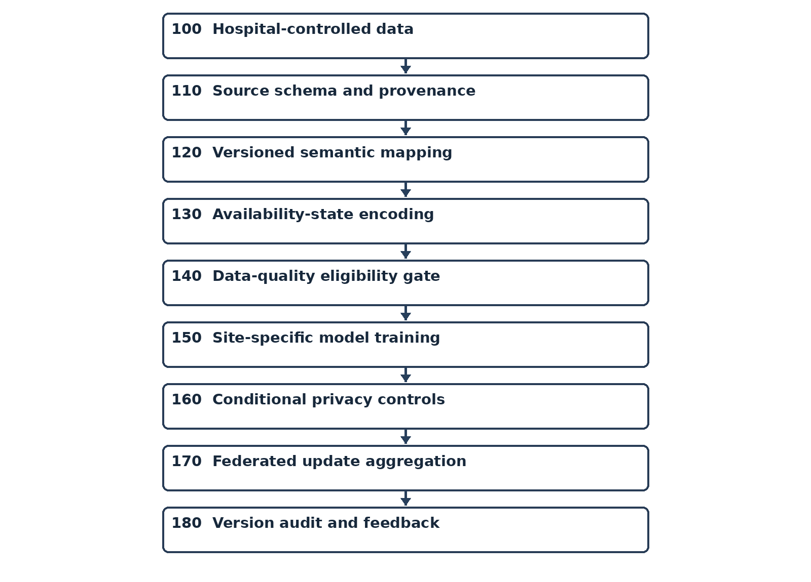
FIG. 1: Numbered method sequence.

FIG. 2
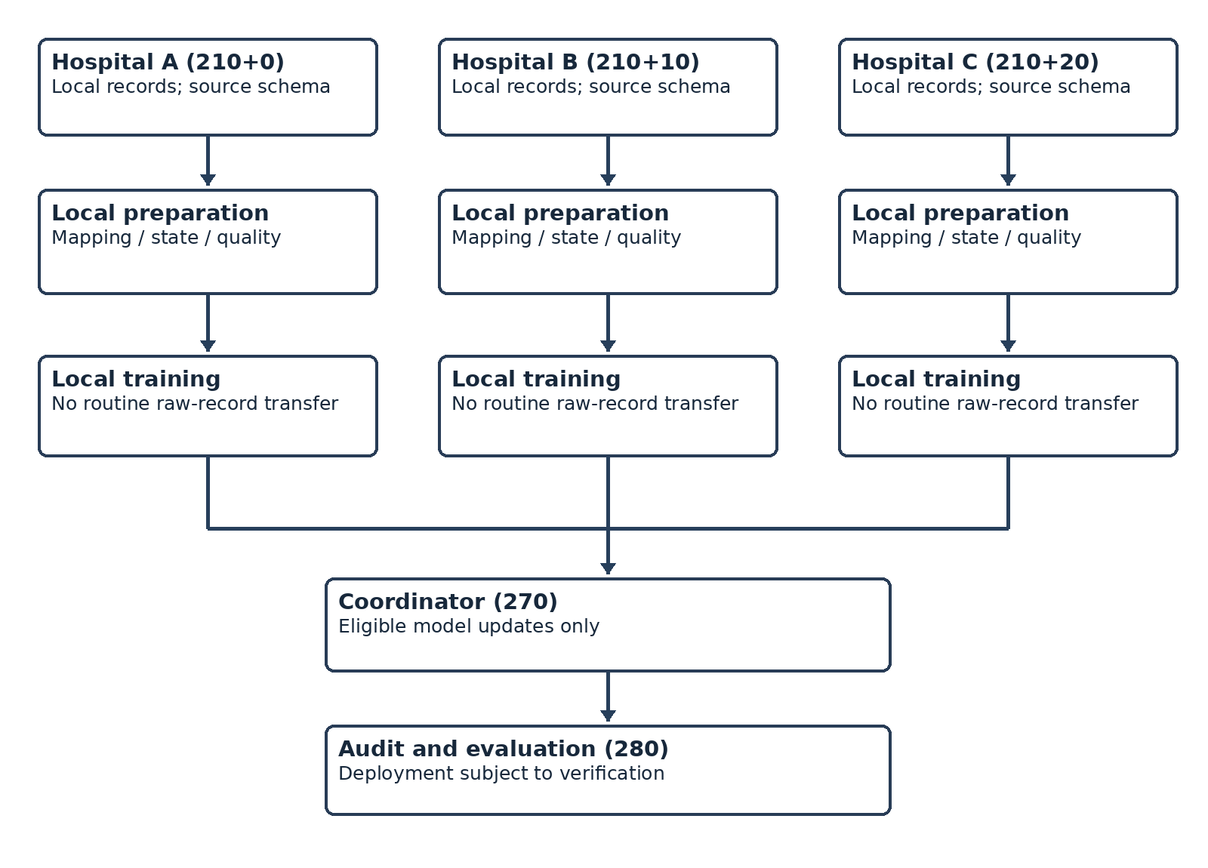
FIG. 2: Illustrative three-hospital training arrangement. Physical hospital-local deployment has not been verified.

ANNEX B — Code and Evidence Cross-Reference (to complete)
- data_utils.py — verify identifier transformation, deduplication and schema preparation; attach only confirmed excerpts.
- clean_app.py — verify that missingness indicators are recorded before imputation; otherwise amend claimed step 130.
- main.py and federated client/server files — verify physical data location, local training and coordinator logic.
- DP and SecAgg modules/configuration — document actual enabled state and test logs; omit unsupported functionality from final claims.
- Experimental records — validate metrics and record a reproducible comparison against relevant prior art.

