EFC Denominational Affiliate Visualization – Instructions  
v9.9

## Contact

For any questions or technical support, please contact:

Justin Chiu  
Designer and Developer  
[justin_chiu@outlook.com](mailto:justin_chiu@outlook.com)

## Contents

Downloading visualization files

Starting the visualization

Updating the data

Data requirements

Interacting with the visualization

Manual zoom

## Downloading visualization files

NOTE: If you’re reading this document, you have probably already downloaded and extracted the files for the visualization. However, if you haven’t done so, follow these instructions:

Download the folder or .zip folder that contains this document onto your computer. After the folder has been downloaded:

* **On Mac**, double-click the .zip folder. An uncompressed copy of the folder will be created.
* **On Windows**, right-click the .zip folder and click Extract All… and follow the wizard to create an uncompressed copy of the folder.

## Starting the visualization

1. Open the visualization:

Open the visualization folder and double-click the file named index.html to open it in your default web browser. This file can be found in the same folder as this document.

1. Load the data and start the visualization:

When the visualization has opened in your web browser, click on the Choose File button.

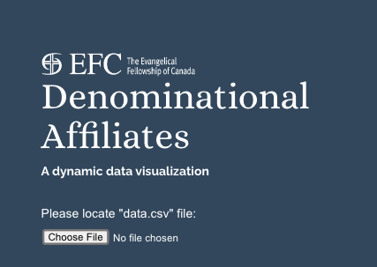

Then, browse and select the file named data.csv, which can be found in the same folder as this document and index.html. Click Open to start the visualization.

## Updating the data

To update the affiliate data displayed in the visualization, open data.csv in a spreadsheet application such as Excel, Numbers, or Google Sheets. This file can be found in the same folder as this document.

* To edit the data of an existing affiliate, simply **modify the values** in the existing cells.
* To add a new affiliate, **enter values into a new row**.

**Please read the requirements in the table on the next page** to your changes are properly read into the visualization. When you’re done, save the file.

## Data requirements

| **COLUMN NAME** | “Name (Display)” | “Faith Traditions” | “Congregations” |
| --- | --- | --- | --- |
| **What it is** | The operating name of the denominational affiliate | A comma-separated list of the faith traditions to which the affiliate belongs | The number of member congregations registered with the affiliate |
| **Mandatory?** | Yes | Yes | Yes |
| **Formatting  requirements** | - Add “<br>” where you would like the name text to break and continue on a new line  - Keep the name text shorter than 50 characters  - Use the operating name of the affiliate rather than the legal name  - Use “&” rather than “and”  - Omit “The” at the beginning of the affiliate name  - DO NOT use short forms or acronyms, e.g. “EFC” | - Use only the following case-sensitive values, exactly as shown:  Anabaptist Anglican/Episcopal Baptist Holiness Lutheran Mainline Pentecostal/Charismatic Pietist Reformed Restorationist Other  - To use other values or add new categories, please contact Justin at [justin_chiu@outlook.com](mailto:justin_chiu@outlook.com)  - For affiliates belonging to multiple traditions, separate them with commas “,”  - DO NOT use any punctuation or special characters other than commas “,” to separate multiple values | - DO NOT leave this column empty  - DO NOT add commas or spaces to the number, e.g. “1,000”  - DO NOT use any letters, punctuation, or special characters, e.g. “200-250”, “~200”, or “200+”  - DO NOT use “0” or “1” in place of values that are unknown |

## Interacting with the visualization

To **enter or exit full full-screen mode**, click the full-screen icon at the bottom-right of the visualization.



To see the **name, faith traditions, and count of congregations** for an affiliate on the visualization, hover over its circular node.

To see the **count of affiliates and total congregations for a faith tradition category**, hover over its circular node, which is styled differently than the circular nodes for affiliates.

To **select and visually focus on a faith tradition or affiliate** on the visualization, click on its circular node. To **deselect**, click on a different node or a blank area of the visualization.

To show **statistics on the EFC as a whole**, including counts of total faith traditions, affiliates, and congregations, click the EFC node at the center or any blank area in the visualization.

## Manual zoom

To enable manual zooming of the visualization, uncheck Scale to window size when first launching the visualization.

