**JUSTIN CROUCH – Module 7: Final Project Reflection**

Within the project, four objects and a ground plane were chosen to be replicated from a reference image, which is attached at the end of this document. The objects were chosen due to being the dominant figures within the reference image. To add more realism to the digital replication, a ground plane was added, which had an additional effect of providing an area to relate each object to another.

In order to satisfy the requirement of creating 3D objects that represent real-life objects, the program displays a multitude of primitive shapes with specific transformations and textures that, when observed together, present the illusion of a single object. Take, for example, the bottle: it is made up of a sphere as the base, a cylinder for the neck, a cone to transition between the base and neck, and a torus as the lip of the bottle. These primitive shapes, when drawn onto the screen, give the illusion of a bottle standing on a ground plane.

Although each object can be broken down into primitive shapes, better realism can be simulated through the use of lighting. Specifically, the program uses the Phong Reflection Model to simulate realistic real-time lighting and reflections. This technique combines the amount of residual light, or ambient light, an object receives, the amount of light reflected off the surfaces, or diffuse light, of an object, and the maximum amount of light reflected at a specific angle, or specular light, off an object to produce this realistic simulated lighting (Cabag, 2023).

A user can navigate the 3D scene through keyboard and mouse inputs. Specifically, by pressing the WSAD keys, the user can move forward, backward, left, and right within the scene, respectively. Through the E and Q keys, the user can move up and down respectively. These controls can be made more sensitive, i.e. move more quickly, by scrolling the mouse wheel up. The opposite can be done by scrolling the mouse wheel down. The user can look around by simply moving the mouse around. Finally, the scene can be viewed in either perspective or orthographic view by pressing the P or O key, respectively. This navigation functionality was accomplished by forwarding input events from OpenGL to methods that transform the camera to accomplish a specific movement, such as moving forward.

To ensure modularity within the code, custom functions were created, which also help with the organization of the codebase. Within the SceneManager class, which handles the rendering preparation of the scene, there are functions that are used to add objects into the scene. These objects are essentially a tag that points to a vector of shapes that constitute that object. To aid in adding shapes to an object, a function is used that expects the tag of the object to assign the shape to, as well as a container with data that defines a specific shape and its transformations. In order to duplicate a specific object repeatedly, such as a bottle, a function is used that utilizes the previously mentioned methods to easily and consistently add a duplicate of that specific object to the scene at a user-defined position.

**Image Reference**

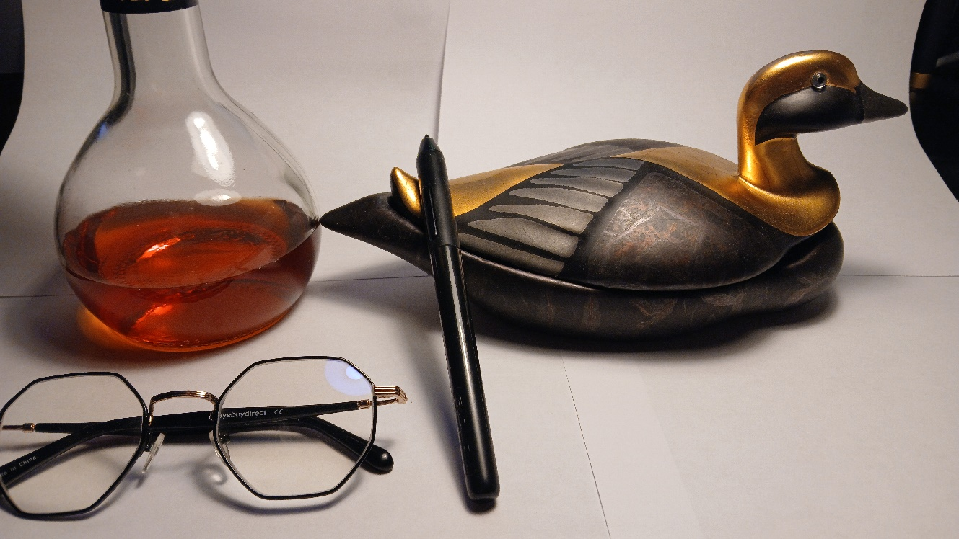

**References**

Cabag. (2023, November 1). *A breif note about Phong reflection model, derivation of its formula, different approach to shading*. Medium. https://medium.com/@leo6150631016/a-breif-note-about-phong-reflection-model-derivation-of-its-formula-different-approach-to-7711936cd231