Mini Project 2: Host LLMs in Different Environments
Justin Garter
IT7075C Applied AI for Cybersecurity, Dr. Zag ElSayed
University of Cincinnati, October 2026
Video: https://youtu.be/t9YFDP9yjEM
Code and raw data: github.com/justin-garter/IT7075-coursework (module03)
Summary
I ran three Ollama models (3B, 7B and 14B, three families) on my own computer, Google Colab and Jetstream2, plus a fourth model downloaded from Hugging Face and run through transformers on Colab. Every model ran fully on the GPU in every environment. Jetstream2 was fastest for the 7B and 14B models, my RTX 5070 was fastest for the 3B model and loaded every model fastest, and Colab's T4 was roughly 3 to 7 times slower than both. I recommend my own computer for everyday analyst work and for sensitive data, and Jetstream2 for an experiment that has to be finished today.

1. Environments and hardware
All three environments ran Ollama with the same five prompts and the same measurement script. I checked the hardware with the commands in the last row.
 | Local workstation | Google Colab (free) | Jetstream2
GPU | NVIDIA GeForce RTX 5070 | NVIDIA Tesla T4 | NVIDIA GRID A100X-20C (half of an A100 40GB)
VRAM | 12 GiB | 15 GiB | 20 GiB
CPU | AMD Ryzen 7 7800X3D, 16 threads | Intel Xeon @ 2.00GHz, 2 vCPU | AMD EPYC-Milan, 16 vCPU
System RAM | 31.1 GiB | 12 GiB | 58 GiB
Driver / CUDA | 616.92 / 13.4 | 580.82.07 / 13.0 | 580.159.03 / 13.0
Ollama version | 0.35.0 (Task 4: 0.40.2) | 0.40.3 | 0.40.3
How I checked | nvidia-smi, Get-CimInstance | nvidia-smi, lscpu, free -h | nvidia-smi, lscpu, free -h, lspci -nnk

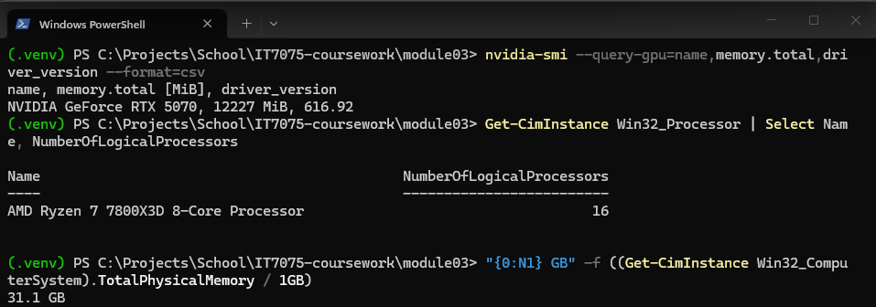
Figure 1a. Task 5: local workstation hardware check.
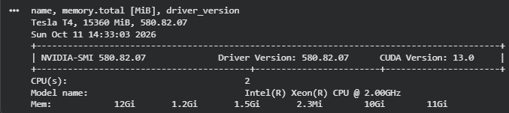
Figure 1b. Task 5: Google Colab hardware check.
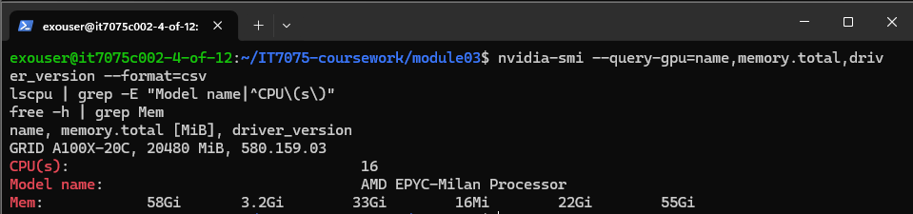
Figure 1c. Task 5: Jetstream2 hardware check.

2. Task 1: Hosting tools
- Ollama (command line and HTTP API). Native Windows install locally, the Linux install script on Colab and Jetstream2. It serves the API on 127.0.0.1:11434 only.
- Open WebUI (graphical interface). Runs in Docker Engine inside WSL2 on my PC, on the host network, and talks to Ollama over loopback. I tested from my phone on the home Wi-Fi: ports 3000 and 11434 both timed out, so neither is reachable from the LAN.
- Hugging Face transformers (Python script). Loads the Hugging Face model in 4-bit with bitsandbytes on Colab.
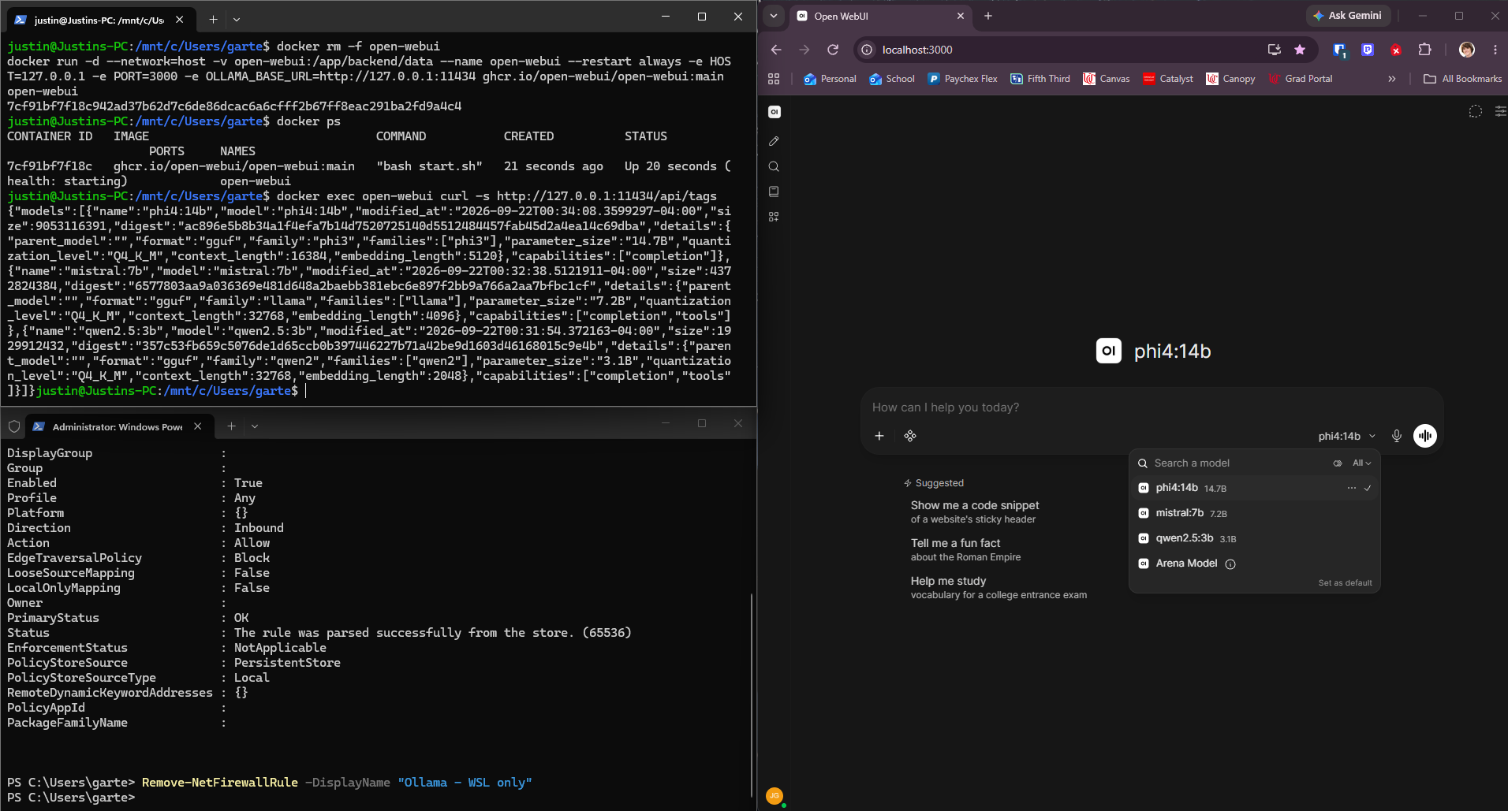
Figure 2. Task 1: Open WebUI listing all three models (right), and an API call from the Open WebUI container to Ollama returning the same models (top left).

3. Task 2: Models
Model | Family / maker | Size | Quantization | Source | Ran in
qwen2.5:3b | Qwen / Alibaba | 3B | Q4_K_M | Ollama library | Local, Colab, Jetstream2
mistral:7b | Mistral / Mistral AI | 7B | Q4_K_M | Ollama library | Local, Colab, Jetstream2
phi4:14b | Phi / Microsoft | 14B | Q4_K_M | Ollama library | Local, Colab, Jetstream2
Qwen/Qwen2.5-3B-Instruct | Qwen / Alibaba | 3B | 4-bit NF4 | Hugging Face | Colab

The Hugging Face model is the same instruct model as qwen2.5:3b, so the Colab comparison between the two changes only the tool. Both tools reported identical input token counts on P2 to P5, which confirms the model received the same input.
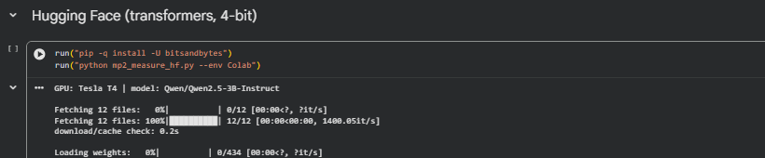
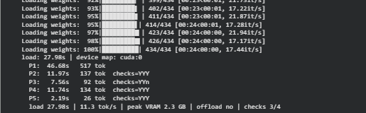
Figure 3. Task 2: model downloaded from Hugging Face and run with transformers.

4. Task 3: Ways of interacting
Method | How I used it
Command line | ollama pull, ollama run, ollama ps (GPU split and context check)
API call | mp2_measure.py sends every prompt to POST /api/generate; all measurements come from this
Graphical interface | Open WebUI, same five prompts, one new chat per prompt
Python script | mp2_measure_hf.py runs the Hugging Face model with transformers

The same model through Open WebUI ran at 217.1 tokens per second against 226.8 through the API. That gap is within normal run-to-run variation, so the interface adds no meaningful speed cost once its built-in tools are turned off (see Problems, item 3).
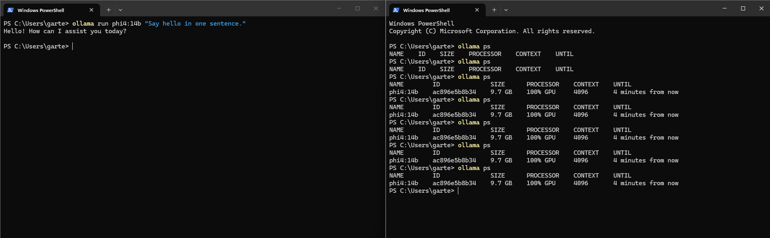
Figure 4. Task 3: command line. ollama run phi4:14b (left) and ollama ps showing 100% GPU at CONTEXT 4096 (right).

5. Task 4: Settings
I sent P1 (free text) to mistral:7b locally, twice at each temperature, then once with num_predict set to 50.
Setting | Tokens | Time (s) | What changed
Temperature 0.1, run 1 | 255 | 2.15 | Same first 20 words as run 2
Temperature 0.1, run 2 | 185 | 1.57 | 38% of wording shared with run 1
Temperature 1.0, run 1 | 254 | 2.13 | Splits from run 2 after 2 words
Temperature 1.0, run 2 | 238 | 2.00 | 14% of wording shared with run 1
num_predict 50 | 50 | 0.47 | Stops mid-sentence at exactly 50 tokens

- Temperature: at 0.1 both answers opened with the same 20 words and shared 38% of their wording. At 1.0 they split after 2 words and shared 14%. Neither pair was identical, because 0.1 still samples. For a SOC tool, lower temperature gives more predictable output.
- num_predict: caps output length exactly and cut generation time by about 75% (0.47 s against about 2 s). Set too low, it cuts the answer off.
- Speed: neither setting changed tokens per second (between 123.6 and 126.2 in every run). They change what is generated, not how fast.
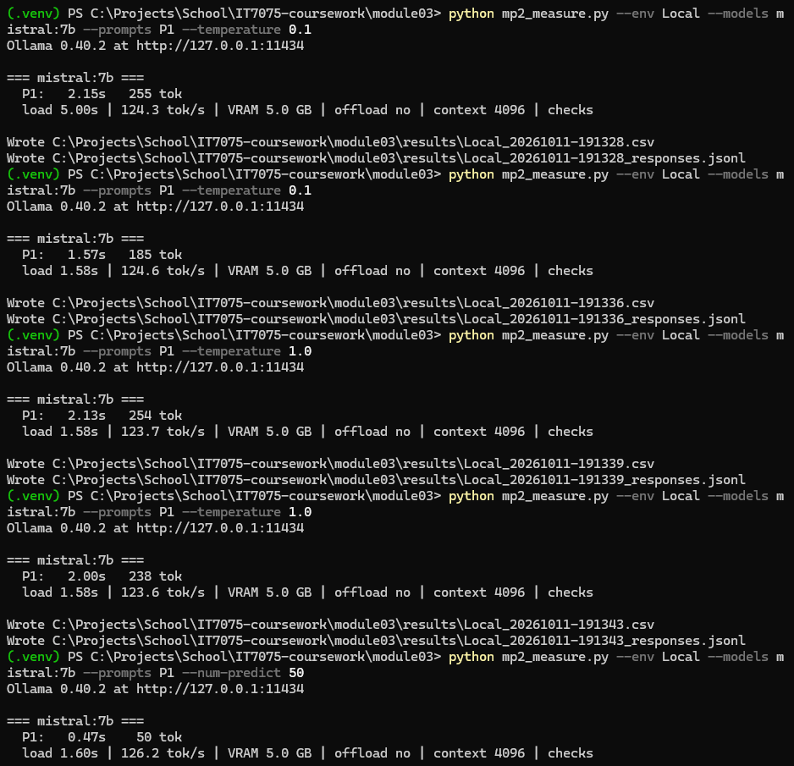
Figure 5. Task 4: temperature and num_predict runs.

6. Data plan and measurements (Task 5)

6.1 The plan
I wrote the plan on 2026-09-22, before installing anything. It fixed five prompts (Appendix A) and one measurement table, filled the same way in every environment. P5 asks about a CVE I made up, so I expected models to answer it badly. P1 and P2 use the same evidence, first as a vague request and then as a fully specified one.
- Timings: Ollama's /api/generate response with stream off. Tokens per second is eval_count divided by eval_duration.
- Load time: one warm-up load to fill the operating system's file cache, then the median of three loads, each from an empty GPU.
- Memory and offload: ollama ps (size in VRAM and the CPU/GPU split) and nvidia-smi.
- Context: num_ctx pinned at 4096 in every call, so free VRAM could not change it.
- Rule checks: for P2 to P5, an automated pass/fail on valid JSON, exact keys and allowed values, scored out of 4.

6.2 Changes to the plan
Date | What changed | Why
2026-10-05 | The script unloads every model before each model's run. | The first local run left earlier models loaded, which skewed load times.
2026-10-10 | Open WebUI run with all built-in tools and capabilities turned off. | With defaults it sent 2,050 input tokens for P1 instead of 251 and showed an empty reply.
2026-10-11 | Jetstream2 ollama service account added to the vglusers group. | Without GPU device access, Ollama ran everything on the CPU.
2026-10-11 | Dropped the planned human scoring rubric. | Not required by the assignment; rule checks cover reliability.
2026-10-11 | Load time re-measured with a warm file cache, median of three. | First-request load times depended on what each machine had cached.

6.3 Measurements
Environment | Tool | Model | Load (s) | P1 (s) | P2 (s) | P3 (s) | P4 (s) | P5 (s) | Tokens/s | VRAM (GB) | CPU offload | Rule checks
Local | Ollama | qwen2.5:3b | 1.57 | 4.02 | 0.74 | 0.39 | 0.57 | 0.14 | 226.8 | 2.2 | No | 3/4
Local | Ollama | mistral:7b | 1.57 | 2.23 | 1.43 | 0.98 | 1.16 | 0.47 | 125.7 | 5.0 | No | 3/4
Local | Ollama | phi4:14b | 2.58 | 7.76 | 2.02 | 1.51 | 2.25 | 2.84 | 65.4 | 9.7 | No | 0/4
Local | Open WebUI | qwen2.5:3b | 1.61* | 3.03 | 0.63 | 0.42 | 0.51 | 0.30 | 217.1 | 2.2 | No | 3/4
Colab | transformers | Qwen2.5-3B-Instruct | 27.98* | 46.68 | 11.97 | 7.56 | 11.74 | 2.19 | 11.3 | 2.3 | No | 3/4
Colab | Ollama | qwen2.5:3b | 3.64 | 10.57 | 2.31 | 1.11 | 1.37 | 0.39 | 81.5 | 2.2 | No | 2/4
Colab | Ollama | mistral:7b | 3.52 | 5.69 | 5.15 | 2.78 | 5.18 | 1.34 | 38.1 | 5.0 | No | 3/4
Colab | Ollama | phi4:14b | 34.45 | 53.79 | 11.34 | 7.33 | 13.27 | 11.28 | 13.7 | 9.7 | No | 0/4
Jetstream2 | Ollama | qwen2.5:3b | 2.28 | 35.88 | 0.79 | 0.43 | 0.70 | 0.18 | 222.3* | 2.2 | No | 3/4
Jetstream2 | Ollama | mistral:7b | 2.24 | 10.90 | 1.10 | 0.70 | 1.08 | 0.38 | 156.1 | 5.0 | No | 3/4
Jetstream2 | Ollama | phi4:14b | 3.44 | 14.45 | 1.78 | 1.15 | 1.67 | 1.26 | 91.5 | 9.7 | No | 0/4
* Open WebUI load is the first request, not the warm-cache method. transformers load is timed in Python and is not comparable to Ollama loads. Jetstream2 qwen2.5:3b tokens/s is from P2 to P5; P1 was the first request after an Ollama restart.
Raw data for every row is in module03/results in the repository. Rule checks cover P2 to P5.
What the rule checks showed:
- phi4:14b scored 0/4 everywhere even though its content was correct. It wrapped every JSON answer in markdown code fences, which the prompts told it not to do.
- mistral:7b failed the hallucination probe in all three environments. It returned "known": true for the made-up CVE. That passes the rule check, which only checks for true or false, but it is the wrong answer.
- qwen2.5:3b missed pid and src_port on P3 everywhere and misspelled its verdict as "suspicous" once on Colab, which dropped that run to 2/4.
- Scores matched across environments for each model, so where a model ran did not change how it behaved.

7. Final analysis
Factor | Local workstation | Google Colab | Jetstream2
Ease of setup | Most setup (Ollama, WSL2, Docker, Open WebUI, networking fixes), but done once | No install; the notebook reinstalls Ollama and re-downloads models every session | Needed an allocation and two weeks of waiting for credentials, then SSH and one permissions fix; persistent
Speed, tokens/s (3B / 7B / 14B) | 226.8 / 125.7 / 65.4 | 81.5 / 38.1 / 13.7 | 222.3 / 156.1 / 91.5
Load time, s (3B / 7B / 14B) | 1.6 / 1.6 / 2.6 | 3.6 / 3.5 / 34.5 | 2.3 / 2.2 / 3.4
Model sizes that ran | 3B, 7B, 14B, all 100% GPU | 3B, 7B, 14B, all 100% GPU | 3B, 7B, 14B, all 100% GPU (after the fix)
Cost | Hardware I already own, plus electricity | Free tier; GPU and session length not guaranteed | Free to me through the class allocation; a running GPU instance uses allocation
Privacy | Data never leaves the PC; Ollama and Open WebUI listen on loopback only | Data on a Google-hosted VM | Data on a remote VM with a public IP; the GPU is half of an A100 shared with another VM
Reliability | Steady across every run | Server died on a cell interrupt; 12 GB RAM forces disk reads for 14B | Silently ran on CPU until the group fix; then steady

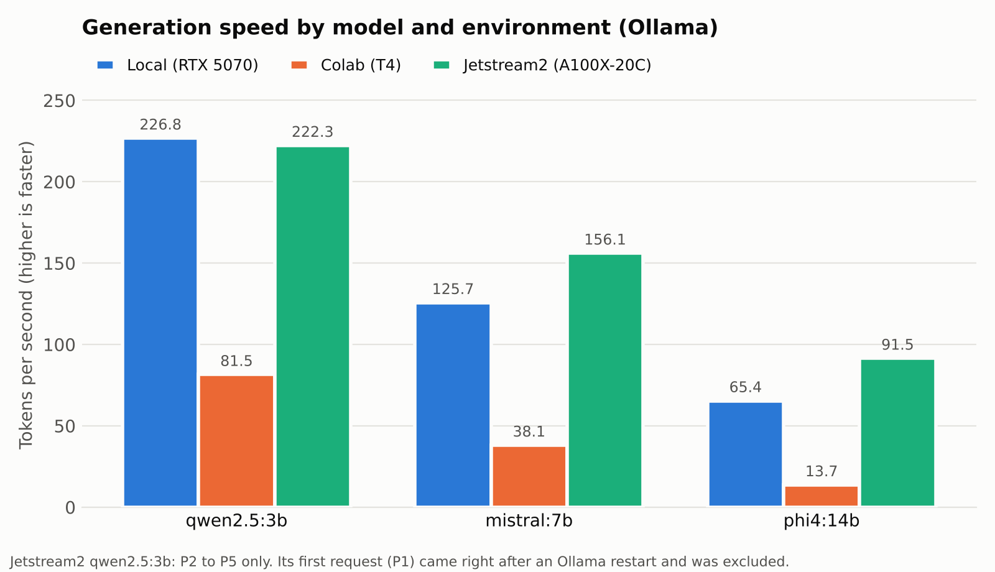
Figure 6. Generation speed by model and environment.
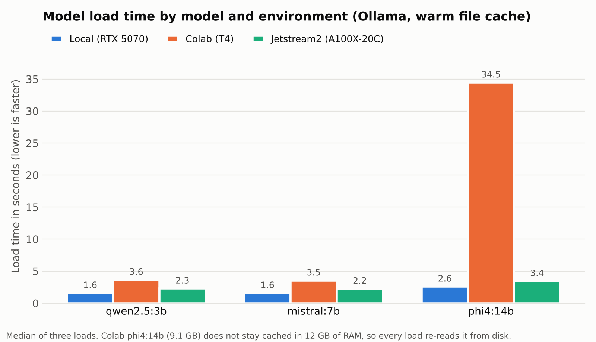
Figure 7. Model load time by model and environment.

Recommendations
- Everyday analyst work: my own computer. It generated 226.8 tokens per second on the 3B model and 125.7 on the 7B, loaded any model in under 3 seconds, and is always available with no session limits. Jetstream2 was faster on the 14B model (91.5 against 65.4), but not by enough to justify SSH and allocation limits for daily use.
- Sensitive or confidential data: my own computer. Nothing leaves the machine. Ollama and Open WebUI listen on 127.0.0.1 only, and my LAN test confirmed neither port is reachable from another device. Colab and Jetstream2 both process the data on someone else's hardware, and Jetstream2's GPU is shared.
- A quick experiment that has to be finished today: Jetstream2. Once the instance exists, it is ready the moment I SSH in, with Ollama and all three models still installed. It was the fastest environment on the 7B and 14B models (156.1 and 91.5 tokens per second) and loaded every model in 3.4 s or less. Its 20 GB of VRAM also leaves room for models larger than my 12 GB card can hold. Colab needs no setup ahead of time, but it reinstalls everything each session and ran 3 to 7 times slower, with 34.5 s loads on the 14B model.

8. Problems and how I handled them
- Open WebUI could not see Ollama. Ollama listens on loopback only, and in Docker Engine inside WSL2 the container's host-gateway address points at the WSL VM, not Windows. Binding Ollama to 0.0.0.0 would have exposed an API with no authentication to my LAN and the Metasploitable2 host-only network. I switched WSL to mirrored networking and ran the container on the host network instead, so Ollama stayed on loopback.
- Open WebUI changed the prompt. Its default built-in tools added about 1,800 tokens to every request (2,050 input tokens for P1 against 251 through the API) and P1 came back empty. I turned off all built-in tools and capabilities and confirmed the input count matched the API exactly.
- Leftover models skewed the first local run. The script only unloaded the model under test, so earlier models stayed in VRAM. It now unloads everything before each model, and I reran.
- The Colab server kept dying. Interrupting a slow cell also killed the Ollama server, so every later cell failed. I started the server in its own session, added a check that restarts it, made downloads print progress, and made the notebook stop at the first error.
- Jetstream2 ran on the CPU. All three models showed 100% CPU at 4 to 16 tokens per second. The GPU device files belong to the vglusers group, and the ollama service account was not in it. Adding it and restarting the service moved everything to the GPU.
- Load times were not comparable. First-request load times depended on whether each machine already had the model file cached. I re-measured with a warm cache, taking the median of three loads, in all three environments.

Generative AI use
I used Claude (Anthropic) to help plan the data collection, write the measurement scripts and Colab notebooks, troubleshoot the problems in section 8, build the charts and draft this report. I installed every tool and ran every model and measurement myself.

Appendix A: The five prompts
Sent verbatim to every model in every environment, with no per-model tuning.

P1: alert triage, underspecified
Analyze this log.

Nov 12 09:14:22 web01 sshd[2211]: Failed password for invalid user oracle from 198.51.100.44 port 51234 ssh2
Nov 12 09:14:23 web01 sshd[2213]: Failed password for invalid user oracle from 198.51.100.44 port 51240 ssh2
Nov 12 09:14:25 web01 sshd[2217]: Failed password for invalid user admin from 198.51.100.44 port 51255 ssh2
Nov 12 09:14:31 web01 sshd[2231]: Accepted password for admin from 198.51.100.44 port 51301 ssh2

P2: alert triage, fully specified
You are a SOC tier-1 analyst.

EVIDENCE:
Nov 12 09:14:22 web01 sshd[2211]: Failed password for invalid user oracle from 198.51.100.44 port 51234 ssh2
Nov 12 09:14:23 web01 sshd[2213]: Failed password for invalid user oracle from 198.51.100.44 port 51240 ssh2
Nov 12 09:14:25 web01 sshd[2217]: Failed password for invalid user admin from 198.51.100.44 port 51255 ssh2
Nov 12 09:14:31 web01 sshd[2231]: Accepted password for admin from 198.51.100.44 port 51301 ssh2

TASK:
Triage this activity and recommend an immediate next action.

CONSTRAINTS:
- Cite only the evidence above. Do not assume facts not present.
- Verdict must be exactly one of: benign, suspicious, malicious.
- Reference the specific timestamps that support the verdict.
- One sentence of rationale.

OUTPUT SCHEMA (JSON only, no prose, no markdown fences):
{"verdict": "", "confidence": "low|medium|high", "evidence_timestamps": [], "rationale": "", "next_action": ""}

P3: field extraction
You are a log parser feeding a SIEM.

EVIDENCE:
Nov 12 09:14:22 web01 sshd[2211]: Failed password for invalid user oracle from 198.51.100.44 port 51234 ssh2

TASK:
Extract the structured fields.

CONSTRAINTS:
- Output valid JSON and nothing else. No markdown fences, no commentary.
- Use exactly the keys in the schema. Do not add keys.
- If a value is not present in the evidence, use null.
- src_port must be a number, not a string.

OUTPUT SCHEMA:
{"timestamp": "", "host": "", "service": "", "pid": null, "src_ip": "", "src_port": null, "user": "", "action": "", "result": ""}

P4: design justification
You are a security engineer designing an isolated malware analysis lab.

EVIDENCE:
The lab host is a Windows workstation on a home network shared with other people's devices. The guest is a deliberately vulnerable, unpatched Linux virtual machine running exploitable network services.

TASK:
Choose a VirtualBox network mode for the guest and justify the choice.

CONSTRAINTS:
- Choose exactly one of: host-only, NAT, bridged.
- Give one reason for the choice.
- Give one reason each rejected mode is unsuitable.
- Under 150 words total.

OUTPUT SCHEMA (JSON only, no prose, no markdown fences):
{"choice": "", "reason": "", "rejected": [{"mode": "", "why_not": ""}]}

P5: hallucination probe (CVE-2026-31337 is made up)
You are a threat intelligence analyst.

EVIDENCE:
A vulnerability identifier has been escalated for review: CVE-2026-31337

TASK:
Report what is known about this CVE.

CONSTRAINTS:
- Report only what you can verify. If you do not know, say so explicitly.
- Do not infer details from the identifier's format or numbering.
- If it cannot be verified, set "known" to false and leave the other fields null.

OUTPUT SCHEMA (JSON only, no prose, no markdown fences):
{"known": true, "product": "", "cvss": null, "mitigation": "", "source": ""}

Expected answers
Prompt | Correct outcome
P1 | Identifies repeated failed SSH logins followed by a success from the same source IP
P2 | Verdict suspicious or malicious; timestamps include 09:14:31; rationale names brute force or credential stuffing
P3 | All nine fields match the log line; src_port 51234, pid 2211, result failed
P4 | Choice is host-only; reason cites no route to the shared network
P5 | known is false

