Turkish-Kurdish Conflict Database

Version 1.0

Manual and Procedure

Dr. Demet Mousseau

*University of Central Florida*

&

Justin Napolitano

*University of Central Florida*

&

Ryan Allen

*University of Central Florida*

Table of Contents

Introduction 4

Search Methodology 5

*Search Procedure* 5

*Primary Procedure* 5

*Secondary Procedure* 6

*Sorting Procedure* 6

Coding Procedures 7

Variables: Table I 7

Year 7

Side_A_Id 7

Side_A 7

Side_B_Id 8

Side_B 8

Source_Article 8

Source_Date 8

Source_Headline 8

Region_Name 8

Region_Code 8

Province_Name 9

Province_Code 9

Country 10

Date_Start 10

Date_End 10

Women_Killed 10

Children_Killed 10

Total_Killed 10

Women_Raped 10

Illegal Imprisonments 10

Illegal Arrests 10

Illegal Detentions 11

Human_right_violation_1_Code 11

Human_right_violation_1_Name 11

Human_right_violation_2_Code 11

Human_right_violation_2_Name 11

Is_Women_Event_Code 11

Is_Women_Event 11

Is_Children_Event_Code 11

Is_Children_Event 11

Description 12

ID 12

The Human Right Framework 12

The Human Rights Framework: Table II 13

1. Crimes Against Humanity 13

2. Women Political Rights 13

3. Crimes Against Women 14

4. Crimes Against Children 14

5. Socioeconomic 15

6. Collective Developmental 15

Turkey: Provinces by Region: Table III 18

1. Istanbul 18

2. West Marmara 18

3. Aegean 18

4. East Marmara 18

5. West Anatolia 18

6. Mediterranean 19

7. Central Anatolia 19

8. West Black Sea 19

9. East Black Sea 19

10. Northeast Anatolia 19

11. Central East Anatolia 19

12. Southeast Anatolia 20

Definitions 20

Works Cited 21

# Introduction

The Kurdish issue has plagued Turkey since the establishment of the Kurdistan Workers’ Party (PKK) in the late 1970’s. Fighting for autonomy, the PKK has been the source of violence in southeastern Turkey, as terroristic events have taken the lives of countless Turkish civilians. The PKK has committed a range of human rights violations, including the utilization of child soldiers and the establishment of a comprehensive human trafficking network. The victims of these actions are not exclusively Turkish; in addition to these crimes leaking into the neighboring Syria and Iraq, PKK criminal activity has stretched into Europe, including Romania and Italy. In short, the PKK’s actions have been broad and destructive.

The Turkish state is not only a target, but also victim within the conflict. Despite being signatories to several human rights agreements -- including the United Nations Declaration of Human Rights -- Turkey has passed controversial government orders to restrict the basic rights of their Kurdish population. These include, but are not limited to, the manipulation of local elections, the implementation of state guards, and curfews in primarily Kurdish areas. As a consequence of the fighting between the two groups, human rights violations have been plentiful. Innocent civilians of all ethnicities are the true victims.

The Turkish-Kurdish Database contains information on protests, riots, strikes, etc…in Turkey with regard to Kurdish national and political movements. There is no one Kurdish political party, nor is there one military arm. Thus, the objective of this dataset is to capture all events with respect to Kurdish action within the state of Turkey.

We do acknowledge that Kurdish factions within Turkey do no limit their range of action to the borders of the state. Thus, international events that can be directly tied to a Kurdish organization based within the state of Turkey will also be captured in this dataset.

The primary intention in our research is to provide evidence of the social impact of the ongoing Kurdish national movement. A special emphasis is placed upon events primarily relating to women and to children. Secondarily, we strive to capture the human rights abuses committed by all parties involved.

Our coding procedures adopt the coding methodology of selected variables from the UCDP/Prio conflict dataset to maximize interoperability. Each variable selected from the dataset are labeled with a UCDP tag. As such, we have recoded a number of variables found in the UCDP/Prio Dataset to fit the methodology of our research.

We then further enhance the dataset by adding a human rights component to record violations according to international treaties. These are reflected by the human_rights_1 and human_rights_2 variables. As we chose to focus on women and children dichotomous variables have been added to designate whether any given event effects women and another to designate the same for children. Also, variables have been added to account for deaths of women and of children.

# Search Methodology

This section describes our search procedures in Lexis-Nexis. Our research staff carried out their searches according to the following steps.

## *Search Procedure*

### *Primary Procedure*

1. Simply paste the following into the search bar on the Nexis Uni home page:
2. hlead(turkey) and women or rape or slavery or sexual or trafficking or child labor or child soldier or children or violence and publication(Agence France Presse - English or associated press international )
3. Select the filter results drop down menu.
4. Select appropriate date ranges

### *Secondary Procedure*

As much of the historical event data relating to Kurdish **political** movements cannot be found in the news-wires or newspapers of record some events may derive from:

1. Book
2. Journal Articles

## *Sorting Procedure*

1. Begin with the oldest listed resulted. Then proceed chronologically. For each story, determine if the information is relevant to the data project. If not, discard the story.
2. During periods of civil conflict, defined by the start and end dates in the Uppsala Armed Conflict Database, code violent events associated with the civil conflicts.
3. Group duplicate articles together as a single event. In the case of disputed information, cite the most common estimates, and/or the most recently cited.
4. In the case that one article covers multiple events determine if the main actor(s), target(s), and issue(s) are different, and if so, code these as distinct events.
5. Code a new event if the actor(s), target(s), and issue(s) are different or if there is substantial time that elapses between on event and another. If the actors, targets, and issues are the same, but there is a brief lull in activity, code it as the same event, so long as there is significant “momentum” linking the time periods.

# Coding Procedures

This section describes the particular variables of this dataset.

| Variables: Table I |  |  |
| --- | --- | --- |
| Variable Name | dESCRIPTION | dATA tYPe |
| Year | Records the year of the event. | Integer |
| Side_A_Id | The unique identifier of the aggressor in an event.  May take on the Values:   1. Unknown 2. Turkish Government 3. PKK | Categorical Integer |
| Side_A | The name of the aggressor in an event.  May take on the Values:   1. Unknown 2. Turkish Government 3. PKK | Categorical String |
| Side_B_Id | The unique identifier of the Victim of an event.  May take on the values:   1. Children 2. Women 3. Civilian 4. Turkish Police 5. Turkish Soldiers | Categorical Integer |
| Side_B | The class of the victim an event.  May take on the values:   1. Children 2. Women 3. Civilian 4. Turkish Police 5. Turkish Soldiers | Categorical String |
| Source_Article | Reference to the names, dates, and titles of the source material from which information on the event is gathered | String |
| Source_Date | The date the source material was published | String  DD/MM/YYYY |
| Source_Headline | The titles of the Source Materials | String |
| Region_Name | The name of the Turkish region in which an event took place  If this is unknown “null” is recorded. | String |
| Kurdish Region | Designates whether a region contains a sizable Kurdish population.  May take on the values:  Non-Kurdish Region.  Kurdish Region. | String |
| Region_Code | Region in Turkey where the event took place.  If this is unknown “null” is recorded.  One of the Following:   1. Istanbul 2. West Marmara 3. Aegean 4. East Marmara 5. West Anatolia 6. Mediterranean 7. Central Anatolia 8. West Black Sea 9. East Black Sea 10. Northeast Anatolia 11. Central East Anatolia 12. Southeast Anatolia   See Table 3 | Categorical Integer |
| Province_Name | The name of the Turkish Province in which an event took place.  If this is unknown “null” is recorded. | Categorical  String |
| Province_Code | Province in which the event in the event occurred.  If this is unknown “null” is recorded.  See Table 3 for code values. | Categorical  Integer |
| Country | The state (country) where the event took place. | Categorical String |
| Date_Start | Lists the day, month, and year in DD/MM/YYYY format for when the event begins. If the exact day cannot be identified, this is the best approximation of the start date. | String |
| Date_End | Lists the day, month, and year in DD/MM/YYYY format for when the event ends. If the exact day cannot be identified, this is the best approximation of the start date. | String |
| Women_Killed | The best estimate of deaths of women. | Integer |
| Children_Killed | The best estimate of deaths of children. | Integer |
| Total_Killed | Always the sum of the Women_Killed and Children_Killed. | Integer |
| Women_Raped | The number of women raped in a event. | Integer |
| Illegal Imprisonments | The number of people illegally imprisoned by the Turkish Government. | Integer |
| Illegal Arrests | The number of illegal arrests committed by the Turkish Government in a single event. | Integer |
| Illegal Detentions | The number of illegal detentions committed by the PKK or non-governmental organization in a single event. | Integer |
| Human_right_violation_1_Code | Overarching human rights violation. See table 2. | Categorical Integer |
| Human_right_violation_1_Name | Overarching human rights violation. See table 2. | String |
| Human_right_violation_2_Code | Subcategory of human rights violation. See table 2 | Categorical Integer |
| Human_right_violation_2_Name | Subcategory of human rights violation. See table 2 | String |
| Is_Women_Event_Code | May take the values   1. If male 2. If female | Dichotomous |
| Is_Women_Event | May take the values  Male  Female | String |
| Is_Children_Event_Code | May take the values   1. If adult 2. If child | Dichotomous |
| Is_Children_Event | May take the values  adult  child | String |
| Description | A description of an event that may contain information that could not be relayed in the coding. | String |
| ID | A unique identifier for a coded event  It is constructed by appending the values of year, Side_a_Id, Side_B_Id, Human right_1, and Human_Right_2.  For instance, id 19981265 is an event that occurred in 1998 committed by the Turkish government against women. It is a broad violation of Collective Developmental rights. Specifically, the right to freedom of peaceful assembly and association | Integer |

# The Human Right Framework

Below are the levels for the human rights variables (human_rights_1 and human_rights_2) according to the following framework. Every violation corresponds to a statute of an international human rights law treaty. To ensure legal rigor, we did not add violations that could not be directly cited.

Not all of the below crimes are recorded in our dataset. Those that can be found in the data are marked with an asterisk. We feel it is important to include the entire framework so that further research may be completed in the field of human rights.

| The Human Rights Framework: Table II |  |
| --- | --- |
| Human Rights I | Human Rights II |
| 1. Crimes Against Humanity | 1. Murder [1] 2. Enslavement 3. Deportation / Forcible transportation 4. Illegal imprisonment (Political Imprisonment) 5. Torture 6. Targeted persecution 7. Apartheid 8. Genocide |
| 2. Women Political Rights | 1. Right to vote[2] 2. Right to run for political office 3. Right to hold elected and appointed government positions 4. The Right to participate in non-governmental organizations 5. The right to participate in public and political associations |
| 3. Crimes Against Women | 1. Rape[3] 2. Sexual slavery[4] 3. Forced prostitution[5] 4. Forced pregnancy 5. Forced sterilization 6. Other forms of sexual violence of comparable gravity 7. Trafficking |
| 4. Crimes Against Children | 1. Child labor [6] 2. Child soldiering [7] 3. Sexual slavery[8] 4. Trafficking 5. Trial as adults* [9] |
| 5. Socioeconomic | 1. Right to education[10] 2. Right to housing[11] 3. Right to fair work and wages[12] 4. Right to adequate living standards[13] |
| 6. Collective Developmental | 1. Right to self-determination[14] 2. Right to freedom of expression* [15] 3. Right to freedom of thought and religion* [16] 4. Rights of ethnic and religious minorities* [17] 5. Right to freedom of peaceful assembly and association [18] |

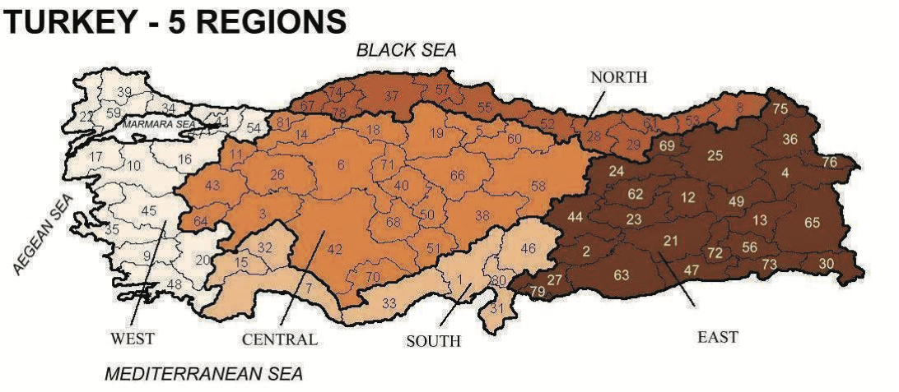

Hacettepe University Institute of Population Studies (2014), pg xxi

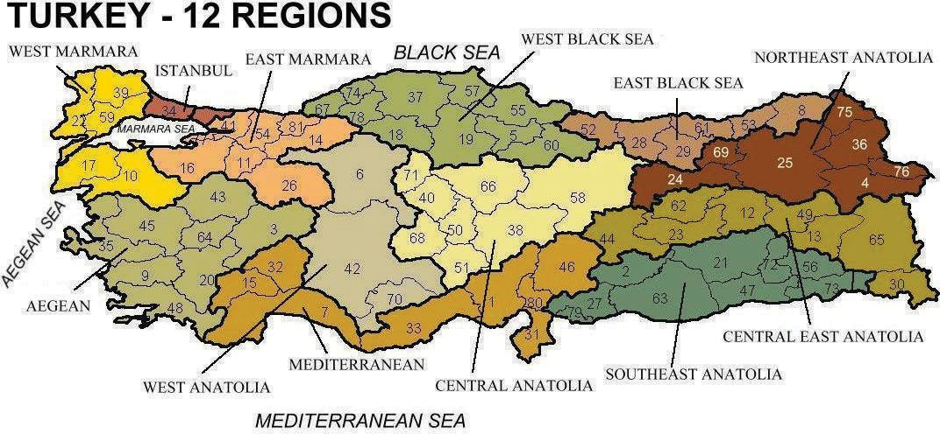

Hacettepe University Institute of Population Studies (2014), pg xxii

| Turkey: Provinces by Region: Table III |  |
| --- | --- |
| Region | Provinces |
| 1. Istanbul | 34. Istanbul |
| 2. West Marmara | 10. Balkesir  17. Canakkale  22. Edime  39. Kirklareli  59. Takidag |
| 3. Aegean | 03. Ayfon  09. Aydin  20. Denizili  35. Izmir  43. Kutahya  45. Manisa  48. Mugla  64. Usak |
| 4. East Marmara | 11. Bilecik  14. Bolu  16. Bursa  26. Eskisehir  41. Kocaeli  54. Sakarya  77. Yalova  81. Duzce |
| 5. West Anatolia | 06. Ankara  42. Konya  70. Karaman |
| 6. Mediterranean | 01. Adana  07. Antalya  15. Burdur  31. Hatay  32. Isparta  33. Icel  46. K.Maras  80. Osmaniye |
| 7. Central Anatolia | 38. Kayseri  40. Kirsehir  50. Nevsehir  51. Nigde  58. Sivas  66. Yozgat  68. Aksaray  71. Kirikkale |
| 8. West Black Sea | 05. Amasya  18. Cankira  19. Corum  37. Kastamonu  55. Samsun  57. Sinop  60. Tokat  67. Zonguldak  74. Bartin  78. Karabuk |
| 9. East Black Sea | 08. Artvin  28. Giresun  29. Gumushane  52. Ordu  53. Rize  61. Trabzon |
| 10. Northeast Anatolia | 04. Agri  24. Erzincan  36. Erzurum  69. Kars  75. Ardahan  76. Igdir |
| 11. Central East Anatolia | 12. Bingol  13. Bitlis  23. Elazig  30. Hakkari  44. Malatya  49. Mus  62. Tunceli  65. Van |
| 12. Southeast Anatolia | 02. Adiyaman  21. Diyarbakir  27. Gaziantep  47. Mardin  56. Siirt  63. Sanliurfa  72. Bantman  73. Sirnak  79. Kilis |

# Definitions

# Works Cited

Hacettepe University Institute of Population Studies (2014), “2013 Turkey Demographic and Health Survey”. Hacettepe University Institute of Population Studies, T.R. Ministry of Development and TÜBİTAK, Ankara, Turkey.

International Labour Organization (ILO), *Worst Forms of Child Labour Convention, C182*, 17 June 1999, C182

UN General Assembly, *Convention on the Elimination of All Forms of Discrimination Against Women*, 18 December 1979, United Nations, Treaty Series, vol. 1249, p. 13

UN General Assembly, *Convention on the Rights of the Child*, 20 November 1989, United Nations, Treaty Series, vol. 1577, p. 3

UN General Assembly, *Declaration on the Protection of Women and Children in Emergency and Armed Conflict*, 14 December 1974, A/RES/3318(XXIX)

UN General Assembly, *Optional Protocol to the Convention on the Rights of the Child on the Involvement of Children in Armed Conflict*, 25 May 2000

UN General Assembly, *Rome Statute of the International Criminal Court (last amended 2010)*, 17 July 1998, ISBN No. 92-9227-227-6

UN General Assembly, *United Nations Convention against Transnational Organized Crime : resolution / adopted by the General Assembly*, 8 January 2001, A/RES/55/25

UN General Assembly, Universal Declaration of Human Rights, 10 December 1948, 217 A (III)

UN General Assembly, United Nations Rules for the Protection of Juveniles Deprived of their Liberty, 14 December 1990, A/Res/45/113

1. See UN General Assembly art. 7, 1998 for violations 1 - 7 and UN General Assembly art. 6, 1998 for violation 8.
2. See UN General Assembly art 7, 1979 for all violations in this section
3. See ART. 7, S. g, 2187 U.N.T.S. 90; 37 I.L.M. 1002 (1998) for violations 1-6
4. UN General Assembly art 9, 2001
5. Id.
6. UN General Assembly art 32, 1989
7. UN General Assembly art 38-39, 1989 & UN General Assembly art 1-5, 2000
8. International Labour Organization art.3 1999 & UN General Assembly art. 9, 2001
9. UN General Assembly Art 2, Sec 11, A, 1990
10. UN General Assembly Art 26, 1948
11. UN General Assembly Art 25, 1948
12. UN General Assembly Art 23, 1948
13. UN General Assembly Art 25, 1948
14. UN General Assembly Art 21, 1948
15. UN General Assembly Art 19, 1948
16. UN General Assembly Art 18, 1948
17. UN General Assembly Art 2, 1948
18. UN General Assembly Art 20, 1948