Samsung Galaxy Note i717/T879 Replacement Battery

Capacity: 2500 mAh

Type: 3.7 V Li-Ion

Dimensions: 2.2 x 0.2 x 2 inches

Weight: 1.6 ounces

Fair Market Price: $9.74 (Amazon.com)

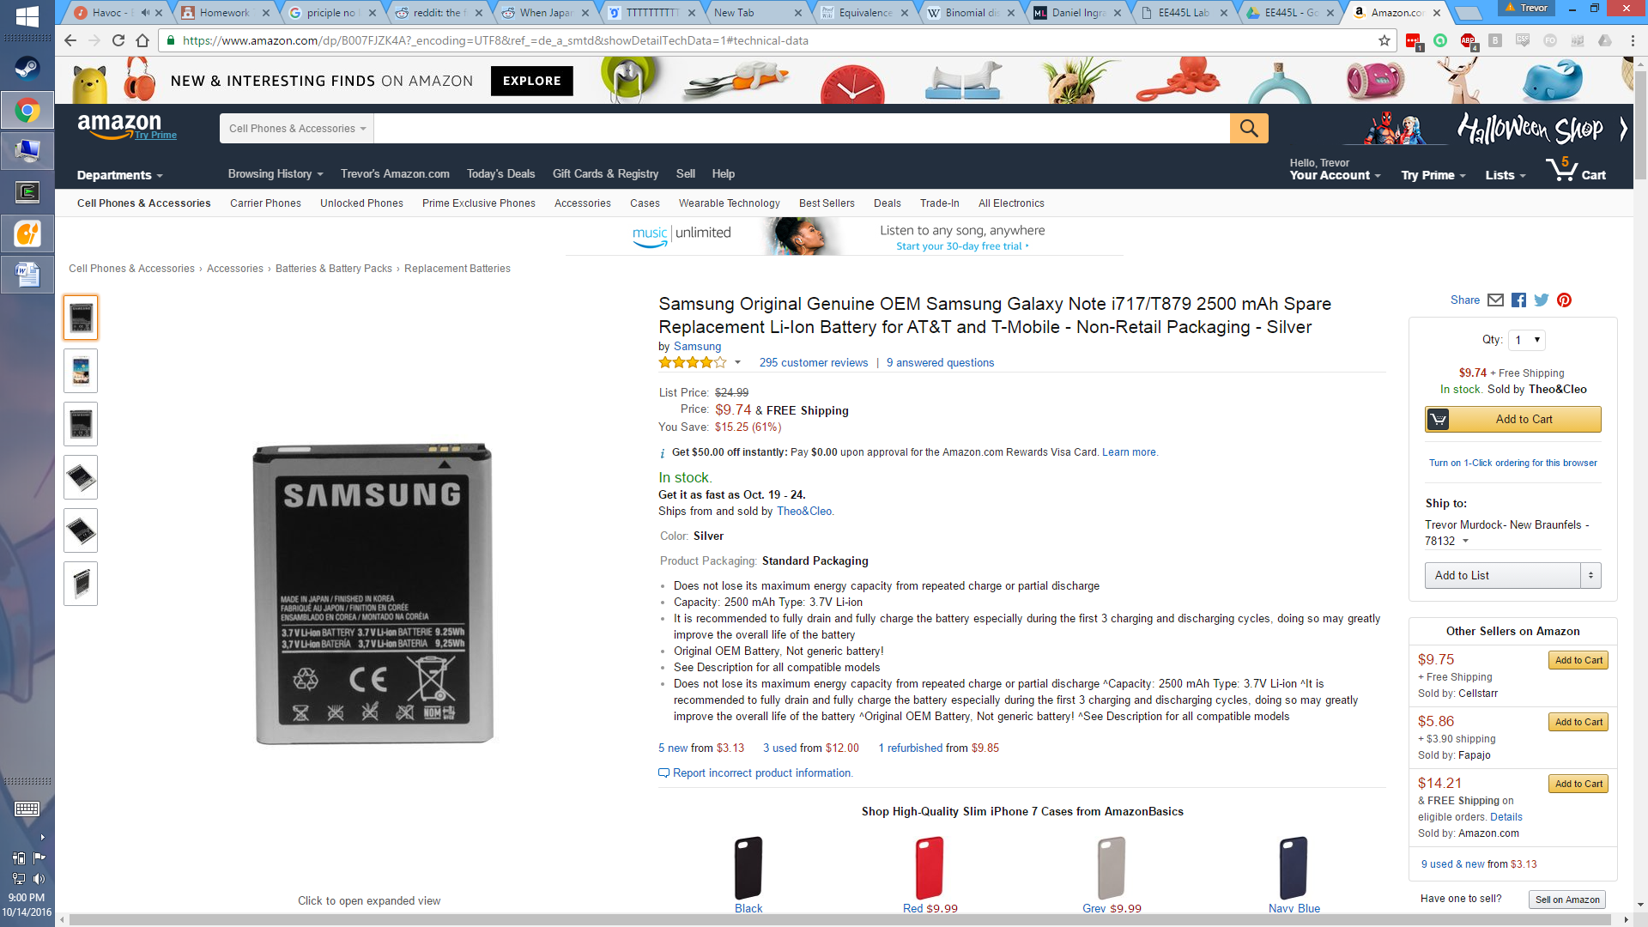

<http://www.upcitemdb.com/upc/803214936499>

<https://www.amazon.com/Samsung-Original-Genuine-Replacement-T-Mobile/dp/B007FJZK4A/ref=sr_1_5?ie=UTF8&qid=1476501785&sr=8-5&keywords=samsung+i717+battery>

* Links showing information on the battery

<https://www.aliexpress.com/item/100pcs-lot-Battery-Holder-Mobile-Phone-Battery-Connectors-for-Samsung-N7100-I9220-N7000/32565624794.html?spm=2114.40010508.4.27.pPSSpo>

* Link showing information on the battery connectors