These directions explain how to create a **data logging server**

By Yerraballi and Valvano

June 14, 2015

1) Create a google account at <https://appengine.google.com/start>

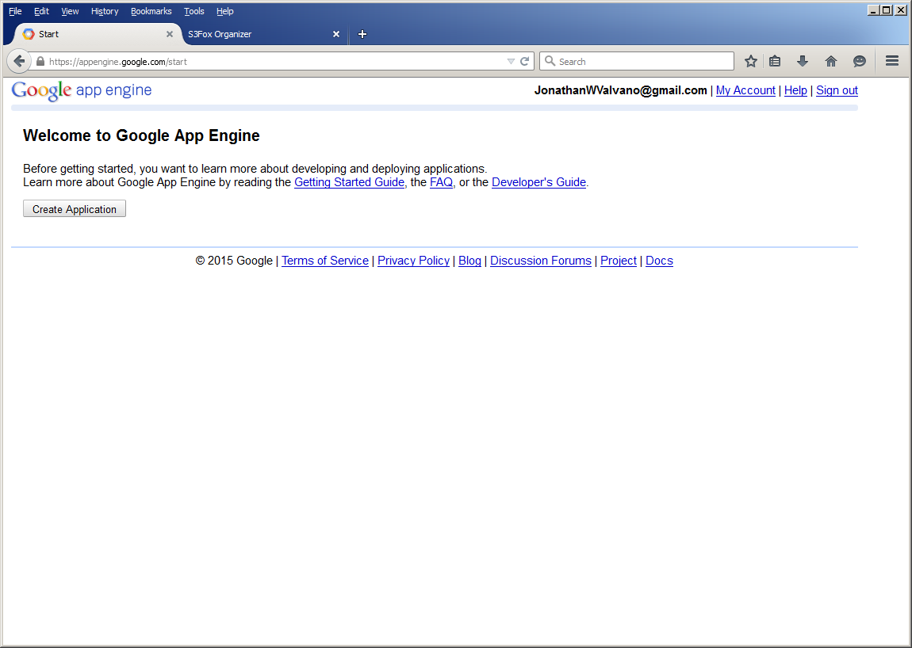

2) Create an application. You need a unique **application identifier**. Valvano was take, so this example is called embedded-systems-server. This will create the web site **embedded-systems-server.appspot.com.** Application Title is the name of the page

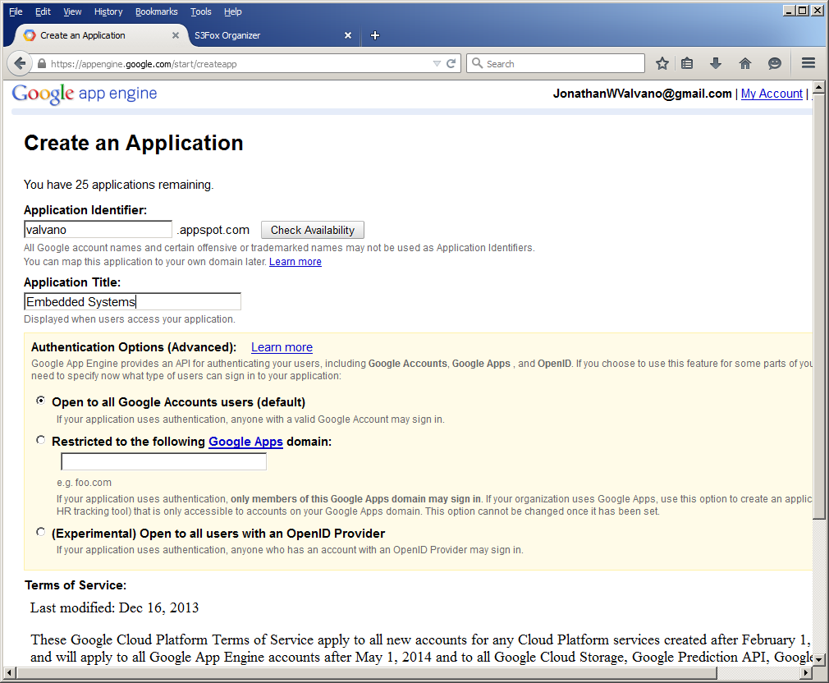

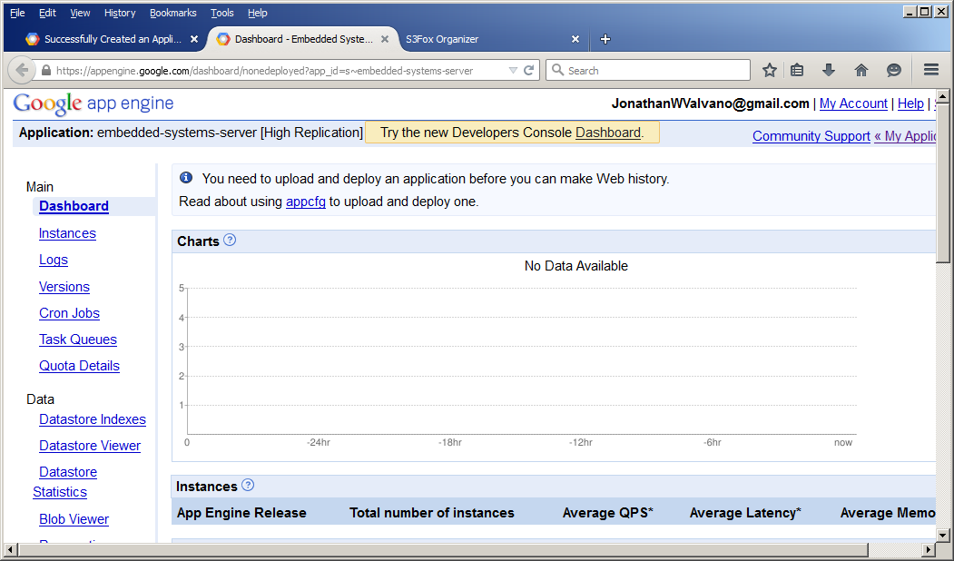

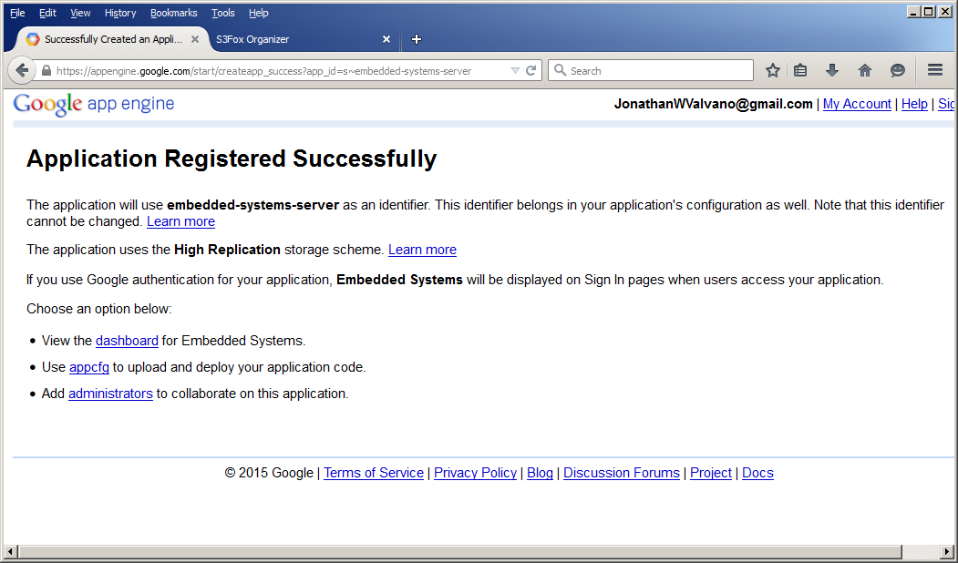

3) Use the **App Config Tool** to download the Google App Engine for Python

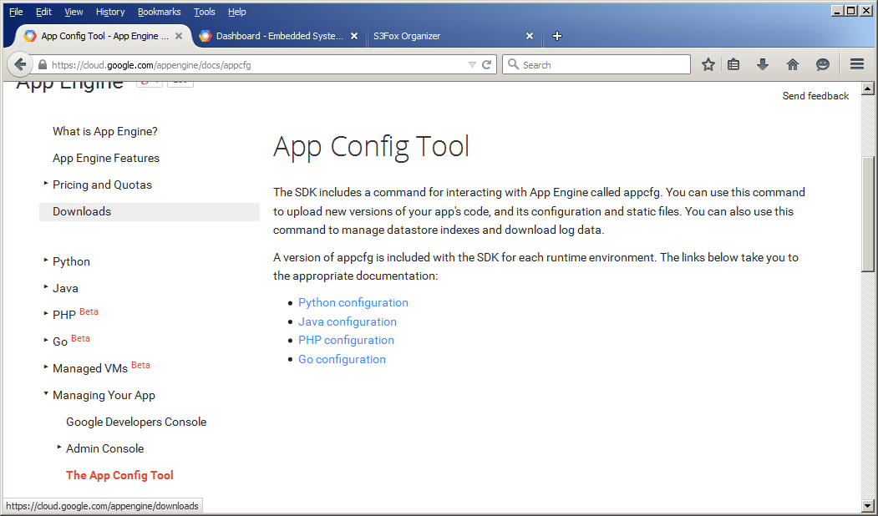

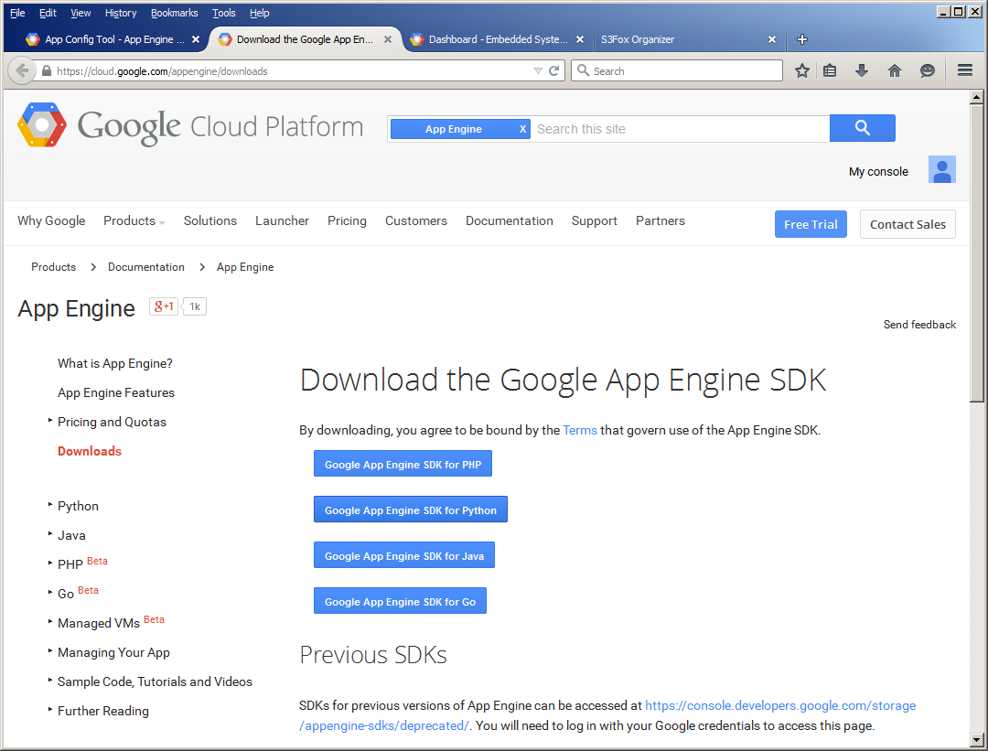

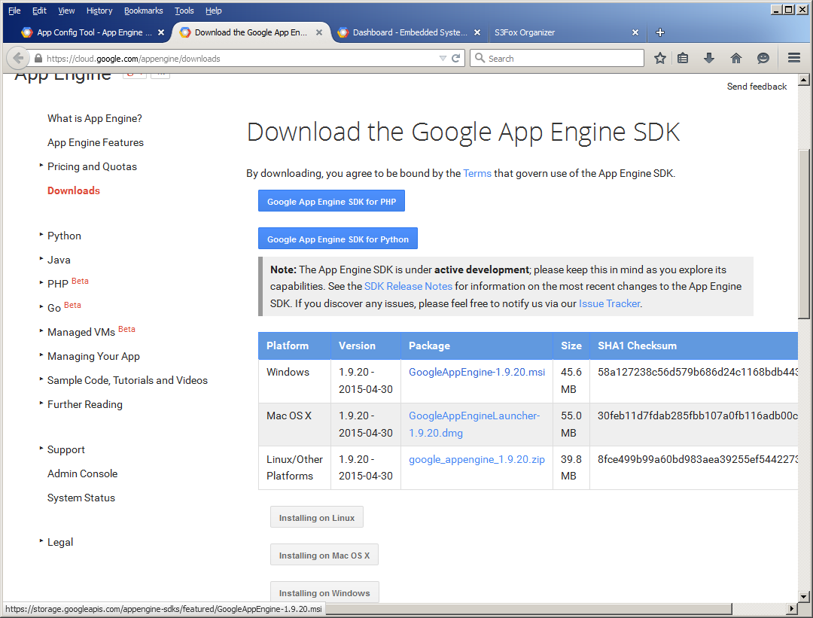

4) Download and Install Python 2.7 (this version only)

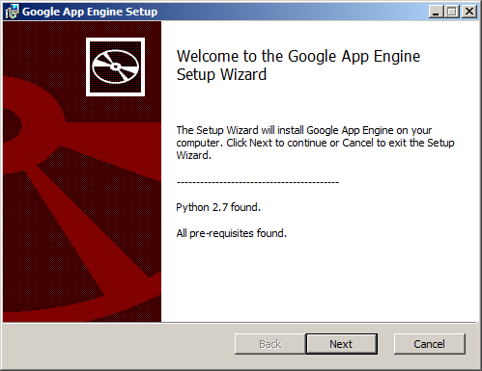

Install with default settings

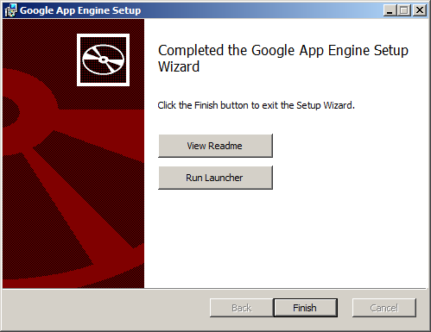

5) Create a new application; use the same application name as step 1 ; the parent directory is somewhere on your computer

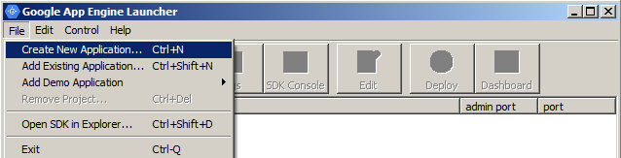

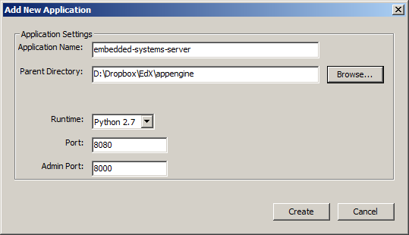

6) Open/edit **main.py** and copy paste Yerraballi’s Python code from his MOOC server

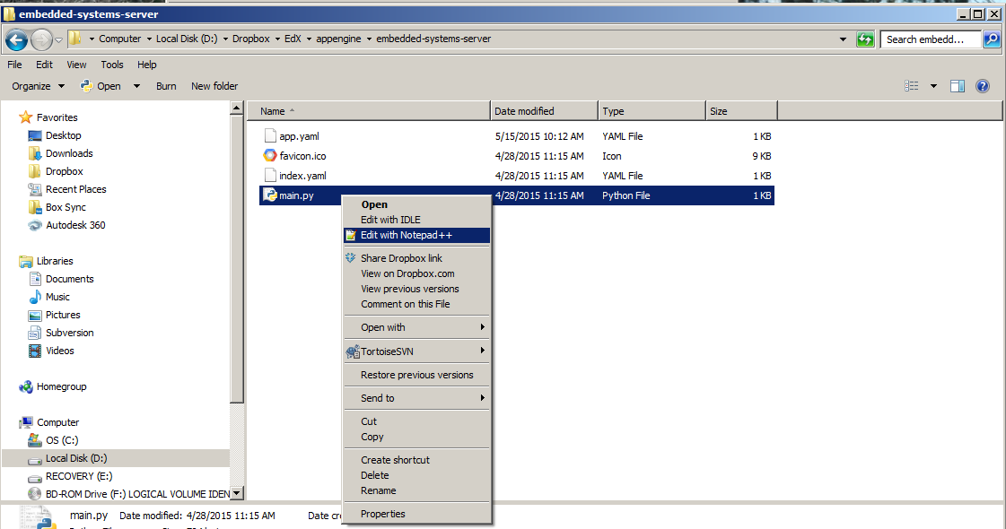

7) Open/edit **app.yaml** and verify application name matches application created in google app engine

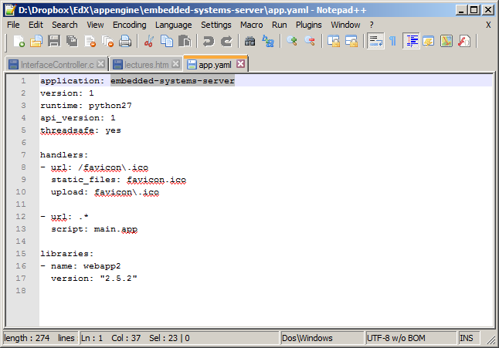

8) Start the **Google App Engine** and run your application

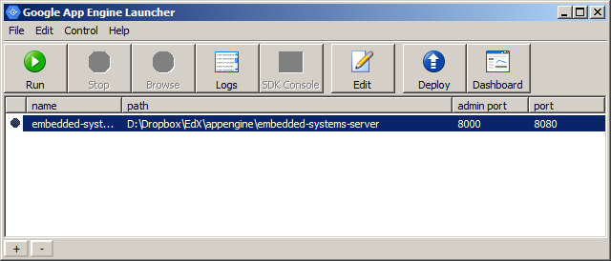

9) Edit your **main.py** for behavior of your server; you can see there are fields it will log

10) Wait until icon turns green and click browse

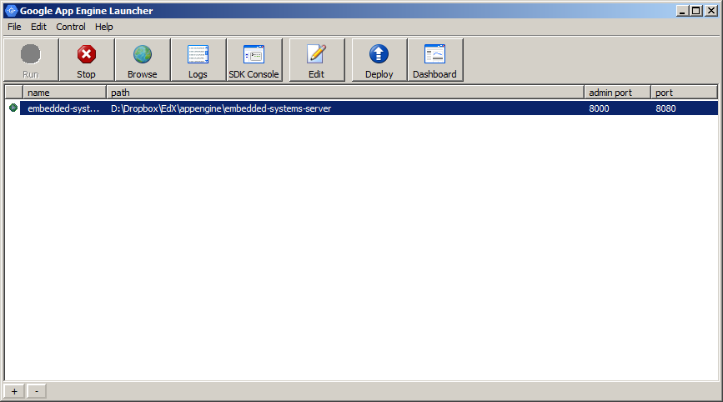

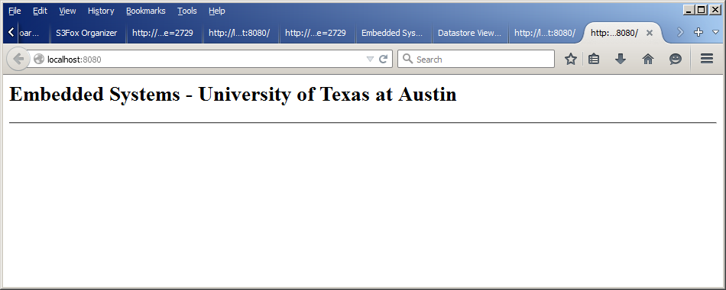

11) Type in this query to test logging on the local version

**localhost:8080/query?city=Austin%20Texas&id=Jon%20Valvano&greet=Guessed%20the%20syntax%20correctly.&edxcode=2729**

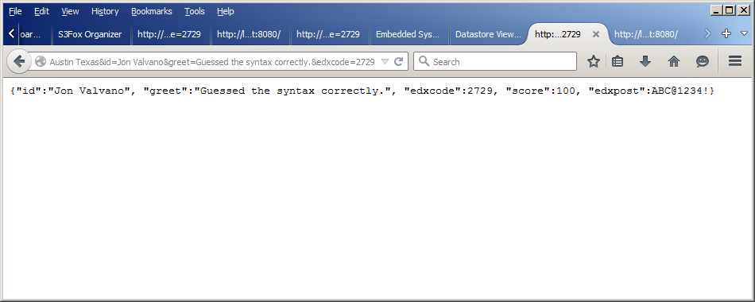

12) look at **localhost:8080** in a browser on the local machine

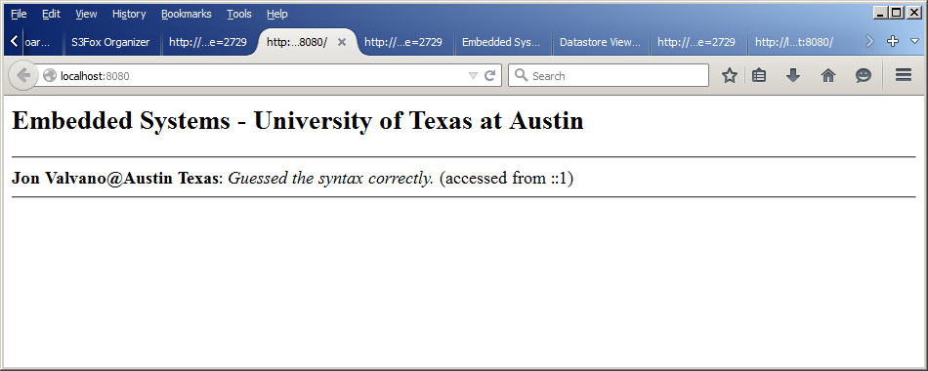

Debug operation on local machine; repeat steps 9,10,11,12 as needed

13) Go to **appengine.google.com**, sign up and complete the **quickstart**

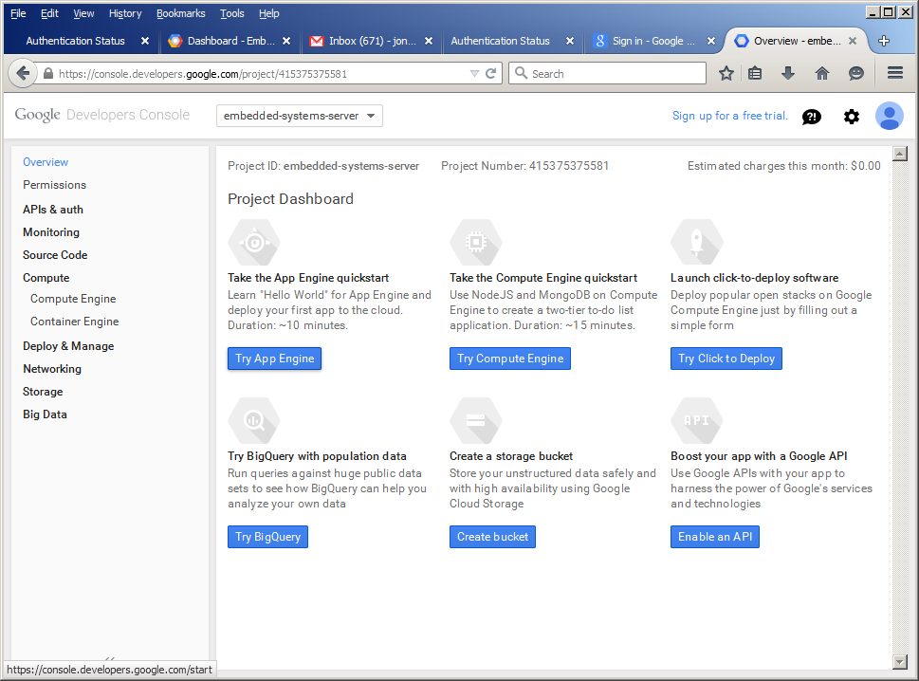

Scroll down and click **complete**

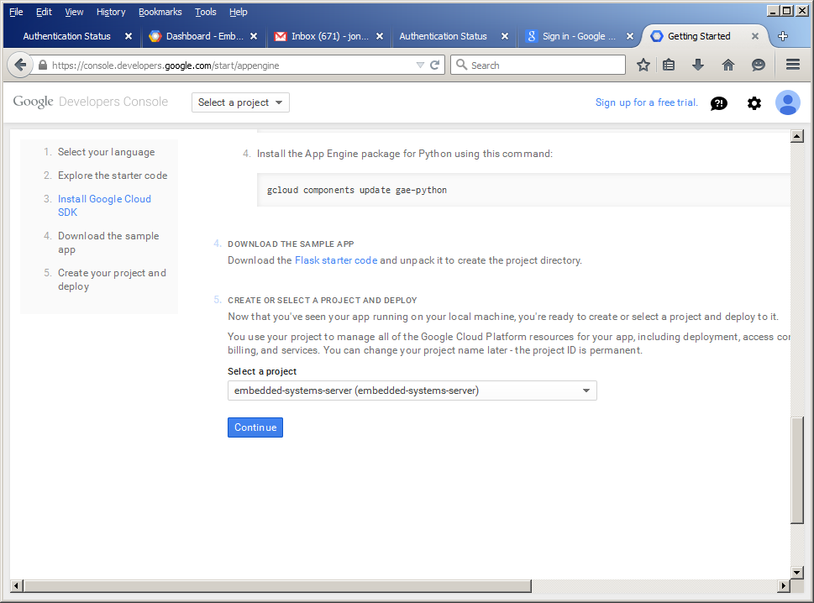

14) **Deploy** to cloud, log into google if needed

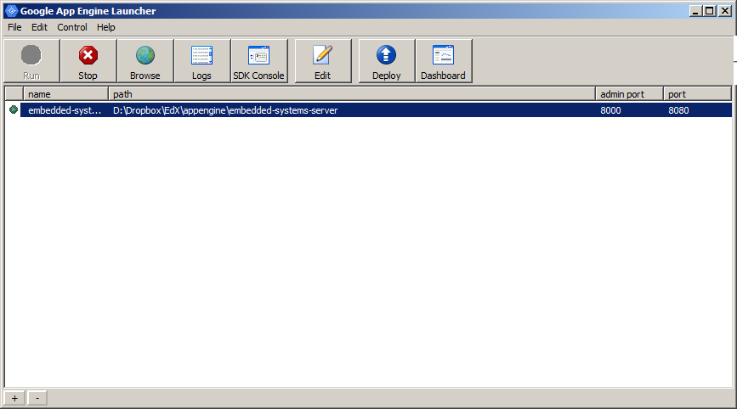

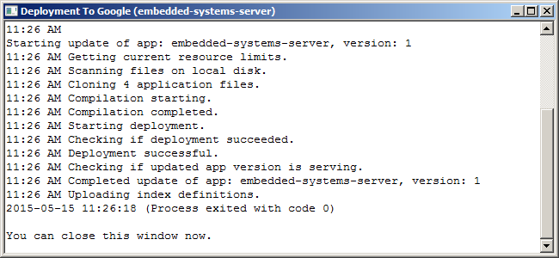

Log into google account, accept terms

15) Check server on the internet

**embedded-systems-server.appspot.com**

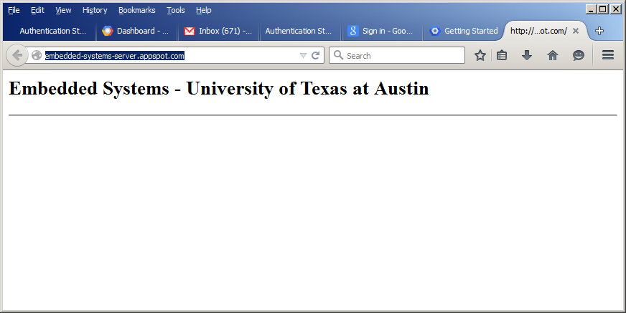

16) Test logging typing this into a browser, with different **city id greet**

**embedded-systems-server.appspot.com/query?city=Austin%20Texas&id=Jon%20Valvano&greet=It%20works.&edxcode=1234**

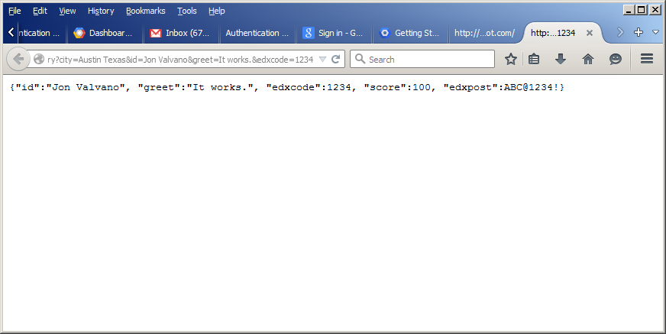

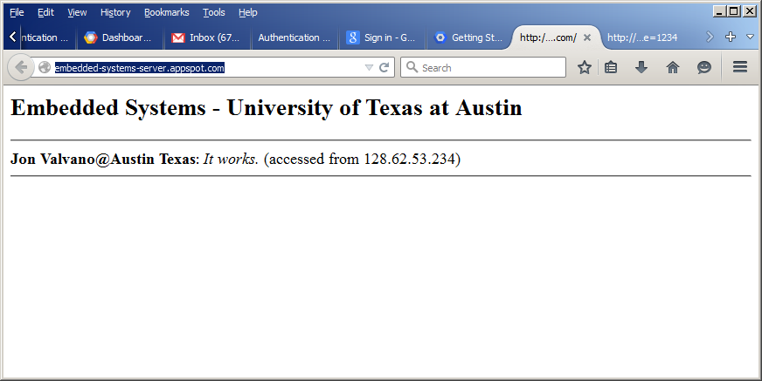

17) Go to <https://appengine.google.com/>

Click server, click **Datastore Viewer**

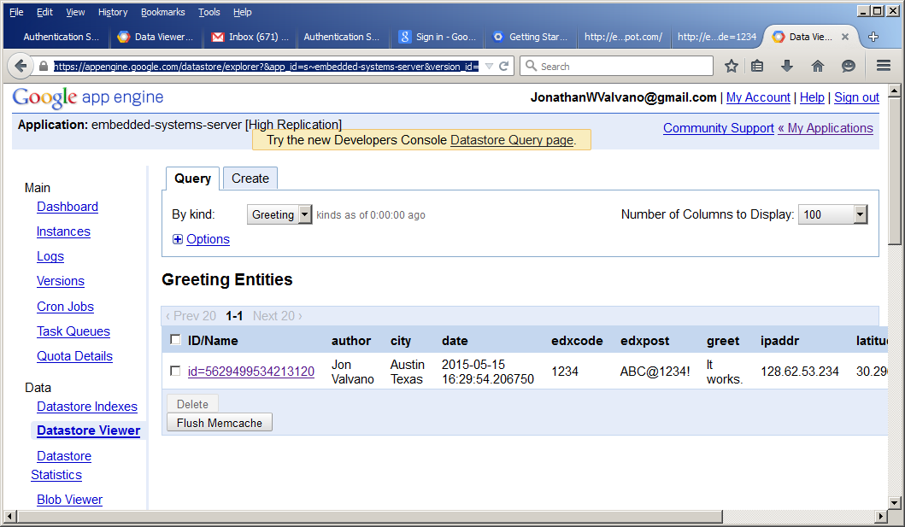

18) Test with TM4C123/CC3100 smart object using **CC3100DataLog_4C123** project

Good luck. This procedure was developed by Ramesh Yerraballi and documented by Jonathan Valvano