AWS Launch Program 2021

# Course description

In this course, we will use [cloudacademy.com](https://cloudacademy.com/learning-paths/aws-solutions-architect-associate-saa-c02-certification-preparation-954/) to learn about AWS. We will get hands-on experience in order to prepare for the exam. Details of the exam are below.

* The AWS Certified Solutions Architect – Associate (SAA-C02) examination is intended for individuals who perform a Solutions Architect role. This exam validates an examinee’s ability to effectively demonstrate knowledge of how to architect and deploy secure and robust applications on AWS technologies. It validates an examinee’s ability to:
  + Define a solution using architectural design principles based on customer requirements.
  + Provide implementation guidance based on best practices to the organization throughout the lifecycle of the project.

# Course Objectives

The objective of this course is to learn about AWS cloud technology. This course will prepare you for the AWS Solutions Architect - Associate Exam.

***Domain 1: Design Resilient Architectures***

*1.1  Design a multi-tier architecture solution*

*1.2  Design highly available and/or fault-tolerant architectures*

*1.3  Design decoupling mechanisms using AWS services*

*1.4  Choose appropriate resilient storage*

***Domain 2: Design High-Performing Architectures***

*2.1  Identify elastic and scalable compute solutions for a workload*

*2.2  Select high-performing and scalable storage solutions for a workload*

*2.3  Select high-performing networking solutions for a workload*

*2.4  Choose high-performing database solutions for a workload*

***Domain 3: Design Secure Applications and Architectures***

*3.1 Design secure access to AWS resources*

*3.2 Design secure application tiers  
3.3 Select appropriate data security options*

***Domain 4: Design Cost-Optimized Architectures***

*4.1 Identify cost-effective storage solutions  
4.2 Identify cost-effective compute and database services*

*4.3 Design cost-optimized network architectures*

# Course Policies and Expectations

The expectation for this Launch program is to gain knowledge of AWS and to pass the AWS exam. Every week we will be covering important concepts in the videos that were watched that week. A list of the lectures and labs that will need to be completed before attending the regularly scheduled weekly meetings is present in the course schedule.

## Class Format

Total time: 1 hr

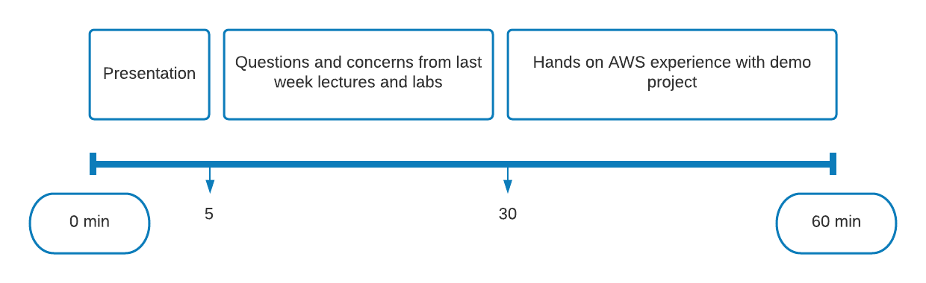

A strong emphasis will be placed on ensuring that all the questions and concerns are addressed from the previous lectures before moving onto the hands on experience. Kindly ensure that you have done all the coursework for the previous week before attending the weekly meetings. This would help reinforce key concepts and it will help you be a part of the discussions.

# Materials and Access

We will be primarily utilizing cloud academy (CA) for the course material. You should have received an invite link to sign up. CA recently released a new feature that will allow you to complete the AWS labs within CA without an AWS account. If you would like to create your own AWS account, there is [AWS Free tier](http://aws.amazon.com/free) which will allow you 12 months of free limited AWS usage. If you decide to do this, be mindful to not spin up multiple EC2 instances, or you will start to rack up an AWS bill. We also make use of some additional resources for exam preparation.

# Course Schedule

|  |  |  |  |  |
| --- | --- | --- | --- | --- |
| **No.** | **Name** | **Type** | **Length (mins)** | **Week** |
| 1 | Storage | Course | 1.00 | 1 |
| 2 | AWS Global Infrastructure | Resource | 10.00 | 1 |
| 3 | Amazon EBS and EC2 Instance Storage | Course | 21.00 | 1 |
| 4 | Introduction to S3 | Course | 25.00 | 1 |
| 5 | Using Amazon S3 Bucket | Course | 48.00 | 1 |
| 6 | Using Amazon EFS | Course | 45.00 | 1 |
| 7 | Common DR & Business Continuity Strategies on AWS | Course | 17.00 | 1 |
| 8 | Using AWS Storage for on-prem backup and disaster recovery | Course | 54.00 | 1 |
| 9 | Understanding and optimizing costs with AWS Storage Services | Course | 42.00 | 2 |
| 10 | Compute | Course | 1.00 | 2 |
| 11 | Elastic Compute Cloud | Course | 32.00 | 2 |
| 12 | Create your first EC2 Instance | Lab | 60.00 | 2 |
| 13 | AWS Cost Savings | Webinar | 46.00 | 2 |
| 14 | Using ELB & EC2 Auto Scaling to support AWS Workloads | Course | 65.00 | 2 |
| 15 | Working with EC2 Auto Scaling Groups and Network Load Balancer | Lab | 120.00 | 3 |
| 16 | AWS Basic EC2 Challenge | Lab | 90.00 | 3 |
| 17 | Understanding AWS Lambda to Run & Scale your Cloud | Course | 51.00 | 3 |
| 18 | Introduction to AWS Lambda | Lab | 45.00 | 4 |
| 19 | Networking | Course | 1.00 | 4 |
| 20 | Working with AWS Networking and Amazon VPC | Course | 77.00 | 4 |
| 21 | Introduction to VPC | Lab | 90.00 | 4 |
| 22 | Securing VPC using Public and Private Subnets | Lab | 150.00 | 5 |
| 23 | Implement VPC HA Best Practices | Lab | 60.00 | 5 |
| 24 | AWS Networking Features Essential | Course | 29.00 | 5 |
| 25 | Difference between HA and Fault Tolerance | Course | 4.00 | 5 |
| 26 | Design Multi-tier Architecture | Course | 48.00 | 5 |
| 27 | Introduction to DNS and Content Delivery | Course | 13.00 | 6 |
| 28 | Configure a website with static website with S3 and Cloudfront | Lab | 75.00 | 6 |
| 29 | Decoupling and Event-Driven Architecture | Course | 38.00 | 6 |
| 30 | Database | Course | 1.00 | 6 |
| 31 | Database Fundamentals for AWS P1 | Course | 68.00 | 6 |
| 32 | Database Fundamentals for AWS P2 | Course | 62.00 | 6 |
| 33 | When to use RDS Multi-AZ and Read Replicas | Course | 22.00 | 6 |
| 34 | Create your first Amazon RDS Database | Lab | 75.00 | 7 |
| 35 | Understanding Costs Associated with Amazon RDS | Course | 33.00 | 7 |
| 36 | Amazon Aurora HA | Course | 34.00 | 7 |
| 37 | Amazon DynamoDB HA | Course | 23.00 | 7 |
| 38 | Using DynamoDB Accelerator to enhance performance | Course | 7.00 | 7 |
| 39 | Introduction to DynamoDB | Lab | 60.00 | 7 |
| 40 | Security | Course | 1.00 | 8 |
| 41 | Overview of IAM | Course | 72.00 | 8 |
| 42 | Introduction to IAM | Lab | 60.00 | 8 |
| 43 | Securing AWS Org with SCPs | Course | 26.00 | 8 |
| 44 | Protection Web Apps with AWS WAF, Shield & Firewall Manager | Course | 77.00 | 8 |
| 45 | Audit, Monitor and Evaluate with AWS CloudTrail and AWS Config | Course | 32.00 | 8 |
| 46 | Compliance check using AWS Config rules | Lab | 120.00 | 9 |
| 47 | AWS CloudWatch | Course | 94.00 | 9 |
| 48 | Monitoring AWS CloudTrail Events with AWS CloudWatch | Lab | 135.00 | 9 |
| 49 | Logging in AWS | Course | 67.00 | 10 |
| 50 | How to use KMS to protect data | Course | 71.00 | 10 |
| 51 | Understanding S3 encryption mechanisms to secure your data | Course | 12.00 | 10 |
| 52 | Amazon Cognito | Resource | 15.00 | 10 |
| 53 | Best Practices to optimize AWS Costs & govern at scale | Webinar | 54.00 | 10 |
| 54 | AWS SA - Certification Challenge | Test | 120.00 | 11 |
| 55 | Cert Prep | Test | 130.00 | 11 |