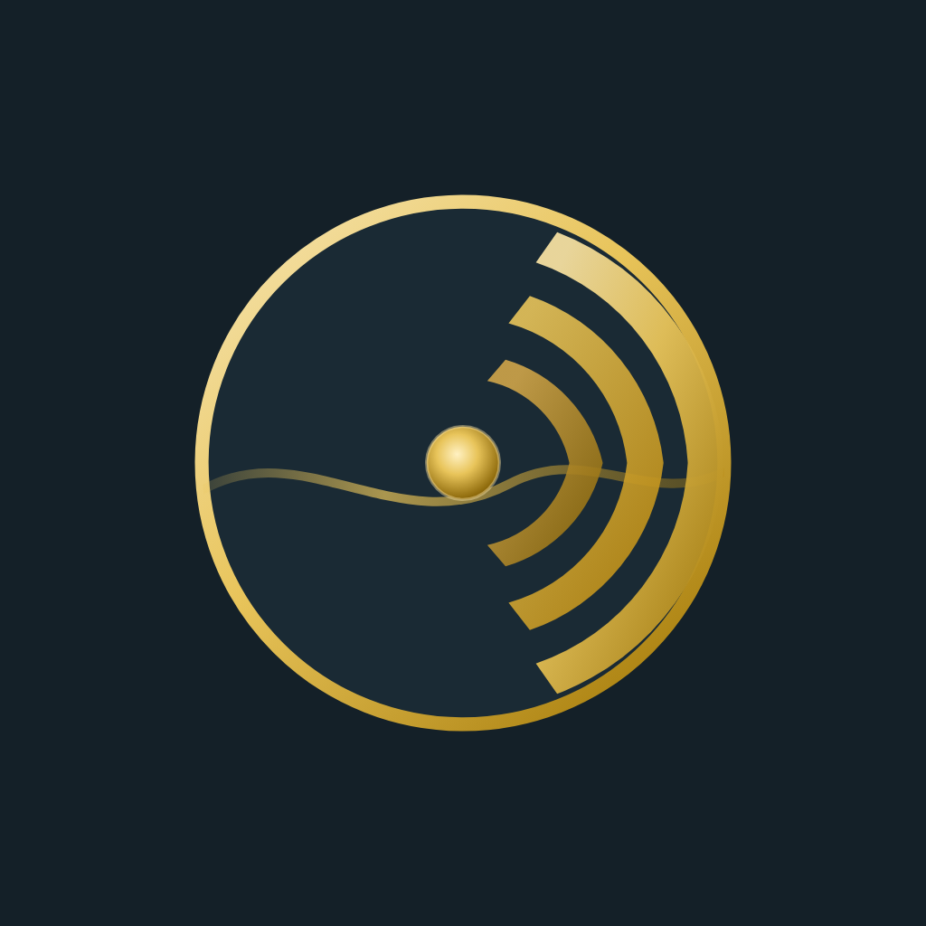
SAMOA · NEW ZEALAND · AUSTRALIA
Cloud · Cyber · Infrastructure
for small & medium business.
• Azure & Microsoft 365
• Security audits
• Hyper-V / servers
• Networking & VPN
• Backup & recovery
• itsamoa.goldentide.cloud

