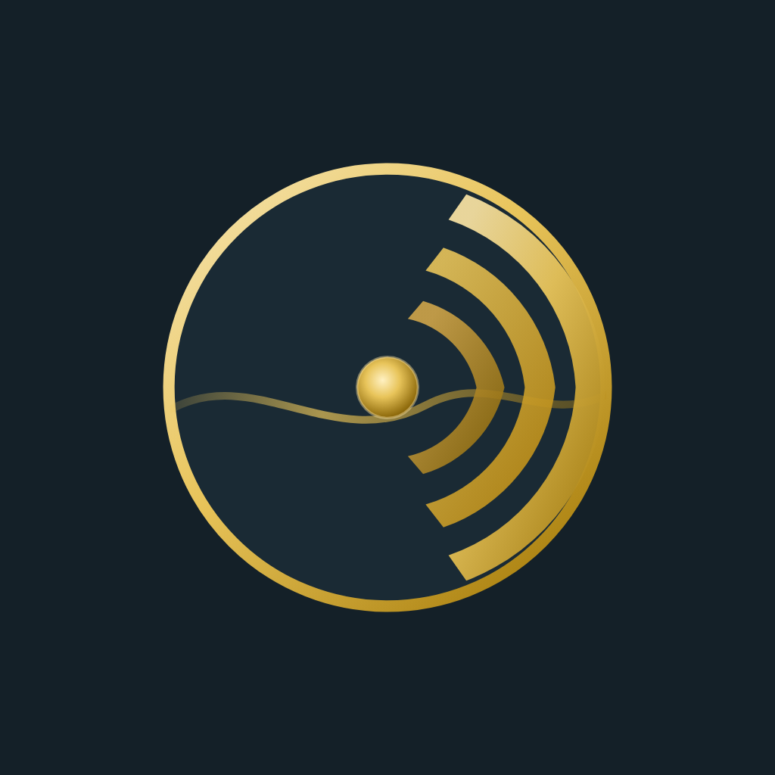
GOLDEN TIDE
IT PROFESSIONAL SERVICES
Samoa · New Zealand · Australia · Quiet systems. Clear signal.
Enterprise-grade IT for small & medium businesses.
Cloud, cybersecurity, Microsoft platforms, and infrastructure — delivered with 28 years of hands-on engineering. From a single office network to a full company migration, SMB work is welcome and done properly.
SMALL TO MEDIUM BUSINESSES WELCOME
WHAT WE DELIVER
Cloud Migration & Azure
Lift-and-shift or greenfield Azure design, Office 365 tenants, identity, and hybrid readiness.
Cyber Resilience
Zero-trust posture, endpoint protection, monitoring, backup, and recovery plans that hold up when connectivity is hard.
Servers & Hyper-V
Physical-to-virtual builds, clustering, and infrastructure that gets the most from what you already own.
Networking & Microsoft 365
Secure LAN/WAN design, VPN/SD-WAN, Exchange, Teams, SharePoint, and Intune — set up so people actually use it.
28 YEARS OF MASTERY
IDEAL FOR SMBs THAT NEED
• A trusted IT partner, not a ticket mill
• Clear next steps after every conversation
• Secure systems without enterprise bloat
• On-site or remote work across the Pacific
• Home offices to multi-site operations
Not sure where you stand? Request a security audit — we’ll map your risks and return a practical remediation plan.
Let’s scope your system. Request a consult.
Justin Van Staden · IT Director · Founder
+685 770 3733
justin@goldentide.cloud
itsamoa.goldentide.cloud
Faleasiu / Apia, Samoa

