Eplan Shortcuts for the Elgato Stream Deck
Install and User Guide
Version 1.0.0 | Walz Engineering
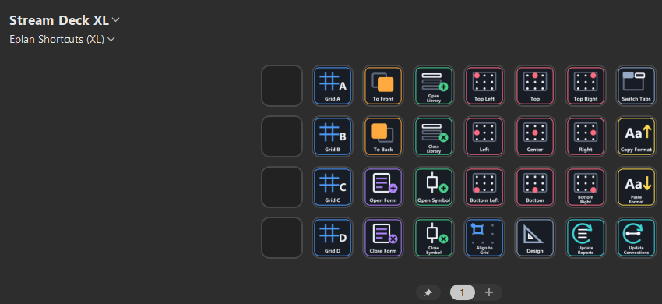
The Eplan Shortcuts profile on a Stream Deck XL
Unofficial community project
Not affiliated with, endorsed by, or supported by EPLAN or Elgato. "EPLAN", "Elgato" and "Stream Deck" are trademarks of their owners. Everything here is original work, released under the MIT license (see LICENSE.txt).

What you get
This package puts 28 everyday Eplan Electric P8 commands on a Stream Deck XL. Each Stream Deck button sends a keyboard shortcut. Eplan must have the matching shortcut for a button to do anything, so setup has two parts:
1. Part 1: put the shortcuts into Eplan (folder 1_Eplan).
2. Part 2: put the buttons on the Stream Deck (folder 2_StreamDeck).
What is in the package:
File or folder | What it is
1_Eplan\ImportShortcutKeys.cs | Script that imports the shortcuts into Eplan
1_Eplan\ShortcutKeys_StreamDeck.xml | The shortcut keys the buttons use
2_StreamDeck\Eplan-Shortcuts-StreamDeck-XL.streamDeckProfile | The Stream Deck buttons
icons\ | The button icons (optional)
docs\Shortcut-Catalog.md | Every button and its Eplan command
INSTALL.txt and this guide | Setup instructions (same steps, this one with screenshots)
CHANGELOG.md, LICENSE.txt | What changed, and the license

What you need
- Eplan Electric P8 2026
- A Stream Deck XL (32 keys)
- The Elgato Stream Deck software for Windows
The profile uses only the built-in Hotkey and Multi Action functions, so there are no plugins to install.

Before you start
Part 1 replaces your Eplan shortcuts
Importing replaces your Eplan user keyboard shortcuts with the set in the file. The script offers to back up your current shortcuts first. Leave that option on, and try everything on a copy of a project first.

Part 1: Shortcuts in Eplan (use the script)
1. Copy the whole folder 1_Eplan to your computer, for example to C:\EplanScripts\. Keep the two files together.
2. In Eplan open File > Extras > Interfaces. Under Scripts click Run.
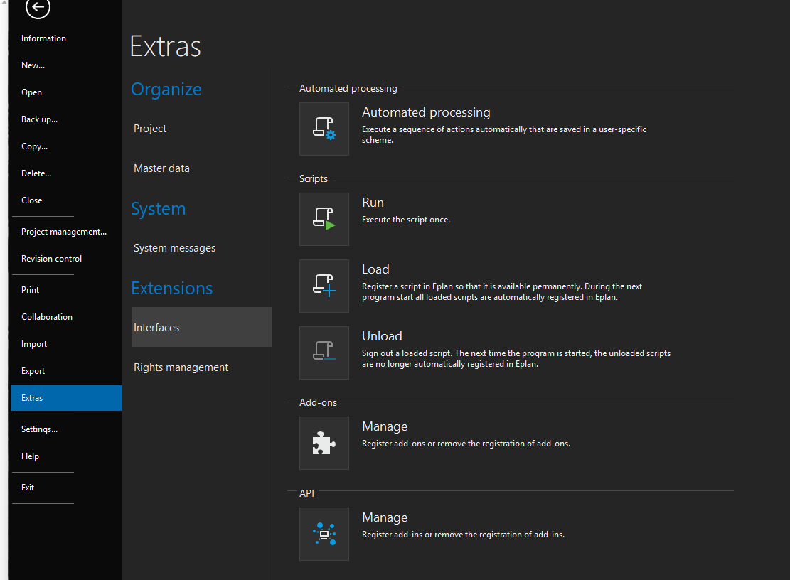
File > Extras > Interfaces: Run, Load and Unload under Scripts
3. Select ImportShortcutKeys.cs and click Open.
4. In the window, click Browse next to Shortcut file and choose ShortcutKeys_StreamDeck.xml (the window fills this in if the file is in Documents, Downloads or the Desktop). Keep Back up my current shortcuts first ticked and choose a backup folder.
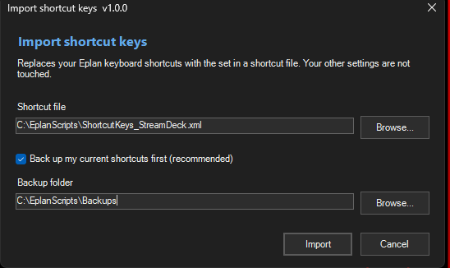
The Import shortcut keys window
5. Click Import, then Yes to confirm.
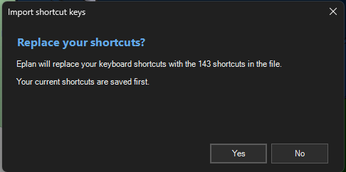
The confirmation window
6. Read the result message. It says whether Eplan now has the shortcuts from the file. If a shortcut does not respond, restart Eplan.
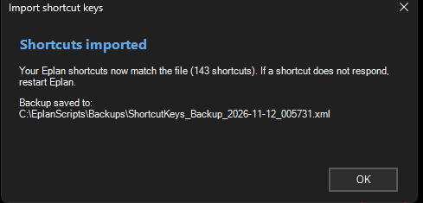
The result: the shortcuts match the file, and the backup is saved

To undo
Run the script again and choose the backup file it saved (named ShortcutKeys_Backup_<date>_<time>.xml).

Prefer to do it by hand?
The same import can be done in Eplan's Settings dialog. Export your own shortcuts first as a backup, the same way.
1. Open the Settings dialog and right-click User. Choose Export... to make your backup, or Import... to load the shortcut file.
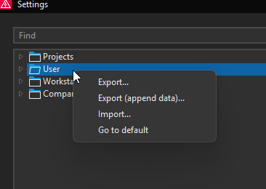
Right-click User in the Settings dialog
2. Tick only Shortcut keys, choose the file, and click OK. The Import window looks the same as this Export window.
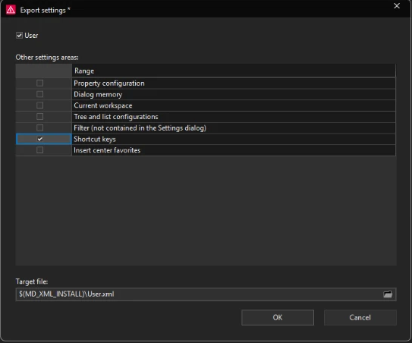
Export settings with only Shortcut keys ticked

Part 2: Buttons on the Stream Deck
1. Install the Stream Deck software from Elgato and connect your Stream Deck XL.
2. Double-click 2_StreamDeck\Eplan-Shortcuts-StreamDeck-XL.streamDeckProfile. Or, inside the Stream Deck app: click the gear icon, open the Profiles tab, click the small arrow below the profile list, choose Import... and pick the file.
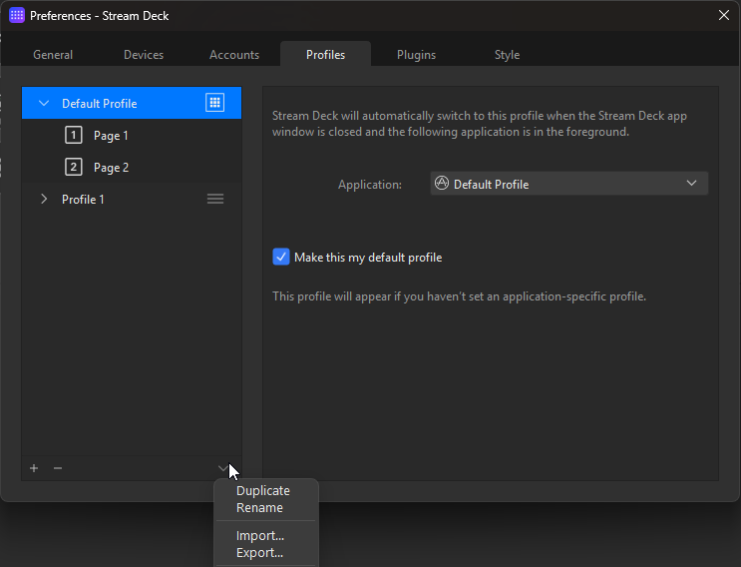
Stream Deck Preferences, Profiles tab: Import is in the menu below the list
3. A new profile named Eplan Shortcuts (XL) appears. Your other profiles are not changed. Pick it with the profile drop-down under the device name.
4. The first column is empty so you can add your own buttons.

Try it
Open an Eplan project (a copy) and press a button, for example one of the Grid buttons or the nine text-position buttons. The table below lists every button and the Eplan command it runs.
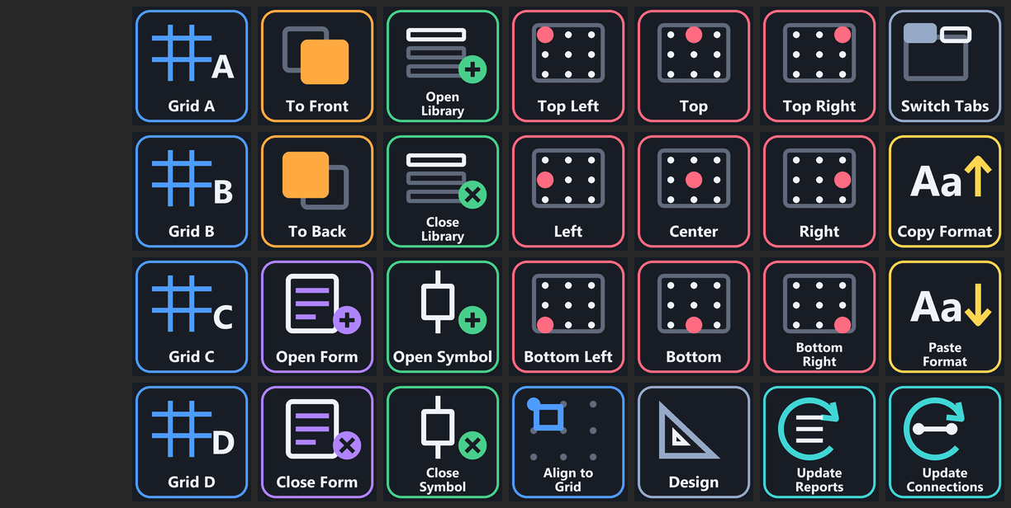
Button layout (first column left free)

Button reference
Each button sends the shortcut shown. The Eplan command column is the internal name Eplan uses for the command.

Graphical editing
Button | Shortcut | Eplan command
Grid A | Ctrl+Shift+Alt+S | XGedSetGridsizeAction /id:1
Grid B | Ctrl+Shift+Alt+D | XGedSetGridsizeAction /id:2
Grid C | Ctrl+Shift+Alt+F | XGedSetGridsizeAction /id:3
Grid D | Ctrl+Shift+Alt+G | XGedSetGridsizeAction /id:4
Align to Grid | Ctrl+Shift+Alt+A | XGedIaArrangeOnGrid
To Front | Ctrl+Shift+Alt+H | XGedIaToForeground
To Back | Ctrl+Shift+Alt+J | XGedIaToBackground
Copy Format | Ctrl+Alt+6 | XGedCopyGraphicalFormatAction (format painter)
Paste Format | Ctrl+Alt+0 | XGedAcceptGraphicalFormatAction (format painter)

Forms, symbols and libraries
Button | Shortcut | Eplan command
Open Form | Ctrl+Alt+\ | XFOEActionFormOpen
Close Form | Ctrl+Alt+] | XFOEActionFormClose
Open Library | Ctrl+Alt+S | XSymLibOpenAction
Close Library | Ctrl+Alt+U | XSymLibCloseAction
Open Symbol | Ctrl+Alt+P | XSymbolOpenAction
Close Symbol | Ctrl+Alt+V | XSymbolCloseAction

Text alignment (nine anchor positions)
Button | Shortcut | Eplan command
Top Left | Ctrl+Alt+O | Text justification 1
Top | Ctrl+Alt+; | Text justification 2
Top Right | Ctrl+Alt+X | Text justification 3
Left | Ctrl+Alt+' | Text justification 4
Center | Ctrl+Alt+/ | Text justification 5
Right | Ctrl+Alt+. | Text justification 6
Bottom Left | Ctrl+Alt+Q | Text justification 7
Bottom | Ctrl+Alt+, | Text justification 8
Bottom Right | Ctrl+Alt+Z | Text justification 9

Updating and navigation
Button | Shortcut | Eplan command
Update Reports | Ctrl+, | XFgUpdateEvaluationAction
Update Connections | Ctrl+Alt+[ | EsGenerateConnections
Switch Tabs | Ctrl+F6 | Windows-style window switch
Design | Ctrl+Alt+L then Ctrl+Alt+N (multi action) | XGedActionToggleConstructionMode, XGedToggleObjectSnapAction

If something does not work
- A button does nothing: the Eplan window must be in front, and Part 1 must be done. Restart Eplan after the import if needed.
- A different command runs: another command in your Eplan already uses that shortcut. Restore your backup with the script, or change the shortcut in Eplan.
- The script does not start: Eplan 2026 is required. Check that Windows has not blocked the file (right-click it, choose Properties, then Unblock).
- The profile does not import: check that the Stream Deck software is up to date and that the device is a Stream Deck XL.

Maintained by Justin Walz, Walz Engineering. Questions and ideas are welcome, and if you would like help with a script of your own, feel free to get in touch.
Project page: https://github.com/justin-walzengineering/Elgato-Stream-Deck-Public

