ELEC 4700

Assignment 4

Justin Smith

100975348

1. a) The following equations are made. They are the ones being transferred into the matrices. They are produced by performing KCL on various nodes in the circuit diagram.

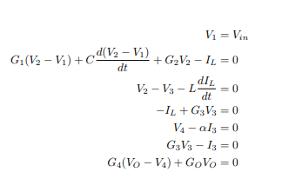

Figure 1: KCL Equations

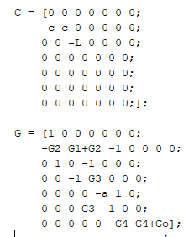

Figure 2: Matrices Formed Using Equations

Figure 2 depicts the matrices created using the equations seen in figure 1.

b)

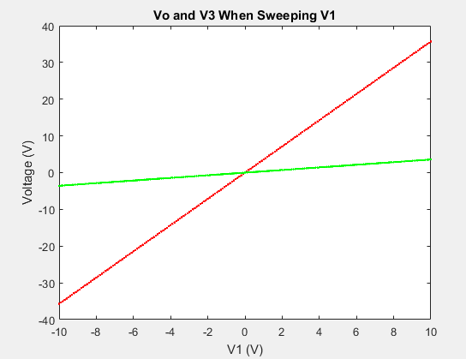

Figure 3: Vo and V3 When Sweeping V1 from -10V to 10V

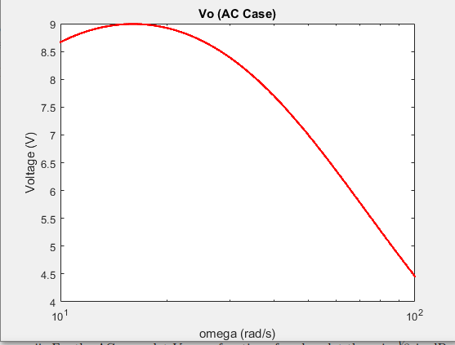

Figure 4: Vo versus Omega in the AC Case

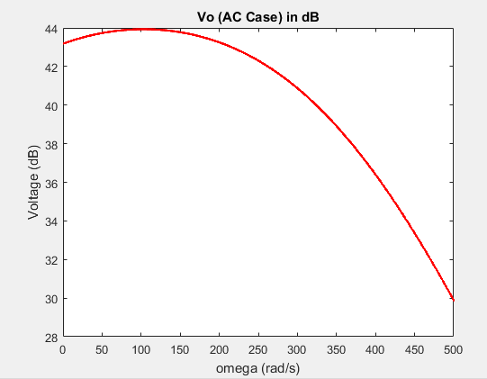

Figure 5: Vo (in dB) versus Omega for AC Case

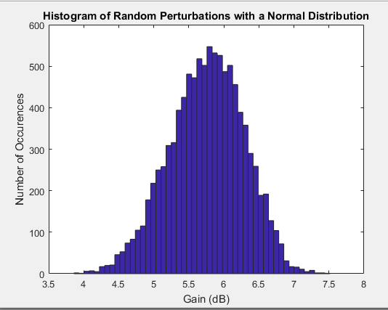

Figure 6: Histogram of Random Perturbations with a Normal Distribution (10000 Occurrences)

1. a) This is an RLC circuit.

b) The expected result is a band pass filter, cutting off at a high and low frequency.

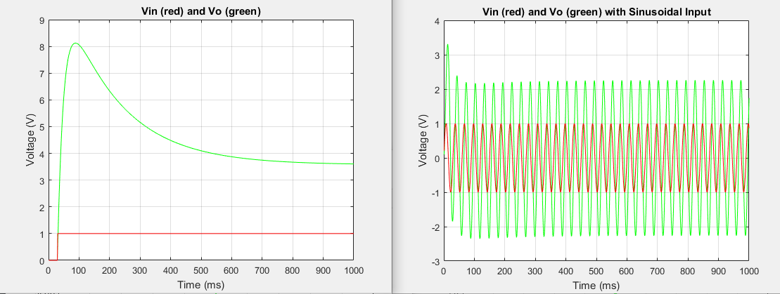

Figure 7: Vo when Vin is step function (plot on left) and Vo when Vin is sinusoidal input (plot on right)

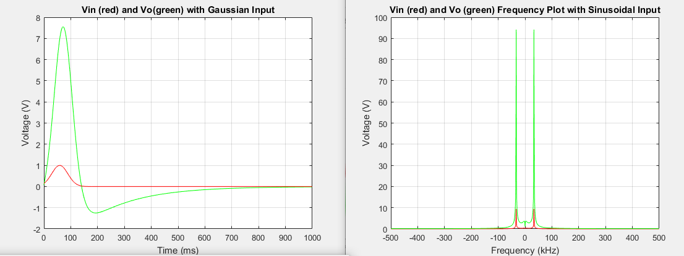

Figure 8: Vo when Vin is Gaussian input (plot on left) and Frequency Response with sinusoidal input (plot on right)

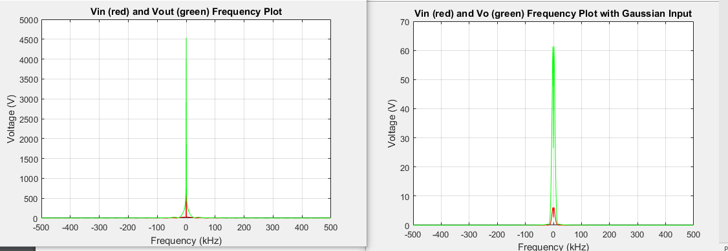

Figure 9: Frequency Response with step input (plot on left) and Frequency Response with Gaussian input (plot on right)

d)

When the frequency is decreased the magnitude of the outputted peaks are significantly greater. When the frequency is increased the magnitude of the outputted peaks are significantly less.

e)

Increasing the time step seems to give less accurate results. For example, in the Gaussian frequency response, the inputted impulse fluctuates less and is smoother. This is because there are less points that are taken, so the response and input are more averaged.

1. a)

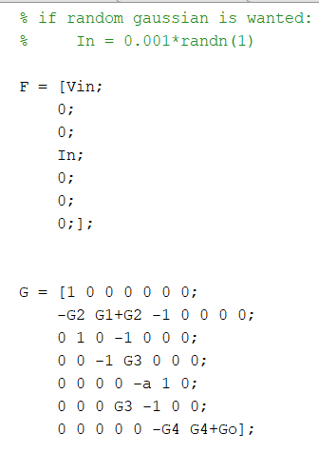

Figure 10: Updated Matrices with the Added Capacitor and Noise Source

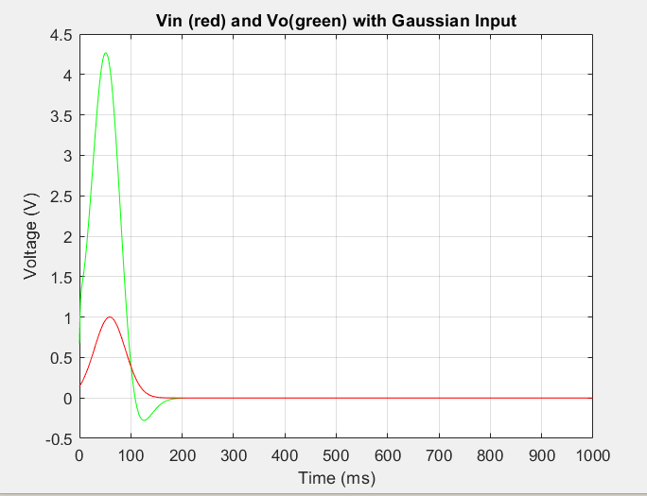

Figure 11: Vin and Vo for Updated Matrices

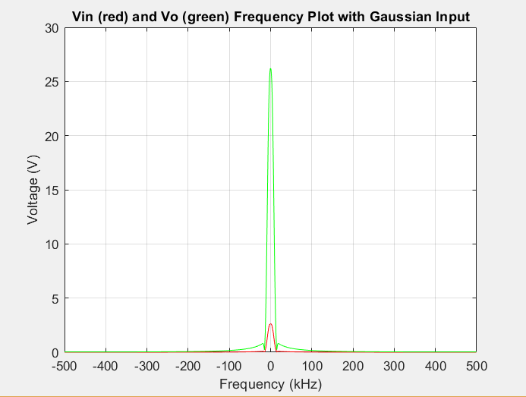

Figure 12: Updated Fourier Transform Plot for Gaussian Input

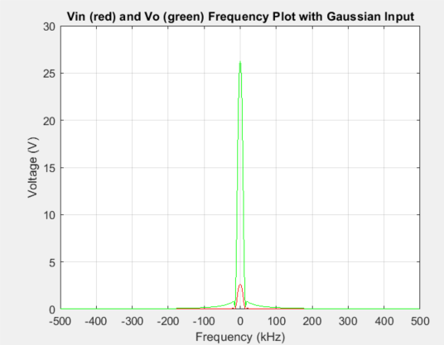

Figure 13: Spectrum plot with C3 = 0.00000001F

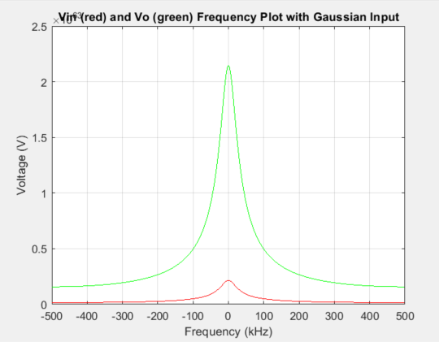

Figure 14: Spectrum plot with C3 = 0.001F

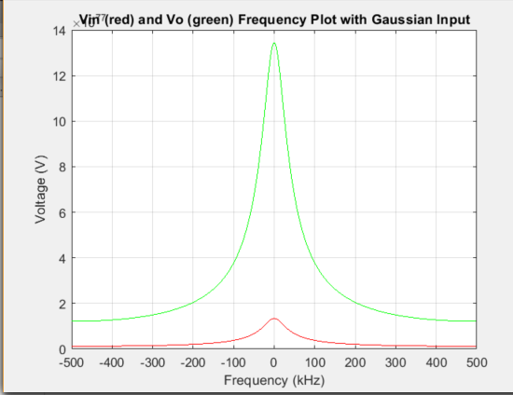

Figure 15: Spectrum plot with C3 = 0.1F

As seen in figures 13 through 15 the larger the value for C3, the larger the magnitude of the spectral peak is and the larger the bandwidth.

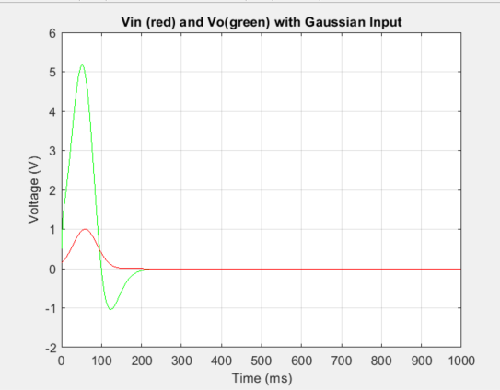

Figure 16: Vo with the timestep = 1e-2

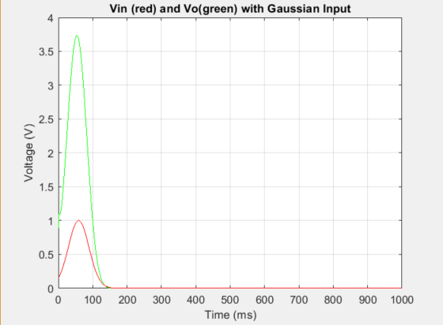

Figure 17: Vo with timestep = 5e-2

It appears that with a larger timestep the Gaussian function does not dip below zero. It potentially misses that portion of the function due to the larger step.

1. If V was given by the following function:



then the G matrix would be different. It would include I3 squared times an arbitrary beta and I3 cubed times an arbitrary gamma. This would result in an cubic voltage given by the current I3­.