**Assignment 2**

**Question 1: Finite Difference Solution to Laplace’s Equation**

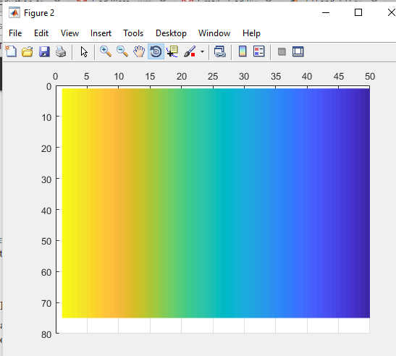

Figure 1: V(x,y) for part a

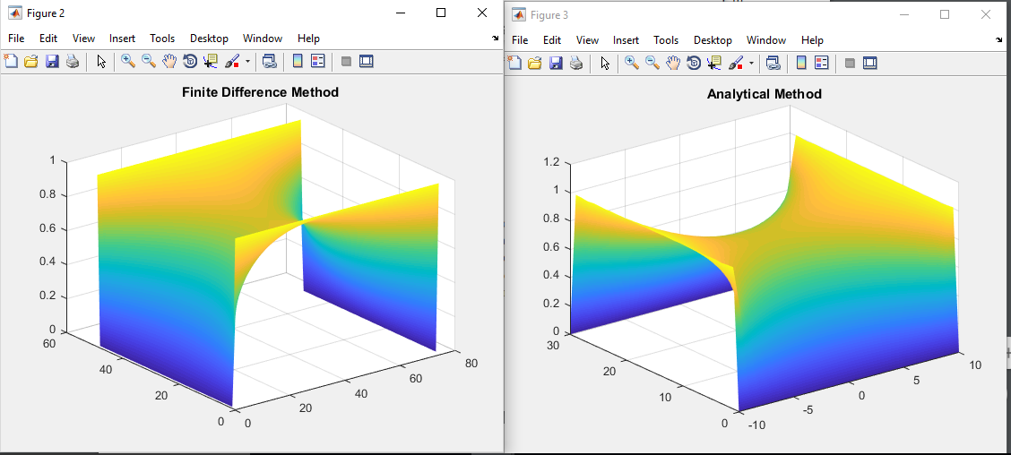

Figure 2: V(x,y) for numerical solution (left) and analytical solution (right)

It was determined that the smaller the mesh size, the less accurate the solution became. When the mesh size was 10 by 15, the solution was skinnier than the analytical counterpart. A mesh size of 50 by 75 appears to give a similar solution to the analytical one. The analytical series was stopped after 300 iterations, because this gave the best results. The advantages of the numerical solution is that it is an immediate solution. However it might not be as accurate (dependent on mesh size). The analytical method is advantageous because with proper iteration size it is accurate. The disadvantage for this is that it must be simulated around 300 times before a solution. With bigger problems, time could be a factor for this solution.

**Question 2: Current Flow in Rectangular Region**

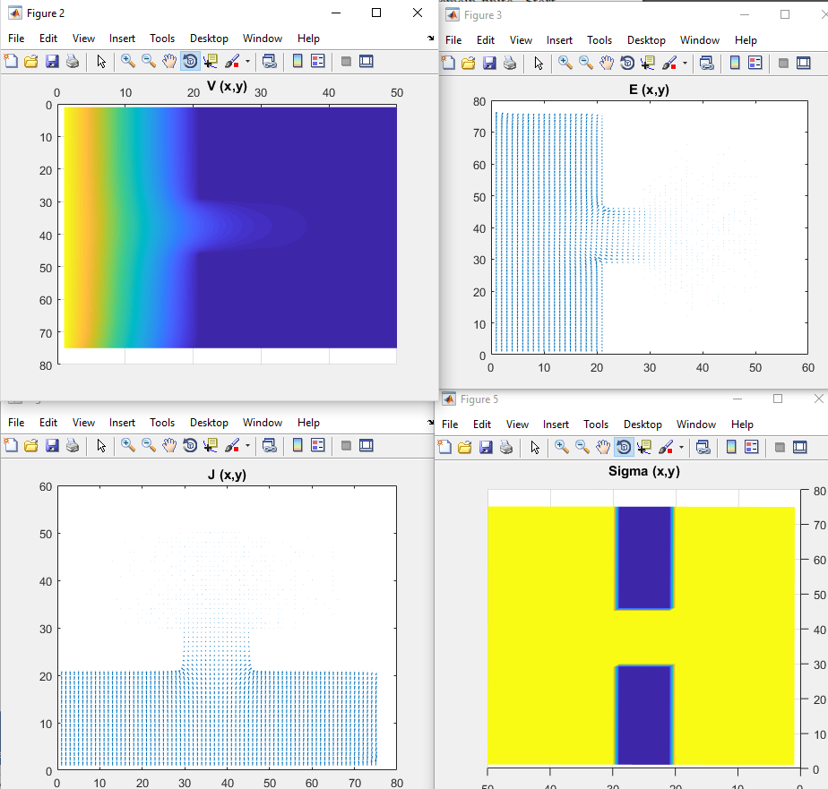

Figure 3: Graphs of V(x,y) (top left), E(x,y) (top right), J(x,y) (bottom left) and Resistivity(x,y) (bottom right)

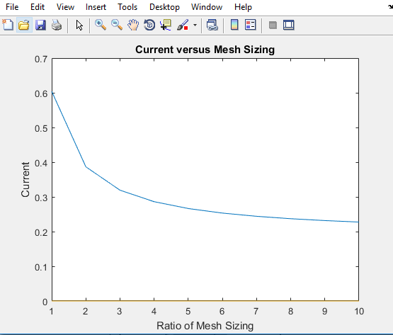

Figure 4: Current versus MeshSizing

The plot produced in figure 4 used factors of meshsizing. This means that the size of the mesh was multiplied by a factor of what is seen on the graph. NX starts at 10 and NY at 15; then both are multiplied by the sizing factor. When the meshsizing is increased, the current decreases.

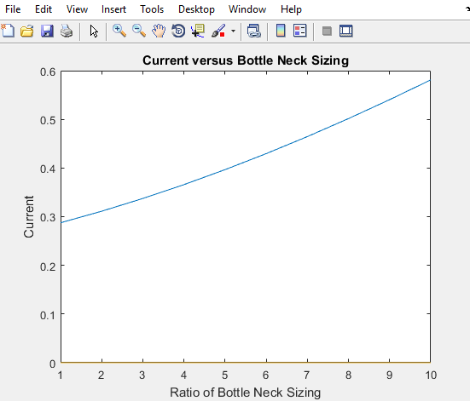

Figure 5: Current versus Bottle Neck Sizing (increasing)

Figure 5 shows the effect of **increasing** the bottle neck sizing versus the current. It is obvious that an increase in the bottle neck allows for a greater current. Thus when the sizing decreases, the current decreases. The x-axis of the figure shows how much is subtracted from the lower limit of NX and NY and how much is added to the upper limits of NX and NY. For example at 1, the bottle neck is increased by 2. At 2 the bottle neck is increased by 4 (2 on each lower and upper limit respectively).

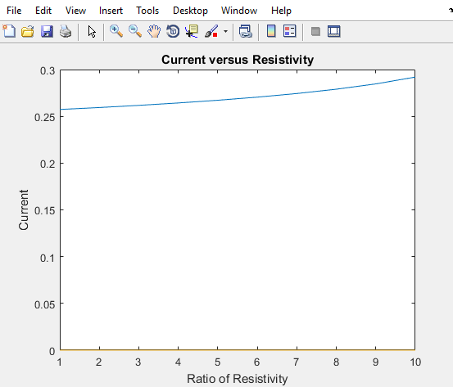

Figure 6: Current versus Resistivity

Figure 6 depicts the current as resistivity of the box increases. It is seen in the figure that the current slowly increases as resistivity increases. The resistivity of the inner box was calculated to be the original resistivity 10-2 plus the ratio/15. Thus when the ratio is 1, the resistivity was 0.01 + 1/15.