**Question 1.**

1. eFieldx = vOnX/(100*10^-9)

for vOnX = 0.1V, the electric field is: 1000000 V/m

This is the line of code to calculate the electric field in the x direction, given a voltage predetermined (vOnX). The value of it is large due to the small size of the simulation (100nm).

1. force = eFieldx*1.6021e-19

= 1.6021e-13 N

The force is determined by multiplying the electric field by the charge of an electron.

1. accX = force/mass;

The acceleration is then found by dividing the force by the mass of one electron (newton’s second law).

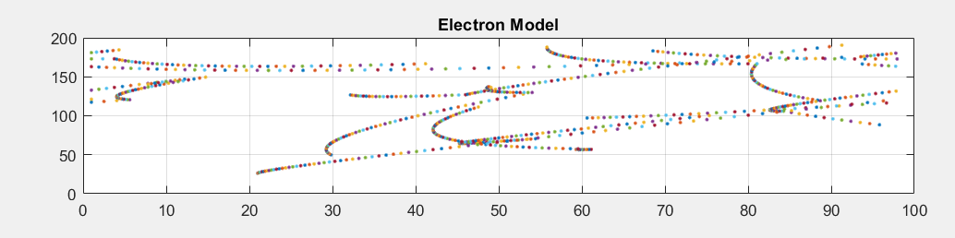

Figure 1: Electron Model

d)

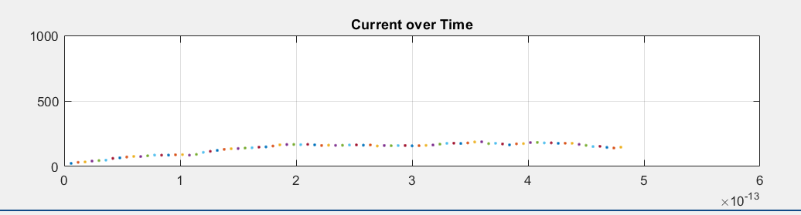

Figure 2: Current over Time Plot

As seen in figure 2 the current gradually increases with time due to the added velocity because of the acceleration. Since scattering is happening the current eventually rolls off and remains more constant.

The current increases with increased average carrier velocity. The current is calculated using the following equation:

dCurrent(r) = Vx(r)*p*q/1e9

Where Vx is the velocity in the x direction, p is the , q is the charge on an electron. It is divided by 1e9 because that is the concentration of electrons given in the assignment.

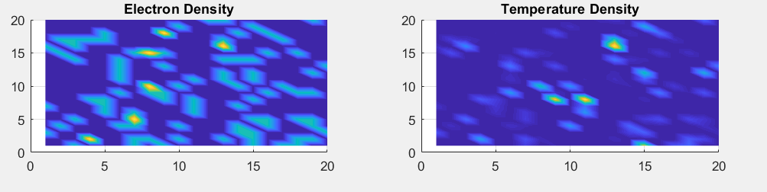

Figure 3: Electron Density and Temperature Density Maps

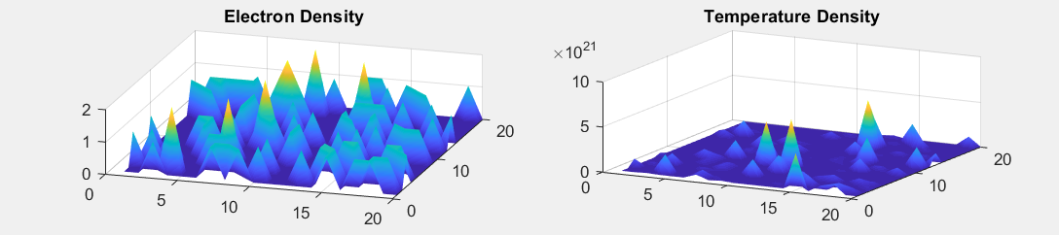Figure 4: 3D Electron Density and Temperature Density Maps

**2.**

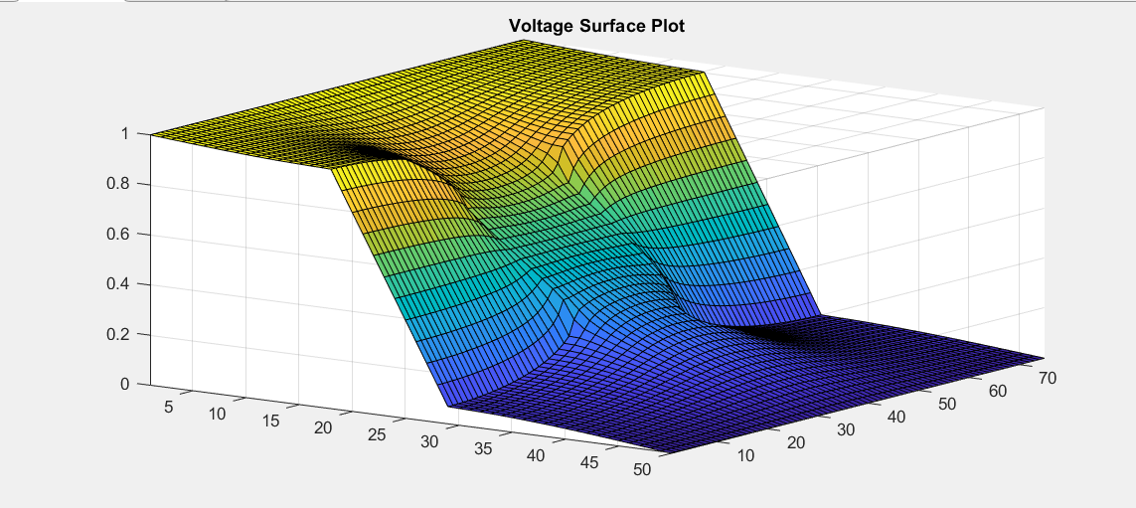

Figure 5: Voltage Surface Plot with Bottle Neck

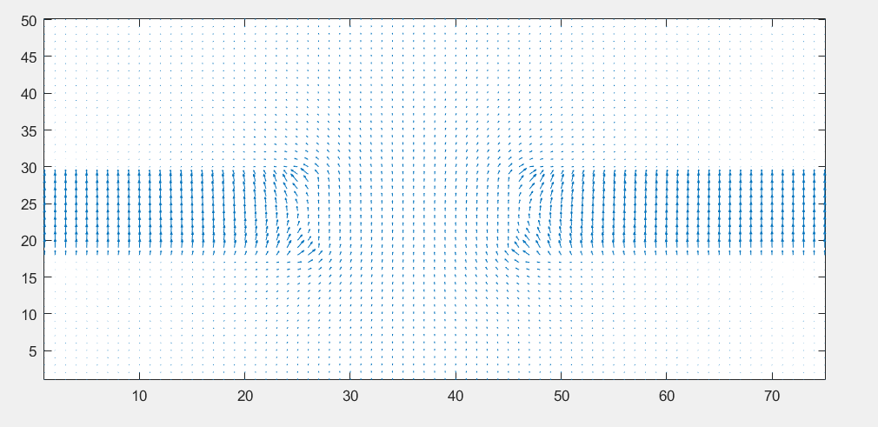

Figure 6: 2D Electric Field Plot

**3.**

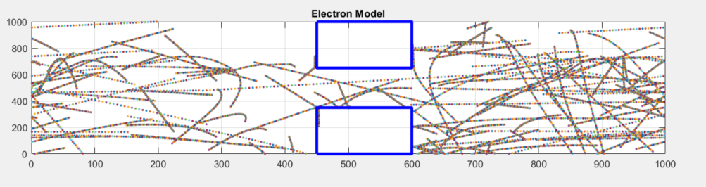

Figure 7: Electron Model with Electric Field

b)

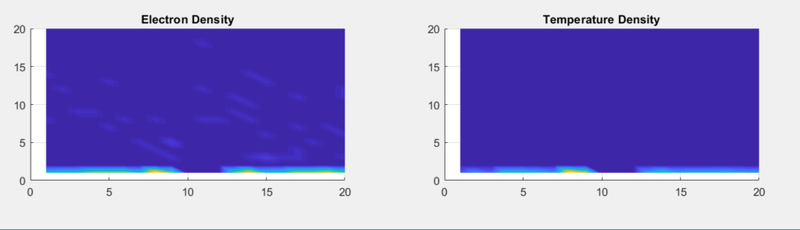

Figure 8: Density Maps for the Electron Model with the Electric Field

As seen in figure 7 and 8 it seems like the electrons turn away from the high resistivity bottle neck and revert to the bottom of the space. The simulation comprised of 300 electrons for 300 timesteps.

c) Longer simulations would increase accuracy. Also accounting for potential losses could effect things. Also the space that is containing the simulation could be increased.