1. The root is 2. The leaves are 1, 4, and 0. Every other node is an internal node
2. Pre: 2,7,3,1,5,9,4,0

In-Order: 1,3,7,2,4,9,5,0

Post: 0,4,9,5,1,3,7,2

1. A, B, C, D
2. 1,3,4,6,7,8,10,13,14
3. 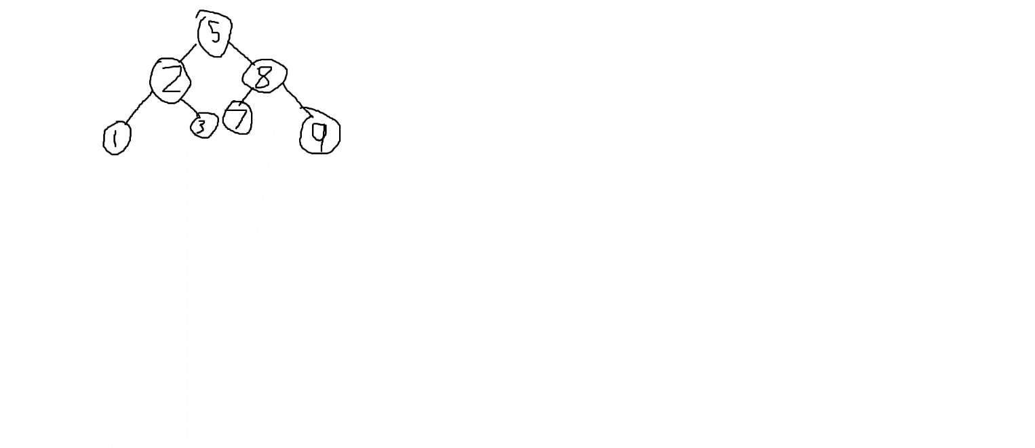
4. 3 and 7

