APPLICATION DEVELOPMENT AND EMERGING TECHNOLOGIES
PROJECT PROGRESS REPORT
Academic Year: 2025–2026
Course: CC313 – Application Development and Emerging Technologies

PROJECT INFORMATION
Project Title: PAY PRO DYNAMICS

Group Name: JE AND FRIENDS

Group Members:
Name | Role
JUSTIN MANZANO | Programmer
KURT BENSURTO | UI/UX Designer
JUAN MIGUEL RAMOS | Tester
JOHN ELIAS AGUILAR  JOHNPAUL GUIRUELA | Documentation
Date Submitted: OCTOBER 3, 2026
Reporting Period: OCTOBER 3, 2026

PROJECT DESCRIPTION
Pay Pro Dynamics is a web-based Employee Payroll Management System built with PHP, HTML, CSS, JavaScript, and MySQL, running locally on XAMPP. It manages employee records, departments, positions, attendance, deductions, and payroll for semi-monthly pay periods.
Payroll is computed on the server with a fixed formula: regular pay based on the salary type, plus overtime pay (overtime hours x overtime rate), minus deductions such as Tax, SSS, PhilHealth, Pag-IBIG, and loans. Every payroll moves from Draft to Processed to Paid, and each record produces a printable payslip.
Three account roles control access: ADMIN has full access, MANAGER handles attendance and payroll, and a shared EMPLOYEE account lets staff search any name to generate and print payslips. Reports cover payroll, attendance, and deductions, with printing and CSV export straight from the database.

PROJECT OBJECTIVES
1. Maintain complete employee, department, and position records with search and filtering.
2. Record daily attendance and apply overtime and late hours to payroll.
3. Compute accurate semi-monthly payroll with Philippine deductions and a Draft-Processed-Paid workflow.
4. Generate printable payslips searchable by employee name, plus printable and exportable reports.
5. Enforce role-based access so each account type only reaches its allowed modules.

CURRENT PROJECT STATUS
✅ Planning
✅ Requirements Analysis
✅ Design
✅ Development
✅ Testing
✅ Deployment
✅ Maintenance

TASKS COMPLETED
Task | Date Completed | Status
Project Proposal |  | ✅
UI Design |  | ✅
Database Design |  | ✅
Coding |  | ✅
Testing |  | ✅
Deployment & Final Testing |  | ✅

CURRENT PROGRESS
Overall Completion:
☐ 10%
☐ 25%
☐ 50%
☐ 75%
☐ 90%
✅ 100%

WORK ACCOMPLISHED
The complete system is built and running on XAMPP: secure login with three roles, a dashboard with payroll charts, employee/department/position management, attendance tracking, deduction management, full payroll computation and processing, payslip search with printing, and reports with CSV export. All 14 main pages load successfully and role restrictions were verified for every account type.
CHALLENGES ENCOUNTERED

- 1. The Reports page crashed with a PHP parse error caused by a duplicated closing tag.
2. The shared employee login was blocked from payslips by an ownership check meant for linked accounts.
3. Removing allowances required recalculating saved payroll records so all totals stay correct.

SOLUTIONS IMPLEMENTED

3. Dropped allowances from the form, formula, and payslip, then recomputed existing records in the database.
2. Changed the check so only linked accounts are restricted; shared accounts can open any payslip.
1. Removed the duplicate tag and syntax-checked all 35 PHP files; the page loads normally.
TASKS FOR NEXT MEETING
- Insert final screenshots of all modules.

Submit the final document for adviser review.
Dry-run the live demo on XAMPP (login, payroll processing, payslip printing).
SCREENSHOTS OF CURRENT SYSTEM
- Login Page
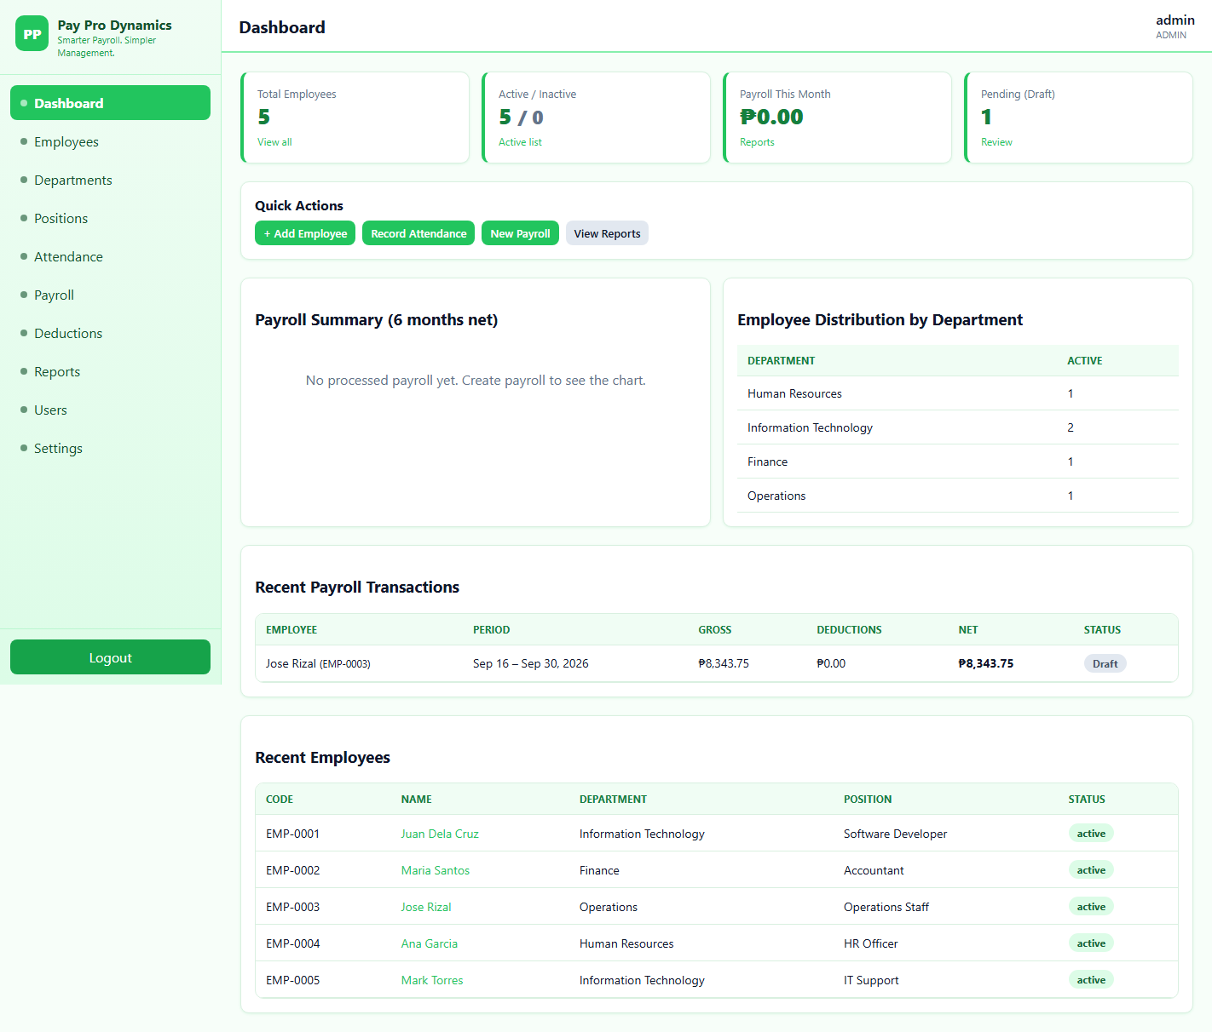
- Dashboard
- Employee Management
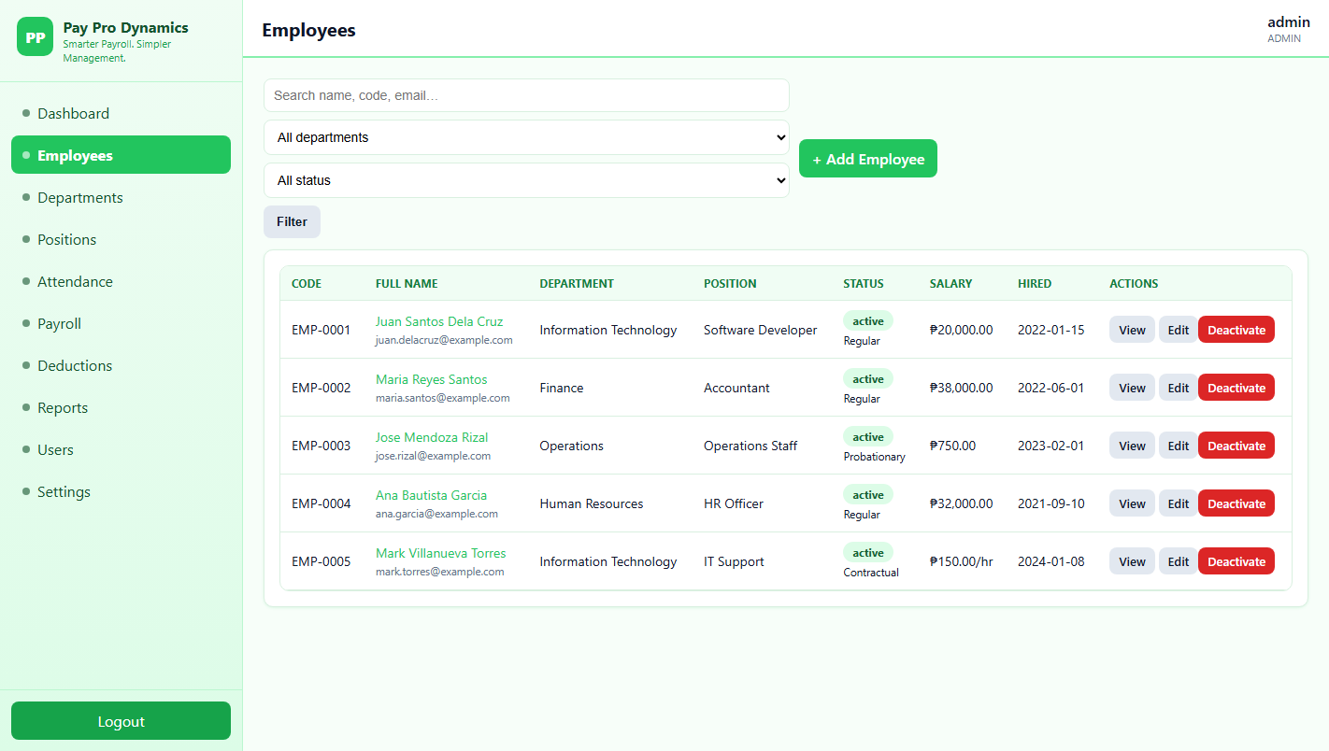
- Payslip Generation
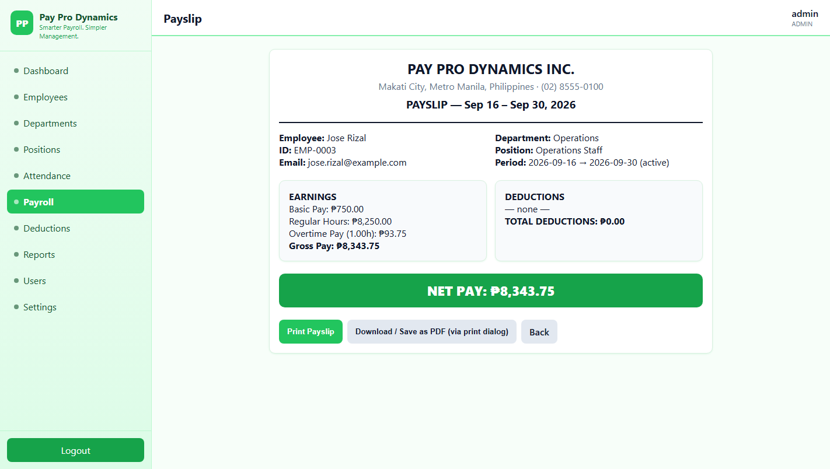
- Payroll Reports
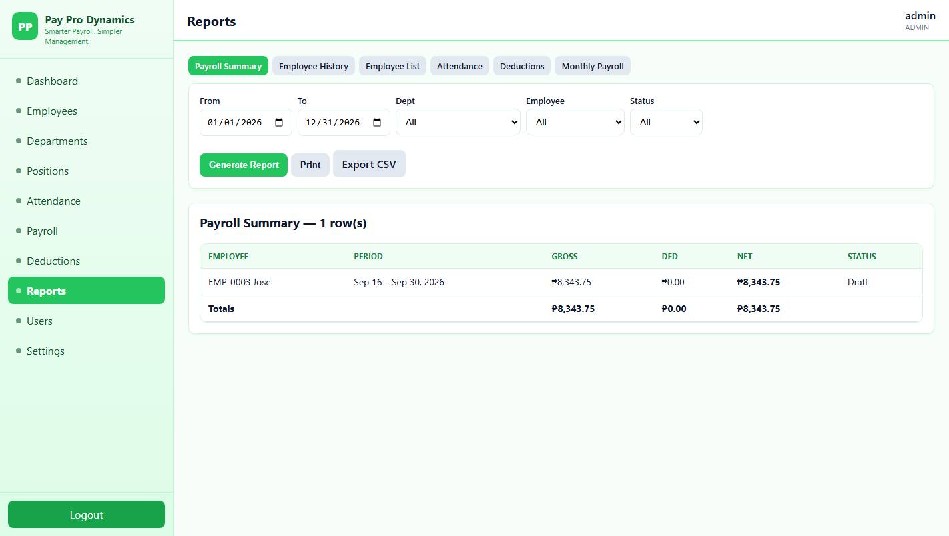

INDIVIDUAL CONTRIBUTIONS
Member | Contribution
Aguilar | Progress report
Giruela | Progress report
Ramos | Testing
Manzano | Coding
BENSURTO | Designing

PROJECT ADVISER'S COMMENTS

Prepared by:
Group Leader
Name:
Juan Miguel Ramos
Signature:...
Date:October 3, 2026

APPLICATION DEVELOPMENT AND EMERGING TECHNOLOGIES
USER MANUAL
PAY PRO DYNAMICS

Version
Version 1.0
Developed By
Group Name: JE and Friends
Members:
JUAN MIGUEL RAMOS
KURT BENSURTO
JOHN ELIAS AGUILAR
JOHNPAUL GUIRUELA
JUSTIN MANZANO

TABLE OF CONTENTS
- Introduction
- System Requirements
- Installation Guide
- Features
- How to Use the System
- Troubleshooting
- Frequently Asked Questions
- Contact Information

1. INTRODUCTION
Pay Pro Dynamics is a web-based payroll system that runs on XAMPP (Apache + MySQL) and is used through a web browser. It covers the full payroll flow: employee records, attendance, deductions, payroll computation and processing, payslips, and reports.
There are three accounts: admin (full access), manager (attendance, payroll, and reports), and employee (a shared account for searching names and printing payslips). Payroll is computed per semi-monthly period as regular pay plus overtime pay, minus deductions.

2. SYSTEM REQUIREMENTS
Hardware
- Intel Core i3 or higher
- 4 GB RAM
- 500 MB Free Storage
Software
- Windows 10/11
- XAMPP with Apache and MySQL running
- A modern web browser (Chrome or Edge)

3. INSTALLATION GUIDE
Step 1
Start Apache and MySQL in the XAMPP Control Panel.
Step 2
Copy the pay-pro-dynamics folder into C:\xampp\htdocs\.
Step 3
Import database\pay_pro_dynamics.sql using phpMyAdmin.
Step 4
Run database\seed_admin.php once in the browser, then delete that file.
Step 5
Open http://localhost/pay-pro-dynamics/login.php and log in.

4. FEATURES
The system includes:
✔ Secure login with ADMIN, MANAGER, and EMPLOYEE roles
✔ Employee, department, and position management
✔ Attendance recording with overtime and late hours
✔ Payroll computation with Draft, Processed, and Paid status
✔ Payslip search, printing, and PDF saving
✔ Delete Records
✔ Reports with print and CSV export

5. HOW TO USE THE SYSTEM
Step 1 - Log in.
Open http://localhost/pay-pro-dynamics/login.php and log in with your account.

Step 5 - Click Print, or choose Save as PDF in the print dialog.
Step 4 - Find the employee name in My Payslip and click Generate Payslip.
Step 3 - Create the payroll, review the computed amounts, then Process it.
Step 2 - Record attendance and deductions for the pay period.
6. TROUBLESHOOTING
Problem | Solution
Login page will not open | Start Apache in the XAMPP Control Panel and use http://localhost/pay-pro-dynamics/login.php.
Login failed | Check caps lock, confirm the account is active, and use the correct password.
Database error | Start MySQL in XAMPP and confirm the pay_pro_dynamics database was imported.
Payslip not found | The payroll record may have been deleted. Search the name again in My Payslip.

7. FREQUENTLY ASKED QUESTIONS
Who can process payroll? Only ADMIN and MANAGER accounts. The shared employee account cannot create or process payroll.
Can an employee view another employee payroll? The shared employee login is meant for payslip printing; staff should only search and print their own names.
Where is payroll data stored? In the MySQL database pay_pro_dynamics. Back it up regularly through phpMyAdmin.
8. CONTACT INFORMATION
For account resets and access issues, contact the system administrator.

