  Zamawiający / Investor: |  | Wykonawca / Subcontractor:
   | GE Power sp. z o.o.
   | ALSTOM Power Systems S.A.S.
Projekt:  Project: | BUDOWA ELEKTROWNI OSTROŁĘKA C  O MOCY OK. 1000 MW |  | Kraj:  Country: | POLSKA
Zamawiający:  Investor: | ELEKTROWNIA OSTROŁĘKA SP. Z O.O. |  | Kraj:  Country: | POLSKA
Miejsce na pieczęć (przegląd i walidacja – jeśli wymagane) / Space for stamping (review and validation status – if needed)

Historia zmian / Revision history
Zm.  Rev. | Data  Date | Opracował  Created by | Sprawdził  Checked by | Zatwierdził  Approved by | Opis  Description
A | Pierwsze wydanie / First issue

Przegląd branżowy / Cross checked
Dział / Department | Nazwisko / Name | Data / Date | Podpis / Signature

Typ dokumentu / Document type
Wytyczne do zastosowania
Note of Applicability

Tytuł dokumentu / Document title

Procurement Concept
Skala / Scale |  | Zastępuje / Replaces |  | Numer dokumentu / Project document no.  OST/00/A/-------PMF/NA/032
Kom. / Dept. | Opracował / Created by  Agnes ROUSSEAU | Sprawdził / Checked by  Anna Kopytowska |  | Zatwierdził / Approved by  Marc Villemin |  | Format  A4
Wydawca dokumentu / Doc. Originator  GE Power sp. z o.o. |  | Inny numer dokumentu / Other document no. |  | Nr identyfikacyjny / Identification number
 |  | Status dokumentu / Doc. status  Do stosowania / Released | Zm. / Rev.  A | Data / Date  13/11/2018 | Język / Lan  EN | Str. / Sheet  1/13

OSTROLEKA, POLAND

Procurement Concept

Document N°: | OST/00/A/-------PMF/NA/032
Issue Date: | 13/11/2018

 | Issued by : | Checked by: | Approved by:
Name : | Agnes ROUSSEAU | Anna Kopytowska | Marc Villemin
Title : | Senior Tender & Project Sourcing Manager | Regional Sourcing Leader | Project Director

Table of Contents

1. PROJECT DESCRIPTION 2
1.1 Introduction 2
1.2 Contract Structure 2
1.3 Key Events of the Project 2
1.4 GE Scope of Supply / Scope Split 2
2. GENERAL INFORMATION 2
2.1 Purchase Order Concept and use of GT&C’s 2
2.2 Purchasing Strategy 2
2.3 Sub-supplier list . 2
2.4 Commercial Conditions between GE and Suppliers. 2
3. NEGOTIABLE TERMS BETWEEN GE AND SUPPLIERS 2
3.1 Defects Liability 2
3.2 Terms of Payment 2
3.3 Performance Bond, Security Provisions 2
3.4 Liquidated Damages 2
3.5 Non-negotiable terms within GT&C 2
3.6 Negotiable terms within GT&C requesting legal advice prior commitment 2
4. PROCUREMENT PROCEDURE 2
4.1 General 2
4.2 Master Procurement Schedule 2
4.3 Subcontracting / Owner’s Right of Approval 2
4.4 Quality Requirements 2
4.5 Distribution of Inquiries and Purchase Orders 2
5. ATTACHMENTS 2

1. PROJECT DESCRIPTION

1.1 Introduction

Project name: OSTROLEKA (OST) ;
Plant type: 1 x 1000 MW Class Supercritical Pulverised Coal Power Station, Poland (Unit C)
Plant location: Ostroleka, Poland
Owner/Client/Employer: Elektrownia Ostroleka Sp. z o. o.
Main Contract/Contract: Contract between Owner and Consortium comprising the following companies :
(i) GE Power sp. z o. o. (Consortium Leader), and (ii) Alstom Power Systems SAS (Consortium Member)
hereinafter referred to jointly as the Contractor.
Importer of record: GE Power sp. z o. o.
Exporter: GE PTL(Shanghai) / Wuhan Boiler Company (WBC) / GE Power India Ltd ( GEPIL) / GE Power s.p. zoo Poland (Generator) / GE Energy Switzerland GmbH
Contract language: Polish (obligatory) or bilingual (Polish/English)
Language of documentation: Polish (obligatory) or bilingual (Polish/English). English can be accepted only upon approval of GE.

1.2 Contract Structure

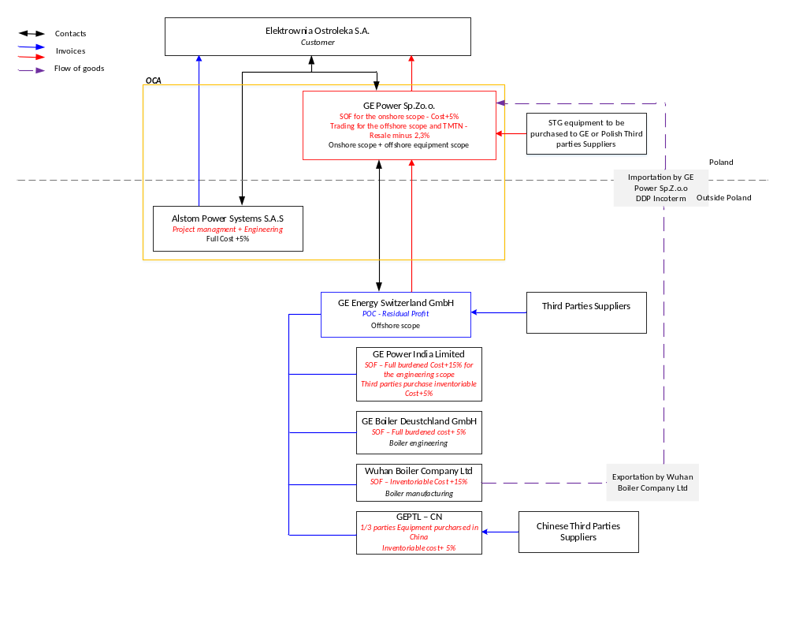
Contractual Set Up - Overview

Concept description:

GE Energy Switzerland (GEES) will act as the Principal Operating Company (POC) and will be remunerated by the residual profit according to tax advise.
The other GE entities will act as Standard Operating Function (SOF) , remunerated with a fixed cost percentage and cooperate with GEES accordingly based on ICA agreements.
GE Power SP. z o.o. is responsible for full onshore scope (components & services supplied directly from Poland) and also is considered as Trading Company for offshore subcontracting GEES for most of the scope : GE India (ESP), all scope of boiler Germany, all scope of boiler Wuhan/ China, all Third Party scope bought in China (other than STG and Third Parties from Poland).

Please also refer to Project Execution Plan and VAT arrangements stated below.

1.3 Key Events of the Project
- Notice to Proceed (NTP) : 21/12/2018 (forecast)
- Working Starting Date : NTP + 60 days
- Transfer for Operation : NTP + 56 months +12 months conditional extension for
defects removal ( = Performance Period)
- Performance Period : Period between Transfer for Operation and Final Acceptance
of Unit (max. 12 months)
- Final Acceptance : Transfer for Operation + 12 months
- Defect Correct Period : 24 months (starting from Transfer for Operation)

Please refer also to latest Master Time Schedule revision for more details.

1.4 GE Scope of Supply / Scope Split
Refer to Engineering Procurement Plan (EPP) Ref PMF NA 031
- Boiler
- Steam Turbine & Generator (STG)
- ESP
- FGD
- Plant

2. GENERAL INFORMATION

2.1 Purchase Order Concept and use of GT&C’s
The following documents have to be used for Purchase Orders:

2.1.1 Off–Shore Purchase Orders

Country of buying Entity | Country where PO is placed | GT&C to be used
Switzerland | Switzerland | GE Power Terms Of Purchase Rev. A - Europe
Poland | Poland | GE Power Terms Of Purchase Rev. A - Poland
China | China | GE Power Terms Of Purchase Rev. A - China
India | India | GE Power Terms Of Purchase Rev. A - India

2.1.2 On–Shore Purchase Orders

Orders for Turnkey Packages shall use:
GTC Of the Procurement of Plant on a Turnkey Basis, Rev. February 6, 2012 - V.20160307

Orders for Procurement of Services at Site shall use:
General Terms and Conditions for Procurement of Services at Site, Rev. March 14, 2016

Orders for Engineering Services shall use:
General Terms and Conditions of Purchase Engineering Services, Rev. March 14, 2016

2.1.3 In all cases

If terms and conditions of Supplier Agreement (SA) stipulate deviations from the Project Related Purchasing Conditions, they must be identified by the Purchaser of Component (POC) and if not properly covered in the SA, need to be agreed with supplier and to be stipulated in the Purchase Order.

2.2 Purchasing Strategy

Refer to Engineering Procurement Plan (EPP), reference OST/00/A/-------PMF/NA/031 registered in MTA together with Master Procurement Schedule (MPS)

2.3 Sub-supplier list.

For all PO, main components sub-supplier list shall be submitted by Sellers and approved by GE.
The sub-supplier list shall be included in PO.

2.4 Commercial Conditions between GE and Suppliers.

Purchase Orders and consequently the payment to suppliers should be made:

For On–Shore Purchase Orders in PLN whenever it is possible to mitigate the Currency Risk and avoid double hedging costs.

For Off – Shore Purchase Orders in PLN whenever it is possible to mitigate the Currency Risk and avoid double hedging costs.

For further details, PPLM shall be contacted.

Where Site services for supervision of erection and/or commissioning and/or on-Site training are necessary, the Supplier has to provide in his offer optional lump sum price and daily rate for additional period (daily rates - period).

In execution, any switch vs the original PCDB Cost allocation sourcing community must inform PPLM before any PO placement.

2.4.1 Price Basis

Off-Shore Purchase Orders:

The PO price is based on delivery FCA Supplier’s factory or any other agreed in PO (place of destination) according to Incoterms 2010 with the goods packed, marked, loaded and delivered in accordance with the Purchaser’s Shipping, Packing and Marking Instructions (HDST602775 & OST/00/A/-------PMF/PP/301)
Additionally, the Supplier has to provide in his offer optional price for DAP Ostroleka Site delivery and in the PO price is to include a DAP Ostroleka Site, Poland delivery basis option with the goods packed, marked, loaded and lashed.

On-Shore Purchase Orders:

The PO price is based on delivery DAP Ostroleka according to Incoterms 2010 with the goods packed, marked, loaded and delivered (transported) in accordance with the Purchaser’s Shipping, Packing and Marking Instructions (HDST602776 & OST/00/A/-------PMF/PP/302)

2.4.2 VAT Regulation for Off-Shore PO’s

All POs placed with Polish Supplier shall be mandatorily placed by the On-Shore: GE Power Poland Sp. z o.o.
All POs placed with non-Polish Supplier shall be mandatorily placed by the Off-shore:
- GE Power India Limited for Suppliers from India (Equipment)
- Wuhan Boiler Company for Suppliers from China (Boiler manufacturing)
- GE PTL-CN for Suppliers from China (Equipment)

- GE Power Switzerland for Suppliers from other countries than above (Equipment / all Product Lines)

All POs for Site Services shall be mandatorily placed by the On-Shore GE Power Poland Sp. z o.o.

2.4.3 Packing, Shipping and Storage Conditions

Registered in MTA -> MCL module -> Library Items:
OST/00/A/-------PMF/PP/301
OST/00/A/-------PMF/PP/302

At GE Power request, the Supplier shall store the Product or part thereof at its own costs during 12 months after the delivery date defined in the PO. For additional storage time, the supplier shall provide us with a detailed offer (costs per month, square meter storage place if possible) – see PRPC.

2.4.4 Spare Parts

All defined below spare parts delivered by the Supplier shall be new, i.e. not used and manufactured not earlier than two years before the date of delivery [separate PO line recommended with adequate delivery date to Site]

2.4.4.1. Mandatory spare parts and consumables for delivery:

- Spare Parts for Erection, Commissioning Period & Consumables (LS001) – shall include emergency spare parts & consumables for erection contingencies and for maintenance during tests, commissioning, adjustment run and trial run until the date of the Unit Transfer for Operation (related to the scope of the Supplier Contract).
Definition of consumables:
- standard elements of filters of fuel, lubricating oil, air and other media
- fluids subject to regular exchange, filling the Power Plant equipment and auxiliary systems, including lubricating oils.
The Supplier shall provide, for his scope of the Contract, with all consumables and shall submit to the GE a set of spare consumables which are brand new.
- Wear & Tear Parts (LS002) for Defect Liability Period if required by manufacturer OMM - shall include all spare parts (mechanical, electrical, instrumentation, control components) which, during the operation of the Work, will be subject to replacement with new ones within the period shorter than the Defect Liability Period (and more frequently than each 3000h operation), in accordance with the operating instructions for equipment and the operation and maintenance manual submitted to the GE Power.
Wear parts shall include all spare parts which, during the operation of the Work within the Defect Liability Period, will be subject to replacement with new ones at intervals more frequent than the planned inspections of the Work.
Wear parts delivered by the Supplier constitute the property of the Buyer and shall be available for removal of defects of the Work. However, they shall be every time restocked by the Supplier if their quantity delivered according to the agreed specification turns out to be insufficient during the Defect Liability Period and especially latest at the end of Defect Liability Period shall be supplemented to initial quantity, if consumed.
During the Guarantee Period, the costs of replacement of wear parts shall be borne by the Owner. Supplier will accordingly notify GE. The payment by the Owner is to be processed by GE unless otherwise agreed. Supplier will support GE throughout the whole process related. The cost of purchasing new parts shall be borne by the Supplier.
- Spare parts (LS003) for Defect Liability Period - shall include all spare parts which will be used for the planned inspections and overhauls of the Work. Quantity of these parts shall cover Defect Liability Period and two additional years of operation
Strategic Spare Parts (LS004) for the Defect Liability Period - shall include spare parts supplied in order to enable a quick repair in the case of failure of a low possibility rate but with potentially great losses resulting from forced downtime of the Work, caused by the necessity to wait for manufacturing or importing of a new missing part. These parts are not planned for replacement during Defect Liability Period, but with long supply time and critical for ensuring the availability of the Power Plant, if the installed parts are damaged. If strategic parts are used during Defect Liability Period, they shall be delivered by the Supplier at its own cost. At the end of the Defect Liability Period, Client shall have a complete set of strategic spare parts.
- Special Tools (LS005) – shall include special equipment and overhaul tools are the set of special tools, specialist equipment, workstations, specialist transport, as well as non-standard control and measurement instruments, for purpose of operation, adjustment and repair of all the equipment and systems of the Power Plant, if necessary.
Supplier shall deliver as minimum all spare items as listed in GE templates [provided in DL100]

2.4.4.2. Spare Parts – readiness to sell/deliver at later date:

Additionally, Supplier shall prepare list of Wear & Tear parts as well as the recommended Spare Parts and Strategic Parts for Post-Guarantee Period.

2.5. Staff (in case of Site Services)

All persons employed by the Supplier in relation to the performance of the Contract will have the qualifications as well as valid licenses or certificates required under the Statutory Requirements that are appropriate for the performance of the Works. Prior to the commencement of the Works, the Supplier shall deliver to GE a list of key persons with their personal data employed by the Supplier in relation to the performance of the Contract.
The Supplier gives written consent to transfer their personal data according to Polish Law issued on May the 10th, 2018 on personal data protection, Official Journal 2018 pos. 1000 through through intermediary of GE to the Owner/Employer for the purpose of Contract performance.

In case the delivered Products will be installed at Site by the Supplier, and Work at Site would be classified as High-Risk Activities in the meaning of GE EHS DIRECTIVE then the Supplier will be obliged to perform its Work in accordance with the requirements of “Requirements for the Critical Contractors”. EHS package is mandatory then and applicable for PO.

3. NEGOTIABLE TERMS BETWEEN GE AND SUPPLIERS

3.1 Defects Liability

3.1.1 Defects Liability Period

Defects liability period shall apply in accordance:
twenty-four (24) months commencing on Final Acceptance (Transfer for Operation)
Additionally, certain Equipment, Facilities and Services shall be covered by the following guarantee periods from the date of Final Acceptance (Transfer for Operation)
60 (sixty) months for Construction Works;
60 (sixty) months for chemo-resistant linings and anticorrosive protection;
60 (sixty) months for heat-resistant protection;
60 (sixty) months for thermal and acoustic insulation;
60 (sixty) months for the Equipment and Facilities which, as of the date of submission of the offer by the Seller within the scope of the proceedings constituting the grounds for the conclusion this Purchase Order, did not commercially operate for at least 20,000 (twenty thousand) hours (the Seller nominates such Equipment and Facilities, provided that the nomination thereof by the Seller does not restrict the Buyer’s rights to verify and determine such Equipment and Facilities).
The above 5 (five) Warranty Periods shall not be subject to any extensions.

The Defect Liability Period for the components / works which the Seller replaced or repaired within the framework of its responsibilities execution for its liability for defects, start afresh for a further period of twenty-four (24) months with respect to that component from the date of signing of the Defect removal certificate.

3.2 Terms of Payment

3.2.1 Advance/ Down Payment

No Advance/ Down Payment available as standard condition. In special cases (e.g. valid Supplier Agreement) shall be five percent (5%) of the Contract Price but shall not exceed ten percent (10%) of the Contract Price. PPLM and PD approval is mandatory.

3.2.2 Intermediate Payment

Due to strong Client restrictions a special attention shall be paid by Purchasers to the compliance of Suppliers with their obligations in terms of documents delivery. Each delivery shall include all documentation (especially O&M) required in technical specification otherwise a delivery will be treated as incomplete and the above condition must be stipulated in PO payment conditions.
Wherever it’s possible we need to improve the GE cash out

The Supplier shall be paid only if the delivered Spare Parts agree with the list of spare parts approved by engineering.

3.2.3 Due Payment

Due payment as per contract should be made within 30 days after receipt of Supplier’s Invoice (in case of On-shore POs and Polish Suppliers) and 150 days after receipt of Supplier’s Invoice (in case of Off –Shore POs and non-Polish On-Shore POs). Requirement of 150 days applicable only if not going against any other local law. Legal support is advised here.

3.3 Performance Bond, Security Provisions

The amount of Performance Bond shall not be less than ten percent (10%) of the Contract Price.
The Performance bond can be reduced to 3% after Plant Acceptance.
The defect liability warranty bond will expire at the Acceptance + warranty time + sixty (60) days.
_In case the Acceptance date(s), is extended, the Supplier is obliged to extend the validity of the performance guarantee (s) he is obliged to submit, respectively to the extended period of the Acceptance date(s) under specific conditions applicable in PRPC.
In case of extension of the Defect Liability Period, the Supplier shall extend the existing performance guarantee, or submit a new performance guarantee for the extension period under specific conditions under specific conditions applicable in PRPC.

Any deviation has to be authorized by PPLM and PD.

3.4 Liquidated Damages

3.4.1 Late Delivery

A. Late Delivery of Work:

The Liquidated Damages for late delivery of Work shall not be less than:

- 0,15% for each completed day (or 1,05% for each week respectively)

The maximum aggregated amount of Liquidated Damages for the late delivery of Work is not less than fifteen percent (15%) of the Contract Price.

B. Late Submission of Documents

The Liquidated Damages for the late submission of copy of the PO in the 5 days from the date of conclusion shall not be less than twenty-five thousand (25000) PLN for civil & construction PO’s

The Liquidated Damages for the late submission of copy of the PO in the 5 days from the date of conclusion shall not be less than ten thousand (10000) PLN for material PO’s

C. Performance Liquidated Damages

The maximum aggregated amount of Liquidated Damages for failing minimum guaranteed Work Availability shall not be less than ten percent (10%) of the Contract Price

Performance Guarantees and Performance Liquidated Damages have to be defined together with the responsible engineer for each piece of Equipment separately.

D. Cap Aggregated Liquidated Damages
The maximum aggregated Liquidated Damages payable for delay in delivery (material and documentation) and non-achievement of the performance guarantees shall not be less than twenty-five percent (25%) of the Contract Price.

3.5 Non-negotiable terms within GT&C

For the avoidance of doubt, the following areas shall not be modified by any POC prior written approval from Legal Department and Sourcing Management, i.e. either lawyer or Contract Manager:

Definitions, Interpretations and Applicability
Compliance
Supplier’s Performance obligation
Remedies
Liabilities and Indemnities
Termination
Liability
Waiver
Governing Law and Contract language

3.6 Negotiable terms within GT&C requesting legal advice prior commitment

The other clauses can be negotiated by POC, however prior finalization it is strongly requested to seek legal advice if and when a deviation shall be agreed: (to be agreed with legal department)

Any deviations from GE official contract requirements shall be stated in Deviation Matrix. Approval of Deviation Matrix by Sourcing Management is mandatory.

4. PROCUREMENT PROCEDURE

4.1 General

Engineering submits the technical specification through MTA tool (DL100) directly to the CL / POC who sends out the inquiries to the Suppliers as per the Engineering Procurement Plan with copy to the PPLM. The CL / POC distributes the quotations received from the Suppliers to the responsible persons in Engineering (+ Lead Engineer) and to the PPLM.

4.1.1 Letter of Intent (LOI)

If applicable (LOI) - approval of legal function is mandatory.

4.1.2 MNDA / NDA and Supplier Integrity Letter

Required to be signed by Suppliers prior issuing RFQ.

4.1.3 RFQ

Required to be issued through Power Source Platform (PWS). In case it is not achiveable shall be
archived / copied into PWS then.

4.1.4 Purchase Order Recommendation (POR)

Mandatory for all Purchase Orders with amount above 25 kUSD + minimum 2 bids.

4.1.5. Purchase Order

Required to be registered in Power Max System, fully approved (with Purchase Requisition released) signed and stamped properly by authorized persons.

4.1.6. New Suppliers & PO notification to the Client

Please refer to Procedure: Subcontracting of Works, Notification of Purchase Orders and new suppliers/subcontractors OST/00/A/-------PMF/NA/006

4.2 Master Procurement Schedule

The Master Procurement Schedule (MPS) for OSTROLEKA Project shall be prepared by Project Planner and distributed by PPLM for monitoring of all purchasing & logistics activities and reporting to the management. This MPS shall be stored in MTA.

4.3 Subcontracting / Owner’s Right of Approval

Owners approval for Purchase Orders is mandatory for
- PO’s above fifty thousand (50000) PLN All
- no price limit for all Subcontractors & civil works

In such a cases pre-negotiated Purchase Orders as well as drafts of any annexes to agreements already signed with short-listed Suppliers must be submitted to Owner to obtain the Owner’s approval at latest 30 days prior to placement of the PO.

4.4 Quality Requirements

Quality Control Plan is mandatory to be attached to every single PO including all relevant attachments (also including necessary PMF's). Supplier also is obliged to issue Inspection and Test Plan.
In order to recognize and fulfill technical and quality requirements, the Supplier shall implement and use the Quality Control and Assurance Program. The said program shall be based on PN EN ISO 9001 standard.
Any deviations – Quality approval is mandatory.

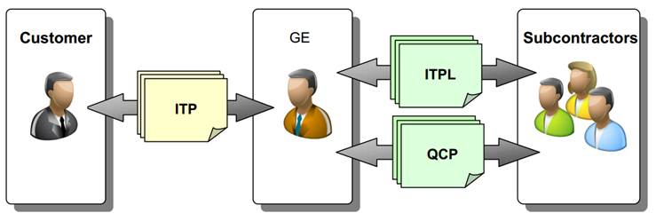

4.5 Distribution of Inquiries and Purchase Orders

Archiving of the Purchase Orders & Amendments shall be done through MTA (MCL module) including distribution list as stated below. Inquiries/ Quotations can be distributed by copy of e-mail but recommended to store in MCL module.

Inquiries/ Quotations:
- ENG Responsible Engineer
- LEE Responsible Lead Engineer
- PPLM Project Manager - Procurement & Logistics
- CL Commodity Leader
- POC Purchaser of Components

Purchase Orders and Modification of Purchase Orders:

- PD / PM : Marc Villemin (on / off-shore) , Lucasz Malec (off-shore), Michal Milosz (on-shore)
- Project Controller : Marta Muchynska
- PSL : Agnes Rousseau
- PPLM : Agnes Rousseau (Plant - Lead & off-shore), Kamil Stawicki (Plant on-shore),
Małgorzata Kozieł (Plant Turnkey)
Stefan Eisenberg (Boiler - Lead), Monika Nowicka (Boiler on-shore),
Yamei Xu (Boiler Wuhan)
Alex Cui (FGD - Lead), Monika Nowicka (WFGD)
Sukanto Dasgupta (ESP - Lead), Małgorzata Kozieł (ESP on-shore)
Agnes Rousseau (ST & Gen)
- Quality : Karol Majewski
- Project Planner : Michał Langda
- (Order Fullfilment) : Piotr Misiak (Plants & Boiler) ; Przemysław Alabrudziński (FGD &
ESP & ST & Gen)
- LEE : Tomasz Kasierski supported by Adam Walasiak

Departments and names:

Please refer to Project Execution Plan OST/00/A/-------PMF/PP/018

All Purchase Orders shall be filed electronically as PO Form in MTA (MCL module) under MTA folder Sourcing Procurement, details as follow:

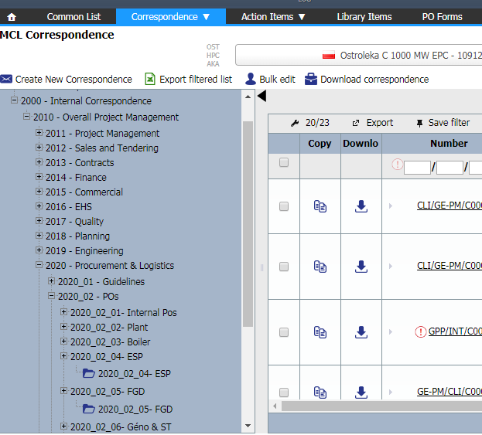

Only authorized team members shall have access to the purchase order files.

5. ATTACHMENTS

Attachment I Engineering Procurement Plan (EPP)

Attachment II Project Execution Plan

Attachment III Master Procurement Schedule (from Primavera)

Attachment IV PO Model, PRPC's and GT&C's package

