IoT Analytics- Extra
Wen-Han Hu(whu24)

Extra credit: Selecting the number of states N
In order to selecting the number of states N, we need to increase the number of states starting from 2 states until the certain pattern be observed. The increasing the number of states will lead to a higher likelihood, but the number of parameters that need to be estimated will also be increased. Hence, AIC and BIC are two indicators to calculate the penalty of parameters. That is, the more parameters add into our model, the higher AIC and BIC value. Hence, our goal is to select a number which has lower AIC and BIC and high likelihood. Please refer to the results as following.
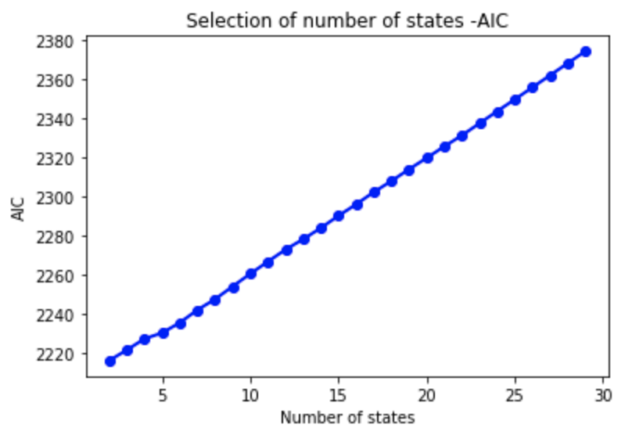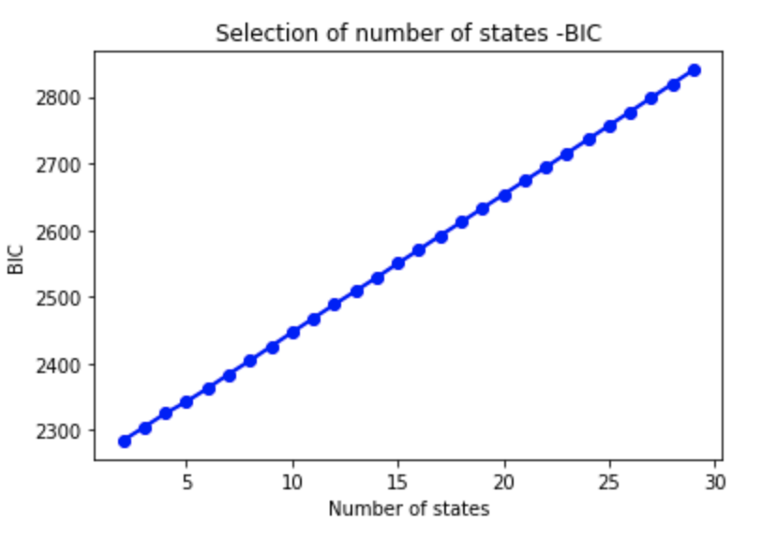
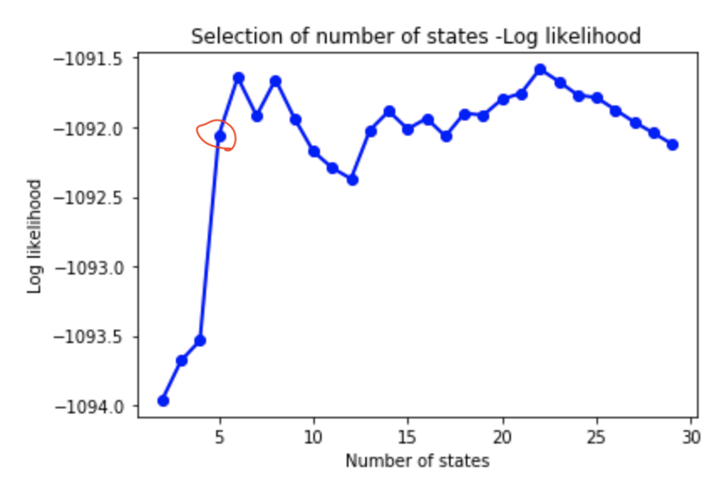
Both AIC and BIC differ by the way they penalize the number of parameters of a model, and more precisely, BIC criterion will induce a higher penalization for models with an intricate parametrization in comparison with AIC criterion. As the results above, both values of AIC and BIC increase linearly. That is not surprising because as we increase number of parameters, the AIC and BIC values are increasing which implies the complexity of model may lead to overfitting. We need to choose the number of states with low AIC and BIC values along with high value of likelihood. Hence, by the rule of thumb, we can find that the when the number of states more than 5, the likelihood is relatively stable. Thus, the best number of states N is 5 based on our results.

