0404
https://colab.research.google.com/drive/1LRpK4KN6VPKBsMu6KvODX6m0z8UDqyyT?usp=sharing

0702

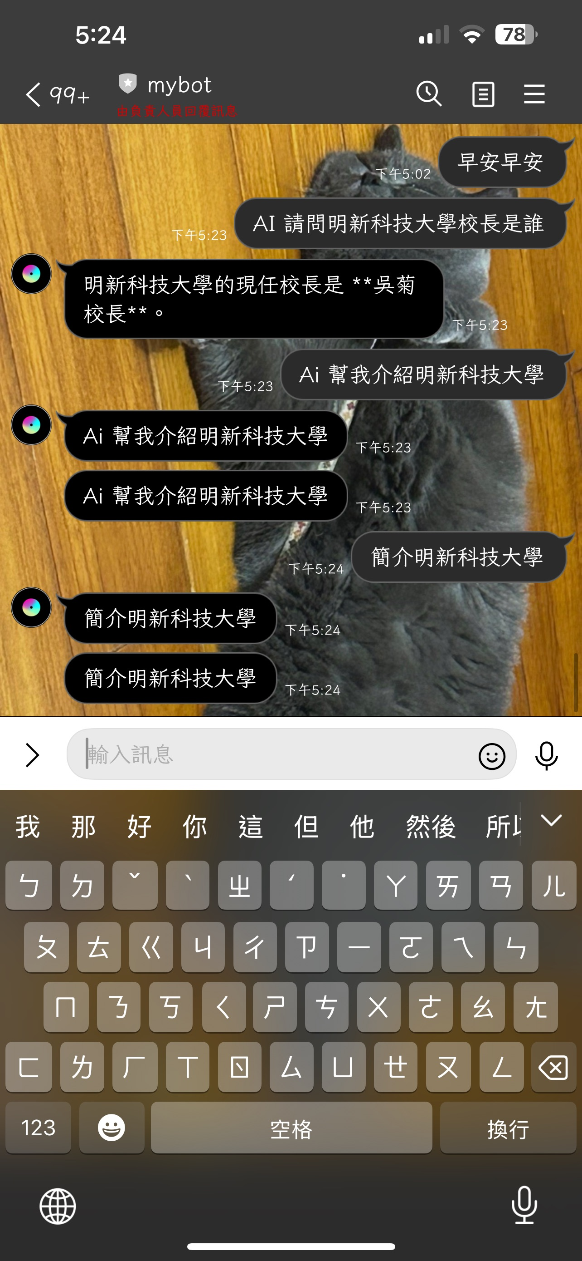
0704
https://colab.research.google.com/drive/1DAVlKmGlPN9kqNGrCWajuVW4PATMGPKJ?usp=sharing

0709
https://colab.research.google.com/drive/1y5Kq_zu7Ca4gRZXDLMTFoLawA_4VPUFg?usp=sharing
