Early Entry Evaluation

# Currency Under Study - BAMBOO

|  |  |  |  |  |
| --- | --- | --- | --- | --- |
| buy_date | sell_date | buy_price | sale_price | currency_id |
| 2021-03-11 | 2021-03-12 | 0.00240077 | 0.0480155 | BAMBOO |
| buy_avg_volume | buy_avg_volume_before_trigger | duration | profit | ROI |
| 107624 | 112521 | 1 | 0.0456147 | 1900 |

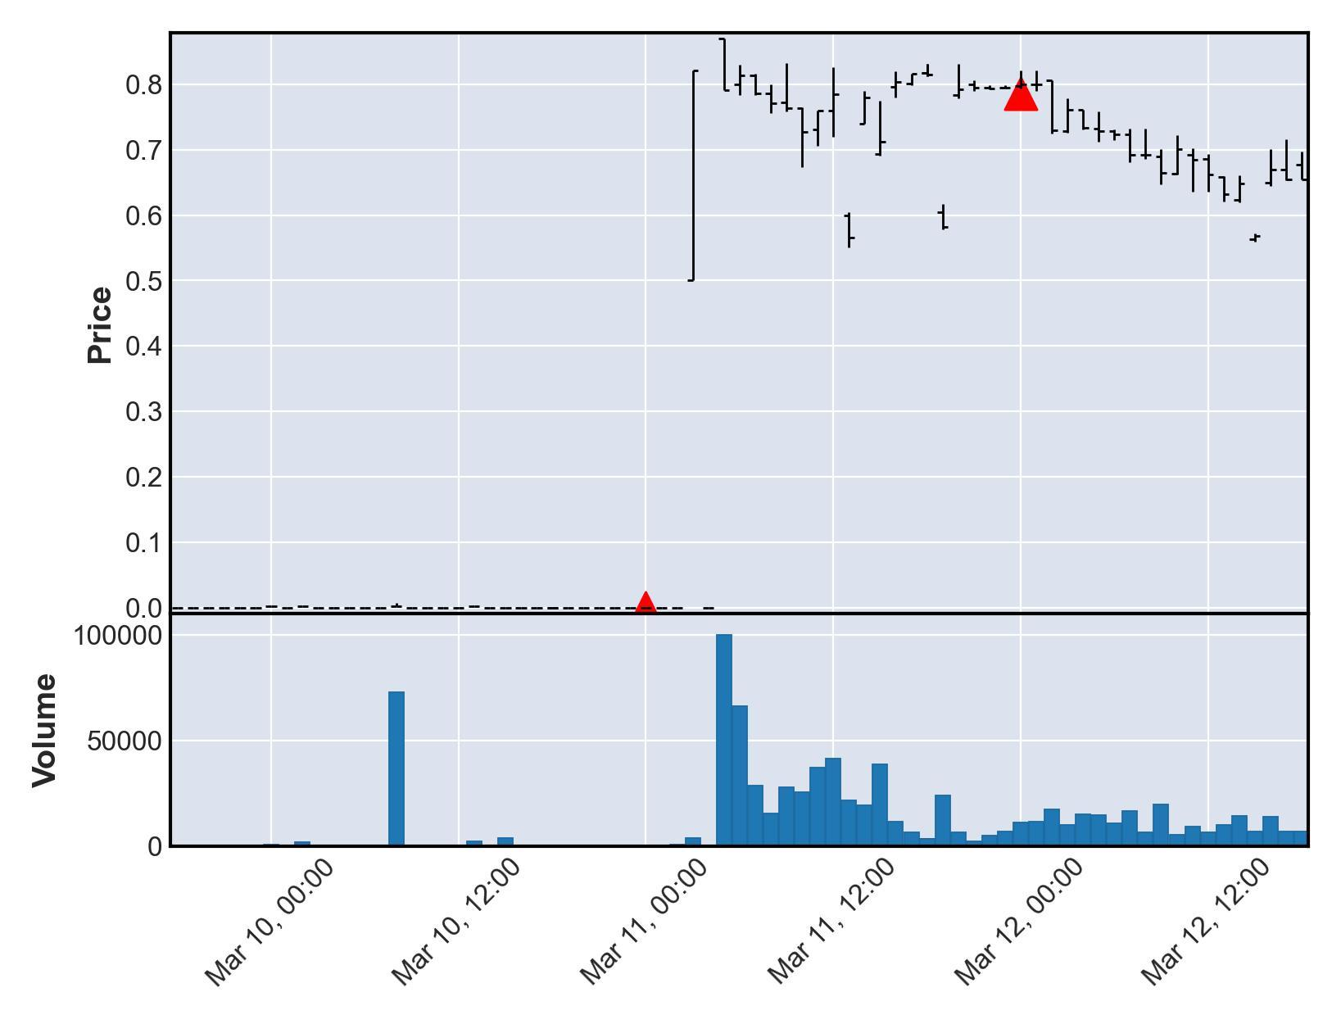

# Currency Under Study - SAFEMARS

|  |  |  |  |  |
| --- | --- | --- | --- | --- |
| buy_date | sell_date | buy_price | sale_price | currency_id |
| 2021-04-20 | 2021-04-24 | 3.96041e-07 | 7.92082e-06 | SAFEMARS |
| buy_avg_volume | buy_avg_volume_before_trigger | duration | profit | ROI |
| 10696965 | 4604876 | 4 | 7.52478e-06 | 1900 |

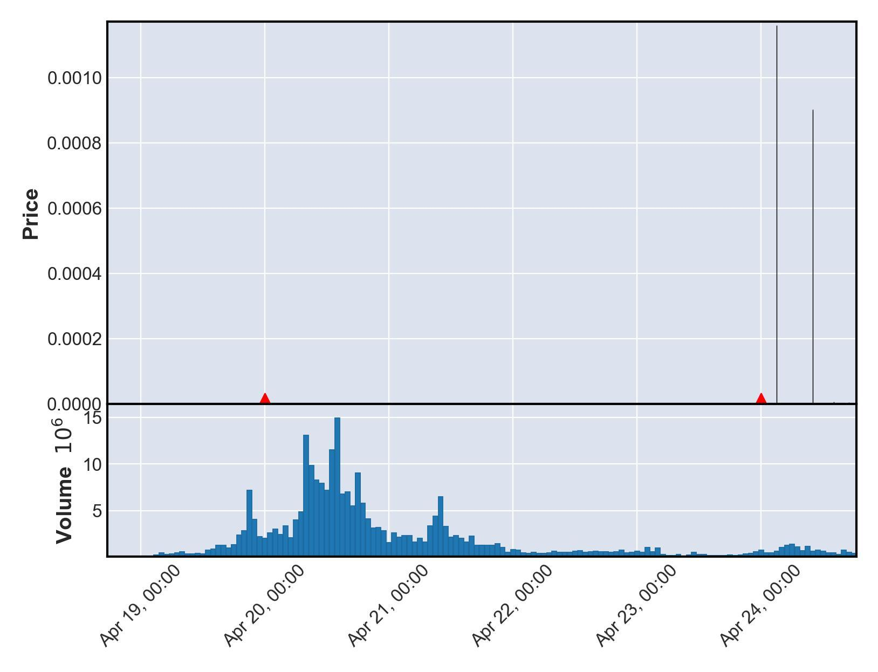

# Currency Under Study - BAFE

|  |  |  |  |  |
| --- | --- | --- | --- | --- |
| buy_date | sell_date | buy_price | sale_price | currency_id |
| 2021-04-21 | 2021-04-27 | 6.43802e-08 | 1.2876e-06 | BAFE |
| buy_avg_volume | buy_avg_volume_before_trigger | duration | profit | ROI |
| 1479383 | 1328674 | 6 | 1.22322e-06 | 1900 |

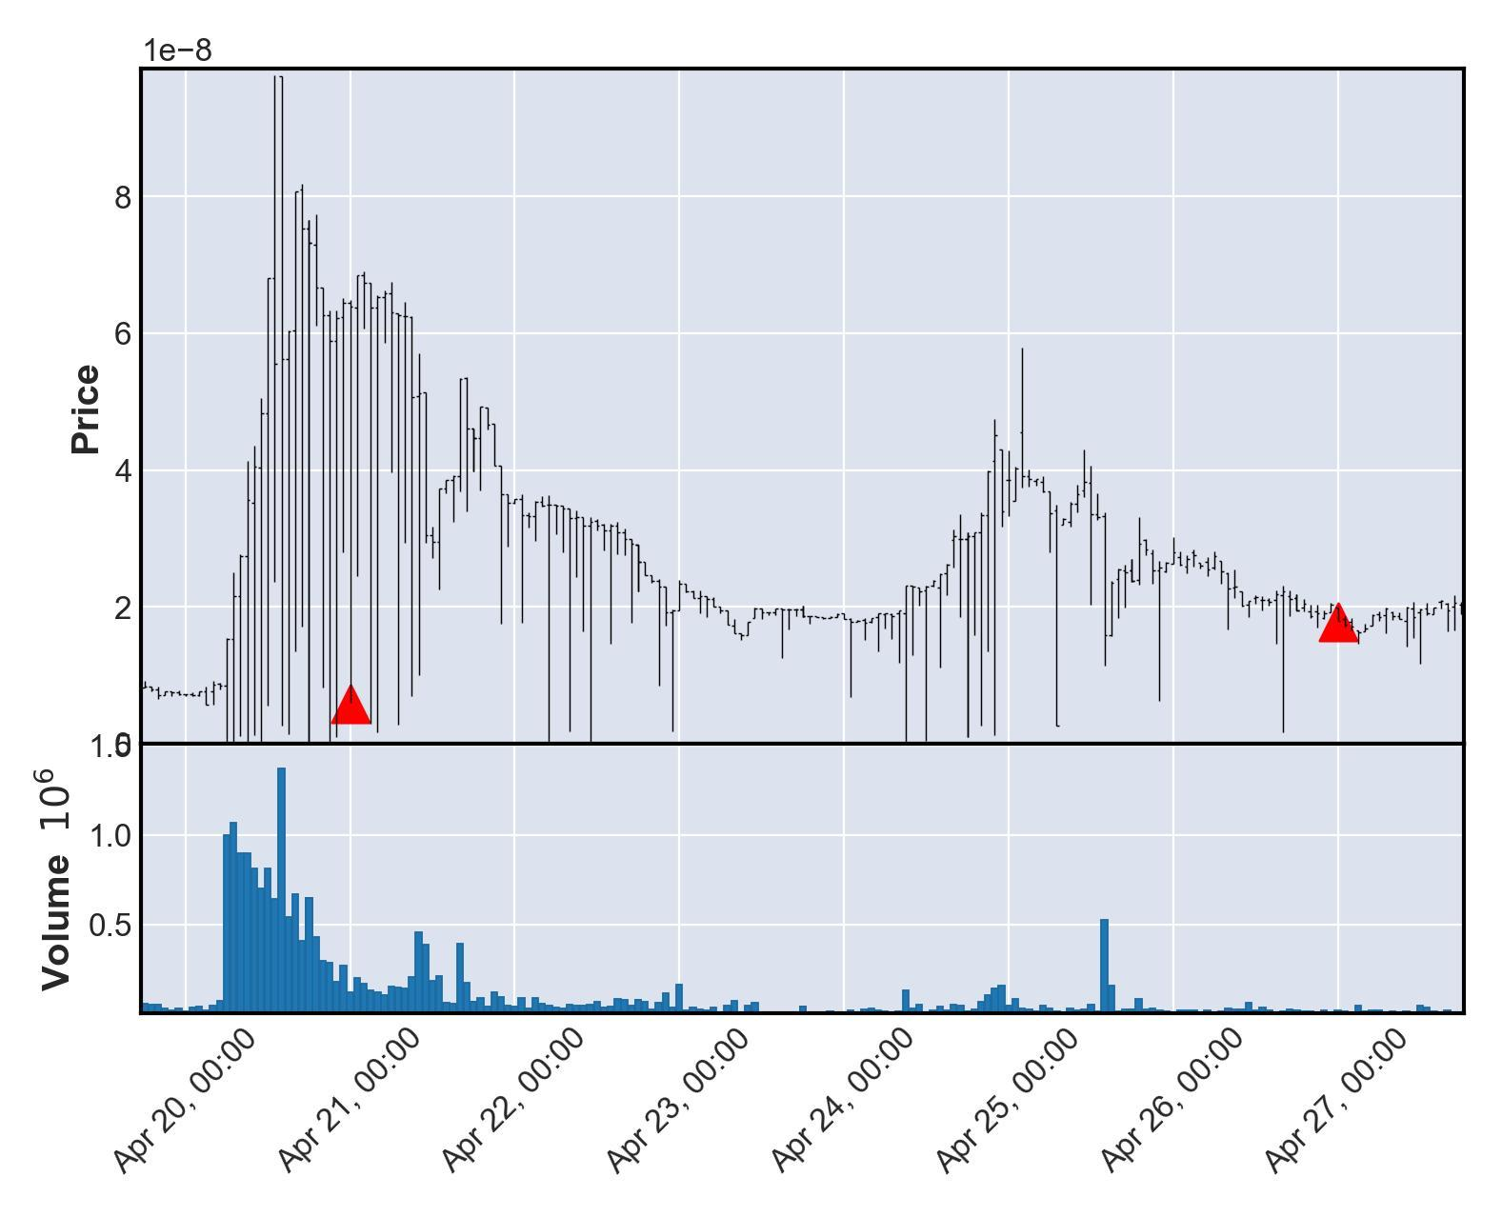

# Currency Under Study - TRDG

|  |  |  |  |  |
| --- | --- | --- | --- | --- |
| buy_date | sell_date | buy_price | sale_price | currency_id |
| 2021-04-21 | 2021-04-24 | 4.09153e-10 | 8.18306e-09 | TRDG |
| buy_avg_volume | buy_avg_volume_before_trigger | duration | profit | ROI |
| 511246 | 368193 | 3 | 7.77391e-09 | 1900 |

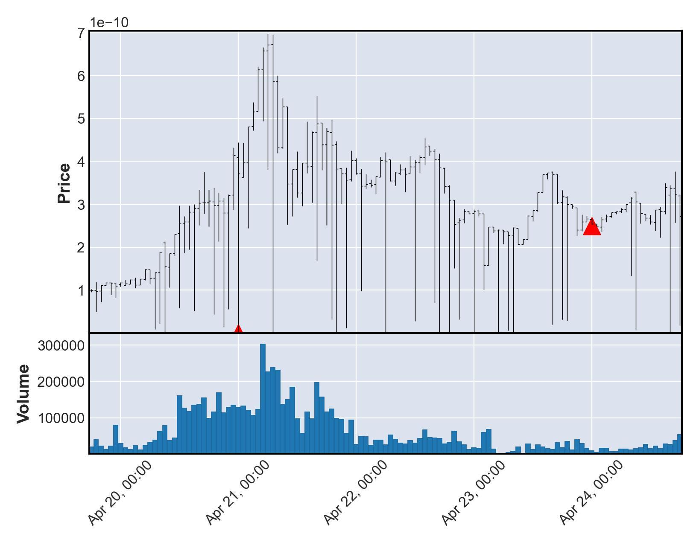

# Currency Under Study - SAFETESLA

|  |  |  |  |  |
| --- | --- | --- | --- | --- |
| buy_date | sell_date | buy_price | sale_price | currency_id |
| 2021-04-21 | 2021-04-25 | 3.59193e-09 | 7.18386e-08 | SAFETESLA |
| buy_avg_volume | buy_avg_volume_before_trigger | duration | profit | ROI |
| 112933 | 75091 | 4 | 6.82467e-08 | 1900 |

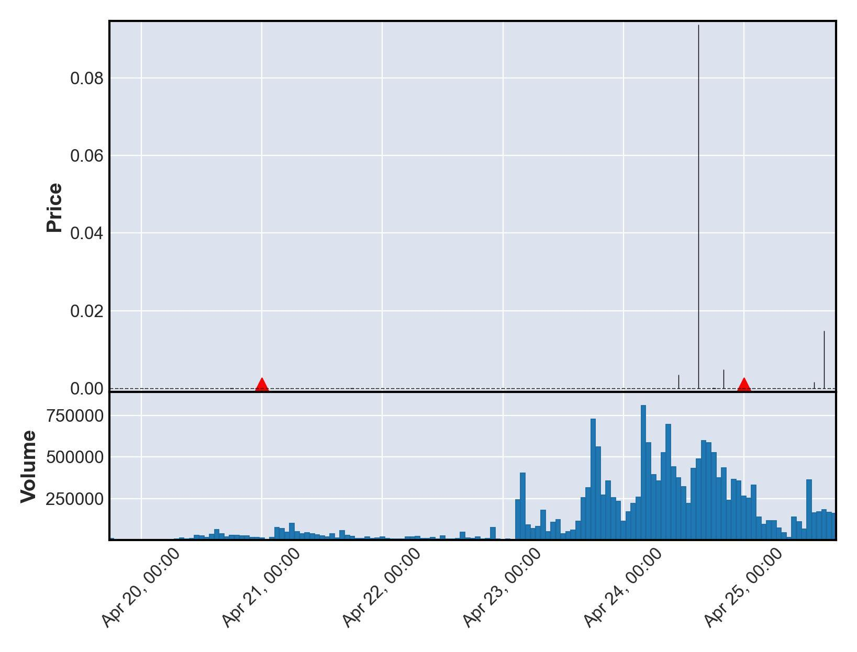

# Currency Under Study - MOONSHOT

|  |  |  |  |  |
| --- | --- | --- | --- | --- |
| buy_date | sell_date | buy_price | sale_price | currency_id |
| 2021-04-22 | 2021-04-26 | 7.70154e-08 | 1.54031e-06 | MOONSHOT |
| buy_avg_volume | buy_avg_volume_before_trigger | duration | profit | ROI |
| 870695 | 782388 | 4 | 1.46329e-06 | 1900 |

Sale timing of 2021-04-26 00:00:00+00:00 not found with matching transparent transaction data from nomics. Exit not shown on chart.

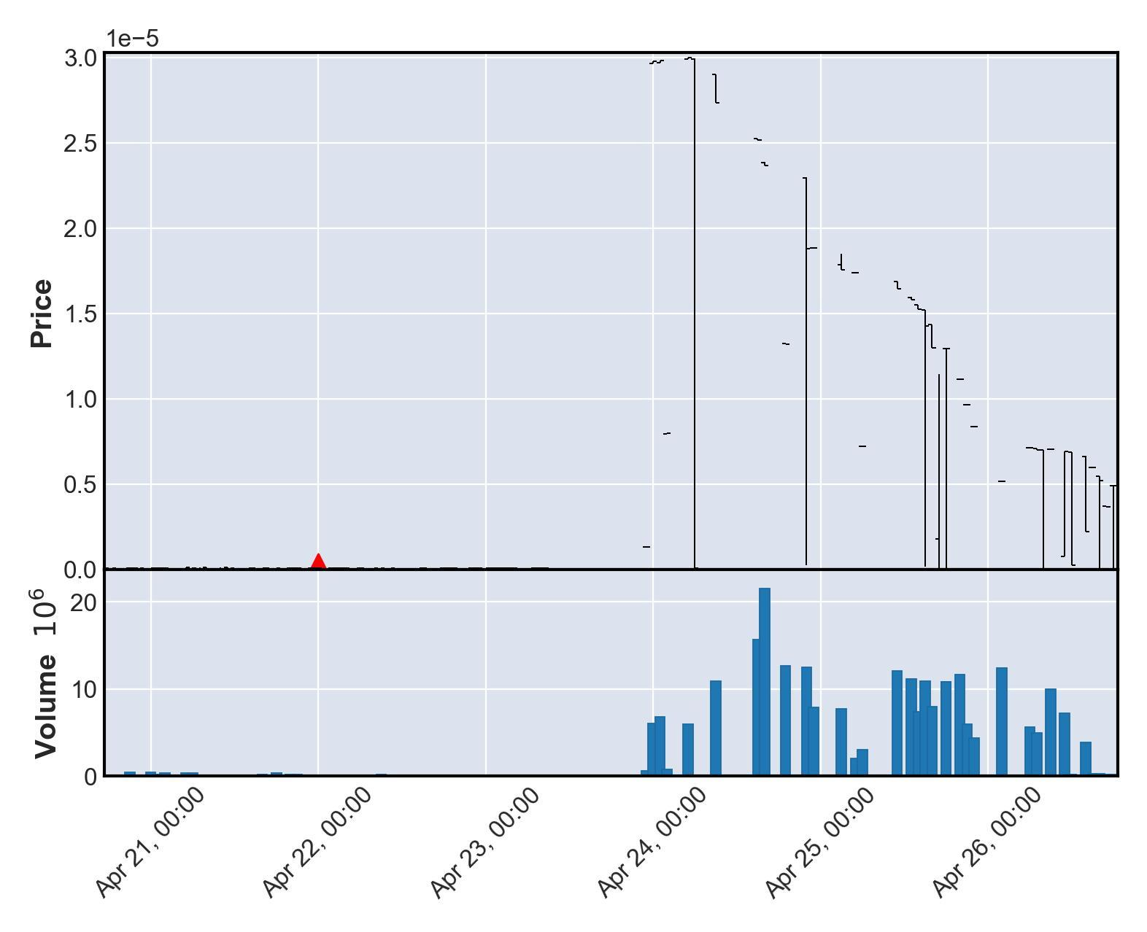

# Currency Under Study - AQUAGOAT2

|  |  |  |  |  |
| --- | --- | --- | --- | --- |
| buy_date | sell_date | buy_price | sale_price | currency_id |
| 2021-04-27 | 2021-04-28 | 4.76219e-10 | 9.52437e-09 | AQUAGOAT2 |
| buy_avg_volume | buy_avg_volume_before_trigger | duration | profit | ROI |
| 1582170 | 1466468 | 1 | 9.04815e-09 | 1900 |

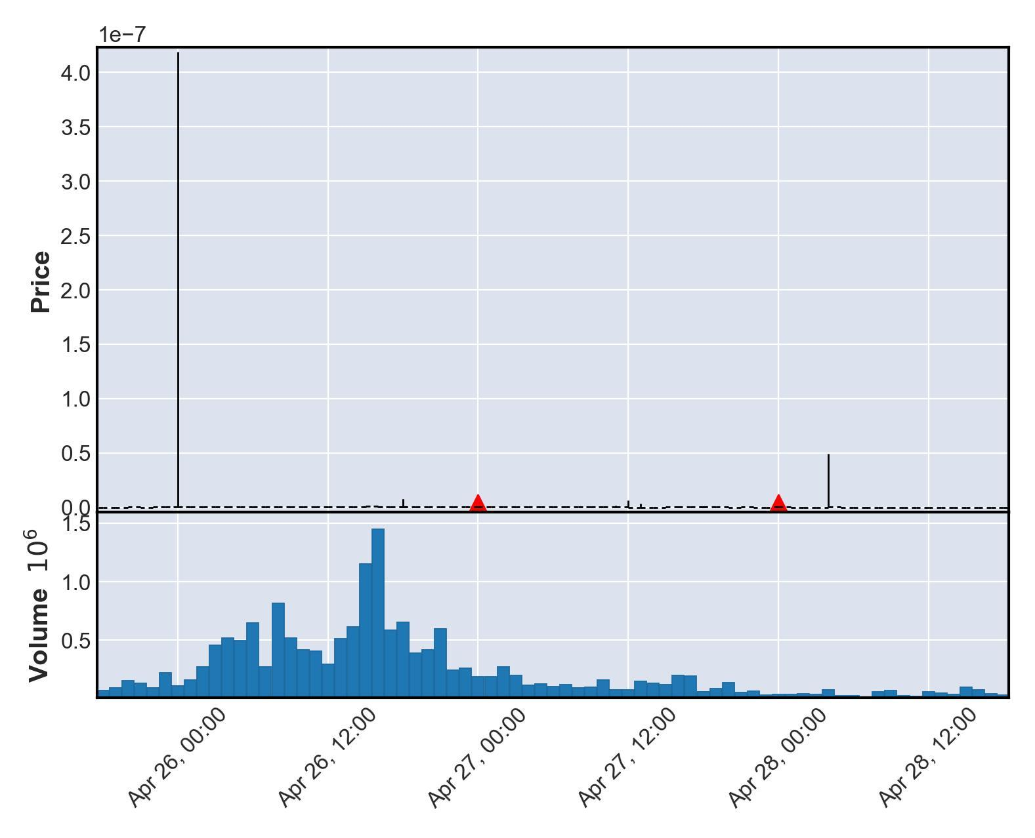

# Currency Under Study - CUMMIES

|  |  |  |  |  |
| --- | --- | --- | --- | --- |
| buy_date | sell_date | buy_price | sale_price | currency_id |
| 2021-05-05 | 2021-05-07 | 0.130503 | 2.61006 | CUMMIES |
| buy_avg_volume | buy_avg_volume_before_trigger | duration | profit | ROI |
| 6495525 | 3730134 | 2 | 2.47956 | 1900 |

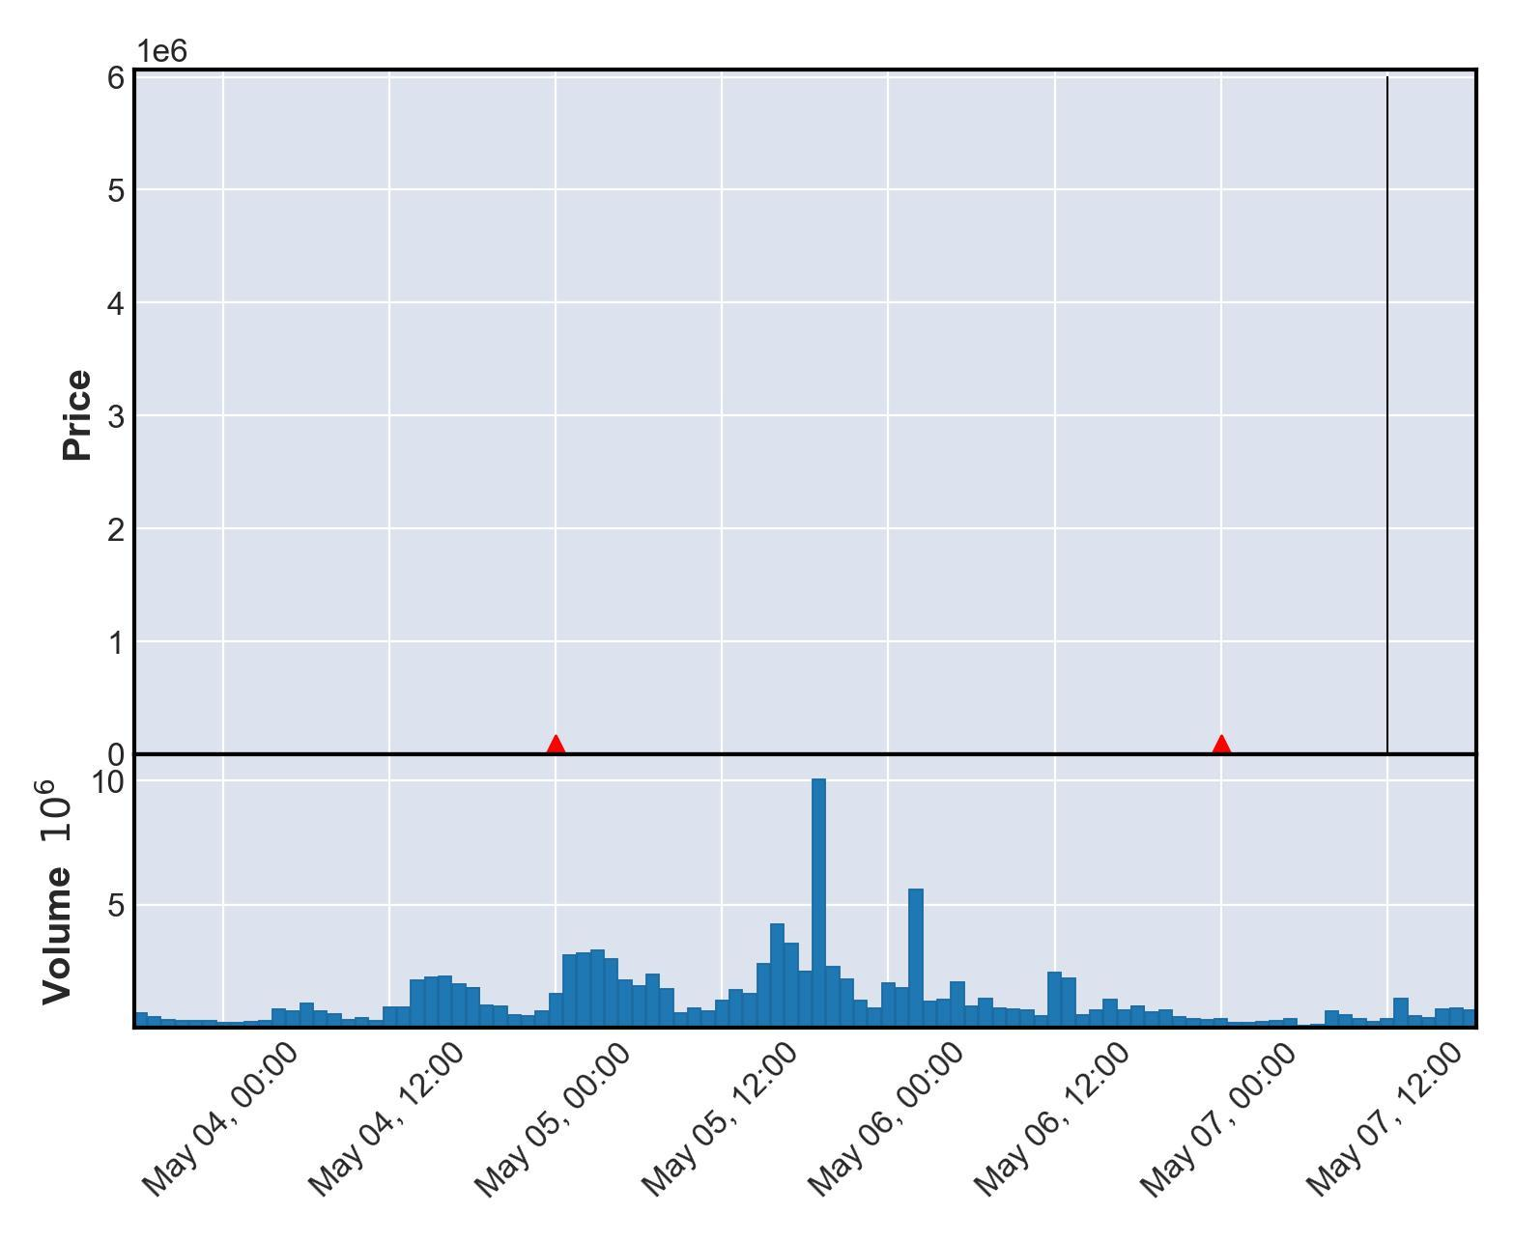

# Currency Under Study - DOP2

|  |  |  |  |  |
| --- | --- | --- | --- | --- |
| buy_date | sell_date | buy_price | sale_price | currency_id |
| 2021-05-05 | 2021-05-12 | 0.208438 | 4.16876 | DOP2 |
| buy_avg_volume | buy_avg_volume_before_trigger | duration | profit | ROI |
| 1681164 | 490288 | 7 | 3.96032 | 1900 |

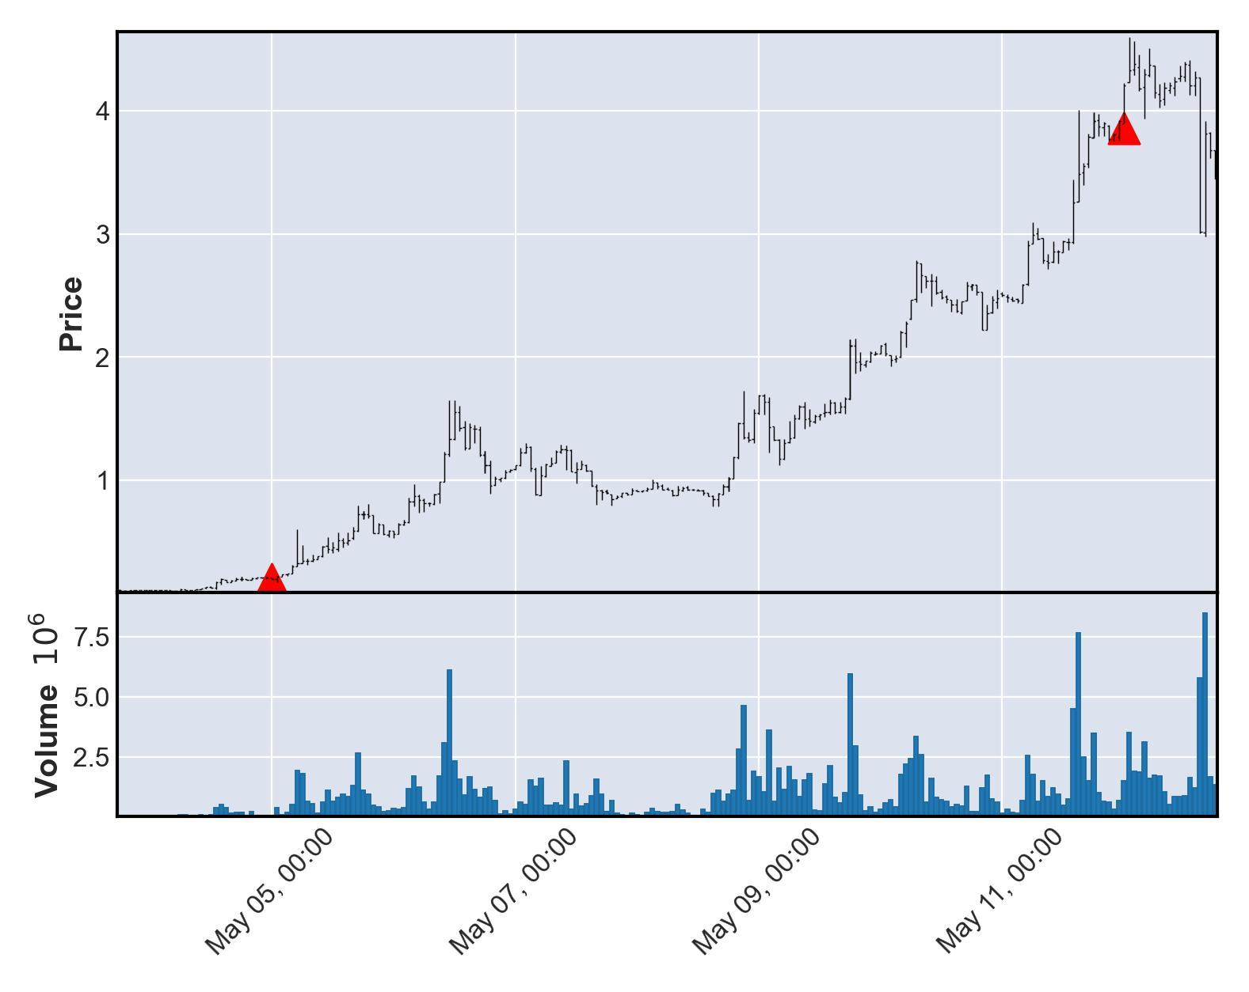

# Currency Under Study - MILK3

|  |  |  |  |  |
| --- | --- | --- | --- | --- |
| buy_date | sell_date | buy_price | sale_price | currency_id |
| 2021-05-06 | 2021-05-07 | 4.44644e-09 | 8.89289e-08 | MILK3 |
| buy_avg_volume | buy_avg_volume_before_trigger | duration | profit | ROI |
| 232227 | 178235 | 1 | 8.44824e-08 | 1900 |

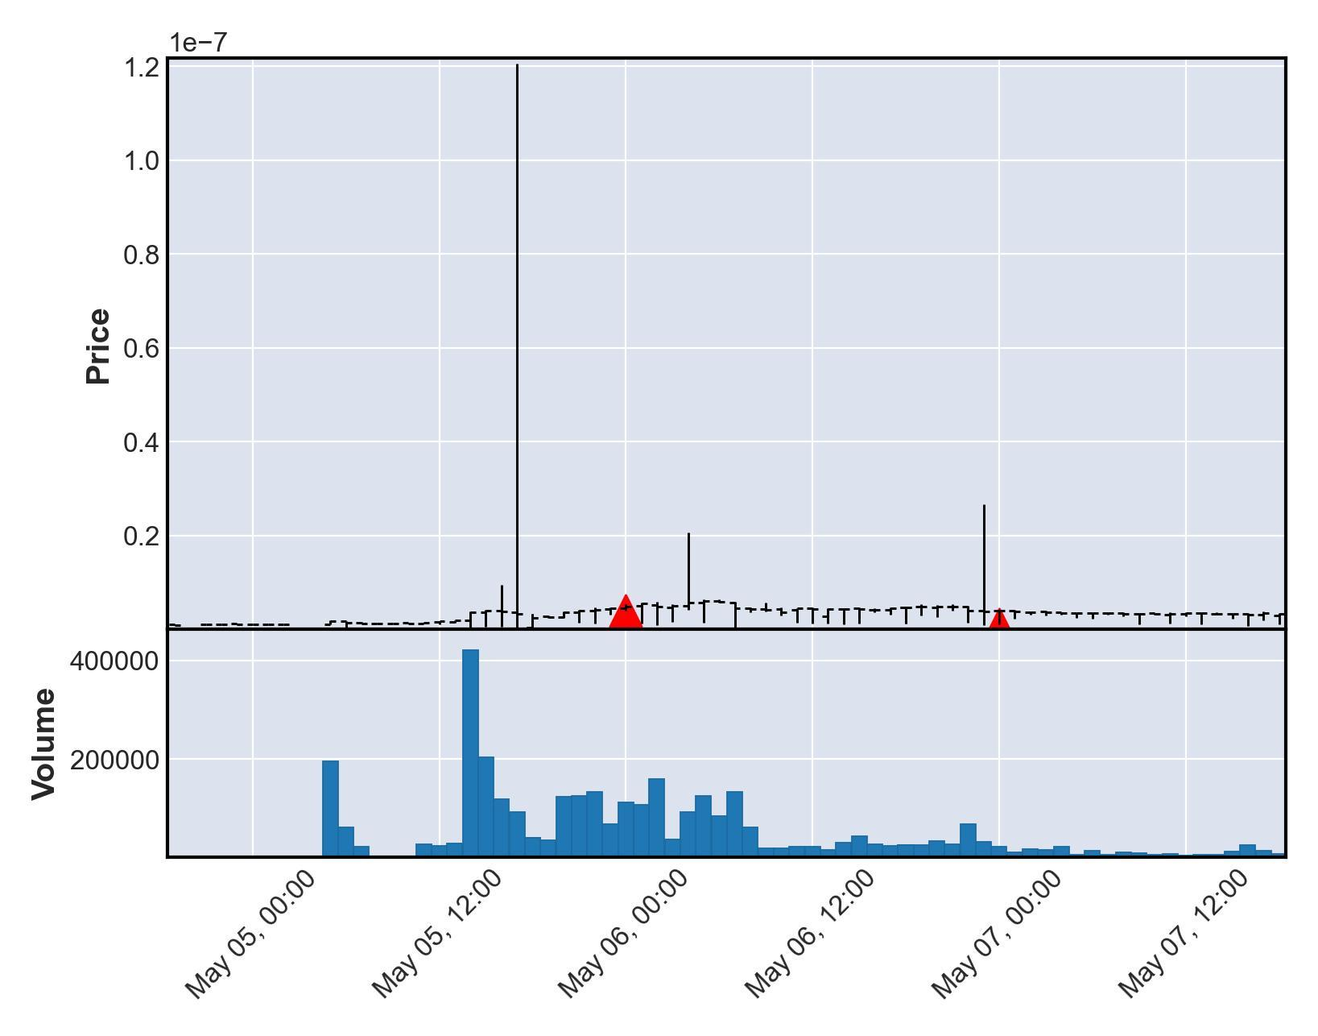

# Currency Under Study - PXL2

|  |  |  |  |  |
| --- | --- | --- | --- | --- |
| buy_date | sell_date | buy_price | sale_price | currency_id |
| 2021-05-09 | 2021-05-11 | 1.22353e-08 | 2.44706e-07 | PXL2 |
| buy_avg_volume | buy_avg_volume_before_trigger | duration | profit | ROI |
| 706722 | 446439 | 2 | 2.3247e-07 | 1900 |

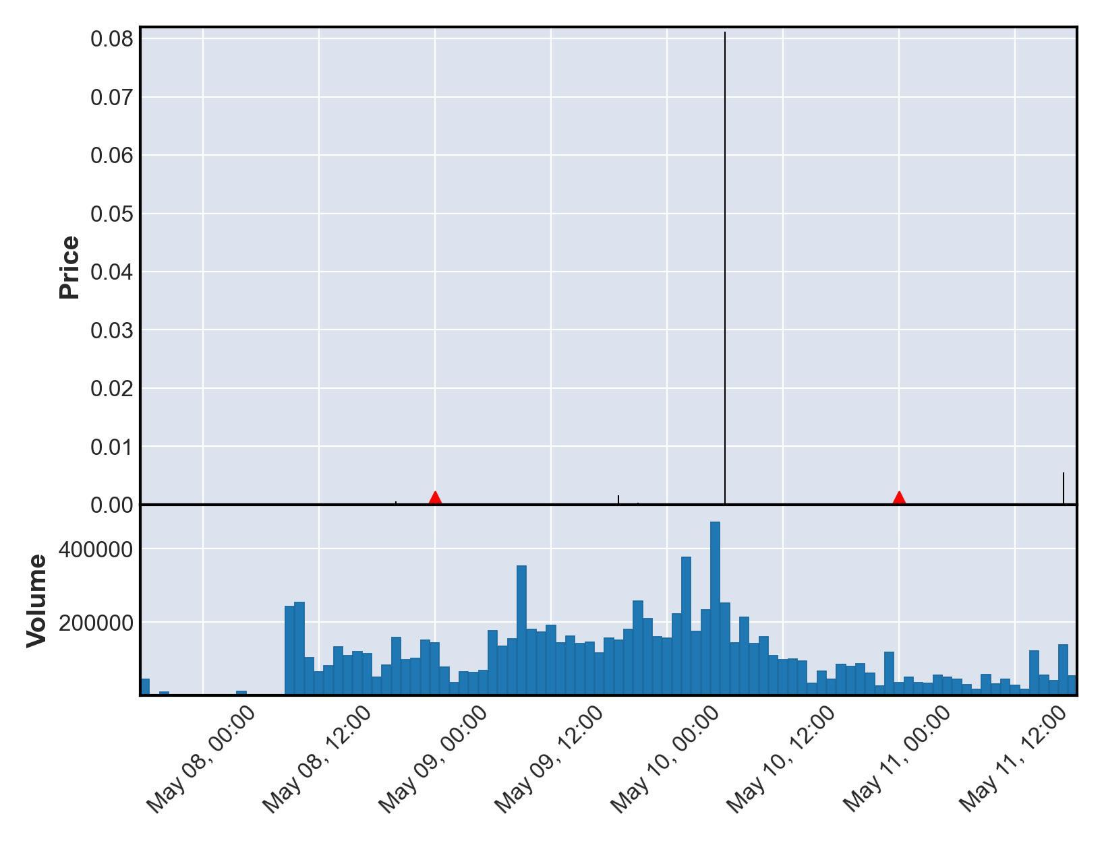

# Currency Under Study - BDIGGBEP20

|  |  |  |  |  |
| --- | --- | --- | --- | --- |
| buy_date | sell_date | buy_price | sale_price | currency_id |
| 2021-05-10 | 2021-05-16 | 58730.9 | 1174620.0 | BDIGGBEP20 |
| buy_avg_volume | buy_avg_volume_before_trigger | duration | profit | ROI |
| 743060 | 720336 | 6 | 1115890.0 | 1900 |

Purchase timing of 2021-05-10 00:00:00+00:00 and Sale timing of 2021-05-16 00:00:00+00:00 not found with matching transparent transaction data from nomics. Neither entry nor exit shown on chart.

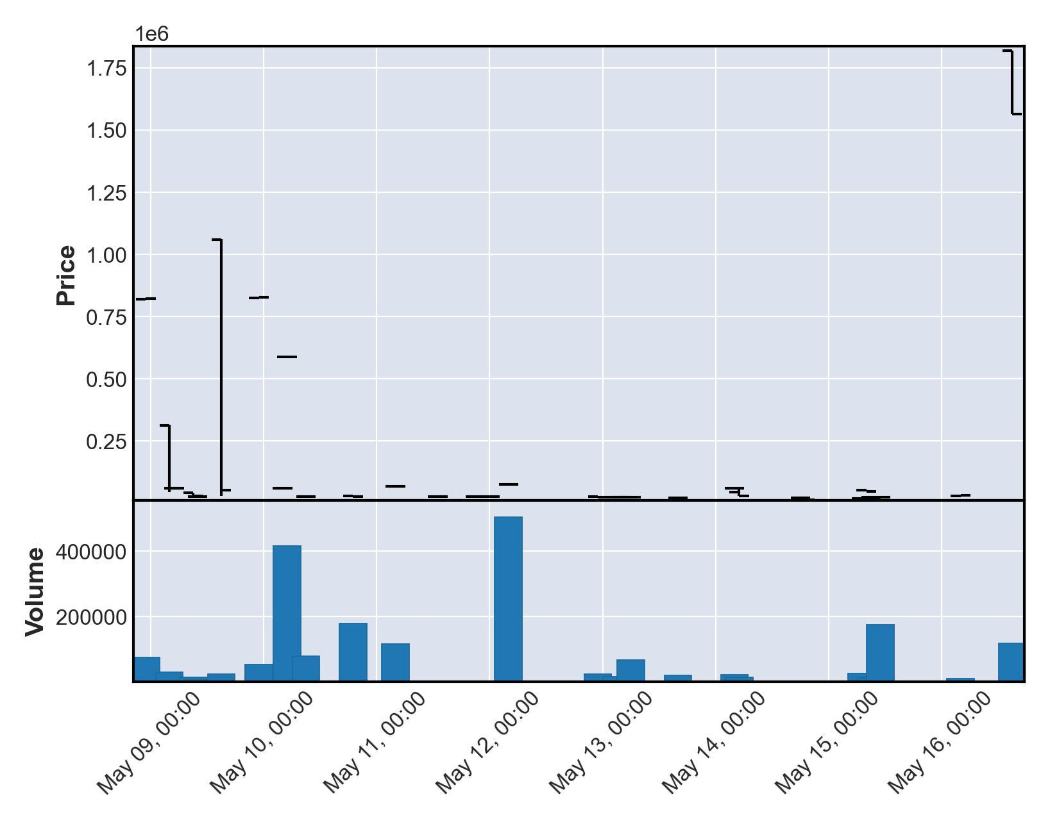

# Currency Under Study - ASS

|  |  |  |  |  |
| --- | --- | --- | --- | --- |
| buy_date | sell_date | buy_price | sale_price | currency_id |
| 2021-05-12 | 2021-05-13 | 1.06338e-08 | 2.12677e-07 | ASS |
| buy_avg_volume | buy_avg_volume_before_trigger | duration | profit | ROI |
| 13975536 | 12909853 | 1 | 2.02043e-07 | 1900 |

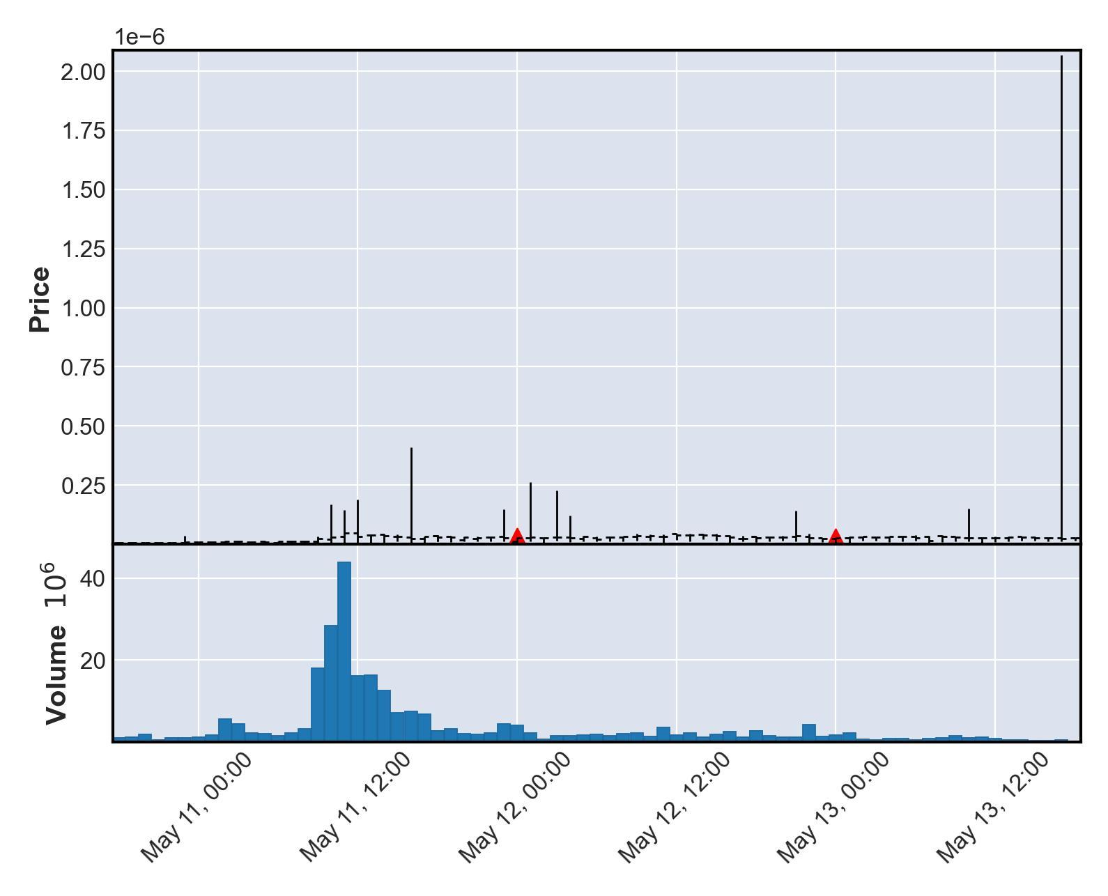

# Currency Under Study - BSHIBA

|  |  |  |  |  |
| --- | --- | --- | --- | --- |
| buy_date | sell_date | buy_price | sale_price | currency_id |
| 2021-05-12 | 2021-05-18 | 2.46702e-08 | 4.93405e-07 | BSHIBA |
| buy_avg_volume | buy_avg_volume_before_trigger | duration | profit | ROI |
| 526786 | 512559 | 6 | 4.68734e-07 | 1900 |

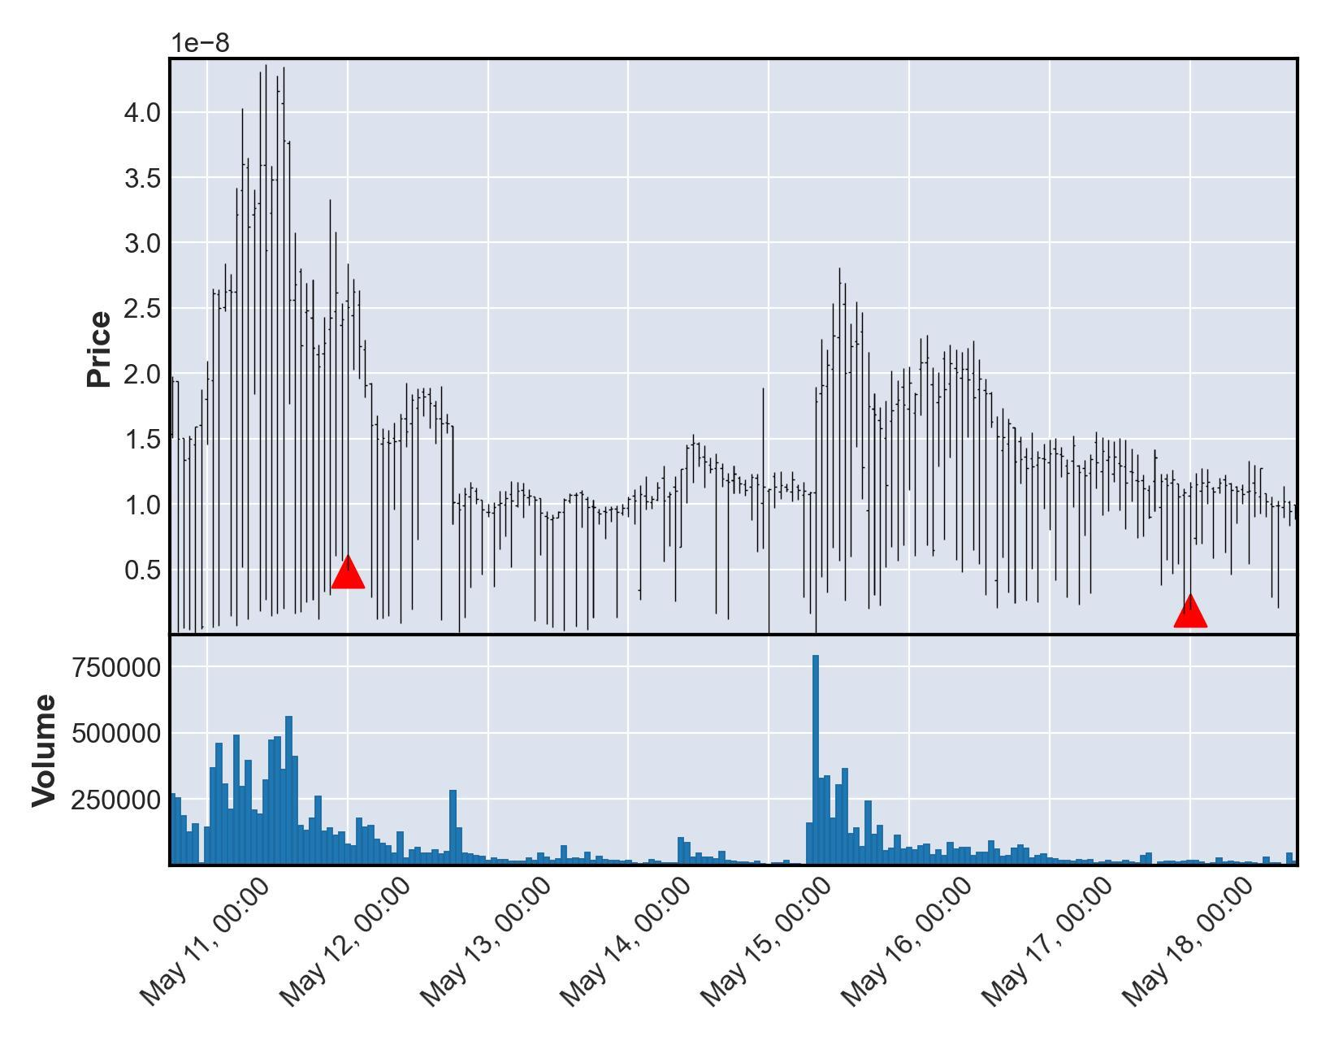

# Currency Under Study - HOTDOGE

|  |  |  |  |  |
| --- | --- | --- | --- | --- |
| buy_date | sell_date | buy_price | sale_price | currency_id |
| 2021-05-12 | 2021-05-13 | 6.62806e-11 | 1.32561e-09 | HOTDOGE |
| buy_avg_volume | buy_avg_volume_before_trigger | duration | profit | ROI |
| 325286 | 340784 | 1 | 1.25933e-09 | 1900 |

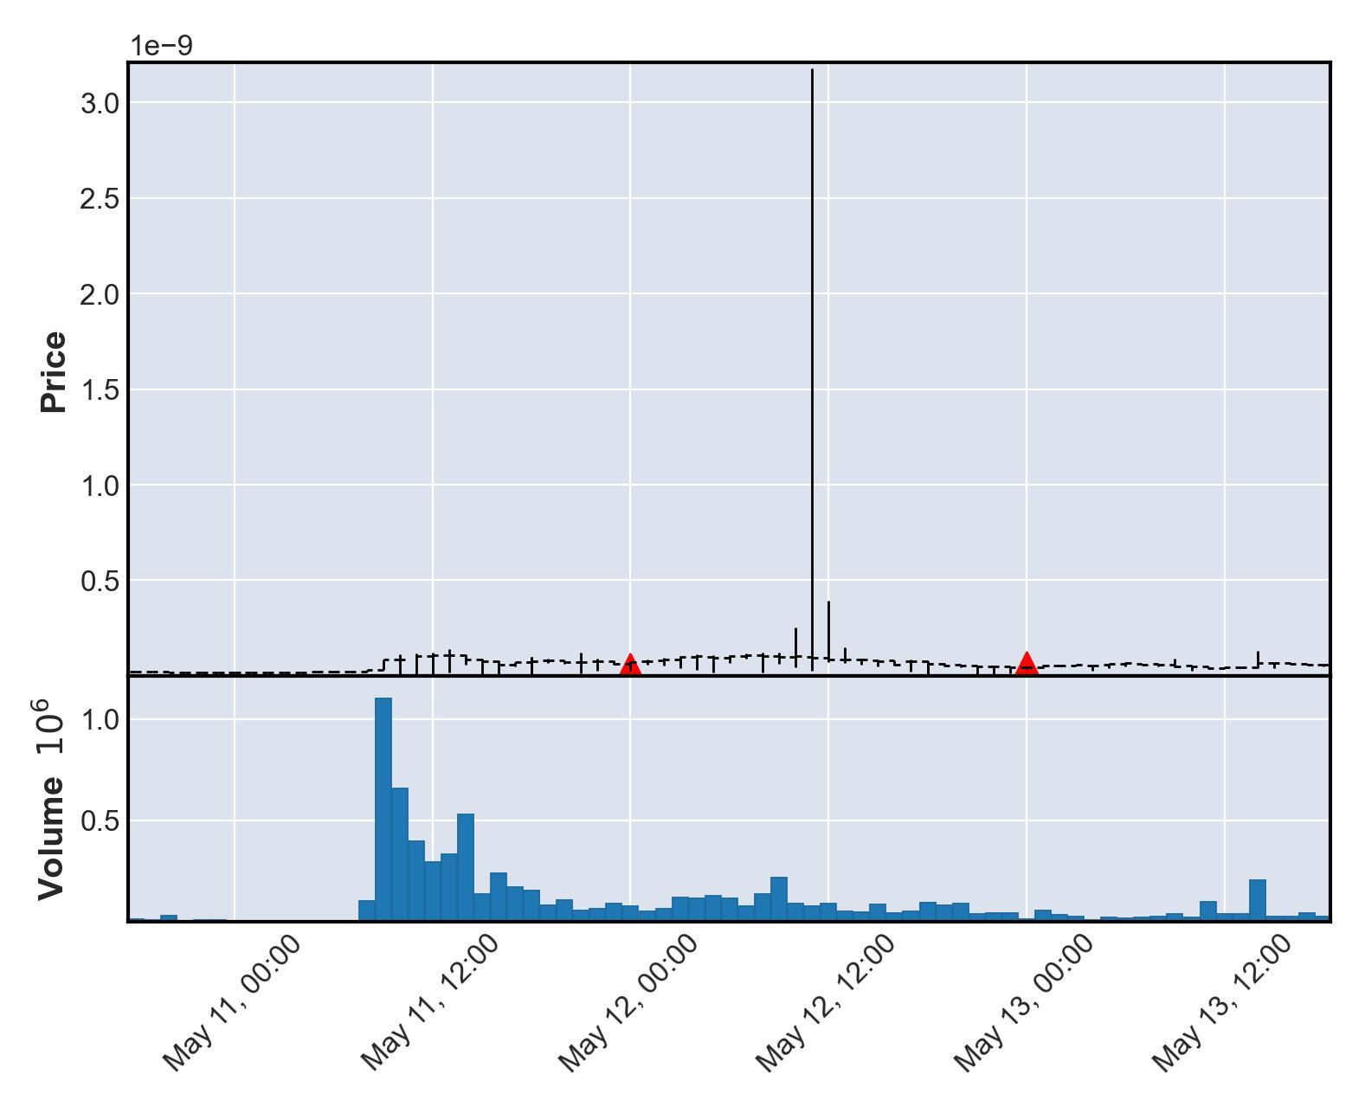

# Currency Under Study - FSAFE

|  |  |  |  |  |
| --- | --- | --- | --- | --- |
| buy_date | sell_date | buy_price | sale_price | currency_id |
| 2021-05-12 | 2021-05-21 | 2.76331e-08 | 5.52661e-07 | FSAFE |
| buy_avg_volume | buy_avg_volume_before_trigger | duration | profit | ROI |
| 467264 | 455748 | 9 | 5.25028e-07 | 1900 |

Sale timing of 2021-05-21 00:00:00+00:00 not found with matching transparent transaction data from nomics. Exit not shown on chart.

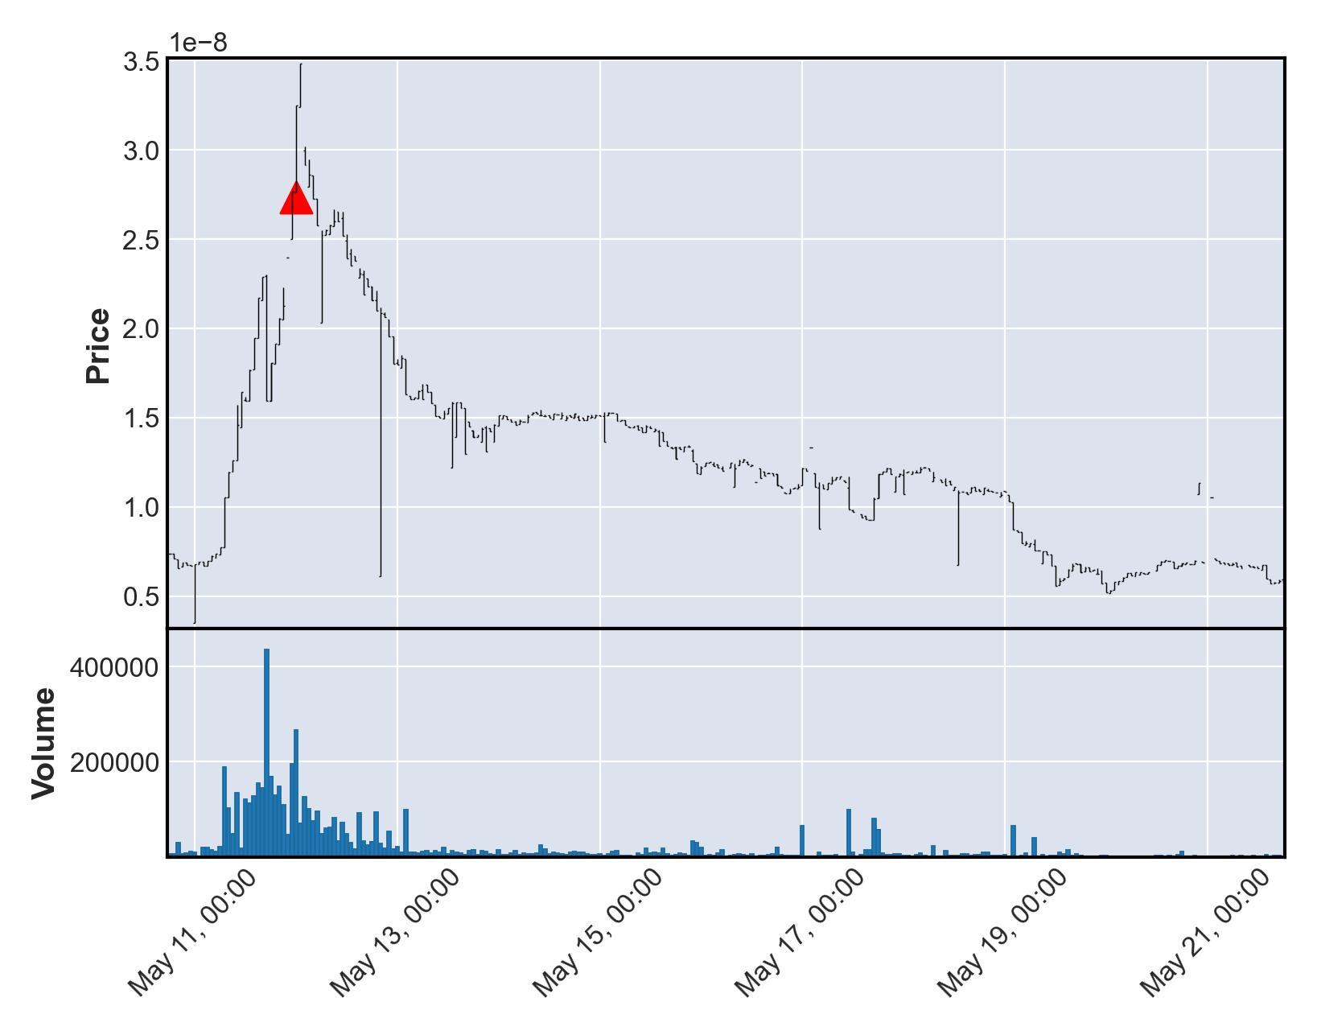

# Currency Under Study - PIT2

|  |  |  |  |  |
| --- | --- | --- | --- | --- |
| buy_date | sell_date | buy_price | sale_price | currency_id |
| 2021-05-12 | 2021-05-13 | 1.06237e-09 | 2.12474e-08 | PIT2 |
| buy_avg_volume | buy_avg_volume_before_trigger | duration | profit | ROI |
| 1823716 | 1653706 | 1 | 2.01851e-08 | 1900 |

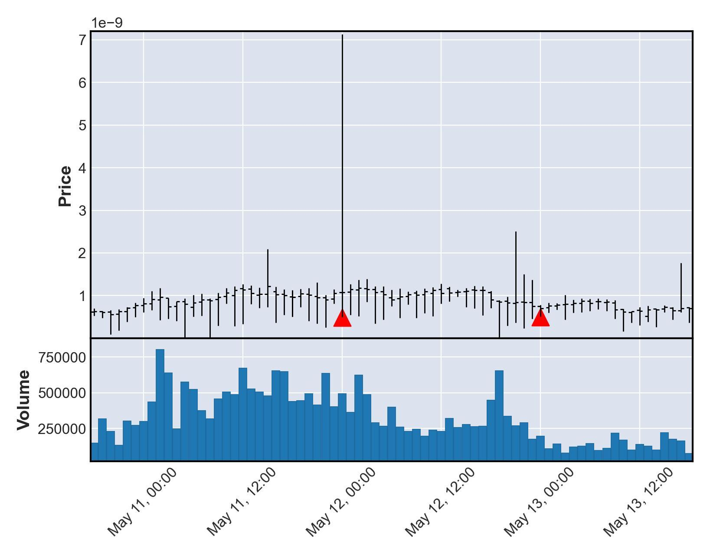

# Currency Under Study - LAS

|  |  |  |  |  |
| --- | --- | --- | --- | --- |
| buy_date | sell_date | buy_price | sale_price | currency_id |
| 2021-05-12 | 2021-05-13 | 3.03883e-08 | 6.07767e-07 | LAS |
| buy_avg_volume | buy_avg_volume_before_trigger | duration | profit | ROI |
| 121251 | 17703 | 1 | 5.77379e-07 | 1900 |

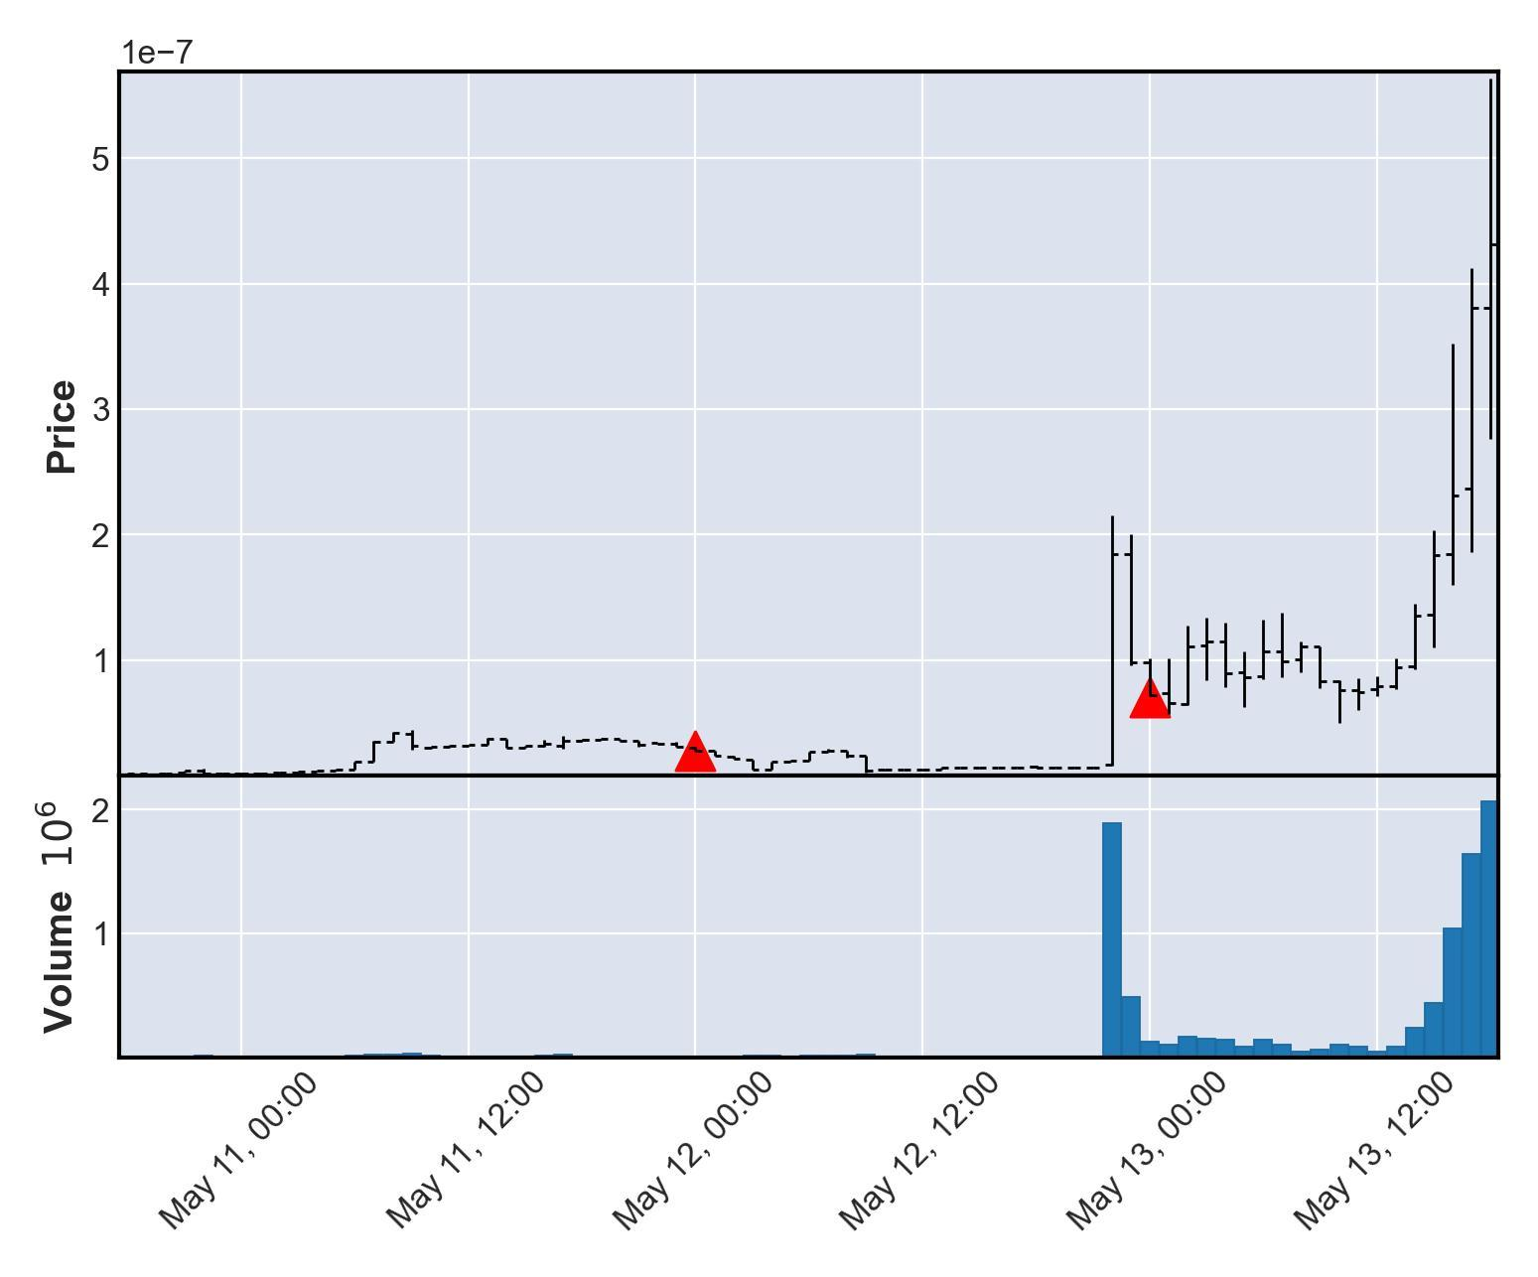

# Currency Under Study - HMNG

|  |  |  |  |  |
| --- | --- | --- | --- | --- |
| buy_date | sell_date | buy_price | sale_price | currency_id |
| 2021-05-13 | 2021-05-14 | 3.24713e-10 | 6.49427e-09 | HMNG |
| buy_avg_volume | buy_avg_volume_before_trigger | duration | profit | ROI |
| 523030 | 238611 | 1 | 6.16955e-09 | 1900 |

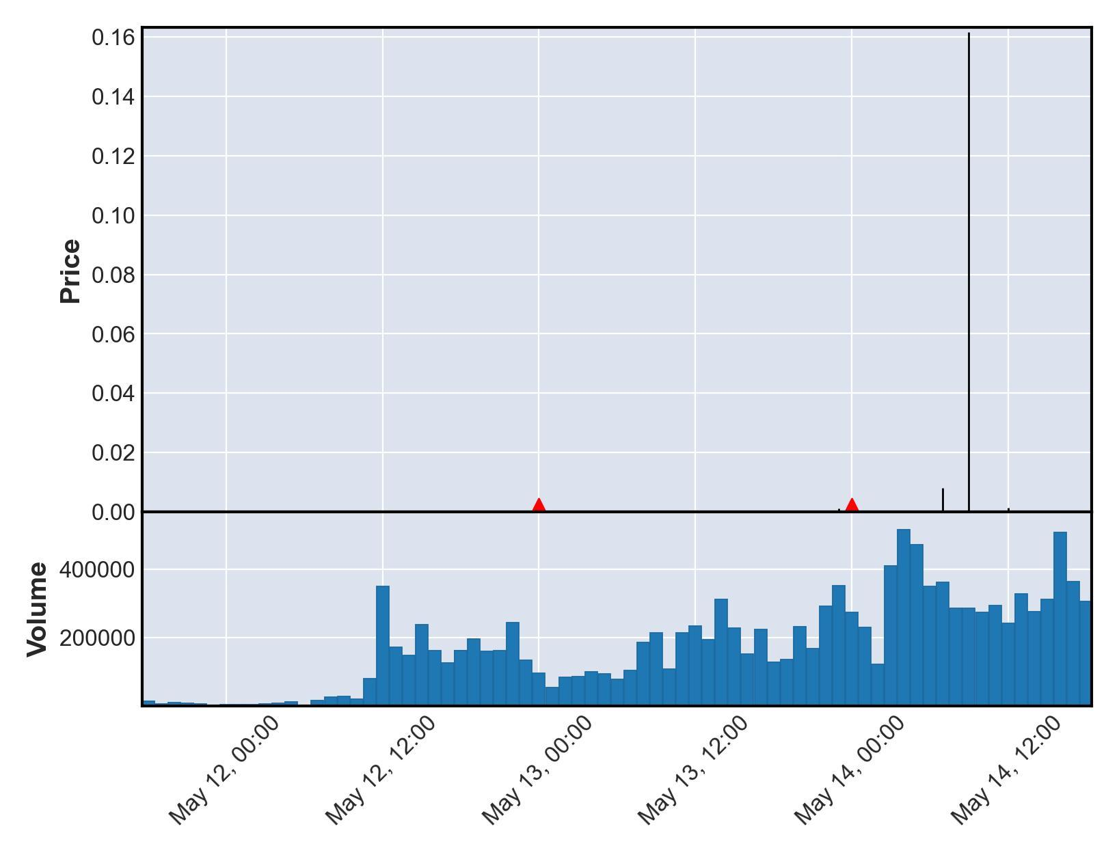

# Currency Under Study - LUNAR2

|  |  |  |  |  |
| --- | --- | --- | --- | --- |
| buy_date | sell_date | buy_price | sale_price | currency_id |
| 2021-05-15 | 2021-05-23 | 3.8299e-09 | 7.65981e-08 | LUNAR2 |
| buy_avg_volume | buy_avg_volume_before_trigger | duration | profit | ROI |
| 321558 | 295337 | 8 | 7.27682e-08 | 1900 |

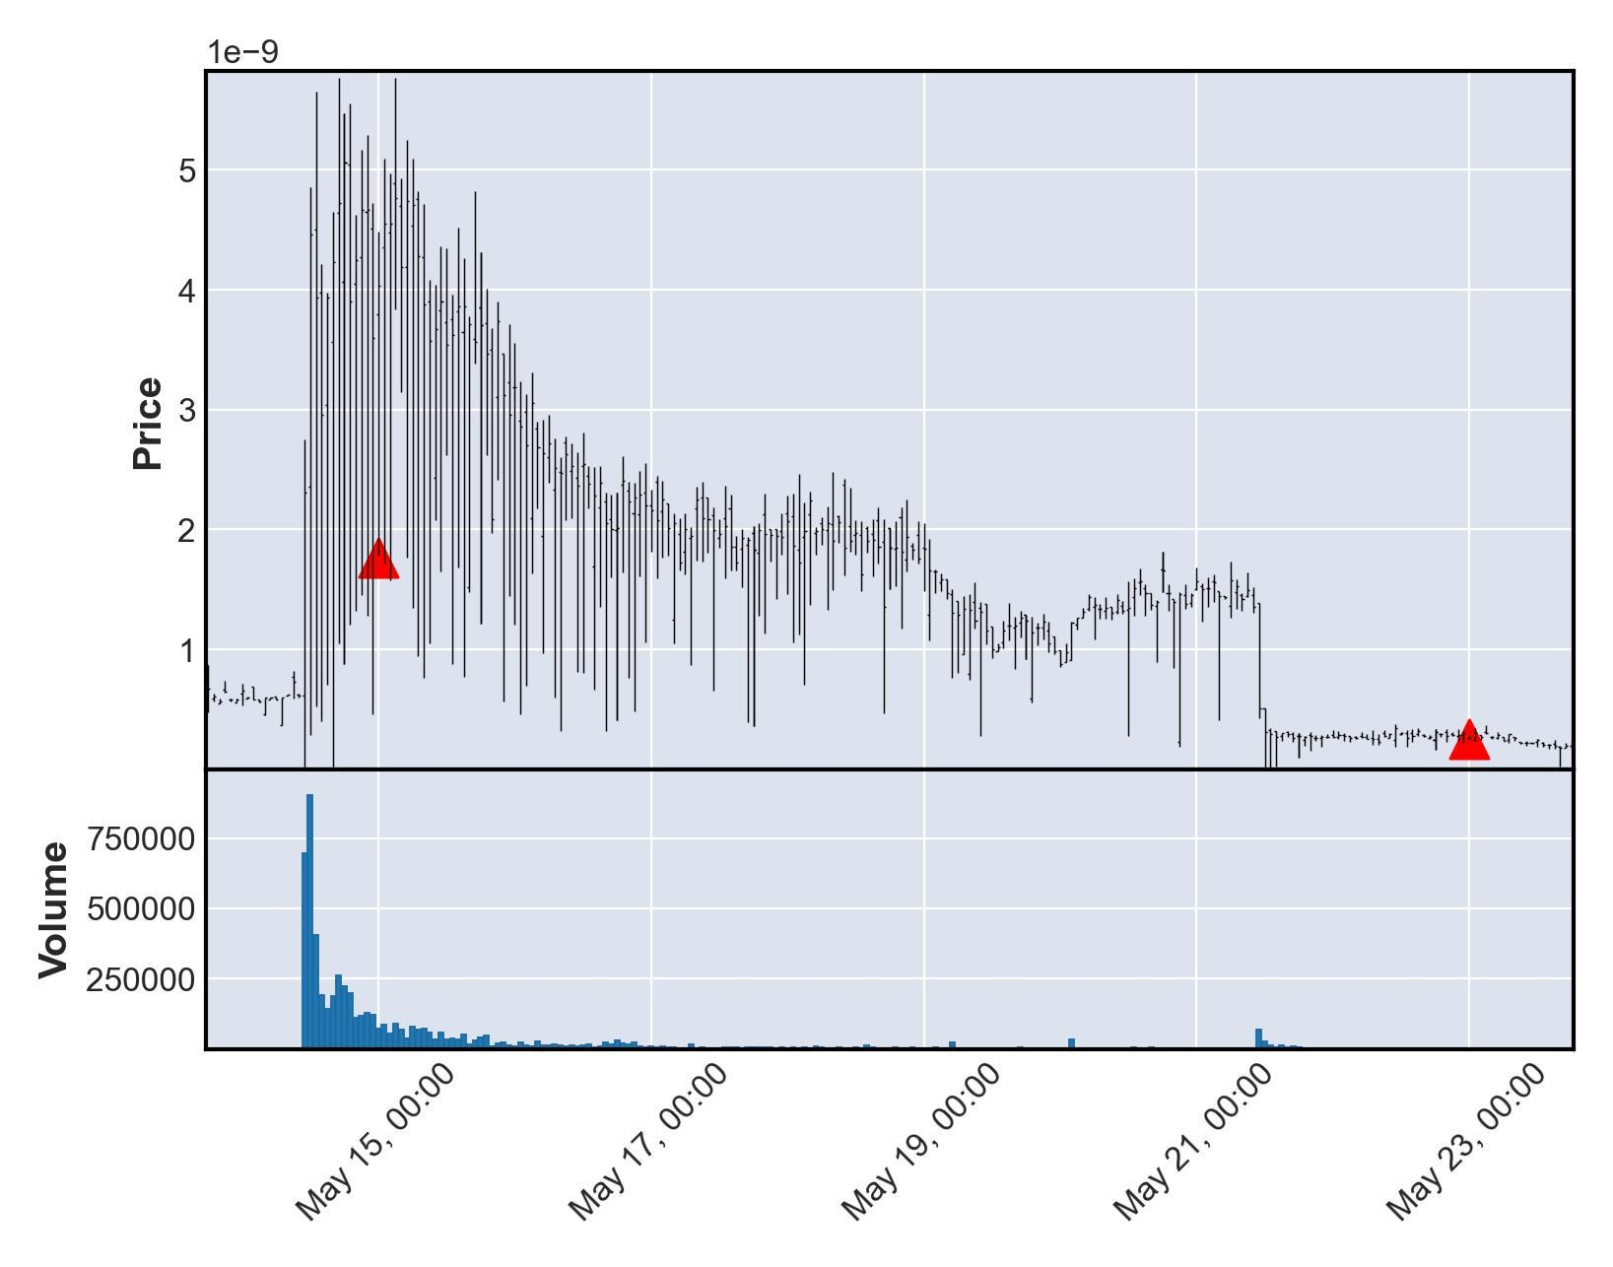

# Currency Under Study - MOJO2

|  |  |  |  |  |
| --- | --- | --- | --- | --- |
| buy_date | sell_date | buy_price | sale_price | currency_id |
| 2021-05-16 | 2021-05-18 | 5.59712e-10 | 1.11942e-08 | MOJO2 |
| buy_avg_volume | buy_avg_volume_before_trigger | duration | profit | ROI |
| 784635 | 574723 | 2 | 1.06345e-08 | 1900 |

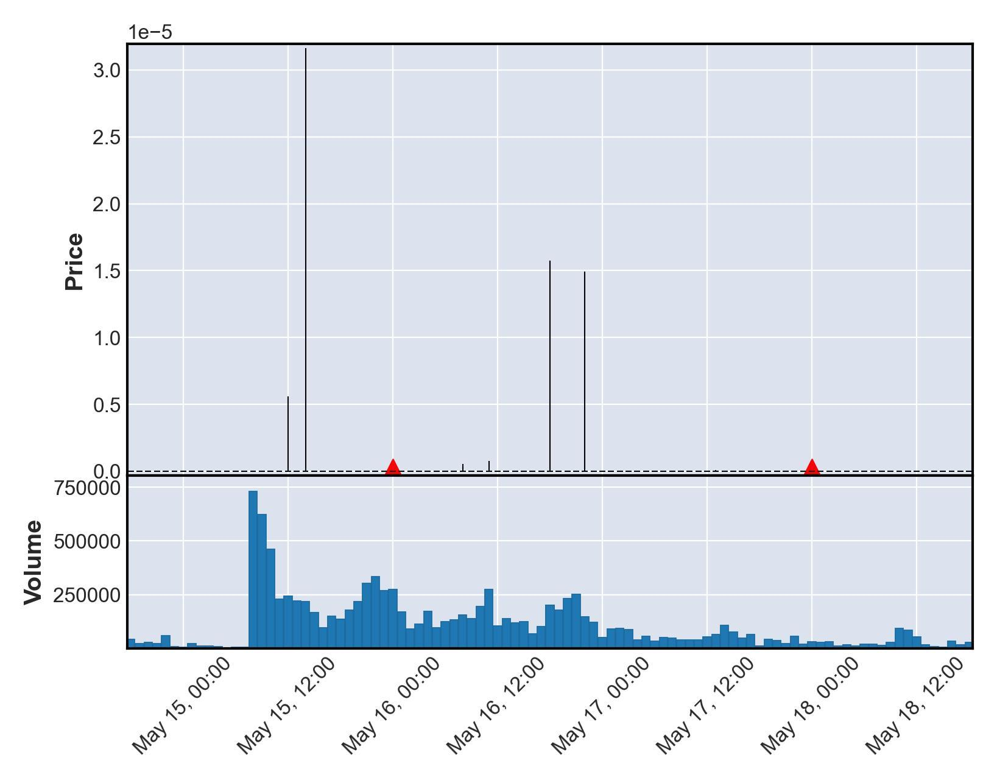

# Currency Under Study - SMOON2

|  |  |  |  |  |
| --- | --- | --- | --- | --- |
| buy_date | sell_date | buy_price | sale_price | currency_id |
| 2021-06-07 | 2021-06-09 | 2.90115e-08 | 5.8023e-07 | SMOON2 |
| buy_avg_volume | buy_avg_volume_before_trigger | duration | profit | ROI |
| 792987 | 678754 | 2 | 5.51219e-07 | 1900 |

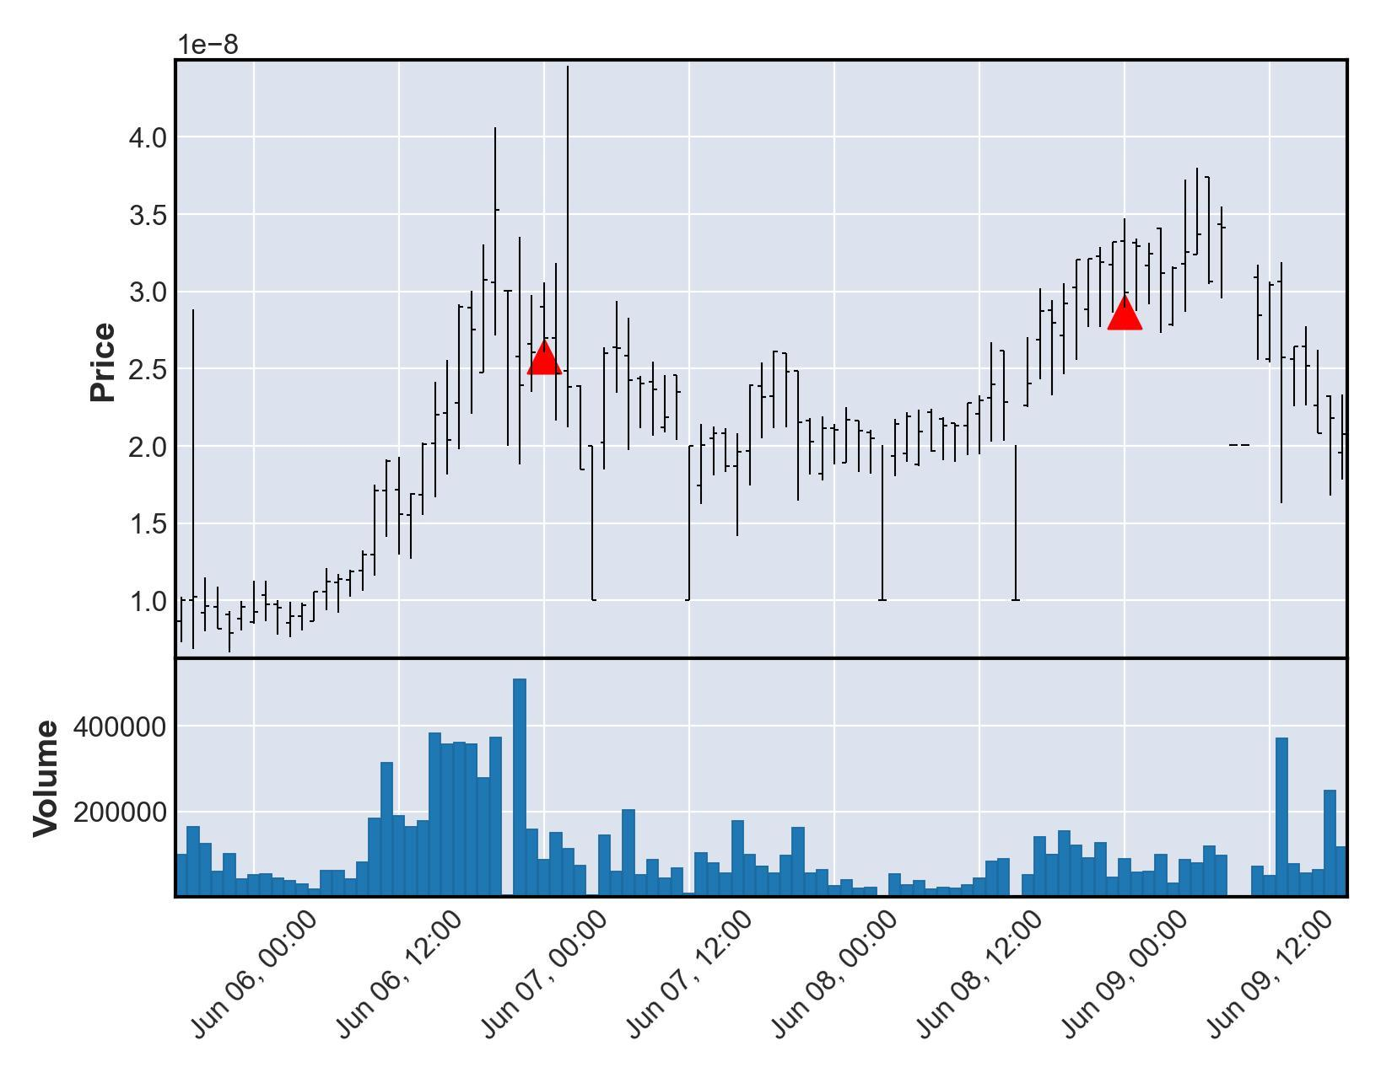

# Currency Under Study - PANTHER2

|  |  |  |  |  |
| --- | --- | --- | --- | --- |
| buy_date | sell_date | buy_price | sale_price | currency_id |
| 2021-06-14 | 2021-06-19 | 0.177165 | 3.54329 | PANTHER2 |
| buy_avg_volume | buy_avg_volume_before_trigger | duration | profit | ROI |
| 1118397 | 1160007 | 5 | 3.36613 | 1900 |

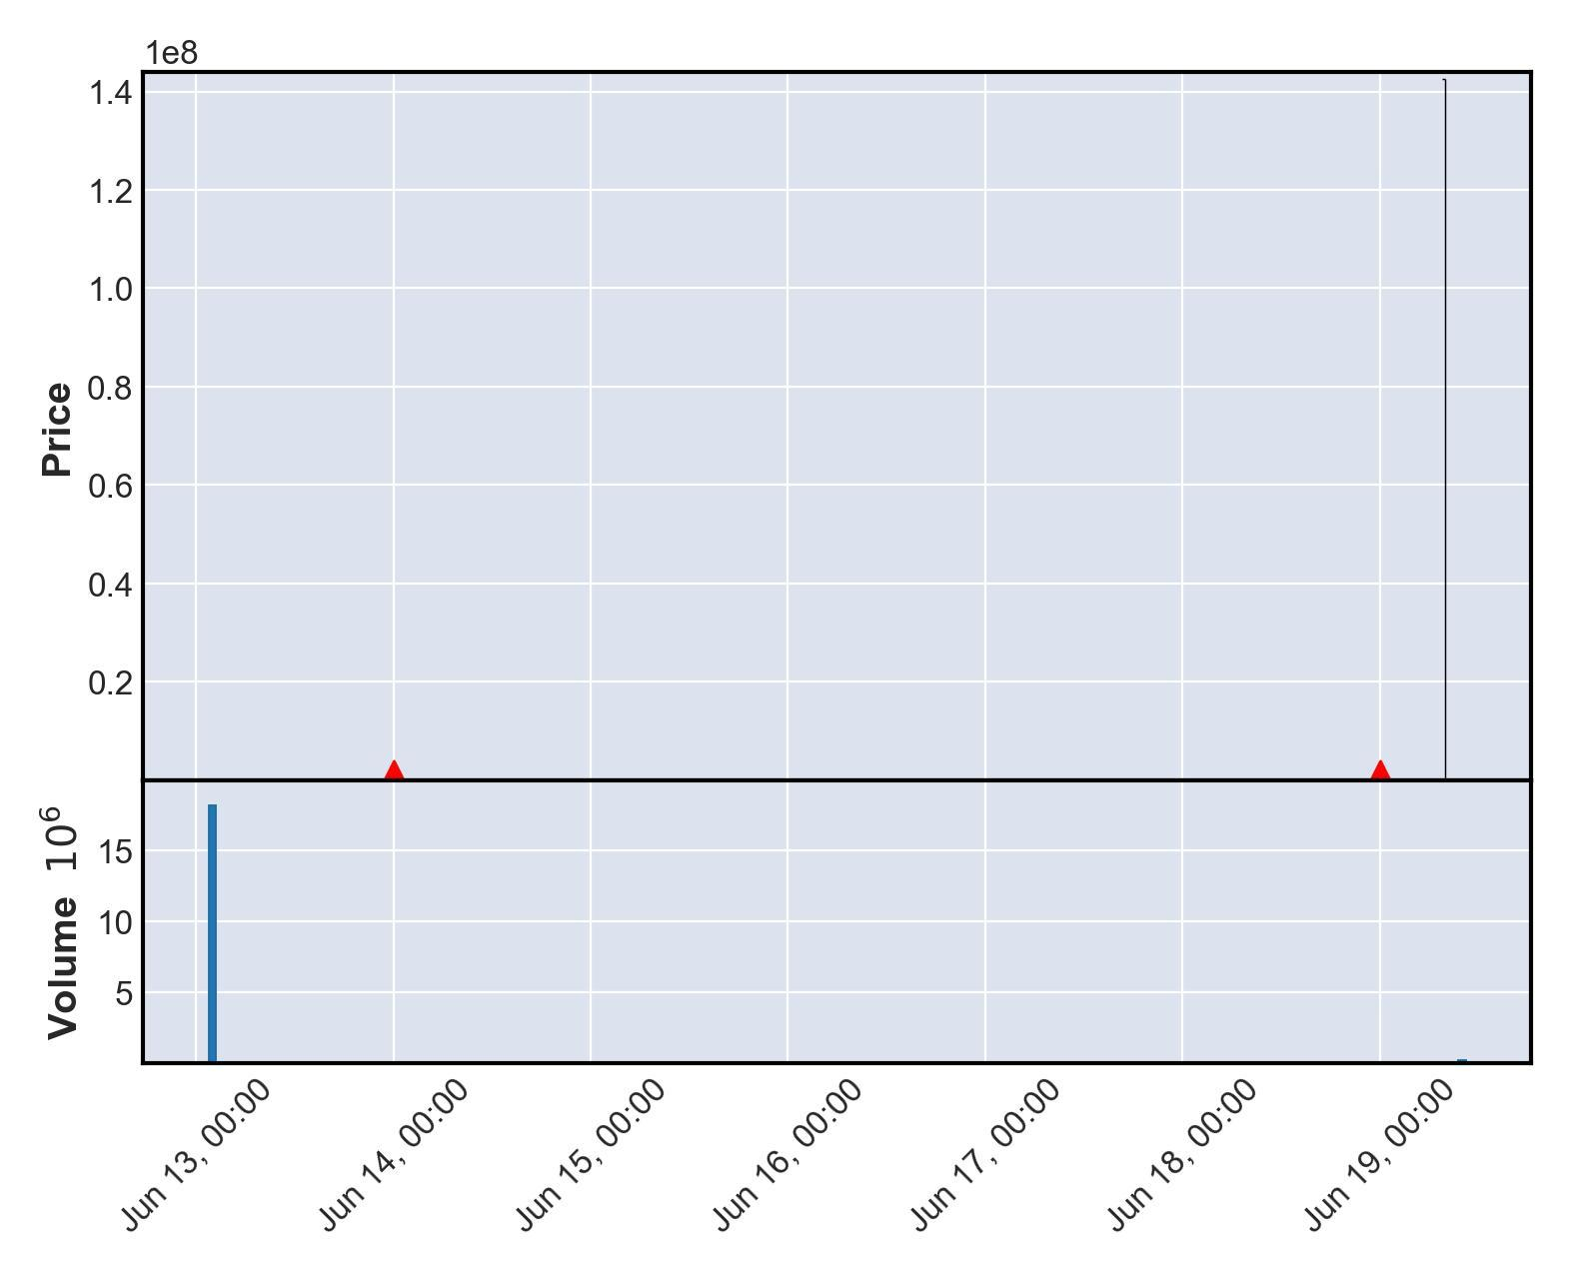

# Currency Under Study - DINGO3

|  |  |  |  |  |
| --- | --- | --- | --- | --- |
| buy_date | sell_date | buy_price | sale_price | currency_id |
| 2021-06-15 | 2021-06-17 | 2.52219e-09 | 5.04438e-08 | DINGO3 |
| buy_avg_volume | buy_avg_volume_before_trigger | duration | profit | ROI |
| 122831 | 93714 | 2 | 4.79216e-08 | 1900 |

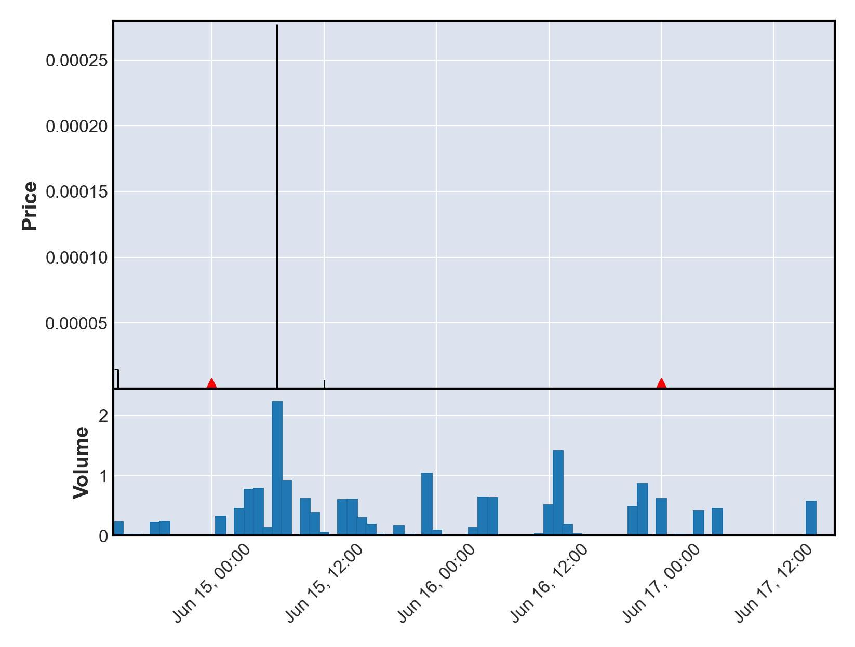

# Currency Under Study - X2P

|  |  |  |  |  |
| --- | --- | --- | --- | --- |
| buy_date | sell_date | buy_price | sale_price | currency_id |
| 2021-07-03 | 2021-07-04 | 1.97748e-07 | 3.95496e-06 | X2P |
| buy_avg_volume | buy_avg_volume_before_trigger | duration | profit | ROI |
| 142666 | 129070 | 1 | 3.75722e-06 | 1900 |

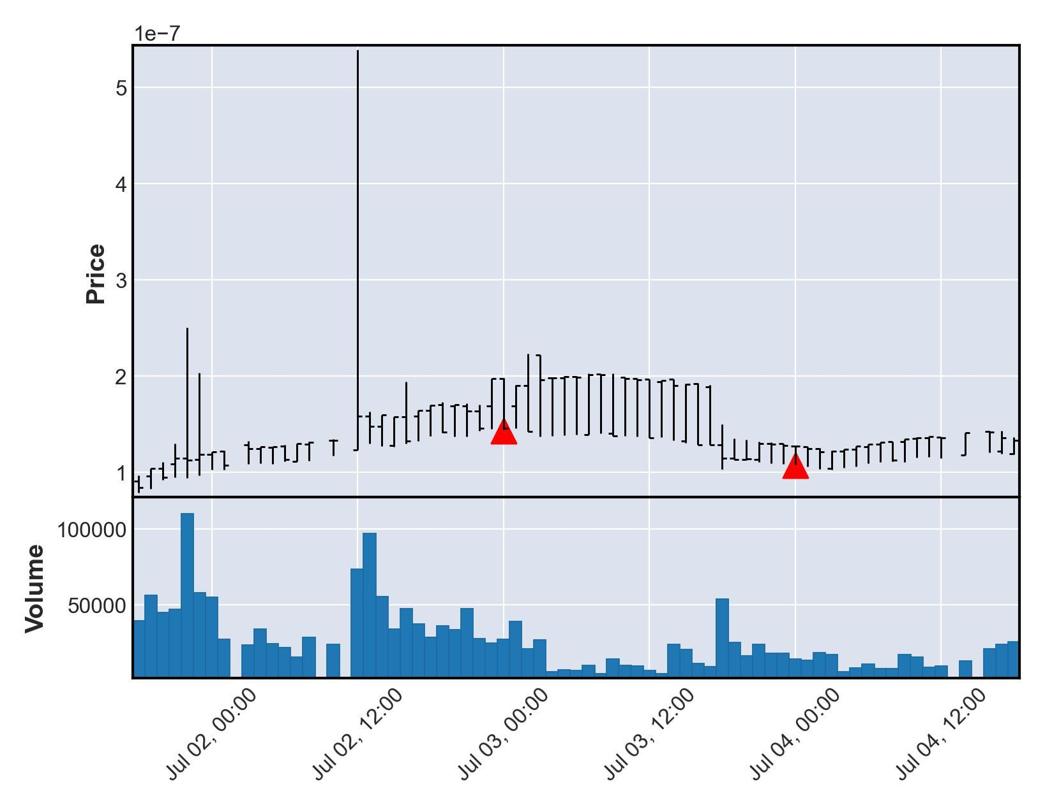

# Currency Under Study - BABYWOLF

|  |  |  |  |  |
| --- | --- | --- | --- | --- |
| buy_date | sell_date | buy_price | sale_price | currency_id |
| 2021-07-09 | 2021-07-12 | 4.58385e-10 | 9.16769e-09 | BABYWOLF |
| buy_avg_volume | buy_avg_volume_before_trigger | duration | profit | ROI |
| 453945 | 421310 | 3 | 8.70931e-09 | 1900 |

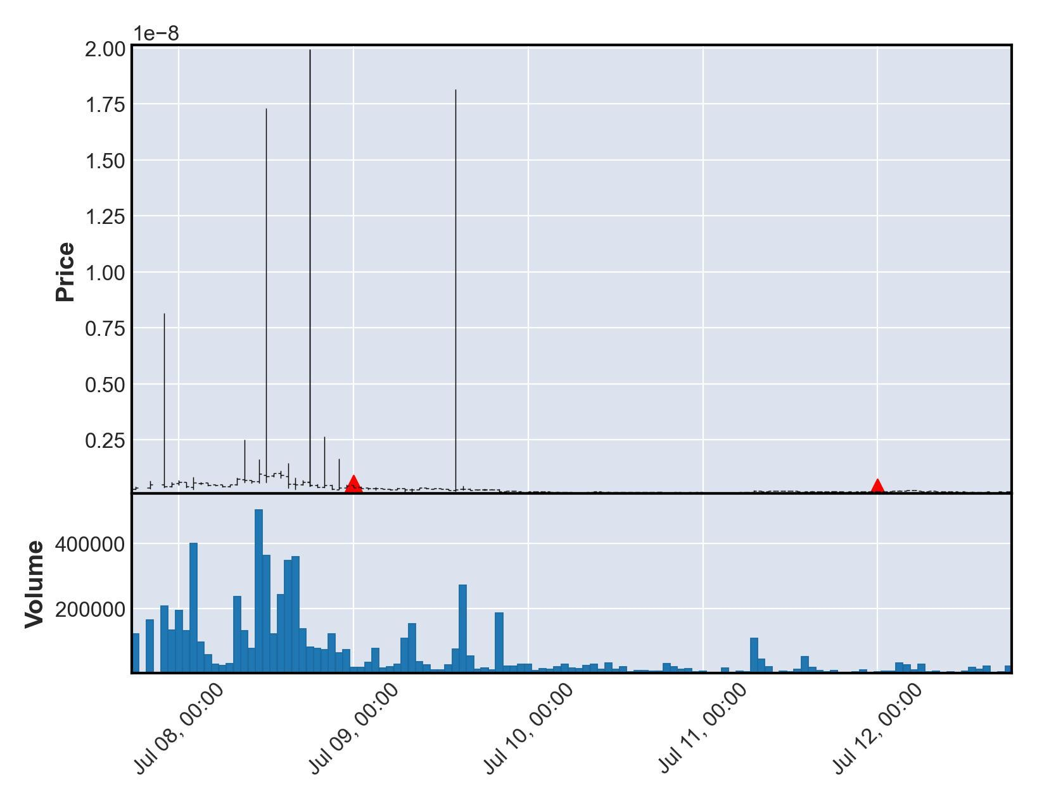

# Currency Under Study - KKI

|  |  |  |  |  |
| --- | --- | --- | --- | --- |
| buy_date | sell_date | buy_price | sale_price | currency_id |
| 2021-07-10 | 2021-07-11 | 0.00109992 | 0.0219984 | KKI |
| buy_avg_volume | buy_avg_volume_before_trigger | duration | profit | ROI |
| 4470760 | 4639642 | 1 | 0.0208985 | 1900 |

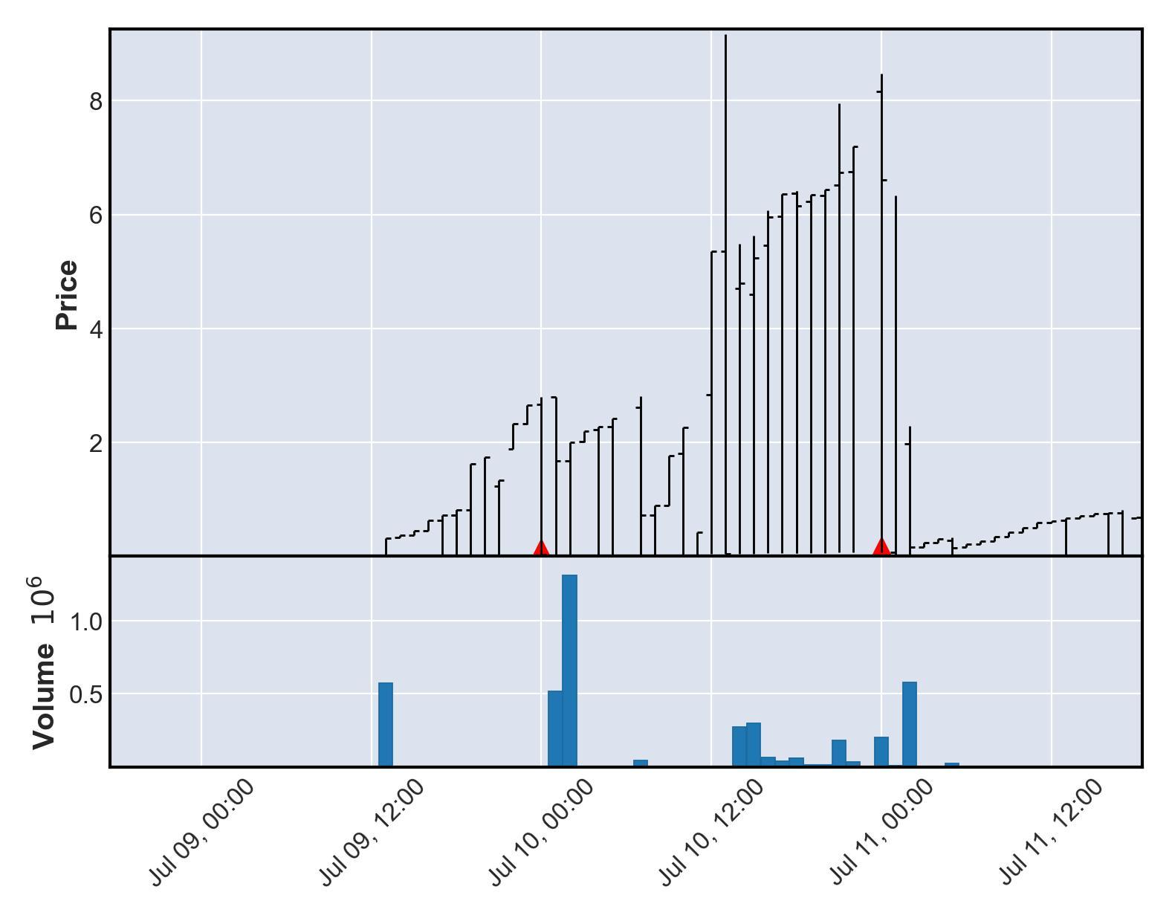

# Currency Under Study - ROOM

|  |  |  |  |  |
| --- | --- | --- | --- | --- |
| buy_date | sell_date | buy_price | sale_price | currency_id |
| 2021-07-11 | 2021-07-12 | 0.0029487 | 0.0589741 | ROOM |
| buy_avg_volume | buy_avg_volume_before_trigger | duration | profit | ROI |
| 194147 | 104238 | 1 | 0.0560254 | 1900 |

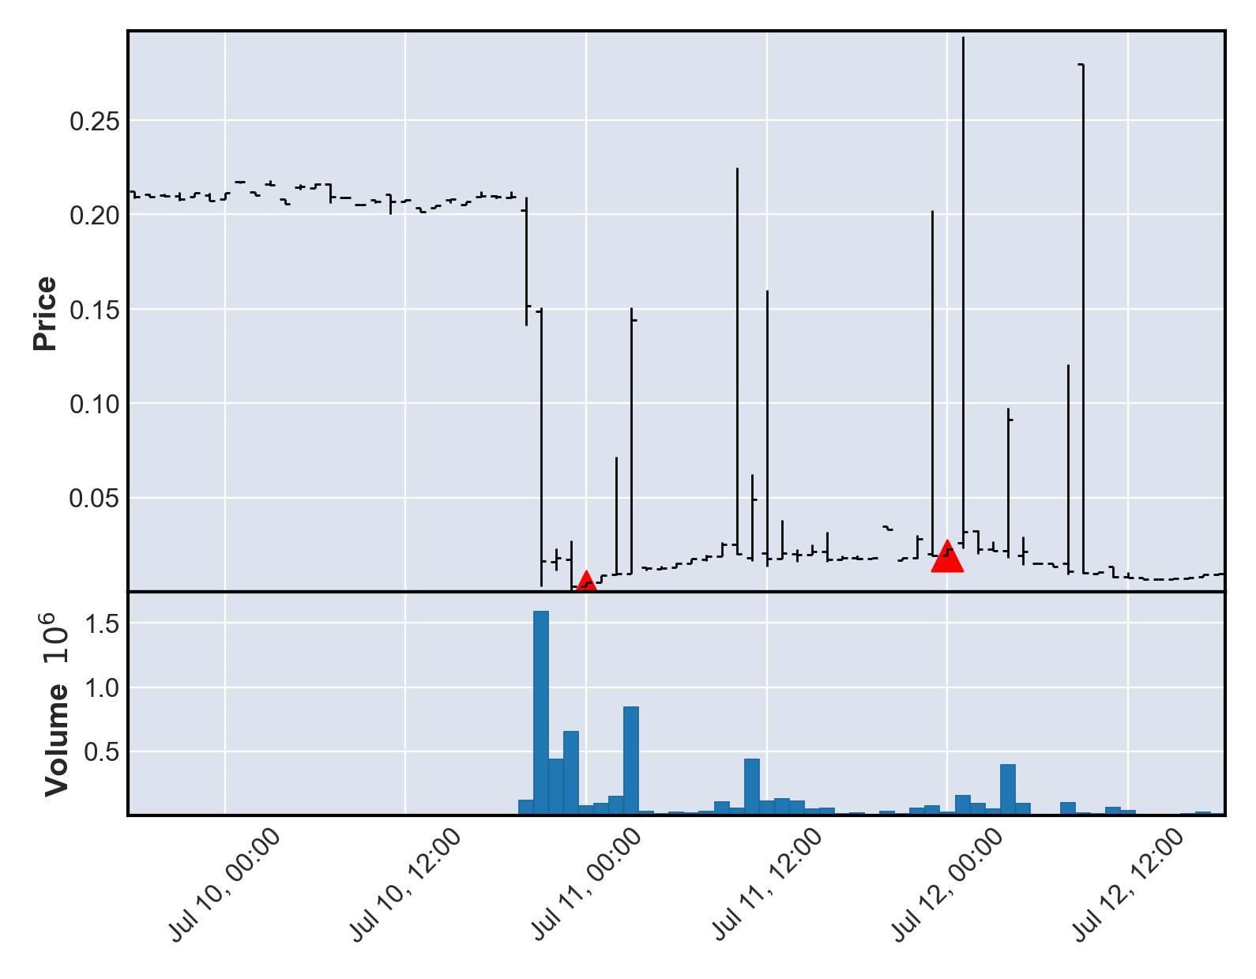

# Currency Under Study - MARS4

|  |  |  |  |  |
| --- | --- | --- | --- | --- |
| buy_date | sell_date | buy_price | sale_price | currency_id |
| 2021-08-02 | 2021-08-03 | 0.00529309 | 0.105862 | MARS4 |
| buy_avg_volume | buy_avg_volume_before_trigger | duration | profit | ROI |
| 10673930 | 4245145 | 1 | 0.100569 | 1900 |

Purchase timing of 2021-08-02 00:00:00+00:00 and Sale timing of 2021-08-03 00:00:00+00:00 not found with matching transparent transaction data from nomics. Neither entry nor exit shown on chart.

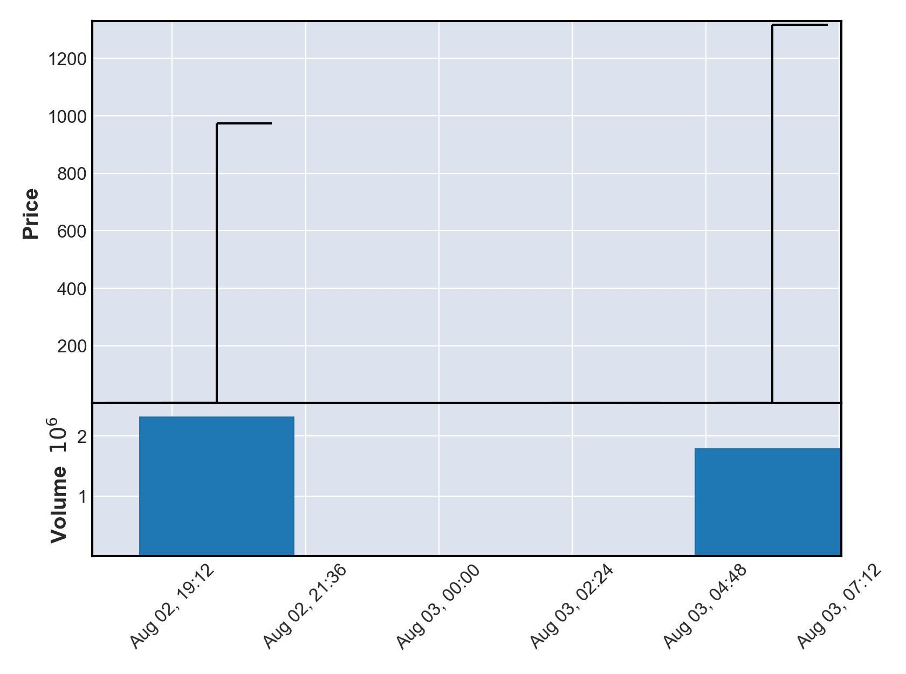

# Currency Under Study - TASTE

|  |  |  |  |  |
| --- | --- | --- | --- | --- |
| buy_date | sell_date | buy_price | sale_price | currency_id |
| 2021-08-13 | 2021-08-15 | 4.93001e-09 | 9.86002e-08 | TASTE |
| buy_avg_volume | buy_avg_volume_before_trigger | duration | profit | ROI |
| 131090 | 113169 | 2 | 9.36702e-08 | 1900 |

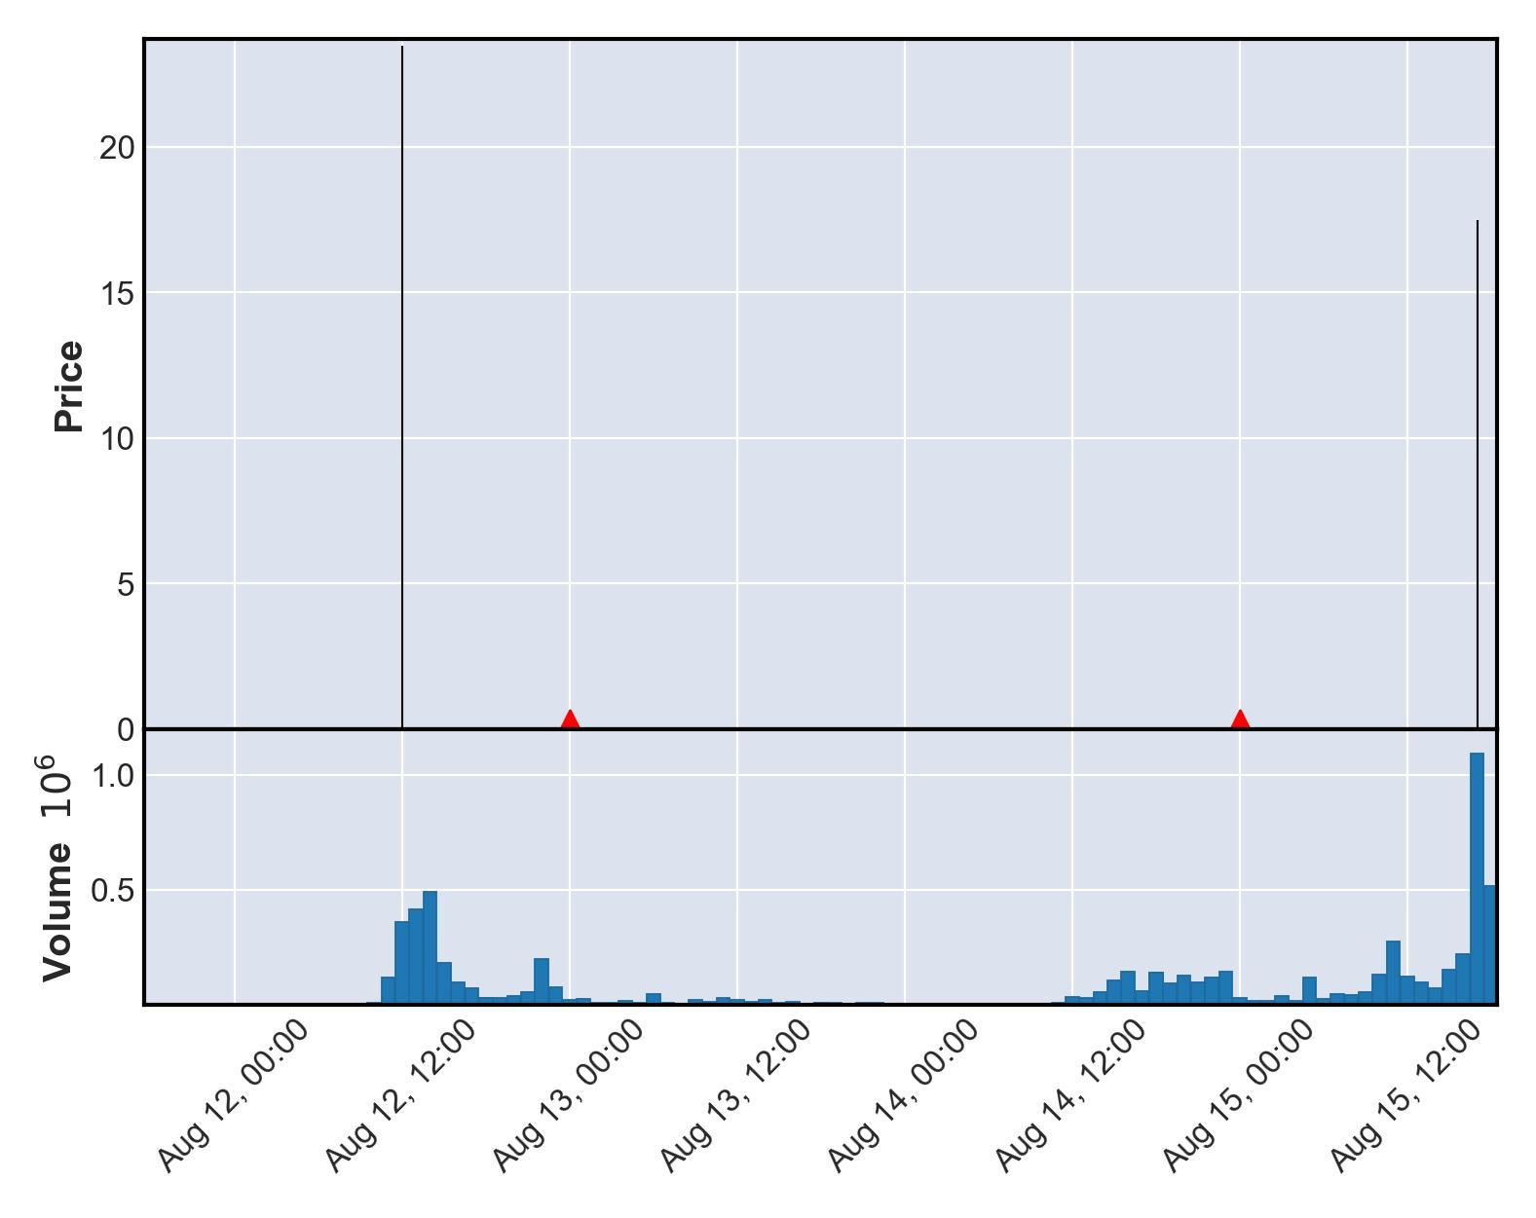

# Currency Under Study - BNBG2

|  |  |  |  |  |
| --- | --- | --- | --- | --- |
| buy_date | sell_date | buy_price | sale_price | currency_id |
| 2021-08-20 | 2021-08-28 | 9.8e-17 | 1.96e-15 | BNBG2 |
| buy_avg_volume | buy_avg_volume_before_trigger | duration | profit | ROI |
| 1998170 | 508029 | 8 | 1.862e-15 | 1900 |

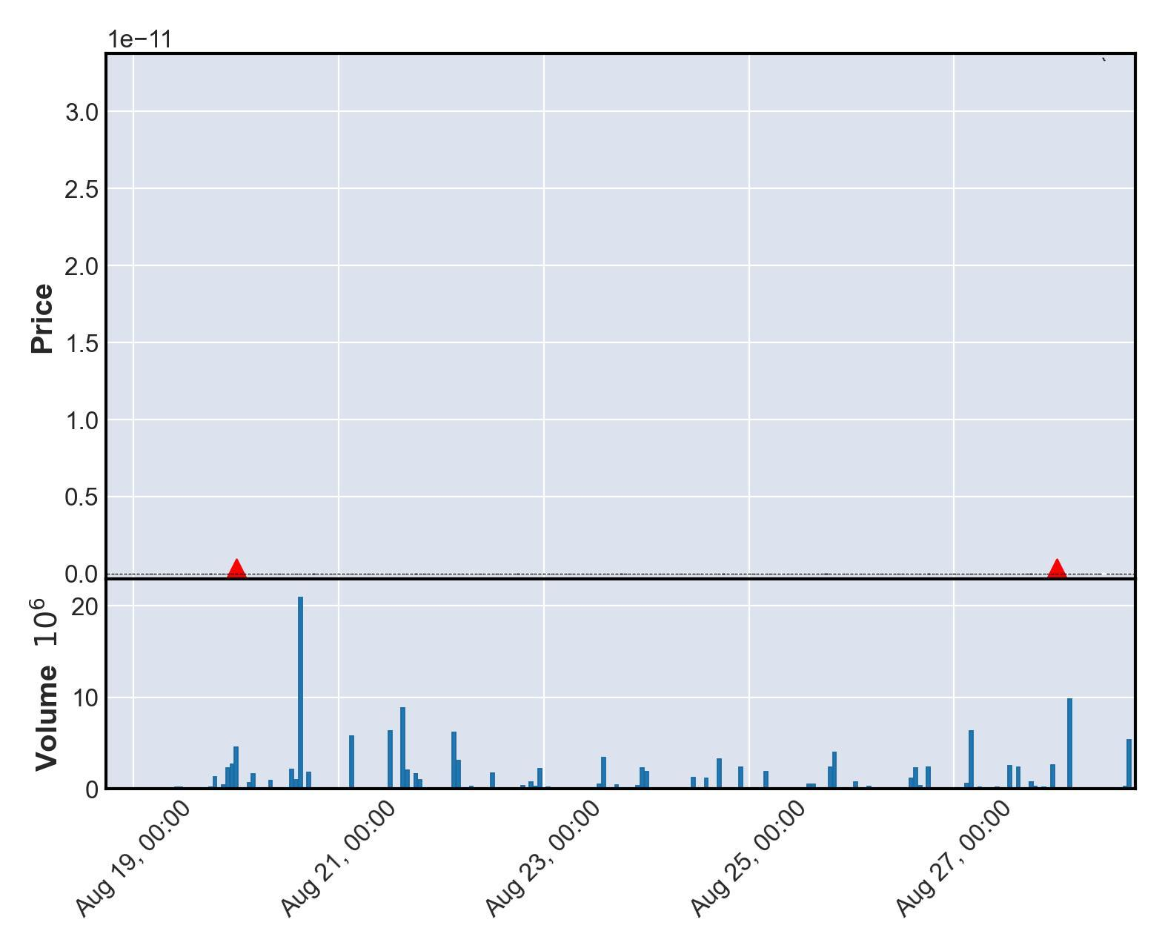

# Currency Under Study - MOON7

|  |  |  |  |  |
| --- | --- | --- | --- | --- |
| buy_date | sell_date | buy_price | sale_price | currency_id |
| 2021-08-21 | 2021-08-30 | 0.127174 | 2.54349 | MOON7 |
| buy_avg_volume | buy_avg_volume_before_trigger | duration | profit | ROI |
| 121547 | 98834 | 9 | 2.41631 | 1900 |

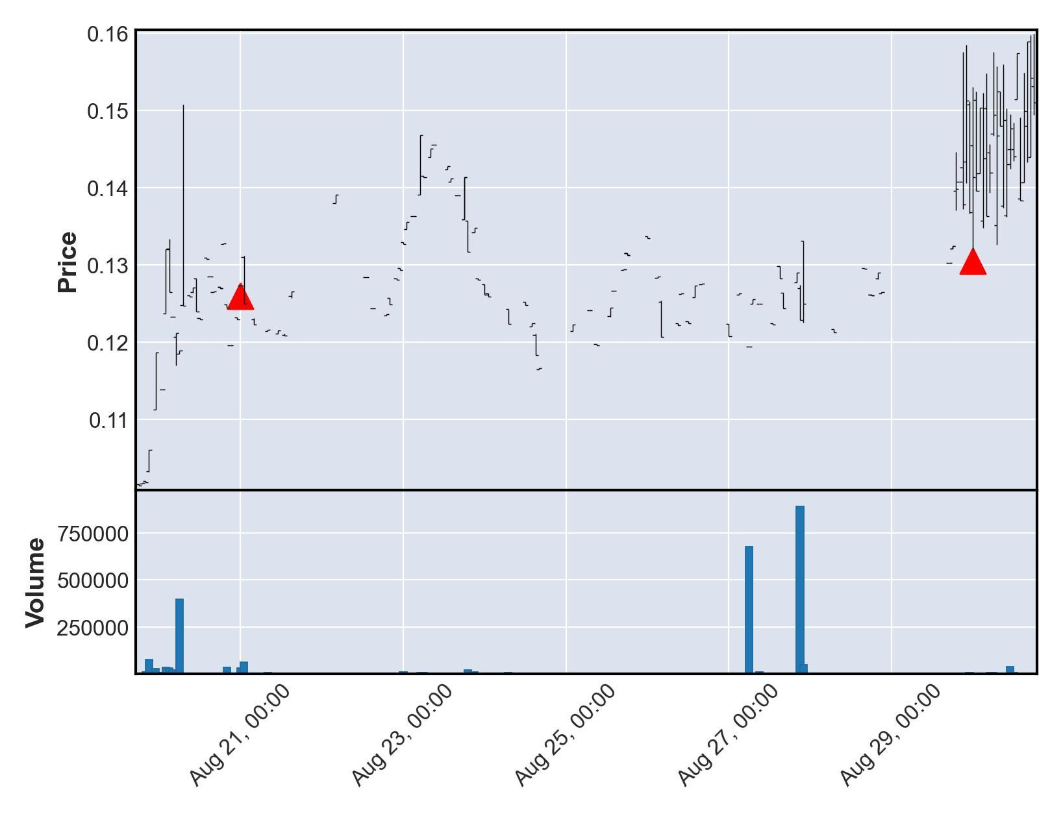

# Currency Under Study - BNX4

|  |  |  |  |  |
| --- | --- | --- | --- | --- |
| buy_date | sell_date | buy_price | sale_price | currency_id |
| 2021-08-23 | 2021-08-25 | 11.4611 | 229.223 | BNX4 |
| buy_avg_volume | buy_avg_volume_before_trigger | duration | profit | ROI |
| 265455 | 129023 | 2 | 217.762 | 1900 |

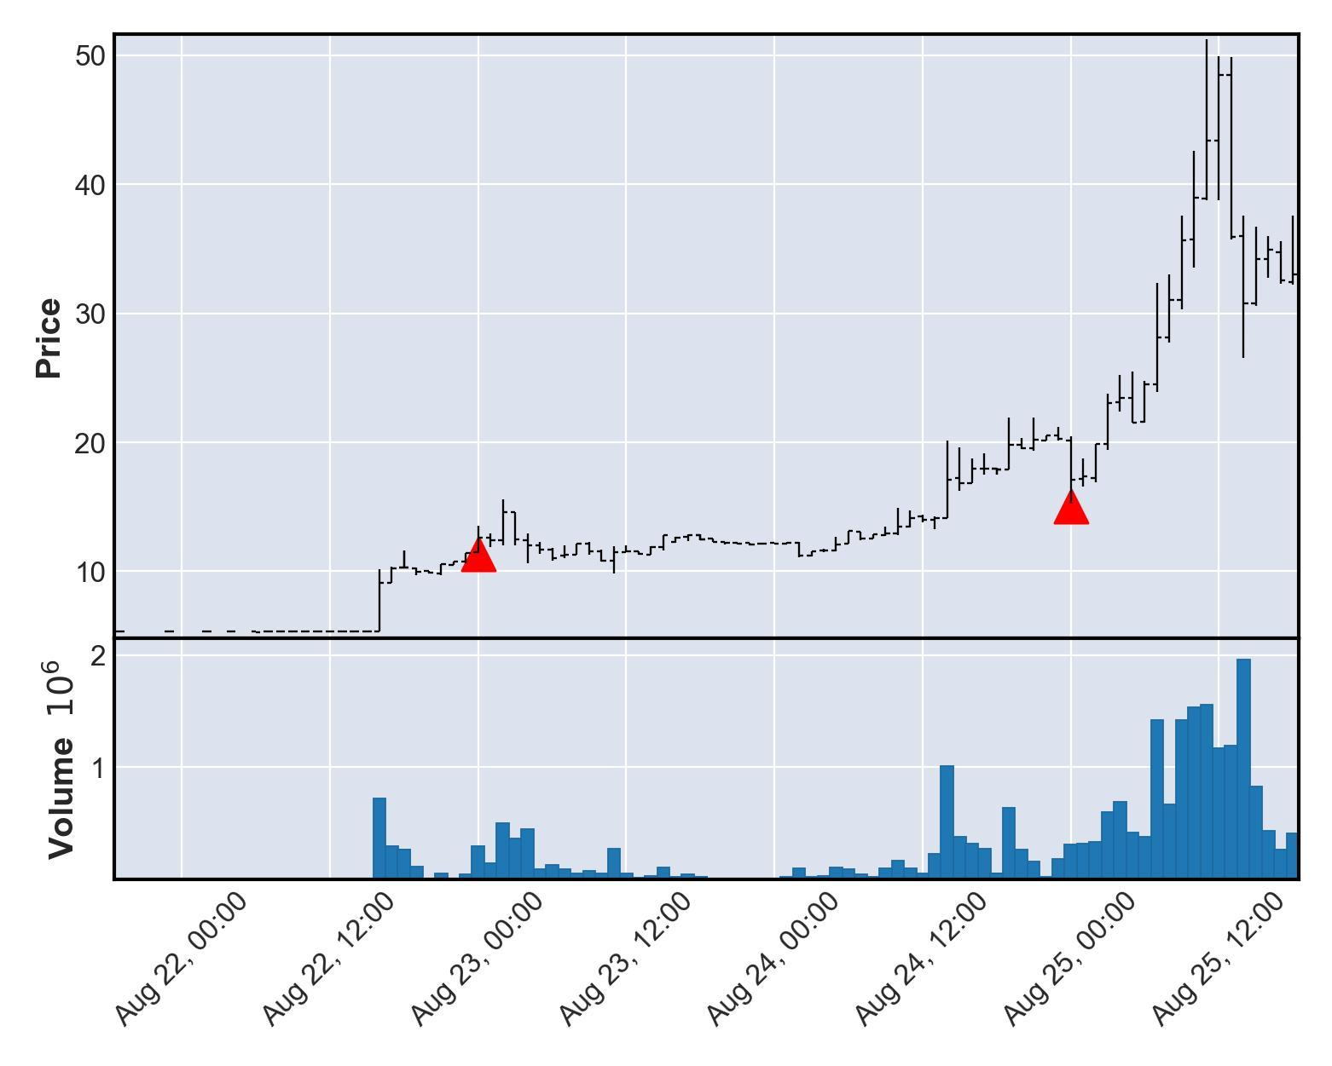

# Currency Under Study - TSC3

|  |  |  |  |  |
| --- | --- | --- | --- | --- |
| buy_date | sell_date | buy_price | sale_price | currency_id |
| 2021-08-28 | 2021-09-04 | 0.0940785 | 1.88157 | TSC3 |
| buy_avg_volume | buy_avg_volume_before_trigger | duration | profit | ROI |
| 1168689 | 1156186 | 7 | 1.78749 | 1900 |

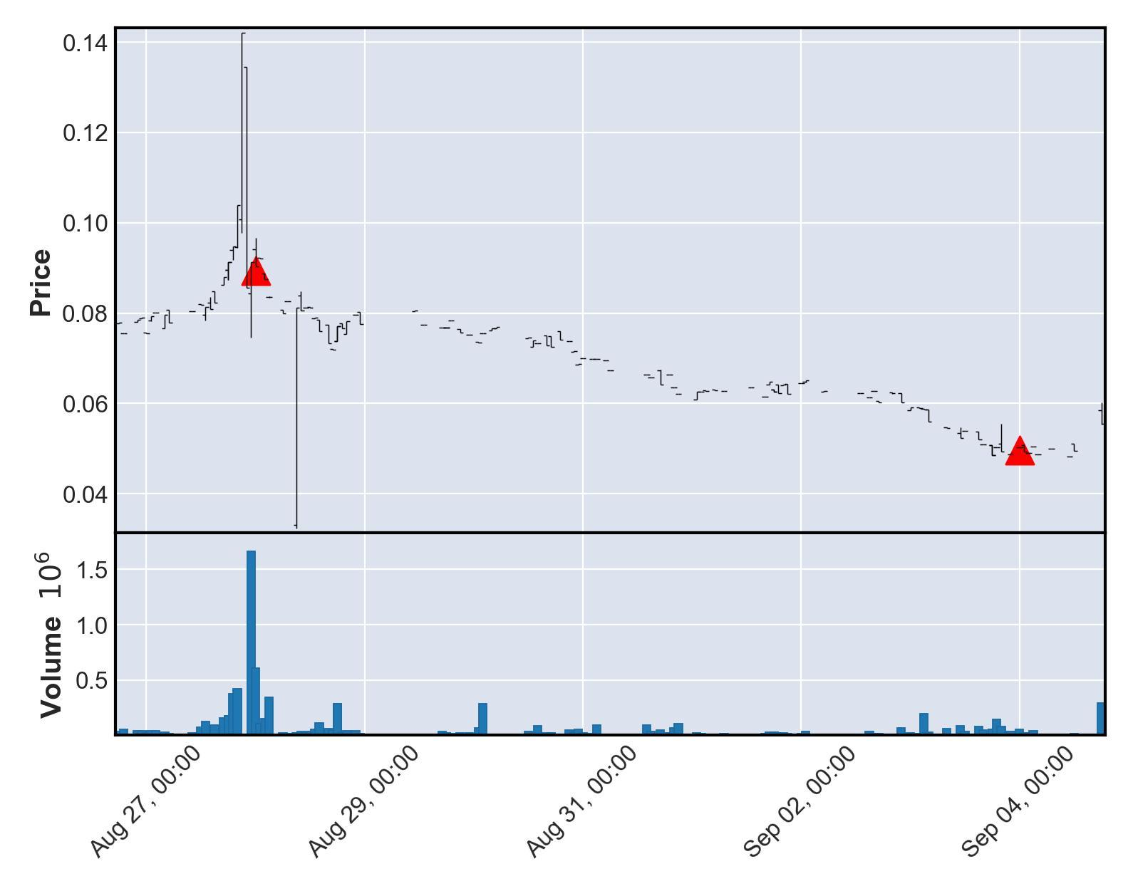

# Currency Under Study - WIFEDOGE

|  |  |  |  |  |
| --- | --- | --- | --- | --- |
| buy_date | sell_date | buy_price | sale_price | currency_id |
| 2021-09-08 | 2021-09-13 | 9.78421e-11 | 1.95684e-09 | WIFEDOGE |
| buy_avg_volume | buy_avg_volume_before_trigger | duration | profit | ROI |
| 227476 | 189468 | 5 | 1.859e-09 | 1900 |

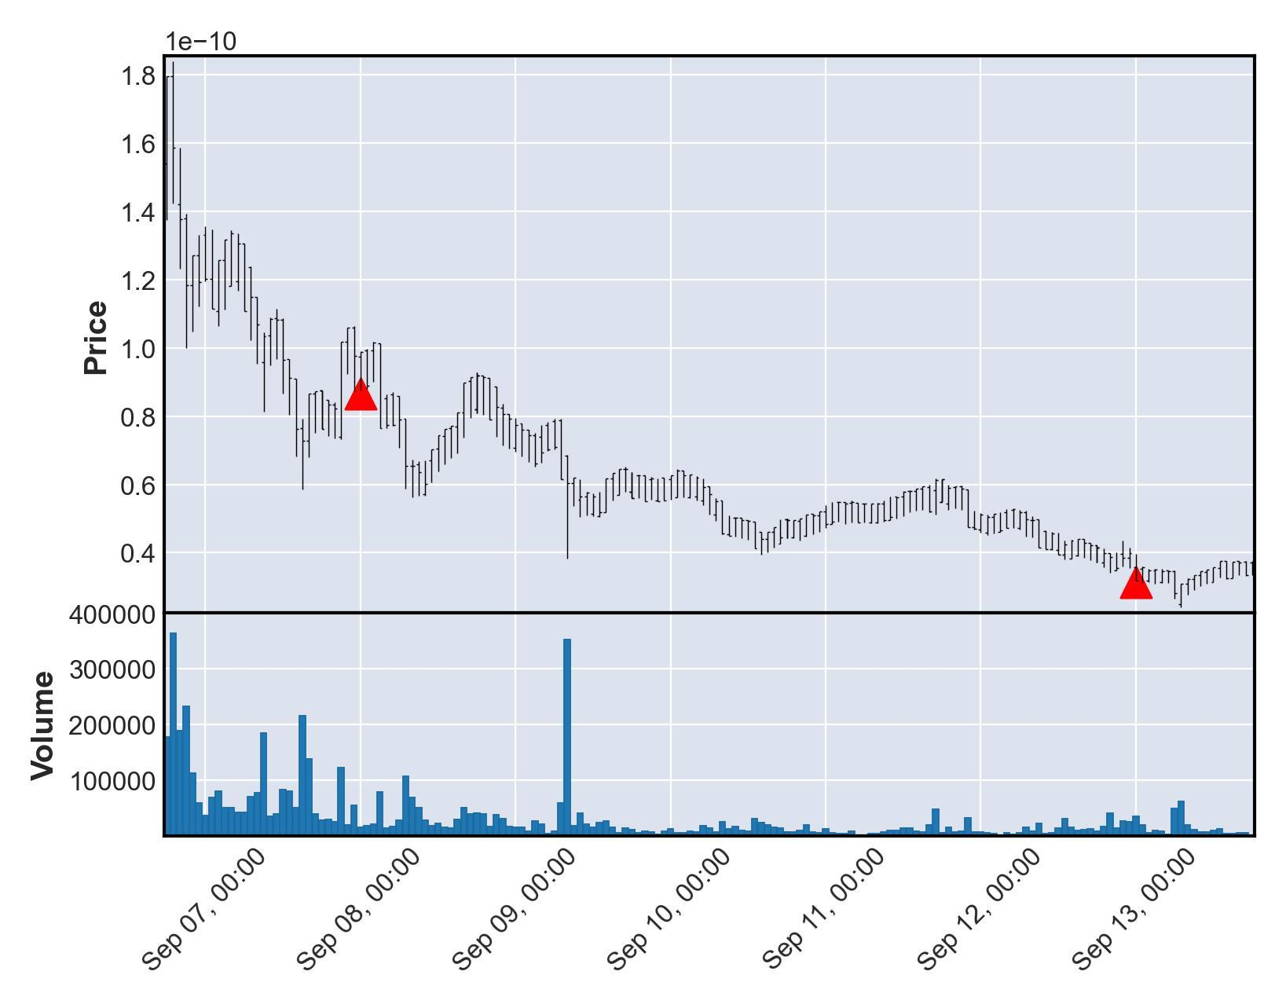

# Currency Under Study - FLOKI3

|  |  |  |  |  |
| --- | --- | --- | --- | --- |
| buy_date | sell_date | buy_price | sale_price | currency_id |
| 2021-09-14 | 2021-09-15 | 1.8655e-08 | 3.731e-07 | FLOKI3 |
| buy_avg_volume | buy_avg_volume_before_trigger | duration | profit | ROI |
| 270751 | 11235 | 1 | 3.54445e-07 | 1900 |

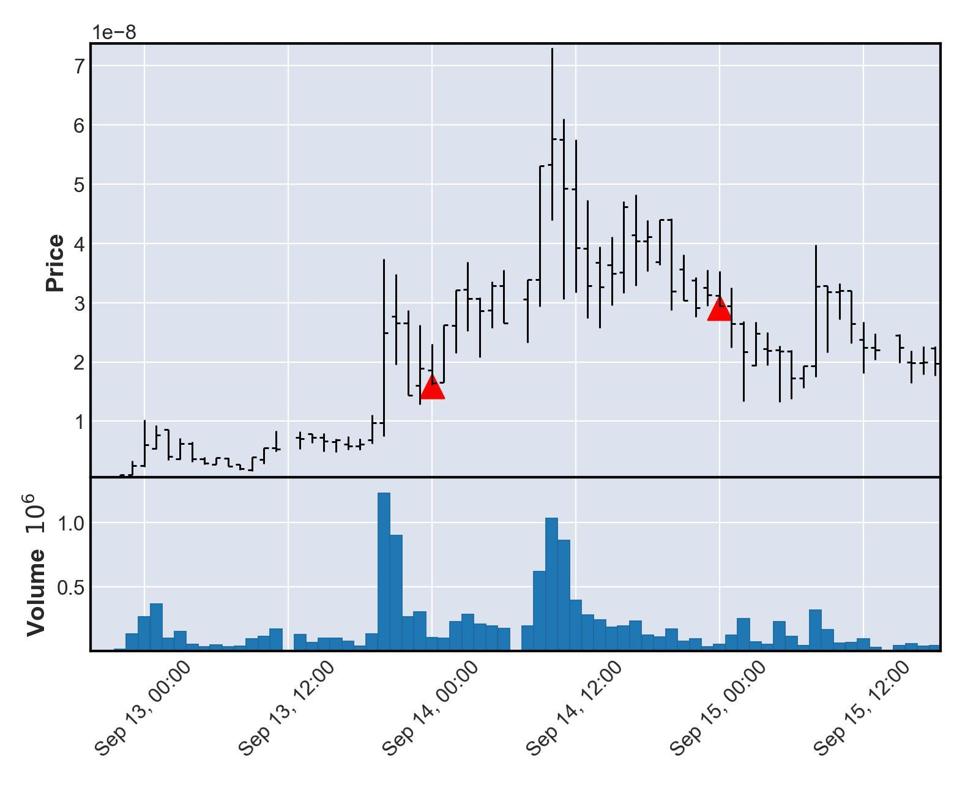

# Currency Under Study - UP

|  |  |  |  |  |
| --- | --- | --- | --- | --- |
| buy_date | sell_date | buy_price | sale_price | currency_id |
| 2021-10-01 | 2021-10-02 | 1.9094e-08 | 3.81881e-07 | UP |
| buy_avg_volume | buy_avg_volume_before_trigger | duration | profit | ROI |
| 1001842 | 829335 | 1 | 3.62787e-07 | 1900 |

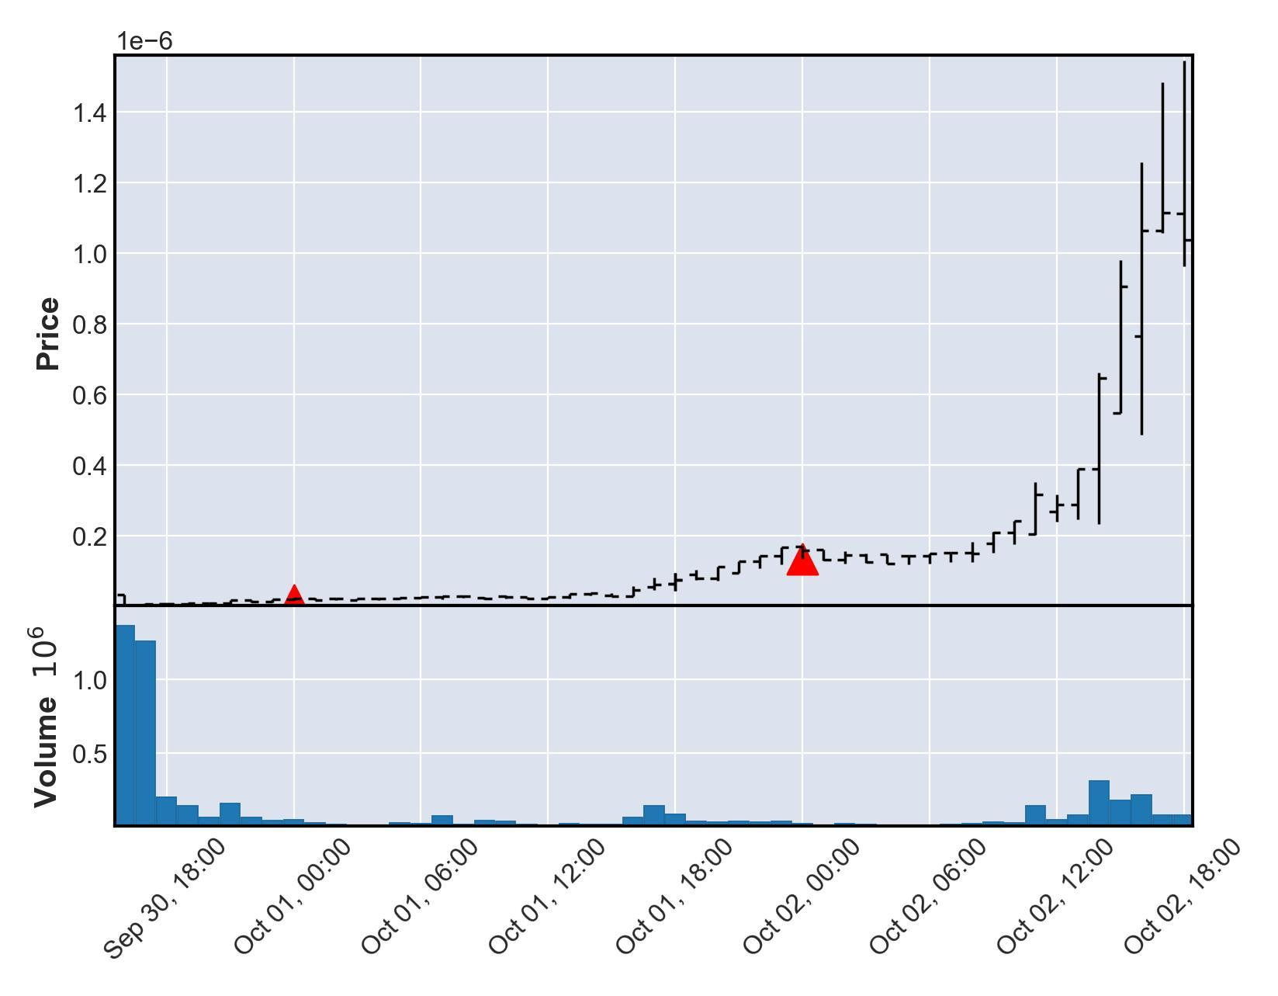

# Currency Under Study - BABYSHIBAINU

|  |  |  |  |  |
| --- | --- | --- | --- | --- |
| buy_date | sell_date | buy_price | sale_price | currency_id |
| 2021-10-07 | 2021-10-10 | 3.13703e-09 | 6.27406e-08 | BABYSHIBAINU |
| buy_avg_volume | buy_avg_volume_before_trigger | duration | profit | ROI |
| 423681 | 7338 | 3 | 5.96035e-08 | 1900 |

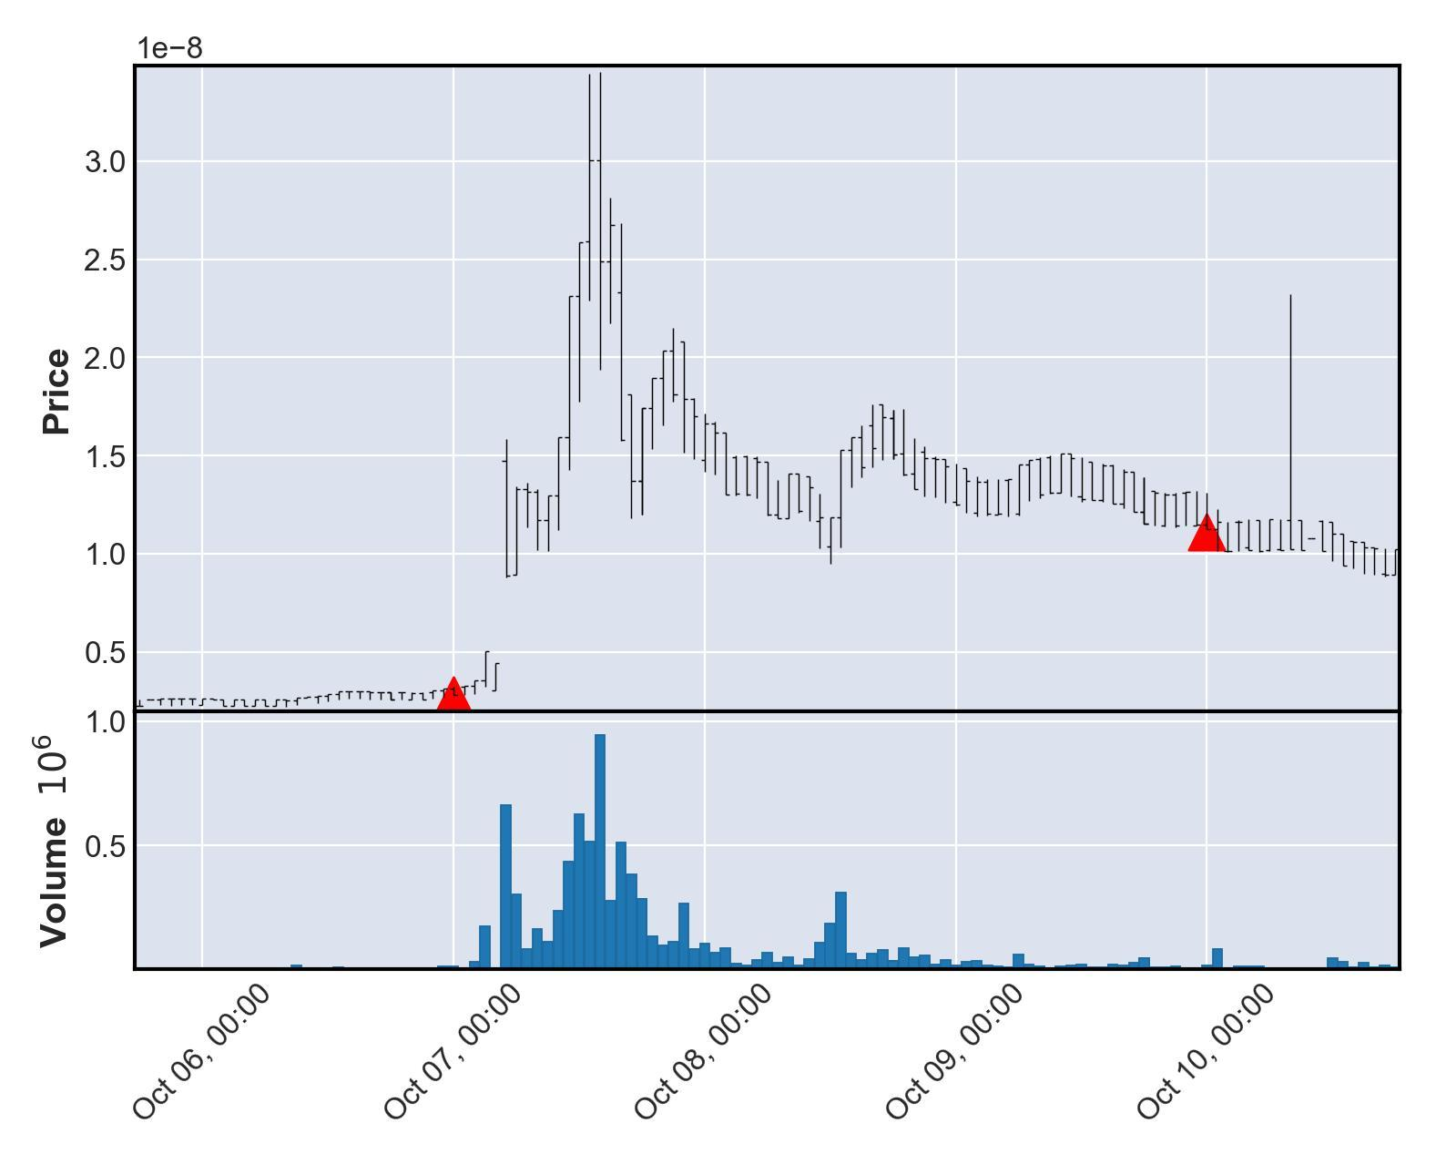

# Currency Under Study - GYRO

|  |  |  |  |  |
| --- | --- | --- | --- | --- |
| buy_date | sell_date | buy_price | sale_price | currency_id |
| 2021-10-15 | 2021-10-17 | 696.549 | 13931.0 | GYRO |
| buy_avg_volume | buy_avg_volume_before_trigger | duration | profit | ROI |
| 1447384 | 1208977 | 2 | 13234.4 | 1900 |

Sale timing of 2021-10-17 00:00:00+00:00 not found with matching transparent transaction data from nomics. Exit not shown on chart.

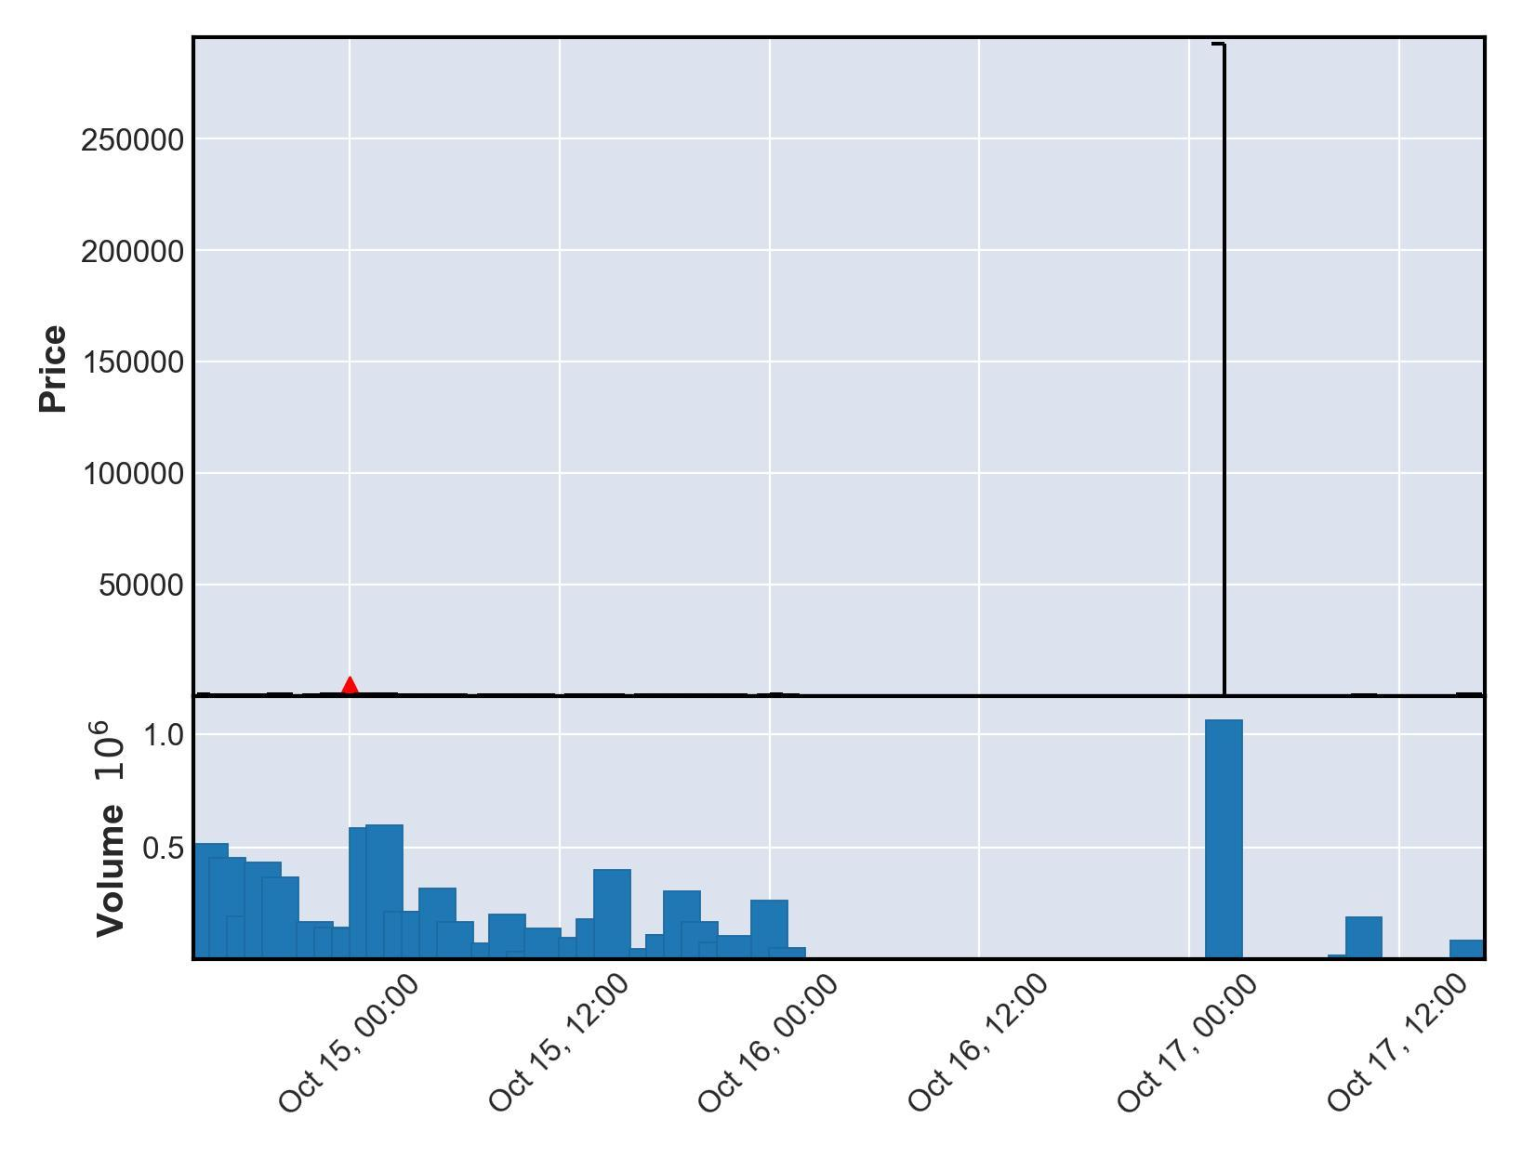

# Currency Under Study - BBTC3

|  |  |  |  |  |
| --- | --- | --- | --- | --- |
| buy_date | sell_date | buy_price | sale_price | currency_id |
| 2021-10-22 | 2021-10-29 | 2.09489e-08 | 4.18978e-07 | BBTC3 |
| buy_avg_volume | buy_avg_volume_before_trigger | duration | profit | ROI |
| 169531 | 132557 | 7 | 3.98029e-07 | 1900 |

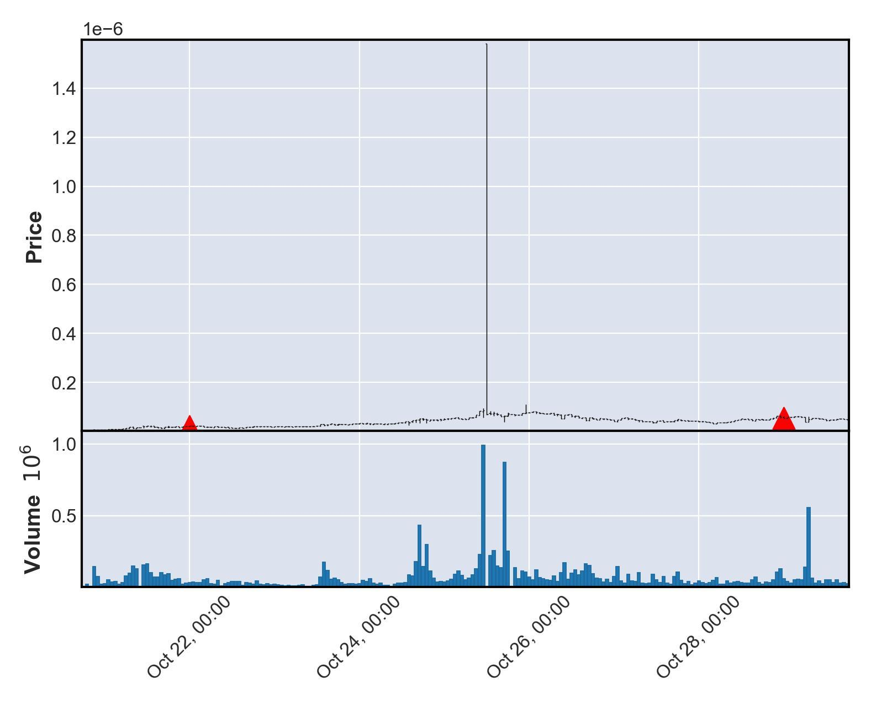

# Currency Under Study - STEAMX2

|  |  |  |  |  |
| --- | --- | --- | --- | --- |
| buy_date | sell_date | buy_price | sale_price | currency_id |
| 2021-10-23 | 2021-10-30 | 0.000238169 | 0.00476338 | STEAMX2 |
| buy_avg_volume | buy_avg_volume_before_trigger | duration | profit | ROI |
| 222058 | 197888 | 7 | 0.00452521 | 1900 |

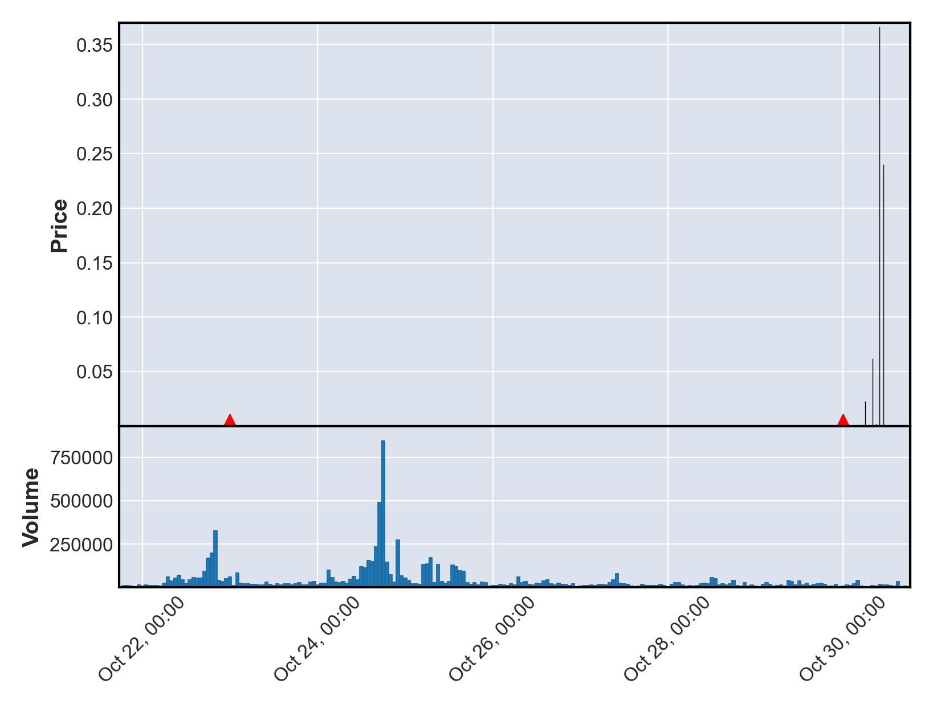

# Currency Under Study - SMX

|  |  |  |  |  |
| --- | --- | --- | --- | --- |
| buy_date | sell_date | buy_price | sale_price | currency_id |
| 2021-10-25 | 2021-10-29 | 7.80491e-09 | 1.56098e-07 | SMX |
| buy_avg_volume | buy_avg_volume_before_trigger | duration | profit | ROI |
| 172064 | 145907 | 4 | 1.48293e-07 | 1900 |

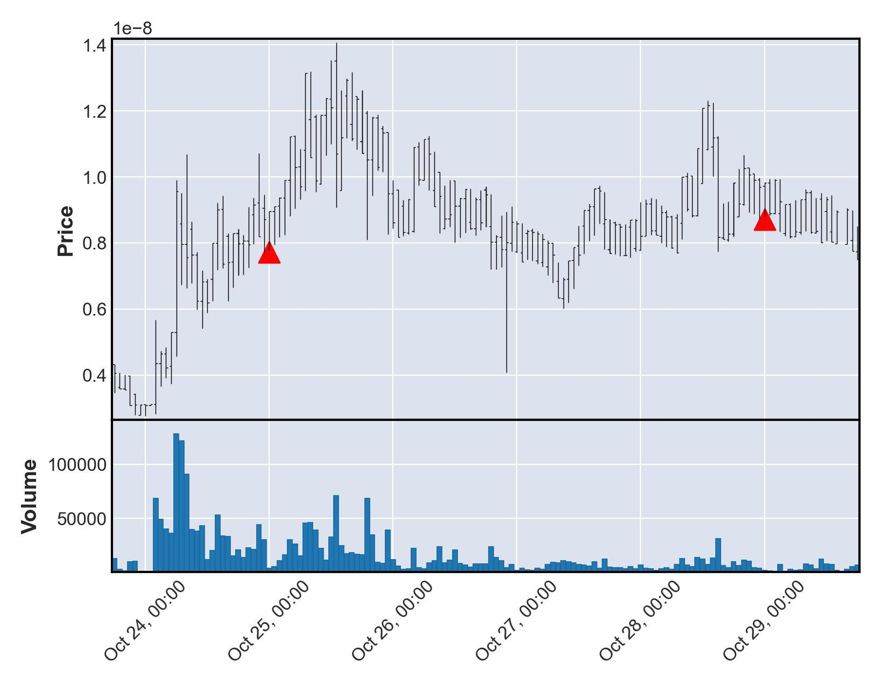

# Currency Under Study - SYA

|  |  |  |  |  |
| --- | --- | --- | --- | --- |
| buy_date | sell_date | buy_price | sale_price | currency_id |
| 2021-10-25 | 2021-10-29 | 8.29021e-08 | 1.65804e-06 | SYA |
| buy_avg_volume | buy_avg_volume_before_trigger | duration | profit | ROI |
| 241449 | 171113 | 4 | 1.57514e-06 | 1900 |

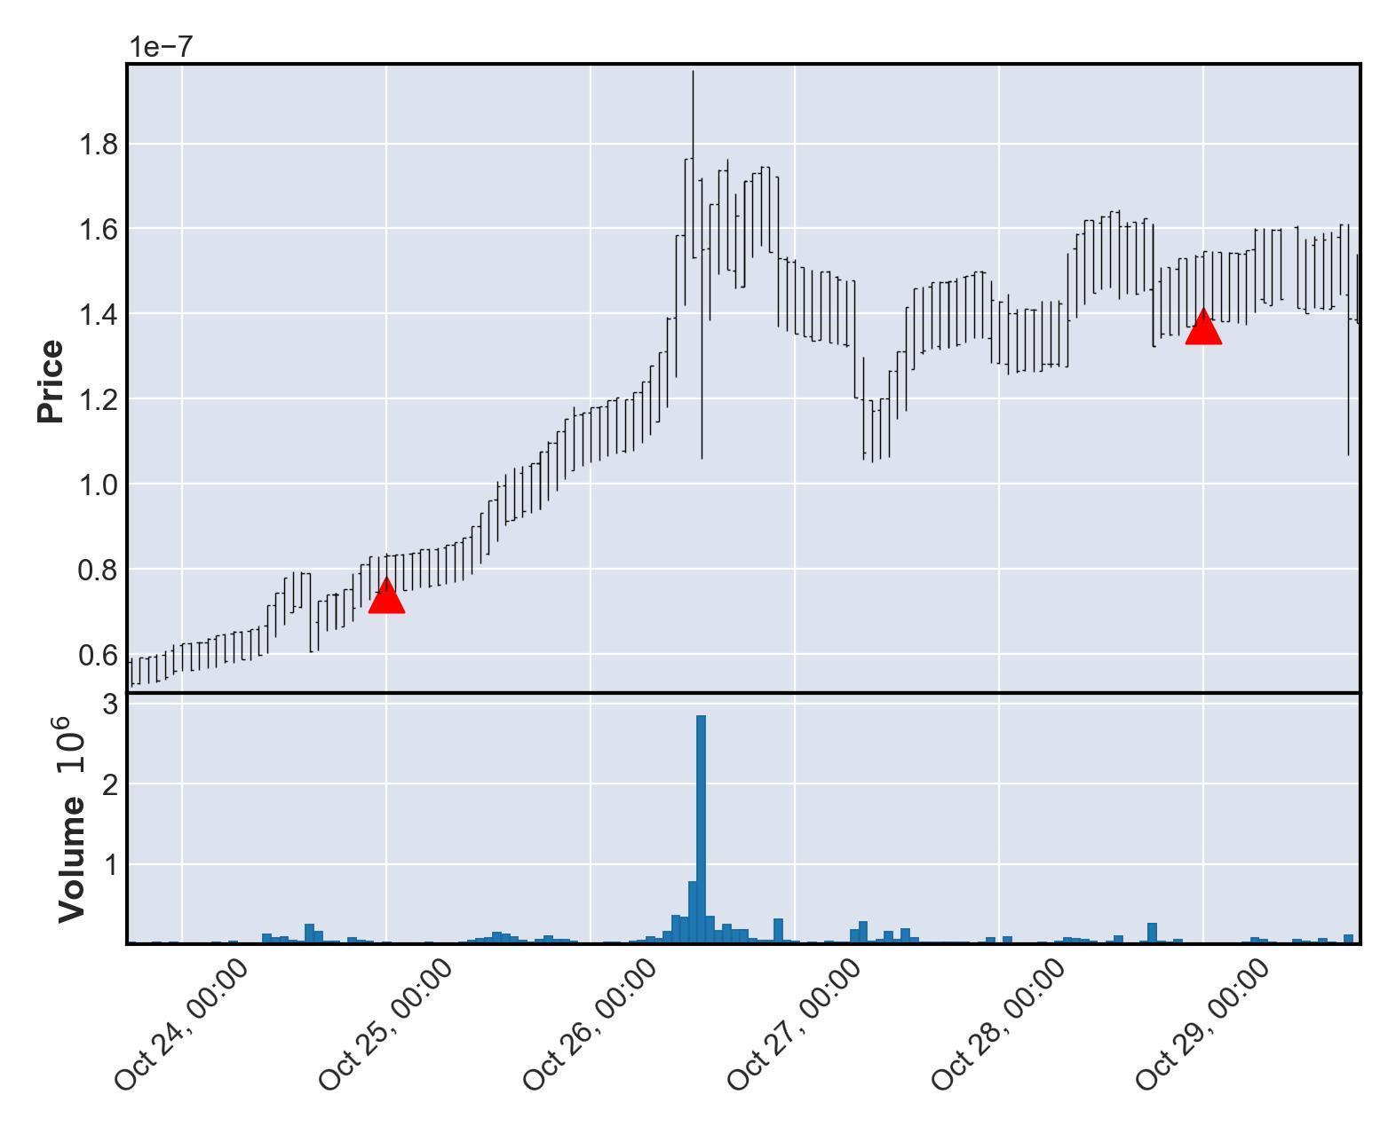

# Currency Under Study - YOOSHI

|  |  |  |  |  |
| --- | --- | --- | --- | --- |
| buy_date | sell_date | buy_price | sale_price | currency_id |
| 2021-10-29 | 2021-10-30 | 1.72975e-06 | 3.45951e-05 | YOOSHI |
| buy_avg_volume | buy_avg_volume_before_trigger | duration | profit | ROI |
| 2765714 | 1939411 | 1 | 3.28653e-05 | 1900 |

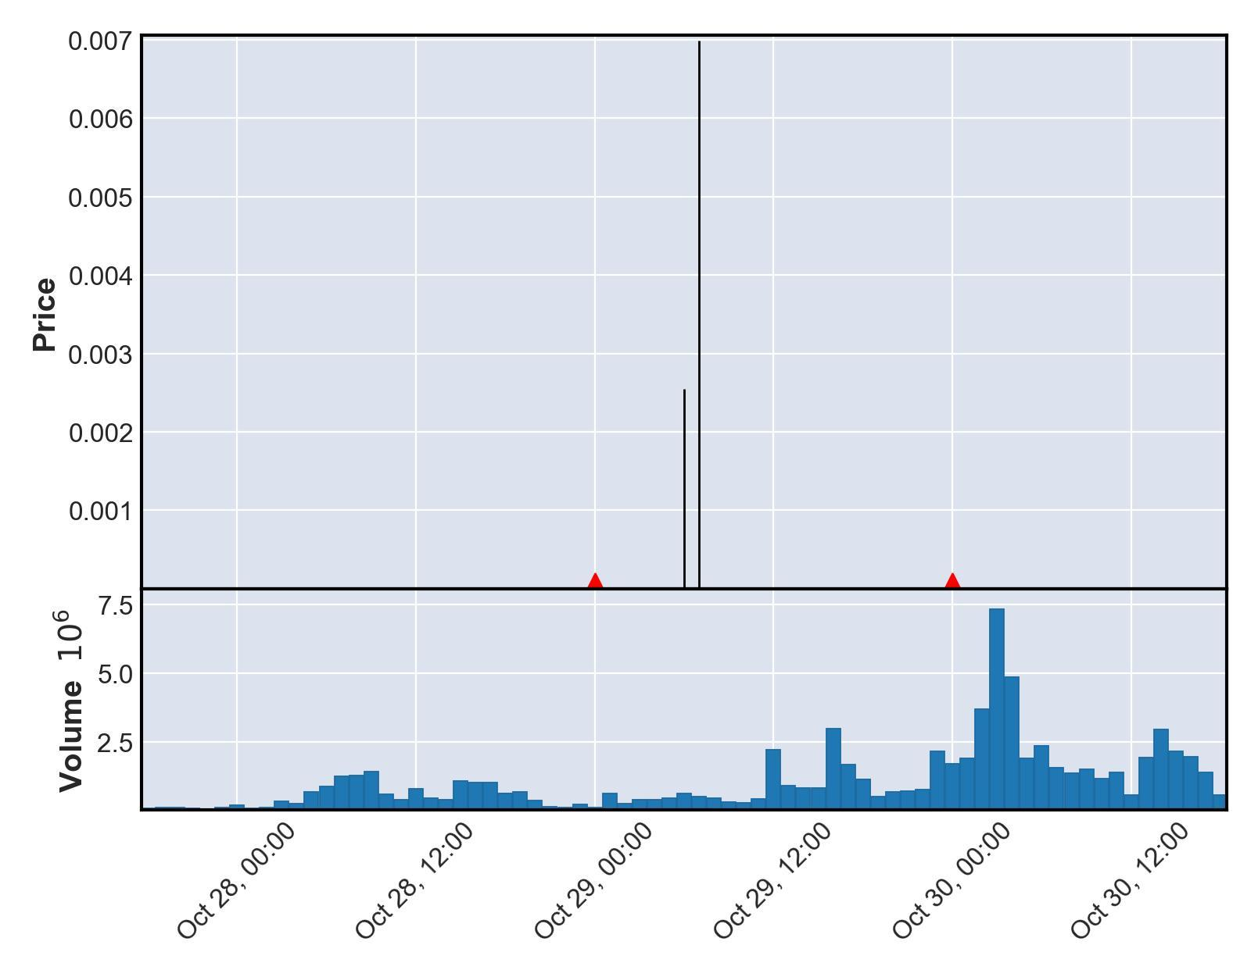

# Currency Under Study - FLOKIELON

|  |  |  |  |  |
| --- | --- | --- | --- | --- |
| buy_date | sell_date | buy_price | sale_price | currency_id |
| 2021-10-29 | 2021-10-30 | 1.89605e-10 | 3.7921e-09 | FLOKIELON |
| buy_avg_volume | buy_avg_volume_before_trigger | duration | profit | ROI |
| 300411 | 173367 | 1 | 3.60249e-09 | 1900 |

