5.

Converting to correct format:

Loading into browser:
- Open browser
- Select “Tools” > “Internet Options” > “Content” > “Certificates”
- Select “Trusted Root Certification” > “Import”
- Follow the Wizard’s intructions
  - “Next”
  - Select .crt file: “Browse” > “ca.crt:” > “ Open”
  - “Next” > “Next” > “Finish
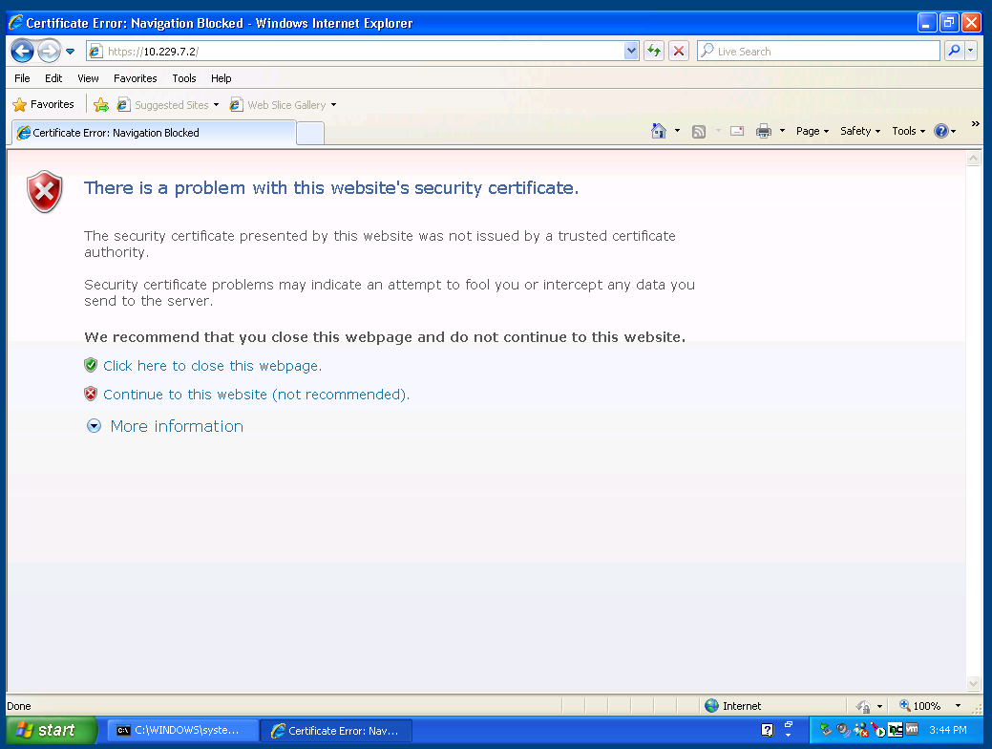
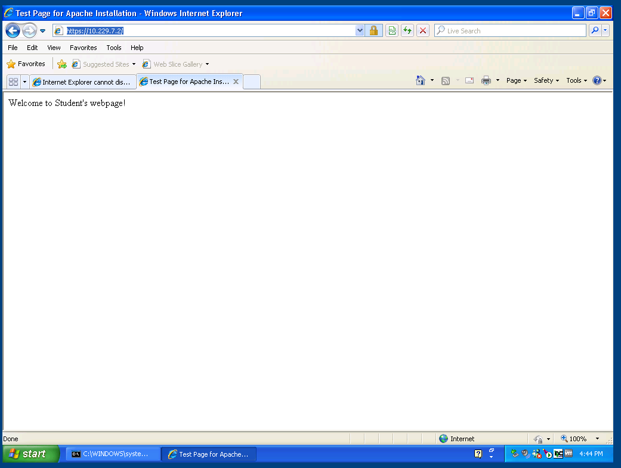

Before Certificate installation
Before Certificate installation
After Certificate Installation

File Types Encountered
What each type is used for, why it is needed
- *.pem: Is a container format that incudes the certificate file for an apache install. It is used to present the certificate to the server in a format that it understands. It is needed to make SSL work on the server
- *.crt: It is the same as a .pem file, (certificate file), but is recognized by windows file explorer as a certificate file
- *.csr: Certificate Signing Request. This file is signed by the CA when a certificate is returned. It is used to send the CA information about the server that will be using the certificate. It is needed to provide the CA with information about the server certificate that you want generated (including the public key)
- *.key: this is a .pem formatted file containing the private key for the certificate the CA generated. This is used to decrypt traffic signed by the public key corresponding to the certificate the CA has issued

Problems Encountered
We encountered a great deal of trouble getting SSL to work with Apache. It was ultimately revealed that the ssl.conf file was improperly formatted (requiring quotes), even though they were never shown in any tutorials

6.

How to sign Java code
- Create the keystore, and key pair . Fill out necessary information
keytool -genkeypair -alias javaKey -keyalg EC -keysize 571 -validity 730 -keystore javakeystore_keepsecret.jks
  - Done to create a certificate signing request. This step is identical to creating a .csr for SSL
  - To generate keys and information for the creation of a certificate by a CA
  - Creates a Java keystore file (.jks)
- Export the certificate to share
keytool -exportcert -keystore javakeystore_keepsecret.jks -alias javaKey -file publicCert
  - This creates a .cer (certificate file)
  - It is done to provide information to other users to verify your code.
- Sign the file
jarsigner *.jar javaKey
  - This signs the Java code with your previously created private key file
  - It is done to allow machines with the certificate file to verify your signature of this file

Differences in web certificates:
- There is essentially no practical difference between signing and SSL certificates, as they perform essentially the same function
- Minor differences
  - If properly configured, you can sign code with an SSL certificate, but you cannot perform SSL with a signing certificate (big security risk)
  - SSL certificates truly expire, and will not be accepted once expired. Signing certificates that expire can still be accepted via a time stamping service, which allows you to verify the code was properly signed when the signing certificate was still valid

Sources:
http://serverfault.com/questions/9708/what-is-a-pem-file-and-how-does-it-differ-from-other-openssl-generated-key-file
https://blogs.oracle.com/java-platform-group/entry/self_signed_certificates_for_a
https://docs.oracle.com/javase/tutorial/deployment/jar/signing.html
http://stackoverflow.com/questions/9527972/ssl-certificate-same-as-signing-certificate

