Justin Calhoun

Professor Summer Rae Elasady

Foundations Of Programming: Python

1 October 2018

Creating an Introductory Python and Shell Script

This document will detail the process used to complete Assignment 01 for the Foundations of Programming: Python course. For this assignment, I chose to use tools already available and installed as part of previous projects, which differ slightly from the recommendations provided in the syllabus:

* The Windows Subsystem for Linux, running Debian GNU/Linux (WSL)
* Python 3.5.3
* ConEmu
* Vim

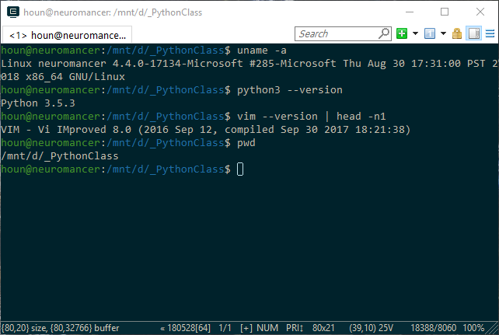

Figure 1: ConEmu displaying tool versions

Using vim, I created a new file named “test.py” and added the requested python statement.

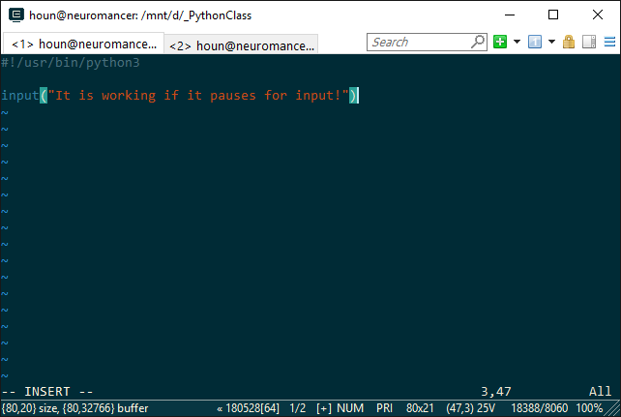

Figure 2: Contents of test.py file in vim

I saved this file, and then created a bash script named “test.sh” which runs the “test.py” file. I did not need to set this shell script to be executable due to the default behavior of mounted Windows file systems under the WSL, but to be complete, I did it anyway.

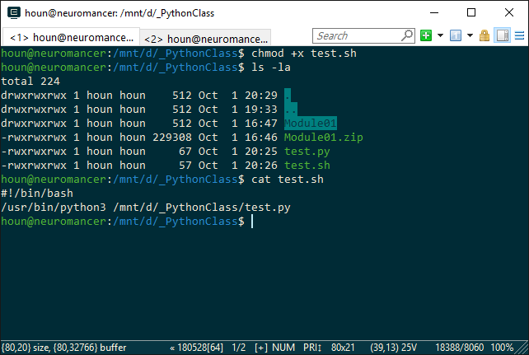

Figure 3: Files, permissions, and contents of test.sh

Finally, I tested the two files and confirmed that the scripts, both shell and python, functioned as expected. Running the test.sh file, it in turn ran the test.py file, displaying the expected text and waiting for me to press the Enter key before finishing execution and ending both scripts.

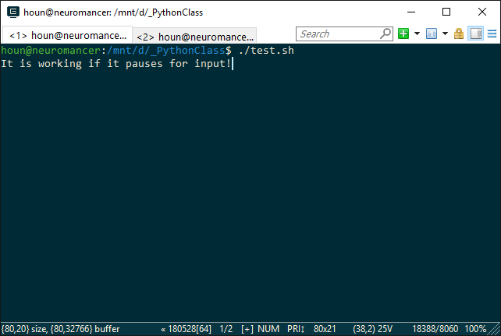

Figure 4: Successful run of both scripts

For this assignment, I endeavored to follow the instructions as closely as possible, given my non-standard choice of environment and tools, and was able to complete it successfully.